A Python module for quaternions.
Abstract:
In modern navigation systems, Direction-Cosine Matrix is widely used to represent rotation in three dimensions. Because of number round in computer and number operation, DCM costs many time and space to compute a little no-accurate output. In real engineering world, this may cause a serious problem. The quaternions are a number system that extents the complex numbers [1]. Compared to the DCMs, quaternions have many advantages in engineering area. To prove our assumption, a Python class called Quaternion is built to compute quaternion object, a function Python file is written to store some useful functions and a test Python file is wrote to test Quaternion class and compare numeric calculation ability between Quaternion and DCM. By using random initial placement, we got outputs with high precision show that quaternion works better than DCM in many cases.

Python data type:
Our quaternion module is based on Python 3. It has basic data types, like integer etc. To show how different the quaternion and DCM perform in same data type, we first use integer, then float, then a built-in functions Decimal. As one of dynamically-typed languages, we can use one data type without declare it and can even change it data type without a compilation error like in C language.

Integers
In computer science, they are called ints or integers. They can be positive or negative or equal to 0. But they cannot have a decimal part, which means they can have part only before the dot.
floating point numbers
In computer science, they are called floats. They can be positive or negative or equal to 0.0 with a decimal part.
Decimal
The decimal module provides support for decimal floating point arithmetic [2]. It can be seen as an extent of standard floating point numbers. For its precision, it’s always used in finance calculations. To compute more accurate outputs to compare quaternion and DCM, we use Decimal module to produce outputs with more digits. With user alternative precision, Decimal has a defaulting 28 places, which lead to a better precision than float.

Object-oriented programming
Object-oriented programming is a programming paradigm based on the concept of “objects”, which may contain data, in the form of fields, often known as attributes, in the form of procedures, often known as methods [3]. By using the thinking of OOP, a Quaternion class is made to represent quaternion. Assuming a quaternion is in form of

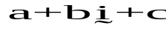

then its attributes are real part a, imagery part b, c and d. For quaternion methods, they would be explained in Quaternion part.
In general, there are many advantages to use OOP in your programming.
- It hides many things that user do not need to know. For example, user do not need to know the details how a method works. User only cares about what is this method doing and its output/input.
- Easy to extent. If someone want a new function of this class, programmer do not need to rewrite whole class but to add what user needs.
- Reuse. While it doesn’t show the inheritance in this Quaternion codes, it is still a really important advantage of OOP.
Assuming we make a People class. As a human, people have many similarities like they both have hair or sights in most cases. After hard work, we finally get a People class with hair() and sights() methods. Then our boss said, hey, we need another class of Children and third class Old. Both of them are people, so it can inherit hair() and sights() methods without write same methods again. This advantage will cut codes much shorter and easier to understand.
To make each subclass unique, every subclass can add their own method, like in Children() class may have a method called drink_milk() which may not show up in Old() class, and Old() may have a method called experiences() which may not useful in Children() class.
- Codes will be easy to read and easy to rewrite.
Once again, OOP has many advantages which make it one of the most important thinking in programming. And in our Quaternion class, some advantages will be shown, some would not be shown. Please remember that codes can be reused, so it would be clear if people decide to extent this class or write a class inherit from Quaternion class.
Quaternion
In our implementation of quaternion, there are 12 basic methods for quaternion. They would be explained one by one as below.

.__init__(self, a, b, c, d)：
If a quaternion object can be represented as below:

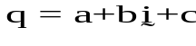

To initialize a Quaternion object, 4 numbers are required to represent the real part a, the imagery part parameters of b, c and d. In computer science, it is important to protect data itself. A method called encapsulation is invented to protect data and hide details of designed class. To encapsulize the data, 4 arguments are given to the object attributes. The basic formula of this method as below:

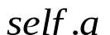;

If user want to use some encapsulated data, the designed class need to have some methods like setter() or getter(). By their names, user can set data using setter() methods and get data using getter() methods.
In this thesis Quaternion class, we have no need for specific single parameter of a Quaternion object, so the author didn’t implement these normal methods in the class. If user find they are useful in future work, this method can be added without any correction to other codes. Thanks to encapsulation thinking, we could do this work without any pain.

.__add__(self, other)
Addition is a normal operation in Quaternion objects. Assuming we have two Quaternion objects A and B, their sum is C. All of them are Quaternion objects. If we have them in:

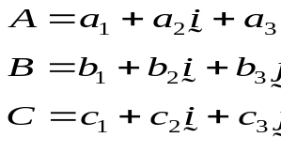
then the addition works like:

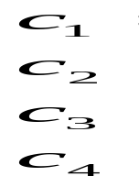
In this rule, we can conclude easily that C can be written as:

Addition rule between two Quaternion objects is clear, then we meet a difficulty to translate the rule into programming language, in our case, in Python.
It has two ways to implement addition in Quaternion. One is to create a method and used as a dot method like other methods. In this way, once we want to add two Quaternion objects together, we need to initial a Quaternion object first, then initial another Quaternion object. Let’s called the first one A, then the second one B. we can do addition like this:



Above is quite normal in OOP, but what if the user wants to add two objects like what we do when we have two natural number. In fact, another way makes it possible. In this way, user with little programming experiences can use it without any pain and it looks like this:

A + B;

Some people with programming experiences may think it as overloading. As Python is a dynamic language, it doesn’t support overloading as many other languages do. In Python, they are called methods, they are magic methods [4]. Long in short, magic method let it possible to do addition like above in a more human readable way.

.__sub__(self, other)
Subtraction is almost the same as addition. It can be seen as a Quaternion object add a negative Quaternion object.
Assuming we have two Quaternion objects A and B, their sum is C. All of them are Quaternion objects. If we have them in:

then the subtraction works like:

In this rule, we can conclude easily that C can be written as:

In Quaternion class, it implemented as a magic method too. User can use it as below:

A – B;

.__mul__(self, other)
The multiplication of two Quaternion objects is not as easy as above. Before we dive into how to multiply two quaternions, we need to know how to compute multiplication product between each element.
As said before, the quaternion can be seen as an extent to complex number. So in some area, they have same rules.
A number multiply a imagery part follows the rule of scalar product between number and imagery part of complex number:

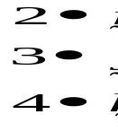

The rule applies to products between same imagery part:

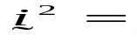

The basis elements I, j, and k commute with the real quaternion 1, that is

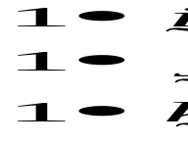 [5]

Then come to the different part:

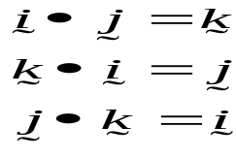

Using the rules above, we can draw a multiplication table for quaternion:

x | 1 | i | j | k
1 | 1 | i | j | k
i | i | -1 | k | -j
j | j | -k | -1 | i
k | k | j | -i | -1
In our Quaternion class, we compute __mul__() method as a Hamilton product. Assuming we have two Quaternion objects, one is called A, another is called B. Assuming A is in form of

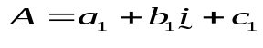

B is in form of

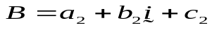

The Hamilton product is determined by the product of the basis elements and the distributive law[6]. Then the Hamilton Product as below:

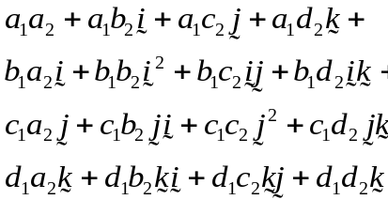

By using the rules in multiplication table, it can be rewritten as:

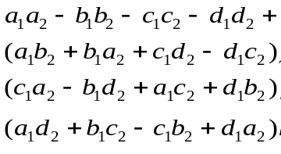

But in our Quaternion class, we use Quaternion objects in angle rotations. In case like this, we can see it as rotation B followed by the rotation A, that is rotation
followed by rotation
.scalar_mul(self, scalar)
To scale a Quaternion object, the rule is a little different from normal multiplication between two Quaternion objects. In the class, method scalar_mul() handles this.
Assuming we have a Quaternion object called A and a scalar number B. A is in the form of

the scalar product can be computed as below:
scalar part :

vector part:
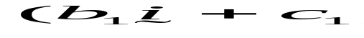
Put them together:
For scalar multiplication, it can be seen as each part of Quaternion object A is scaled B times.
if 0 < B < 1, then A becomes smaller; if B = 1, A is of the same as the original A; if B > 1, then A becomes bigger.

.dot(self, other)
From what we did above in Quaternion multiplication, we know that it’s not easy to compute Hamilton product between two Quaternion objects. Like any other mathematical class, there is a operation called dot product between two Quaternion object and its rule is straight forward. To compute the dot production of two Quaternion objects, a dot() method is used. A multiplication between two objects is a Hamilton product while a dot product means each element multiply with same corresponding element in another quaternion object.
Assuming we have two Quaternion objects, one is called A, another is called B. Let A in form of

and B in form of
then the dot product rule is like:

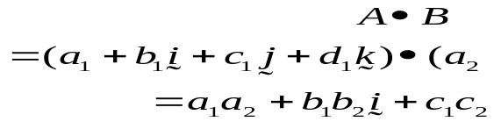

.norm(self)
To understand norm of a Quaternion object, let’s explain a simple instance in complex number. As we could treat quaternion as extent to complex number, the rule applies in complex number can be used in quaternion field as well. In the complex number system, assuming we have a complex number
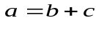
then we can get its norm following this rule
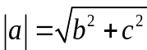
One way to understand the norm in complex number is to think about b + ci as a point (b, c) in complex plain. Then the square root of 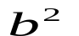 is in fact nothing more than the length from the origin to the point (b, c).
Thinking in the same way, we can take a quaternion as in four dimensions, one axis is for the scalar part, other three axis are for the complex part. It’s a hard work to explain 4D one a 2D plain frame. At this step, we need some imagination. Assuming we have a 4D frame, one is scalar axis, one is for i-axis, one is for j-axis, the last one is for k-axis. Refer to what we talked above in complex number, we can take the norm of a quaternion as the length from origin to the point (a₁, b₁, c₁, d₁). the norm of Quaternion object A should be:

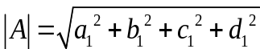

Another way to think about norm of complex number, is to think it in a more geometric perspective. Assuming we have a complex number like , then its conjugate is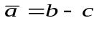. We can draw a norm formula like this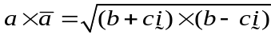. The final output is the same, but the way of thinking it is different. We can rewrite it as matrix multiplication like:

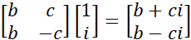

As it in number theory, the norm is the square of determinant of above matrix. for any two quaternions p and q, multiplicativity is a consequence of the formula for the conjugate of a product [7]. Then it follows the rule by using the determinant like:

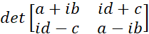

after calculate the determinant of above, we could know that .

.norm_q(self)
This method is to compute unit quaternion object. In its definition, the unit quaternion is the quaternion of norm 1. In other word, if we have a Quaternion object like

,
then a₁ + b₁+ c₁ + d₁ = 1. User may treat it as a useless method at first, but as we dive deeper into rotation test, we need to normalize the output quaternion object each time to make sure we are in the way of same scale.
The definition is not complex, for each element of a Quaternion object, divide them by norm of this Quaternion object, then we are done.

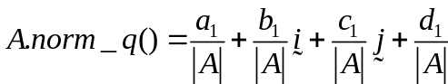

The tricky is, we calculate norm of this object in the method rather than calculate four times in return operation. It may have little effect when we get small number normalizations, but when we test for million times, it makes huge difference. There are some other tricky in computing this class and author will explain it when we come to the part.

.conj(self)
Conjugation of quaternions is analogous to conjugation of complex numbers and to transposition of elements of Clifford algebras [8]. If a quaternion object can be represented as

then the conjugation of this quaternion object is

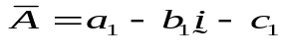

We have already talked about some conjugation definition in  method part, now in this part we first talked about complex conjugation then we will talk about quaternion conjugation. Please keep in mind, we can treat quaternion as an extent in 4D space of complex number, so many attributes are in the same form but of different dimensions.
Conjugation of complex number
In mathematics, the complex conjugate of a complex number is the number with an equal real part and an imaginary part equal in magnitude but opposite in sign [9].
Complex conjugation has some useful properties as follow:
Assuming we have two complex numbers, z and w.
The conjugation of sum of them equals conjugation of z add conjugation of w.

The conjugation of subtraction of them equals conjugation of z minus conjugation of w.

The conjugation of multiplication of them equals conjugation of z multiply conjugation of w.

The norm of conjugation z equals to the norm of conjugation.

We have many other properties in complex conjugation. But our aim here is to see how similar a complex number and a quaternion alike. Now we come to the quaternion part.
Assuming we have two Quaternion objects, one is A in form of
another is B in form of
According to the conjugation rule of quaternion, the conjugation of A is:

the conjugation of B is:

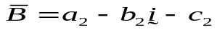
the conjugation of sum of A and B is:
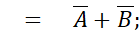
the conjugation of subtraction of A and B is:
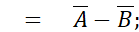
the conjugation of multiplication of A and B is:
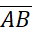
while multiplication of conjugation A and conjugation B is:
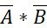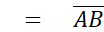
The norm of A is:

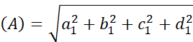

The norm of conjugation of A is:

From above, we could see that in quaternion field, the rules can be used as well.

.rotator(self, theta, vectors)
The aim of rotator() method is to rotate the Quaternion object for theta angle around the vectors. From what we say above, we could see that this function has two steps, the first is to compute the needed rotator, the second is to calculate the rotated Quaternion object.
But less is more[10]. In the rule of function design, usually only one thing can be done in a single function. According to this rule, in usual way, we need to write a independent function to build he rotator, then use it in a Quaternion object rotation. There are two advantages using this way, one is the strengthen of codes reusable, another is to make each function has its specific aim which would make others easy to understand.
Author chose another way to build this function for the reason we only care about rotated Quaternion object in this thesis. Every time we compute a Quaternion object to rotate another Quaternion object, we used it immediately. In other words, we only care about aimed Quaternion object, so it can be written like this.

.toDCM(self)
Both quaternion and DCM can represent rotations. But what are their differences?
In quaternion, the advantages are:
1. The advantage of Quaternion over DCM in computer computing, is in matrix representing of step by step rotation the floats is rounded every time and would cause a huge difference from real output.
2. For quaternion structure, it operates less multiplication than DCM.
3. Easy to compute a normalized one
4. Represent pure rotation
5. Avoid a problem called gimbal lock.
The disadvantages are:
- hard to understand
- sometimes you had to do normalization to get a pure rotation.
As for DCM, advantages are:
1. widely used and easy to understand
2. can be split into three simpler constitutive rotations.
Disadvantages are:
1. because it’s depended on axis about which rotation made and their sequence, the sequence of multiply is important and can be misused easily.
2. The inverse to get rotation angles is not unique
3. may meet some problem called gimbal lock.
4. It has six constraints. For using three parameters we can describe a rotation, while DCM use 9 parameters.
Sometimes you cannot compare which one is better than another one only by words, author write a series of test codes to test both DCM and Quaternion. These tests would be explained later in this thesis. Now let’s focus on the method of .toDCM().
Assuming we have a Quaternion object like

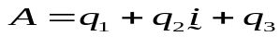

and our aimed DCM is in form of
.__str__(self)

Math
It is a module made for mathematical functions. It has six parts, one part for number-theoretic and representation functions, one for power and logarithmic functions, one for trigonometric functions, one for angular conversion, one for hyperbolic functions, one for special functions and the last is for constants.
For math module used in our Quaternion module, we mainly use the trigonometric functions part to produce our rotation quaternion and square function in power and logarithmic part to get some square root.
NumPy
It is a functional package made for scientific computing. In quaternion implement, it is used as short term np to rearrange Direction-Cosine matrix into a array object.

[1] https://en.wikipedia.org/wiki/Quaternion
[2] https://docs.python.org/2/library/decimal.org
[3] https://en.wikipedia.org/wiki/Object-oriented-programmings
[4] https://github.com/RafeKettler/magicmethods
[5] https://en.m.wikipedia.org/wiki/Quaternion
[6] https://en.m.wikipedia.org/wiki/Quaternion
[7] https://en.m.wikipedia.org/wiki/Quaternion
[8] https://en.wikipedia.org/wiki/Quaternion
[9] https://en.m.wikipedia.org/wiki/Complex_conjugate
[10]

