Figures for manuscript - ATAC-Seq

2023-07-28

**Fig.** Fragment size distribution for a representative sample. Left, distribution of the fragment size lengths; right, autocorrelation coefficient showing the expected periodicity.

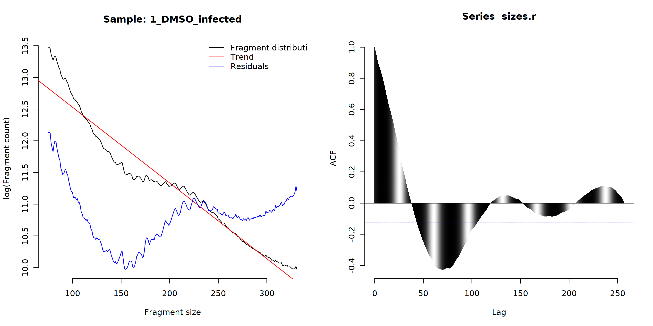

**Fig.** Heatmap showing correlation matrix between peaks.

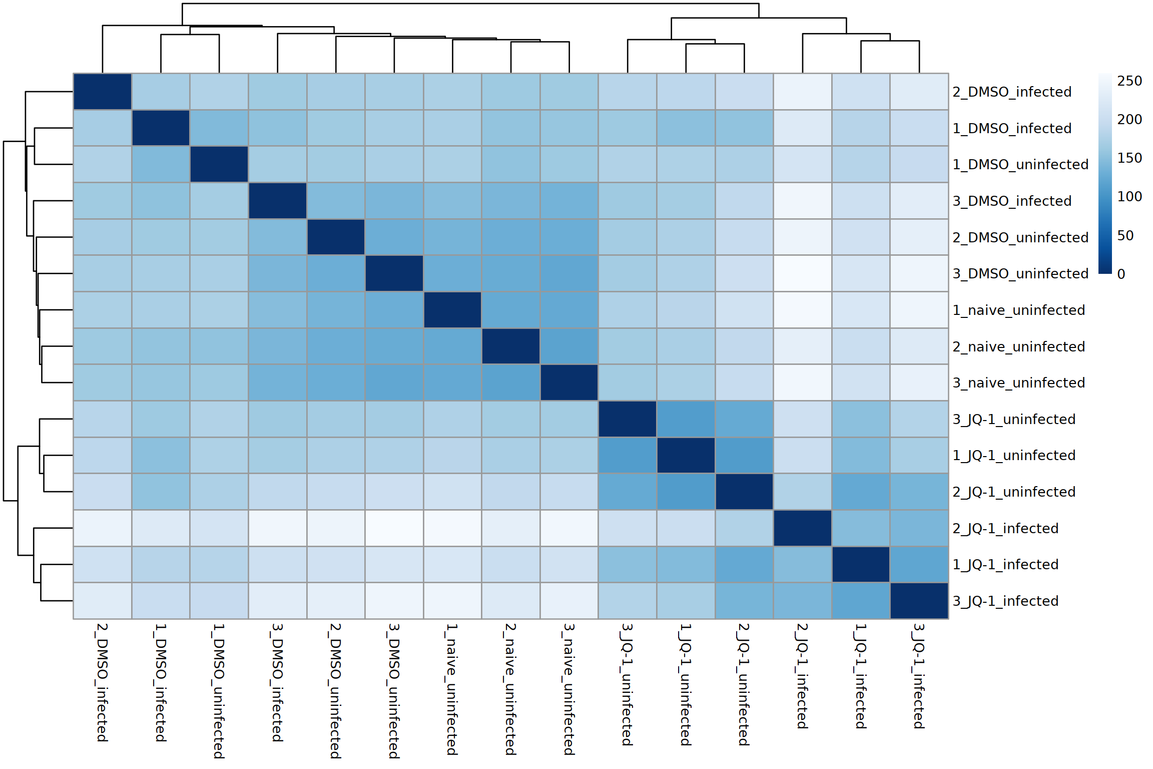

**Fig.** Distribution of the TSS. Plot showing the distance from TSS against the read density.

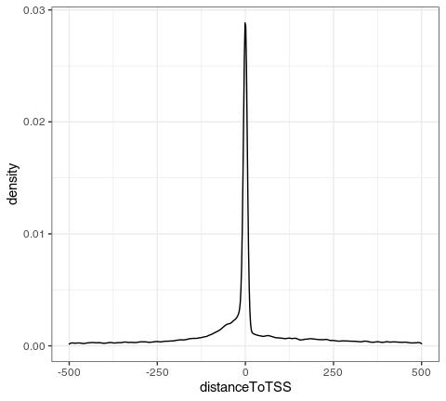

**Fig.** Chromatin feature analysis showing the peak distribution across the chromatin.

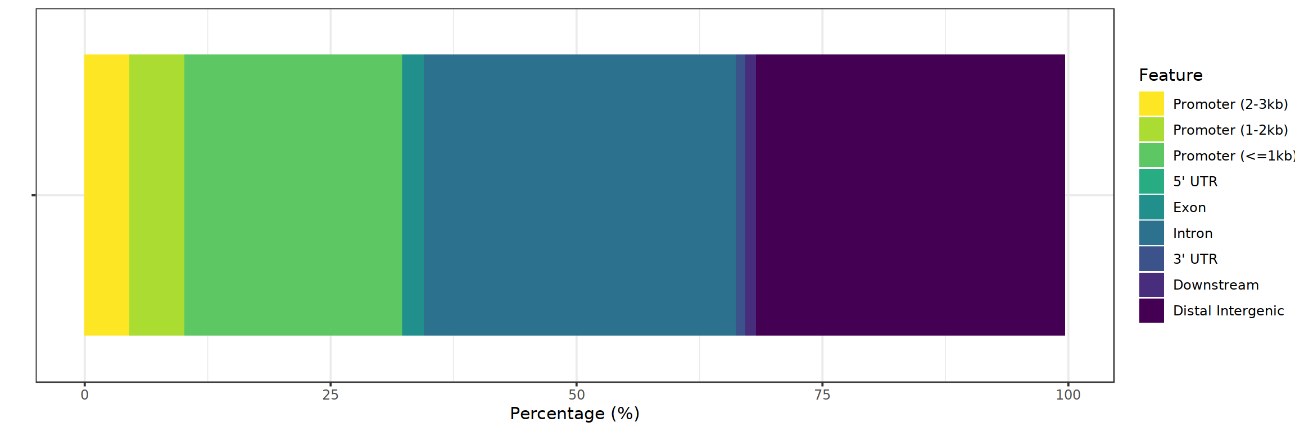

**Fig.** Occupancy heatmap for peaks corresponding to selected genes (read from file genesets_allgenes.csv)

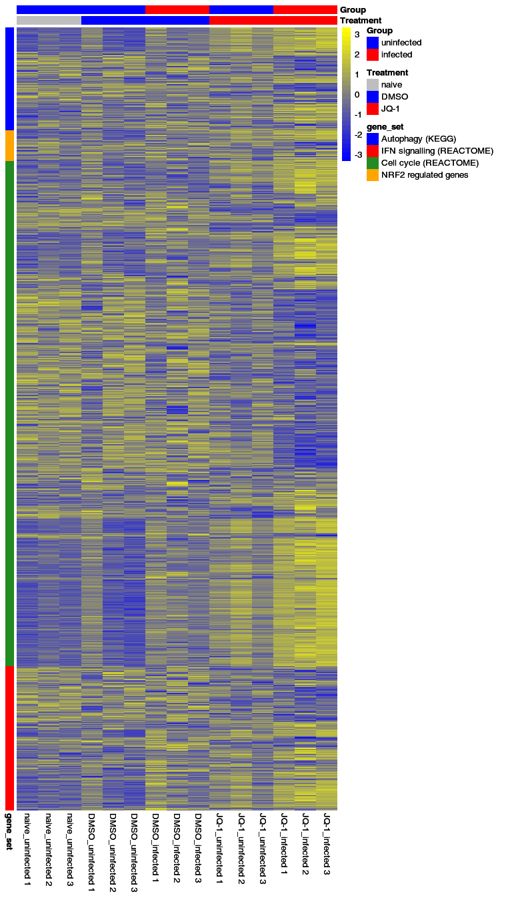

**Fig.** Occupancy heatmap for peaks corresponding to top 30 differentially binding peaks from each contrast.

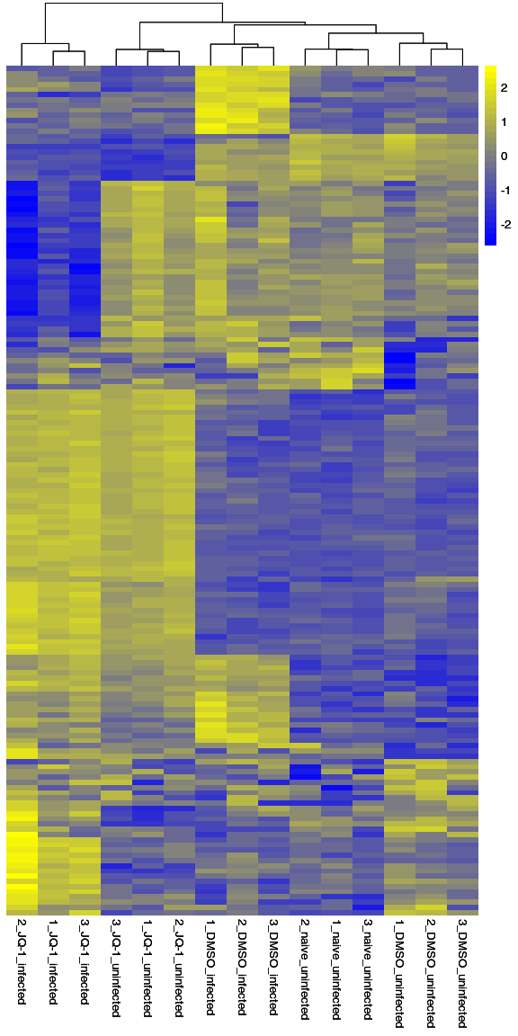

**Fig.** Volcano plots showing peak fold changes (x axis9 and p-values (y axis).

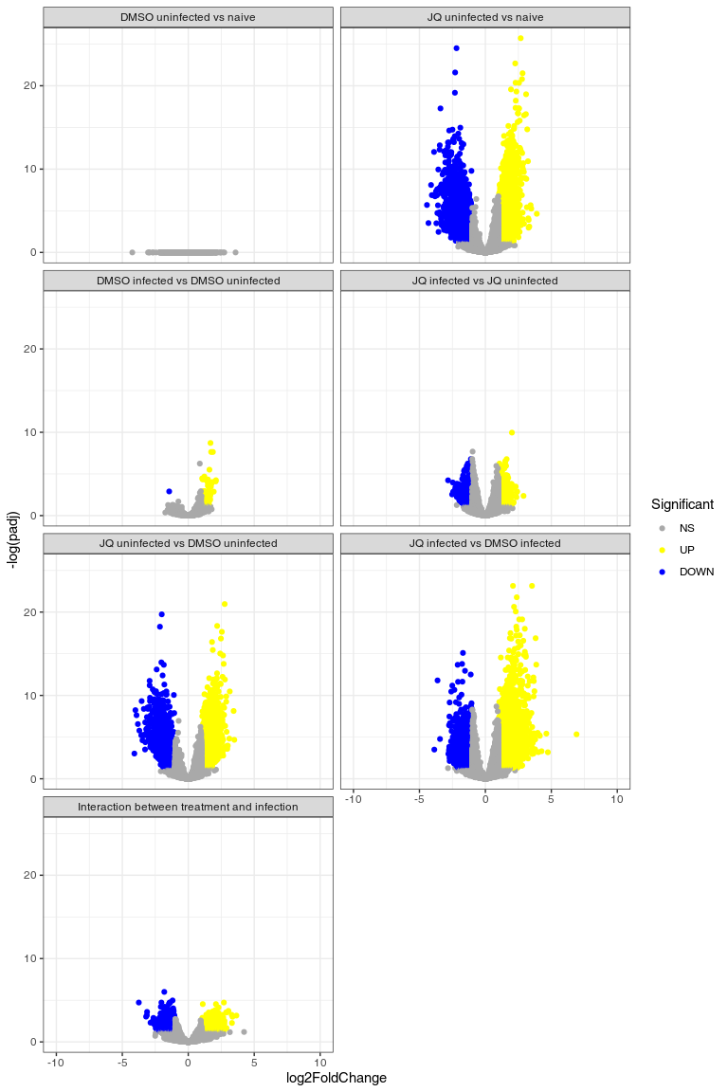

**Fig.** Volcano plots showing peak fold changes (x axis9 and p-values (y axis). Colors correspond to peaks associated with genes from the ISG gene set.

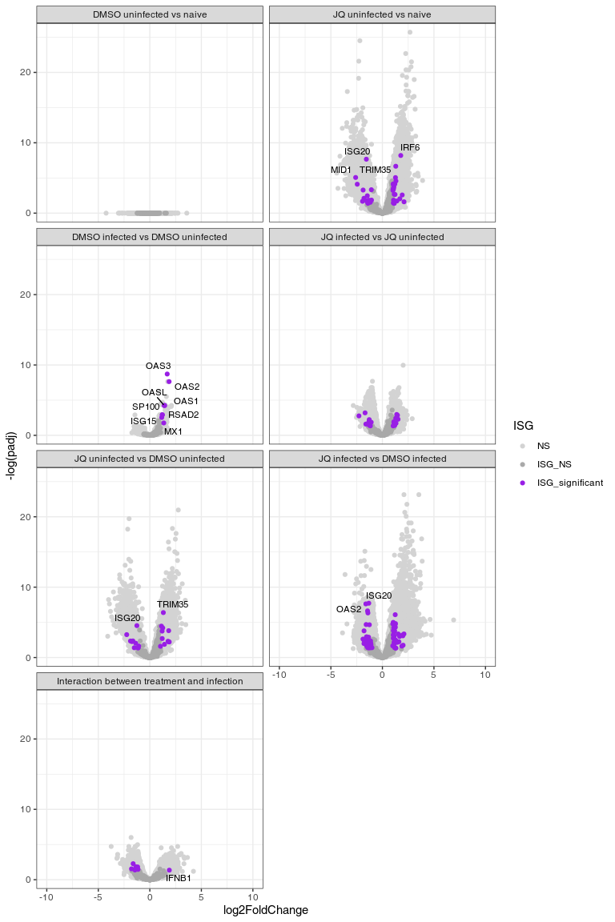

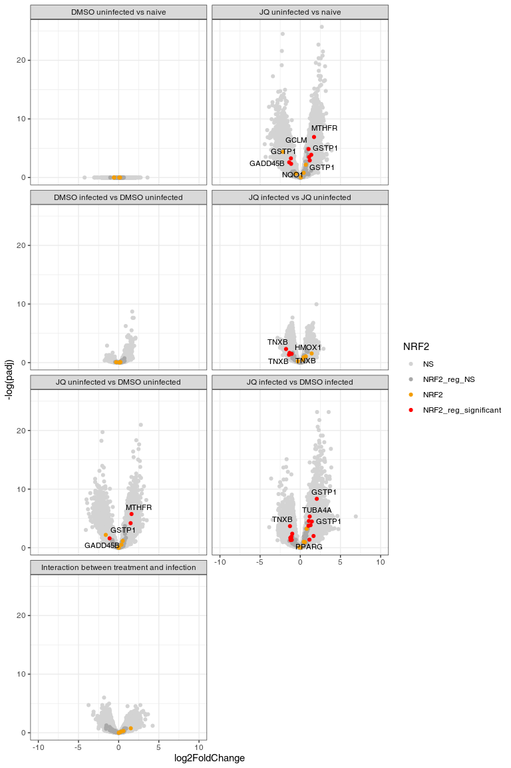

**Figs. Panel plots.** Please use the figures from the report.

**Fig. Motif analysis.** Please use the motifs from the report.

**Fig. PCA** Principal component analysis (components 1 and 2).

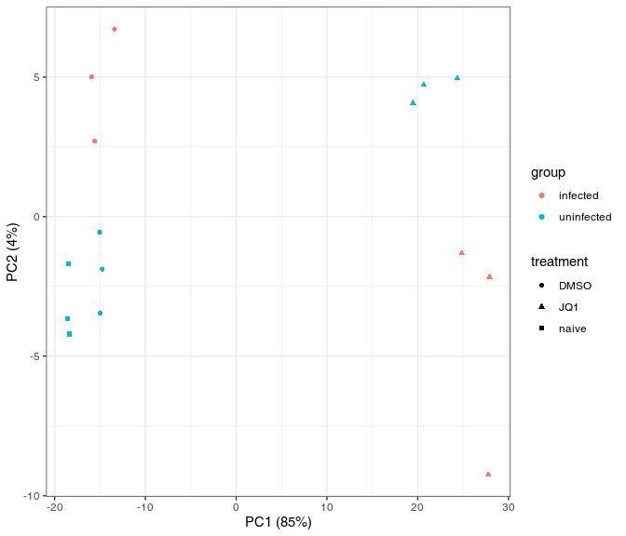

**Fig.** Evidence plot for cytoprotection (Reactome gene set REACTOME_REGULATION_OF_HMOX1_EXPRESSION_AND_ACTIVITY, ID M41831).

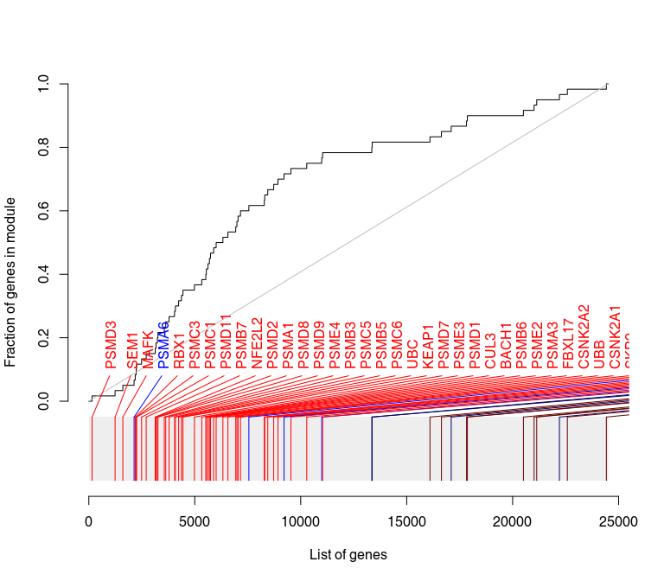

**Fig. Cluster profiler results separate by up- and down-regulated gene sets.** Contrast uni_DMSO_vs_naive_ID0, database GO, subcategory BP.

**Fig. Cluster profiler results separate by up- and down-regulated gene sets.** Contrast DMSO_inf_vs_uninf_ID1, database GO, subcategory BP.

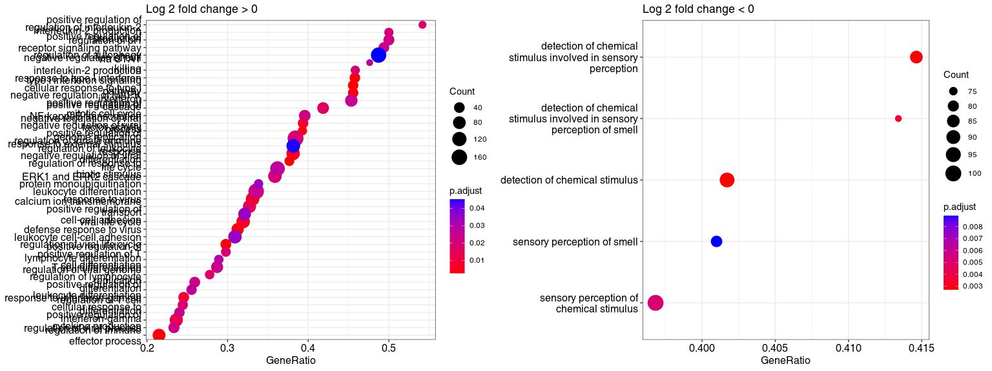

**Fig. Cluster profiler results separate by up- and down-regulated gene sets.** Contrast JQ_uninf_vs_naive_ID2, database GO, subcategory BP.

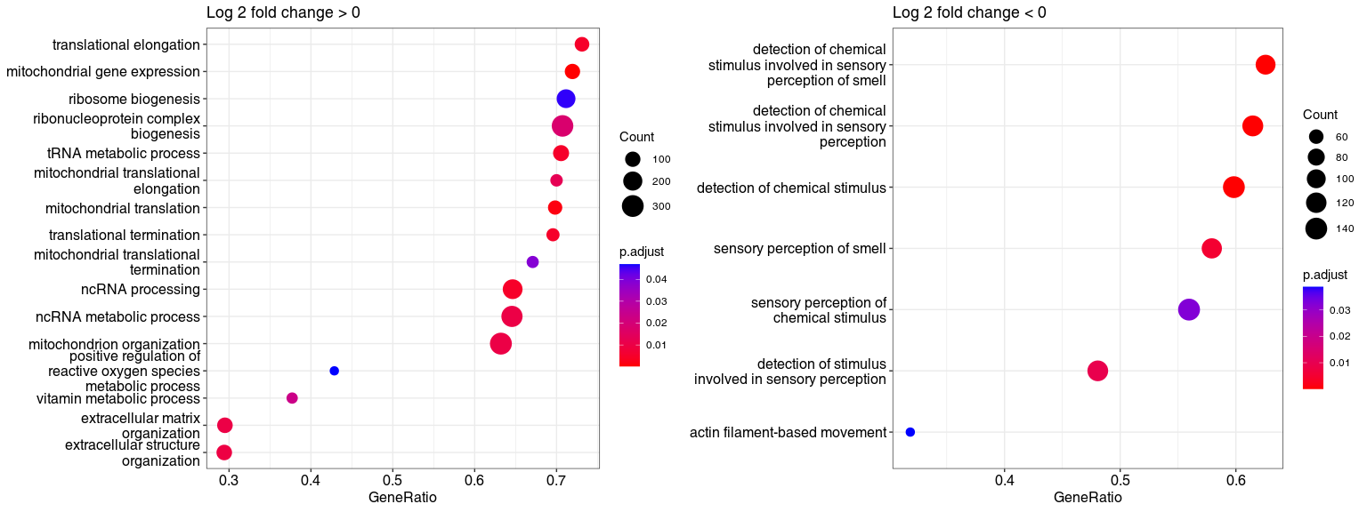

**Fig. Cluster profiler results separate by up- and down-regulated gene sets.** Contrast JQ_inf_vs_uninf_ID3, database GO, subcategory BP.

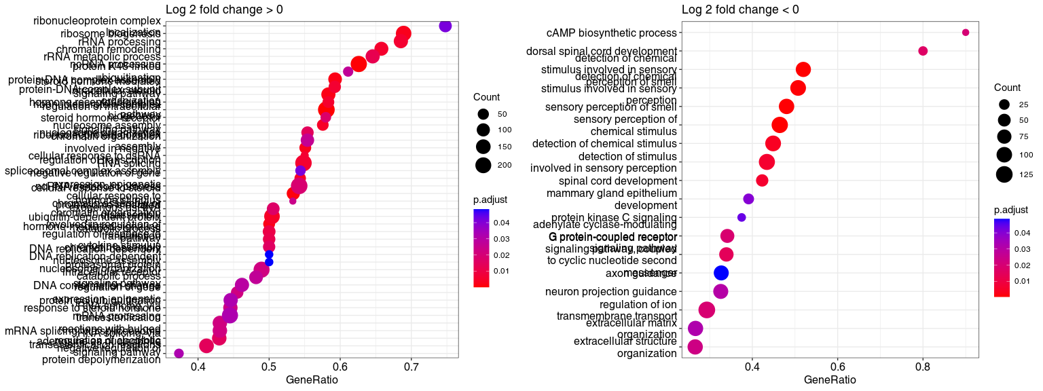

**Fig. Cluster profiler results separate by up- and down-regulated gene sets.** Contrast interaction_ID4, database GO, subcategory BP.

**Fig. Cluster profiler results separate by up- and down-regulated gene sets.** Contrast JQ_uninf_vs_DMSO_uninf_ID5, database GO, subcategory BP.

**Fig. Cluster profiler results separate by up- and down-regulated gene sets.** Contrast JQ_inf_vs_DMSO_inf_ID6, database GO, subcategory BP.

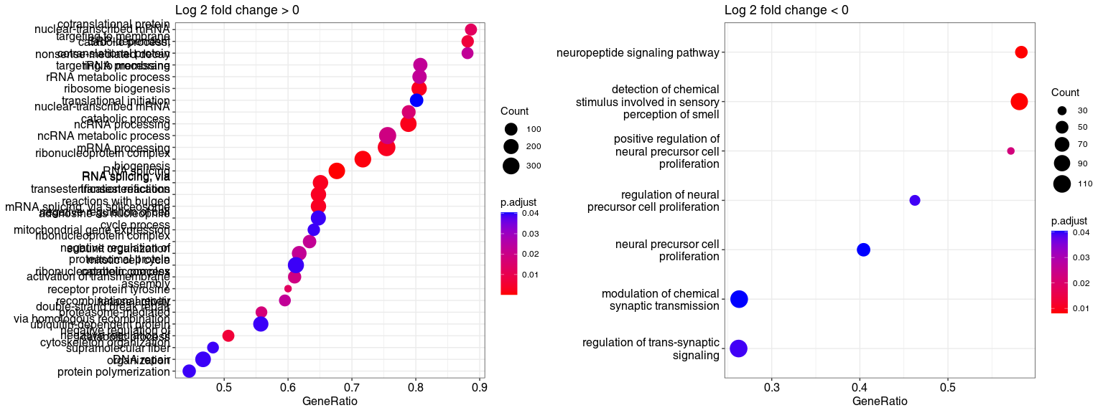

**Fig.** Cluster profiler results, alternate visualization

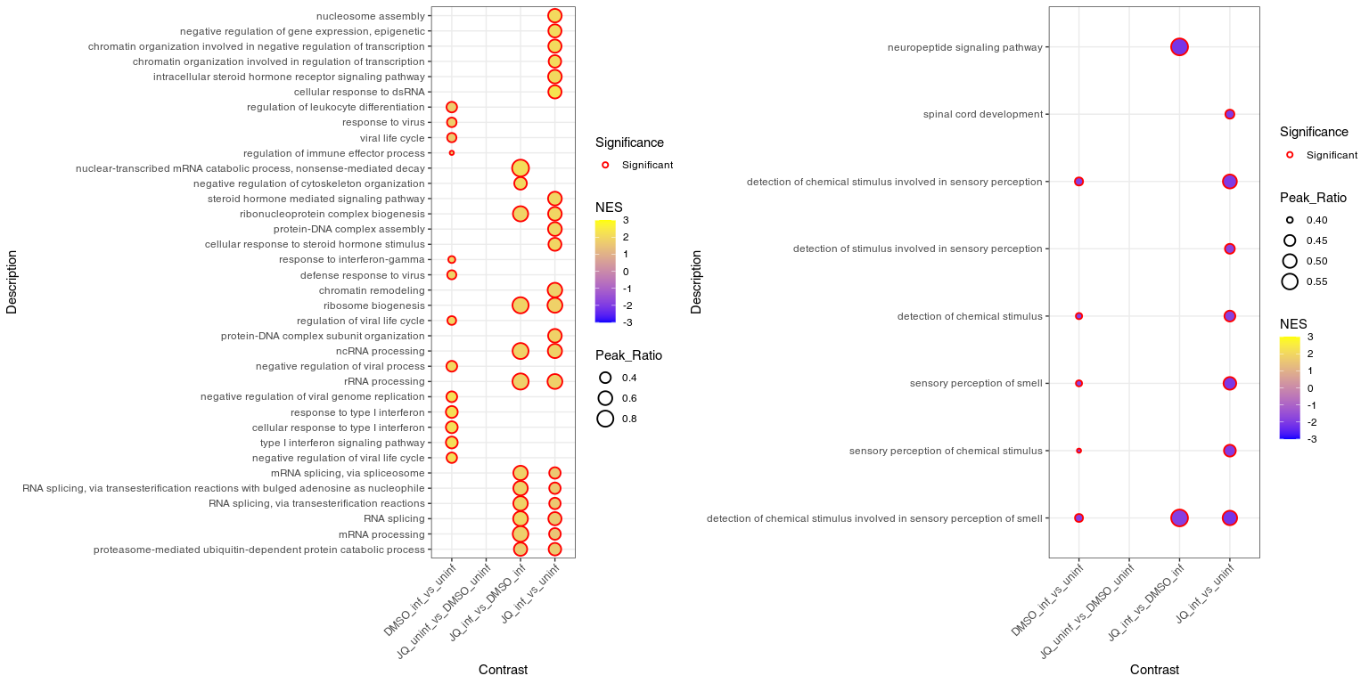

**Fig.** Distribution of higly occupied fragments (average number of reads > 100) by sample group.

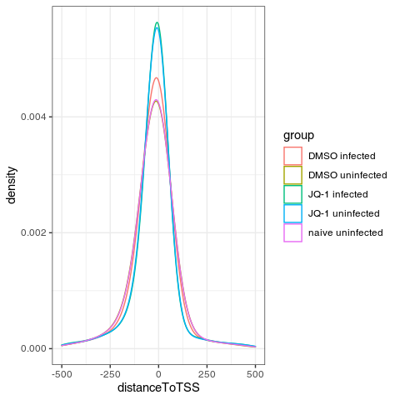

**Fig.** Distribution of highly occupied fragments (average number of reads > 100) by sample group.

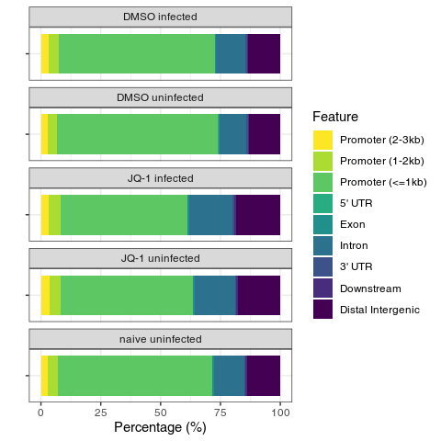

**Table.** Distribution of highly occupied fragments (average number of reads > 100) by sample group. Values are percentages of peaks assigned to the given region.

| Feature | DMSO infected | DMSO uninfected | JQ-1 infected | JQ-1 uninfected | naive uninfected |
| --- | --- | --- | --- | --- | --- |
| 3’ UTR | 0.53 | 0.44 | 0.53 | 0.55 | 0.56 |
| 5’ UTR | 0.06 | 0.08 | 0.06 | 0.06 | 0.09 |
| Distal Intergenic | 13.34 | 13.01 | 18.54 | 17.67 | 13.95 |
| Downstream | 0.65 | 0.62 | 0.80 | 0.78 | 0.54 |
| Exon | 0.61 | 0.50 | 0.70 | 0.73 | 0.58 |
| Intron | 12.22 | 11.36 | 18.05 | 16.80 | 12.65 |
| Promoter (<=1kb) | 65.18 | 67.43 | 53.25 | 55.15 | 64.73 |
| Promoter (1-2kb) | 4.29 | 3.76 | 4.67 | 4.80 | 3.91 |
| Promoter (2-3kb) | 3.12 | 2.81 | 3.40 | 3.46 | 3.00 |

**Table.** Number of peaks significant at FDR < 0.05 in each contrast.

| Contrast | Up | Down | Total |
| --- | --- | --- | --- |
| uni_DMSO_vs_naive_ID0 | 0 | 0 | 0 |
| DMSO_inf_vs_uninf_ID1 | 128 | 2 | 130 |
| JQ_uninf_vs_naive_ID2 | 11003 | 4606 | 15609 |
| JQ_inf_vs_uninf_ID3 | 5064 | 2092 | 7156 |
| interaction_ID4 | 796 | 539 | 1335 |
| JQ_uninf_vs_DMSO_uninf_ID5 | 7679 | 3755 | 11434 |
| JQ_inf_vs_DMSO_inf_ID6 | 17137 | 8169 | 25306 |