O Holy Night

**Verse 1**

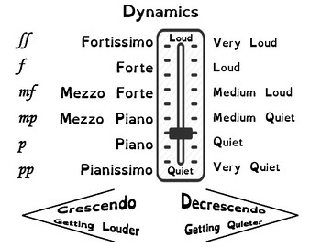O Holy night! The stars are brightly shining

It is the night of our dear Savior's birth

Long lay the world in sin and error pining

'Til He appeared and the soul felt its worth

A thrill of hope the weary world rejoices

For yonder breaks a new and glorious morn

Fall on your knees; O hear the Angel voices!

O night divine, O night when Christ was born

O night, O Holy night, O night divine!

**Verse 2**

Led by the light of Faith serenely beaming

With glowing hearts by His cradle we stand

So led by light of a star sweetly gleaming

Here come the Wise Men from Orient land

The King of kings lay thus in lowly manger

In all our trials born to be our friend

He knows our need, to our weakness is no stranger

Behold your King; before Him lowly bend

Behold your King; before Him lowly bend

**Verse 3**

Truly He taught us to love one another;

His law is love and His Gospel is Peace

Chains shall He break, for the slave is our brother

And in His name, all oppression shall cease

Sweet hymns of joy in grateful chorus raise we

Let all within us Praise His Holy name

Christ is the Lord; O praise His name forever!

His power and glory evermore proclaim

His power and glory evermore proclaim