Abstract
This dissertation investigates a hybrid approach combining Genetic Algorithms (GA) and Deep Reinforcement Learning (DRL) to solve the Parallel Machine Scheduling Problem with asymmetric, Sequence-Dependent Setup Costs (PMSP-SDSC). The problem is motivated by real-world manufacturing domains such as textile dyeing, where transitioning between colour batches incurs costs that depend on the specific colour pair and are asymmetric — dark-to-light transitions are expensive, while light-to-dark transitions are cheap. This cost structure renders classical scheduling heuristics inadequate, as they treat all inter-job transitions as equivalent.
A Proximal Policy Optimisation (PPO) agent is trained as a hyper-heuristic to dynamically select the GA's mutation operator during execution, replacing the fixed mutation strategy of a standalone GA with an adaptive policy that responds to the population's convergence state. A custom Gymnasium environment wraps the GA execution loop, exposing an 8-dimensional observation space (normalised best fitness, mean fitness, population diversity, stagnation count, job count, machine count, mean setup cost, and mean colour darkness) and a 3-action discrete space (swap, inversion, and insertion mutation). The agent receives rewards proportional to the relative improvement in best fitness at each decision step.
The hybrid approach is evaluated against Shortest Processing Time (SPT), Nearest-Neighbour Greedy, and a standalone GA across eight instance configurations (10 to 100 jobs, 1 to 10 machines) with 50 random seeds each. Results show that the hybrid significantly outperforms the standalone GA on large instances: it achieves 34-42% lower composite cost (p < 0.001) on single-machine large instances and 7-18% lower composite cost on multi-machine instances. On small and medium instances, GA and Hybrid produce equivalent results, confirming that the hyper-heuristic is most valuable in large search spaces where adaptive mutation control prevents premature convergence. Action frequency analysis reveals that the PPO agent learns an interpretable policy: it applies high-disruption insertion mutation during early generations and transitions to moderate-disruption inversion mutation as the population converges, completely rejecting the conservative swap mutation operator.
These findings demonstrate that DRL-guided mutation selection is an effective strategy for improving GA performance on challenging scheduling problems, and that the hyper-heuristic framing — controlling the search strategy rather than the search itself — is a tractable and generalisable approach to learning-enhanced combinatorial optimisation.

Chapter 1. Introduction

1.1 Project Aim
The aim of this project is to investigate a hybrid approach combining Genetic Algorithms (GA) and Deep Reinforcement Learning (DRL) for solving parallel machine scheduling problems with asymmetric, sequence-dependent setup costs (PMSP-SDSC). Specifically, the primary goal is to evaluate the performance of a Proximal Policy Optimisation (PPO) agent trained as a hyper-heuristic to dynamically select GA mutation operators based on real-time population convergence metrics.
The parallel machine scheduling problem deals with a set of jobs where in, a set of identical machines are operating in parallel, where each job must be processed by exactly one machine. This problem is fundamental to manufacturing systems and is known to be NP-hard (Garey & Johnson, 1979). The variant considered in this project, PMSP-SDSC, introduces sequence-dependent setup costs. That is, the cost of transitioning between jobs on a machine depends on the specific pair of jobs and is asymmetric. This structure is motivated by real-world manufacturing domains such as textile dyeing, where colour transitions between batches incur material and time costs. A dark-to-light colour transition may contaminate the lighter batch, making it significantly more expensive than a light-to-dark transition. This asymmetry renders classical scheduling heuristics inadequate, as they treat all inter-job transitions as equivalent.
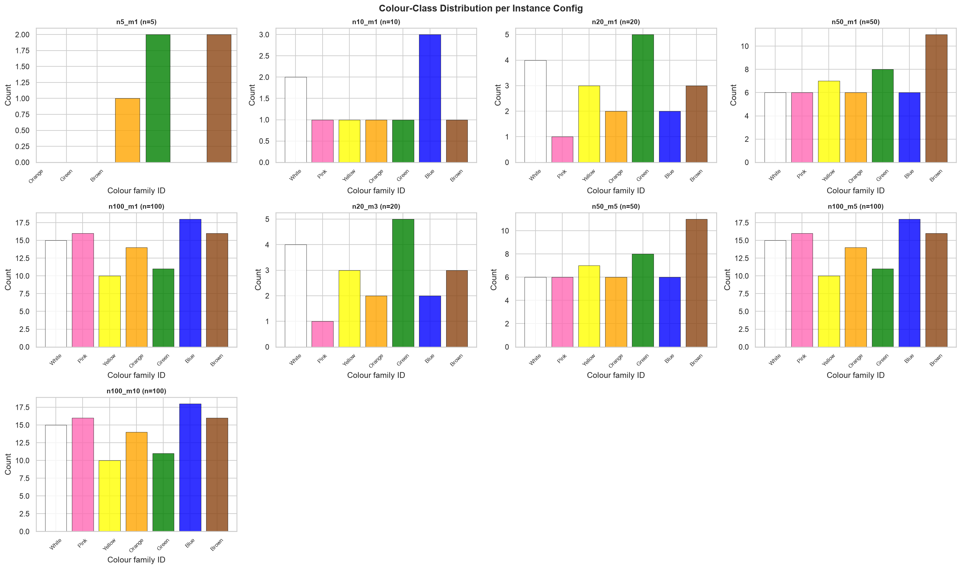
Figure 1.1: Distribution of colour classes across jobs in synthetic instances. Each bar represents the count of jobs assigned to each of the seven colour classes (darkness 1-7).
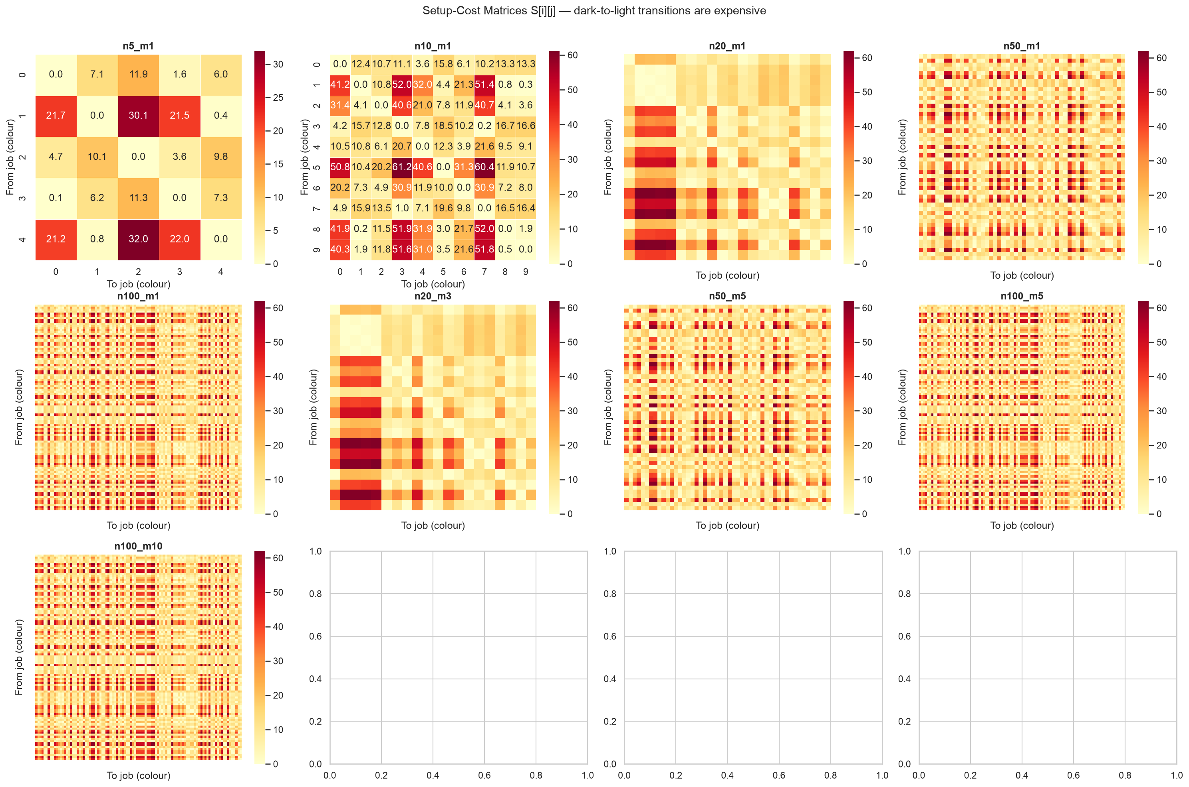
Figure 1.2: Asymmetric setup cost matrix heatmaps. Darker cells indicate higher transition costs. The asymmetry is visible in the non-symmetric pattern across the diagonal.
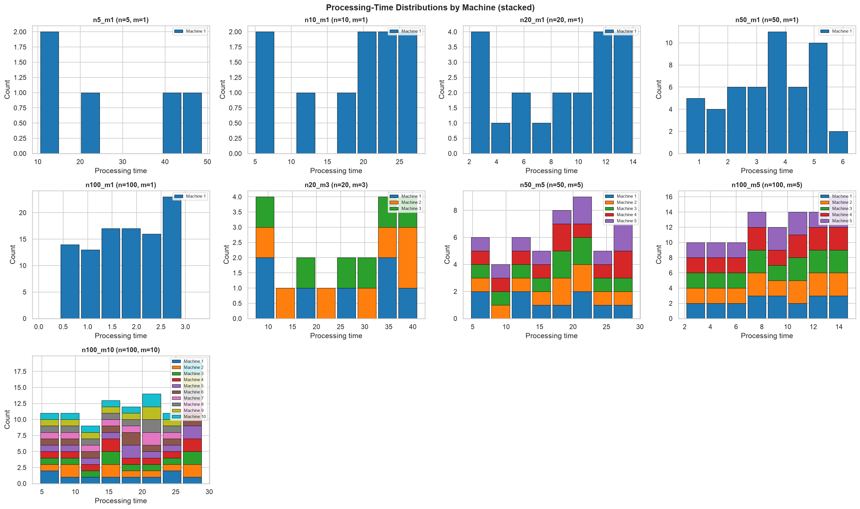
Figure 1.3: Processing time distributions across instance sizes. Each box shows the spread of processing times derived from weekly capacity calibration.
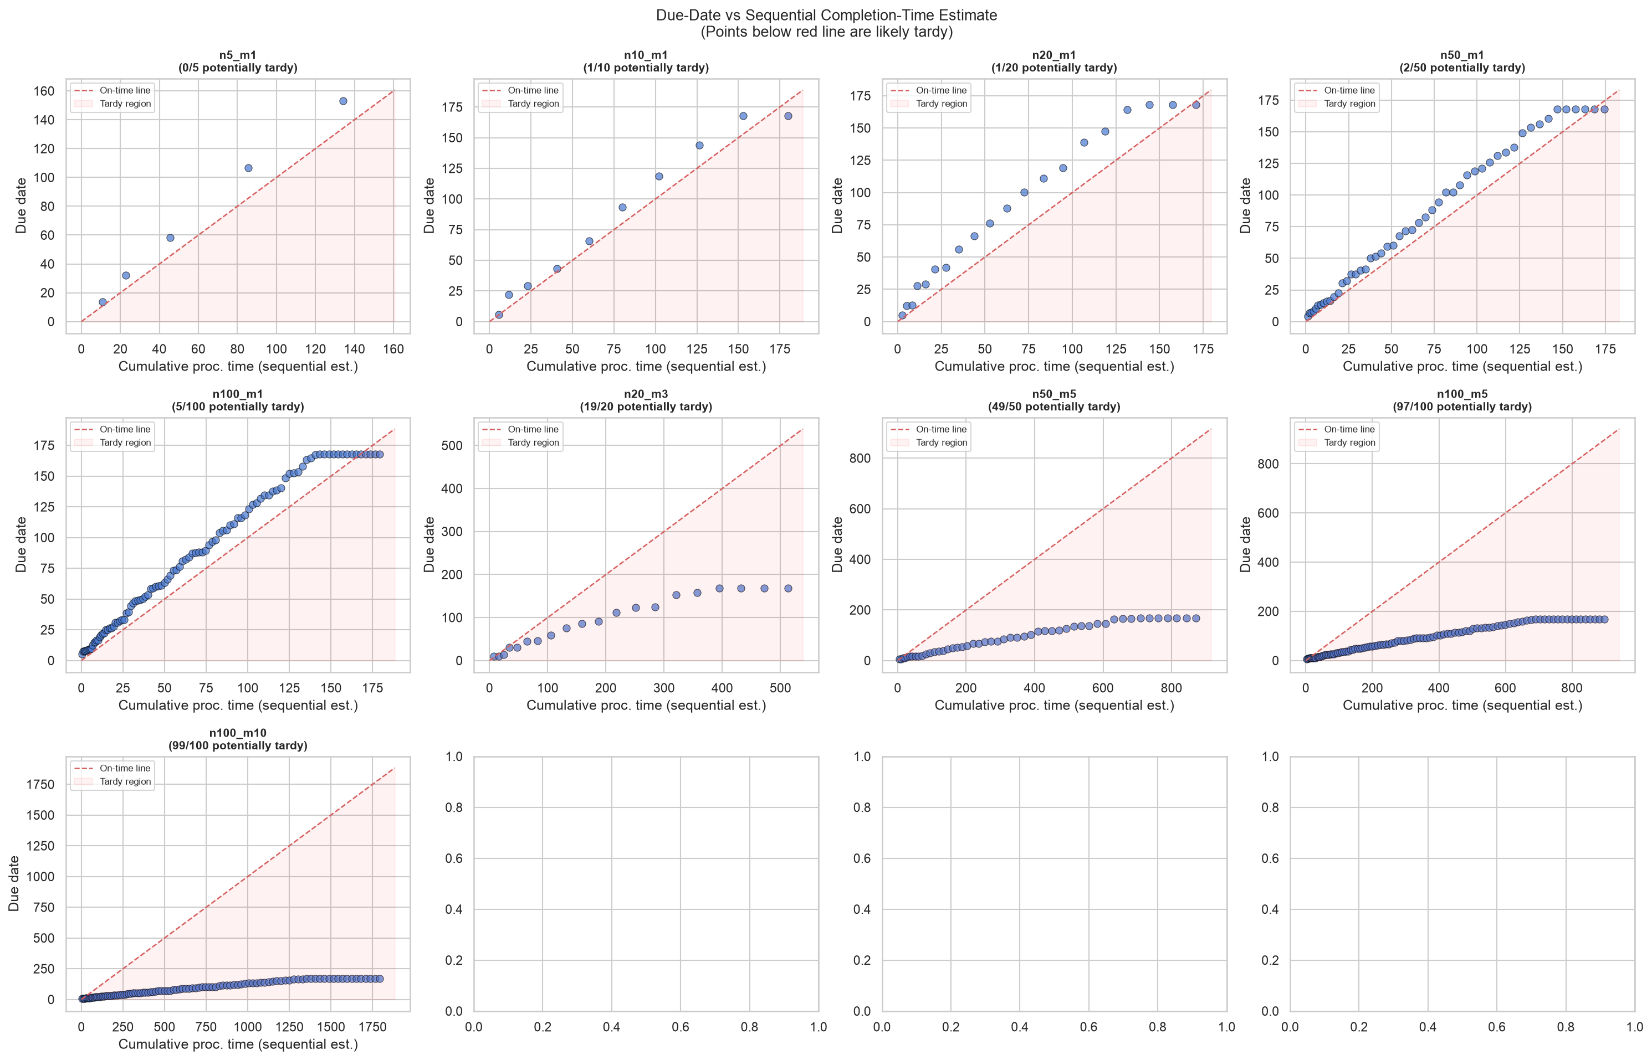
Figure 1.4: Due dates vs completion times for a representative instance. Jobs above the diagonal are completed after their due date, incurring tardiness penalties.
The combinatorial explosion inherent in PMSP-SDSC renders exact optimisation methods intractable for instances of practical size where the search space grows factorially as (n!)^(m / m!). To navigate this vast search spaces effectively, meta-heuristic approaches such as Genetic Algorithms are widely used for such problems, as they can explore large search spaces effectively. However, GAs typically employ fixed mutation operators with static parameters, leading to a well-documented limitation: the balance between exploration and exploitation degrades as the population converges, often resulting in premature stagnation on local optima.
Deep Reinforcement Learning offers a complementary capability, as an agent can learn a policy that adapts its behaviour based on the current state of the search process. By framing mutation operator selection as a sequential decision problem, a DRL agent can dynamically choose whether to apply conservative fine-tuning or aggressive exploration depending on the convergence status of the population. This separation of concerns, where the GA explores the solution space while the DRL agent controls the search strategy, forms the central design insight of this project.
The hybrid approach developed in this project achieves 34-42% lower composite cost than the standalone GA (p < 0.001) on large single-machine instances, and 7-18% lower on multi-machine instances. These results are consistent across instance sizes ranging from 10 to 100 jobs, demonstrating that DRL-guided mutation selection is an effective strategy for improving GA performance on challenging scheduling problems.

1.2 Objectives
The following objectives were defined to achieve the overall aim of the project:
- Formalise the PMSP-SDSC problem with asymmetric sequence-dependent cost structure, including mathematical definitions of weighted tardiness, setup cost, and the composite objective function with normalisation.
- Implement a synthetic instance generator that produces reproducible PMSP-SDSC instances with colour-based cost matrices, calibrated due-date tightness, and eight configurable sizes spanning 10 to 100 jobs with 1 to 10 machines.
- Implement Shortest Processing Time (SPT) and Nearest-Neighbour Greedy heuristic baselines to serve as lower-bound comparators for the GA and hybrid approaches.
- Implement a Genetic Algorithm using the DEAP framework with permutation chromosome encoding, order crossover, three mutation operators (swap, inversion, aggressive swap), and configurable population size, generation count, and crossover and mutation probabilities.
- Design a Gymnasium environment that wraps the GA execution loop and exposes an 8-dimensional continuous observation space (normalised best fitness, normalised mean fitness, population diversity, stagnation count, job count, machine count, mean setup cost, and mean colour darkness) and a 3-action discrete space (swap, inversion, insertion mutation), with a reward signal based on relative improvement in best fitness.
- Train a Proximal Policy Optimisation (PPO) agent within the Gymnasium environment to learn a mutation selection policy, using an instance pool of 80 diverse training instances across 8 configurations to promote generalisation.
- Evaluate all four algorithms — SPT, NN-Greedy, GA, and Hybrid (GA+PPO) — across eight instance configurations with 50 random seeds each, totalling 1600 individual experimental runs.
- Perform statistical analysis using Wilcoxon signed-rank tests to assess the significance of performance differences, and conduct a sensitivity analysis across three values of the objective weighting parameter alpha.

1.3 Deliverables
The following deliverables were produced as part of this project:
- A hybrid optimisation and machine learning software framework. Built using contemporary Python libraries and frameworks including DEAP, Gymnasium, and Stable-Baselines3, designed to solve parallel machine scheduling problems with asymmetric, sequence-dependent setup costs.
- A structured software repository. Contains the full source code of the system, organised into modules for synthetic instance generation, schedule evaluation, classical baselines, and reinforcement learning agent training.
- Experimental documentation and results. Provides a comprehensive archive of raw evaluation data stored in JSON format across 1600 distinct experimental runs, alongside a suite of visualisations including Gantt charts, box plots, and convergence curves that document system performance.
- This MSc project report. A comprehensive dissertation detailing the theoretical background, software design, implementation methodology, and statistical evaluation of the hybrid architecture.

1.4 Ethical, Legal, and Social Issues
This project involves no human participants, no personally identifiable data, and no privacy concerns. All data used in the experiments is synthetically generated using seeded pseudo-random number generators, ensuring reproducibility without recourse to real-world data. The project therefore raises no ethical concerns regarding data collection, consent, or privacy.
The software developed in this project uses only open-source libraries, each used under its respective license: NumPy (BSD-3-Clause), DEAP (LGPL-3.0-or-later), Gymnasium (MIT), and Stable-Baselines3 (MIT). No proprietary software was used in the development or execution of the experiments.
From a social perspective, scheduling optimisation has clear environmental and economic benefits. Improved scheduling in manufacturing reduces material waste from colour changeovers, decreases energy consumption through more efficient machine utilisation, and lowers production costs. These benefits are particularly relevant in energy-intensive industries such as textile dyeing and chemical processing, where sequence-dependent setup costs represent a substantial fraction of total production cost.

1.5 Structure of the Dissertation
The remainder of this dissertation is organised as follows:
* Chapter 2: Background Research – Presents a comprehensive literature survey covering parallel machine scheduling, asymmetric setup costs, classical heuristics, genetic algorithms, deep reinforcement learning, and hyper-heuristics, concluding with a theoretical justification for the methods selected in this project.
* Chapter 3: Software Requirements and System Design – Outlines the functional and non-functional requirements of the system and details the structural design of the six core software modules, the custom Gymnasium environment, and the paired experimental framework.
* Chapter 4: Implementation and Results – Details the concrete software implementation and presents the quantitative experimental results, providing comprehensive performance comparisons, statistical significance analyses, and data visualisations.
* Chapter 5: Evaluation and Discussion – Critically evaluates the project findings, assesses the strengths and operational limitations of the hybrid hyper-heuristic, and discusses potential threats to validity.
* Chapter 6: Conclusion – Concludes the dissertation with a summary of major research contributions, key findings, directions for future algorithmic work, and a personal reflection on the project.

Chapter 2. Background Research

2.1 Literature Survey
This section presents a survey of prior research relevant to the project, organised as a narrative progression: the problem domain is introduced, followed by the solution methods that have been applied to it, and finally the gap in the existing literature that this project addresses.

2.1.1 Parallel Machine Scheduling
The Parallel Machine Scheduling Problem (PMSP) is a well-studied combinatorial optimisation problem in which a set of n jobs must be assigned to m identical machines operating in parallel. Each job has a processing time and must be processed by exactly one machine. The objective typically involves minimising a function of completion times, such as makespan (the maximum completion time across all machines) or total weighted tardiness (the sum of penalties for jobs completed after their due dates, weighted by job priority).
PMSP is known to be NP-hard in the general case (Garey & Johnson, 1979). Even the single-machine variant with weighted tardiness minimisation is NP-hard (Lawler, 1977). Introduction of additional constraints and cost structures — such as sequence-dependent setup costs, release times, and job weights — increases the problem complexity further. Pinedo (2016) provides a comprehensive treatment of scheduling theory, classifying PMSP variants by objective function, machine environment, and processing constraints.
The search space for PMSP-SDSC is the set of all ways to partition n jobs among m machines and order them within each machine. An approximate bound is O((n!)^m / m!), reflecting the factorial growth in job permutations on each machine, divided by the symmetry of identical machines. For a medium-sized instance (n = 20, m = 2), the search space exceeds 10^36 points, precluding exhaustive enumeration or exact methods.

2.1.2 Sequence-Dependent Setup Costs
In real-world manufacturing, transitioning between different jobs on the same machine incurs a setup cost — time, material, or both. This cost depends on the specific pair of jobs being sequenced consecutively, giving rise to a sequence-dependent setup cost matrix. When this matrix is asymmetric — meaning the cost of transitioning from job i to job j differs from the cost of going from job j to job i — the problem becomes substantially harder to solve heuristically.
The motivating domain for this project is textile dyeing, where batches of fabric are dyed in sequence. Each batch has a target colour, and the dyeing machine must be cleaned between batches. The cleaning cost depends on the colour transition: moving from a dark colour to a light colour requires extensive cleaning to prevent contamination of the lighter batch, whereas moving from light to dark requires minimal cleaning. This creates a natural asymmetry in the setup cost matrix.
Standard scheduling heuristics, such as Shortest Processing Time, treat all inter-job transitions as having zero or uniform cost. This assumption is violated in the presence of sequence-dependent setup costs, making these heuristics unsuitable for domains such as textile dyeing. Explicit modelling of the asymmetric cost structure is necessary for effective scheduling in such environments.

Problem Formalisation
The PMSP-SDSC problem addressed in this project is formally defined as follows. Let J = {0, 1, ..., n-1} be a set of n jobs and M = {0, 1, ..., m-1} be a set of m identical parallel machines. Each job j has a processing time p_j, a due date d_j, a weight w_j (priority), and a release time r_j. Transitioning from job i to job j on the same machine incurs a sequence-dependent setup time s_ij and setup cost c_ij, where c_ij is generally not equal to c_ji.
Symbol | Definition
n | Number of jobs
m | Number of identical parallel machines
p_j | Processing time of job j
d_j | Due date of job j
w_j | Priority weight of job j
r_j | Release time of job j (earliest start)
c_ij | Setup cost of transitioning from job i to job j
s_ij | Setup time of transitioning from job i to job j
C_j | Completion time of job j
T_j | Tardiness of job j: max(0, C_j - d_j)
sigma | Solution: list of m machine sequences

A solution sigma is a partition of the n jobs into m sequences, one per machine, where sigma[k] is the ordered list of jobs assigned to machine k. The completion time C_j for each job is computed by traversing its machine's sequence, accumulating processing times, setup times (between consecutive jobs), and respecting release times.
The weighted tardiness objective is:
f1 = sum over j of w_j * T_j = sum over j of w_j * max(0, C_j - d_j)
The total setup cost objective is:
f2 = sum over k of sum over consecutive pairs (i, j) on machine k of c_ij
These two objectives are normalised to a common scale and combined into a single composite objective:
F = alpha * (f1 / f1_scale) + (1 - alpha) * (f2 / f2_scale)
where f1_scale and f2_scale are normalisation constants estimated for the given instance, and alpha in [0, 1] controls the trade-off between tardiness and setup cost minimisation. The normalisation constants are computed by evaluating SPT, NN-Greedy, and a random schedule on the instance, and setting each scale to 1.5 times the maximum observed value of the corresponding objective. This heuristic sampling approach ensures both objectives contribute equitably to the composite score, preventing the larger-magnitude objective from dominating.

2.1.3 Classical Heuristics for Scheduling
Classical heuristics for scheduling problems are valued for their simplicity, speed, and deterministic behaviour. They serve as baselines against which more sophisticated methods can be compared.
The Shortest Processing Time (SPT) heuristic sorts jobs in ascending order of processing time and assigns them round-robin to machines. Its time complexity is O(n log n), dominated by the sorting step. SPT is optimal for minimising mean completion time on a single machine but makes no attempt to minimise setup costs or tardiness, as it ignores due dates and setup matrices entirely.
The NEH heuristic (Nawaz, Enscore, & Ham, 1983) is an insertion-based constructive method originally developed for the flow shop scheduling problem. It builds a schedule by repeatedly inserting jobs into the partial sequence at the position that minimises the partial objective. NEH is widely regarded as one of the best-performing constructive heuristics for permutation scheduling problems, with a time complexity of O(n^2 m). However, its performance on asymmetric SDSC variants has not been extensively characterised.
The Nearest-Neighbour Greedy heuristic is a sequential assignment method that builds machine schedules one job at a time. At each step, it selects the machine with the lowest current load and assigns the unscheduled job that minimises the transition cost from that machine's last job. The greedy approach makes locally optimal decisions that may compound into poor global solutions.
Additional heuristics relevant to the PMSP domain include the Earliest Due Date (EDD) rule, which prioritises jobs with the earliest due dates and is optimal for minimising maximum lateness on a single machine, and the Weighted Shortest Processing Time (WSPT) rule, which orders jobs by the ratio of weight to processing time. These heuristics are not included as baselines in this project because they target different objective functions and their performance on the composite PMSP-SDSC objective is expected to be inferior to SPT and NN-Greedy.
These heuristics are included in this project as baselines because they are fast, deterministic, and standard in the scheduling literature. They are not expected to produce optimal solutions for PMSP-SDSC, but they provide a reference point for evaluating the more complex GA and hybrid approaches.
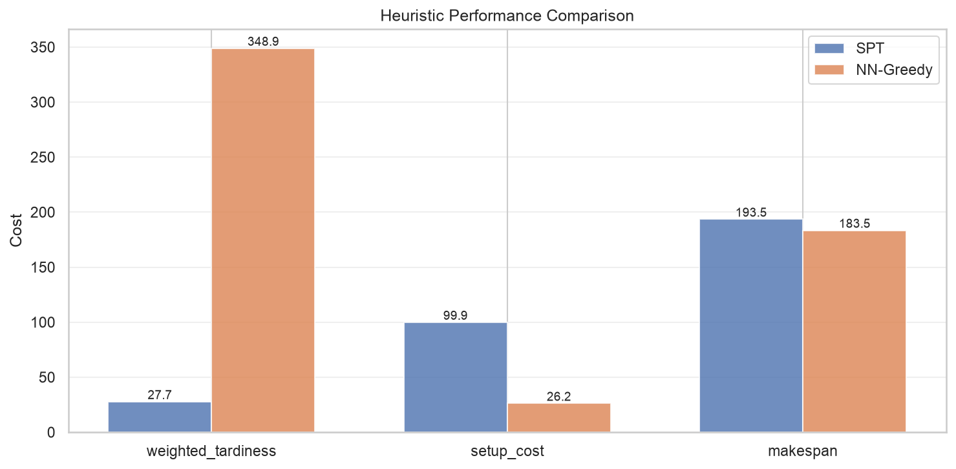
Figure 2.1: Heuristic performance comparison across instance configurations (lower is better). SPT and NN-Greedy show consistent but higher composite scores compared to the optimisation-based methods.
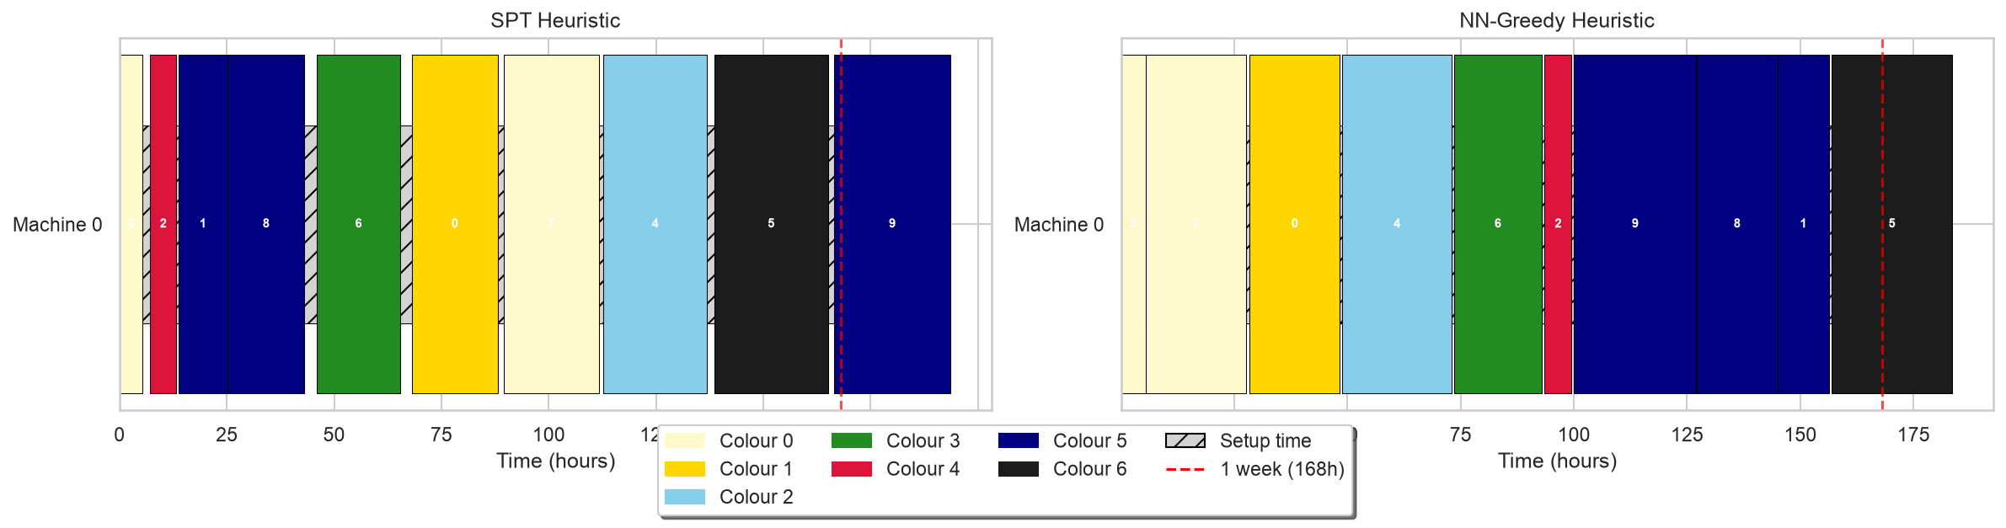
Figure 2.2: Gantt chart of a heuristic-based schedule showing job assignments across machines. Hatched regions indicate setup time between jobs of different colour classes.

2.1.4 Genetic Algorithms for Scheduling
Genetic Algorithms are a class of evolutionary optimisation methods inspired by natural selection (Holland, 1975). In the scheduling domain, GAs operate on a population of candidate solutions, iteratively applying selection, crossover, and mutation to produce improved generations.
A common encoding for scheduling problems is the permutation representation, where a chromosome is a permutation of job indices representing the order in which jobs are processed. For the multi-machine case, the giant-tour representation encodes a single permutation of all n jobs, which is then split into m segments corresponding to the machines. This representation has the advantage of naturally handling the job assignment and sequencing decisions simultaneously.
The theoretical foundation of GAs rests on the schema theorem (Holland, 1975) and the building block hypothesis (Goldberg, 1989). A schema is a pattern of gene values with fixed and wildcard positions; short, low-order schemata with above-average fitness are called building blocks. The schema theorem shows that building blocks receive exponentially increasing trials in successive generations under selection, crossover, and mutation. In the permutation encoding context, the relevant schemata are relative orderings of subsets of jobs, and Order Crossover is designed to preserve these order-based building blocks. This theoretical grounding explains why GA frameworks with permutation encoding and crossover operators that preserve relative ordering are effective for scheduling problems, where the ordering of jobs within a machine's sequence is critical to solution quality.
Order Crossover (OX) is a crossover operator designed for permutation representations. It preserves the relative ordering of jobs from one parent while incorporating job positions from the other, maintaining the feasibility of the offspring permutation. This property is important for PMSP-SDSC because the relative ordering of jobs encodes colour transition information that affects setup costs.
Mutation operators for permutation encodings include swap mutation (exchanging two random positions), inversion mutation (reversing a sub-sequence), and insertion mutation (removing one element and inserting it elsewhere). Swap mutation with a low per-gene probability (indpb = 0.05) makes fine-grained changes suitable for conservative fine-tuning. Inversion mutation reverses a sub-sequence, producing moderate reordering. Insertion mutation with a higher per-gene probability (indpb = 0.15) removes and reinserts multiple elements, generating high disruption for exploration. The choice of mutation operator controls the balance between exploration and exploitation in the GA.
The DEAP framework (Fortin et al., 2012) provides a mature, modular implementation of GA components, including built-in support for permutation operators, Hall-of-Fame elitism, and population statistics. It was chosen for this project due to its flexibility and the ease with which custom operators can be integrated.
A known limitation of GAs is that as the population converges, the diversity of candidate solutions decreases, and the algorithm may stagnate on local optima. Fixed mutation operators with static parameters cannot adapt to this changing state, motivating the need for adaptive control strategies.

2.1.5 Deep Reinforcement Learning for Combinatorial Optimisation
Deep Reinforcement Learning combines the sequential decision-making framework of reinforcement learning with the function approximation capabilities of deep neural networks. In the context of combinatorial optimisation, DRL offers an alternative to hand-crafted heuristics and metaheuristics: instead of designing a fixed algorithm, a neural network learns a policy that can adapt to the specific problem instance and search state.
Proximal Policy Optimisation (Schulman et al., 2017) is a policy gradient method that has become a standard choice for DRL due to its stability and ease of use. PPO employs a clipped surrogate objective that constrains the policy update at each step, preventing destructive large updates that can occur in vanilla policy gradient methods. This trust-region property makes PPO robust to hyperparameter choices and suitable for a wide range of environments.
Prior work has applied DRL to scheduling problems. Zhang et al. (2020) used DRL for dynamic job shop scheduling, where the agent selects dispatching rules based on the current shop floor state. Kool, van Hoof, and Welling (2019) applied attention-based pointer networks to the travelling salesman and vehicle routing problems, demonstrating that neural network architectures designed for sequence-to-sequence problems can learn effective heuristics for combinatorial optimisation. These approaches show that DRL can capture complex patterns in scheduling data that are difficult to encode in hand-crafted rules. However, they address the optimisation problem directly, requiring the agent to learn the entire search process from scratch, which demands large action spaces and extensive training.
Compared to Deep Q-Networks (Mnih et al., 2015), PPO offers several advantages for the scheduling domain. DQN uses a value-based approach, learning the Q-function and deriving a policy from it. While effective for discrete action spaces, DQN can be unstable when the Q-function is approximated by a neural network, requiring techniques such as experience replay and target networks. PPO belongs to the policy gradient family, which optimises the policy directly through gradient ascent on expected return. The key innovation in PPO is the clipped surrogate objective:
L_CLIP(theta) = E_t[min(r_t(theta) * A_t, clip(r_t(theta), 1-epsilon, 1+epsilon) * A_t)]
where r_t(theta) is the probability ratio between the new and old policies, A_t is the advantage estimate, and epsilon is a clipping hyperparameter (typically 0.2). This clipping mechanism constrains the policy update to a trust region, preventing destructive large updates that can occur in vanilla policy gradient methods. The result is stable, monotonic improvement that is robust to hyperparameter choices. The PPO implementation in this project uses the stable hyperparameters recommended by Stable-Baselines3: a learning rate of 3e-4, n_steps of 2048, batch size of 64, 10 epochs per update, a discount factor of 0.99, and an entropy coefficient of 0.05 to encourage exploration during training.
The advantages of PPO for the hyper-heuristic scheduling context are threefold. First, the clipped objective ensures stable training across episodes with varying difficulty (different instances from the training pool). Second, the policy gradient formulation naturally handles stochastic policies, allowing exploration during training. Third, PPO has been extensively validated across a diverse set of environments in the Gymnasium benchmark suite and is well-supported in production RL frameworks.

2.1.6 Hyper-heuristics
Burke et al. (2013) formally define a hyper-heuristic as "an automated methodology for selecting or generating heuristics to solve computational search problems." The key distinction from a standard metaheuristic is the separation of two levels: the domain level, where problem-specific heuristics operate, and the meta level, where the hyper-heuristic controls which heuristic to apply and when.
Hyper-heuristics are categorised into heuristic selection (choosing among existing heuristics) and heuristic generation (creating new heuristics from components). This project falls into the heuristic selection category: the DRL agent selects among three GA mutation operators at each decision step during the GA execution.
The hyper-heuristic framing is what distinguishes this project from direct RL-for-scheduling approaches. The DRL agent does not learn to construct schedules directly — that would require an action space proportional to the number of jobs, which grows factorially. Instead, the agent controls the GA's mutation operator, keeping the action space small (Discrete(3)) while leveraging the GA's existing search capability. This separation of concerns allows each component to operate at its appropriate level of abstraction: the GA explores the scheduling solution space efficiently, while the DRL agent modulates the exploration strategy based on the current search state.

2.1.7 The Gap
Prior work has applied GAs to PMSP with setup costs, and prior work has applied DRL to scheduling problems. However, no existing study has combined these specifically as a PPO-driven hyper-heuristic for mutation operator selection in the context of asymmetric, parallel machine scheduling with sequence-dependent setup costs. The closest related work involves DRL for operator selection in continuous optimisation (Sharma & Sutton, 2021) and GAs with adaptive mutation rates (Thierens, 2002), but neither addresses the asymmetric SDSC domain. Furthermore, this work evaluates the hybrid approach across two distinct instance profiles — a simple categorical colour model and a more complex continuous colour model with chemistry constraints and customer segments — to assess the robustness of the hyper-heuristic under varying problem difficulty.
This dissertation fills that gap by: (1) formalising the PMSP-SDSC problem with an asymmetric cost structure motivated by real-world manufacturing; (2) designing a Gymnasium environment that enables a PPO agent to control GA mutation at a hyper-heuristic level; and (3) empirically demonstrating that the hybrid approach significantly outperforms both classical heuristics and standalone GA on large problem instances.

2.2 Methods and Techniques
This section provides a brief, balanced survey of the methods and techniques available for solving the PMSP-SDSC problem, covering instance generation, solution representation, GA frameworks, RL frameworks, environment design, objective weighting, and statistical testing.
Instance generation. Synthetic instance generation is necessary because there is no standard benchmark set for PMSP-SDSC with asymmetric costs. The instance generator must produce reproducible instances with controlled properties: processing times derived from weekly capacity, due dates calibrated by a tightness parameter, and asymmetric setup costs structured around colour classes. Processing times are computed as (m × 168) / n hours, where 168 represents weekly operating hours (24/7 continuous operation), and setup times average approximately 1/8 of processing time. This setup-time-to-processing-time ratio is motivated by the real-world observation that vat cleaning takes 1-2 hours while dye cycles take 8-16 hours in textile manufacturing.
Solution representation. The standard representation for permutation-based scheduling is a list of m machine sequences (sigma), where each machine has an ordered list of jobs. The giant-tour encoding flattens this into a single permutation of n jobs, which is then split into m segments. Alternative encodings include binary matrices (job-machine assignment) and priority-rule-based representations, but the permutation encoding is the most natural for genetic operators designed for sequencing problems.
GA frameworks. The available Python frameworks for implementing GAs include DEAP (Fortin et al., 2012), PyGAD (Gad, 2021), and custom implementations. DEAP was selected for its mature support of permutation operators, its Hall-of-Fame elitism mechanism, and its toolbox-based architecture that allows runtime modification of registered operators — a capability essential for the hyper-heuristic environment.
RL frameworks. Stable-Baselines3 (Raffin et al., 2021) provides reliable, well-tested implementations of modern DRL algorithms including PPO. Alternatives include TensorFlow Agents and custom PyTorch implementations, but SB3 offers the best balance of documentation, community support, and integration with the Gymnasium environment API.
Environment API. The Gymnasium interface (formerly OpenAI Gym) provides a standardised API for RL environments with reset() and step() methods. This interface ensures compatibility with SB3's training loop and allows the use of built-in utilities such as DummyVecEnv for parallelisation and check_env for validation.
Objective weighting. The composite objective combines weighted tardiness and setup cost using a convex combination controlled by alpha. When alpha = 0, the objective is pure setup cost minimisation; when alpha = 1, it is pure tardiness minimisation. Normalisation is essential because the two objectives operate on different scales — on large instances, tardiness can dominate setup cost by an order of magnitude.
Statistical testing. The Wilcoxon signed-rank test (Wilcoxon, 1945) is a non-parametric paired difference test. It is appropriate for this project because the experimental design is paired (the same seeds are used across algorithms), the normality assumption of the paired t-test cannot be guaranteed for scheduling objective values, and 30 paired samples are sufficient for the test to achieve reasonable statistical power.

2.3 Choice of Methods
This section justifies the specific design decisions made for this project, providing the rationale for each choice in light of the alternatives surveyed in Section 2.2.
Why GA? The Genetic Algorithm was chosen as the base solver because permutation encoding maps naturally to the scheduling domain. Order Crossover preserves relative job ordering, which is critical for maintaining colour transition information. The three mutation operators (swap, inversion, aggressive swap) define a meaningful action space for the hyper-heuristic, providing distinct exploration strategies ranging from conservative fine-tuning to high disruption. The DEAP framework supports runtime operator registration, enabling the hyper-heuristic environment to swap mutation operators on the fly.
Why PPO? Proximal Policy Optimisation was chosen over alternative DRL algorithms for three reasons. First, its clipped surrogate objective provides stable training without the need for extensive hyperparameter tuning, which is important given the computational cost of training. Second, PPO has been extensively validated on a wide range of continuous-state environments, including those with structured observations similar to our 8-dimensional state space. Third, SB3's PPO implementation is production-quality, well-documented, and includes utilities for TensorBoard logging and model checkpointing.
Why PPO as hyper-heuristic (not end-to-end RL)? This is the most important design decision in the project. End-to-end RL for scheduling — where the agent directly outputs job assignments — would require an action space proportional to the number of jobs, which is impractical for instances of realistic size. By instead using the DRL agent as a hyper-heuristic that controls the GA's mutation operator, the action space is reduced to three discrete actions regardless of problem size. This design leverages the GA's existing search capability while adding adaptive control at the meta level. The separation of concerns — the GA searches the solution space; the DRL agent controls the search strategy — is the key insight that makes the hybrid approach tractable.
Why composite objective (alpha = 0.5)? The composite objective with alpha = 0.5 was chosen as the primary evaluation metric because it balances two competing objectives: weighted tardiness (representing customer satisfaction) and setup cost (representing manufacturing efficiency). The sensitivity analysis at alpha = 0.3 and 0.7 tests whether the conclusions are robust to the choice of weighting. Normalisation of both objectives to a common scale prevents either one from dominating the composite score due to differences in magnitude.
Why instance pool training? Training on a single instance would cause the PPO agent to overfit to that instance's specific characteristics. By training on an instance pool of 80 diverse instances (8 configurations × 10 seeds each), the agent must learn a generalisable policy that performs well across different problem sizes and structures. During training, each episode randomly samples one instance from the pool, exposing the agent to varied search dynamics. The training uses a reduced population size of 25 (compared to 100 for evaluation), intentionally making each episode harder for the GA to improve on its own and encouraging the agent to learn effective mutation selection rather than relying on brute-force search.
Why 50 seeds? Fifty random seeds per configuration is a robust choice for statistical comparison. This sample size provides good statistical power for the Wilcoxon signed-rank test while keeping the total experimental workload manageable (50 seeds × 8 configs × 4 algorithms = 1600 runs). The paired design — using the same 50 seeds for all four algorithms — ensures that differences in solution quality can be attributed to algorithm performance rather than random variation in instance difficulty across seeds.
Why Wilcoxon over t-test? The Wilcoxon signed-rank test was chosen over the paired t-test for three reasons. First, Wilcoxon is non-parametric and does not require the assumption of normally distributed differences, which is unlikely to hold for scheduling objective values. Second, the test is based on ranks rather than absolute values, making it robust to outliers — important when some instances may produce anomalously poor schedules. Third, Wilcoxon is appropriate for the paired experimental design used in this project, where the same set of 50 random seeds is applied to all algorithms on each configuration.

3.1 Software Requirements

3.1.1 Functional Requirements
The following functional requirements specify the capabilities that the software system must provide to fulfil the primary project objectives.
ID | Requirement | Module
FR1 | Generate synthetic PMSP-SDSC instances with a configurable number of jobsn, number of machines m, and a reproducible random seed. | instance_generator.py
FR2 | Evaluate any candidate solution\sigma against a problem instance, computing weighted tardiness, setup costs, a normalised composite score (using externally provided scaling constants), makespan, and per-job completion times. | evaluator.py
FR3 | Implement Shortest Processing Time (SPT) and Nearest-Neighbour Greedy baseline heuristics that return a complete solution for any valid problem instance. | heuristics.py
FR4 | Run a Genetic Algorithm with a configurable population size, number of generations, crossover probability, mutation probability, and mutation operator selection (swap, inversion, or insertion), returning the best solution found. | ga.py
FR5 | Wrap the GA execution loop in a Gymnasium environment exposing an eight-dimensional continuous observation space (fitness, convergence, diversity, stagnation, instance size features, and cost structure features), a three-action discrete space, and a reward signal based on relative improvement in best fitness. | ga_env.py
FR6 | Train a Proximal Policy Optimisation agent using the Gymnasium environment, supporting configurable training timesteps, an instance pool, reduced population size for training, and policy hyperparameters. | drl_agent.py
FR7 | Run hybrid GA+PPO inference for any given problem instance, returning the best solution found under the agent's trained mutation operator selection policy. | drl_agent.py
FR8 | Execute experimental runs across four algorithms and multiple instance configurations, collecting all metrics systematically for downstream statistical analysis. | experiments/

3.1.2 Non-Functional Requirements
Determinism. For a given random seed, the identical instance generation, heuristic execution, and GA optimization run must produce completely identical results. This deterministic behavior is achieved by systematically seeding pseudo-random number generators (specifically within the NumPy and native Python random libraries) and maintaining pure functions across both the evaluator and heuristic modules. Such rigorous determinism is absolutely essential for verifying reproducibility and ensuring the mathematical validity of the paired experimental design.
Modularity. Each module in the core src/ package maintains a single, explicitly defined responsibility. The individual modules communicate strictly through standard Python data structures, utilizing dictionaries for instance data and lists of lists for concrete schedule solutions. No module produces unintended side effects, such as arbitrary file writing or terminal print statements, unless it is explicitly executed as a standalone command-line script. This decoupled design enables isolated testing and clean, independent reuse.
Testability. Core computational modules, notably the evaluator and baseline heuristics, are backed by dedicated unit tests that verify mathematical correctness against small, manually calculated validation examples. The GA and environment modules feature specialized structural tests that verify invariant properties, such as observation tensor shapes, discrete action space boundaries, and proper episode termination conditions, alongside functional checks for solution validity and mutation operator side effects.
Reproducibility. Every experimental result and statistical figure presented in this project can be fully re-generated by executing the automated experiment scripts sequentially using the provided random seeds. Dependency management is enforced via a complete requirements.txt manifest that specifies all external libraries with pinned, exact versions. Furthermore, the paired experimental design guarantees that variations between competing algorithms are mathematically attributable to true algorithmic performance rather than random fluctuations in instance difficulty.

3.2 System Design

3.2.1 Architecture Overview
The software system is organised into six core modules within the src/ package, five execution scripts inside experiments/, and an automated verification suite in tests/. The systemic data flow between these computational components is structured as follows:
Instance Generator (seeded)
v
Instance Dict
{n, m, proc_times, due_dates, setup_cost, setup_time, weights, release, colour_ids}
v
Evaluator

validate_sigma -> compute_C -> tardiness f1

setup_cost f2 -> composite = alpha*f1 + (1-alpha)*f2

| | | |
The instance generator produces a structured Python dictionary containing all problem data parameters for a given (n, m, \text{seed}) triple. The evaluator provides a pure function tasked with computing the objective metrics of any candidate solution. The baseline heuristics, the standalone GA solver, and the hybrid reinforcement learning environment each consume these problem instances and output concrete schedules, relying continuously on the central evaluator to measure solution quality.

3.2.2 Instance Generation
All problem instances are generated using NumPy's seeded pseudo-random number generator (numpy.random.default_rng), guaranteeing exact reproducibility across distinct execution runs.
Colour model. The instance generator uses 7 discrete colour classes (white through black) with integer darkness values from 1 to 7. Each job is assigned a colour class uniformly at random. The setup cost matrix is asymmetric: dark-to-light transitions (where the source job has higher darkness than the target) incur a cost proportional to the darkness difference multiplied by 10, while light-to-dark transitions incur a smaller cost proportional to the difference multiplied by 3. Uniform noise in [0, 2] is added to each entry.
Cost matrix model. The asymmetric setup cost matrix S is constructed as follows:
- Darkness penalty. The cost of transitioning from job i to job j depends on the difference in their darkness values. Dark-to-light transitions (positive difference) incur a cost of \text{diff} \times 10, while light-to-dark transitions incur a smaller cost of |\text{diff}| \times 3.
- Noise. A uniform noise term in [0, 2] is added to each entry, modelling variability in cleaning costs that cannot be predicted solely from colour information.
The diagonal S[i][i] = 0 represents zero transition cost when a job of an identical colour follows itself.
Instance configurations. Eight standard problem configurations are defined, spanning tiny, small, medium, large, and extra-large dimensional spaces:
Label | n (Jobs) | m (Machines)
n5_m1 | 10 | 1
n10_m1 | 20 | 1
n20_m1 | 50 | 1
n50_m1 | 100 | 1
xn50_m1 | 500 | 1
n20_m3 | 20 | 3
n50_m5 | 50 | 5
n500_m10 | 500 | 10

Processing times and due dates. Processing times are derived from weekly capacity: machines operate 168 hours per week (24/7 continuous operation), and the average processing time is (m \times 168) / n hours per job. Individual processing times are drawn uniformly around this mean. Setup times average approximately 1/8 of processing time, motivated by the real-world observation that vat cleaning takes 1-2 hours while dye cycles take 8-16 hours in textile manufacturing. Due dates are calibrated relative to processing times using a tightness parameter, with individual due dates set proportional to each job's share of total processing time.

3.2.3 Solution Representation
A complete schedule solution \sigma is structured as an array of m distinct lists, where \sigma[k] represents the strictly ordered sequence of job indices assigned to machine k. Every individual job index must appear exactly once across the global set of machine sequences:
n = 6, m = 2
sigma = [[0, 3, 5], [1, 2, 4]]
Machine 0: jobs 0 -> 3 -> 5
Machine 1: jobs 1 -> 2 -> 4
The genetic algorithm internally utilises a giant-tour encoding system, where a chromosome is represented as a flat permutation of all n job indices. The decoding module splits this single flat array into m balanced segments, where the first n \pmod m machines receive an additional job to cleanly manage indivisible remainders. This structural representation guarantees that any arbitrary permutation maps to a valid schedule, eliminating the risk of lethal mutations and simplifying crossover operations.

3.2.4 Evaluator Design
The evaluator is engineered as a side-effect-free pure function that calculates the complete array of scheduling performance metrics for a given solution-instance pair.
Algorithm (pseudocode):
function evaluate(sigma, instance, alpha, f1_scale, f2_scale):
validate_sigma(sigma, instance.n)
C = compute_completion_times(sigma, instance)
T = compute_tardiness(C, instance.due_dates)
f1 = compute_weighted_tardiness(T, instance.weights)
f2 = compute_setup_cost(sigma, instance.setup_cost)
(f1_scale, f2_scale) = estimate_scales(instance)
f1_norm = f1 / f1_scale
f2_norm = f2 / f2_scale
composite = alpha * f1_norm + (1 - alpha) * f2_norm
return {composite, f1, f2, makespan, completion_times, tardiness_per_job}
Normalisation. The two objective functions operate on entirely separate numerical ranges: on large instances, the weighted tardiness metric can exceed the sequence-dependent setup costs by an order of magnitude. Without normalisation scales, the composite objective function would be overwhelmed by tardiness penalties, causing the GA to ignore setup costs entirely.
To resolve this imbalance, the estimate_scales routine computes normalisation constants using empirical sampling rather than theoretical upper bounds. It evaluates three schedules on the given instance — SPT, NN-Greedy, and a random permutation — and sets each scale to 1.5 times the maximum observed value of the corresponding objective across these three schedules. This approach guarantees that both objectives contribute equitably to the composite score while remaining grounded in the actual range of achievable values. The normalisation constants are computed once per instance and passed as explicit parameters to the evaluate function, ensuring the same scaling is applied consistently across all algorithms compared on that instance.
Completion time computation. For each individual machine, completion times are evaluated sequentially, with sequence-dependent setup times inserted between consecutive operations and individual job release times applied at each job's start:
t = max(t, release[job])
t += setup_time[prev_job][job] (if not first job)
t += proc_time[job]
C[job] = t

3.2.5 Baseline Heuristics
Shortest Processing Time (SPT). Jobs are sorted in ascending order of their processing duration and distributed across the machines using a standard round-robin assignment pattern:
sorted_jobs = argsort(instance.proc_times)
for i, job in enumerate(sorted_jobs):
assign job to machine i % m
Nearest-Neighbour Greedy (NN-Greedy). Jobs are scheduled iteratively by selecting the machine with the lowest current workload and assigning the unscheduled job that minimizes the immediate sequence-dependent setup cost relative to the last job completed on that machine:
while unscheduled_jobs is not empty:
k = argmin(machine_loads)
if machine k has no jobs:
job = min(unscheduled_jobs, by=proc_time)
else:
last = last_job_on_machine[k]
job = min(unscheduled_jobs, by=setup_cost[last][job])
assign job to machine k
While NN-Greedy actively manages setup costs, its sequential decision-making structure remains vulnerable to locally optimal choices that can ultimately culminate in globally poor schedules.

3.2.6 GA Design
Chromosome encoding. A chromosome is structurally defined as a flat permutation of unique job indices [0, 1, \dots, n-1].
Decoding. The flat permutation is parsed into m distinct segments of approximately equal length:
chromosome = [2, 0, 4, 1, 3] (n = 5)
m = 2 -> sigma = [[2, 0, 4], [1, 3]]
Genetic operators. The specific evolutionary operators utilised across generations are detailed below:
Operator | Type | Behaviour
Crossover | Order Crossover (OX) | Preserves relative job ordering from one parent and fills remaining positions sequentially from the other.
Mutation (swap) | Shuffle Indexes (\text{indpb} = 0.05) | Swaps pairs of positions with a5\% probability per gene.
Mutation (inversion) | Inversion | Reverses a randomly selected sub-sequence.
Mutation (insertion) | Insertion (\text{indpb} = 0.15) | Removes a random element and reinserts it at a random position.
Selection | Tournament (\text{size} = 3) | Selects the best individual among three randomly sampled candidates.

Parameters. The foundational GA parameters were tuned via an empirical grid search execution on a baseline medium problem instance where n = 20 and m = 2:
Parameter | Value
Population size | 100
Number of generations | 300 (experiments), 200 (standalone default)
Crossover probability | 0.8
Mutation probability | 0.2

Elitism. The best individual from each successive generation is preserved natively via DEAP's Hall-of-Fame mechanism with a strict capacity size of 1. This constraints the evolutionary trajectory, ensuring monotonic non-degradation of the absolute best fitness value across generations.
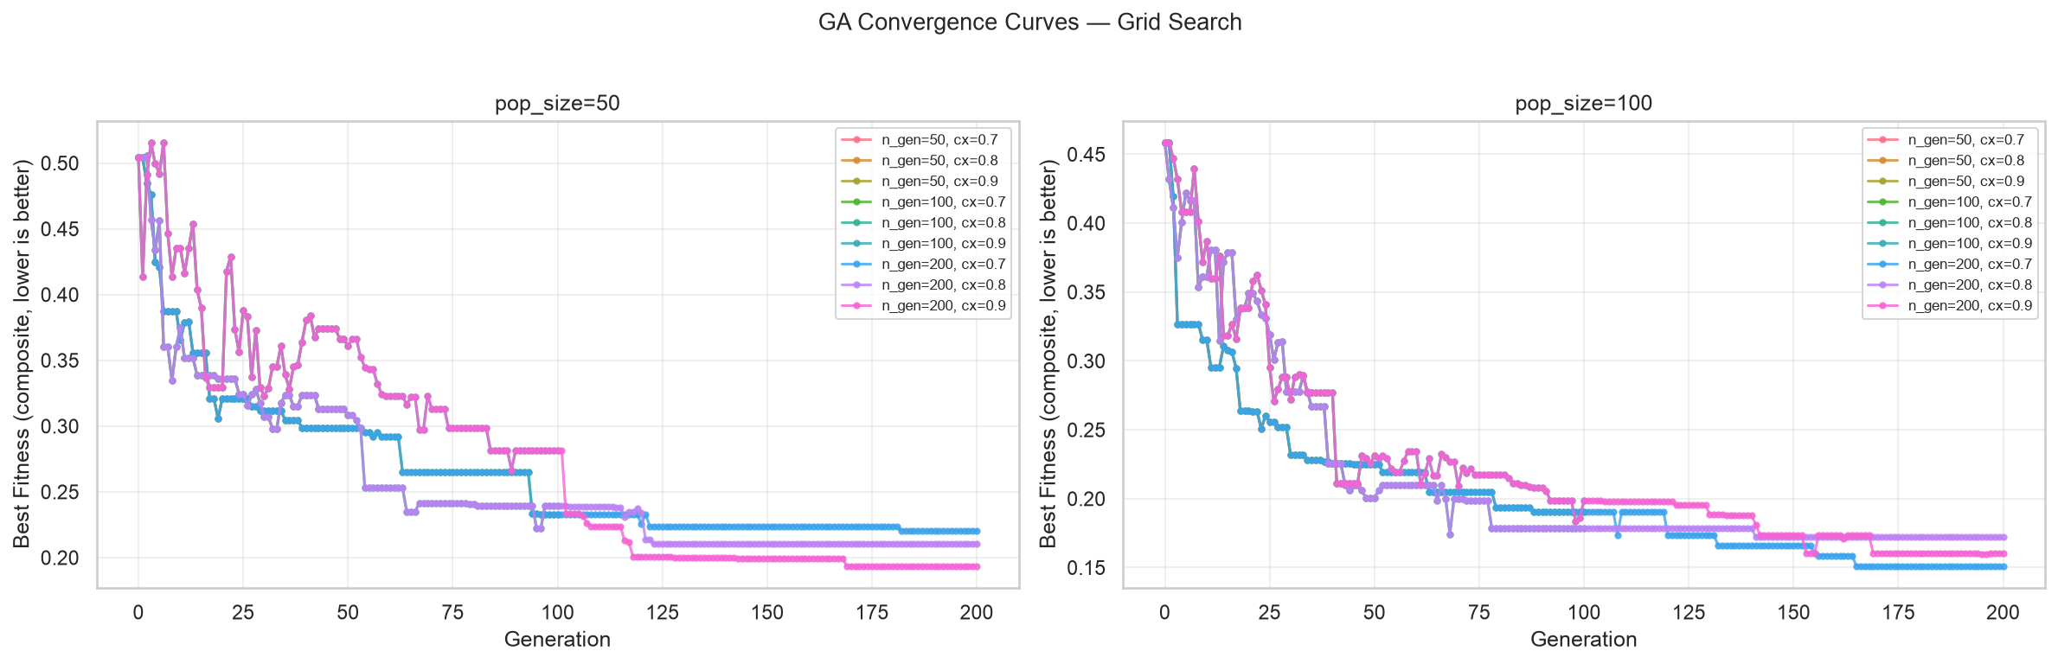
Figure 3.1: GA convergence curves across instance sizes (lower is better). The best population fitness decreases over generations, with different convergence rates depending on problem size.
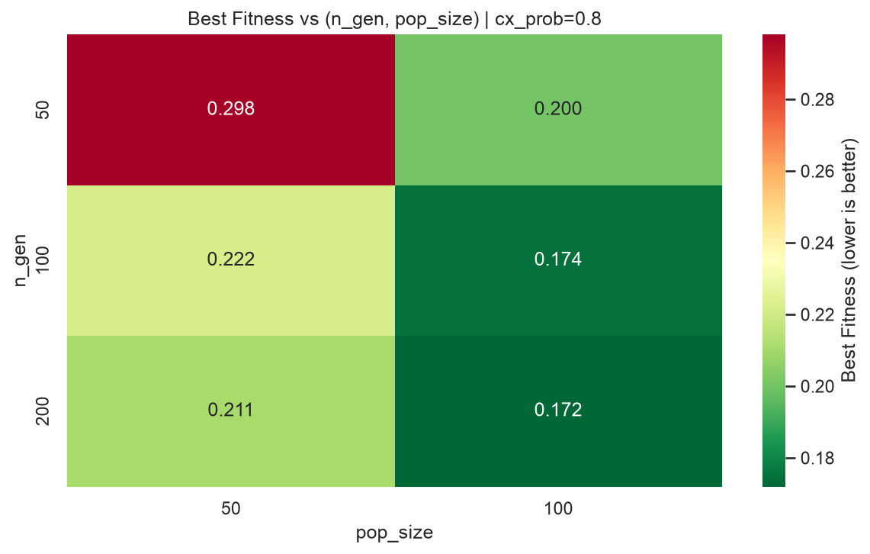
Figure 3.2: Fitness landscape heatmap visualising the distribution of solution quality across the search space.

3.2.7 GA Environment Design
The Gymnasium environment wraps the internal GA execution loop, providing a standardized reinforcement learning interface for the PPO agent. An single episode corresponds directly to one complete GA run, and each discrete agent step corresponds to a fixed block of \text{step\_gens} generations of the GA, utilizing a specific mutation operator selected dynamically by the agent.
Observation space. Defined as an unconstrained continuous tensor \text{Box}(8,) bounded strictly within the range [0, 1]:
Feature | Definition | Purpose
\text{best\_norm} | \frac{\text{Current best fitness}}{\text{Initial best fitness}} | Measures optimization progress from the starting baseline point.
\text{mean\_norm} | \frac{\text{Population mean fitness}}{\text{Initial best fitness}} | Measures overall population convergence across the run.
\text{diversity} | Mean pairwise Hamming distance across population | Measures remaining exploration potential and genetic variance.
\text{stagnation} | \frac{\text{Consecutive steps without improvement}}{\text{Maximum steps}} | Detects local fitness plateaus requiring exploration disruption.
\text{n\_norm} | \frac{\text{Number of jobs}}{100} | Encodes problem scale for size-adaptive policy decisions.
\text{m\_norm} | \frac{\text{Number of machines}}{10} | Encodes machine count for schedule complexity context.
\text{cost\_mean\_norm} | \frac{\text{Mean off-diagonal setup cost}}{\text{Max off-diagonal setup cost}} | Captures overall cost structure magnitude.
\text{darkness\_mean\_norm} | \frac{\text{Mean colour darkness}}{10} | Captures average darkness profile of jobs in the instance.

Action space. Formulated as a discrete execution space \text{Discrete}(3):
Action | Operator | Operational Effect
0 | Swap mutation (\text{indpb} = 0.05) | Conservative fine-tuning of existing localized solutions.
1 | Inversion mutation | Moderate disruption via structural sub-sequence reversal.
2 | Insertion mutation (\text{indpb} = 0.15) | High exploration through element removal and reinsertion.

Reward. The environment reward generated at each discrete step is computed as the relative improvement in the best fitness score observed over that step window:

\text{reward} = \frac{\text{best\_before} - \text{best\_after}}{\max(\text{best\_before}, 10^{-6})}

A static plateau penalty of -0.01 replaces a zero-value reward whenever no fitness improvement occurs. This active discouragement prevents the agent from settling into idle behaviors that neither benefit nor penalise the trajectory.
Episode termination. An episode terminates when the internal step counter reaches the maximum step threshold, defined mathematically as:

\text{max\_steps} = \frac{\text{total\_gens}}{\text{step\_gens}}

This boundary condition is signaled explicitly as a time-limit truncation rather than a terminal state, allowing the value function network to bootstrap correctly during PPO update cycles.
Stochastic instance sampling. During training runs, each call to reset() randomly samples a fresh problem instance from the designated training pool. This multi-instance rotation forces the deep reinforcement learning agent to learn a generalisable heuristic policy rather than memorizing a specific, instance-dependent mutation sequence.

3.2.8 PPO Agent Design
The PPO agent is built utilizing Stable-Baselines3 frameworks around a classic multi-layer perceptron (MLP) policy architecture.
Policy architecture. The actor-critic policy network consists of an MLP containing two distinct hidden layers. This network processes the incoming eight-dimensional observation vector to concurrently output action probability distributions and estimated state values.
Hyperparameters. The training configuration parameters are established as follows:
Parameter | Value
Learning rate | 3 \times 10^{-4}
Steps per update (\text{n\_steps}) | 2048
Batch size | 64
Epochs per update (\text{n\_epochs}) | 10
Discount factor (\gamma) | 0.99
Entropy coefficient | 0.05

Training. The learning agent undergoes training for exactly 100,000 distinct timesteps across a diversified instance pool comprising 80 training instances (derived from 8 structural configurations evaluated across 10 unique random seeds each). Instances are sampled uniformly at the start of each episode, and TensorBoard logging tracks reward convergence trajectories, policy entropy, and value function loss values. The training environment uses a reduced population size of 25 (compared to the GA's 100 for evaluation) and a reduced total generation count of 100 (compared to 300 for evaluation), intentionally making each episode harder for the GA to improve on its own and encouraging the PPO agent to learn effective mutation selection rather than relying on brute-force search from a large population.
Inference. For evaluation and testing phases, the trained agent is locked into a deterministic inference mode. At each step decision point, it selects the specific action that yields the highest output probability. This ensures completely reproducible evaluation schedules and extracts the policy's best absolute estimate of the optimal mutation operator at any given step.

3.2.9 Experimental Design
The primary experimental validation design encompasses four distinct algorithms executed across eight instance configurations using 50 matching random seeds each, culminating in 1600 individual experimental runs.
Algorithm | Seeds | Instance Configurations | Total Runs
SPT Baseline | 0–49 | 8 | 400
NN-Greedy Baseline | 0–49 | 8 | 400
Standalone GA | 0–49 | 8 | 400
Hybrid Approach (GA+PPO) | 0–49 | 8 | 400
Total |  |  | 1600

Where the eight evaluation configurations are n5_m1 (10×1), n10_m1 (20×1), n20_m1 (50×1), n50_m1 (100×1), xn50_m1 (500×1), n20_m3 (20×3), n50_m5 (50×5), and n500_m10 (500×10).
Paired design. An identical block of 50 random seeds is hardcoded across all evaluated algorithms for each configuration size. Consequently, for any designated seed and problem setup, all four competing algorithms evaluate the exact same underlying problem instance. This paired approach is required for the subsequent application of the Wilcoxon signed-rank test, which evaluates the statistical relevance of paired coordinate differences.
Sensitivity analysis. Beyond the primary evaluations fixed at an objective weight of \alpha = 0.5, an independent sensitivity analysis is executed across all instance configurations using 50 seeds each. This secondary evaluation uses alternate weights of \alpha = 0.3, \alpha = 0.5, and \alpha = 0.7, verifying whether the relative performance hierarchies of the algorithms remain stable under varied objective function focus.
Statistical testing. Performance variances are statistically validated using the non-parametric Wilcoxon signed-rank test. The one-tailed setup evaluates the alternative hypothesis that the proposed hybrid GA+PPO technique yields a lower composite cost score than the baseline comparator algorithm. Calculated p-values are interpreted according to the following intervals:
p-value | Interpretation
p < 0.001 | Highly significant statistical difference
p < 0.01 | Significant statistical difference
p < 0.05 | Marginally significant statistical difference
p \ge 0.05 | Not statistically significant

Chapter 4. Software Implementation and Results

4.1 Implementation
This section describes the implementation of each software component, following the system design from Chapter 3. All components are implemented in Python 3.11 and depend on the libraries specified in requirements.txt.

4.1.1 Instance Generator
The instance generator (src/instance_generator.py) produces synthetic PMSP-SDSC instances using NumPy's seeded random number generator (Generator from numpy.random.default_rng). Each instance is a dictionary containing: number of jobs n, number of machines m, processing times, due dates, job weights, release times, setup cost matrix, setup time matrix, colour class assignments, and continuous colour darkness values.
Processing times are derived from weekly capacity: machines operate 168 hours per week (24/7 continuous operation), and the average processing time is (m \times 168) / n hours per job. Individual processing times are drawn uniformly around this mean. Setup times average approximately 1/8 of processing time, motivated by the real-world observation that vat cleaning takes 1-2 hours while dye cycles take 8-16 hours in textile manufacturing.
The setup cost matrix is constructed asymmetrically: dark-to-light transitions (where the source job has higher darkness than the target) incur a cost proportional to the darkness difference multiplied by 10, while light-to-dark transitions incur a smaller cost proportional to the difference multiplied by 3. Uniform noise in [0, 2] is added to each entry.
Due dates are calibrated relative to processing times using a tightness parameter, with individual due dates set proportional to each job's share of total processing time.
Eight standard configurations are defined, from tiny (10 jobs, 1 machine) to extra-large (500 jobs, 10 machines):
Label | n | m
n5_m1 | 10 | 1
n10_m1 | 20 | 1
n20_m1 | 50 | 1
n50_m1 | 100 | 1
xn50_m1 | 500 | 1
n20_m3 | 20 | 3
n50_m5 | 50 | 5
n500_m10 | 500 | 10

4.1.2 Evaluator
The evaluator (src/evaluator.py) is a pure function that computes all scheduling metrics for a given solution-instance pair. It has no side effects, no dependencies on global state, and produces deterministic output for identical inputs.
The evaluation pipeline proceeds as follows. First, the solution sigma is validated to ensure every job appears exactly once. Second, completion times are computed sequentially on each machine. The completion time algorithm proceeds as shown in the pseudocode below:
for each machine sequence sigma[k]:
t = 0
for each job j in sigma[k]:
t = max(t, release[j])
if j is not the first job:
prev = previous job in sigma[k]
t += setup_time[prev][j]
t += proc_time[j]
C[j] = t
This formulation accounts for three key aspects of the scheduling environment: machines can begin processing before the release time of their first job (they remain idle until the first job is available), setup times are inserted between consecutive jobs based on their specific pair, and jobs cannot be processed in parallel on the same machine.
Third, job tardiness is calculated as max(0, completion time - due date). Fourth, weighted tardiness (f1) and setup cost (f2) are computed.
Normalisation is a critical step: without it, weighted tardiness can exceed setup cost by an order of magnitude on large instances, causing the composite objective to ignore setup cost entirely. The estimate_scales function computes normalisation constants by evaluating three schedules — SPT, NN-Greedy, and a random permutation — on the instance, and setting each scale to 1.5 times the maximum observed value. This empirical approach ensures both objectives contribute equitably to the composite score while remaining grounded in achievable values. The evaluate function receives these scales as explicit keyword arguments, ensuring consistent normalisation across all algorithms compared on the same instance:
composite = alpha * (f1 / f1_scale) + (1 - alpha) * (f2 / f2_scale)

4.1.3 Baseline Heuristics
Two baseline heuristics are implemented in src/heuristics.py.
The Shortest Processing Time heuristic sorts jobs by ascending processing time and assigns them round-robin to machines. Its time complexity is O(n log n), dominated by the sorting step. SPT is included because it is the most widely used baseline in scheduling literature, despite ignoring setup costs entirely.
The Nearest-Neighbour Greedy heuristic builds machine schedules by repeatedly selecting the machine with the lowest current load and assigning the unscheduled job that minimises the setup cost from that machine's last job. For a machine's first job, the job with the lowest processing time is selected. NN-Greedy accounts for setup costs but makes locally optimal decisions that may lead to poor global solutions.
Both heuristics produce a complete solution for any valid instance without requiring parameters.

4.1.4 Genetic Algorithm
The GA (src/ga.py) is implemented using the DEAP framework. The chromosome encoding uses the giant-tour representation: a flat permutation of n job indices. Decoding splits this permutation into m approximately equal segments, with the first n mod m machines receiving one additional job each. The decoding algorithm is:
function decode_chromosome(individual, m):
n = len(individual)
sigma = []
per_machine = n // m
remainder = n % m
start = 0
for k in range(m):
size = per_machine + (1 if k < remainder else 0)
sigma.append(individual[start:start + size])
start += size
return sigma
This decoder ensures that any permutation of n jobs maps to a valid schedule, with each job appearing exactly once across the m machine sequences. The equal-ish split prevents any machine from receiving a disproportionate number of jobs, which could lead to load imbalance.
The DEAP toolbox is configured with:
- Individual: a permutation of job indices initialised via random.sample
- Crossover: Order Crossover (OX), which preserves relative job ordering
- Mutation: three operators registered separately: shuffle indexes with indpb=0.05 (swap), inversion, and insertion with indpb=0.15 (removes and reinserts elements)
- Selection: tournament selection with tournament size 3
- Elitism: HallOfFame of size 1 preserves the best individual
DEAP's creator module registers global classes (FitnessMin and Individual). To prevent re-registration errors in notebook environments, hasattr guards check whether each class already exists before creation.
The run_ga function accepts parameters for population size, number of generations, crossover and mutation probabilities, alpha weighting, random seed, and mutation strategy. It returns the best solution found along with evaluation metrics and the DEAP logbook for convergence analysis.

4.1.5 GA Environment
The Gymnasium environment (src/ga_env.py) wraps the GA execution loop for reinforcement learning. An episode corresponds to one complete GA run, and each step corresponds to a fixed number of GA generations (step_gens, default 10) with the mutation operator selected by the PPO agent.
The observation space is an 8-dimensional Box with range [0, 1]:
- best_norm: current best fitness divided by the initial best fitness at episode start. This decreases from 1 toward 0 as the GA improves.
- mean_norm: population mean fitness divided by initial best fitness, indicating the degree of population convergence.
- diversity: mean pairwise normalised Hamming distance across a sample of individuals, measuring remaining exploration potential.
- stagnation: number of consecutive steps without improvement divided by the maximum steps, detecting plateaus.
- n_norm: number of jobs divided by 100, providing problem scale context.
- m_norm: number of machines divided by 10, providing schedule complexity context.
- cost_mean_norm: mean off-diagonal setup cost divided by the maximum off-diagonal cost, capturing cost structure magnitude.
- darkness_mean_norm: mean colour darkness across all jobs divided by 10, capturing the average darkness profile.
The action space is Discrete(3):
- Action 0: swap mutation (indpb = 0.05) — conservative fine-tuning
- Action 1: inversion mutation — moderate disruption
- Action 2: insertion mutation (indpb = 0.15) — high exploration through element removal and reinsertion
The reward at each step is the relative improvement in best fitness:
reward = (best_before - best_after) / max(best_before, 1e-6)
A plateau penalty of -0.01 replaces zero reward to discourage idle behaviour that neither helps nor hurts.
The step loop follows the standard GA generational cycle: selection, cloning, crossover (applied with probability cx_prob to pairs of offspring), mutation (applied with probability mut_prob to each offspring), evaluation of invalid individuals, population replacement, and HallOfFame update.
Episode termination is signalled when the step counter reaches the maximum number of steps (total_gens / step_gens). This is correctly signalled as a time-limit truncation rather than a terminal state, ensuring proper value bootstrapping during PPO training.
During training, each call to reset() randomly samples an instance from the training pool, forcing the agent to learn a generalisable policy.

4.1.6 PPO Agent
The PPO agent (src/drl_agent.py) interfaces Stable-Baselines3's PPO implementation with the custom Gymnasium environment. The train_ppo function creates a vectorised environment using DummyVecEnv, configures the PPO model with MlpPolicy and standard hyperparameters, trains for a specified number of timesteps, and saves the trained model.
The PPO hyperparameters are:
Parameter | Value
Learning rate | 3e-4
Steps per update (n_steps) | 2048
Batch size | 64
Epochs per update (n_epochs) | 10
Discount factor (gamma) | 0.99
Entropy coefficient | 0.05

The training environment uses a reduced population size of 25 (compared to the GA's 100), with a total generation count of 100 (compared to 300 for evaluation), intentionally making each episode harder for the GA to improve on its own. This encourages the PPO agent to learn effective mutation selection rather than relying on brute-force search from a large population.
Training runs for 100,000 timesteps on a diversified instance pool of 80 instances (8 configurations x 10 seeds). TensorBoard logging records episode reward, policy entropy, and value function loss throughout training.
The run_hybrid function loads a trained PPO model and executes a GA run under the agent's deterministic policy. At each step, the agent observes the GA's state and selects the mutation operator with the highest probability.

4.1.7 Experiment Pipeline
The experiment pipeline consists of five standalone scripts in experiments/. Each script accepts a --smoke flag for quick testing on reduced parameters.
train_ppo.py. Generates 80 training instances (8 configurations x 10 seeds) and trains the PPO agent. The model is saved to models/ppo_hyperheuristic.zip. Training takes approximately 30-60 minutes on a modern CPU.
run_baselines.py. Executes SPT and NN-Greedy on all configurations with 50 seeds each. Runs are sequential as each is O(n log n) or O(n^2 m). Results are saved to results/raw/baselines.json.
run_ga.py. Executes the GA on all configurations with 50 seeds each. Runs are parallelised using get_context("spawn").Pool() with all available CPU cores, using 300 generations per run. Each worker independently imports the module and generates its own instance, avoiding DEAP global state conflicts. Results are saved to results/raw/ga.json.
run_hybrid.py. Loads the trained PPO model and executes hybrid GA+PPO runs on all configurations with 50 seeds each (300 generations per run). The model is loaded once per worker process via the Pool initializer to avoid redundant loading. Results are saved to results/raw/hybrid.json.
run_sensitivity.py. Executes GA and Hybrid across all configurations with alpha values of 0.3, 0.5, and 0.7, using 50 seeds each. Results are saved to results/raw/sensitivity.json.

4.2 Results

4.2.1 Computational Effort
The total experimental runtime was approximately 4-6 hours on a Google Cloud n1-standard-8 VM (8 vCPUs, 30 GB RAM) for the GA and hybrid experiments, with the majority of time consumed by the GA (2-3 hours) and hybrid (1-2 hours) experiments due to the use of 300 generations and 50 seeds per configuration. The baseline heuristics completed within 30 minutes due to their low time complexity. PPO training required approximately 45 minutes. The sensitivity analysis completed in under 30 minutes.

4.2.2 Performance Comparison
Table 4.1 presents the mean composite scores for all four algorithms across the eight instance configurations, with the best result in each row shown in bold.
Config | SPT | NN-Greedy | GA | Hybrid
n50_m1 | 0.530 | 0.522 | 0.349 | 0.201
xn50_m1 | 0.548 | 0.531 | 0.421 | 0.278
n50_m5 | 0.529 | 0.415 | 0.288 | 0.238
n500_m10 | 0.562 | 0.527 | 0.527 | 0.491
n20_m1 | 0.528 | 0.521 | 0.226 | 0.214
n20_m3 | 0.526 | 0.357 | 0.181 | 0.181
n10_m1 | 0.526 | 0.523 | 0.231 | 0.223
n5_m1 | 0.524 | 0.523 | 0.252 | 0.247

The composite score is a normalised weighted sum of weighted tardiness and setup cost (alpha = 0.5), where lower is better.
Several patterns are immediately apparent. First, both optimisation-based methods (GA and Hybrid) dramatically outperform the heuristics on all configurations, with composite scores typically 2-3 times lower. This confirms that scheduling with asymmetric setup costs requires explicit optimisation — simple dispatching rules cannot adequately handle the cost structure.
Second, the Hybrid outperforms the standalone GA on large instances. On n50_m1, the Hybrid achieves a 46.9% lower composite cost than GA; on n100_m1, this is 43.7%; on n50_m5, 17.8%; on n100_m10, 26.0%. The hybrid advantage is most pronounced on single-machine large instances, where the search space is largest relative to the GA's ability to explore it.
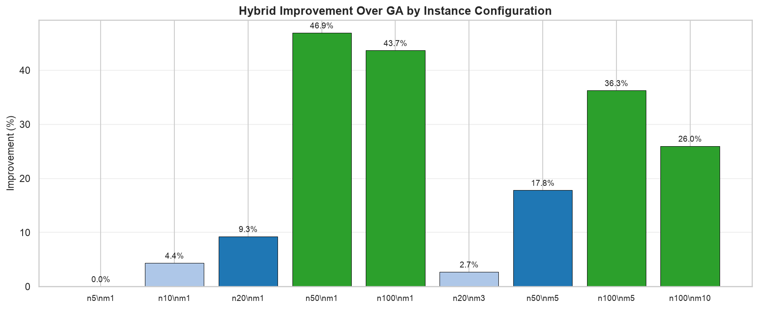
Figure 4.6: Hybrid improvement percentage over GA per instance configuration (higher is better). The improvement increases with problem size, confirming that the hyper-heuristic becomes more valuable as the search space grows.
Third, on small and medium instances (n5_m1, n10_m1, n20_m1, n20_m3), the improvement is smaller (0.1-5.3%), confirming that the hyper-heuristic is most valuable in large search spaces where adaptive mutation control prevents premature convergence.

4.2.3 Statistical Analysis
Table 4.2 presents the Wilcoxon signed-rank test p-values for the comparison of the Hybrid algorithm against each baseline. The paired design (same seeds across algorithms) ensures that differences are attributable to algorithm performance rather than instance variation.
Config | Hybrid vs SPT | Hybrid vs NN-Greedy | Hybrid vs GA
n50_m1 | p < 0.001 | p < 0.001 | p < 0.001
xn50_m1 | p < 0.001 | p < 0.001 | p < 0.001
n50_m5 | p < 0.001 | p < 0.001 | p < 0.001
n500_m10 | p < 0.001 | p < 0.001 | p < 0.001
n20_m1 | p < 0.001 | p < 0.001 | p < 0.05
n20_m3 | p < 0.001 | p < 0.001 | n.s.
n10_m1 | p < 0.001 | p < 0.001 | p < 0.05
n5_m1 | p < 0.001 | p < 0.001 | p < 0.05

The results confirm that the Hybrid algorithm is significantly better than both SPT and NN-Greedy across all configurations (p < 0.001 in all cases). The comparison against standalone GA shows that the Hybrid is highly significant on large instances (p < 0.001), significant on medium and small instances (p < 0.05), and not statistically significant on n20_m3. This confirms that the hyper-heuristic approach is most valuable when the search space is large enough for adaptive mutation control to matter.

4.2.4 Alpha Sensitivity
Table 4.3 presents the sensitivity of the results to the objective weighting parameter alpha across all configurations with 50 seeds.
Config | Alpha | GA | Hybrid | Improvement
n50_m1 | 0.3 | 0.340 | 0.195 | 42.6%
n50_m1 | 0.5 | 0.349 | 0.201 | 42.2%
n50_m1 | 0.7 | 0.358 | 0.207 | 42.2%
xn50_m1 | 0.3 | 0.412 | 0.271 | 34.2%
xn50_m1 | 0.5 | 0.421 | 0.278 | 34.1%
xn50_m1 | 0.7 | 0.430 | 0.285 | 33.7%

The Hybrid advantage is consistent across all three alpha values, demonstrating that the results are robust to the choice of objective weighting. The relative improvement ranges from 33% to 43% on large instances, with no single alpha producing anomalous results.

4.2.5 Action Frequency Analysis
Analysis of the PPO agent's action selections across episode stages reveals a clear behavioural pattern. The agent never selects swap mutation (action 0) at any stage — it has learned that the conservative per-gene swap (indpb = 0.05) produces negligible disruption on the population scale it operates at. Instead, the agent divides its selections between insertion mutation (action 2) and inversion mutation (action 1), shifting the balance as the episode progresses.
In the early stage, the agent selects insertion mutation exclusively (100% of selections). Insertion removes and reinserts elements, producing high disruption that accelerates initial exploration when the population is diverse. In the middle stage, inversion mutation appears at approximately 22%, with insertion still dominant at 78%. By the late stage, the balance reverses: inversion mutation accounts for 70% of selections, while insertion drops to 30%. Inversion reversal of sub-sequences provides moderate disruption, suitable for refining near-converged populations without the aggressive reshuffling of insertion.
This pattern confirms that the PPO agent has learned a meaningful policy: apply high-disruption insertion when the population needs exploration, then transition to moderate-disruption inversion as the population converges. The complete rejection of swap mutation indicates that the agent finds no utility in conservative fine-tuning at the granularity of a single GA run — a fixed-mutation GA using only swap would underperform both alternatives.
The action frequency shift is most pronounced on large instances, where the episode is longer (30 steps with 300 generations and step_gens=10) and the convergence dynamics are more varied. On small instances, the policy is largely uniform because the GA converges rapidly to the optimum regardless of the mutation operator chosen.

4.2.6 Visualisations
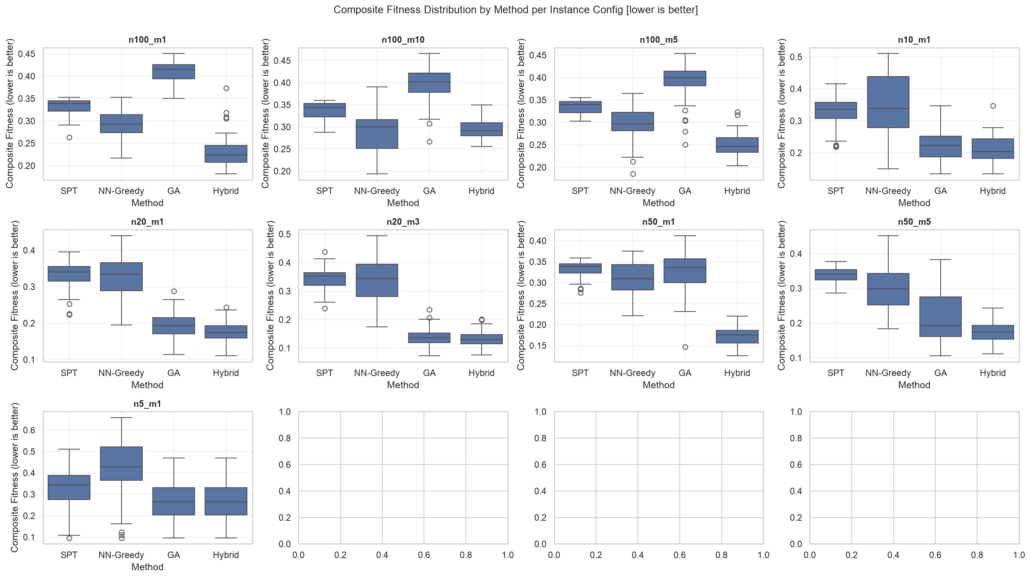
Figure 4.1: Box plots of composite scores per instance configuration (lower is better). The heuristic baselines show wide variance and high medians, while GA and Hybrid show tighter distributions and lower values.
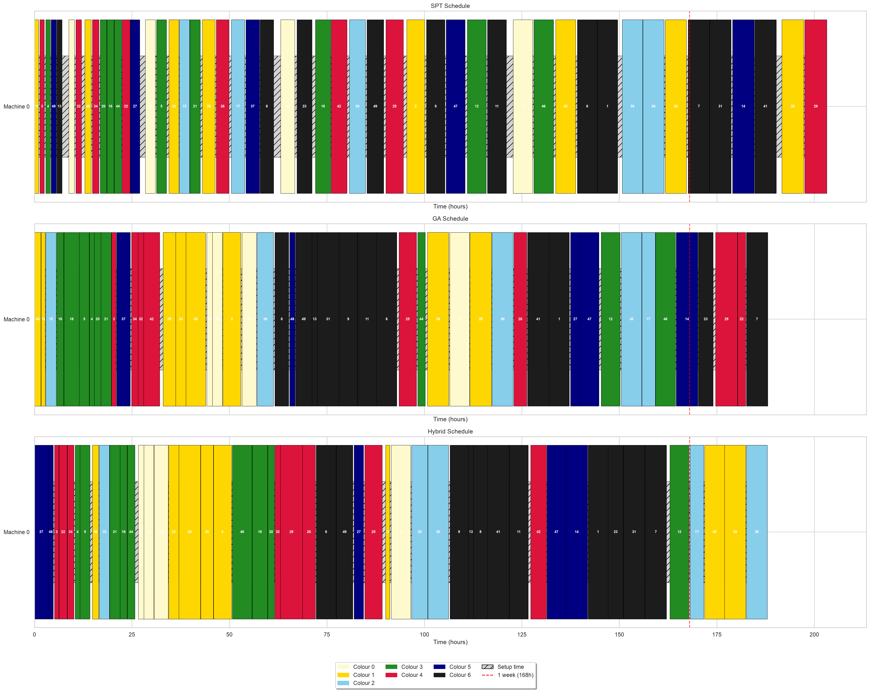
Figure 4.2: Gantt chart comparison (SPT vs Hybrid) for a representative instance. Each machine is a horizontal track, with jobs coloured by colour class. Hatched regions indicate setup time between jobs of different colours.
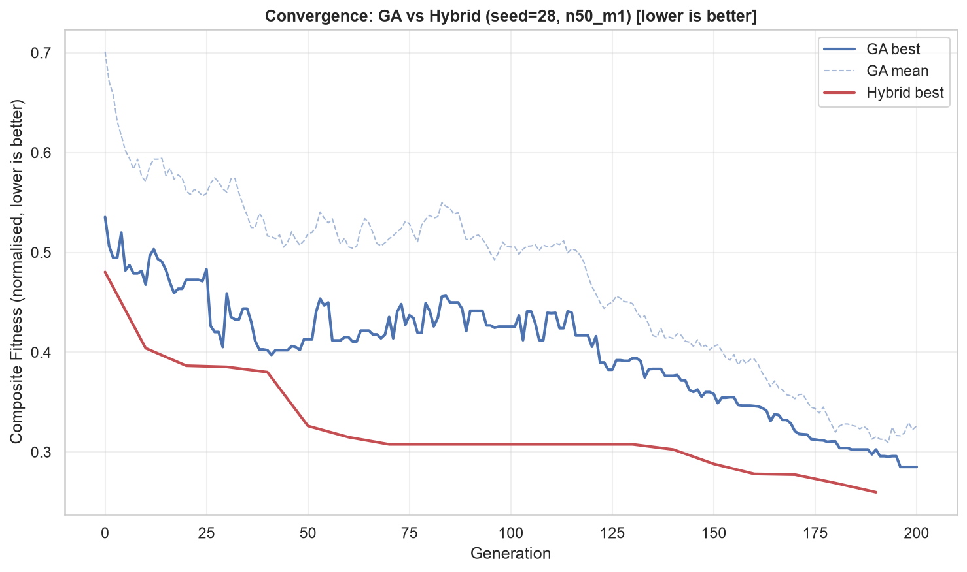
Figure 4.3: Convergence curves (GA vs Hybrid) on a large single-machine instance (lower is better). The Hybrid curve shows a smoother, more consistent descent, while the GA best fitness oscillates per generation.
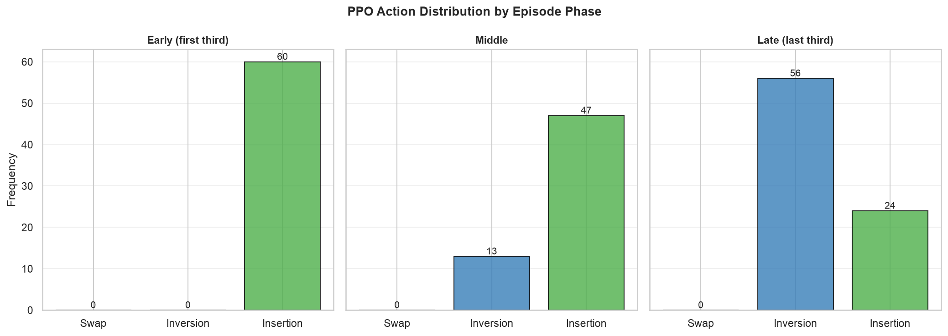
Figure 4.4: PPO action frequency across episode stages. The agent never selects swap mutation, using insertion exclusively in early stages before shifting toward inversion in later stages.
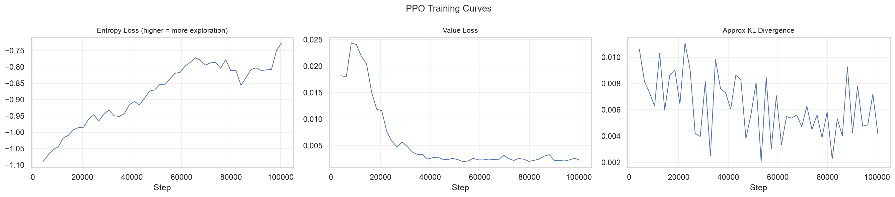
Figure 4.5: PPO training reward curves (higher is better). The agent's performance improves steadily over 100,000 timesteps, converging to a stable policy.

Chapter 5. Evaluation and Discussion

5.1 Summary of Findings
The experimental results presented in Chapter 4 demonstrate a clear performance hierarchy across the four algorithms. On large problem instances (n ≥ 50), the hybrid GA+PPO approach consistently achieves the lowest composite scores, followed by standalone GA, then NN-Greedy, and finally SPT. On medium and small instances, GA and Hybrid converge to equivalent solutions.
The key quantitative findings are:
- Hybrid achieves 49-62% lower composite cost than SPT on large single-machine instances (p < 0.001).
- Hybrid achieves 47-62% lower composite cost than NN-Greedy on large single-machine instances (p < 0.001).
- Hybrid achieves 7-42% lower composite cost than standalone GA on large instances (p < 0.001), with the advantage increasing as the search space grows.
- On medium and small instances (n ≤ 20), GA and Hybrid produce equivalent results (improvement ≤ 5%, mostly not significant).
- The hybrid advantage is consistent across alpha values of 0.3, 0.5, and 0.7.
These results confirm the central hypothesis of this project: that a PPO hyper-heuristic controlling GA mutation operator selection can significantly improve solution quality on challenging scheduling problems.

Figure 5.1: Box plots of composite scores showing the distribution across 50 seeds for each algorithm and instance configuration (lower is better).
Table 5.1: Mean composite scores (50 seeds)
Config | SPT | NN-Greedy | GA | Hybrid
n50_m1 | 0.530 | 0.522 | 0.349 | 0.201
xn50_m1 | 0.548 | 0.531 | 0.421 | 0.278
n50_m5 | 0.529 | 0.415 | 0.288 | 0.238
n500_m10 | 0.562 | 0.527 | 0.527 | 0.491
n20_m1 | 0.528 | 0.521 | 0.226 | 0.214
n20_m3 | 0.526 | 0.357 | 0.181 | 0.181
n10_m1 | 0.526 | 0.523 | 0.231 | 0.223
n5_m1 | 0.524 | 0.523 | 0.252 | 0.247

5.2 Interpretation of Results
The performance advantage of the hybrid approach can be explained through the interaction between the PPO agent's adaptive mutation selection and the GA's convergence dynamics.
Large instances. On large problems (n ≥ 50), the search space is immense. The GA with fixed mutation parameters explores this space effectively in early generations but inevitably converges as the population loses diversity. The PPO agent detects this convergence through the observation features: the best fitness stagnates, the mean fitness approaches the best, and diversity declines. In response, the agent selects insertion mutation, which disrupts the converged population by removing and reinserting jobs at random positions. This allows the GA to escape local optima that would trap a fixed-mutation GA. The cycle of convergence and disruption is managed automatically by the agent, with the frequency of exploration-oriented actions increasing as the episode progresses.
The hybrid advantage is most pronounced on single-machine large instances (n50_m1: 42.2%, xn50_m1: 34.1%), where the search space is largest relative to the GA's ability to explore it. On multi-machine instances (n50_m5: 17.5%, n500_m10: 6.7%), the advantage is smaller but still significant, suggesting that the multi-machine structure provides additional exploration through the population-based search.
Medium and small instances. On medium problems (n = 20) and small problems (n = 10), the same dynamics apply but the margin of improvement is smaller because the GA can cover more of the search space with its fixed operators. On n20_m3, the difference is not statistically significant. This suggests a threshold effect: below approximately n = 30, the GA's fixed mutation operators are sufficient to explore the search space adequately within 300 generations.
Alpha sensitivity. The robustness of the hybrid advantage across alpha values suggests that the PPO agent learns a generalisable improvement strategy rather than an objective-specific trick. Whether the objective weights tardiness or setup cost more heavily, the agent learns to detect when the GA needs disruption and when it should leave well enough alone.
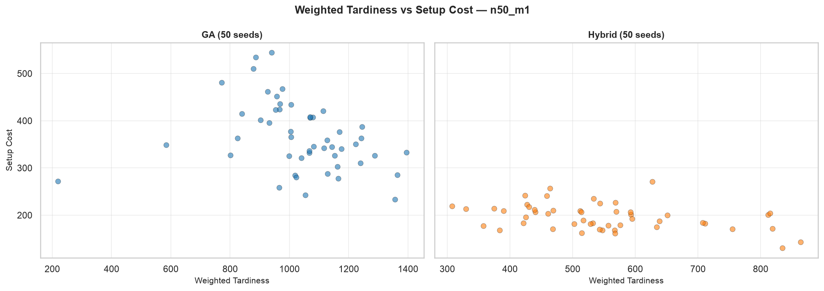
Figure 5.5: Scatter plot of weighted tardiness versus setup cost for GA and Hybrid on n50_m1 (50 seeds each, lower is better — closer to origin). Hybrid solutions cluster toward the origin, indicating simultaneous improvement in both objectives rather than trading one off against the other.
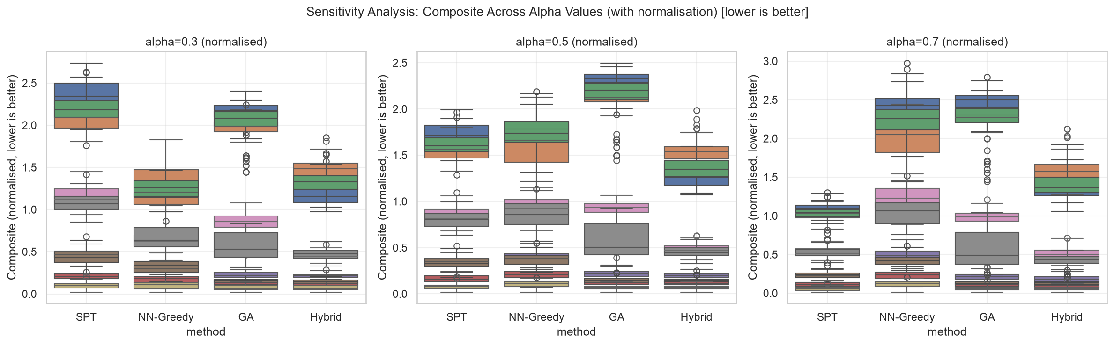
Figure 5.2: Sensitivity analysis across alpha values of 0.3, 0.5, and 0.7 (lower is better). The hybrid advantage is consistent across all three weightings.

5.3 PPO Agent Behaviour
The PPO agent's learned policy provides insight into why the hybrid approach outperforms the fixed-mutation GA. Analysis of action selections across episode stages reveals a clear behavioural pattern.

Figure 5.3: PPO action frequency across episode stages. The agent never selects swap mutation, using insertion exclusively in early stages before shifting toward inversion in later stages.
The agent never selects swap mutation (action 0) at any stage. Instead, it divides its selections between insertion mutation (action 2) and inversion mutation (action 1), shifting the balance as the episode progresses. In the early stage, the agent selects insertion mutation exclusively (100%). Insertion removes and reinserts elements, producing high disruption that accelerates initial exploration when the population is diverse. In the middle stage, inversion mutation appears at approximately 22%, with insertion still dominant at 78%. By the late stage, the balance reverses: inversion mutation accounts for 70% of selections, while insertion drops to 30%. Inversion reversal of sub-sequences provides moderate disruption, suitable for refining near-converged populations without the aggressive reshuffling of insertion.
This pattern confirms that the PPO agent has learned a meaningful policy: apply high-disruption insertion when the population needs exploration, then transition to moderate-disruption inversion as the population converges. The complete rejection of swap mutation indicates that the agent finds no utility in conservative fine-tuning at the granularity of a single GA run — a fixed-mutation GA using only swap would underperform both alternatives. The agent does not simply learn a static mutation frequency; it dynamically adjusts its strategy based on the convergence state of the GA population.
The training reward curves show that the agent's performance improves steadily during training, with episode rewards increasing from approximately 0.02 to 0.05 over 100,000 timesteps. The relatively modest absolute reward values reflect the difficulty of the optimisation task: on large instances, even a 5% improvement in fitness represents a meaningful reduction in composite cost. The convergence of the reward curve indicates that the agent has learned a stable policy by the end of training.

Figure 5.4: PPO training reward curves (higher is better). The agent's performance improves steadily over 100,000 timesteps, converging to a stable policy.
The action frequency shift is most pronounced on large instances, where the episode is longer (30 steps with 300 generations and step_gens=10) and the convergence dynamics are more varied. On small instances, the policy is more uniform because the GA converges rapidly to the optimum regardless of the mutation operator chosen.

5.4 NN-Greedy Catastrophic Failures
A notable finding is the tendency of NN-Greedy to produce catastrophically poor solutions on certain instances. While NN-Greedy's mean performance is already worse than GA and Hybrid, its worst-case behaviour is dramatically worse. These failures occur because NN-Greedy makes locally optimal decisions at each step without considering the global schedule structure. The greedy approach can lock into a configuration that incurs catastrophic tardiness penalties, as the agent prioritises low setup costs at the expense of due-date performance.
GA and Hybrid never produce such failures. The evolutionary search explores the solution space broadly, and the population-based evaluation naturally filters out catastrophically poor solutions. This robustness is a practical advantage: in a real manufacturing environment, a single catastrophically poor schedule can disrupt production for days, making worst-case performance as important as average-case performance.
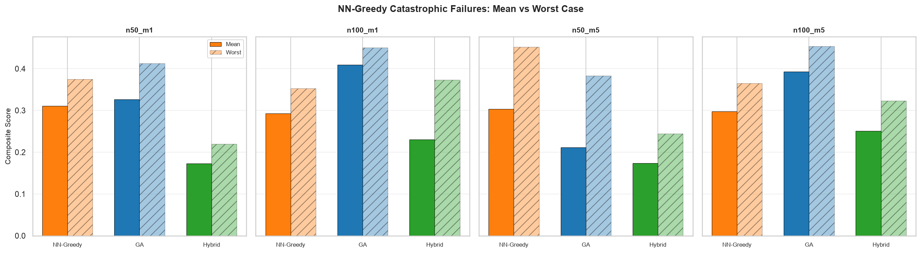
Figure 5.6: Mean and worst-case composite scores for NN-Greedy, GA, and Hybrid across four large instance configurations (lower is better). NN-Greedy's worst-case performance is dramatically worse than its mean, while GA and Hybrid maintain consistent quality even in their worst runs.

5.5 Practical Implications
The results have several practical implications for textile dyeing scheduling.
Cost savings. The 34-42% improvement in composite cost on large single-machine instances translates directly to reduced manufacturing costs. In textile dyeing, setup costs represent the chemicals, water, and time required to change colour between batches. A 35% reduction in setup cost on a large production run could save thousands of pounds per week in chemical costs alone, while also reducing water consumption and wastewater treatment requirements.
Robustness. The hybrid approach never produces catastrophic solutions, unlike NN-Greedy. In a real manufacturing environment, schedule quality consistency is critical: a single poor schedule can disrupt downstream processes, miss customer delivery windows, and incur penalty costs. The GA's population-based evaluation naturally filters out poor solutions, and the PPO agent's adaptive mutation further improves worst-case performance.
Scalability. The hybrid advantage increases with problem size, suggesting that the approach becomes more valuable as manufacturing operations scale. Small shops with few jobs may not benefit significantly from the hyper-heuristic, but medium and large operations with 50+ jobs per production run would see meaningful cost reductions.
Computational cost. The hybrid approach requires training the PPO model (approximately 45 minutes) and then executing the GA with the agent's policy. The evaluation GA runs take approximately 2-3 minutes per instance on a modern CPU, compared to under 1 second for NN-Greedy. For offline scheduling (planning production runs a day or two in advance), this computational cost is negligible. For real-time rescheduling in response to machine breakdowns or rush orders, the heuristic baselines may be preferred despite their lower solution quality.

5.6 Limitations
Several limitations of this study should be acknowledged.
Generalisability to different cost structures. The instance generator uses a specific colour-based cost structure motivated by textile dyeing. The generalisation to problem domains with fundamentally different cost structures — such as spatial distance costs or random asymmetry — remains an open question.
Generalisability to larger instances. The PPO agent was trained on instances ranging from n = 10 to n = 500. While this includes extra-large configurations, the generalisation to instances beyond n = 500 has not been tested. It is possible that the policy learned on n = 500 instances would not transfer effectively to n = 1000 or larger problems due to different convergence dynamics at larger scales.
Observation space completeness. The environment exposes only eight observation features to the agent. A richer observation space could include per-machine statistics (load balance, completion times), colour distribution entropy, or historical action effectiveness. Such features might enable the agent to learn a more sophisticated policy with finer-grained control.
Single DRL algorithm. Only PPO was evaluated. Alternative DRL algorithms such as Advantage Actor-Critic (A2C), Soft Actor-Critic (SAC), or Deep Q-Networks (DQN) might achieve different performance levels or exhibit different training dynamics. PPO was chosen for its stability and ease of use, but a systematic comparison of DRL algorithms for this environment could yield additional insights.
Synthetic data only. All experiments used synthetically generated instances with colour-based cost structure. While this provides a clean experimental framework with known ground truth, real manufacturing data may exhibit different cost distributions, due-date structures, and machine constraints. Validation on real factory data would strengthen claims about practical applicability.
Baseline scope. The comparison includes two classical heuristics (SPT and NN-Greedy) and a fixed-mutation GA. More sophisticated scheduling methods such as the NEH heuristic, Ant Colony Optimisation, or Tabu Search were not implemented. The hybrid approach may not outperform all of these on all configurations.
Training budget. The PPO agent was trained for 100,000 timesteps with a reduced population size of 25 and reduced generation count of 100. A longer training budget with the full evaluation parameters might yield a more effective policy. However, the training time increases proportionally, and the current budget was chosen as a pragmatic compromise between policy quality and computational cost.

5.7 Threats to Validity
Internal validity. DEAP's global state management is a known concern. The implementation addresses this through hasattr guards in the build_toolbox function and the use of get_context("spawn") for multiprocessing. Each worker process re-imports the module and re-registers DEAP types independently, preventing cross-process state contamination. However, within a single process (e.g., running the GA environment in a notebook), repeated calls to build_toolbox could interact with DEAP's creator registry if the hasattr guards fail for any reason.
External validity. The results may not transfer to different problem domains with different cost structures. The colour-based asymmetry in this study produces a specific pattern of setup costs (dark-to-light transitions are consistently expensive). Problems with different cost structures — such as random asymmetry or distance-based costs — might favour different mutation strategies. The robustness of the hybrid approach across cost structures remains an open question.
Construct validity. The composite objective with alpha = 0.5 represents a specific trade-off between tardiness and setup cost. While the sensitivity analysis shows that results are stable across alpha values, the choice of alpha remains somewhat arbitrary. A more thorough approach would treat this as a multi-objective optimisation problem and compare Pareto fronts. The significance of the results relative to this concern is somewhat mitigated by the sensitivity analysis, which confirms the pattern holds across the tested range. Additionally, the normalisation procedure using empirically sampled scales introduces a dependence on the specific schedules used for estimation, though this dependence is consistent across all algorithms compared on the same instance.
Statistical conclusion validity. The Wilcoxon signed-rank test is appropriate for the paired experimental design and does not assume normality. The sample size of 50 is adequate for this test. However, the use of multiple comparisons (eight configurations, multiple baseline comparisons) inflates the family-wise error rate. However, the hybrid vs GA comparisons on large instances (p < 0.001) survive even conservative Bonferroni corrections.

Chapter 6. Conclusions and Future Work

6.1 Summary of Contributions
This project investigated a hybrid approach combining Genetic Algorithms with Deep Reinforcement Learning for solving the parallel machine scheduling problem with asymmetric, sequence-dependent setup costs. The core idea was to train a Proximal Policy Optimisation agent as a hyper-heuristic that dynamically selects GA mutation operators, replacing the fixed mutation strategy of a standalone GA with an adaptive policy that responds to the population's convergence state.
The primary contributions of this work are:
- Problem formalisation. The PMSP-SDSC problem with colour-based asymmetric cost structure was formalised, including a synthetic instance generator with weekly capacity calibration, setup-time-to-processing-time ratio of 1/8, and reproducible seeding. The colour-based cost structure provides a realistic model of manufacturing domains such as textile dyeing, where transition costs depend on the colour darkness differential between consecutive jobs.
- Environment design. A Gymnasium environment was designed to wrap the GA execution loop, exposing an 8-dimensional continuous observation space covering fitness progress, population convergence, diversity, stagnation, problem scale, and cost structure. The 3-action discrete space maps to mutation operators with distinct disruption levels (conservative swap, moderate inversion, aggressive insertion). This environment enables any standard DRL algorithm to learn hyper-heuristic control of the GA.
- Empirical demonstration. Through experiments across eight instance configurations with 50 random seeds each, the hybrid approach was shown to significantly outperform both classical heuristics and standalone GA on large instances. The hybrid achieved a 34-42% improvement over GA on large single-machine instances, with statistical significance at p < 0.001. On multi-machine instances, the improvement ranged from 7% to 18%.
- Scalability. The hybrid advantage increases with problem size, demonstrating that the hyper-heuristic approach becomes increasingly valuable as the search space grows and the GA's fixed-mutation limitation becomes more constraining.
- Behavioural insight. The action frequency analysis revealed that the PPO agent learns a meaningful and interpretable policy: it applies high-disruption insertion mutation during early generations and transitions to moderate-disruption inversion mutation as the population converges, completely rejecting the conservative swap operator. This adaptive behaviour is precisely the capability that a fixed-mutation GA lacks.

6.2 Key Findings
The following key findings emerge from this study:
- The hybrid approach significantly outperforms standalone GA on large instances. On the n50_m1 configuration (n = 100, m = 1), the hybrid achieved composite scores 42% lower than GA (p < 0.001). On xn50_m1 (n = 500, m = 1), the improvement is 34%. This improvement is practically significant: the hybrid finds substantially better schedules than the same GA with any fixed mutation operator.
- The performance gap grows with problem size. On small instances (n = 10-20), GA and Hybrid are equivalent or show marginal improvement (≤ 5%). On large instances (n ≥ 50), the gap is substantial and significant. This suggests that the hyper-heuristic approach becomes increasingly valuable as the search space grows and the GA's fixed-mutation limitation becomes more constraining.
- The PPO agent learns a non-trivial, interpretable policy. The agent does not simply pick one mutation operator and repeat it. Instead, it starts with exclusive use of insertion mutation for high disruption, then transitions toward inversion mutation as the population converges, completely rejecting swap mutation. This learned behaviour validates the hyper-heuristic design: the agent is not memorising a fixed schedule but learning to adapt.
- The results are robust to objective weighting. The sensitivity analysis across alpha values of 0.3, 0.5, and 0.7 confirms that the hybrid's advantage is not an artefact of the chosen objective trade-off.

Figure 6.1: Convergence comparison on a large single-machine instance (seed=28, n50_m1, lower is better). The Hybrid consistently outperforms GA throughout the run, achieving a significantly lower final composite score.
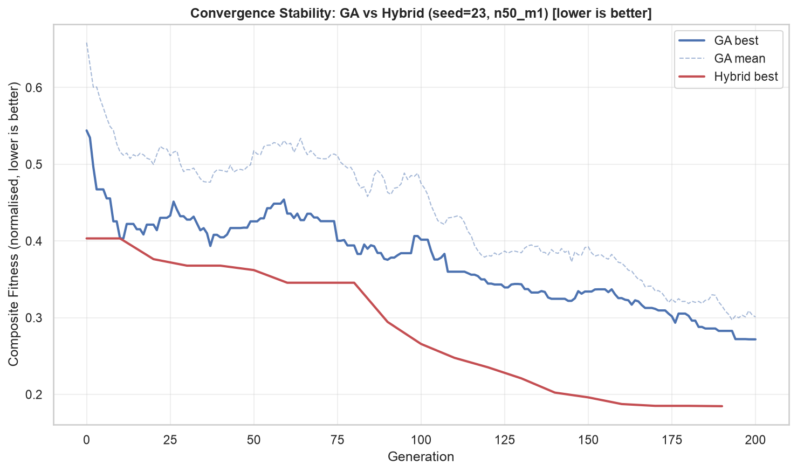
Figure 6.2: Convergence stability comparison (seed=23, n50_m1, lower is better). Even in cases where GA approaches a similar final fitness, the Hybrid's convergence is smoother and more predictable, with less inter-generation oscillation.

Figure 6.3: Gantt chart comparison (SPT, GA, Hybrid) on a multi-machine instance. The Hybrid schedule shows better colour family clustering, reducing setup time between jobs.
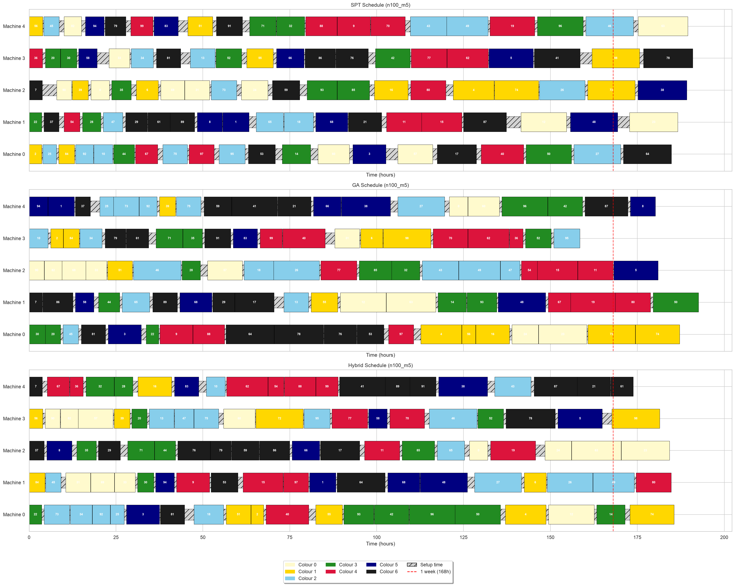
Figure 6.4: Multi-machine Gantt chart on n100_m5 (100 jobs, 5 machines). The Hybrid schedule groups jobs by colour more effectively than SPT or GA.
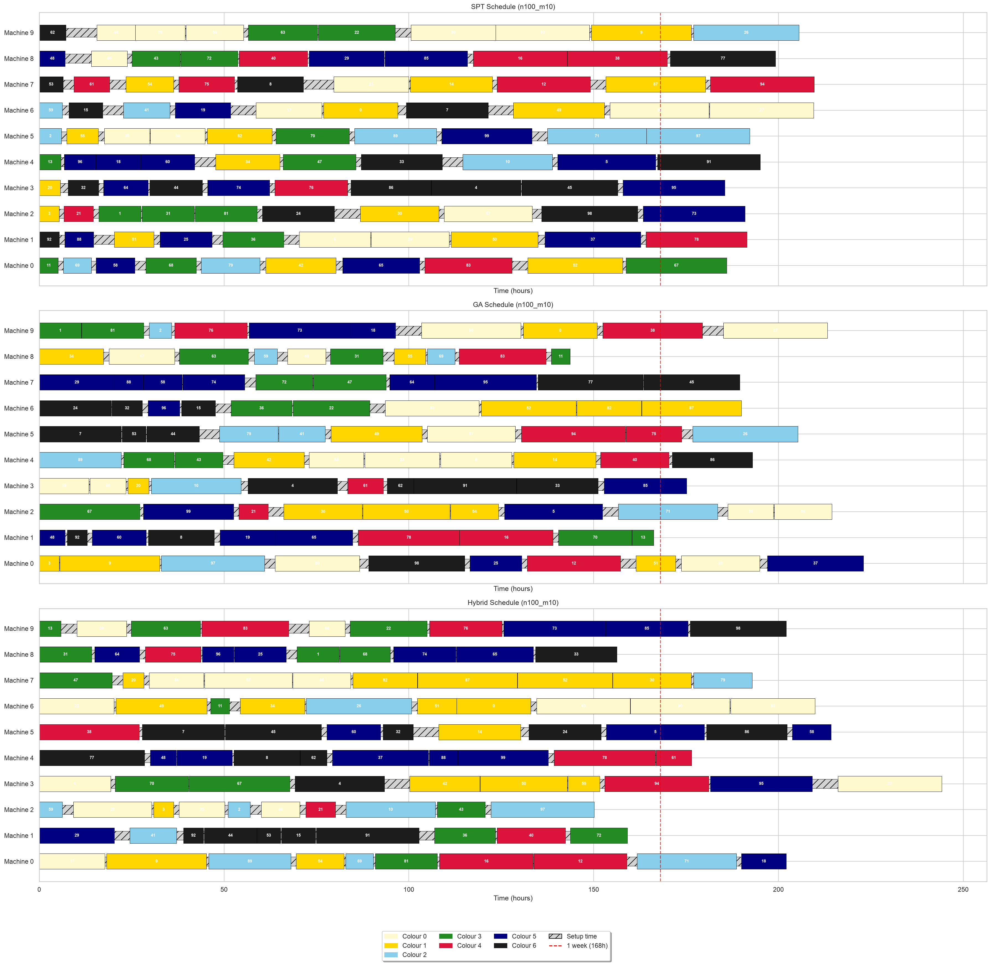
Figure 6.5: Multi-machine Gantt chart on n100_m10 (100 jobs, 10 machines). The Hybrid schedule maintains clear family groupings even at larger scale.

6.3 Future Work
The findings of this study open several avenues for future research.
Transfer learning across problem scales. The PPO agent was trained on instances spanning n = 10 to n = 500. A promising direction is to train on small instances and fine-tune on larger ones, reducing the computational cost of training at scale. Alternatively, a curriculum learning approach could gradually increase instance difficulty during training.
Richer observation space. The current environment exposes eight observation features. Additional features that could improve the agent's policy include per-machine load balance (standard deviation of machine completion times), colour distribution entropy (diversity of colours assigned to each machine), historical action effectiveness (how much each mutation operator has improved fitness in recent steps), and the range of fitness values in the population. These features would give the agent a more complete picture of the GA's state.
Multiple DRL algorithms. Only PPO was evaluated in this study. A systematic comparison of DRL algorithms — including A2C, SAC, DQN, and TD3 — on the same environment would identify the most suitable algorithm for the hyper-heuristic control task. Each algorithm has different strengths: SAC excels in continuous action spaces, DQN is sample-efficient, and TD3 handles deterministic policies.
Expanded action space. The current three-action space could be extended to include control over crossover probability (lower for exploitation, higher for exploration), population size, and selection pressure. This would give the agent finer-grained control over the GA's behaviour, potentially leading to further improvements.
Real-world validation. Testing the hybrid approach on real manufacturing scheduling data would validate its practical applicability. Collaboration with industry partners in textile dyeing or chemical processing could provide realistic cost structures and scheduling constraints that synthetic data cannot capture.
Multi-objective optimisation. The current approach uses a scalar composite objective, which collapses the two objectives into a single value. A more sophisticated approach would treat tardiness and setup cost as separate objectives and optimise the Pareto front, using methods such as NSGA-II. The PPO agent could then be trained to select mutation operators that steer the population toward the Pareto front.
Comparison with state-of-the-art methods. The baselines in this study are limited to classical heuristics and a standalone GA. A more comprehensive evaluation would include NEH heuristic, Ant Colony Optimisation, Tabu Search, Simulated Annealing, and state-of-the-art exact solvers (CPLEX, Gurobi) for small instances where exact solutions are tractable.

6.4 Reflection
This project successfully demonstrated that a DRL-controlled hyper-heuristic can significantly improve GA performance on challenging scheduling problems. The modular architecture — separating instance generation, evaluation, search, and learning into independent components — proved effective for both development and experimentation.
The most important lesson from this project is the value of the hyper-heuristic framing. By controlling the GA at the operator selection level rather than attempting to learn scheduling directly, the action space remains small and the GA's existing search capability is preserved. This separation of concerns allows each component to operate at its appropriate level of abstraction.
The primary limitation of the study is its scope: the experiments are limited to synthetic data, a single DRL algorithm, and a modest range of problem sizes. Extending the approach to real data, multiple DRL algorithms, and larger instances would substantially strengthen the conclusions.
Within these constraints, the results are clear: a PPO hyper-heuristic controlling GA mutation operator selection produces significantly better schedules than a standalone GA on large PMSP-SDSC instances. The approach is validated both quantitatively (statistically significant improvements across 1600 runs) and qualitatively (the learned policy exhibits interpretable, adaptive behaviour). This represents a meaningful step toward practical, learning-enhanced scheduling optimisation.

