**Exercise 1: Implementing the Singleton Pattern**

// Logger.java

public class Logger {

    private static Logger instance;

    private Logger() {

        System.out.println("Logger initialized only once.");

    }

    public static Logger getInstance() {

        if (instance == null) {

            instance = new Logger();

        }

        return instance;

    }

    public void log(String message) {

        System.out.println("Log: " + message);

    }

}

//Main.java

public class Main {

    public static void main(String[] args){

        System.out.println("\n------- Logger Application: Singleton Pattern -------\n");

        Logger logger1 = Logger.getInstance();

        Logger logger2 = Logger.getInstance();

        System.out.println("Are logger1 and logger2 the same instance? " + (logger1 == logger2));

        logger1.log("First log message \n");

        logger2.log("second log message \n");

    }

}

**OUTPUT:**

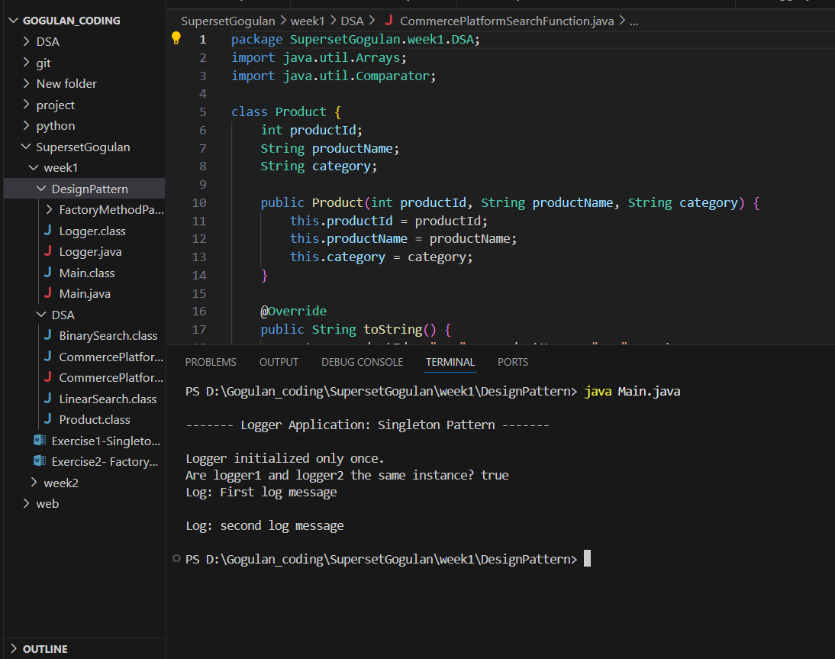

**Exercise 2: Implementing the Factory Method Pattern**

//Product

public interface Document {

    void create();

}

public class PdfDocument implements Document {

    public void create() {

        System.out.println("Creating PDF Document.");

    }

}

public class ExcelDocument implements Document {

    public void create(){

        System.out.println("Creating Excel Document.");

    }

}

public class WordDocument implements Document {

    public void create() {

        System.out.println("creating Word Document.");

    }

}

//Creator(Factory Method)

public abstract class DocumentFactory {

    public abstract Document createDocument();

}

public class PdfDocumentFactory extends DocumentFactory {

    public Document createDocument() {

        return new PdfDocument();

    }

}

public class WordDocumentFactory extends DocumentFactory{

    public Document createDocument(){

        return new ExcelDocument();

    }

}

public class ExcelDocumentFactory extends DocumentFactory {

    public Document createDocument() {

        return new ExcelDocument();

    }

}

//Main class

public class Main {

    public static void main(String[] args) {

        System.out.println("-----------------");

        DocumentFactory wordFactory = new WordDocumentFactory();

        Document word = wordFactory.createDocument();

        word.create();

        DocumentFactory pdfFactory = new PdfDocumentFactory();

        Document pdf = pdfFactory.createDocument();

        pdf.create();

        DocumentFactory excelFactory = new ExcelDocumentFactory();

        Document excel = excelFactory.createDocument();

        excel.create();

        System.out.println("-----------------");

    }

}

**OUTPUT:**