**Exercise 1: Control Structures**

--CUSTOMERS TABLE

CREATE TABLE customers (

customer_id NUMBER PRIMARY KEY,

name VARCHAR2(50),

age NUMBER,

interest_rate NUMBER(5,2),

balance NUMBER(10,2),

isvip VARCHAR2(5)

);

--LOANS TABLE

CREATE TABLE loans (

loan_id NUMBER PRIMARY KEY,

customer_id NUMBER,

due_date DATE,

FOREIGN KEY (customer_id) REFERENCES customers(customer_id)

);

--Customers DATA

INSERT INTO customers VALUES (1, 'Gogulan', 65, 7.5, 15000, 'FALSE');

INSERT INTO customers VALUES (2, 'Arun', 58, 8.0, 9500, 'FALSE');

INSERT INTO customers VALUES (3, 'Sneha', 62, 9.0, 12000, 'FALSE');

INSERT INTO customers VALUES (4, 'Priya', 45, 8.5, 11000, 'FALSE');

INSERT INTO customers VALUES (5, 'Rahul', 70, 7.2, 8000, 'FALSE');

INSERT INTO customers VALUES (6, 'Deepa', 35, 8.8, 10500, 'FALSE');

INSERT INTO customers VALUES (7, 'Vikram', 61, 9.2, 13000, 'FALSE');

INSERT INTO customers VALUES (8, 'Kavya', 29, 8.6, 5000, 'FALSE');

INSERT INTO customers VALUES (9, 'Anil', 75, 6.9, 14000, 'FALSE');

INSERT INTO customers VALUES (10, 'Meena', 50, 7.8, 9100, 'FALSE');

select * from customers;

--Loans data

INSERT INTO loans VALUES (101, 1, SYSDATE + 10);

INSERT INTO loans VALUES (102, 2, SYSDATE + 45);

INSERT INTO loans VALUES (103, 3, SYSDATE + 5);

INSERT INTO loans VALUES (104, 4, SYSDATE + 25);

INSERT INTO loans VALUES (105, 5, SYSDATE + 15);

INSERT INTO loans VALUES (106, 6, SYSDATE + 31);

INSERT INTO loans VALUES (107, 7, SYSDATE + 7);

INSERT INTO loans VALUES (108, 8, SYSDATE + 60);

INSERT INTO loans VALUES (109, 9, SYSDATE + 20);

INSERT INTO loans VALUES (110, 10, SYSDATE + 2);

select * from loans;

commit;

SET SERVEROUTPUT ON;

**Scenario 1:**

DECLARE

  v_discounted_rate NUMBER(5,2);

BEGIN

  FOR cust IN (

    SELECT customer_id, name, age, interest_rate FROM customers

  ) LOOP

    IF cust.age > 60 THEN

      v_discounted_rate := cust.interest_rate - (cust.interest_rate * 0.01);

      UPDATE customers

      SET interest_rate = v_discounted_rate

      WHERE customer_id = cust.customer_id;

      DBMS_OUTPUT.PUT_LINE('Discount applied to ' || cust.name ||

                           ' (Age: ' || cust.age ||

                           ', New Interest Rate: ' || v_discounted_rate || '%)');

    END IF;

  END LOOP;

  COMMIT;

END;

/

**OUTPUT:**

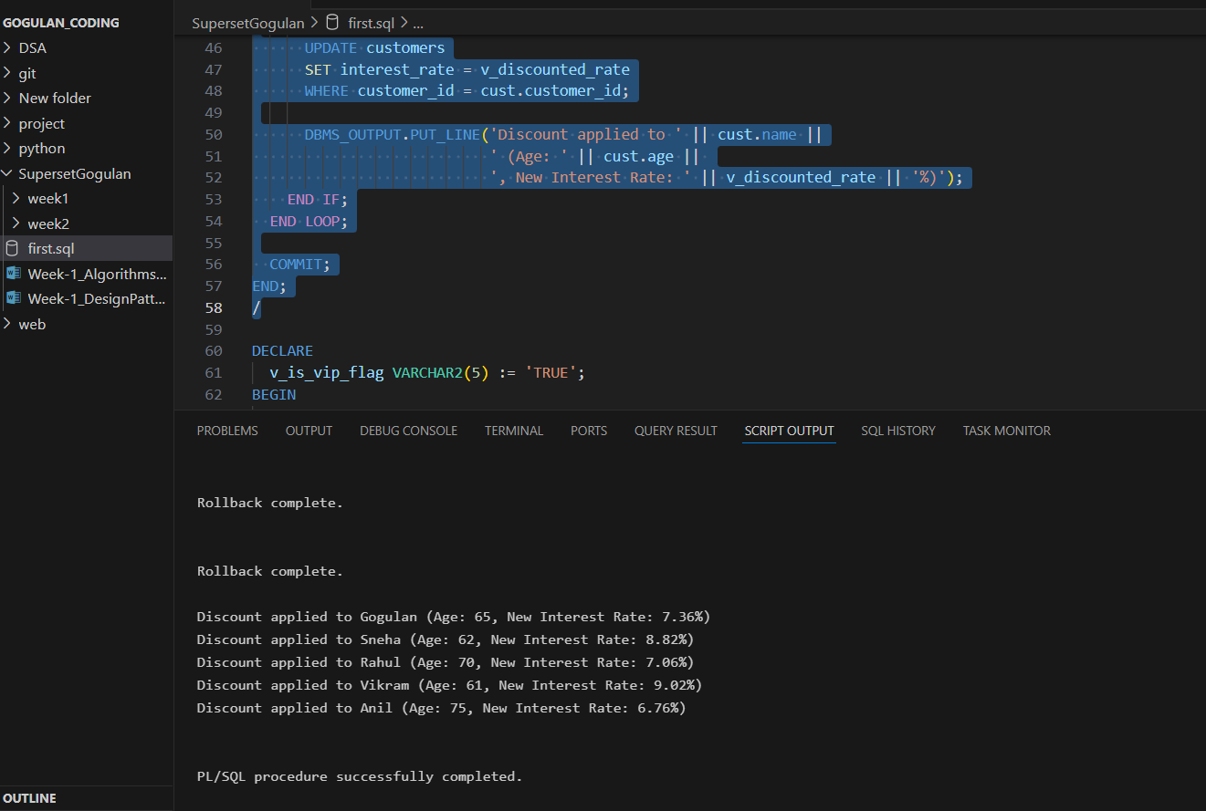

**Scenario 2**

DECLARE

  v_is_vip_flag VARCHAR2(5) := 'TRUE';

BEGIN

  FOR cust IN (

    SELECT customer_id, name, balance FROM customers

  ) LOOP

    IF cust.balance > 10000 THEN

      UPDATE customers

      SET isvip = v_is_vip_flag

      WHERE customer_id = cust.customer_id;

      DBMS_OUTPUT.PUT_LINE('Customer ' || cust.name ||

                           ' promoted to VIP (Balance: $' || cust.balance || ')');

    END IF;

  END LOOP;

  COMMIT;

END;

/

**OUTPUT:**

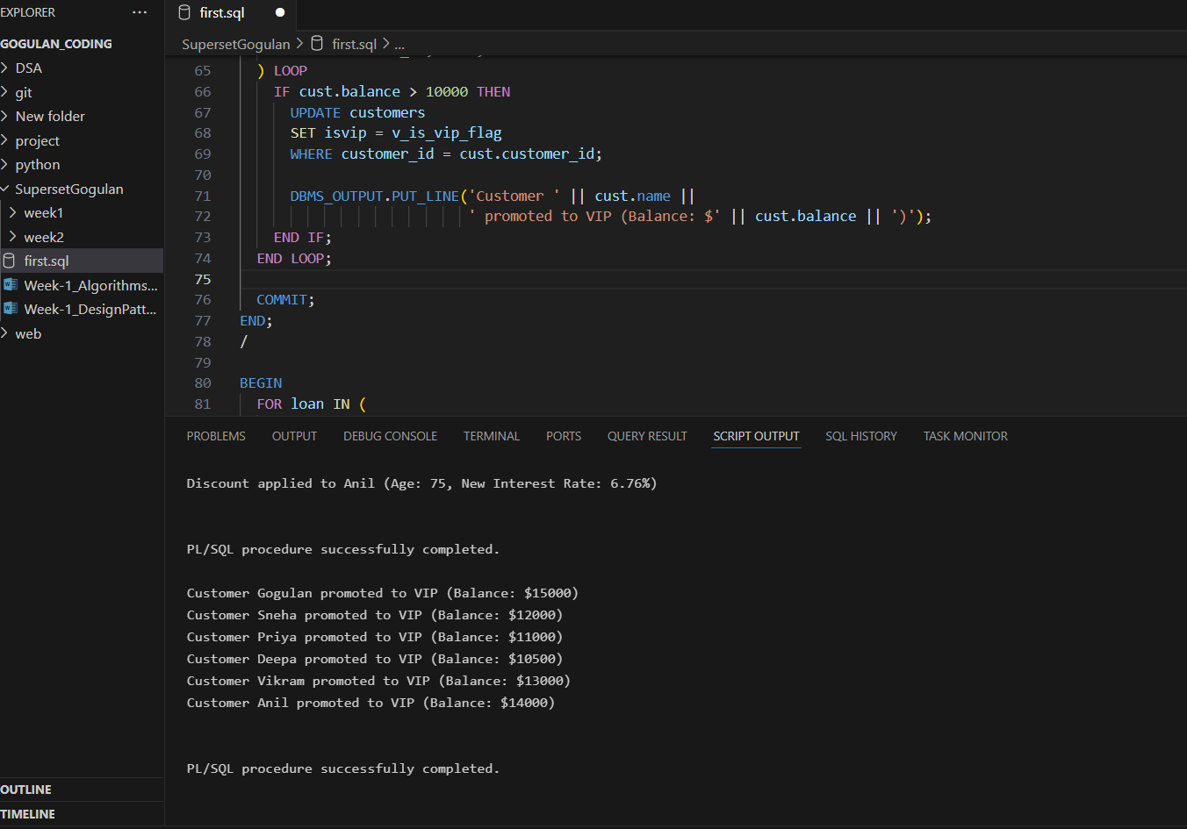

**Scenario 3**

BEGIN

  FOR loan IN (

    SELECT loan_id, customer_id, due_date FROM loans

    WHERE due_date <= SYSDATE + 30

  ) LOOP

    DBMS_OUTPUT.PUT_LINE('Reminder: Loan #' || loan.loan_id ||

                         ' for Customer ID ' || loan.customer_id ||

                         ' is due on ' || TO_CHAR(loan.due_date, 'DD-Mon-YYYY'));

  END LOOP;

END;

/

**OUTPUT:**

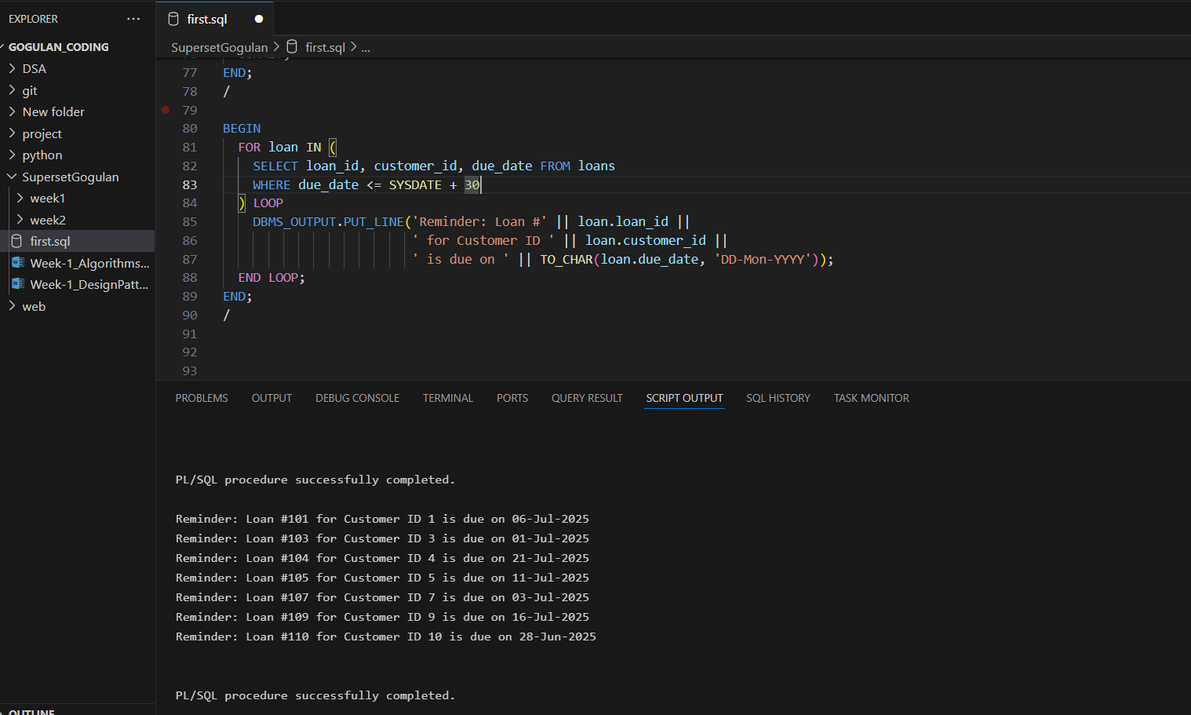

**Exercise 3: Stored Procedures**

-- Savings Accounts Table

CREATE TABLE savings_accounts (

  account_id NUMBER PRIMARY KEY,

  customer_id NUMBER,

  balance NUMBER(12,2)

);

-- Employees Table

CREATE TABLE employees (

  emp_id NUMBER PRIMARY KEY,

  name VARCHAR2(50),

  department_id NUMBER,

  salary NUMBER(10,2)

);

-- General Accounts Table (used in TransferFunds)

CREATE TABLE accounts (

  account_id NUMBER PRIMARY KEY,

  customer_id NUMBER,

  balance NUMBER(12,2)

);

-- Insert into savings_accounts

INSERT INTO savings_accounts VALUES (101, 1, 5000);

INSERT INTO savings_accounts VALUES (102, 2, 8000);

INSERT INTO savings_accounts VALUES (103, 3, 12000);

-- Insert into employees

INSERT INTO employees VALUES (1, 'Gogulan', 201, 30000);

INSERT INTO employees VALUES (2, 'Arun', 202, 25000);

INSERT INTO employees VALUES (3, 'Sneha', 201, 28000);

-- Insert into accounts

INSERT INTO accounts VALUES (1001, 1, 15000);

INSERT INTO accounts VALUES (1002, 2, 10000);

INSERT INTO accounts VALUES (1003, 3, 5000);

COMMIT;

**Scenario 1:**

SET SERVEROUTPUT ON;

CREATE OR REPLACE PROCEDURE ProcessMonthlyInterest AS

  v_interest NUMBER(10,2);

BEGIN

  FOR acc IN (SELECT account_id, balance FROM savings_accounts) LOOP

    v_interest := acc.balance * 0.01;

    UPDATE savings_accounts

    SET balance = balance + v_interest

    WHERE account_id = acc.account_id;

    DBMS_OUTPUT.PUT_LINE('Interest ₹' || v_interest || ' applied to Account ID: ' || acc.account_id);

  END LOOP;

  COMMIT;

END;

/

BEGIN

  ProcessMonthlyInterest;

END;

/

**OUTPUT:**

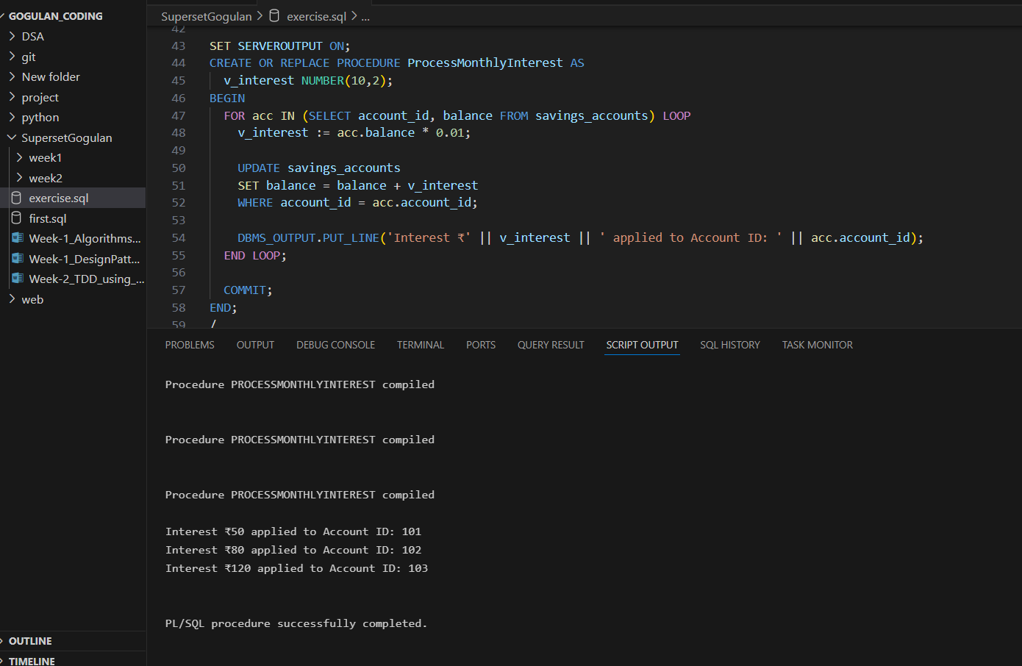

**Scenario 2:**

CREATE OR REPLACE PROCEDURE UpdateEmployeeBonus (

  p_dept_id IN NUMBER,

  p_bonus_pct IN NUMBER

) AS

  v_bonus_amt NUMBER(10,2);

BEGIN

  FOR emp IN (

    SELECT emp_id, name, salary FROM employees WHERE department_id = p_dept_id

  ) LOOP

    v_bonus_amt := emp.salary * (p_bonus_pct / 100);

    UPDATE employees

    SET salary = salary + v_bonus_amt

    WHERE emp_id = emp.emp_id;

    DBMS_OUTPUT.PUT_LINE('Bonus ₹' || v_bonus_amt || ' added to ' || emp.name);

  END LOOP;

  COMMIT;

END;

/

BEGIN

  UpdateEmployeeBonus(201, 10);

END;

/

**OUTPUT:**

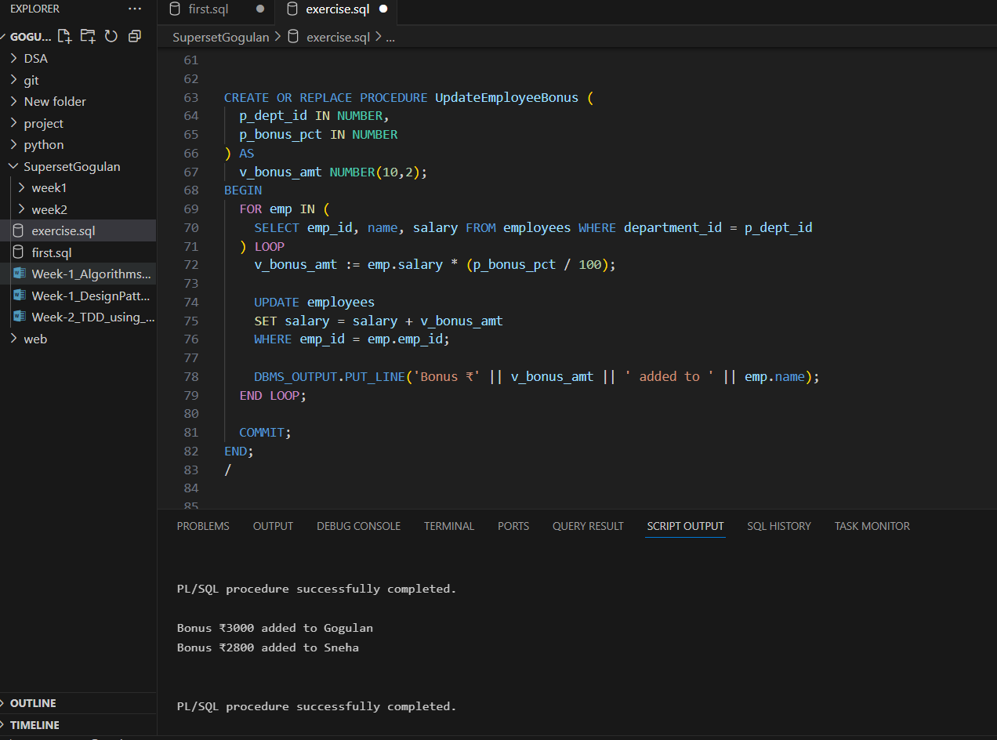

**Scenario 3:**

CREATE OR REPLACE PROCEDURE TransferFunds (

  p_from_acc IN NUMBER,

  p_to_acc IN NUMBER,

  p_amount IN NUMBER

) AS

  v_from_balance NUMBER(12,2);

BEGIN

  SELECT balance INTO v_from_balance FROM accounts WHERE account_id = p_from_acc;

  IF v_from_balance < p_amount THEN

    DBMS_OUTPUT.PUT_LINE('Transfer Failed: Insufficient balance in Account ' || p_from_acc);

  ELSE

    UPDATE accounts

    SET balance = balance - p_amount

    WHERE account_id = p_from_acc;

    UPDATE accounts

    SET balance = balance + p_amount

    WHERE account_id = p_to_acc;

    DBMS_OUTPUT.PUT_LINE('₹' || p_amount || ' transferred from Account ' || p_from_acc ||

                         ' to Account ' || p_to_acc);

    COMMIT;

  END IF;

END;

/

BEGIN

  TransferFunds(1001, 1003, 2000);

END;

/

**OUTPUT:**

