**Software Engineering**

**Assignment # 4**

**Humza Khatri (K132104)**

**Sarim Mumtaz (K132364)**

**Taha Alvi (K132050)**

**Jaffer Raza (K132272)**

**Abubakr Sarvar (K132212)**

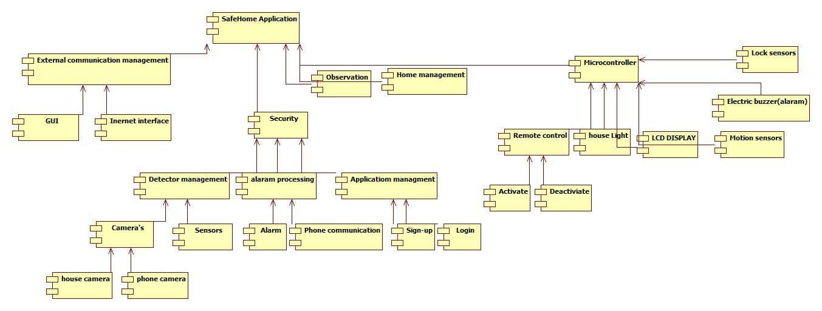

|  |  |
| --- | --- |
| **Gui** | |
| **Responsibility** | **Class** |
| View camera feed | Camera |
| Switch appliances | appliances |
| Monitor lock status | Lock sensors |

|  |  |
| --- | --- |
| **Online interface** | |
| **Responsibility** | **Collaborator** |
| View camera feed | Camera |
| Switch appliances | Appliance |
| Monitor lock status | Lock sensor |

|  |  |
| --- | --- |
| **Appliance** | |
| **Responsibility** | **Collaborator** |
| Switch state | Gui/online interface |
| Status | Gui/online interface |

|  |  |
| --- | --- |
| **Alarm** | |
| **Responsibility** | **Collaborator** |
| Alert for intrusion | Gui/Online interface |
| Alert for locks | Gui/Online interface |

|  |  |
| --- | --- |
| **camera** | |
| **Responsibility** | **Collaborator** |
| Detect motion | Gui/Online interface |

|  |  |
| --- | --- |
| **Lock Sensor** | |
| **Responsibility** | **Collaborator** |
| Check status | Gui/Online interface |

|  |  |
| --- | --- |
| **Motion sensor** | |
| **Responsibility** | **Collaborator** |
| Check status | Gui/Online interface |

|  |  |
| --- | --- |
| **Door** | |
| **Responsibility** | **Collaborator** |
| Check status | Gui/Online interface |
| Lock | Gui/online interface |