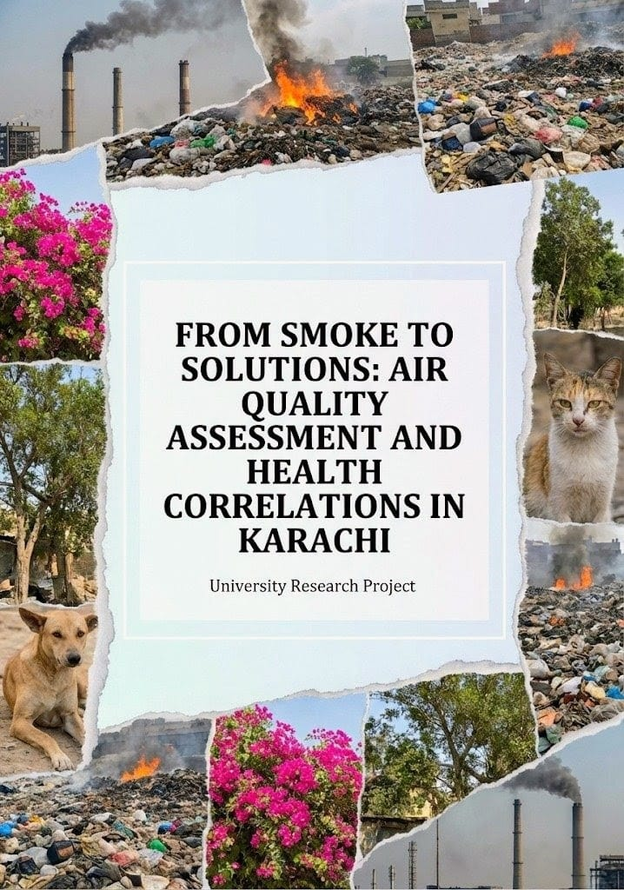

COURSE TITLE: ENVIRONMENTAL STUDIES AND SUSTAINABILITY
(Lab and Theory)

INSTRUCTOR NAME: MS MARYAM ZEHRA

GROUP MEMBERS:
- Gohar Hanif (72615)
- Ayesha Farooq (72259)
- Noor us Saba Kamran (69566)
- Alisha Farooqi (69714)

1. INTRODUCTION: 5
1.1 Science and Domain of Work: 5
1.2 Nature of the Work: 5
1.3 Significance of the Project: 6
1.4 Type of research: 6
1.4.1 Primary Data; 6
1.4.2 Secondary Data; 6
2. STUDY AREA: 6
2.1 Historical Background 7
2.2 Economic Status 7
2.3 Environmental Condition 7
2.4 Biodiversity and Natural Environment: 9
2.5 Industrial development 10
2.6 Present Situation and Future Outlook 10
3. OBJECTIVES: 11
4. IDENTIFY THE PROBLEM: 11
5. METHODOLOGY: 12
5.1 Research Design 12
5.2 Primary Data Collection: 12
5.3 Secondary Data Collection 14
5.4 Use of Mobile Applications 14
5.5 Use of Software: 15
5.6 Study Area Selection 17
5.7 Sampling Strategy 17
5.8 Data Validation 17
5.9 HIRARCHIECAL CHART: 18
6. RESULTS AND DISCUSSIONS: 18
6.1 SECTION 1: Awareness and Perception of Air Pollution: 18
6.2 Section 3: Health Impacts of Air Pollution 24
6.2.1 FLORA AND FAUNA OBSERVED: 26
7. CONCLUSION: 30
8. COMPARATIVE ANALYSIS: 30
9. TEMPORAL ANALYSIS 2010-2025: 32
9.1 Administrative and Governance Changes (2000–2015) 32
9.2 Urban and Industrial Expansion (1980s–Present) 33
9.3 Environmental Degradation (Past vs Present) 34
9.3.1 Past Conditions 34
9.3.2 Present Conditions (2000–2020) 35
10. CONCLUSION: 35
11. SUSTAINABLE DEVELOPMENT AND ADAPTATION MEASURES (SDG-WISE) 36
12. Learning from International Best Practices: The London (UK) Model 38
12.1.1 Traffic and Air Pollution Control Measures 38
12.1.2 Promotion of Public Transport and Green Mobility 38
12.1.3 Waste Management and Environmental Governance 38
12.1.4 Monitoring, Public Awareness, and Data Transparency 39
12.1.5 Relevance to Korangi and Karachi 39
13. PREDICTIONS BASED ON STUDY FINDINGS: 40
14. References: 42
1- Google. (n.d.). Google Earth Pro (Version 7.3) [Computer software]. https://www.google.com/earth/versions/#earth-pro. 42
2- Indus Hospital and Health Network. (n.d.). Lung health program and respiratory disease data. 42

For this study on ‘Air Quality Assessment and Health Correlations in Karachi,’ the Korangi area has been selected as the focus. Korangi, located in the eastern part of Karachi, is a densely populated area with a mix of residential and industrial zones.

INTRODUCTION:
Air pollution has become one of the major environmental challenges of the 21st century. It occurs when harmful substances such as gases, particles, and chemicals enter the air, making it unsafe for humans, animals, and the environment. Urban areas, especially industrial regions, are often the most affected because of rapid industrialization, vehicle emissions, and other human activities. In this research project, we focus on Korangi, a densely populated area in Karachi, Pakistan, which is both a residential and industrial hub. The combination of heavy industries and large residential neighbourhoods makes Korangi an important area to study air pollution and its impacts on daily life.

Science and Domain of Work:
This project falls under the environmental science domain, which studies how natural and human-made factors affect the environment. The research explores air quality, sources of pollution, and the health and social impacts on people living and working in Korangi. The nature of this work is applied research, as it involves collecting real data from the field to understand a current environmental problem. The project involves field surveys and questionnaires that will be conducted in both residential areas and industrial zones of Korangi to record the level of air pollution and its effects on the community.

Nature of the Work:
The work mainly involves two activities:
Field Survey;
visiting selected locations in Korangi to observe pollution sources such as factories, vehicles, and other industrial activities.
Questionnaire Distribution;
collecting responses from residents and workers regarding their exposure to air pollution, health problems, and perceptions of air quality in their area.
By combining observations with survey responses, the research aims to provide a clear picture of how air pollution affects people in both residential and industrial settings.

Significance of the Project:
Understanding air pollution in Korangi is important for several reasons:
Health Awareness: Air pollution can cause respiratory problems, allergies, and other chronic diseases. Recording these issues helps raise awareness among residents and workers.
Policy and Action: Data collected through this project can inform local authorities and policymakers about areas with high pollution levels, helping them take corrective measures.
Community Education: Educating people about pollution sources and preventive measures can reduce health risks and improve quality of life.
Environmental Impact: Studying air pollution helps understand its effect on the environment, such as the deterioration of air quality, harm to plants and animals, and contribution to climate change.

Type of research:

Primary Data;
This is collected directly from the field through questionnaires and surveys in Korangi’s residential and industrial areas. Residents and workers will provide information about air pollution levels, health issues, and their observations of pollution sources. This helps in gathering first-hand, original data specific to this study.

Secondary Data;
This includes existing information from books, articles, government reports, and previous studies about air pollution in Karachi and industrial areas. It provides background knowledge, comparisons, and context for the primary data collected.

STUDY AREA:
Korangi Industrial and Residential Zones (Karachi, Pakistan)

Historical Background
Korangi is in the eastern part of Karachi and is named after the Korangi area. According to the 2023 census, about 1.36 million people live there.
In 2000, the government changed the local government system. The old “division” system was removed and replaced with districts. In Karachi, the five districts were merged into one big Karachi City-District, which had 18 towns, including Korangi Town.
In 2011, this town system was stopped, but it was still used for some administrative work until 2015. In 2015, Korangi Town became part of Karachi East District, and later it became part of the newly created Korangi District

Economic Status
Korangi is home to one of the largest industrial zones in Pakistan, with more than 4,000 factories producing textiles, leather goods, pharmaceuticals, food, and engineering products.
The Korangi Crossing area serves as a transport hub, allowing the movement of raw materials and finished goods between factories and Karachi Port.
Despite its industrial importance, the surrounding residential areas (Korangi, Qayyumabad, and Zia Colony) are mostly lower- to middle-income communities, facing issues like poor housing, traffic congestion, and limited public services.
Economic inequality is noticeable while industries contribute millions to Karachi’s economy, nearby residents often struggle with low wages and pollution.

Environmental Condition
The area faces serious environmental challenges due to industrial waste, untreated sewage, and air pollution. Many factories discharge chemical effluents directly into Malir River or drainage channels passing near Korangi Crossing, leading to water contamination. Air quality is poor because of heavy traffic, diesel emissions, and smoke from factories. Flooding during monsoon seasons is also common, especially when the Korangi Causeway gets s submerged due to poor drainage.
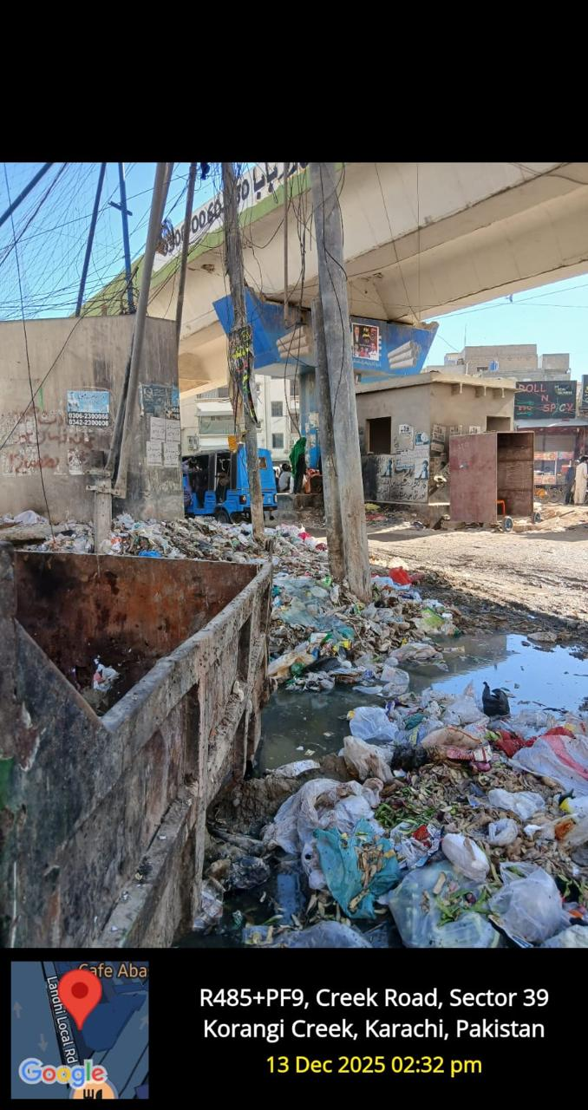
Figure:(i) residential area of korangi
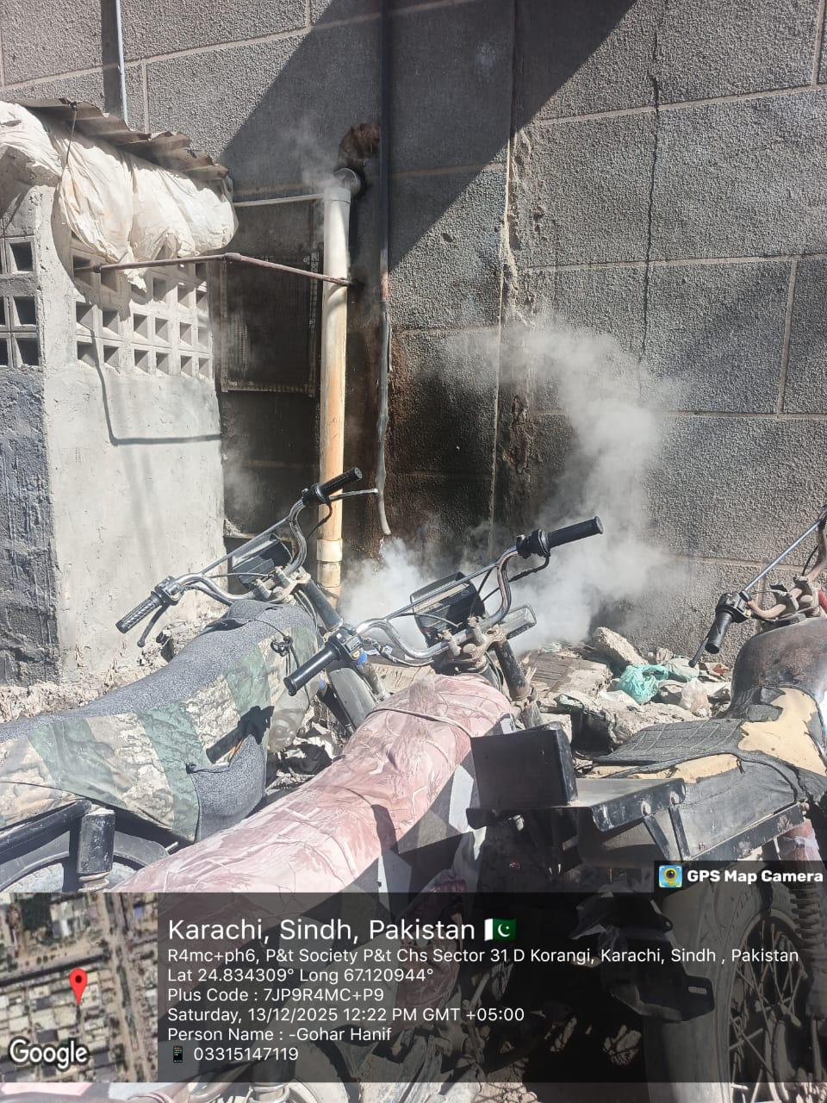
Figure:(ii) Industrial area due to pollution

Biodiversity and Natural Environment:
Historically, the Malir River and surrounding mangrove areas near Korangi Creek supported rich biodiversity, including fish, crabs, migratory birds, and mangroves.
However, due to urban expansion and pollution, much of the natural biodiversity has declined.
Mangrove forests, which once acted as natural barriers against erosion and provided habitats for marine life, have been cut down or polluted by oil and waste.
Some environmental organizations are now working to restore mangroves and promote sustainable waste management in nearby coastal areas.

Industrial development
Korangi Industrial Area (KIA): The area grew into one of Pakistan’s largest industrial zones, with many major pharmaceutical companies and other businesses locating there.

Present Situation and Future Outlook
Korangi Crossing remains economically vital but environmentally stressed.
There are government and NGO efforts to improve wastewater treatment and clean the Malir River.
If managed properly, the area could balance industrial growth with environmental protection, benefiting both the economy and biodiversity of Karachi.

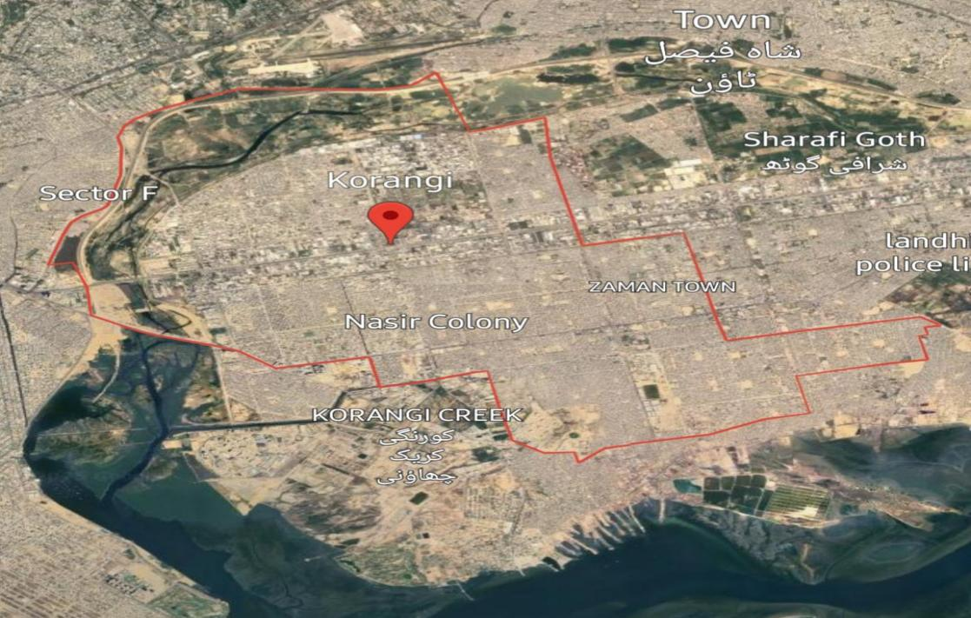
Figure:(iii) Satellite map of Korangi
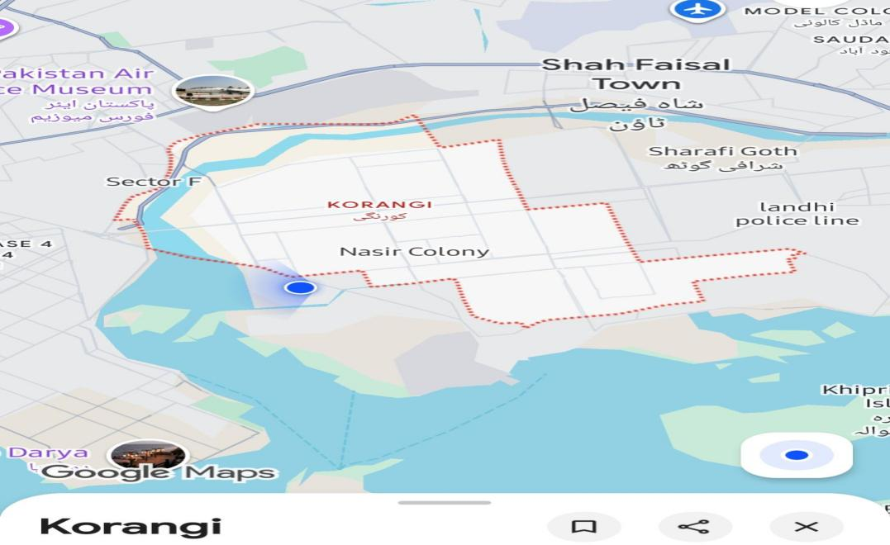
Figure:(iv) Google map of Korangi

OBJECTIVES:
- To measure air pollution levels (PM2.5, PM10, NO₂, SO₂, CO, O₃) in different areas of Karachi.
- To study how population density affects exposure to air pollution.
- To assess the health effects of air pollution by analyzing hospital and respiratory case data.
- To compare air quality in residential and industrial areas to find the most polluted zones.
- To suggest practical solutions and policies for reducing air pollution and protecting public health.

IDENTIFY THE PROBLEM:
Air pollution in Karachi has reached hazardous levels, causing respiratory, cardiovascular, and ocular diseases.
- Environmental Problems
- Diseases
- Biodiversity
Key statistical indicator includes,
INDICATORS | VALUE  STATISTIC | SOURCE
Population | 20.3 million | Pakistan Bureau of Statistics
AQI (Average) | 180 (Unhealthy) | IQAir
PM2.5 | 97 µg/m³ | WHO, IQAir
Vehicular Contribution | 55% of total emissions | Sindh EPA
Industrial Emissions | 30% SEPA | Annual Report
Waste Burning Contribution | 10–15% | WWF Pakistan
Green Area | <3% of total city area | Urban Forestry Dept.
Table:(i) statistical indicators

METHODOLOGY:
This study on “Air Quality Assessment and Health Correlations in Karachi (Korangi Area)” is based on a mixed‑method research approach, in which both primary data and secondary data were used. The methodology has been revised to clearly explain data sources, tools, apps, software, and techniques in a simple and systematic manner.

Research Design
A mixed method research design was adopted.
- Quantitative method was used to collect numerical data through questionnaires and observations.
- Qualitative method was used to understand people’s perceptions, experiences, and health issues through interviews and field notes.
This approach helped in understanding both environmental conditions and their impact on human health in the Korangi area.

Primary Data Collection:
Primary data refers to the data that is collected directly by the researcher for the first time for a specific research purpose.
Methods of Primary Data Collection;
Primary data in this study was collected through:
1. Questionnaire Survey
2. Interviews
3. Field Observation
4. Geotagged Photography

A. Questionnaire
Definition:
A questionnaire is a research tool consisting of a set of structured questions used to collect information from respondents in a systematic way.
In this research: Questionnaires were used to collect data about ;
- Awareness of air pollution
- Health problems (asthma, allergies, breathing issues)
- Living conditions near industrial areas.
Questionnaires were filled by residents, workers, and shopkeepers of Korangi.
B. Interview
Definition:
An interview is a direct verbal interaction between the researcher and the respondent to obtain detailed information, opinions, and experiences.
In this study:
- Informal interviews were conducted with:
- Factory workers
- Local residents
- Shopkeepers and labourers
Interviews helped in understanding real‑life health issues and pollution exposure.
C. Field Observation
Direct field visits were conducted to observe:
- Industrial smoke and emissions
- Vehicle pollution
- Open waste burning
- Sewage and polluted water drains
- Residential proximity to factories
Observations were recorded with notes and photographs.

Secondary Data Collection
Secondary data refers to information that has already been collected, published, or recorded by other sources and is used for research purposes.
Sources of Secondary Data;
- Secondary data for this research was collected through:
- Google Search
- Published reports and articles
Online platforms such as:
- Google.
- Wikipedia.
- Research articles.
- Government and environmental reports.
This data was used to support primary findings and provide background information on air pollution and health impacts.

Use of Mobile Applications
A. Weather Application:
Definition:
A weather app provides real‑time information about temperature, humidity, wind speed, and air conditions.
Usage in research:
- Weather conditions during field visits were noted
- Helped relate pollution levels with weather conditions
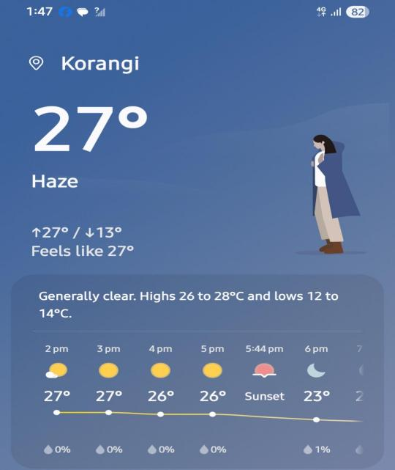
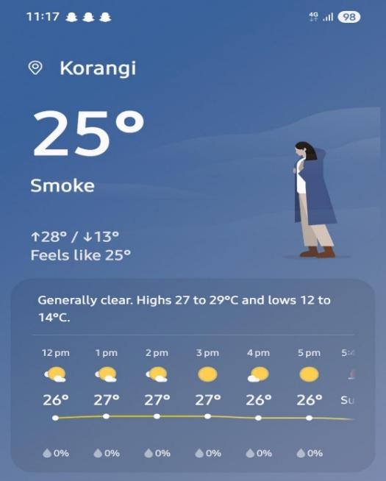
Figure:(v) Weather image during survey
B. Geo‑Tag Camera Application
Definition:
A Geo Tag Camera app captures photographs with automatically embedded location (GPS), date, and time.
Usage in research:
- Field photographs were taken using the geo‑tag camera.
- Exact location and time of pollution sources were recorded.
- Ensured authenticity and accuracy

Figure:(vi) google tagged app used for data collection and analysis

Use of Software:
A. Google Earth Pro
Definition:
Google Earth Pro is a geospatial software that provides satellite images and historical data of different locations.
Usage in research:
- Analysis of historical satellite images of Korangi
- Comparison of past and present land use changes
- Identification of industrial expansion and loss of greenery

Figure:(vii) google earth software used for data collection and analysis

B. Microsoft Word (MS Word)
Definition:
Microsoft Word is a word‑processing software used for writing, editing, and formatting documents.
Usage in research:
- Preparation of questionnaire
- Writing and formatting the research report
- Organizing tables, figures, and references

Figure:(viii) Microsoft word used for analysis

C. Google Forms

Definition:
Google Forms is an online survey tool used to create digital questionnaires and collect responses electronically.

Usage in research:

- The questionnaire was designed using Google Forms.
- Responses were collected online from participants.
- It helped in saving time, reducing paper use, and organizing data automatically.
- Collected responses were easily reviewed and analysed.

Study Area Selection
Korangi was selected due to:
- Presence of major industrial zones.
- Dense residential population
- High exposure to air and environmental pollution
Survey areas included:
- Korangi Industrial Area (KIA)
- Residential sectors (Korangi Crossing)

Sampling Strategy
A stratified sampling technique was used.
Participants included:
- Factory workers and labourers
- Residents
- Shopkeepers and informal workers (drivers, vendors)
- This ensured representation from different socio‑economic groups.

Data Validation
- Primary data was cross‑checked with secondary sources
- Geo‑tagged images and satellite data supported field observations
- This improved reliability and accuracy of the research findings.

HIRARCHIECAL CHART:
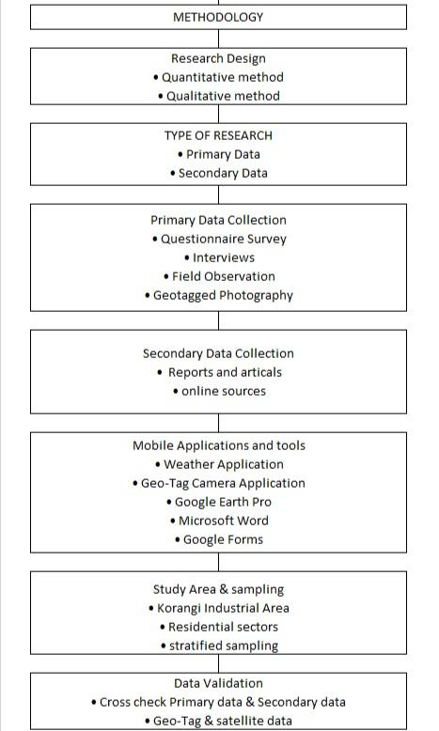
Chart:(i) hierarchical chart

RESULTS AND DISCUSSIONS:

SECTION 1: Awareness and Perception of Air Pollution:
- According to the survey results, respondents from residential areas show a very high level of awareness regarding environmental issues. Most participants are familiar with problems such as air pollution, climate change, and waste management.
Seriousness of Air Pollution:
- Most respondents (77.3%) rated air pollution as “Very Serious.”
- Some respondents considered it “A Little Serious” or “Serious,” while only a very small number reported it as “Not Serious.”
Presence of Air Pollution:
- Most respondents believe that air pollution exists in their residential areas.
Main Causes of Air Pollution (Residential):
- Burning of garbage (36.8%)
- Dust from construction activities (31.6%)
- Vehicle smoke (15.8%)
- Factory smoke (15.8%)
This data indicates that garbage burning and construction activities are the major contributors to air pollution in residential areas.
Actions to Reduce Pollution:
- Most respondents reported that they sometimes or often take actions to reduce pollution, such as planting trees, reducing plastic use, and using public transport.
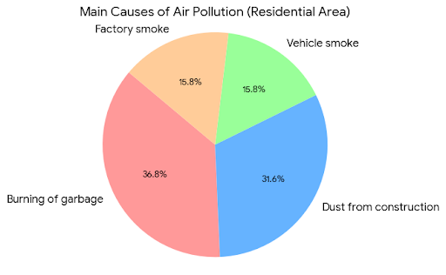
Graph:(ii) Causes of Air Pollution Residential Area
The pie chart identifies the primary sources of air pollution in residential areas:
​Garbage Burning (36.8\%): The largest contributor.
​Construction Dust (31.6\%): The second major cause.
​Vehicle and Factory Smoke (15.8\% each): These contribute equally to the remaining pollution.

- Respondents from industrial areas also demonstrate awareness of environmental issues; however, in some cases, the level of awareness is slightly lower than that of residential areas.
Seriousness of Air Pollution:
- 66.7% of respondents rated air pollution as “Serious.”
- 33.3% considered it “Very Serious.”
This indicates that air pollution is a major environmental concern in industrial areas.
Main Causes of Air Pollution (Industrial):
- Factory smoke
- Vehicle smoke
The findings show that emissions from factories and vehicles are the primary contributors to air pollution in industrial areas.
Actions to Reduce Pollution:
- Some respondents reported making little or no effort to reduce pollution, which reflects limited awareness, lack of facilities, or reduced public participation.
Industrial Conclusion:
- Air pollution is present at a serious level
- Factory and vehicle emissions are the main sources
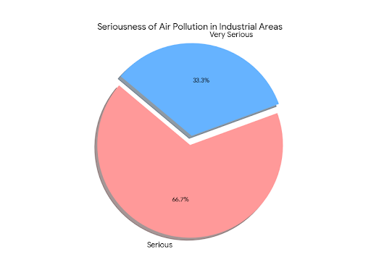
- Public participation in pollution control is lower compared to residential areas.

Graph:(ii) Main Causes of Air Pollution Industrial Area
The chart shows how people living or working in industrial (factory) areas feel about the air they breathe.
​The Big Slice (66.7\%): About two out of every three people say that air pollution is a “Serious” problem. This is the majority of the group.
​The Smaller Slice (33.3\%): The remaining one out of every three people feel the situation is even worse, calling it “Very Serious.”

Comparative Analysis of Air Pollution Causes:
Residential vs Industrial Areas
Air pollution exists in both residential and industrial areas; however, the causes and intensity differ due to differences in human activities, land use, and infrastructure.
Causes of Air Pollution in Residential Areas;
In residential areas, air pollution is mainly caused by daily household and local activities.
The major reasons include:
- Burning of garbage, which releases harmful smoke and toxic gases
- Dust from construction activities, such as building and road work
- Vehicle smoke from cars, motorcycles, and public transport
- Nearby factory smoke, affecting residential zones located close to industrial sites
These causes show that poor waste management, rapid urban construction, and traffic congestion are the main contributors to air pollution in residential areas. Since people live very close to these sources, the impact is felt more strongly, which is why residents consider air pollution a very serious issue.

Causes of Air pollution in Industrial Areas;
In industrial areas, air pollution is mostly linked to industrial and transport-related activities.
The key causes are:
- Factory smoke, produced by industrial processes and fuel burning
- Vehicle smoke, especially from heavy vehicles, trucks, and transport used for industrial operations
Industrial emissions are continuous and large in scale, but people working or living there may be more accustomed to them. This could be a reason why most respondents rated pollution as serious rather than very serious.
Section 2: Biodiversity Loss:
The findings of this study demonstrate that biodiversity loss has occurred in both residential and industrial areas, confirming that environmental degradation is not confined to a single type of urban setting. Respondents from both areas reported a decline in birds, animals, and insects, indicating a widespread reduction in local biodiversity.
In residential areas, biodiversity loss was more strongly perceived and frequently reported. A large number of respondents stated that their surroundings previously supported a richer presence of birds and animals. The primary factors identified for this decline include deforestation, rapid urban construction, air pollution, and climate change. Furthermore, most respondents expressed concern that biodiversity is currently under serious threat, reflecting a relatively high level of environmental awareness among residents.
In industrial areas, respondents also acknowledged that biodiversity loss has taken place. Although the number of respondents reporting this loss was comparatively lower, this does not imply the absence of biodiversity decline. Instead, it suggests reduced awareness, limited observation, or normalization of environmental degradation due to continuous exposure to industrial pollution. The dominant causes identified in these areas include vehicle emissions, industrial activities, air pollution, and construction-related disturbances.
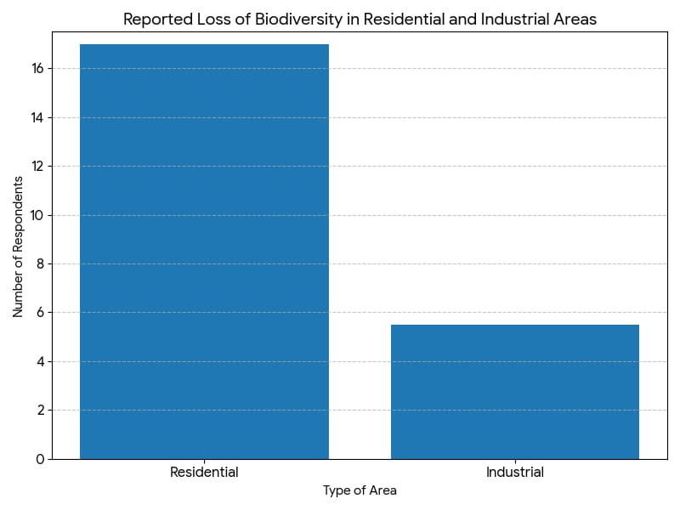

Graph:(iii) Reported Loss of Biodiversity in Residential and Industrial Areas

- This graph clearly illustrates the number of respondents reporting biodiversity loss was higher in Residential areas compared to Industrial areas.
Overall, the results clearly indicate that both residential and industrial areas are affected by biodiversity loss. The difference between the two lies primarily in the level of perception and awareness, rather than in the actual existence of the problem.
Comparative Conclusion:
“The study confirms that biodiversity loss is evident in both residential and industrial areas. While residential respondents demonstrate higher awareness and perception of this decline, industrial areas are equally affected, highlighting biodiversity loss as a shared and pervasive environmental challenge.”

Section 3: Health Impacts of Air Pollution
This section analyzes the health effects of air pollution using primary survey data collected at Indus Hospital and secondary data from the Indus Hospital and Health Network (IHHN).
Primary Survey Findings (Indus Hospital):
The survey results show that respondents from both residential and industrial areas experience several health problems linked to air pollution. The most commonly reported issues include cold and flu, cough and asthma, headache, migraine, and fever.
Among these, asthma and other respiratory problems were the most frequent, especially among individuals exposed to polluted air for long periods. Most respondents believed that air pollution is directly responsible for these health issues and that long-term exposure can lead to chronic diseases.

Secondary Research Evidence (IHHN):
Secondary data from IHHN strongly supports the survey findings. According to hospital records and expert reports:
- Around 60% of pulmonology patients suffer from asthma, largely due to air pollution
- Air pollution is a major trigger of asthma in urban areas like Karachi
- COPD and respiratory tract infections increase significantly during smog seasons
- Rising cases of interstitial lung diseases and lung cancer are linked to prolonged exposure to polluted air
- PM2.5 particles increase the risk of cardiovascular diseases
Health experts describe air pollution as a preventable but deadly health threat, especially for children and the elderly.
Hospital Response and Awareness:
The Indus Hospital and Health Network address this issue through its Lung Health Program, public awareness campaigns, and continuous research on pollution-related diseases, further confirming the strong link between air pollution and poor health outcomes.
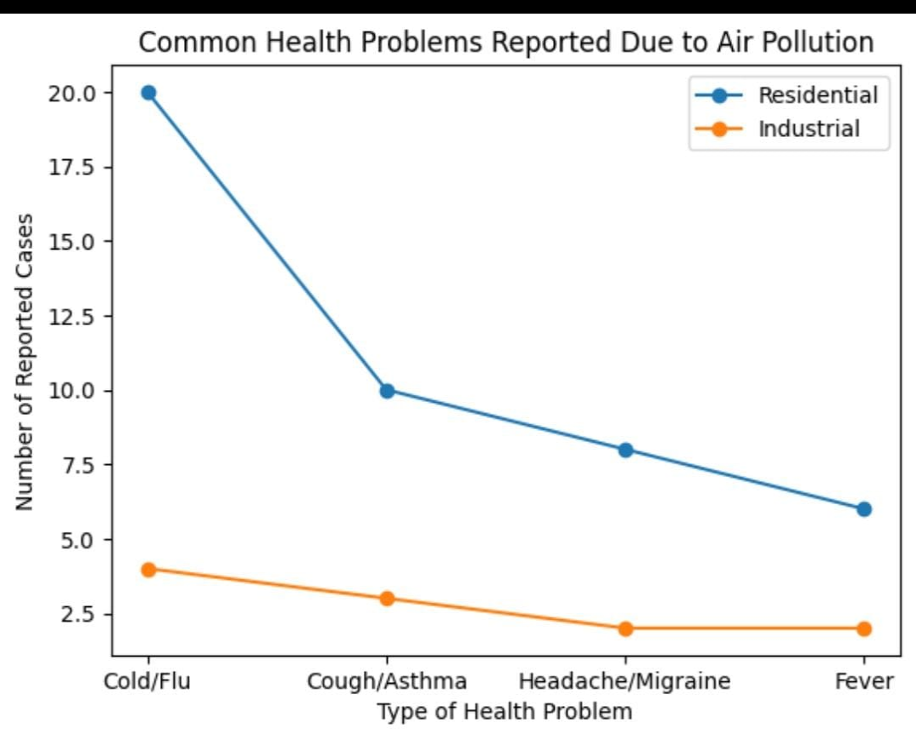

Graph:(iv) Common Health Problems Reported Due to Air Pollution
This line graph compares the number of health problems reported due to air pollution in residential and industrial areas.
- The x-axis shows the type of health problems (Cold/Flu, Cough/Asthma, Headache/Migraine, Fever).
- The y-axis represents the number of reported cases.
The figure clearly shows that respiratory-related illnesses, especially cold/flu and cough/asthma, are the most common health impacts of air pollution in both areas. However, the higher number of cases in residential areas suggests that residents may be more exposed to pollution sources or spend more time in polluted environments.
This trend supports hospital data and confirms a strong link between air pollution and adverse health effects.

FLORA AND FAUNA OBSERVED:
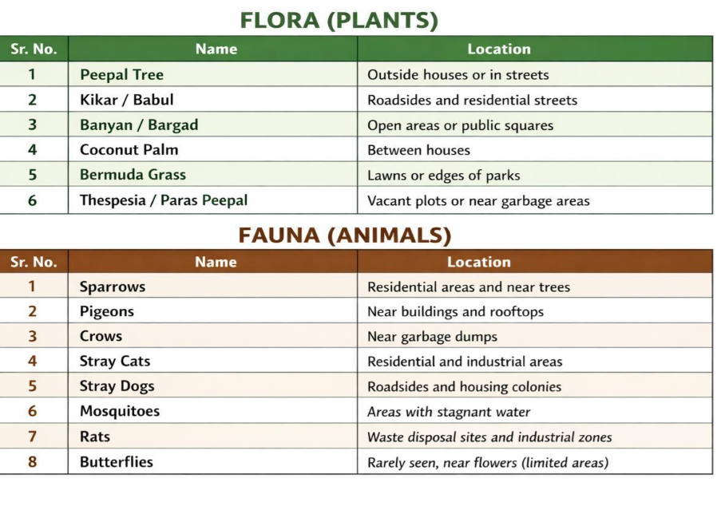Table:(ii) FLORAA FAUNA OBSERVED IN RESIDENTIAL AND INDUSTRIAL
The table shows the common flora (plants) and fauna (animals) found in residential and nearby areas. It is divided into two main sections for easy understanding.
The flora section includes plants such as Peepal tree, Kikar/Babul, Banyan, Coconut Palm, Bermuda grass, and Paras Peepal. These plants are mostly found along roadsides, outside houses, in open areas, parks, and vacant plots. They play an important role in providing shade, improving air quality, and maintaining environmental balance.
The fauna section lists animals and insects like sparrows, pigeons, crows, stray cats, stray dogs, mosquitoes, rats, and butterflies. These animals are commonly seen in residential areas, near buildings, garbage sites, stagnant water, and industrial zones. Some species, like butterflies, are rarely seen due to limited green spaces.
Overall, the table highlights the relationship between living organisms and their surroundings and shows how human activities and urban environments influence the presence of plants and animals.
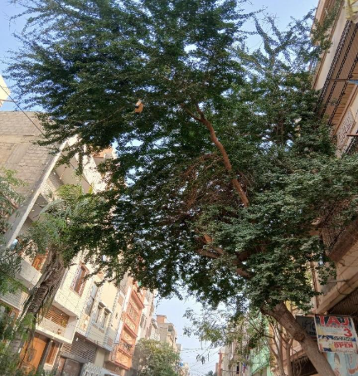
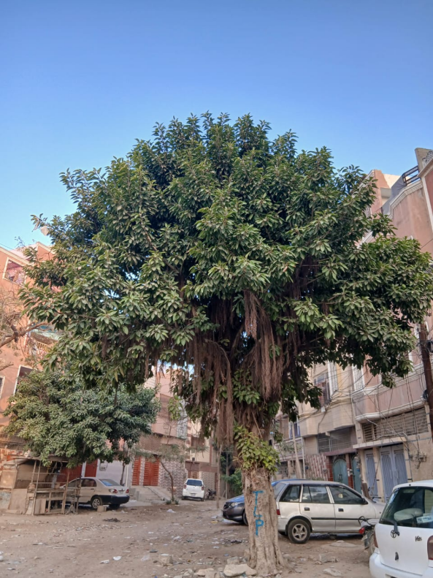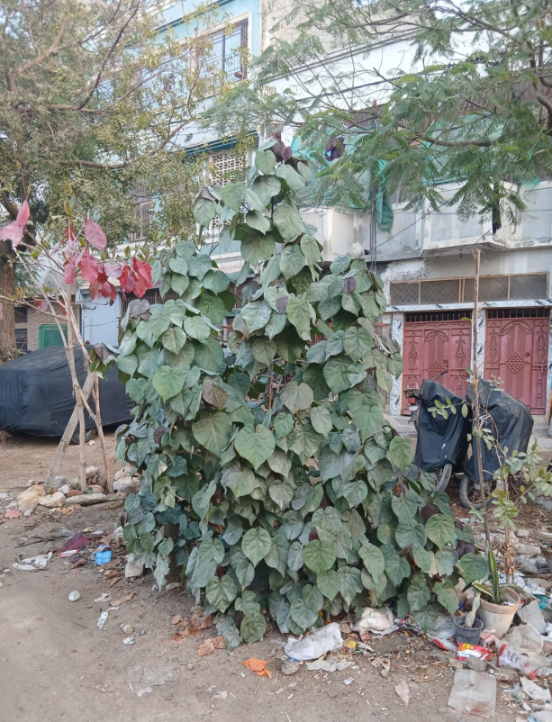
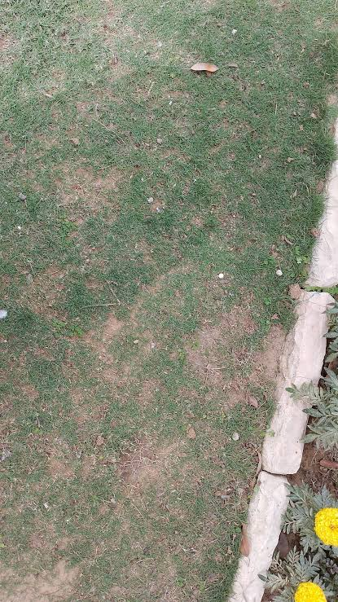

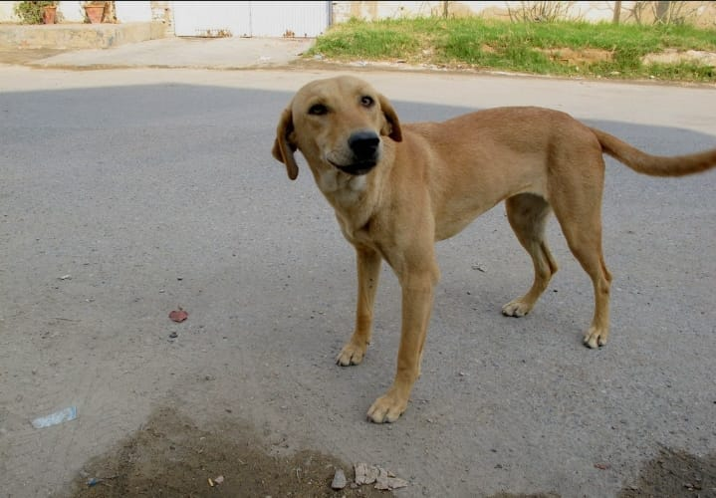


Figure: (ix-xix) FLORA AND FAUNA

CONCLUSION:
This study on “Air Quality Assessment and Health Correlations in Karachi (Korangi Area)” clearly demonstrates that air pollution is a serious and growing environmental and public health problem in the Korangi residential and industrial zones. The findings from field observations, questionnaires, interviews, and secondary sources reveal that industrial emissions, heavy vehicular traffic, open waste burning, and poor urban planning are the main contributors to degraded air quality in the area.
The research shows a clear contrast between residential and industrial zones, with industrial areas experiencing higher levels of pollution due to factory smoke and diesel exhaust, while residential areas are heavily affected by traffic emissions, construction dust, and garbage burning. These pollution sources have a direct impact on the daily lives of residents and workers, resulting in widespread health problems such as asthma, breathing difficulties, eye irritation, allergies, and headaches. Survey data from healthcare facilities, including Indus Hospital, further supports the link between poor air quality and respiratory diseases.
In addition to health impacts, air pollution in Korangi has also contributed to environmental degradation, loss of biodiversity, and reduced quality of life. The proximity of residential areas to industrial zones, combined with weak enforcement of environmental regulations, has increased exposure risks, especially for low-income communities.
Overall, the study highlights the urgent need for effective air quality management, stronger policy implementation, community awareness, and sustainable urban planning. If appropriate measures are taken, Korangi has the potential to balance industrial growth with environmental protection and public health improvement.

COMPARATIVE ANALYSIS:
This report has already initiated a comparison between residential and industrial areas, but it can be further refined:
Comparison of Pollution Causes: In residential areas, the major sources of pollution are garbage burning (36.8%) and construction dust (31.6%). In contrast, in industrial areas, the primary sources are factory smoke and emissions from heavy traffic such as trucks and tankers.
Difference in Awareness and Perception: In residential areas, 77.3% of people perceive pollution as "very serious." In industrial areas, people consider it "serious," but awareness is lower compared to residential areas, possibly because residents there have become accustomed to these conditions.
Health Impacts: Respiratory illnesses, including asthma, are common in both areas. However, the number of reported cases is higher in residential areas, which may be due to greater awareness among residents or their closer exposure to pollution sources.
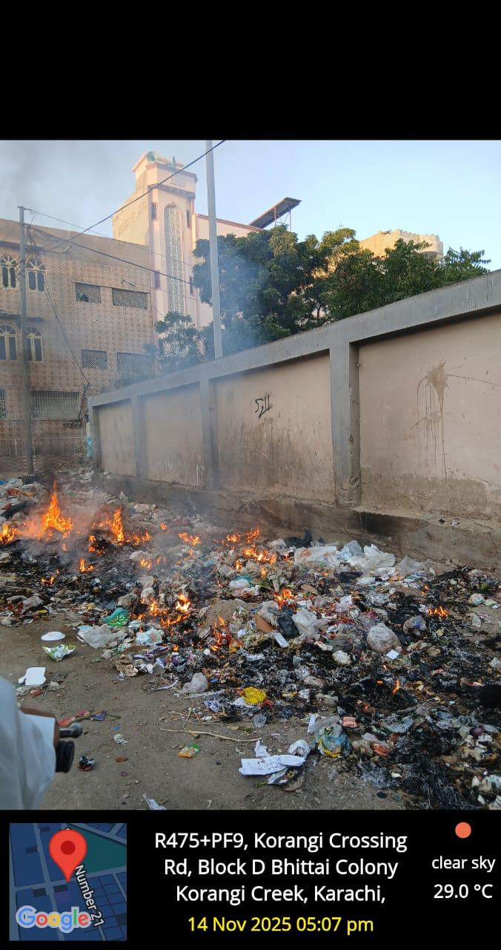
Figure:(xx) Air Pollution Caused by Garbage Burning in Residential Areas of Korangi
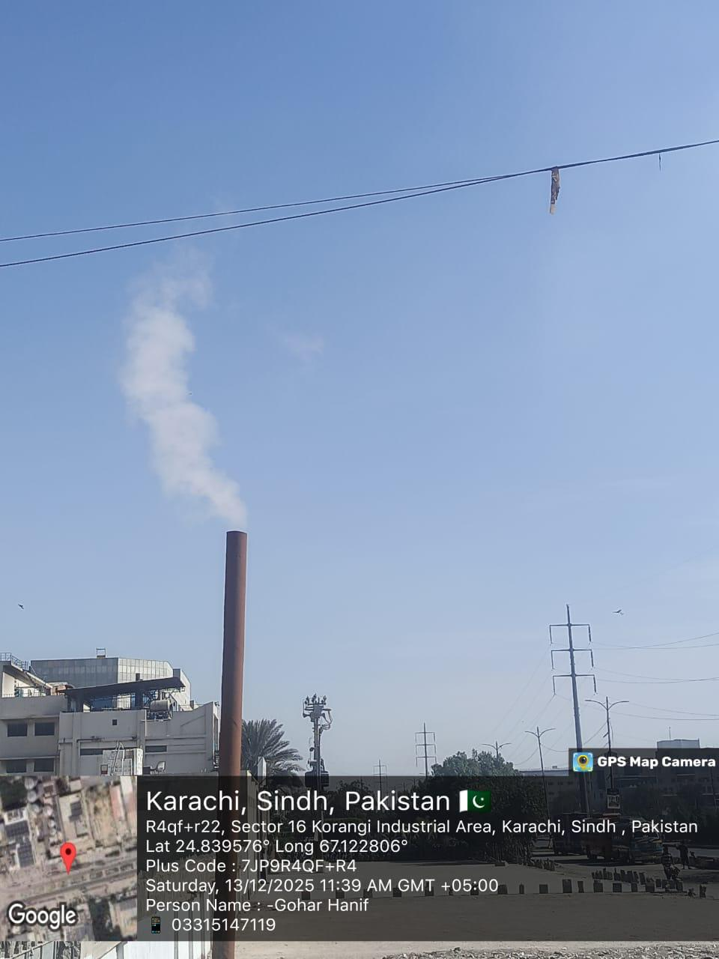
Figure:(xxi) Air pollution caused by factory smoke in industrial areas in Korangi.

TEMPORAL ANALYSIS 2010-2025:

Administrative and Governance Changes (2000–2015)
In the year 2000, Pakistan introduced a new local government system. The old division system was abolished and replaced with districts.
Karachi was declared a City-District, where its five districts were merged into one large administrative unit called Karachi City-District. This system included 18 towns, and Korangi Town was one of them.
In 2011, the town system was officially abolished. However, it continued to be used for some administrative purposes until 2015. After this period, Korangi Town was first made part of Karachi East District and later upgraded to an independent Korangi District.
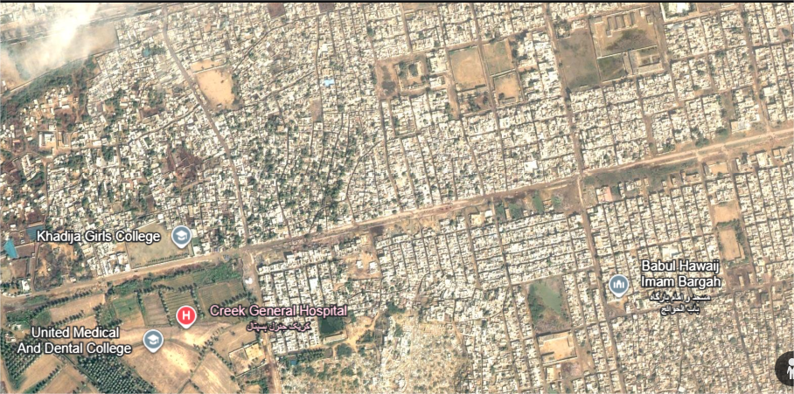
Figure: (xxii) Korangi in 2001 shows open spaces with low-density residential areas and greenery.
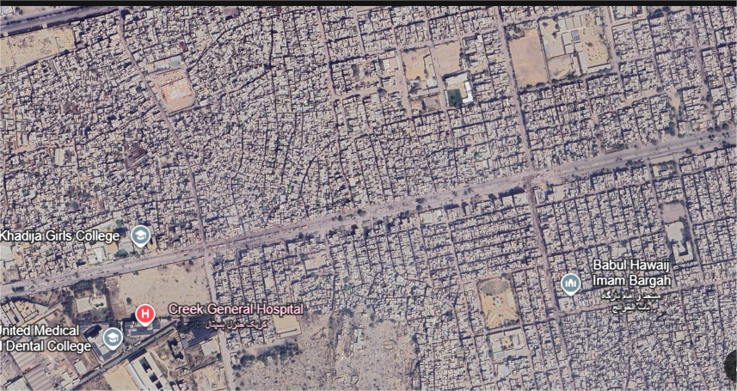
Figure: (xxiii) By 2025, Korangi’s open spaces have largely transformed into dense residential settlements.

Urban and Industrial Expansion (1980s–Present)
Korangi was originally developed during the 1950s and 1960s. By the 1980s and 1990s, it had grown into a dense mix of industrial, commercial, and residential areas.
After the year 2000, population growth continued rapidly. This led to the expansion of unplanned settlements due to the lack of proper urban planning.
As the population increased, infrastructure such as roads and drainage systems failed to keep pace. This resulted in serious issues like traffic congestion, poor sanitation, and environmental pollution.
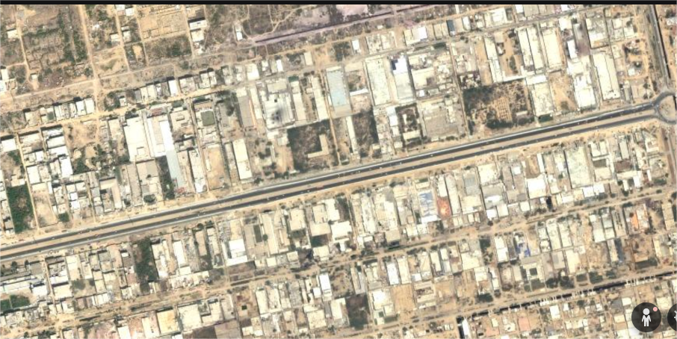 Figure: (xxiii) industrial area in 2001
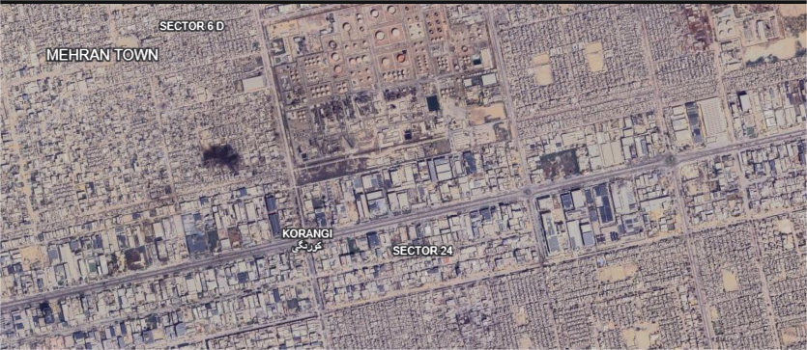Figure: (xxiv) Expansion of industrial footprint and increased logistic activity (2025)

Environmental Degradation (Past vs Present)

Past Conditions
In earlier decades, Korangi had clean air, more green spaces, and healthier ecosystems. Areas like Malir River and Korangi Creek supported mangroves, birds, and aquatic life due to relatively clean water.

Present Conditions (2000–2020)
With rapid industrial growth and urban expansion, much of the natural environment has been destroyed.
- Air Quality: Smoke from factories and vehicle emissions has made Korangi one of the most polluted areas in Karachi.
- Loss of Biodiversity: Mangroves and wetlands have been cut down or polluted with industrial waste, leading to a decline in fish and bird populations.
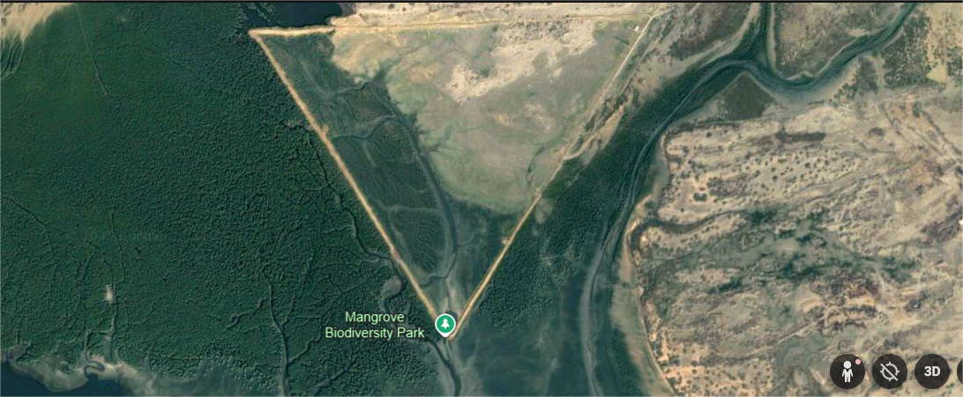Figure: (xxv) In 2001 mangroves and wetlands were relatively healthy, supporting diverse fish and bird populations.
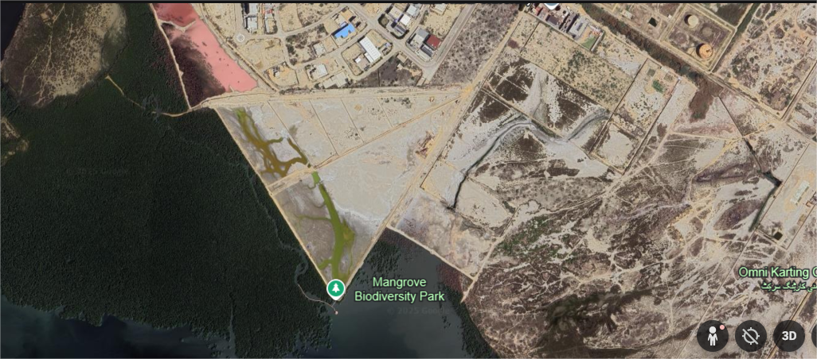
Figure: (xxvi) By 2025, mangroves and wetlands have been degraded by industrial pollution, causing a decline in fish and bird populations

CONCLUSION:
This study on “Air Quality Assessment and Health Correlations in Karachi (Korangi Area)” clearly demonstrates that air pollution is a serious and growing environmental and public health problem in the Korangi residential and industrial zones. The findings from field observations, questionnaires, interviews, and secondary sources reveal that industrial emissions, heavy vehicular traffic, open waste burning, and poor urban planning are the main contributors to degraded air quality in the area.
The research shows a clear contrast between residential and industrial zones, with industrial areas experiencing higher levels of pollution due to factory smoke and diesel exhaust, while residential areas are heavily affected by traffic emissions, construction dust, and garbage burning. These pollution sources have a direct impact on the daily lives of residents and workers, resulting in widespread health problems such as asthma, breathing difficulties, eye irritation, allergies, and headaches. Survey data from healthcare facilities, including Indus Hospital, further supports the link between poor air quality and respiratory diseases.
In addition to health impacts, air pollution in Korangi has also contributed to environmental degradation, loss of biodiversity, and reduced quality of life. The proximity of residential areas to industrial zones, combined with weak enforcement of environmental regulations, has increased exposure risks, especially for low-income communities.

Overall, the study highlights the urgent need for effective air quality management, stronger policy implementation, community awareness, and sustainable urban planning. If appropriate measures are taken, Korangi has the potential to balance industrial growth with environmental protection and public health improvement.

SUSTAINABLE DEVELOPMENT AND ADAPTATION MEASURES (SDG-WISE)
This section outlines sustainable solutions and adaptation strategies to address air pollution in Korangi, aligned with SDGs.

SDG 3 – Good Health and Well-Being
- Establish local health screening camps
- Provide protective masks to workers and traffic-exposed individuals
- Improve healthcare access in low-income areas
- Conduct awareness programs on pollution-related diseases

SDG 11 – Sustainable Cities and Communities
- Develop green belts between industrial and residential zones
- Improve traffic flow and road management
- Increase tree plantation along roads and neighborhoods
- Include environmental planning in future urban development

SDG 12 – Responsible Consumption and Production
- Install air filtration systems, scrubbers, and emission-control chimneys
- Promote cleaner production and energy-efficient machinery
- Enforce strict penalties on industries violating environmental laws
- Encourage recycling and waste reduction practices

SDG 13 – Climate Action
- Promote public transport, carpooling, walking, and cycling
- Replace old diesel vehicles with low-emission vehicles
- Make vehicle emission testing compulsory
- Reduce industrial greenhouse gas emissions

SDG 15 – Life on Land
- Launch large-scale tree plantation drives
- Protect and restore mangroves and wetlands
- Prevent deforestation near industrial zones

SDG 6 – Clean Water and Sanitation
- Treat industrial and domestic wastewater
- Stop waste dumping into drains and water bodies
- Implement proper solid waste management systems

Learning from International Best Practices: The London (UK) Model
An international example relevant to Karachi’s air pollution and traffic challenges is London, United Kingdom. London faced severe air pollution due to traffic congestion, diesel vehicles, and dense urban activity conditions similar to those observed in Karachi’s industrial and residential zones such as Korangi.

Traffic and Air Pollution Control Measures
To tackle vehicular pollution, London introduced the Congestion Charging Zone (CCZ) in 2003, followed by the Ultra Low Emission Zone (ULEZ). Under this system, vehicles that do not meet emission standards are charged a daily fee to enter central areas. According to reports by the UK Department for Environment, Food & Rural Affairs (DEFRA), this policy significantly reduced nitrogen dioxide (NO₂) levels and particulate matter (PM2.5) in high-traffic zones.
This approach is highly relevant to Korangi, where heavy vehicles and industrial transport contribute heavily to air pollution. A similar restricted vehicle zone during peak hours around Korangi Crossing and industrial roads could reduce emissions and traffic congestion.

Promotion of Public Transport and Green Mobility
London invested heavily in public transport, including electric buses, underground trains, and cycling infrastructure. The city expanded dedicated bicycle lanes, pedestrian-friendly streets, and encouraged walking for short distances. As a result, reliance on private vehicles decreased, contributing to improved air quality and reduced noise pollution.
For Karachi, especially Korangi, promoting bus rapid transit (BRT), safe cycling tracks, and pedestrian pathways can help reduce dependence on private and diesel-powered vehicles, lowering pollution exposure for residents.

Waste Management and Environmental Governance
London follows a strict waste segregation and recycling system, where waste is separated into recyclable, organic, and landfill categories. Local councils monitor waste collection, and heavy penalties are imposed for illegal dumping or open burning of waste. Waste-to-energy plants are also used to reduce landfill pressure.
This system directly relates to Korangi, where open waste burning is a major source of air pollution. Implementing segregated waste bins, regular collection, and strict enforcement against burning could significantly improve local air quality.

Monitoring, Public Awareness, and Data Transparency
London has an advanced air quality monitoring network, with real-time data available to the public through mobile apps and digital displays. This transparency increases public awareness and encourages behavior change, such as avoiding polluted areas during peak hours.
Similarly, installing air quality monitoring stations in Korangi and making data publicly available would help residents understand pollution levels and pressure authorities to take corrective actions.

Relevance to Korangi and Karachi
London’s model demonstrates that strong policies, public participation, and strict enforcement can successfully reduce urban pollution. While Karachi differs economically, adapting low-cost versions of these strategies such as restricted traffic zones, public transport promotion, and waste control can lead to measurable improvements in air quality and public health.
Comparative Insight
Aspect |  | Korangi (Karachi)
  London (UK)
Major Pollution Source | Traffic emissions | Industry + traffic
Key Strategy | ULEZ & Congestion Charge | Limited monitoring
Waste Management | Strict segregation & recycling | Open dumping & burning
Monitoring | Real-time AQ data | Limited monitoring
Table: (iii) Comparative Insight

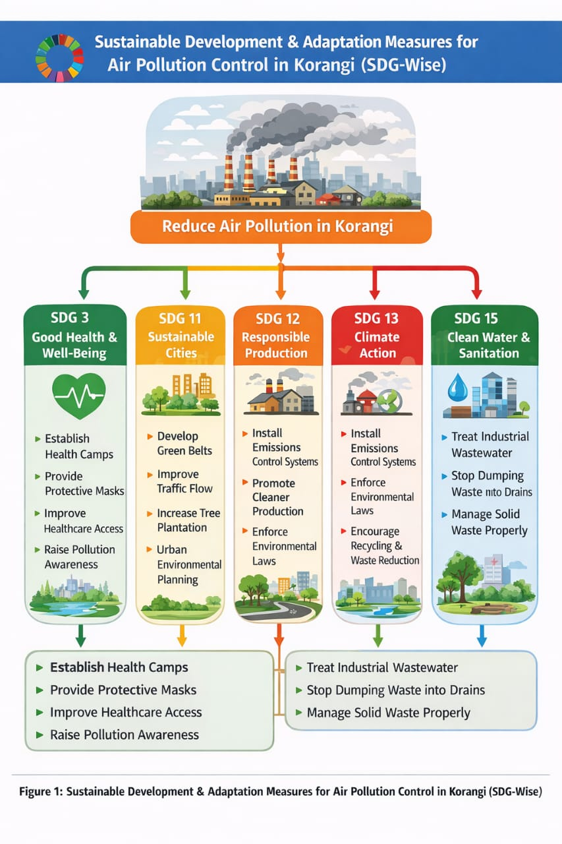

Figure: (xxvii) sustainable development & adaptation measures for air pollution controle in Korangi (SDG-Wise)

PREDICTIONS BASED ON STUDY FINDINGS:
Based on current air quality conditions, industrial activities, and traffic patterns in the Korangi area, several serious environmental and health impacts are expected in the future if pollution levels remain uncontrolled.
Health-Related Predictions:
If air pollution continues at the present rate, respiratory diseases such as asthma, bronchitis, coughing, allergies, and shortness of breath will significantly increase among residents. Children, elderly people, factory workers, and traffic police are expected to be the most affected groups.
Long-term exposure to polluted air may also lead to heart diseases, reduced lung capacity, and weakened immunity, resulting in increased hospital visits and medical expenses. Overall quality of life in Korangi is likely to decline due to poor health conditions.
Environmental Predictions:
Uncontrolled industrial emissions and vehicle exhaust will continue to deteriorate air quality, making Korangi one of the most polluted areas of Karachi. Residential areas located near factories will remain highly exposed to smoke, dust, and toxic gases.
Green cover is expected to decrease further due to pollution stress and lack of proper plantation, resulting in higher temperatures, heat stress, and reduced natural air filtration. Nearby ecosystems, including mangroves and vegetation, may continue to degrade, affecting biodiversity and natural balance.
Urban Living Conditions Predictions:
Increasing traffic congestion and industrial expansion will make Korangi less liveable. Noise pollution, poor visibility due to smog, and unpleasant odors will become more common. Without proper urban planning, the area may face overcrowding, unhealthy housing conditions, and environmental discomfort.
Water and Soil Pollution Predictions:
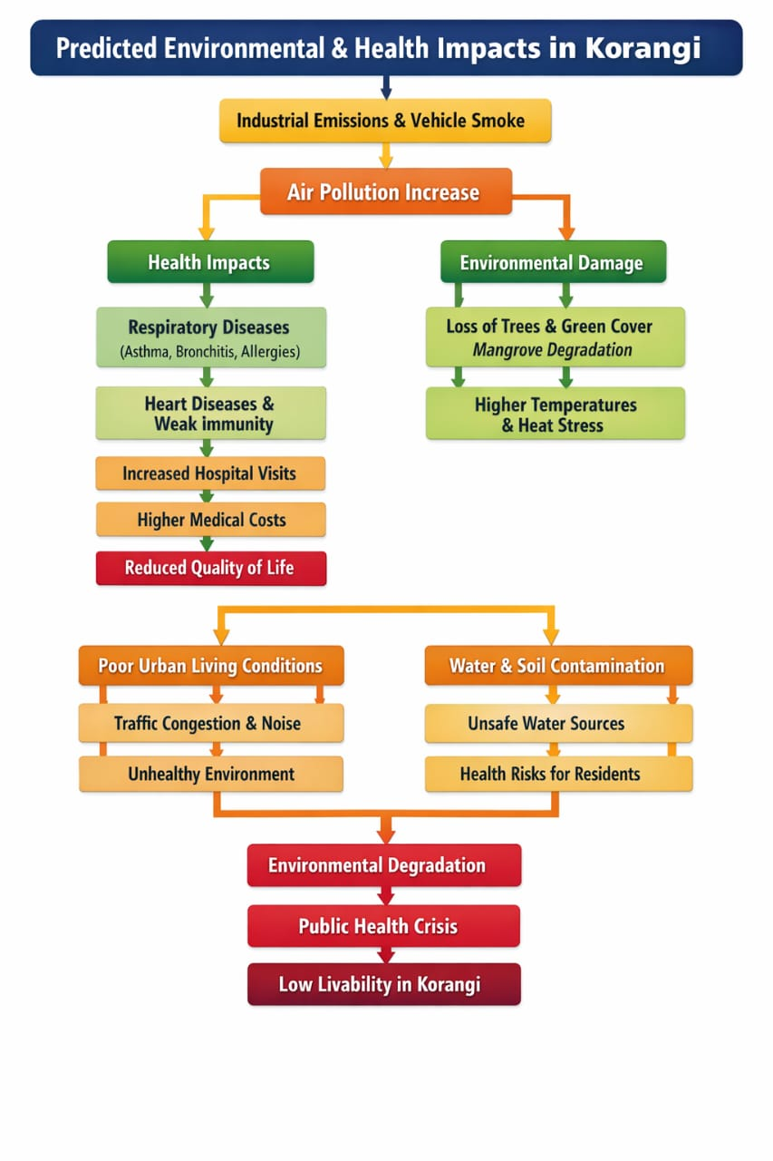
Industrial waste dumping and untreated effluents are expected to further contaminate nearby water bodies and soil. This may result in unsafe water sources, damage to aquatic life, and indirect health risks for communities relying on these resources.

Figure: (xxviii) predicted environment & health impacts in Korangi

References:

Google. (n.d.). Google Earth Pro (Version 7.3) [Computer software]. https://www.google.com/earth/versions/#earth-pro.

Indus Hospital and Health Network. (n.d.). Lung health program and respiratory disease data.
- IQAir. (n.d.). World air quality report: Karachi air quality index (AQI). https://www.iqair.com/.
- Microsoft. (n.d.). Microsoft Word [Computer software].
- Pakistan Bureau of Statistics. (2023). 6th population and housing census 2023.
- Sindh Environmental Protection Agency (SEPA). (n.d.). Annual report on industrial emissions and vehicular contribution to air pollution.
- UK Department for Environment, Food & Rural Affairs (DEFRA). (n.d.). Reports on nitrogen dioxide (NO₂) and particulate matter (PM2.5) levels in London.
- Wikipedia. (n.d.). Air pollution in Karachi. https://en.wikipedia.org/wiki/Air_pollution_in_Karachi.
- World Health Organization (WHO). (n.d.). Ambient (outdoor) air quality guidelines.
- WWF Pakistan. (n.d.). Report on waste burning contributions to environmental pollution.

