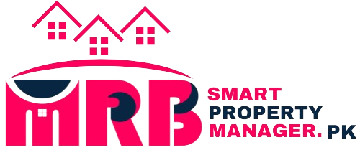

Homepage
Slider #1:
Property Management:
Smooth and Easy Rentals
Simplify renting with our convenient tools and stress-free solutions.


Slider #2:
Sharehouse Manager:
Manage Shared Homes Easily
Keep your shared home organized effortlessly with our user-friendly platform.
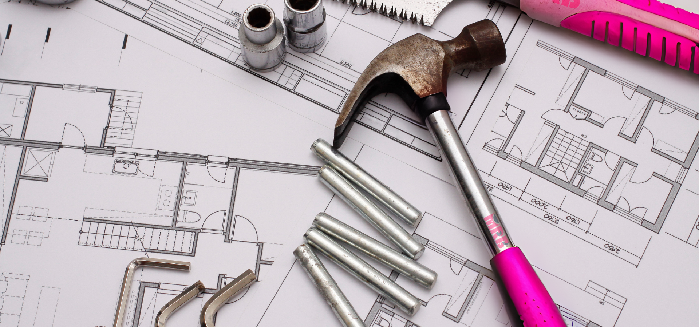

Slider #3:
Property Advisers:
Maximize Your Property's Visibility!
Streamline your property rental business with our user-friendly website. From tenant screening to rent collection, we've got you covered..


3 steps to success with Smart Property Manager
1- Match:
Advertise, find a tenant & secure your lease
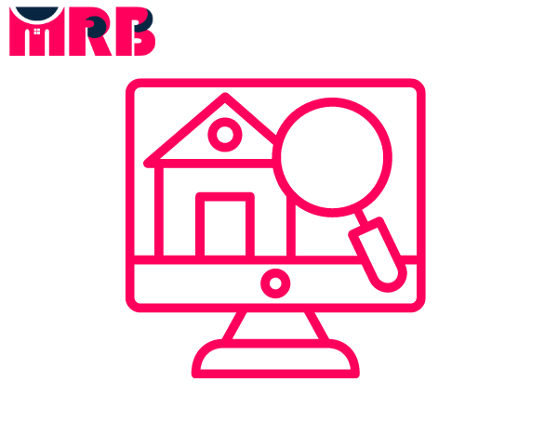

2- Manage:
Manage your tenancy, rental payments, documents & expenses.


3- Maintain:
Keep your property in top condition with our reliable maintenance support.
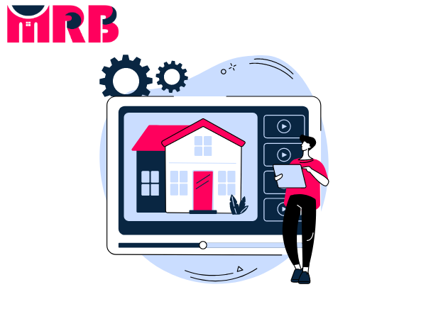

01
Match:
Advertise your property and find a tenant, review enquiries and applications, then make it ‘official’.
- Advertise on smartpropertymanager.pk - Pakistan’s top property website
- Handle enquiries & applications
- Do digital tenant checks through the National Tenancy Database
- Pick & set up a tenant
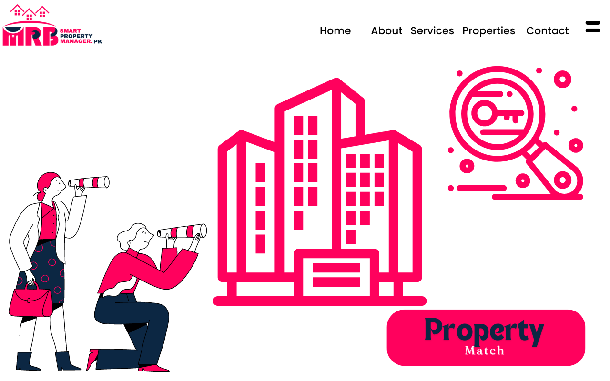
- Create & sign your lease agreement

02
Manage:
Take care of your property and tenant relationship from your computer or phone with our all-in-one solution.
- Track and collect rent payments & bonds
- Conduct digital inspections & condition reports (or hire a pro!)
- Track expenses & generate reports
- Message your tenant instantly on the platform
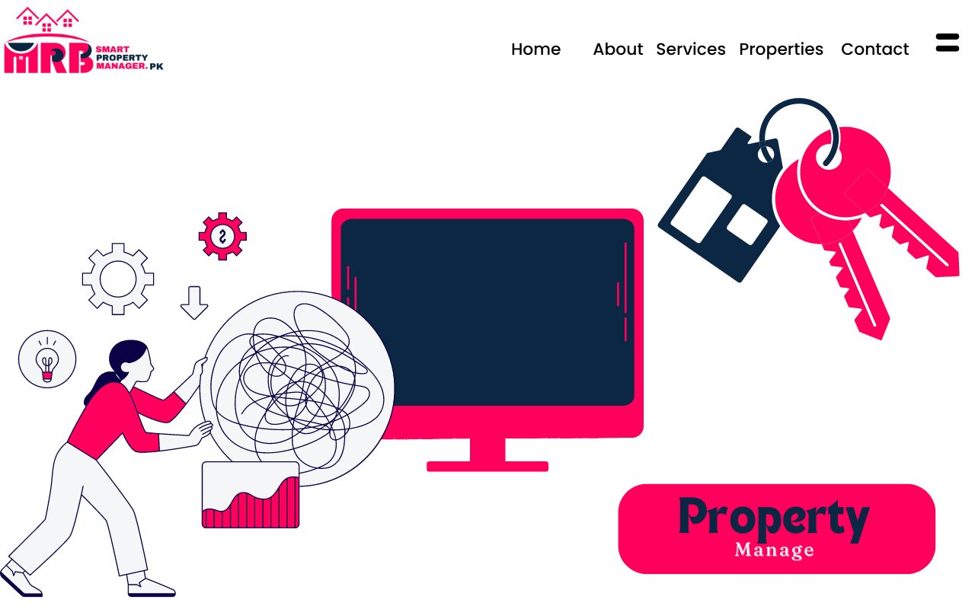
- Manage tenant bills & receipts

03
Maintain:

Keep your property and tenant relationship hassle-free. No calls, no waiting. It’s all done via SmartPropertyManager.pk.
- Store all your documents securely
- Schedule repairs & maintenance effortlessly
- Get automatic reminders & prompts
- Conduct routine inspections (or let a pro handle it)
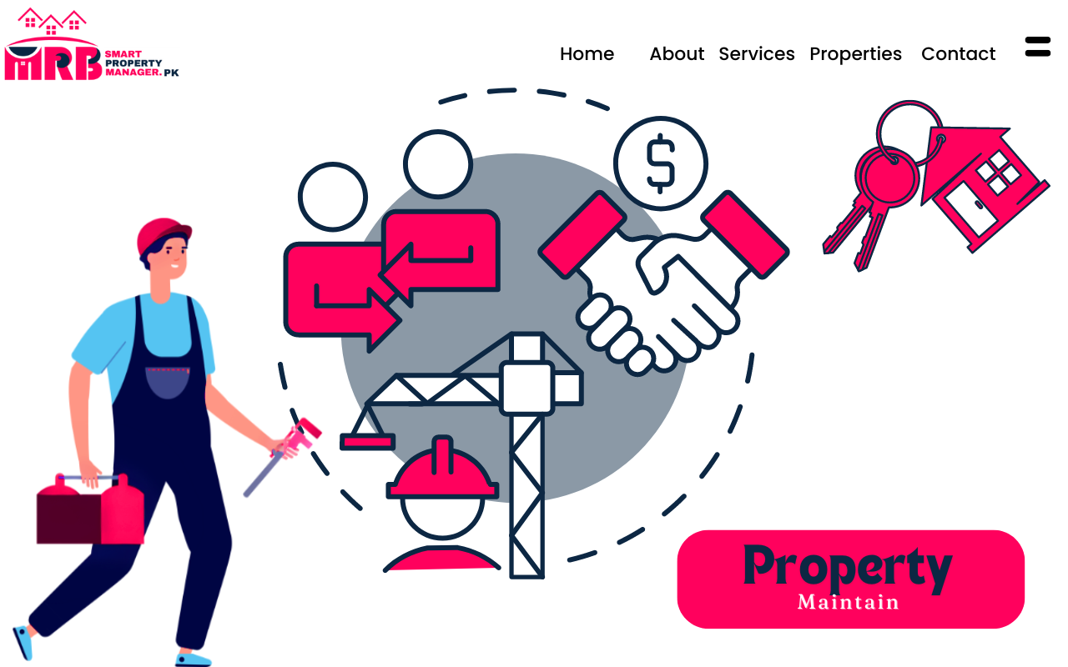

A Few Little Extras

Rental Estimate:

Discover the value of your property with our free rental estimate report.

E-book:

Get all the essential info on renting and managing your property!

Switch-Kit:

Ready to part ways with agents? Here’s our helpful guide to switching to self-managing.

About page

We're Smart Property Managers, changing how things work in Pakistan's housing market. Instead of the old agent way, we use cool tech to help landlords handle everything online.
Find tenants, manage your property, and handle leases easily, all in one place. It's simple, automated, and makes your property management better.


Our platform offers a range of features to make your life easier:
- Effortless Tenant Matching: Find the perfect tenants quickly and easily using our advanced matching tools.
- Centralized Property Management: Manage all your properties from one convenient dashboard, allowing you to keep track of rent payments, maintenance requests, and more, all in one place.
- Secure Document Storage: Store important documents such as lease agreements and tenant records securely online, ensuring easy access whenever you need them.
- Automated Reminders: Say goodbye to missed payments and overdue maintenance tasks! Our platform sends automated reminders to keep you on top of your responsibilities.
- Expert Support: Need help or advice? Our team of real estate experts is here to assist you every step of the way, providing guidance and assistance whenever you need it.
Join us today and discover the ease and convenience of managing your properties with SmartPropertyManager.pk!

# Pricing

Features

1- Match:
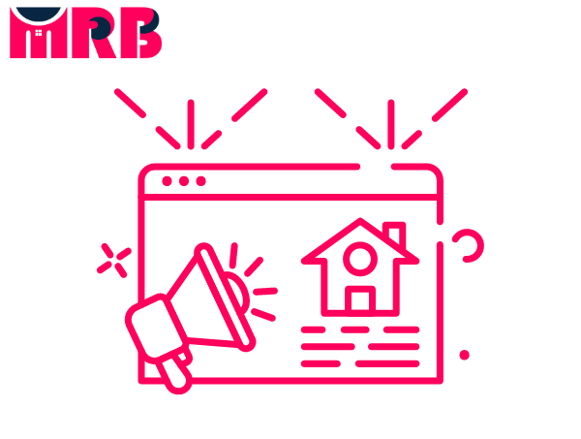
Advertise your property and find a tenant, review inquiries and applications, then make it official. Safe, secure, and managed online, with our support every step of the way.
- Advertise Your Property List your property on top Pakistan property websites.

- Receive Inquiries Get, organize, and respond to inquiries about your property.

- Manage Applications Receive standard applications and pick your preferred tenant.

- Conduct Tenant Checks Check tenants thoroughly with the National Tenancy Database.
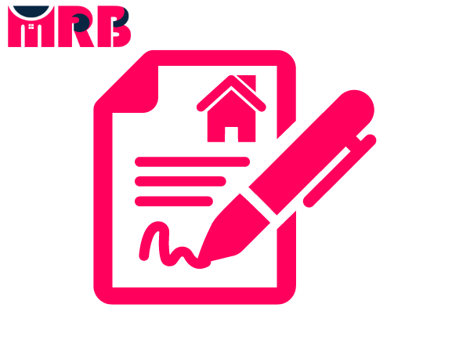
- Create Your Lease Draft, view, send, and digitally sign your lease agreement.

2- Manage:

Handle your property, lease, payments, and documents from your computer or mobile.
- Set Up a Tenant Invite your new or current tenant to join SmartPropertyManager.pk .

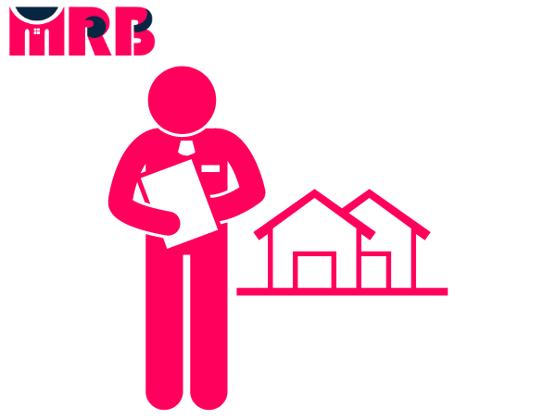
- Complete a Condition Report Fill out and sign a digital report or hire a professional in person (for only 30k Rupee).


- Collect Bond Gather the bond directly from your tenant.


- Collect Rent Payments Automatically receive rent payments, get notifications, and generate receipts.


- Track Expenses Keep track of your expenses easily.


- Create Tenant Invoices Generate, send, and pay invoices through SmartPropertyManager.pk .

3- Maintain:
Keep up with your property and tenant needs easily through SmartPropertyManager.pk.
- Get Reports Quickly generate property reports, including other important reports, in just a few minutes.


- Handle Maintenance & Repairs Submit or receive maintenance requests and hire a tradesperson to get the job done.
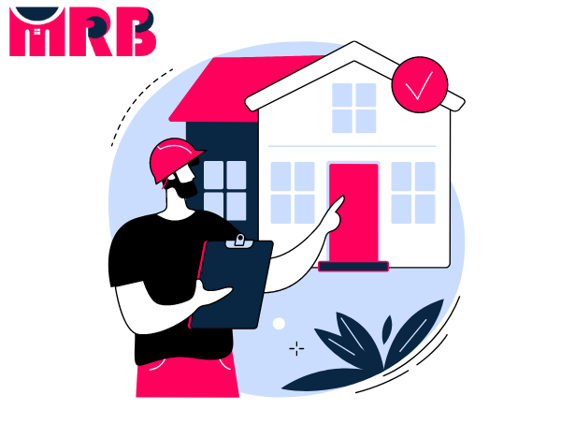
- Do Routine Inspections Complete and sign digital inspection reports or hire a professional in person (for only 30k Rupee).

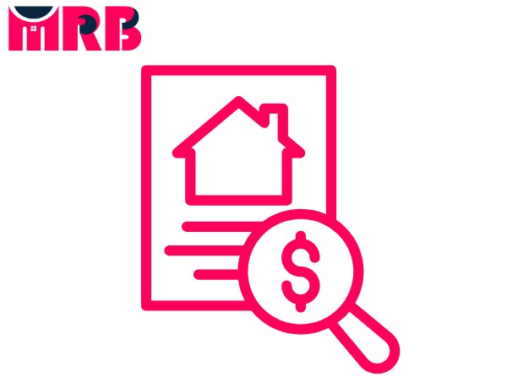
- Store Your Documents Easily search and store all your property documents online.

Toolkits
Property Toolkit
All the tools you need for Smartpropertymanager.Pk – from figuring out rental rates to finding the right tenants and waving goodbye to your agent (and those annoying agent fees).
- Rental Estimate - Discover the weekly rent you can expect for your property.

- Savings Calculator - See how much you could save with self-management using SmartPropertyManager.pk.


- Agent Switch Kit - Ready to part ways with your agent? Here's a helpful guide.

- E-Book - Get all the info you need about renting and managing your property.


- FAQ & Help Center Find answers to all your questions about SmartPropertyManager.pk, self-management, and more.

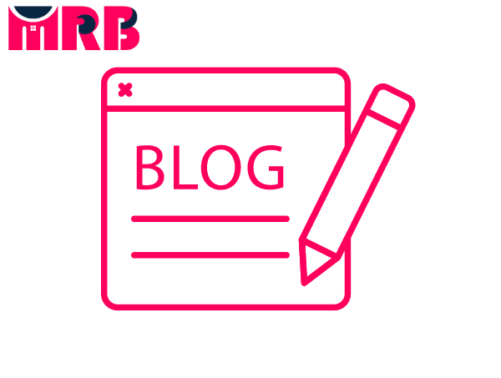
- Smartpropertymanager.Pk Blog Stay updated with news and helpful tips on self-management and the Australian rental market.

Match
Feature#01:
Advertise your property
Advertise Your Property
Advertise your property for rent on Pakistan’s top property sites. You will see our advertisements on our websites (smartpropertymanager.pk or sharehouse.pk) and on Zameen.com/Gharan.com and our social media platforms (facebook /instagram/ youtube).
Get listed on popular platforms at a fraction of the cost, usually reserved for real estate agents, now available for you with SmartPropertyManager.pk.

Step 1
Create Your Property Ad
Add details about your property, such as availability, price, and high-quality photos on Sharehouse.pk. Once done, you can list your property and have full control to edit or update your ad whenever needed.
Don’t have any photos? No worries – we can help with that too! BOOK A PHOTOSHOOT
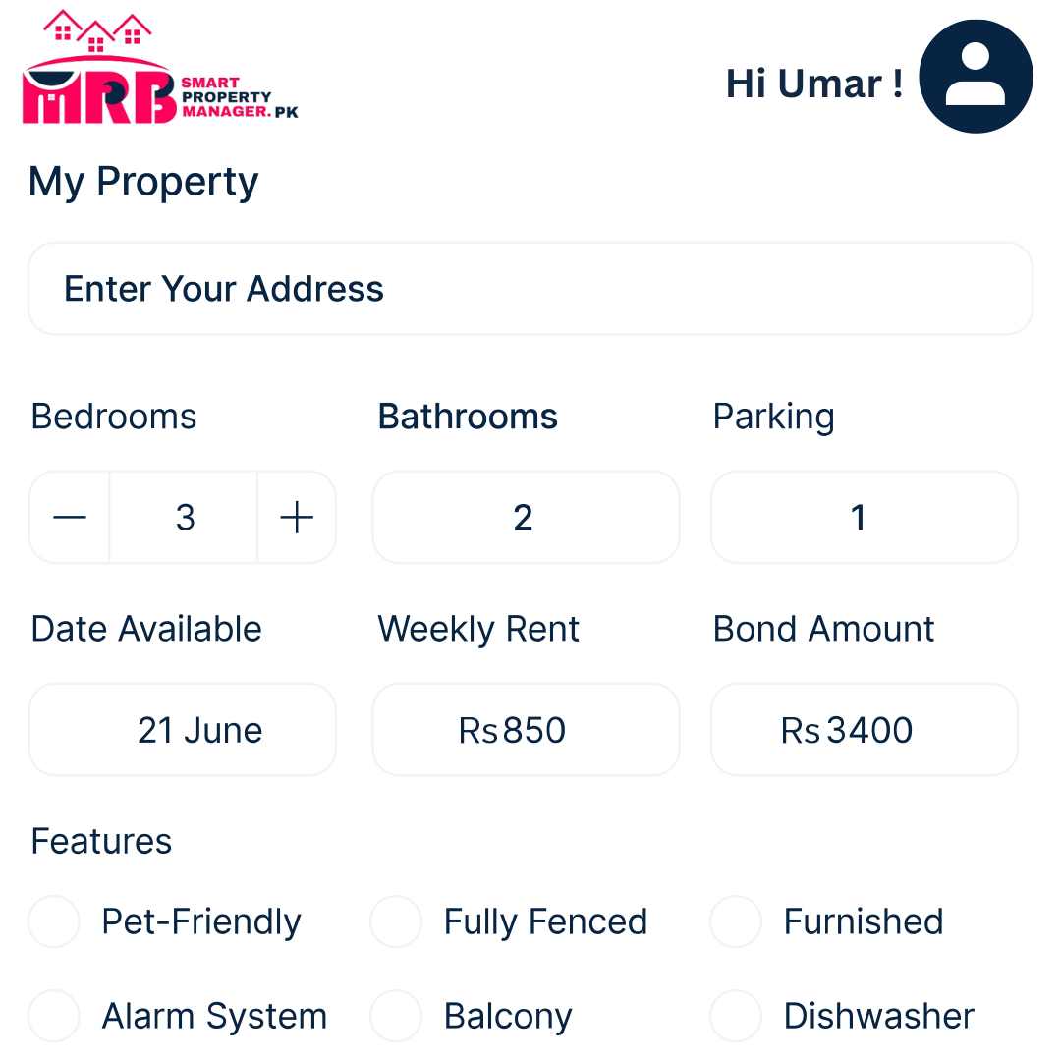

Step 2
Make Your Listing Live
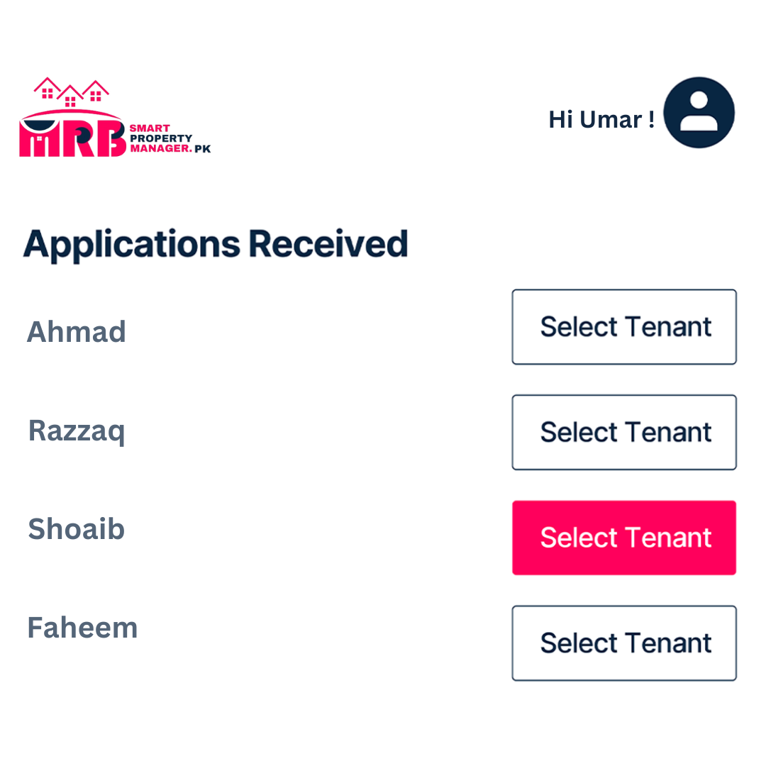
With just a click, set your property live on major property sites. Your ad will stay up until you find a tenant. You can also upgrade to a featured ad for extra visibility.

Step 3
Find a Tenant & Remove Your Ad
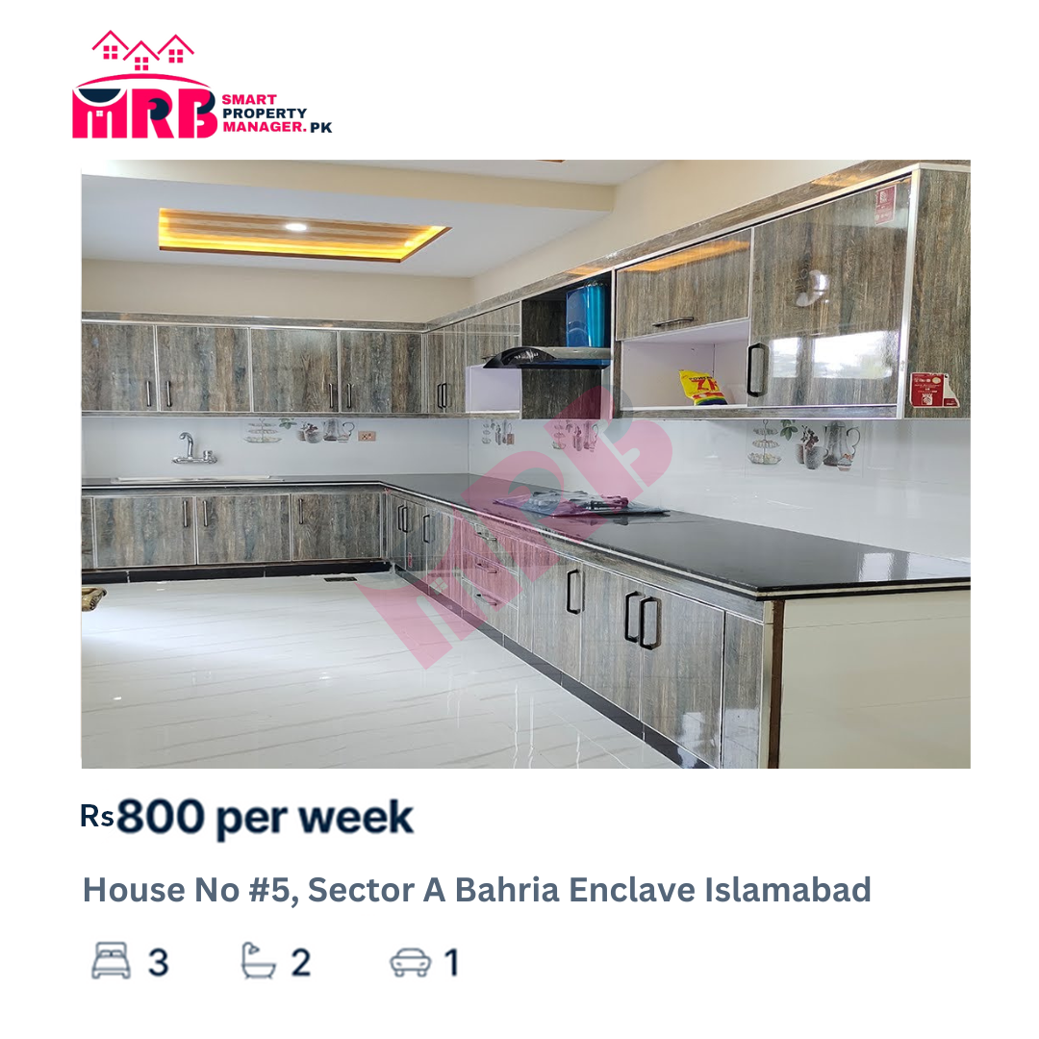
Once you find a tenant, you can remove your ad with a click. The next step: onboarding your tenant!

Feature#02:
Receive Enquiries
Receive Enquiries
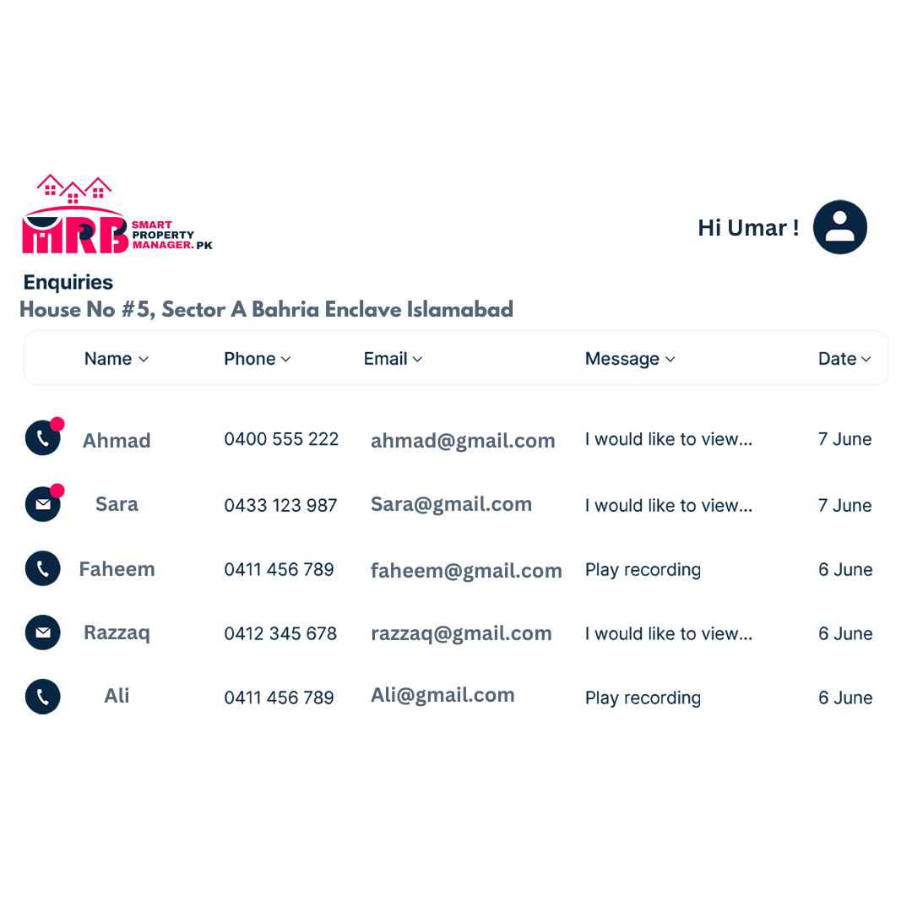
Once your rental property listing is live, you'll start getting interest from prospective tenants. All inquiries will show up in your 'My Properties' dashboard, where you can easily view, sort, manage, and respond to them.

Instant Alerts
You’ll get instant notifications when new inquiries come through for your rental ad.

Record of Inquiries
All inquiries, whether by email or phone, are recorded in your 'My Properties' dashboard. No need to juggle multiple websites – everything is in one place.

Sort & Manage Inquiries
You can sort inquiries by type, date, name, and source to keep them organized. You can also update the status of each inquiry to track your progress with potential tenants.

Conduct Viewings
Arrange times for in-person viewings with your potential tenants easily.

Feature#03:
Manage Applications
Manage Applications
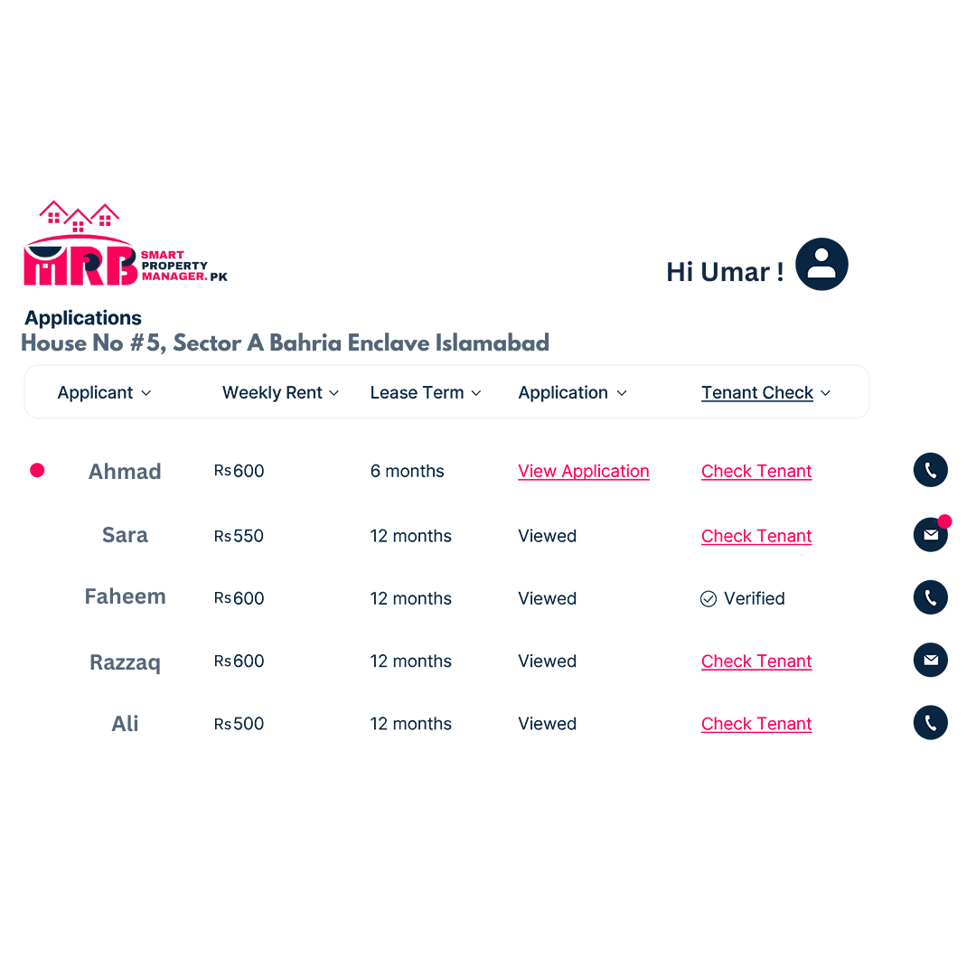
Once your rental property listing is live, you'll start getting interest from prospective tenants. All inquiries will show up in your 'My Properties' dashboard, where you can easily view, sort, manage, and respond to them.

Instant Alerts
Get instant notifications when new inquiries come through for your rental ad.

Record of Inquiries
All inquiries, whether by email or phone, are recorded in your 'My Properties' dashboard. No need to juggle multiple websites – everything is in one place.

Choose a Tenant
Found the right tenant? Select your preferred tenant, run an instant digital tenant check, and create your lease agreement online. It’s that simple.

Feature#04:

Conduct Tenant Checks
Run Tenant Checks
Always check references! Before signing your lease, run a comprehensive digital tenant check for only Rs. 2,500 (or Rs. 2,000 if you’re a SmartPropertyManager.pk customer).
SmartPropertyManager.pk uses the National Tenancy Database, to check your prospective tenant’s background. This is the most extensive tenant information database in Pakistan.

Step 1
Enter Tenant Details
You just need your prospective tenant’s basic details, current address, and one form of ID (e.g., Driver's License Number and State OR Passport Number and Country).

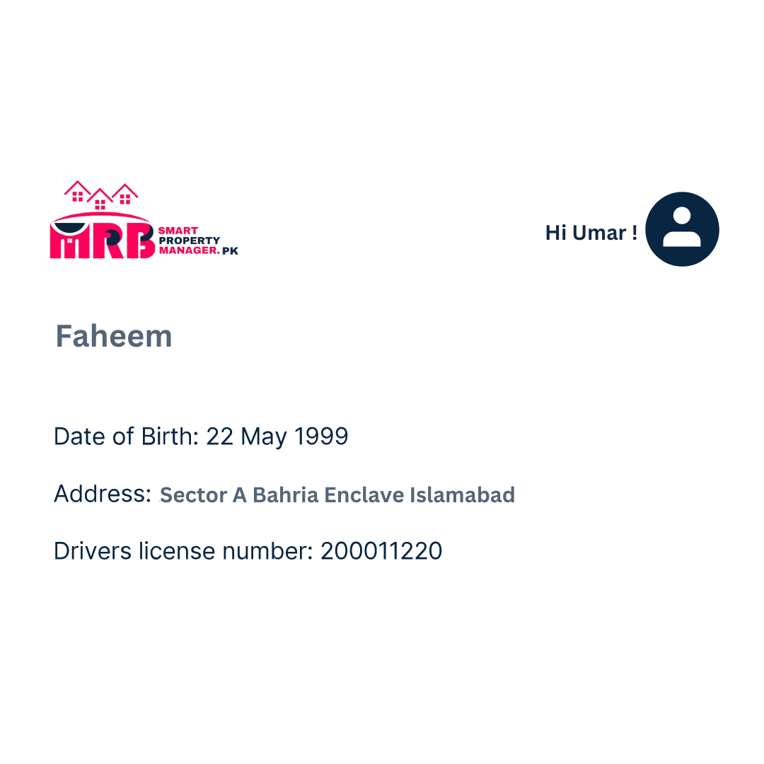

Step 2
Submit Request
Submit your report to check your tenant’s background for only Rs. 3,800 (or Rs. 2,700 as a SmartPropertyManager.pk customer).

Step 3
Receive Your Report in Minutes
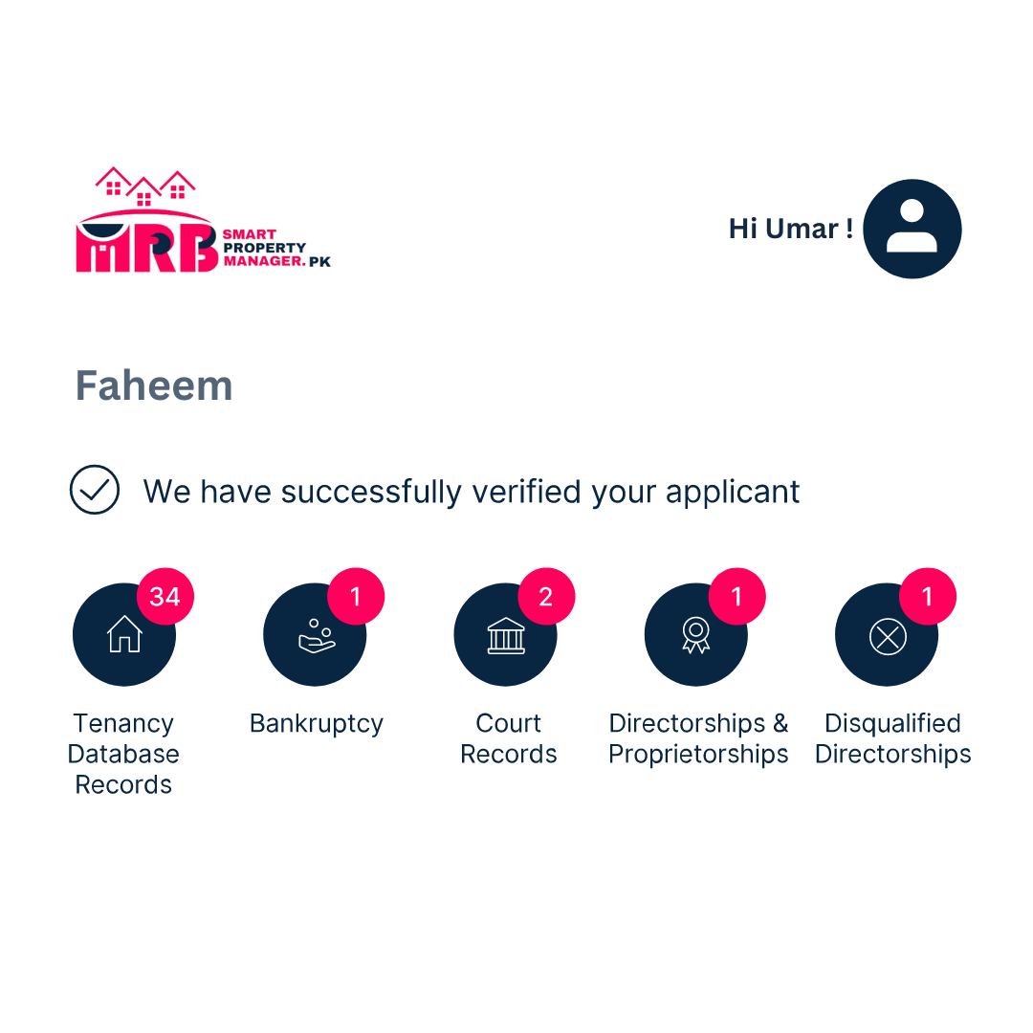
Choose to download your report or have it emailed to you.

What Will My Report Include?
- Past Tenant History:
Review the rental history of your prospective tenant, including previous agency screenings. We’ll also check if they’re listed on the tenant blacklist by a member of the National Tenancy Database.
- Identity Information:
We’ll verify your prospective or current tenant’s identity, checking against several national databases and directories for peace of mind.
- Bankruptcy Information & Court Records:
We’ll check if your tenant has had past financial troubles or legal issues, including previous bankruptcy information and court records.

Feature#05:

Create your lease
Create & Sign Your Lease
Create, view, send, and sign your lease agreement online with SmartPropertyManager.pk. Easily enter your tenant’s details and the lease terms, then send a copy directly to your tenant with a click.
If you’ve signed up for a Match, Manage & Maintain, or Manage & Maintain account, both you and your tenant can digitally sign your lease.

Step 1
Create Lease Agreement
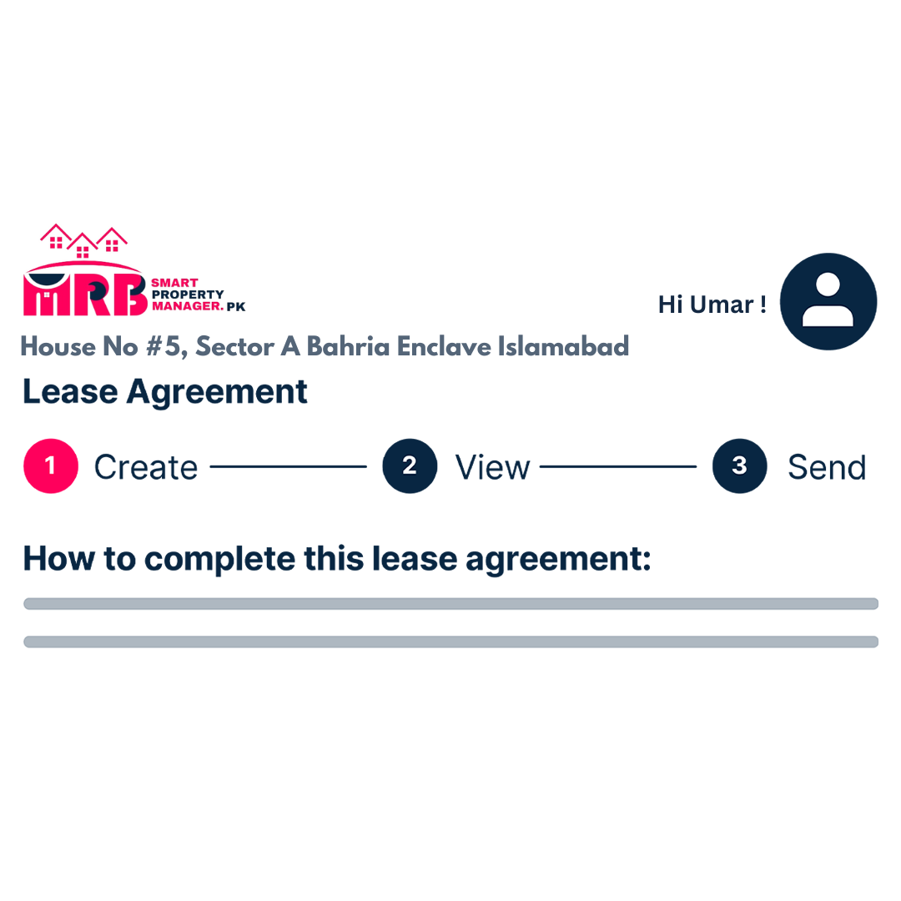
Enter the details and terms of the lease agreement between you and your tenant. Input the amount, frequency, and duration of the payment schedule, and add any extra information or inclusions.

Step 2
View Lease Agreement
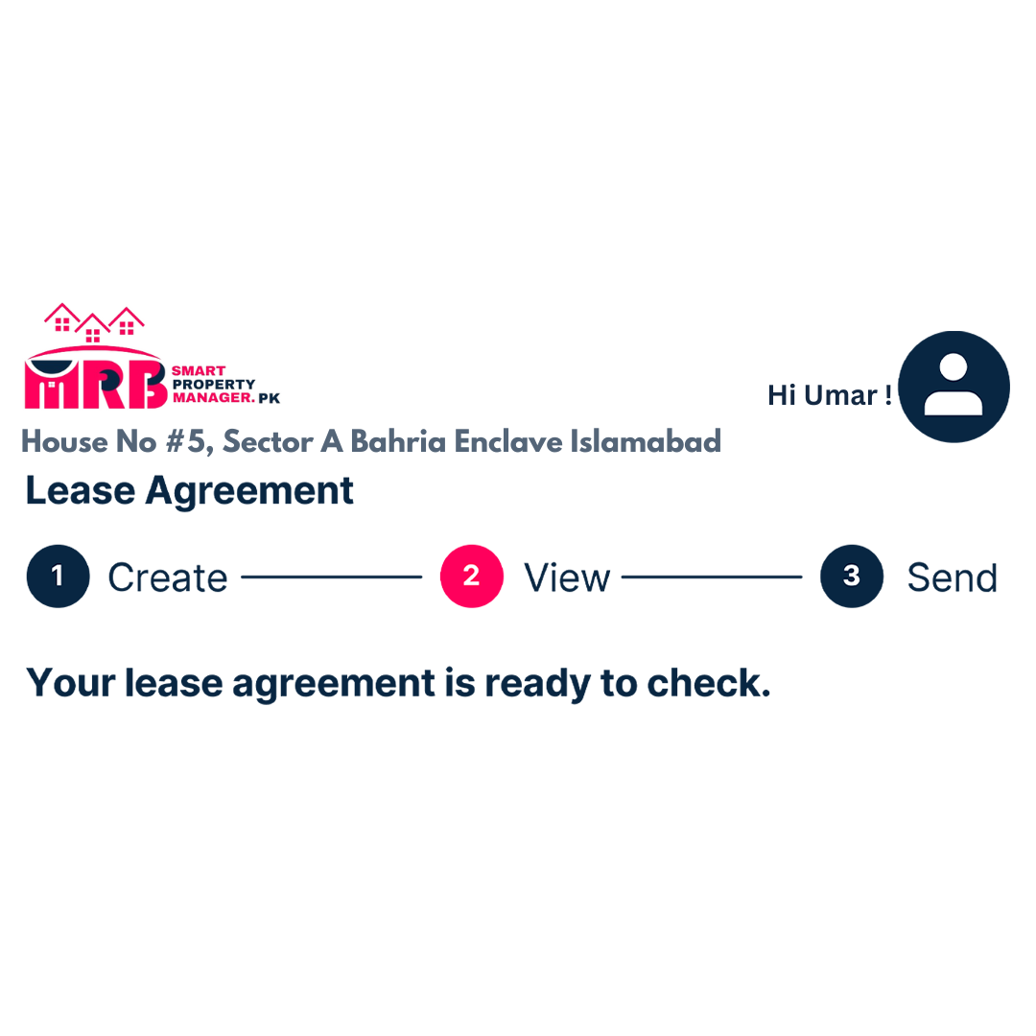
Once the PDF version of the lease agreement is generated, you can view a draft and make any updates or changes before finalizing it.

Step 3
Send Lease to Your Tenant
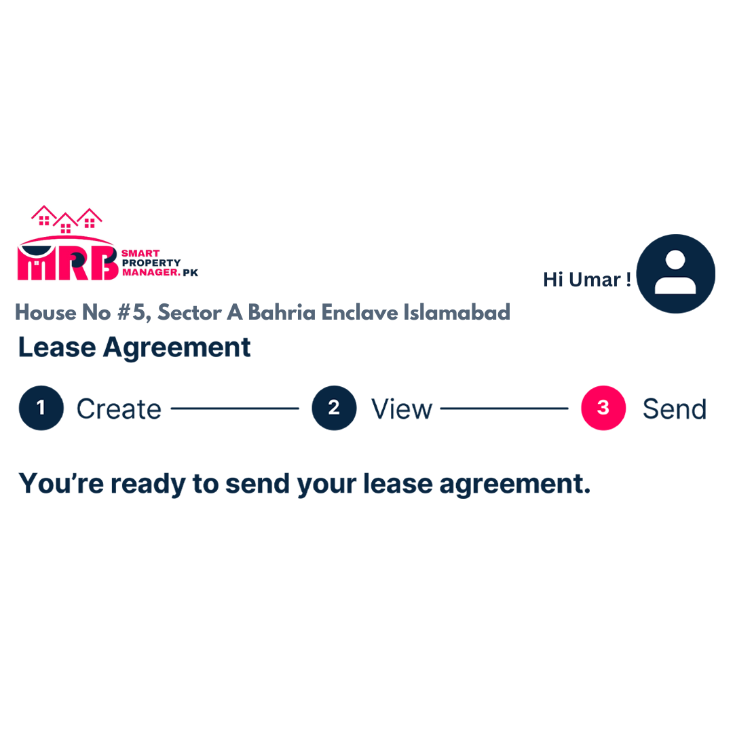
Send the completed lease agreement directly to your tenant to sign with just a click.

Step 4
Digitally Sign Your Lease
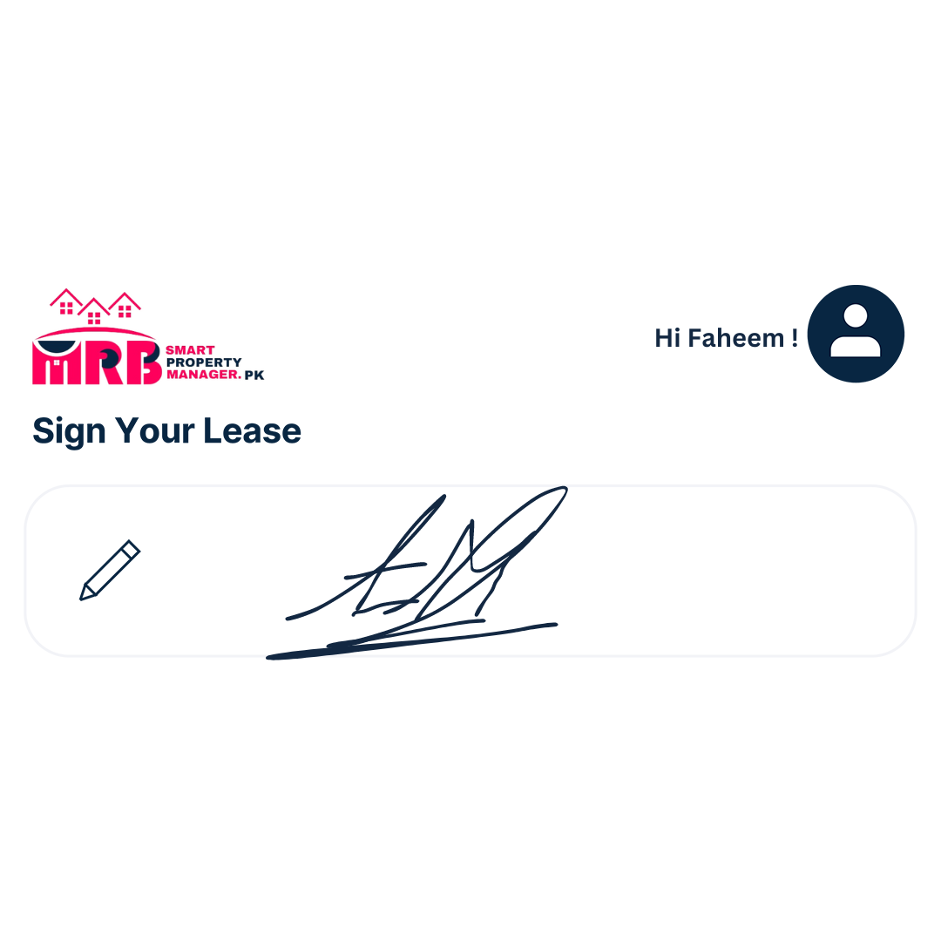
Both you and your tenant can view and digitally sign your lease agreement. It will then be stored in your SmartPropertyManager.pk 'My Properties' dashboard, where you can access it if you need to make changes in the future.

Manage
Feature#06:

Set-up a Tenant
Set Up Your Tenant
Once you’ve chosen a tenant for your rental property (or if you have an existing tenant), you can set them up on SmartPropertyManager.pk in minutes. Here, your tenant can view and sign their lease, access their rental payment schedule, and more.

Step 1
Add Tenant Details
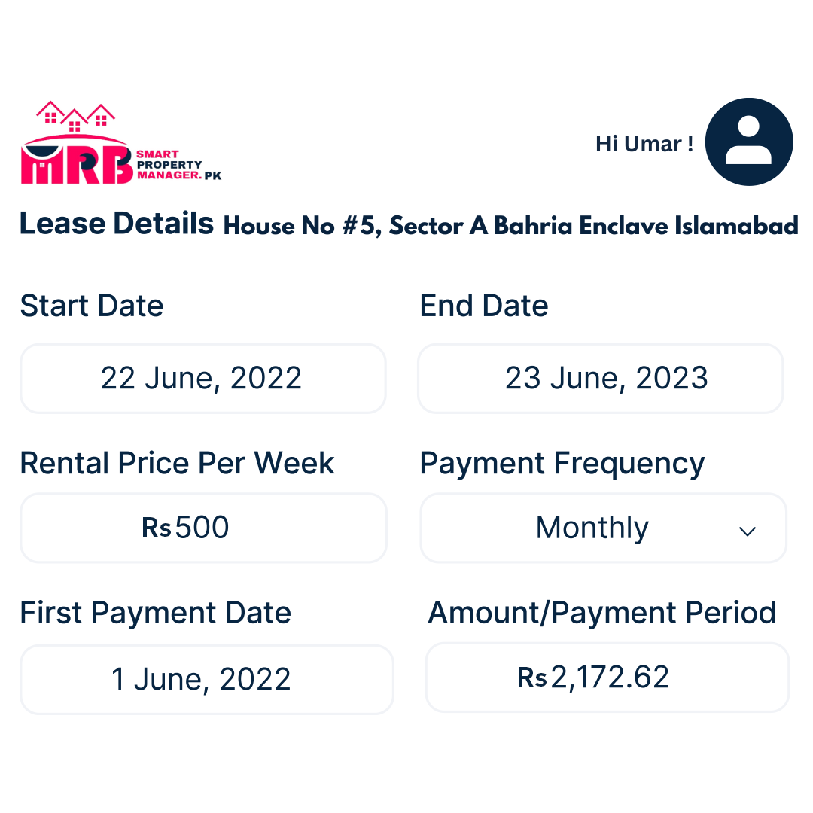
Enter your tenant’s basic details and set up the terms of your lease agreement.

Step 2
Tenant Receives Invite
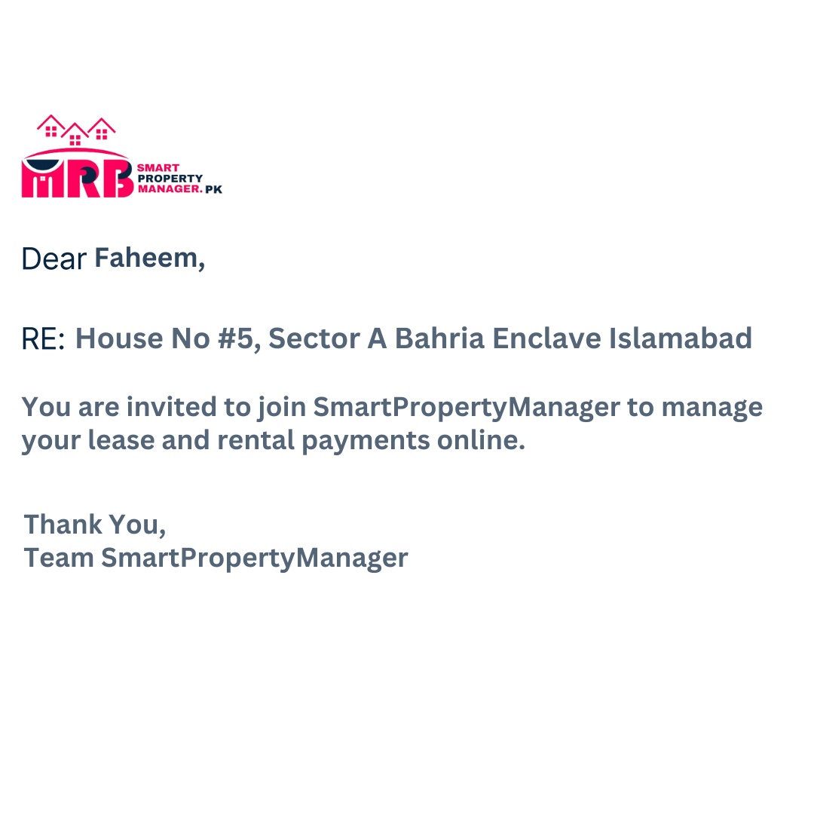
Your tenant will get an invitation to set up their SmartPropertyManager.pk account and start managing their lease and rental payments online.

Step 3
Instant Access
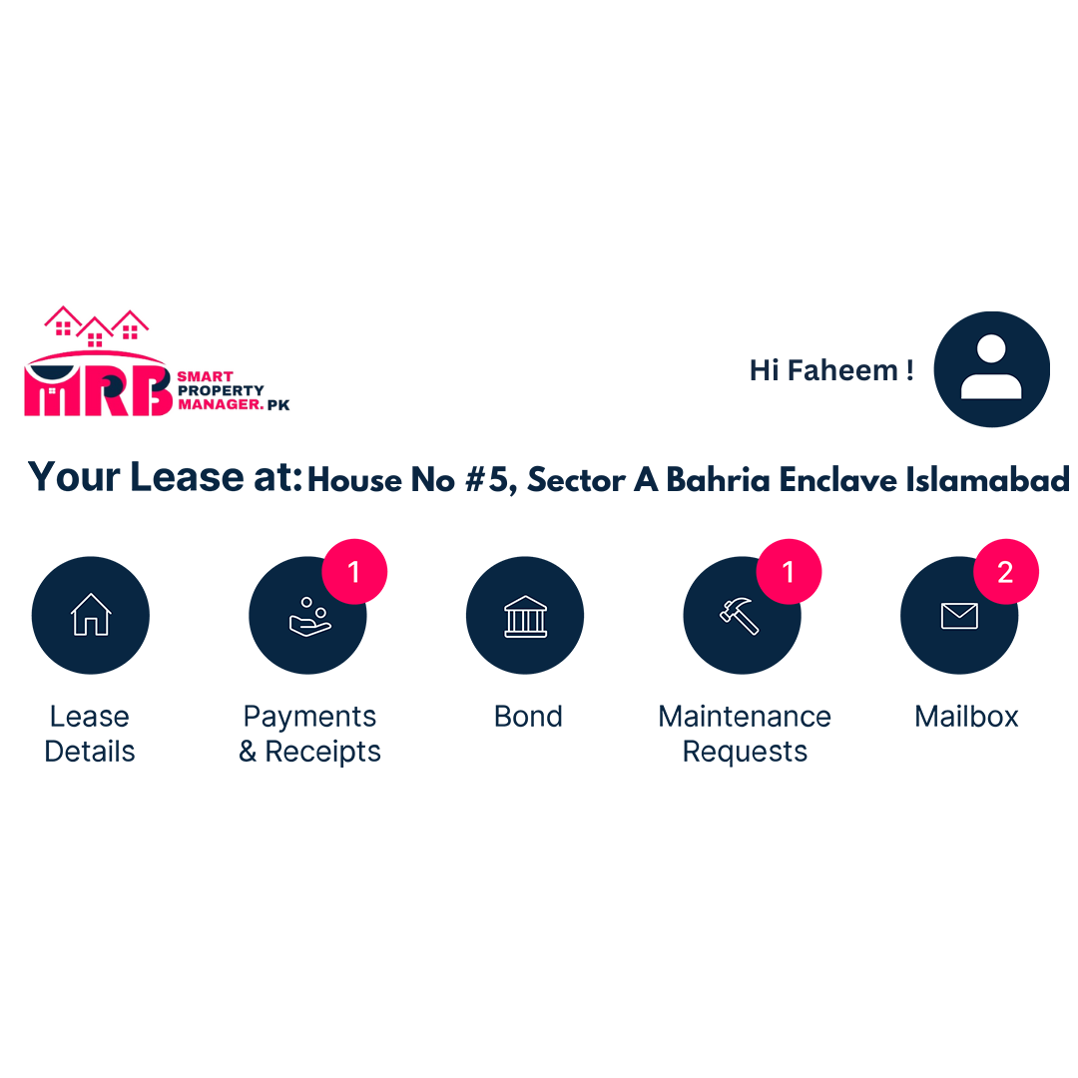
Your tenant will have their own SmartPropertyManager.pk dashboard, where they can access all details of their lease, payment schedule, bond and receipts, make maintenance requests, and more.

Feature#07:

Conduct a Condition Report
Conduct a Condition Report
It’s important to conduct a condition report of your property. You can do this through SmartPropertyManager.pk in two ways:
- Complete a digital condition report
- Hire a professional for an in-person inspection
All reports will be saved in your 'My Properties' dashboard, so you can easily refer back to them or update them throughout your lease.

Step 1
Custom to Your Property
Your SmartPropertyManager.pk condition report template can be customized to reflect the specific number of rooms in your property. No need to add extra info to a generic report.
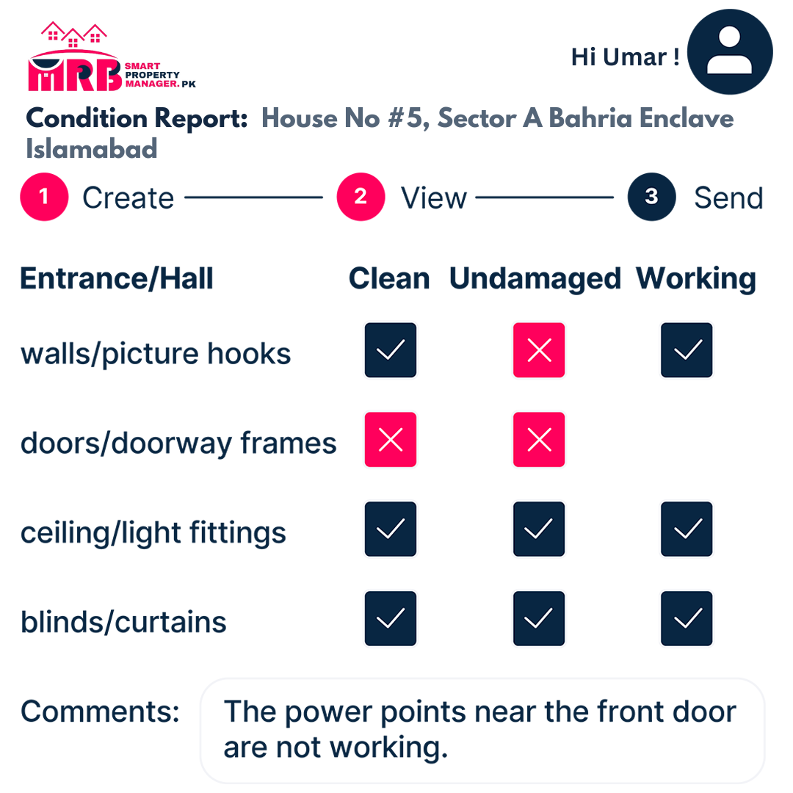

Step 2
Inspect with Ease
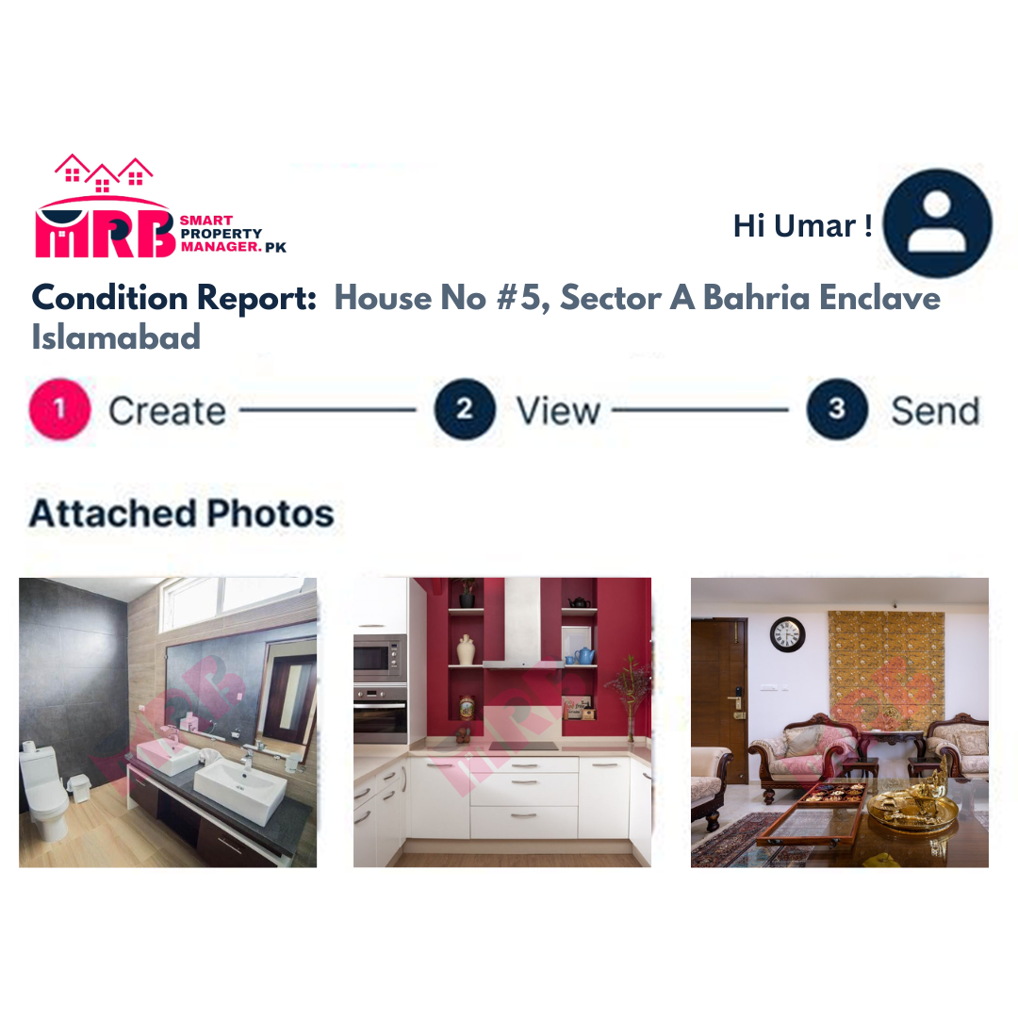
You can add pictures and comments to thoroughly inspect all rooms of your property from your computer or mobile.

Step 3
Report Completed
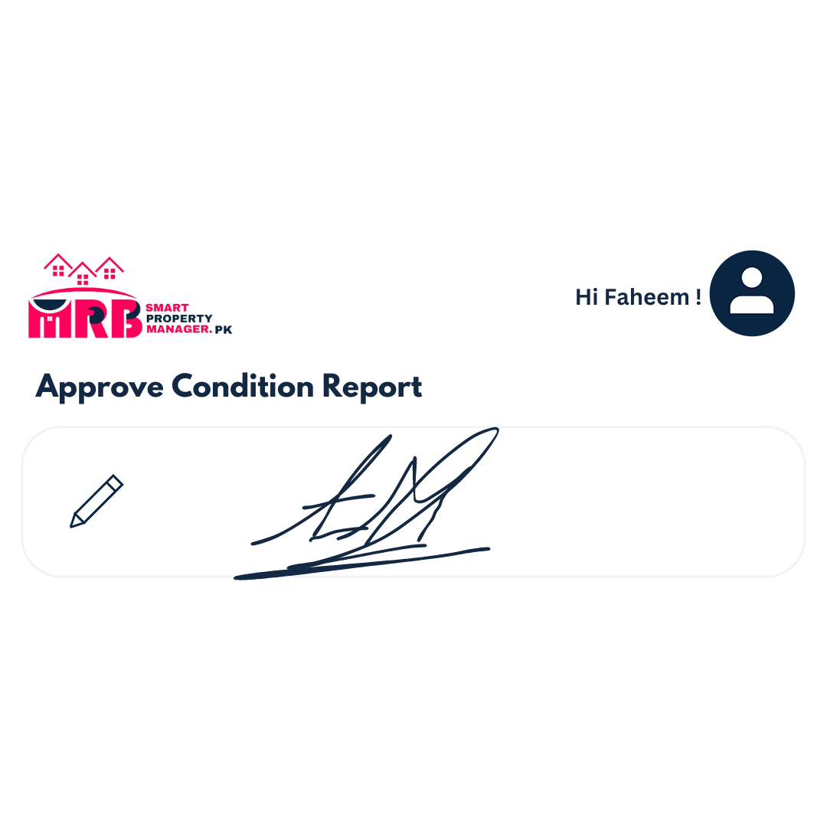
Send the completed condition report to your tenant for them to review and complete their part if needed. You can save the report and access it in the future for any updates.

Book a Professional for Your Condition Report
- Request Booking: Sign in to your ShareHouse.pk account, click on ‘Condition Report’ in the 'My Properties' dashboard, and choose ‘Book a Professional’.
- Booking Confirmed: Your booking request will be confirmed within 24 hours by a team member.
- Report Completed: A certified professional will complete your report in-person.
- Approve & Sign: Once your report is done, it will be available online for you to digitally sign and approve.
Feature#08:

Collect Bonds
Collect Bond
With SmartPropertyManager.pk, you can collect the rental bond directly from your tenant according to the rules of your state.

Step 1
Create Bond Details
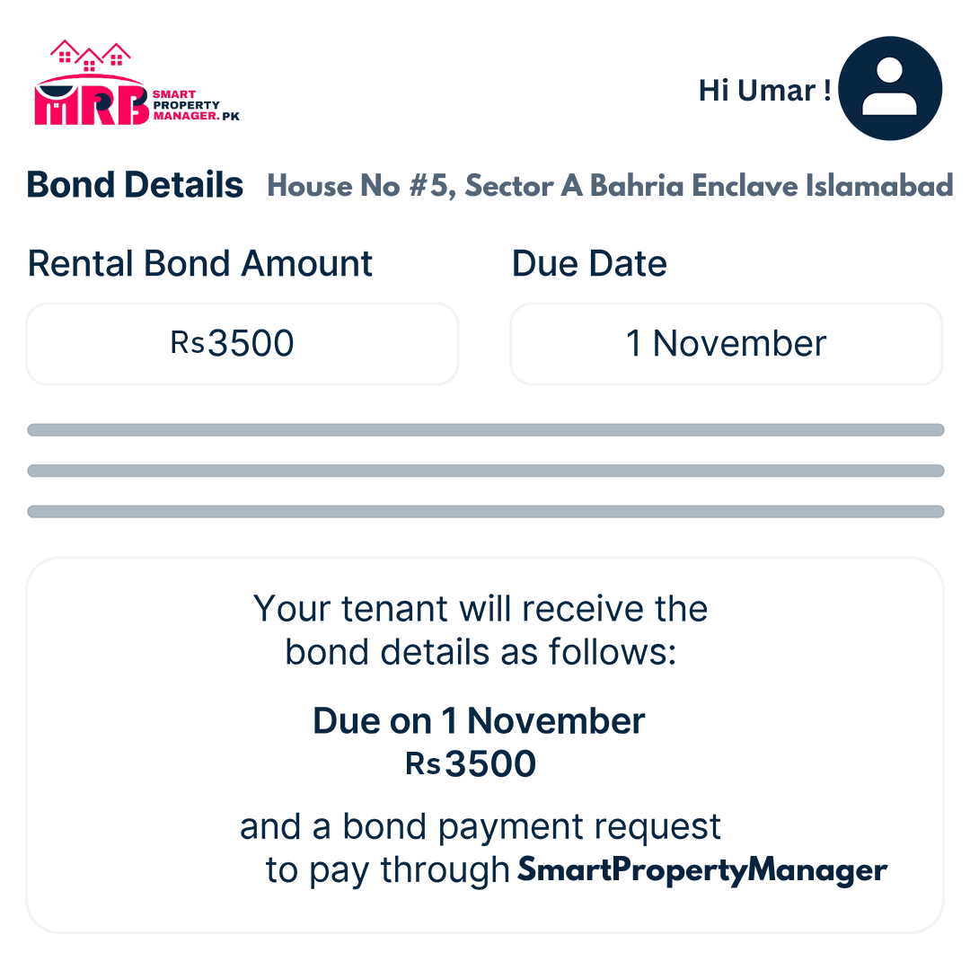
Fill out the bond details and attach any related documents you want to share with your tenant.

Step 2
Send Bond Details to Your Tenant
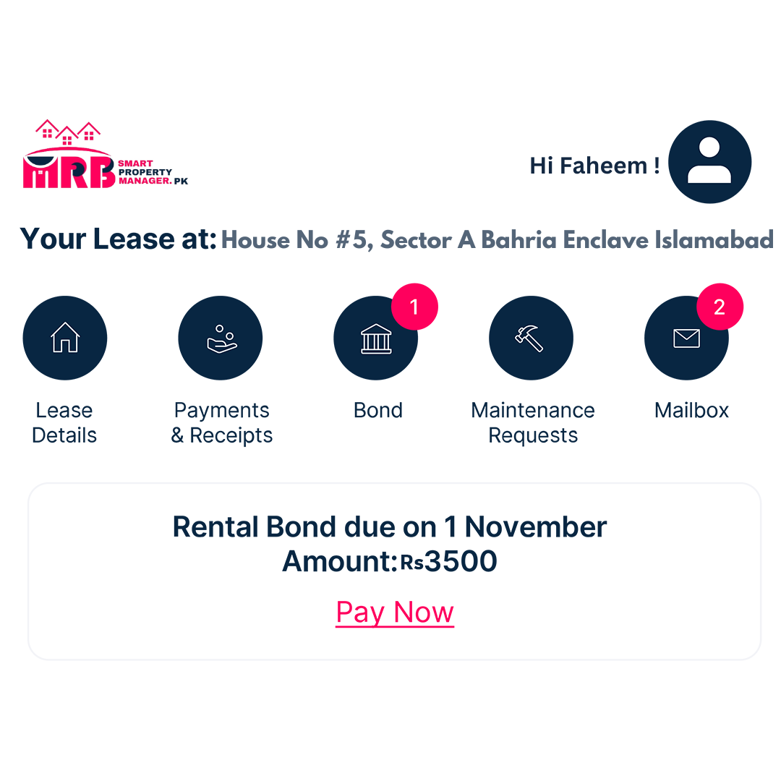
Choose to send the bond details to your tenant immediately or save them to send later. Your tenant will be notified and receive the bond details on their SmartPropertyManager.pk dashboard.

Step 3
Tenant Pays Bond
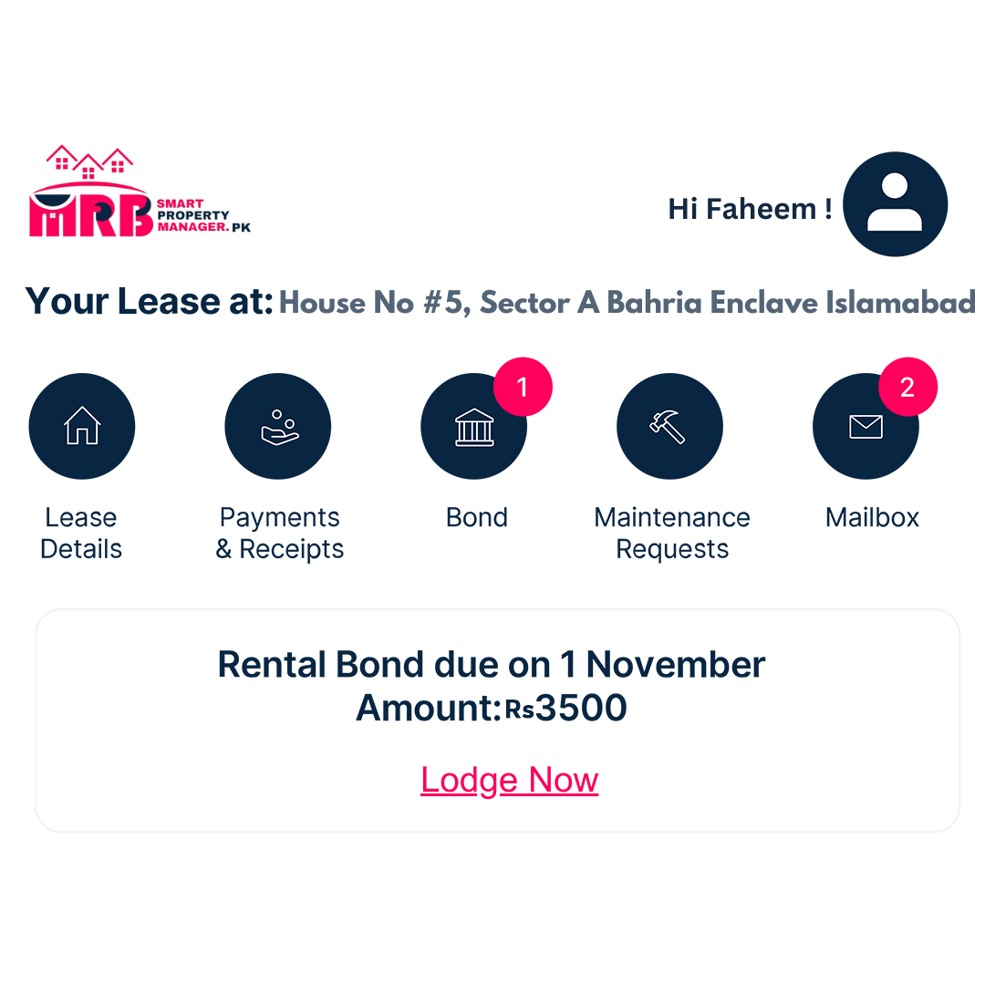
Your tenant can pay their bond through SmartPropertyManager.pk. The payment status will be shown on your 'My Properties' dashboard. You can also upload any bond-related documents for your records.

Feature#09:

Collect Rental Payments
Collect & Track Rental Payments
Tired of chasing tenants for rent? SmartPropertyManager.pk gives you more control over rental payments to make sure you get paid on time, every time.

Step 1
Tenant Selects Payment Method
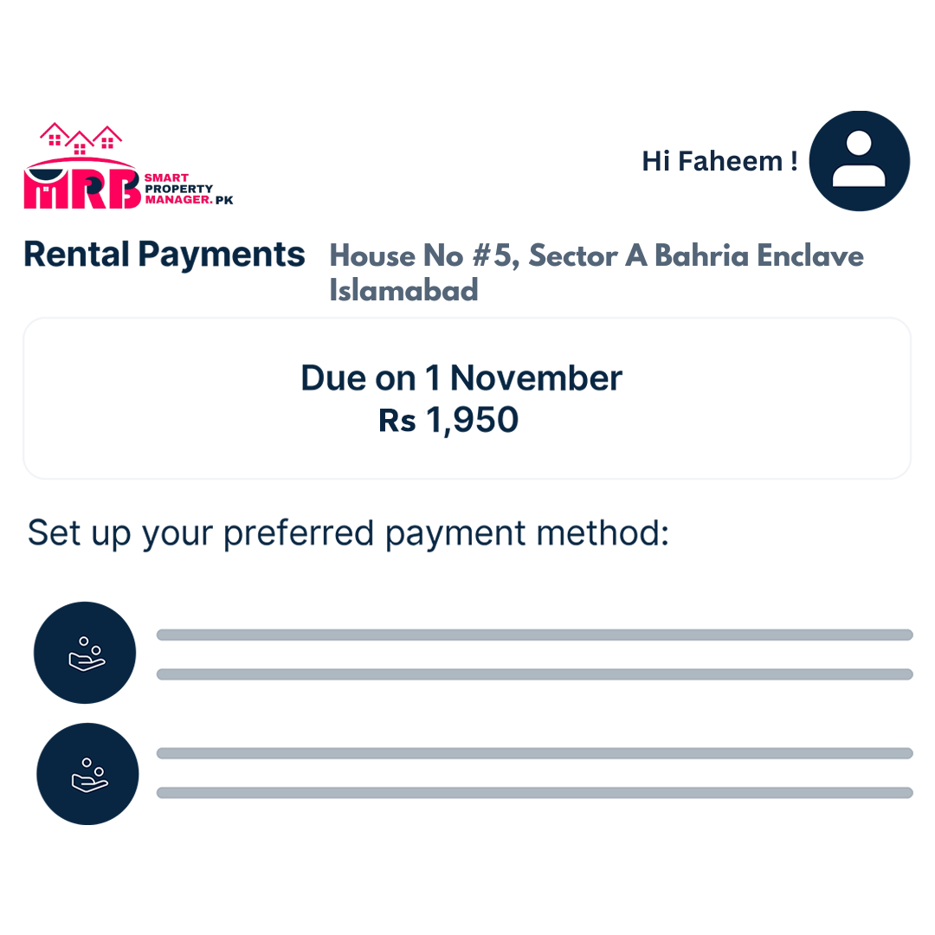
Your tenants can pay rent using a credit card or their bank account. The system ensures payments run on schedule as per your lease agreement.

Step 2
Payment Tracked and Receipt Generated
Payments are tracked, the ledger is automatically updated, and receipts are sent to both you and your tenant.
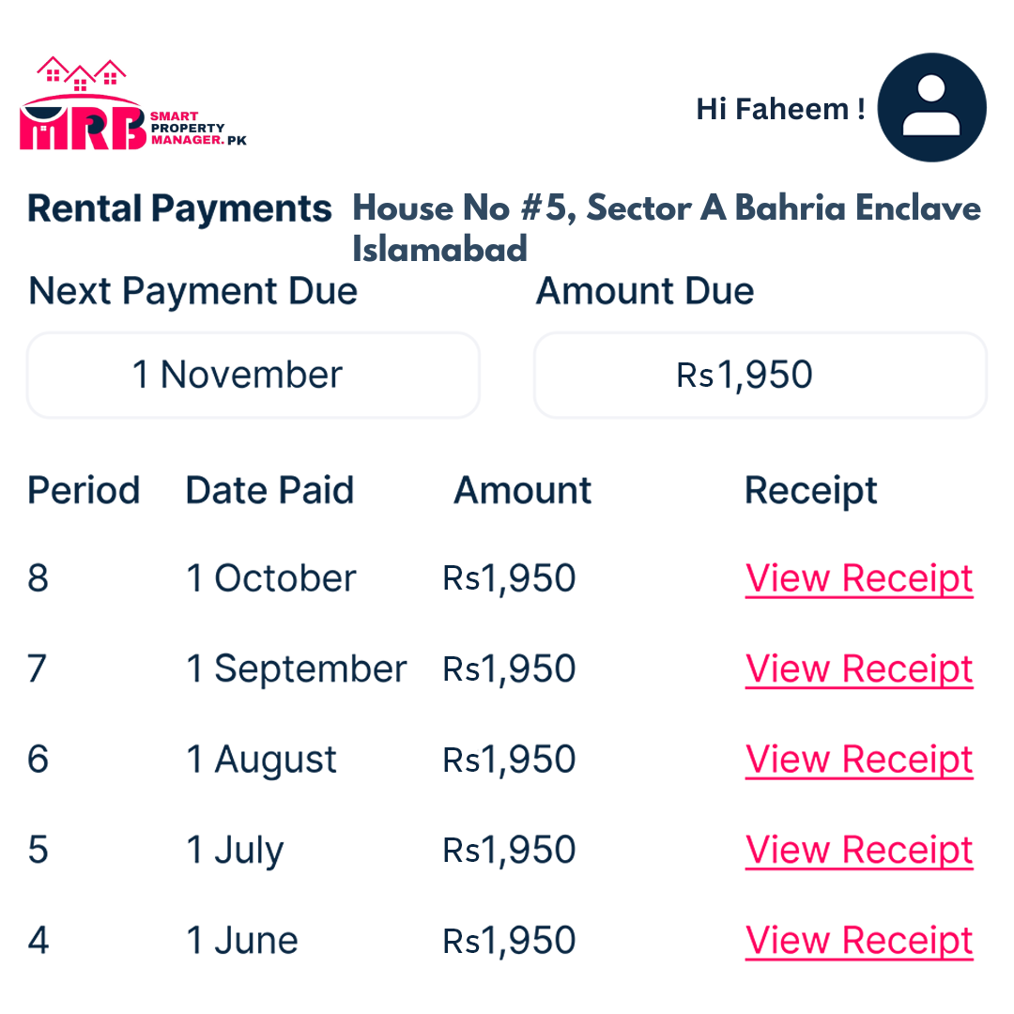

Step 3
Automatic Notifications
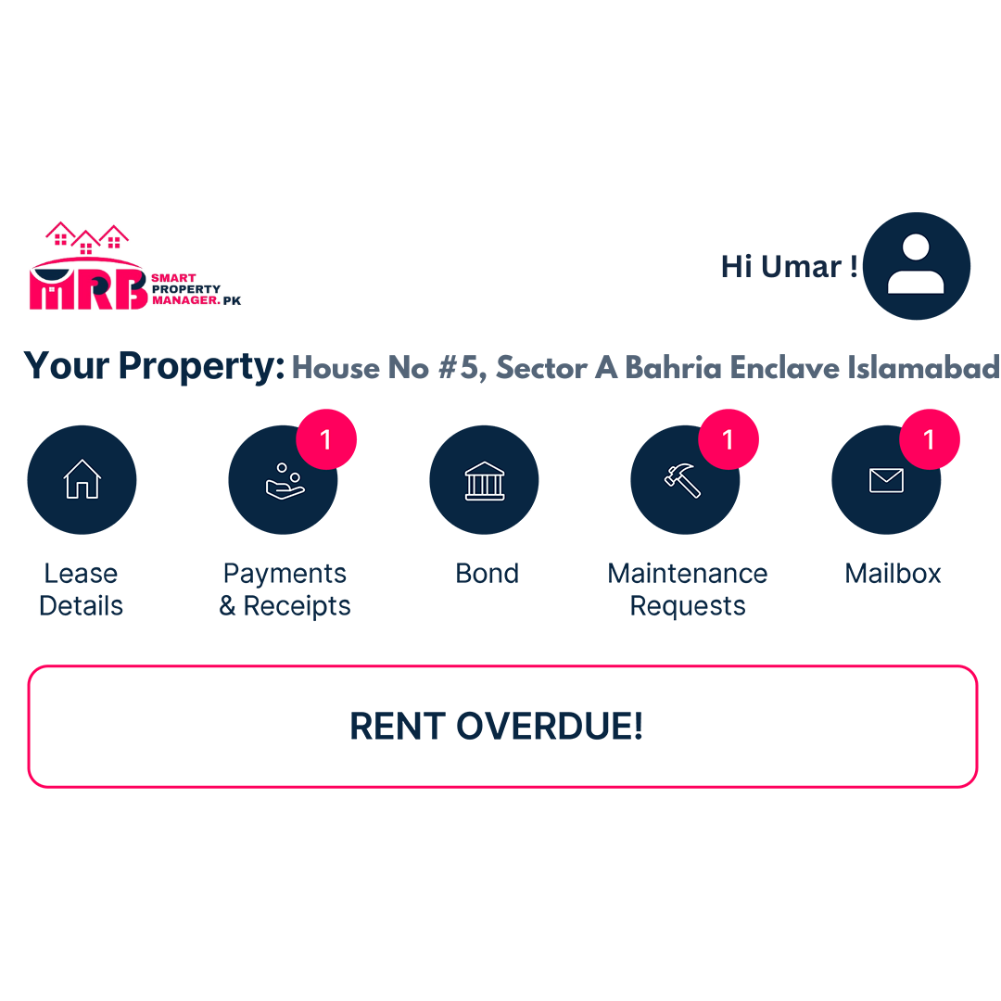
SmartPropertyManager.pk will send automatic alerts and notifications to you and your tenant. It ensures nothing is missed, and all payments are received on time.

Feature#10:

Track Expenses
Track Expenses
Keep track of all your property expenses and manage everything in one place with SmartPropertyManager.pk. No more shoeboxes full of receipts or trying to remember when you paid a bill. It’s all available and searchable with a click.

Step 1
Upload Expense
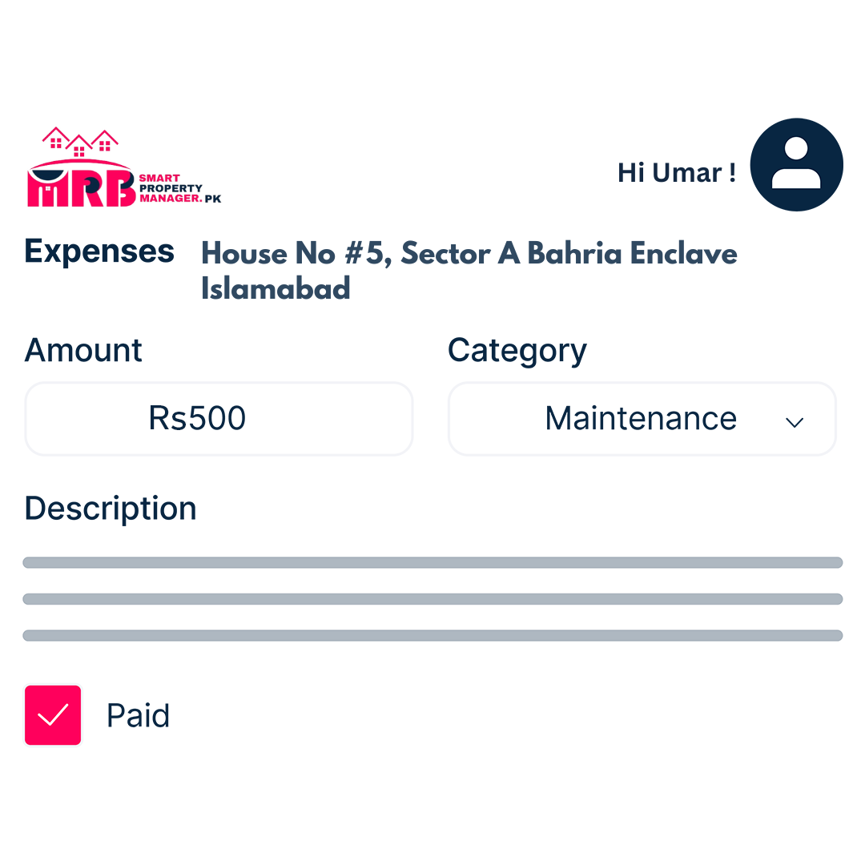
Upload your property-related expense, add a description, the amount, and the date.

Step 2
Take a Photo
Take a photo or scan a copy of the receipt and attach it to the expense item.


Step 3
Save for Reporting
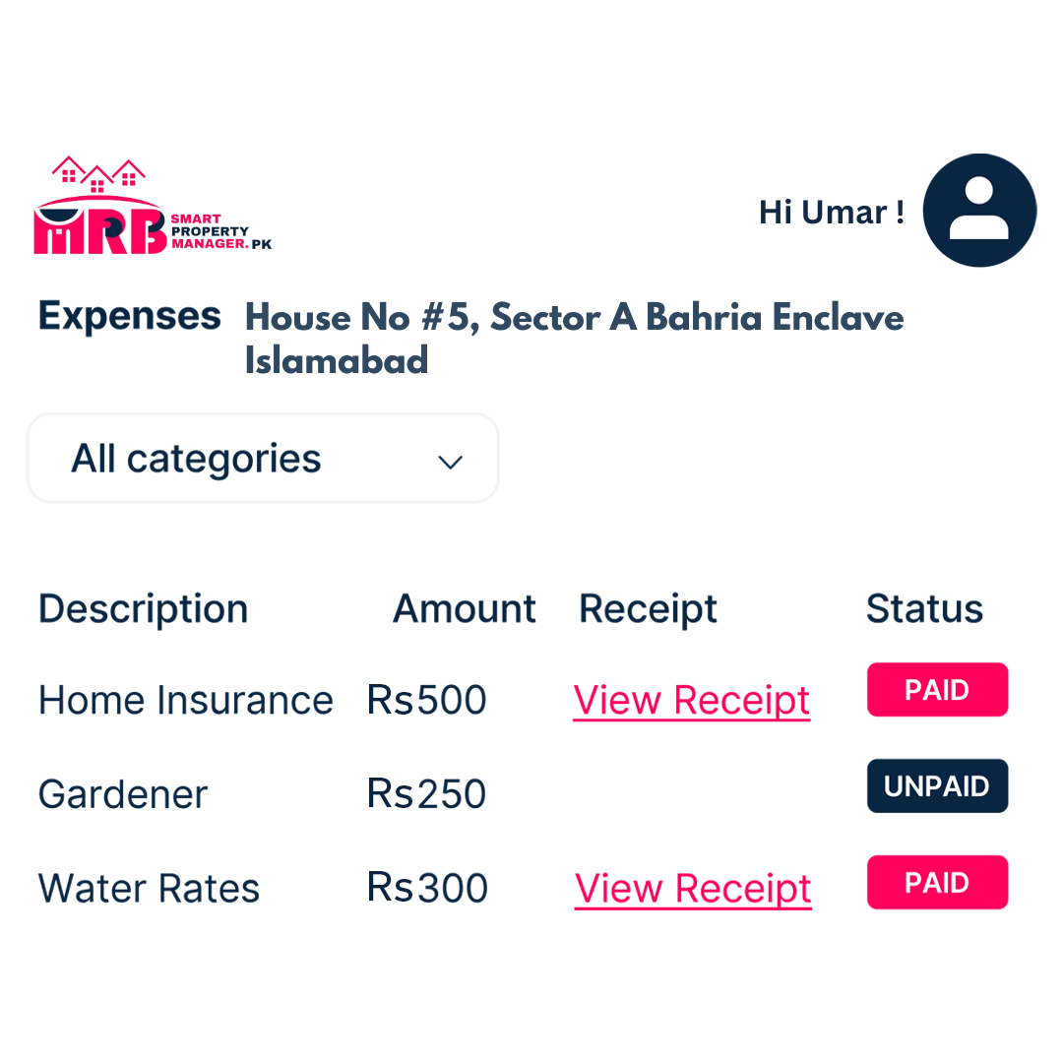
Save the details of your expense item. It will automatically populate in any report for your property, so you'll always know your financial position.

Feature#11:

Create Tenant Bills
Create Tenant Bills
Billing your tenant is hassle-free with SmartPropertyManager.pk. Simply create and send your invoice in under a minute, then click to send it directly to your tenant. No more unnecessary back-and-forth!

Step 1
Create & Send Your Bill
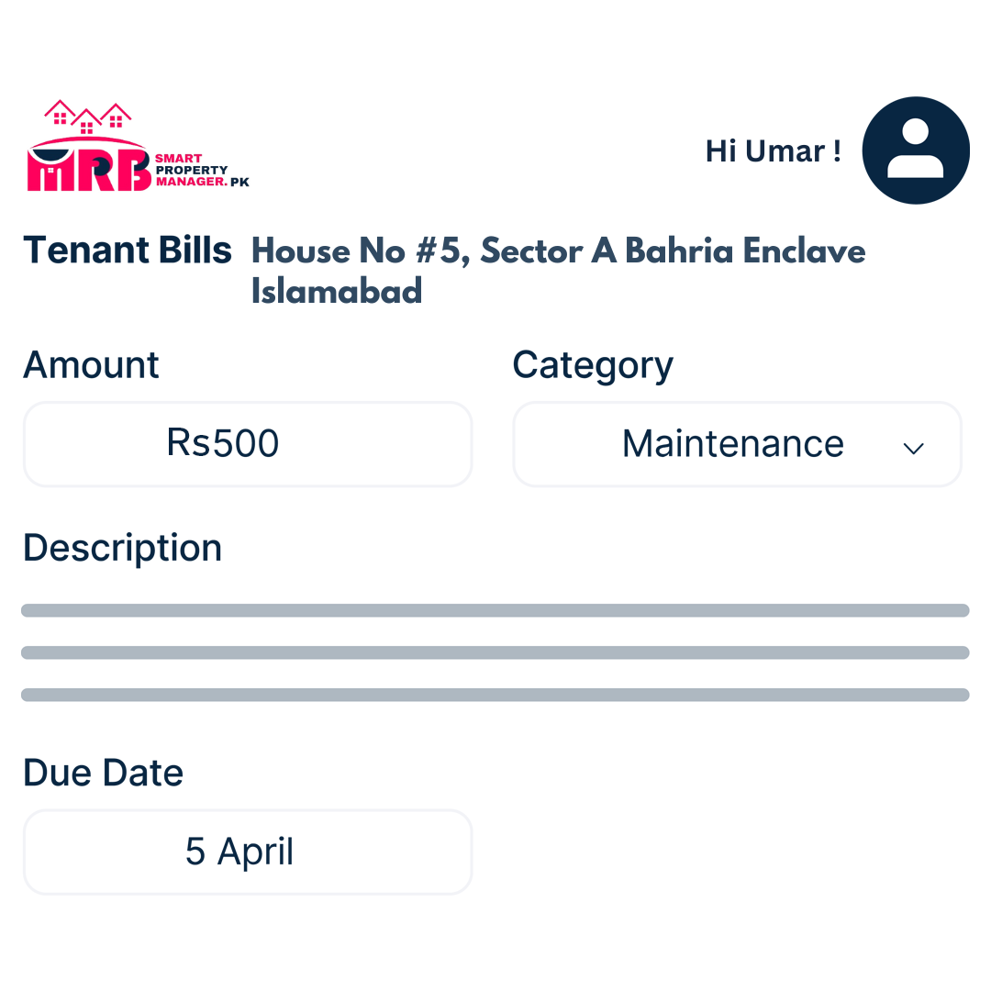
Quickly create and send an invoice to your tenant. Enter the amount owed, attach any receipts or related documents, then instantly send your bill.

Step 2
Check Bill Status & Details
Each bill is stored with invoice details and tagged with payment status (paid/unpaid/processing). Bills are organized by financial year.

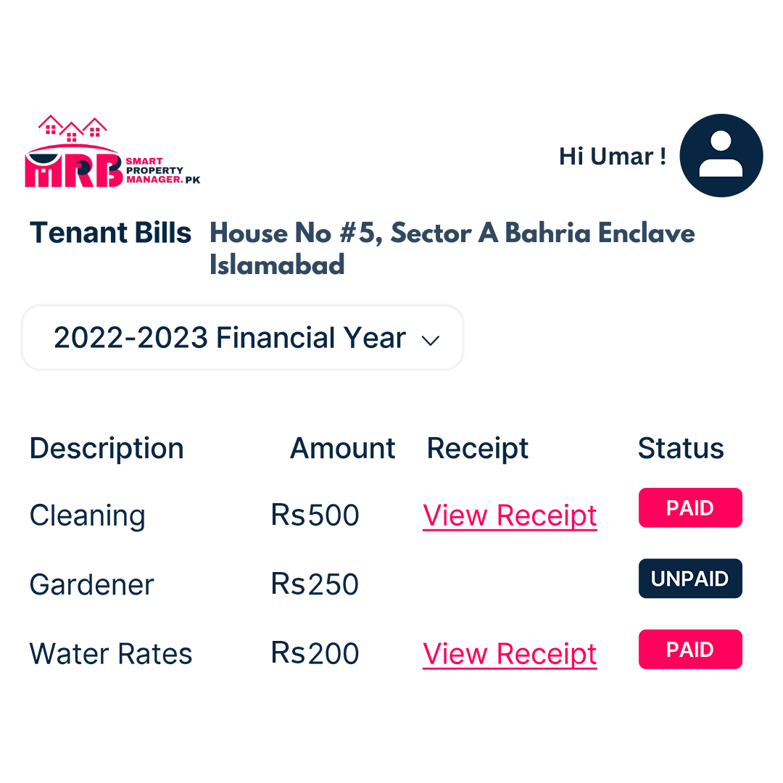

Step 3
Tenant Makes Payment
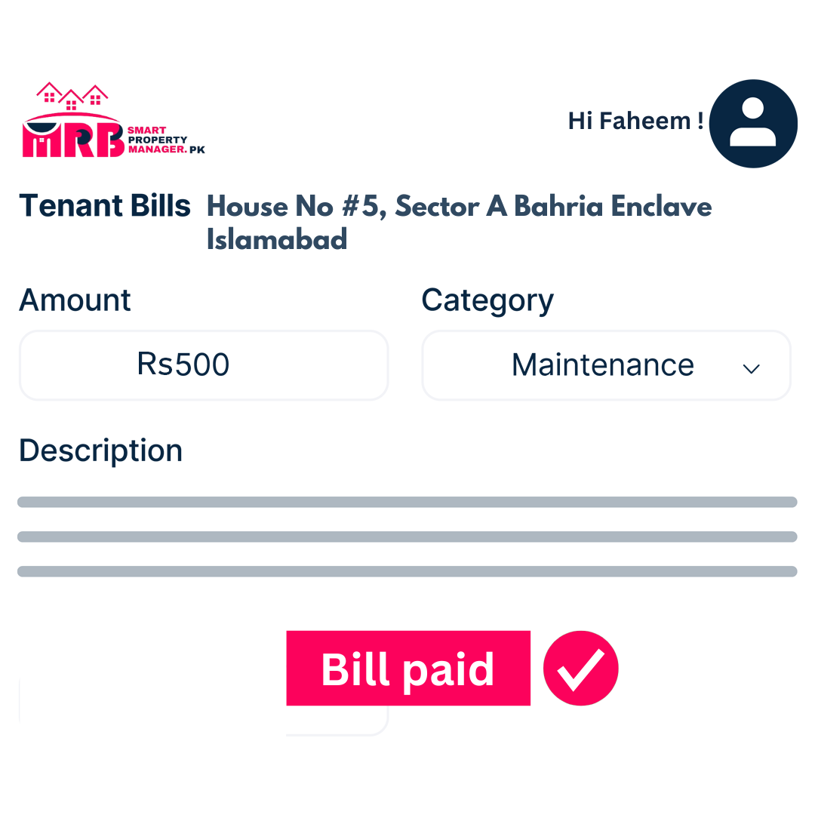
Your tenant will receive an automatic notification about the bill. They can make the payment directly via SmartPropertyManager.pk.

Maintain
Feature#12:

Generate Reports
Generate Reports
Create property reports for tax time or any other time with SmartPropertyManager.pk! Your rental payments and expenses will automatically populate reports whenever you need them. They’ll be ready in minutes.

Step 1
Review Information
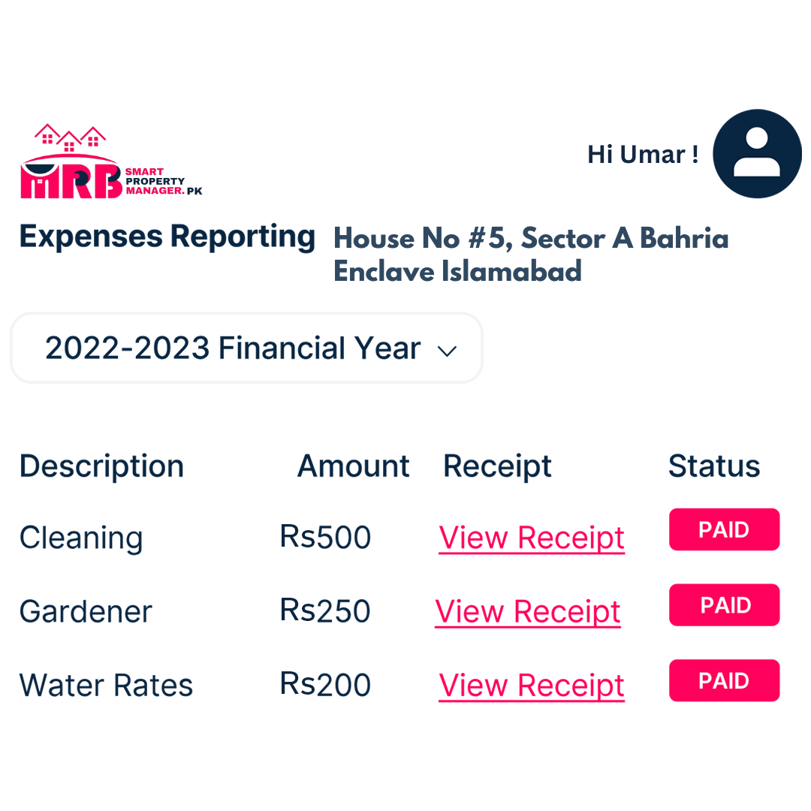
Check the information automatically filled under ‘income’ or ‘expense’ for your property.

Step 2
Add New Report Items
Enter new report items by adding ‘income’ or ‘expense’ and attach receipts or relevant documents for your records.

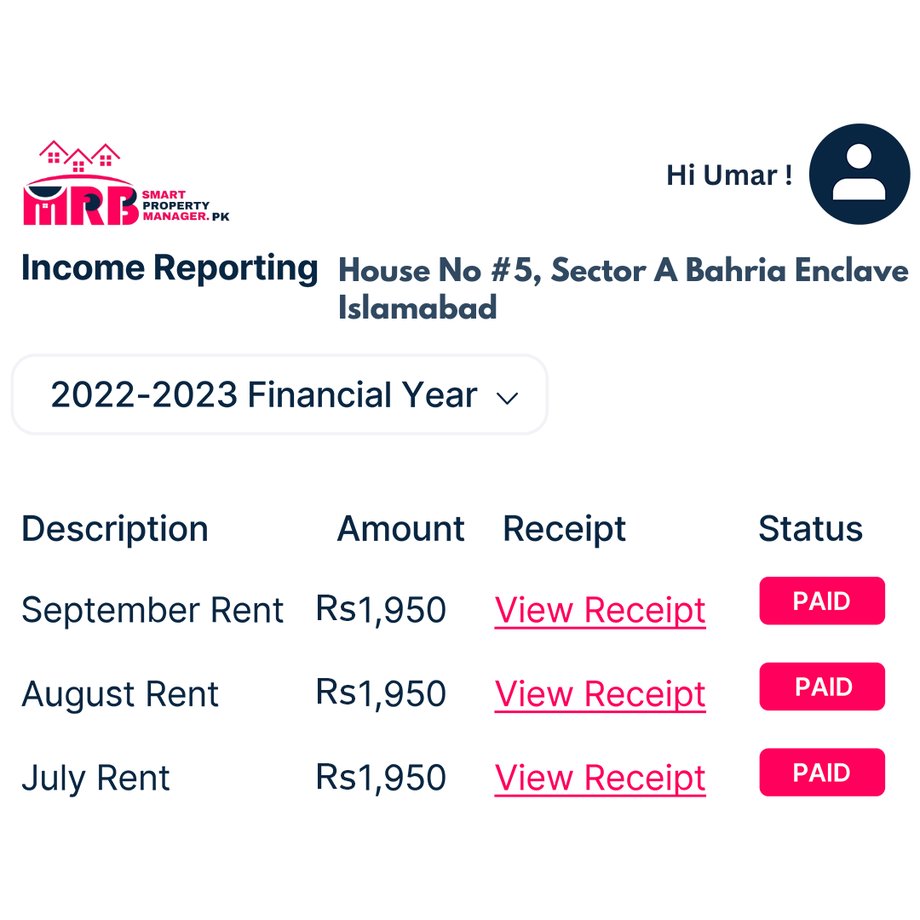

Step 3
Download Report
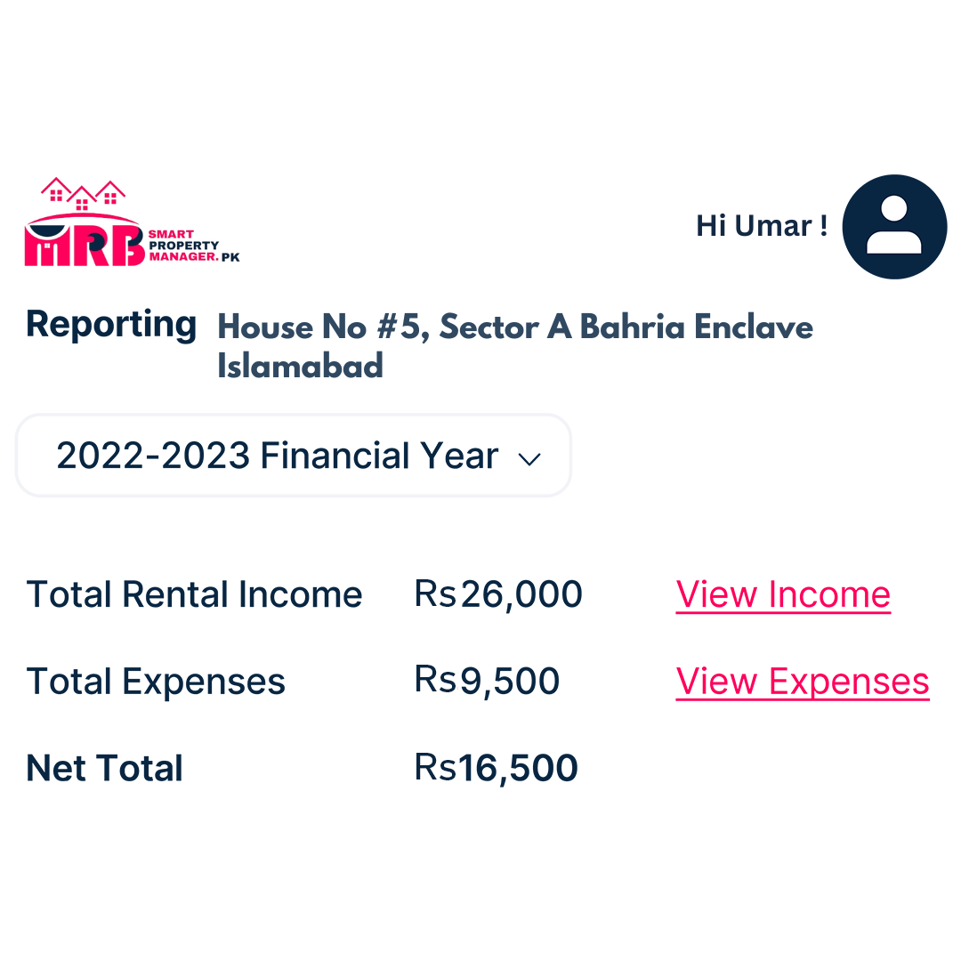
Download a copy of the report immediately or access it on SmartPropertyManager.pk anytime. Your reports will be saved for each financial year.

Feature#13:

Organize Maintenance & Repairs
Organize Maintenance & Repairs
Both you and your tenant can submit maintenance requests through SmartPropertyManager.pk and track their progress. You can then hire a local tradesperson to complete the job. Here's how:

Step 1
Add Task
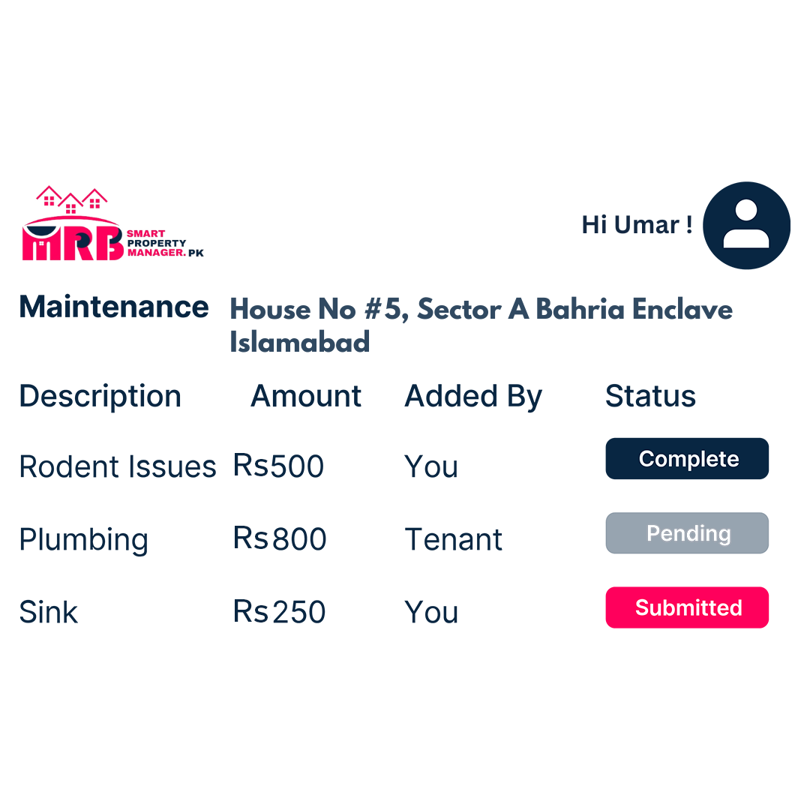
Enter a new task or review existing tasks submitted by your tenant.

Step 2
Task Details & Receipts
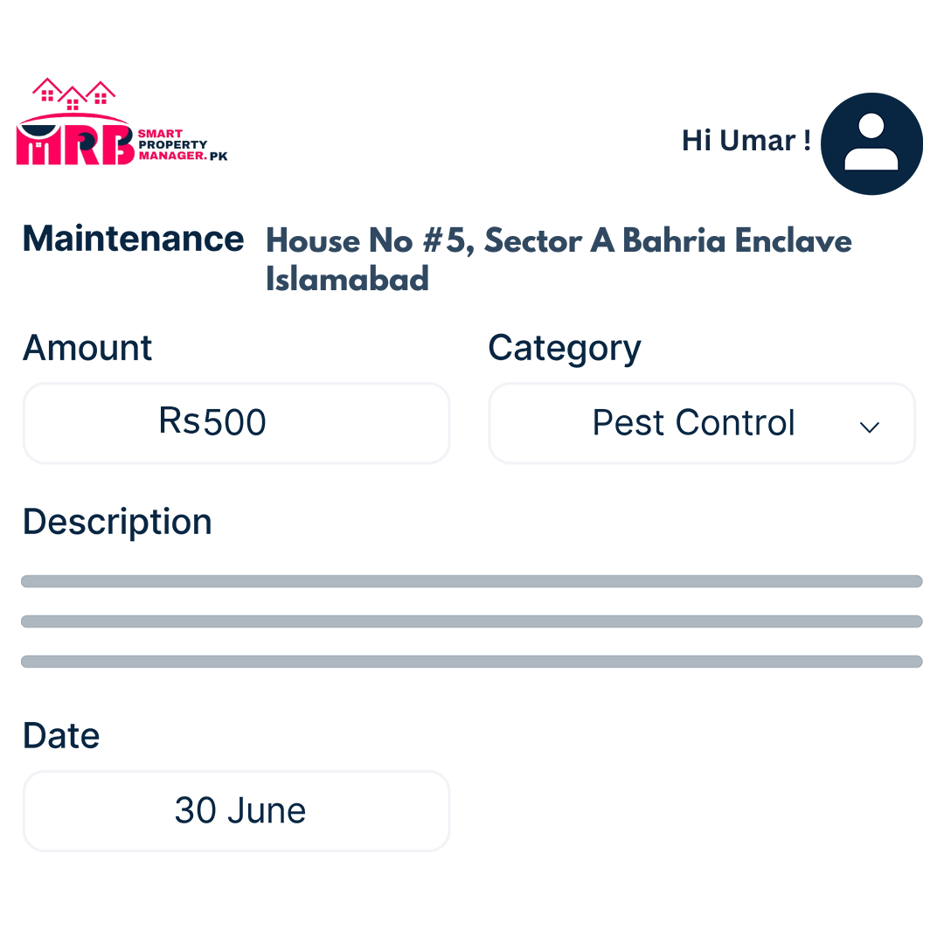
Enter task details and attach receipts or relevant documents.

Step 3
Complete Maintenance & Generate Report
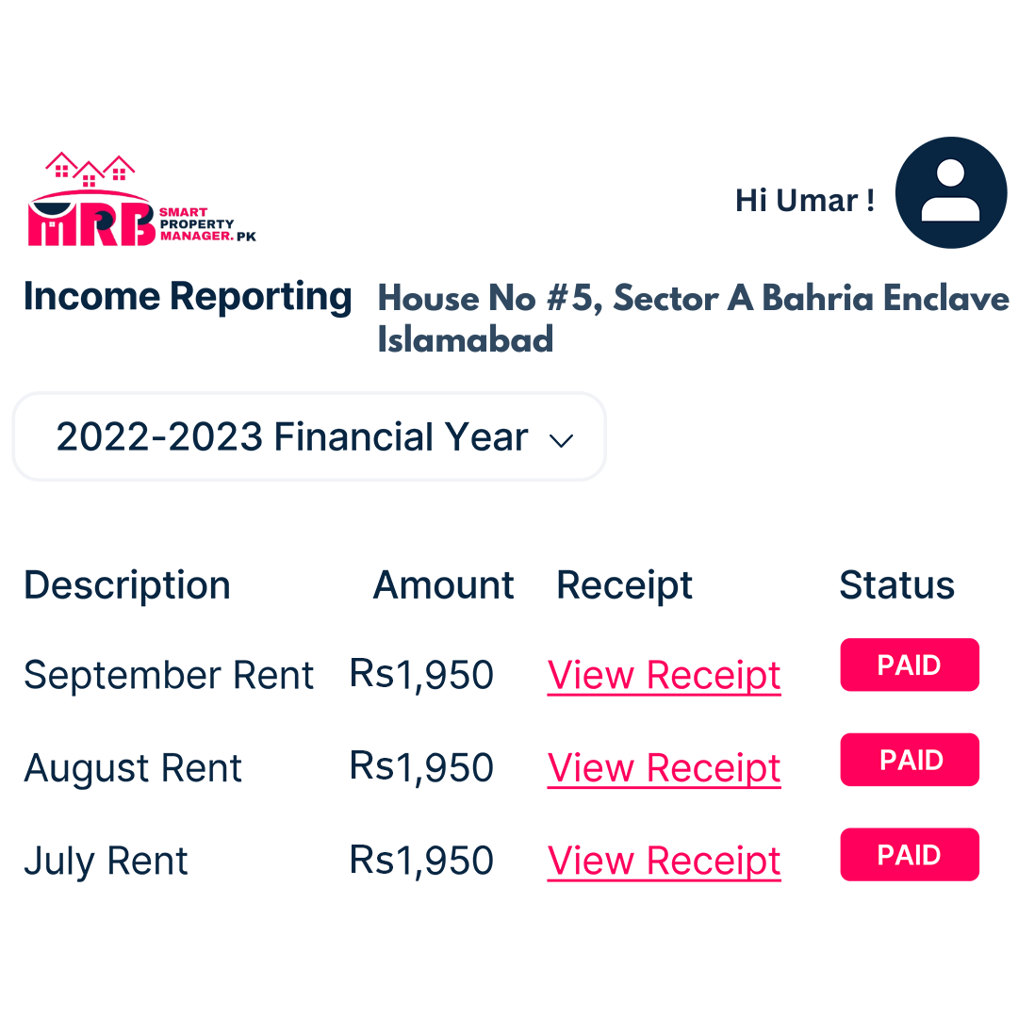
Once done, the maintenance expense details will be automatically logged in SmartPropertyManager.pk and will appear in your reports.

Hire a Tradesperson
Need a gardener, plumber, or electrician? With SmartPropertyManager.pk, you can easily find and hire a qualified professional to handle essential property jobs.
- Search for a Tradesperson Search by trade type (e.g., tiler, cleaner, electrician) in your suburb or postcode.
- Set Up Your Job Provide job details and attach photos if available. Specify when you need the job done.
- Receive Quotes Get prices and quotes from local professionals.
- Select Your Tradie Compare quotes and choose the best person for the job. Finalize the details with your tenant. Easy!

Feature#14:

Conduct Routine Inspections
Conduct Routine Inspections
It’s essential to check the condition of your property regularly. You can do this through SmartPropertyManager.pk in two ways:
- Complete a digital inspection using the Smartpropertymanager.pk condition report template, or
- By Hire a professional for an in-person inspection
All reports will be saved in your 'My Properties' dashboard for easy reference or updates.

Step 1
Customize Your Inspection Template
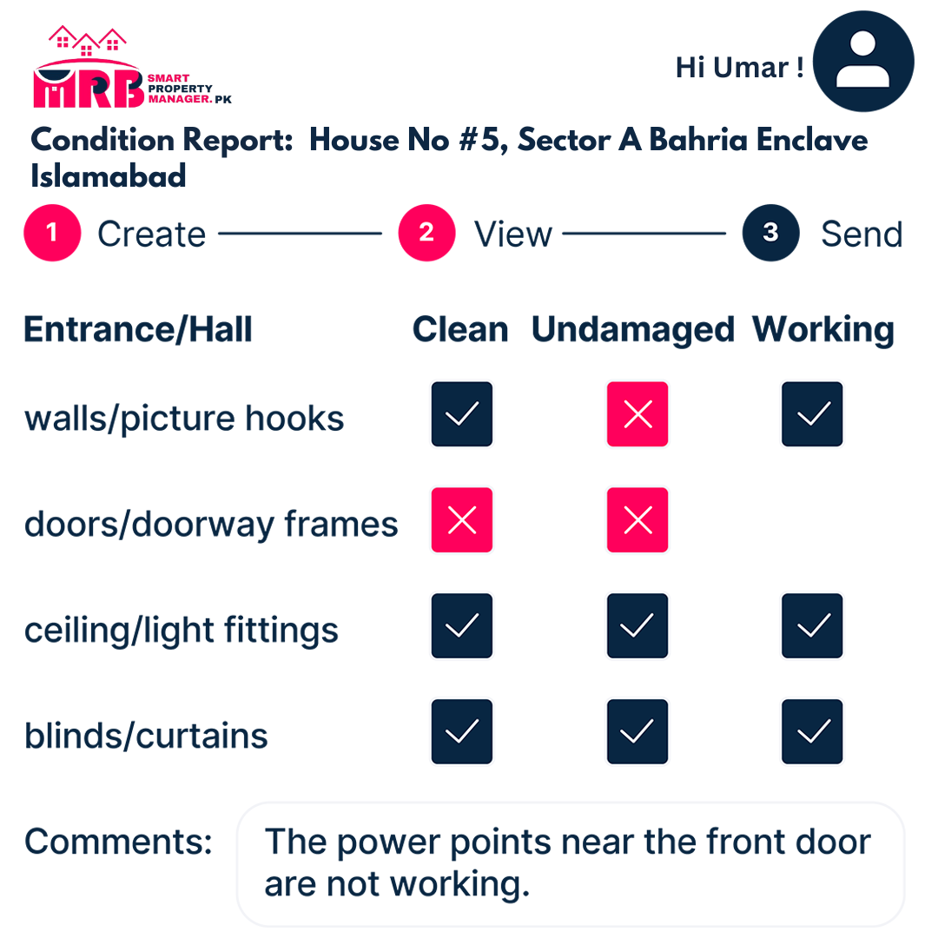
Your SmartPropertyManager.pk inspection template can be tailored to reflect the specific rooms in your property, making it easier to use.

Step 2
Inspect with Ease
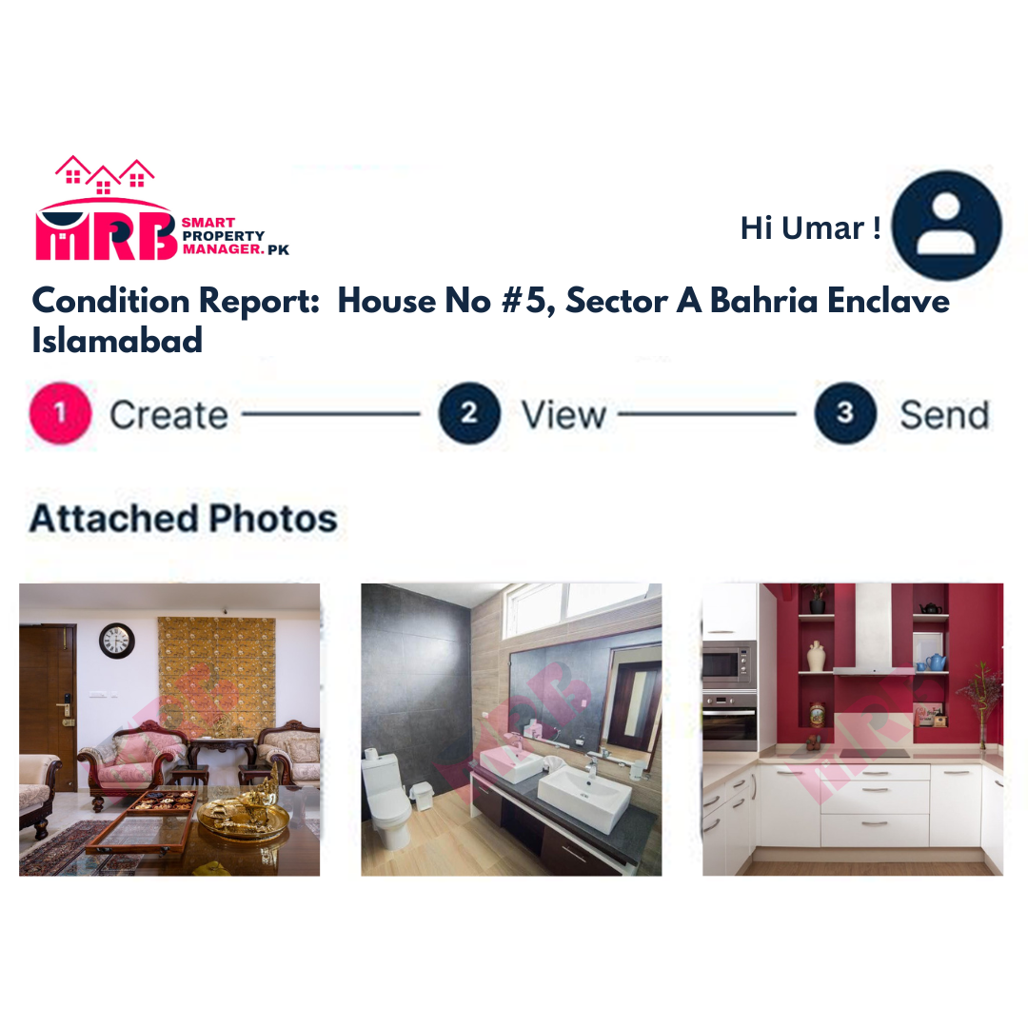
Add pictures and comments to thoroughly inspect all rooms of your property from your computer, tablet, or mobile device.

Step 3
Sign & Send to Your Tenant
Send the completed condition report to your tenant for their review and input if needed. You can save the report for future reference or updates.

Booking a Professional for Your Inspection
- Request Booking Sign in to your SmartPropertyManager.pk account, click on ‘Condition Report,’ and choose ‘Book a Professional.’
- Confirmation Your booking request will be confirmed within 24 hours by a team member.
- Inspection Completed A qualified professional will conduct an in-person inspection of your property.
- Approve & Sign Once the inspection is done, the report will be available online for you to digitally sign and approve.

Feature#15:

Store your Documents
Store Documents
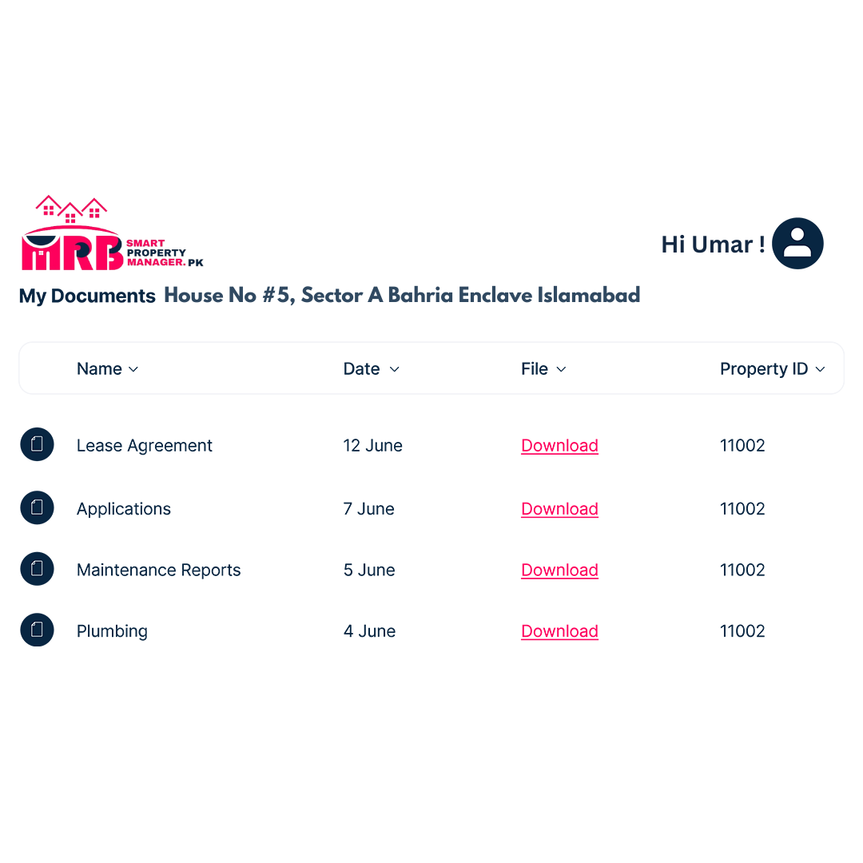
Forget about paper clutter! With SmartPropertyManager.pk, you can store all your important property documents securely online.

Documents Automatically Saved
Any documents you create through SmartPropertyManager.pk will be automatically saved to ‘My Documents’ in your dashboard.

Upload Additional Documents
Say goodbye to the filing cabinet! Upload and save any extra property documents directly to SmartPropertyManager.pk.

Sort Through Documents
Easily search and sort your documents by type, category, property ID, or address. No more wasting time searching for misplaced lease agreements!

Organize Viewings
Schedule in-person viewings of your property with potential tenants effortlessly.

Toolkits
Toolkit#01:

Rental Estimate Report
Rental Estimate Report
Discover how much weekly rent you can expect for your property with Smartpropertymanager.pk. Get a comprehensive report, including property details and current local market data.

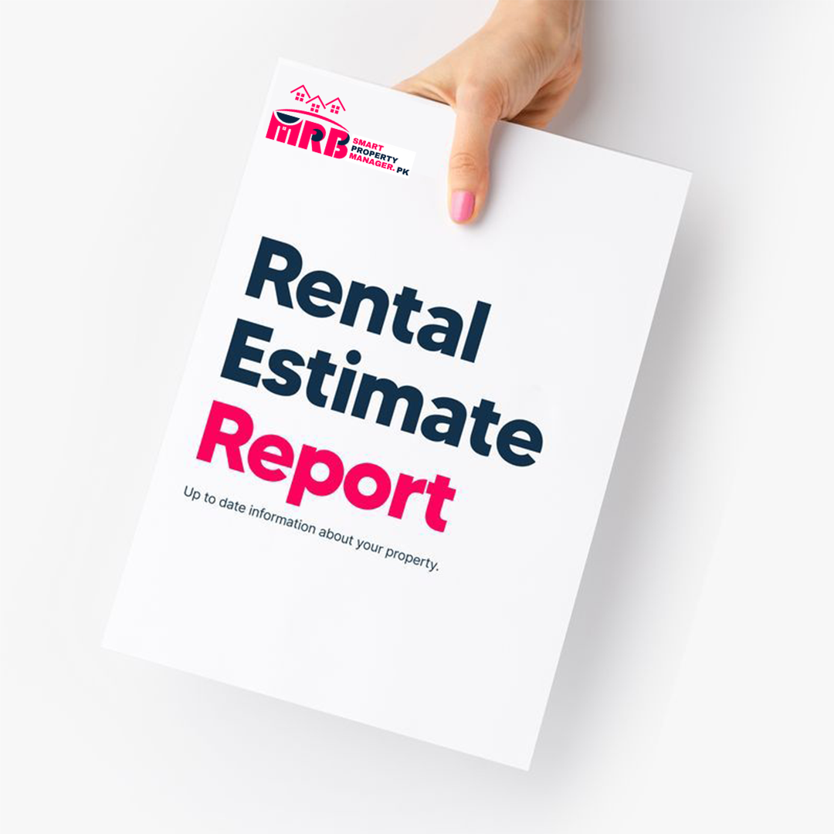

What's Included in Your Report?
Property Features & Details Learn about the key features and details of your property, such as floor area, value, and rental history.
Rental Estimate Find out the estimated rent amount tailored to your property.
Comparative Market Analysis Get insights into the rental and sale prices of similar properties in your area, based on recent listings.
Local Area Insights Gain a better understanding of your suburb, including sales trends and local market insights over time.

Toolkit#02:

Agent Switch Kit
Switch From Your Agent Kit
Ready to take control of your property? This kit will walk you through the process of saying goodbye to your agent (and their fees) and transitioning to self-management.
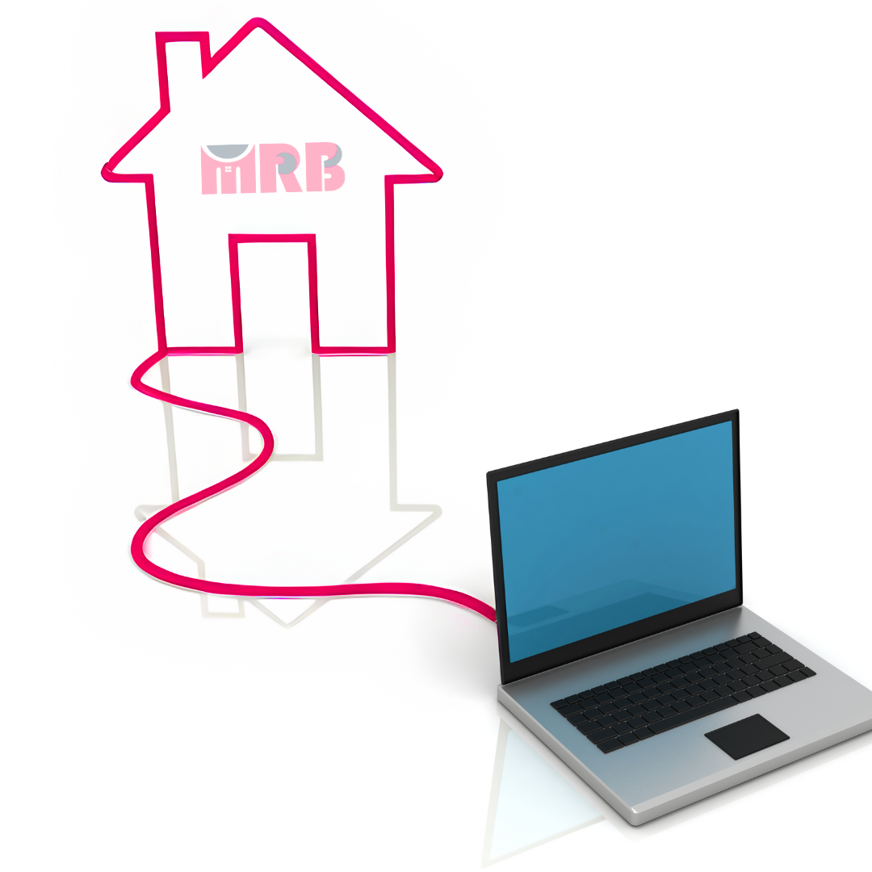

What's Included in Your Kit?
Agent Switch Checklist Follow these basic steps to smoothly transition from your agent to self-management while keeping your tenant onboard.
FAQs on Self-Management Find answers to common questions about starting to manage your property yourself. Save money, take control, and rent better with Smartpropertymanager.pk.
Formal Termination Letter A pre-written letter ready for you to send to your property agent.
Toolkit#03:

E-book
Self-Management E-book

Looking to rent out and manage your property yourself? This guide has got you covered!

What's Included in Your Guide?
Essential Tips Learn valuable insights and tips to help you successfully rent out and manage your property.
Step-by-Step Instructions Follow easy-to-understand steps to navigate the process of self-management, from advertising your property to handling tenant inquiries and maintenance requests.
Common Pitfalls to Avoid Discover common mistakes to steer clear of when self-managing your property to ensure a smooth and successful experience.

Toolkit#04:

Saving Calculator
Savings Calculator

Enter your weekly rent and agency fee to discover the potential savings you could enjoy within a year on Smartpropertymanager.pk.

- Weekly Rent: [Enter Your Weekly Rent]
- Agency Management Fee: [Enter Your Agency Management Fee]
Your Potential Savings per Year: RS. 425.96
(Note: Total savings over 12 months for residential rental properties. Assumes a 12-month average tenancy length, a 2-week leasing fee, and 50,000PKR listing fee.)

Toolkit#05:

FAQs
Frequently Asked Questions

Q: How does SmartPropertyManager.pk work?
A: SmartPropertyManager.pk is a comprehensive property management platform that allows landlords to efficiently manage their rental properties online. It offers features such as property advertising, tenant management, rent collection, expense tracking, and document storage, all accessible from your computer or mobile device.
Q: How do I advertise my property on SmartPropertyManager.pk?
A: Advertising your property on SmartPropertyManager.pk is simple. Just create an account, fill in the details of your property, including description, photos, and rental price, and publish your listing. Your property will then be visible to potential tenants on our platform.
Q: Can I manage tenant enquiries and applications through SmartPropertyManager.pk?
A: Yes, absolutely! SmartPropertyManager.pk provides tools to manage tenant enquiries and applications seamlessly. You can receive, sort, manage, and respond to enquiries directly from your dashboard. Additionally, you can review and process tenant applications efficiently within the platform.
Q: How does rent collection work on SmartPropertyManager.pk?
A: Rent collection on SmartPropertyManager.pk is automated and hassle-free. Tenants can make payments through the platform using various methods such as credit card or bank transfer. You'll receive notifications when payments are made, and receipts are generated automatically for both you and your tenants.
Q: Can I track expenses and generate reports using SmartPropertyManager.pk? A: Yes, you can! SmartPropertyManager.pk allows you to track all your property-related expenses and generate detailed reports. You can upload receipts, categorize expenses, and access financial reports, making it easy to monitor your property's financial performance.
Q: Is there a way to conduct routine inspections through SmartPropertyManager.pk?
A: Absolutely! SmartPropertyManager.pk offers tools for conducting routine inspections of your property. You can use digital inspection templates, add photos and comments, and send inspection reports to your tenants for review.
Q: How secure is my data on SmartPropertyManager.pk?
A: Security and privacy are top priorities for us. SmartPropertyManager.pk employs industry-standard security measures to safeguard your data. All information is encrypted, and access to your account is protected with secure authentication methods.
Q: What support is available if I have questions or encounter issues while using SmartPropertyManager.pk?
A: We offer comprehensive customer support to assist you with any questions or issues you may have. You can reach out to our support team via email or live chat, and we'll be happy to help you resolve any queries promptly.
Toolkit#06:

Blogs
Blog-1


Legal Responsibilities for Self-Managed Landlords
A Guide to Your Legal Duties as a Landlord
‍Renting out a property can be demanding, especially when it comes to understanding your legal obligations. As a self-managed landlord, it's essential to know your rights and responsibilities to ensure a smooth rental experience for both you and your tenants.
At SmartPropertyManager.pk, we're here to help you navigate the legal landscape. In this guide, we'll walk you through the basics of your legal responsibilities, so you can confidently manage your property.

Understanding Your Legal Duties
‍To maintain compliance with the law and protect yourself from legal issues, it's crucial to understand your legal responsibilities as a landlord. Here's why staying informed is essential:
Compliance with State and Local Laws:
Each state has its own set of landlord-tenant laws that you must adhere to. Failure to comply with these laws can result in significant fines or penalties.
Protection from Legal Action:
Being aware of your legal responsibilities helps safeguard you from potential legal disputes or actions taken by tenants.
Building Positive Tenant Relationships:
By understanding and following the law, you demonstrate respect for your tenants' rights, fostering a positive landlord-tenant relationship.‍
Ensuring a Successful Rental Experience:
Compliance with legal requirements ensures a smooth and successful rental experience for both you and your tenants.
Understanding State and Local Laws
In Pakistan, rental property owners must adhere to specific legal standards to ensure tenant safety and well-being. Here are some key legal requirements you need to know:
Property Standards:
You are responsible for providing safe and habitable living conditions for your tenants, including maintaining structural integrity and essential amenities.

‍Repairs and Maintenance:
Promptly addressing repair requests and ensuring the property remains in good condition is essential to meet legal obligations.
Privacy and Access:
Respecting tenants' privacy rights and providing notice before entering the property is crucial, except in emergencies.
By understanding and fulfilling your legal responsibilities, you can ensure a positive rental experience for both you and your tenants.

Blog-2
Top Tips for Ensuring a Smooth Move-in Process


Your Essential Guide to Making Move-in Day Stress-Free
Moving into a new place is an exciting milestone, but it can also be a stressful time for both landlords and tenants. To ensure a smooth transition, it's essential to be prepared and organized. Here are some practical tips to make move-in day a breeze:
Before Move-in Day
In the days leading up to move-in day, there's a lot to do to ensure everything goes smoothly. Here's what you can do to prepare:‍
- Complete Necessary Paperwork: Ensure all lease agreements and other essential documents are signed and ready before move-in day.
- Clean and Prepare the Property: Make sure the property is clean, sanitized, and in good condition for the new tenants.
- Set Up Utilities: Arrange for utilities such as electricity, water, and internet to be connected before move-in day to avoid any inconvenience.
- Inspect the Property: Conduct a final walkthrough of the property to check for any maintenance issues or repairs that need to be addressed.
- Provide Clear Instructions: Give clear instructions to the tenants regarding move-in procedures, key collection, and any other relevant information.

By following these tips, you can help ensure a smooth and stress-free move-in process for both you and your tenants. With proper preparation and organization, move-in day can be a positive and memorable experience for everyone involved.

Blog-3
How to Handle Disputes with Your Tenants

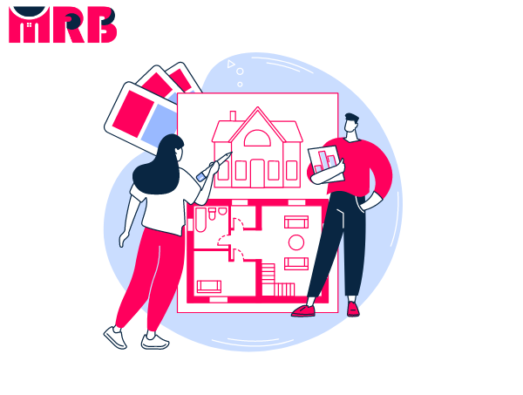

Tenant disputes are a common aspect of property management, but handling them effectively is crucial for maintaining a harmonious tenancy. Here's a comprehensive guide to managing disputes with your tenants:
Understanding Tenant Disputes
Disputes with tenants can arise due to various reasons, including unpaid rent, maintenance issues, property damage, or disagreements over lease terms. As a landlord, it's essential to address these disputes promptly and professionally to prevent further escalation.
Step 1: Review the Lease Agreement
Start by reviewing the lease agreement to understand both your rights and responsibilities as a landlord and those of your tenant. Familiarize yourself with the rules and regulations governing tenancy in your state to ensure compliance with the law.‍
Step 2: Open Communication
Initiate a dialogue with your tenant to discuss the issue at hand. Maintain a calm and respectful demeanor during the conversation and try to reach a mutually acceptable resolution. Document any agreements reached in writing to avoid misunderstandings later on.
Step 3: Consider Mediation
If direct communication fails to resolve the dispute, consider engaging in mediation with the assistance of a neutral third party. Mediation provides an opportunity for both parties to express their concerns and work towards a compromise.

Step 4: Formal Complaint or Tribunal‍
If mediation proves unsuccessful, you may need to escalate the matter by lodging a formal complaint or seeking recourse through a tenancy tribunal or court. Be prepared to present evidence to support your case and adhere to the legal procedures outlined by your state government.
‍
By following these steps and maintaining open communication with your tenant, you can effectively navigate tenant disputes and uphold the integrity of your rental property. Remember to prioritize professionalism and cooperation to achieve a satisfactory resolution for all parties involved.

Marketplace
Marketplace#01
Run a Tenant Check:
Conduct Tenant Check
Step 1
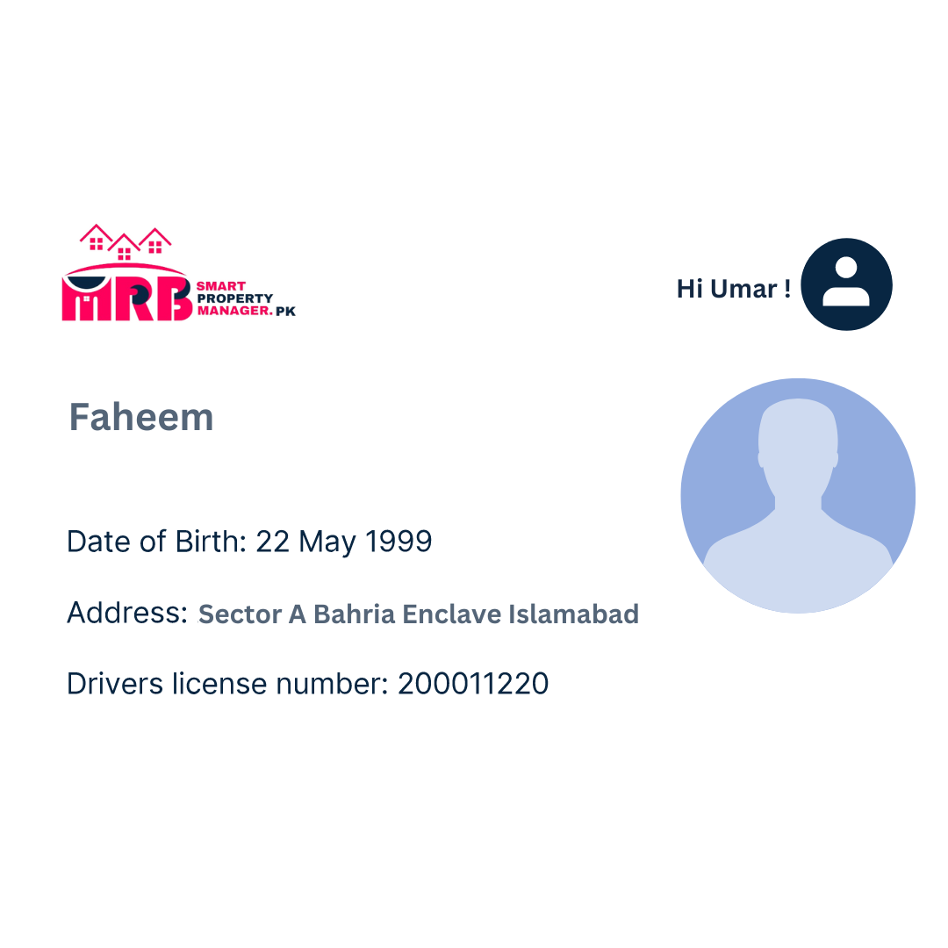
Enter Tenant Details Simply provide basic information about your prospective tenant, such as their name, current address, and one form of identification, like their CNIC number.

Step 2
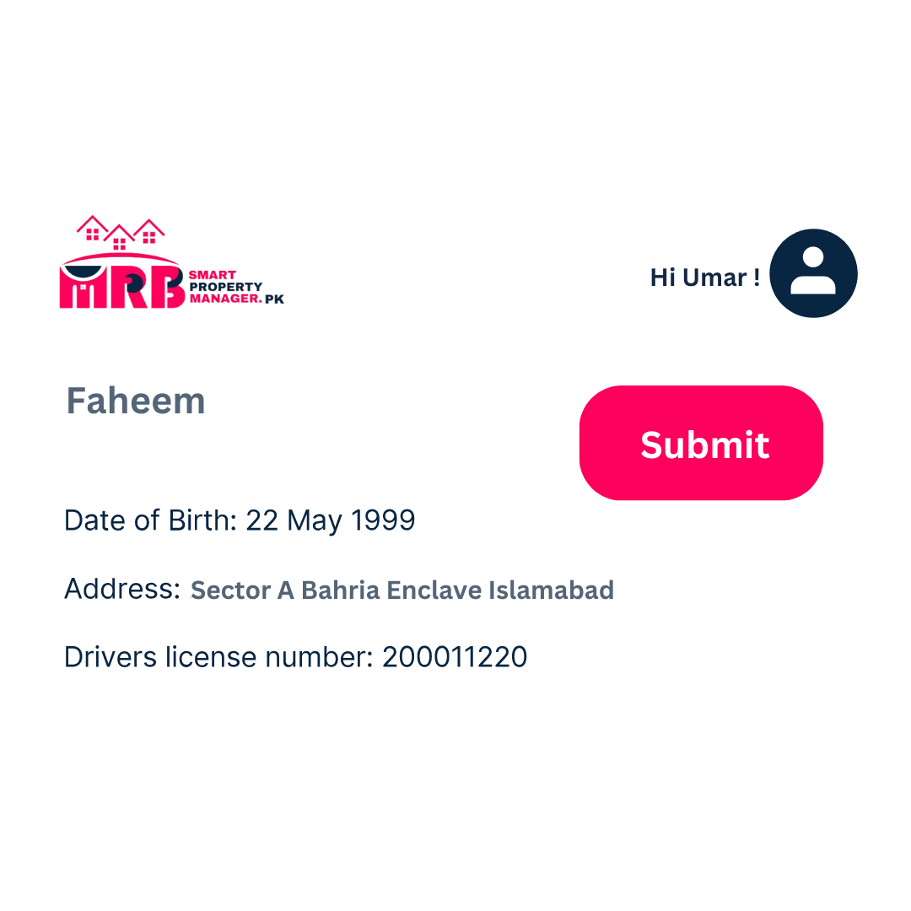
Submit Request Submit your request to conduct a background check on your tenant. This service is available for just PKR 2,000 (or PKR 1,400 for Smartpropertymanager.pk customers).

Step 3
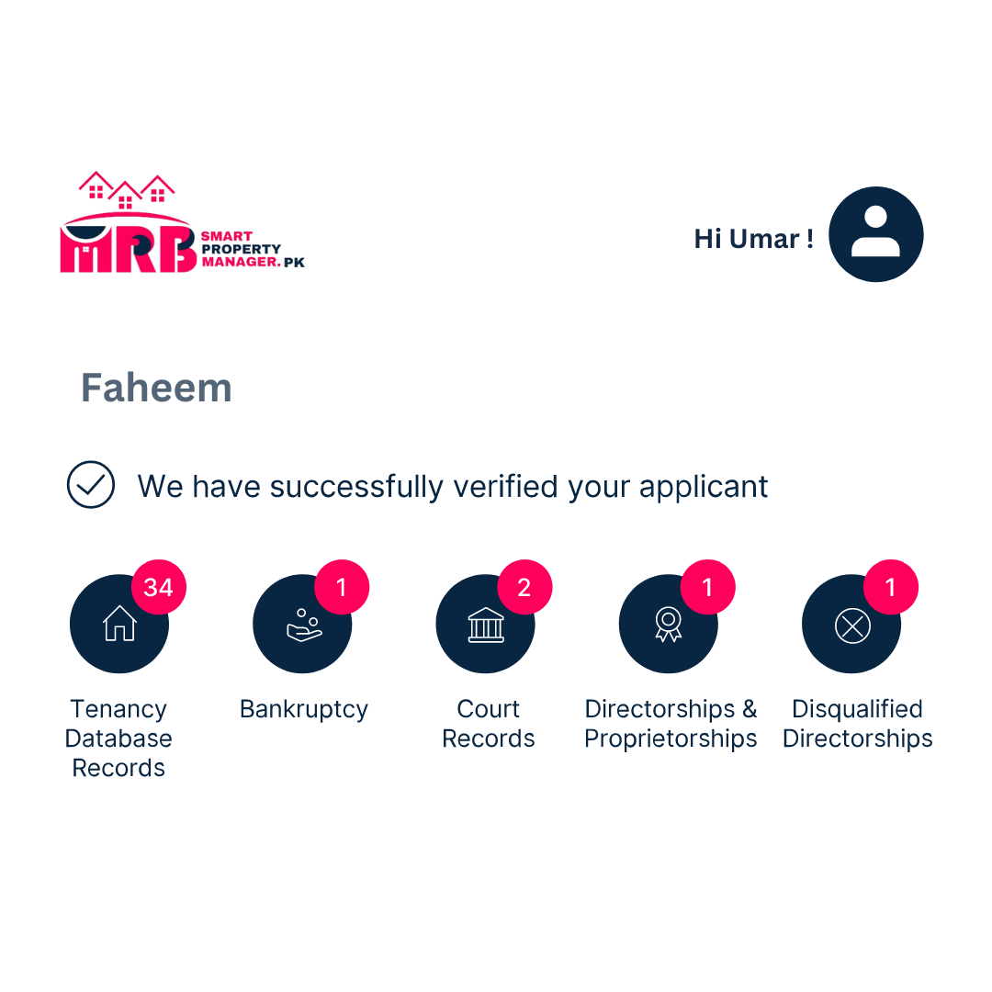
Receive Your Report Instantly Get your comprehensive report within minutes. You can choose to download it or have it emailed directly to you.

What Does the Report Include?
- Past Tenant History: Review the rental history of your prospective tenant, including any past agency screenings or listings on the tenant blacklist.
- Identity Verification: Verify the identity of your tenant by cross-checking against national databases and directories.
- Financial and Legal History: Discover any past financial troubles or legal issues, including bankruptcy information and court records.
- Directorship Details: Find out if your tenant has any associations with companies and their directorship status, including disqualifications.

Marketplace#02
Book a Condition Report:

Schedule a Condition Report
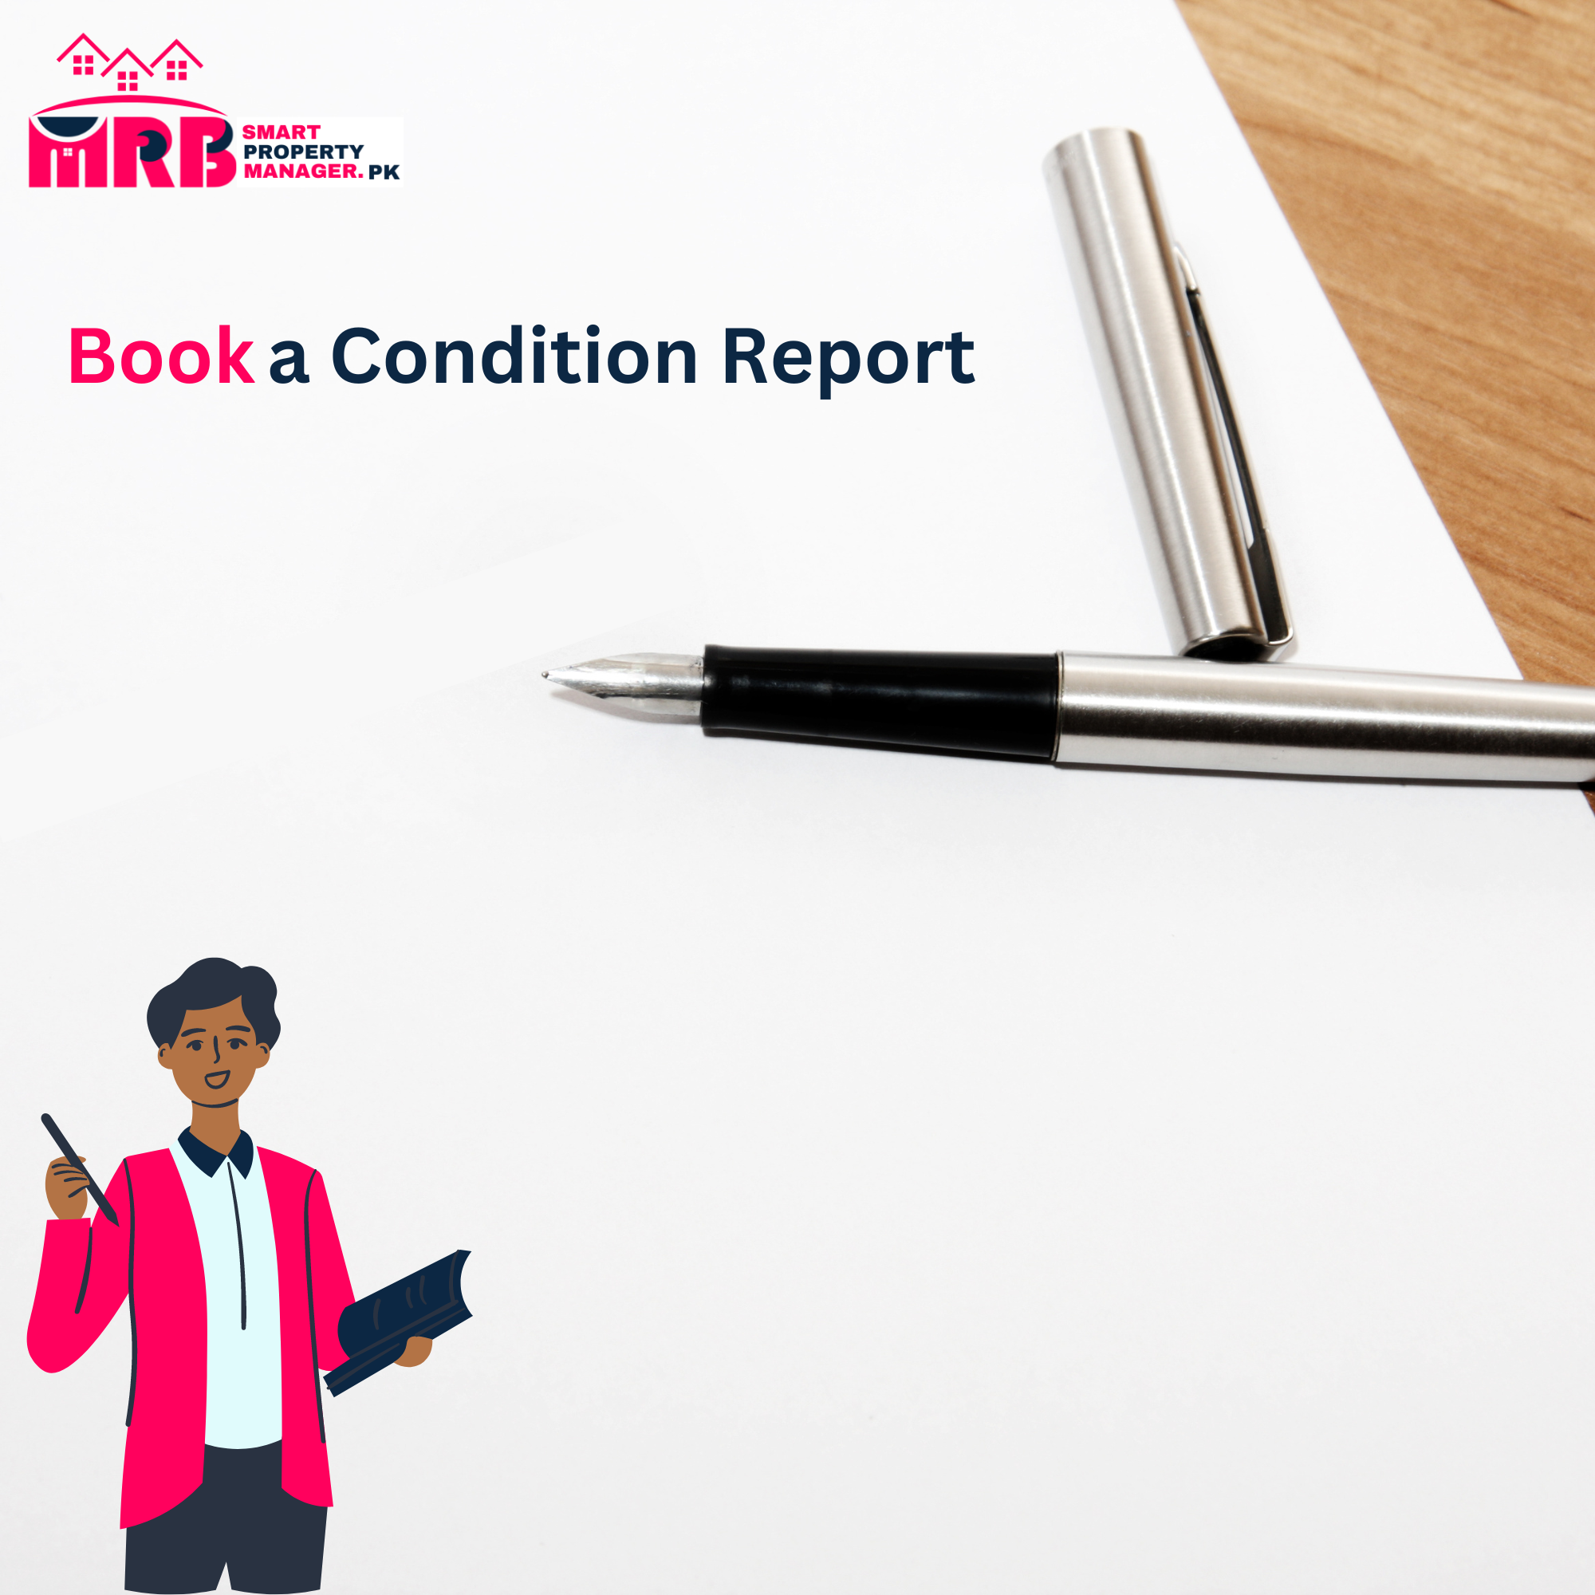
Conducting an initial condition report and regular rental inspections is essential. This helps identify maintenance issues, ensures tenants are maintaining the property well, and helps retain the value of your property.

With SmartPropertyManager.pk, you can easily hire a qualified professional to handle this for you, all for just RS. 25,000.
Step 1: Request Booking
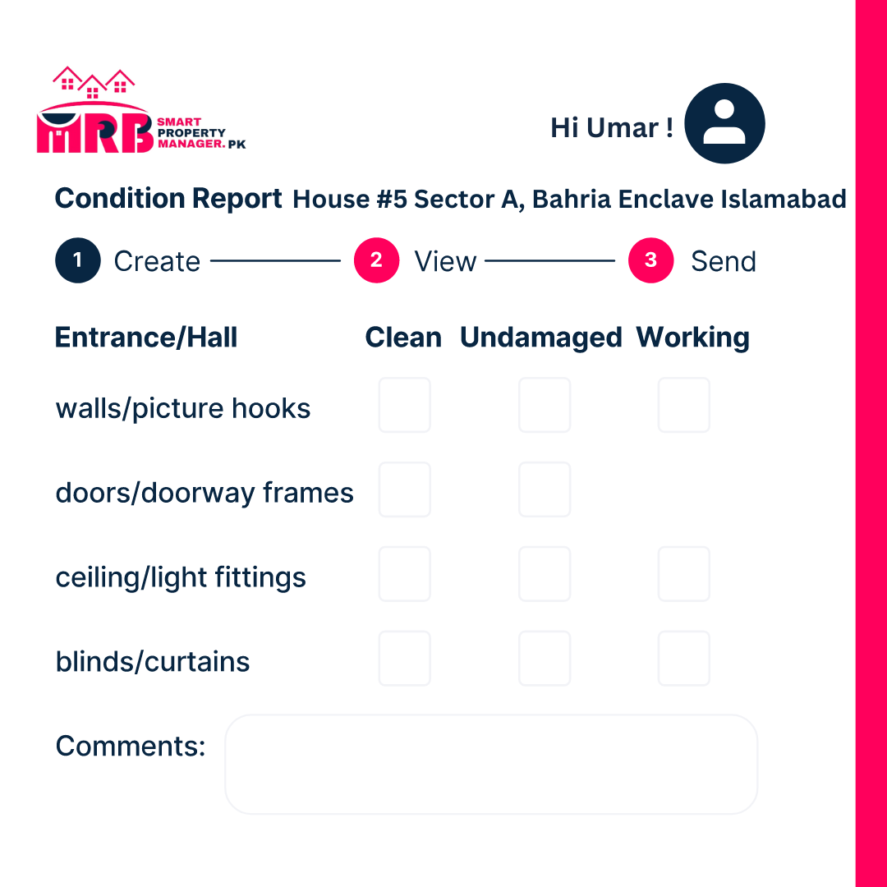
Log in to SmartPropertyManager.pk, navigate to 'Condition Report', and choose 'Book a Professional'.

Step 2: Report Completed
A qualified professional will complete the inspection in person.
.
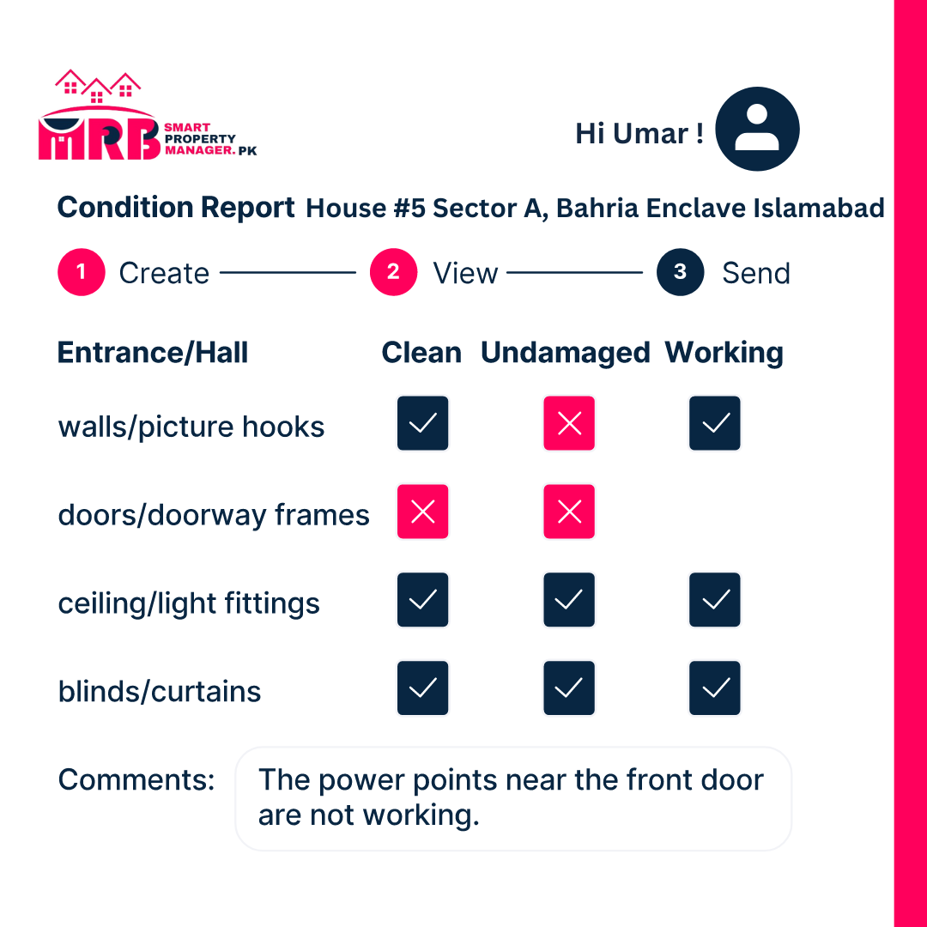

Step 3: Approve & Sign
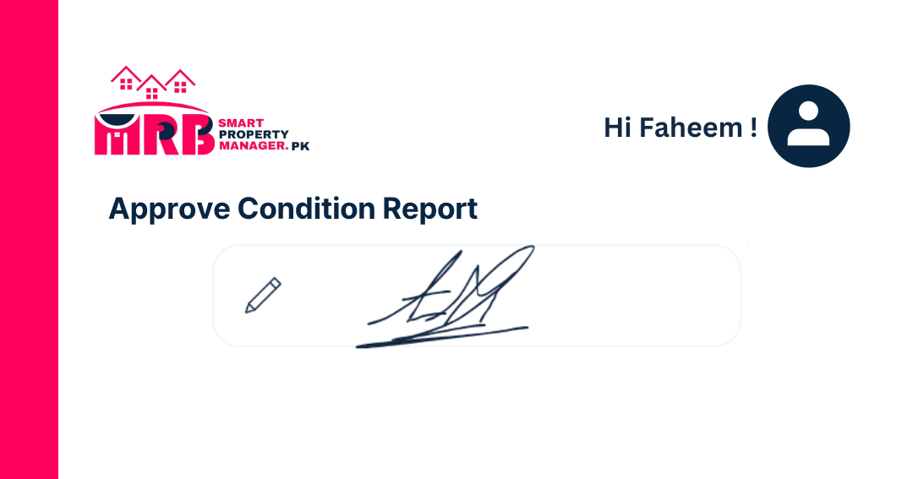
Once the inspection is complete, the report will be available online for you to digitally sign and approve.

Why Book a Professional for Your Condition Report or Routine Inspection?
Easily Book Online
Booking online with SmartPropertyManager.pk is simple. Your property details are automatically populated, so you only need to fill in the inspection form details. We’ll handle the rest!
Fast Turnaround
Need your inspection done quickly? No problem. All booking requests are responded to within 24 hours.
Certified & Trusted Professionals
We’ve partnered with Rapid Building Inspections to provide comprehensive inspections for your property, following Pakistani recognised standards – all at the click of a button.
All the Work Done for You
Completing an in-person inspection can be a hassle. With SmartPropertyManager.pk, you don't need to lift a finger. Everything will be done for you, and you just need to digitally sign your report.

Frequently Asked Questions
What is a condition report?
A condition report is a detailed document that records the state of your property at a specific point in time, usually at the start of a tenancy.
What is a routine inspection?
A routine inspection is a regular check to ensure the property is being maintained properly and to identify any necessary repairs or maintenance.

When does the condition report need to be completed?
The condition report should be completed at the beginning of a new tenancy.
How often should I conduct a routine inspection?
Routine inspections should be conducted every three to six months to ensure ongoing property maintenance.

Marketplace#03
Property Viewing:

Book Property Viewings
Property viewings, also known as open inspections, are crucial for effectively marketing your home. They allow potential tenants to see the property in person, which can be time-consuming and challenging, especially if you have a busy schedule or live far from the property.

With SmartPropertyManager.pk, you can easily manage your open inspections and viewings for just RS. 75,000 for a package of three.
Step 1: Request Booking
Sign up or log in to your SmartPropertyManager.pk account.

Step 2: Booking Confirmed
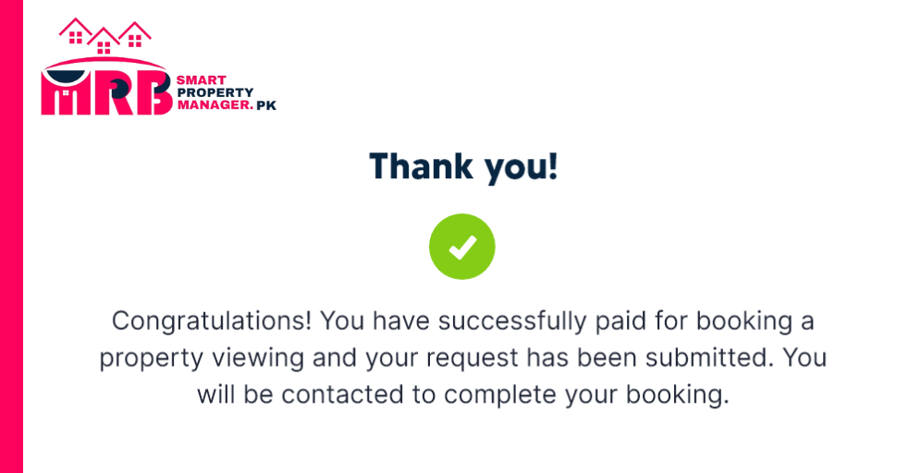
Provide the property and inspection details to our SmartPropertyManager.pk team. Once you complete all the steps, your booking request will be confirmed within 24 hours.

Step 3: Booking Scheduled
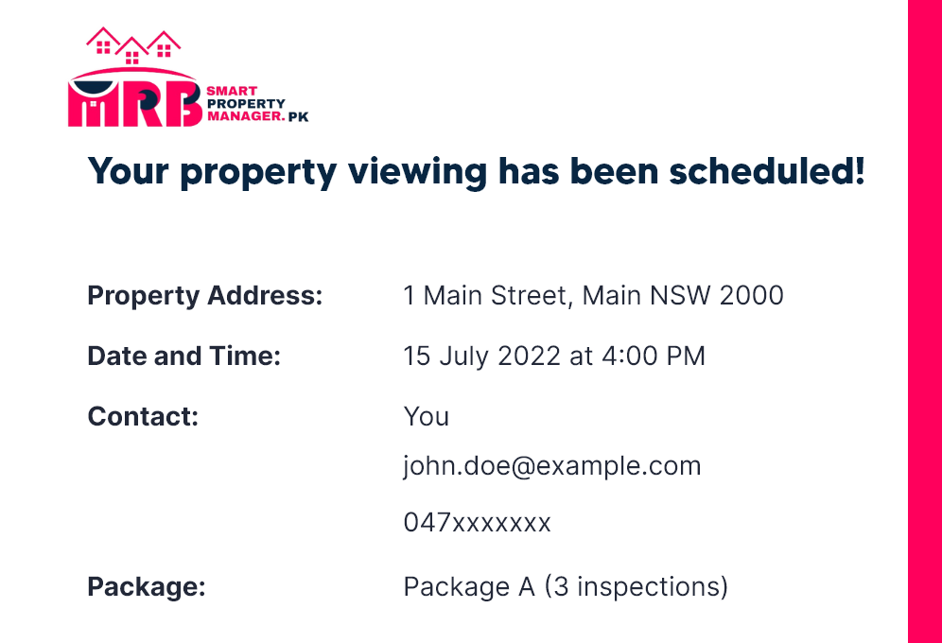
You will receive a confirmation email once your request has been scheduled.

Why Book Property Viewings or Open Inspections?
- Time-Saving Convenience
Organizing a viewing can be challenging, as it usually requires multiple visits. Hiring a trusted professional to conduct property viewings on your behalf can save you valuable time and provide a stress-free, hands-off option when you’re not able to be, or don’t want to be, at the property.
- Online Booking Ease
It's simple to book from any device, anywhere.
- Proven Experience
Rely on trusted professionals with extensive experience.
- Clear Results
We present the outcome of each inspection to help you find a tenant quickly.
- Fast Turnaround
Our prompt service handles the work for you efficiently.
- Convenience & Value
Ideal for when you can’t physically attend the property.
- All the Work Done for You
We manage the entire process of finding a tenant, so you can relax without the stress.

Frequently Asked Questions
How will I get the keys to you?
We'll coordinate with you to arrange key collection in a convenient manner.
How long will the viewing go for?
Viewings or inspections typically take no more than 30 minutes, and we schedule this time accordingly.

When does the condition report need to be completed?
The condition report should be completed at the beginning of a new tenancy.
Will I find out the results of the viewing?
Yes, we will inform you about the outcome of each viewing.
Are there any extra costs involved?
No hidden costs; everything is included in the package price.

Marketplace#04
Hire a TradePerson:

Hire a Tradesperson
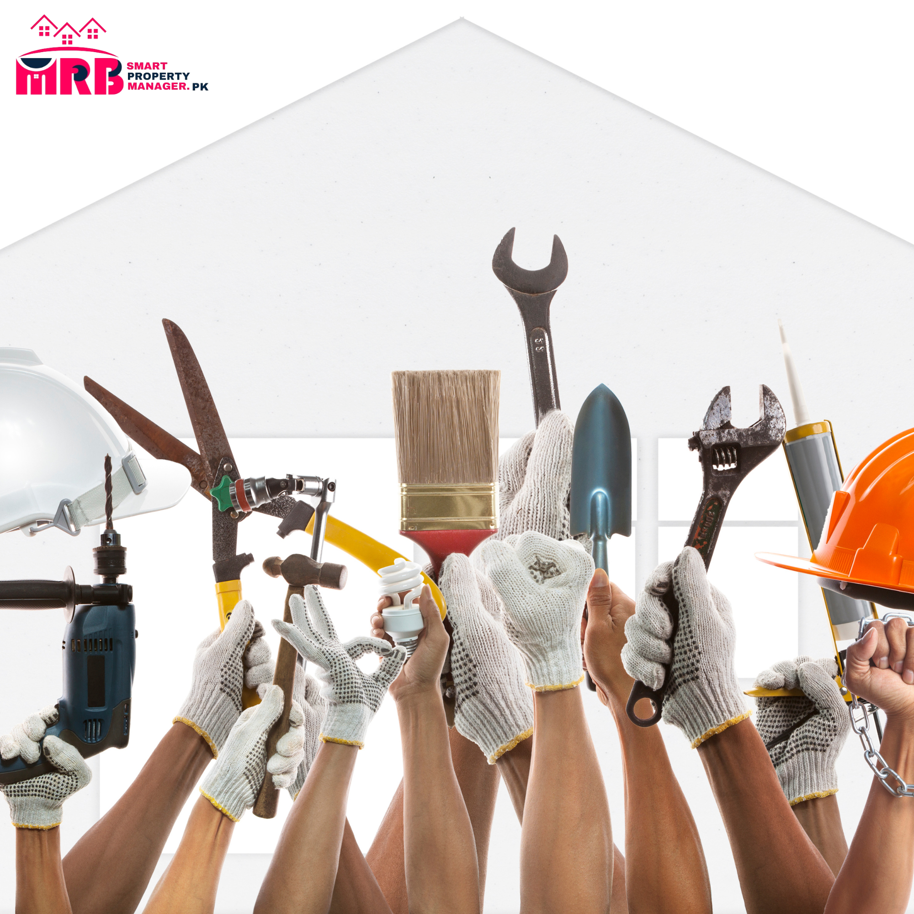
Need to hire a gardener? Find an emergency plumber? Track down a local electrician? When managing your property yourself, it’s crucial to have a network of reliable tradespeople ready to assist – just in case!

Fortunately, through SmartPropertyManager.pk in collaboration with ServiceSeeking.com.au, you’ll get instant access to a vast network of local tradespeople across Pakistan – including electricians, plumbers, painters, gardeners, cleaners, plasterers, movers, tilers, and much more.

How to Hire a Tradesperson in 4 Easy Steps
01. Search for a Tradesperson
Look up the type of tradesperson you need (tiler, cleaner, electrician, etc.) in your specific suburb or area.

02. Set Up Your Job
Provide details about the job and attach photos if available. Specify when you need the job done – urgently, this week, or on a particular date.
03. Receive Quotes
You will get prices and quotes from local professional tradespeople based on your location and job requirements.
04. Select Your Tradesperson
Compare quotes and choose the best person for the job. Finalize the time and details with your tenant. Simple!

Frequently Asked Questions
How does maintenance work on SmartPropertyManager.pk?
You and your tenant can both add any type of maintenance task required. You can address the request and mark it as complete once the work is done. Once the task is marked complete, the result and cost will appear in the expenses section of your reports.
What types of maintenance tasks can I log?
You can log any type of maintenance task needed for the property. This can include plumbing, electrical work, gardening, cleaning, and more.
How much notice do I need to provide a tenant if I require maintenance to be done on my property?
The notice period can vary, but typically it’s best to give your tenant as much notice as possible to ensure a smooth process. Always check local regulations for specific notice requirements.
Marketplace#05
Property Photography:

Professional Property Photography
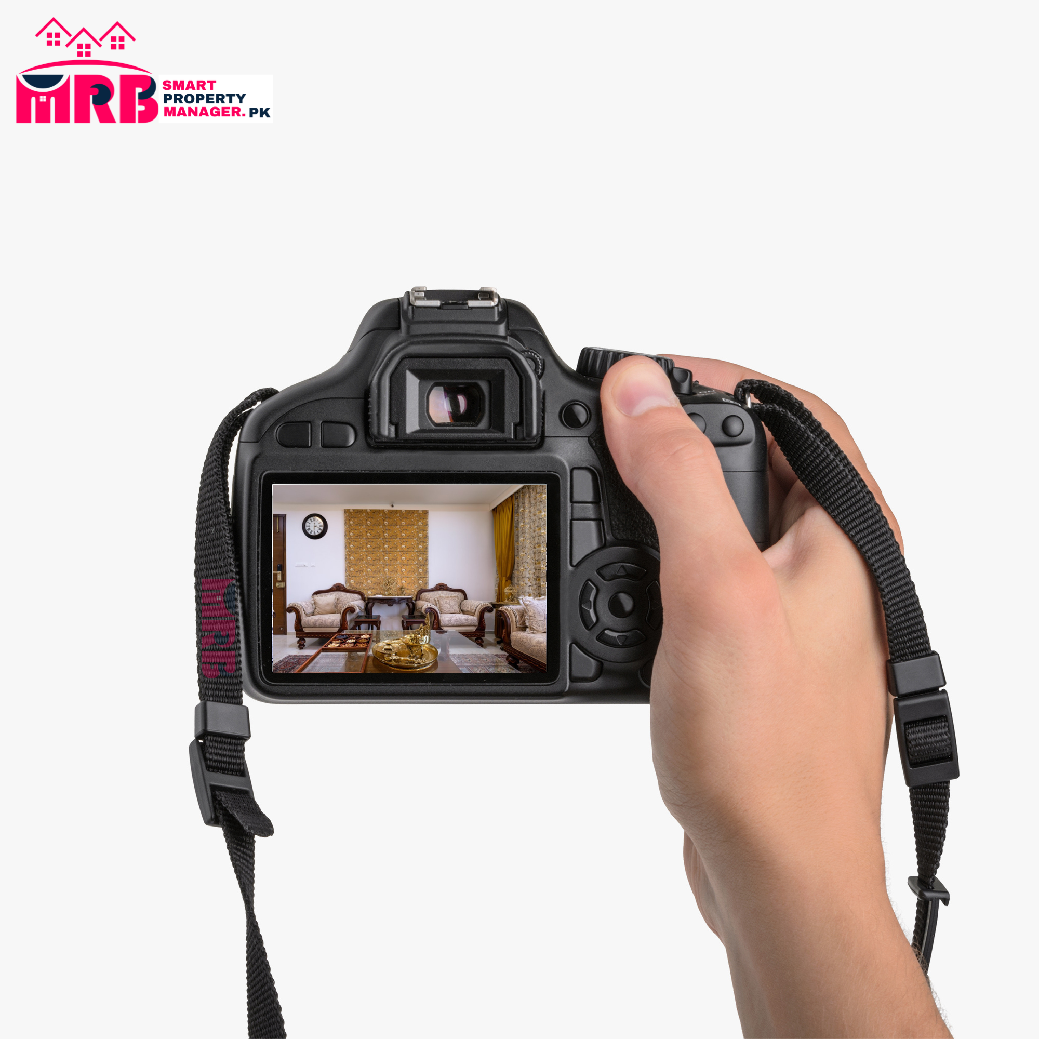
Want to attract more potential tenants, generate more inquiries, and get more clicks on your online property listing? High-quality property photos are essential for creating interest in your rental advertisement.

Through SmartPropertyManager.pk, you can arrange a professional photo shoot with top Pakistani photographers, using the code SPMPK for a 5% discount on any home photography package.

4 Steps to a Property Photoshoot
Step 1: Book
Click here to book your photo shoot and provide some basic information about your property and requirements.
Step 2: Match
In less than a minute, you will be matched with a photographer.
Step 3: Shoot
Your photographer will conduct a full, professional photo shoot at your property at a convenient time for you.
Step 4: Receive Photos & Advertise
You’ll receive your photos within 48 hours and can use them in your SmartPropertyManager.pk rental advertisement.

Frequently Asked Questions
What will I get from a professional property photography package?
You will receive high-quality, professionally taken and edited images using top-notch Pakistani cameras. This includes wide-angle shots of entire rooms, detailed photos of key features, and a consistent set of images to enhance your property listing.
Do I really need professional property photos?
Yes, professional photos attract more attention, generate more inquiries, speed up the leasing process, and help you secure the maximum possible rent for your property. While you can take your own photos, professional photography significantly enhances the presentation of your property.

Marketplace#06
Emergency Assistance:

Emergency Home Assistance
We’d all love a world where drains never clog, glass never shatters, pipes never burst, and keys never vanish. Unfortunately, emergencies do happen, so it's best to be prepared.

SmartPropertyManager.pk provides Emergency Home Assistance to alleviate the stress of finding a tradesperson during emergencies. This service ensures prompt and reliable support for home emergencies, available 24/7.


3 Steps to Get Help
Step 1: Emergency Occurs
One of the 10 emergencies listed below happens at your home. Don’t worry – SmartPropertyManager.pk has got you covered!
Step 2: Call 24/7 Support
Dial the emergency assistance number to be instantly connected with a tradesperson.
Step 3: Tradesperson Arrives
The tradesperson will promptly arrive at your property to make repairs or ensure safety.

Frequently Asked Questions
Why choose Emergency Home Assistance?
Emergency Home Assistance offers reliable, round-the-clock support, ensuring that you receive timely help from skilled tradespeople during emergencies.
What are the 10 most common home emergencies?
The 10 most common home emergencies include:

- Blocked drains
- Shattered glass
- Burst pipes
- Lost keys
- Electrical faults
- Roof leaks
- Broken heating systems
- Malfunctioning air conditioning
- Gas leaks
- Sewer backups
SmartPropertyManager.pk ensures you're never alone in a home emergency.

Marketplace#07
Landlord Insurance:

Landlord Insurance

Investing in property can be a rewarding experience aimed at building wealth and stability for your future. However, like any investment, there are risks involved. You can mitigate these risks by securing Landlord's Insurance.

Landlord's Insurance covers your property for damages caused by events such as fire or storms. Additionally, it provides benefits to safeguard your property asset and rental income from tenant and third-party-related risks.

3 Steps to Get Covered
Step 1: Submit Online Form
Start your Landlord Insurance quote by clicking the 'Get a Quote' button to access the form.
Step 2: Receive Quote
After submitting the necessary details, you'll receive a comprehensive insurance quote via email outlining the coverage options for your property.
Step 3: Get Covered
Select your desired policy, complete the payment process, and enjoy the peace of mind that comes with being covered!

Frequently Asked Questions
Why do I need Landlord Insurance?
Landlord Insurance provides crucial protection for your property investment, covering damages from various events and safeguarding your rental income against potential risks posed by tenants and third parties.
What does Landlord Insurance typically cover?
Landlord Insurance typically covers damages to your property caused by fire, storms, theft, vandalism, and tenant-related issues. Additionally, it may include liability coverage for injuries or damages suffered by third parties on your property.

Marketplace#08
Moving and Utilities:

Moving and Utilities Made Easy
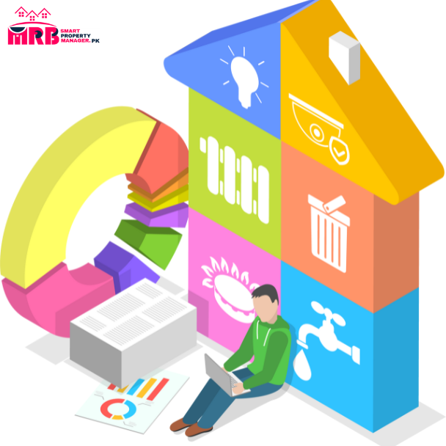
With Move Me In, finding the best deals on utilities and moving services is a breeze. Compare options and choose the plan that suits you best, all while enjoying access to discounted rates from a wide range of suppliers.

3 Steps to Secure a Better Deal
Step 1: Compare Plans
Start by clicking 'Find Better Deal' to access the Move Me In platform, where you can compare various plans and offerings.
Step 2: Select Your Deal
Browse through the options and choose the deals that align with your preferences and needs from your preferred provider.
Step 3: Get Covered
Once you've made your selection, you're all set! Enjoy peace of mind knowing you've secured the best deals for your utilities and moving services.

Frequently Asked Questions
How does Move Me In ensure the reliability of its suppliers?
Move Me In partners with a carefully curated panel of suppliers known for their reliability and quality of service. Rest assured, you'll be dealing with reputable companies that prioritize customer satisfaction.
Can I access Move Me In's services outside of regular business hours?
Yes, Move Me In's online platform allows you to compare and select deals at any time, day or night, offering convenience and flexibility to suit your schedule.

Marketplace#09
Tax Depreciation Schedule:

Simplifying Your Tax Depreciation Process

A tax depreciation schedule is a crucial document for property investors, outlining the anticipated depreciation of various components within your building. This schedule not only helps you understand how your property's value will change over time but also allows you to claim valuable tax deductions on your rental property investment.

How to Get Your Tax Depreciation Quote in 2 Simple Steps
Step 1: Provide Property Details
Click 'Get a Quote' to initiate the process. You'll be prompted to enter basic information about your property and your specific requirements for the depreciation schedule.
Step 2: Receive Your Quote
Once you've submitted the necessary details, you'll promptly receive an email containing a quote for your tax depreciation schedule.

Frequently Asked Questions
What information is required to generate a tax depreciation schedule?
To create an accurate depreciation schedule, you'll need to provide details about your property, including its location, size, construction date, and any renovations or improvements made.
Why is a tax depreciation schedule important for property investors?
A depreciation schedule helps investors maximize their tax deductions by accurately assessing the decline in value of their property assets over time. This can result in significant savings on annual tax liabilities.

…………………………………………………………………

