**Lab Practical #02:**

Study of different types of network cables & connectors and crimping a LAN.

**Practical Assignment #02:**

1. List various networks cable. Also, write short description.
2. Difference between guided and unguided media.
3. Give cross-wired cable and straight through cable diagram (Color Code wise).

## List various networks cable and connectors. Also, write short description.

1. **Coaxial Cable:**

**Description**: **Coaxial cables consist of a central conductor, an insulating layer, a metallic shield, and an outer cover. They are used for cable TV, internet connections, and other data transfer applications.**

**Diagram**:

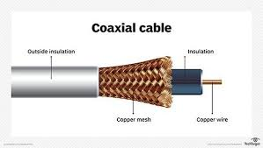

1. **Twisted Pair Cable:**

**Description: Composed of pairs of insulated copper wires twisted together. Common types include Unshielded Twisted Pair (UTP) and Shielded Twisted Pair (STP). Used for Ethernet networks.**

**Diagram:**

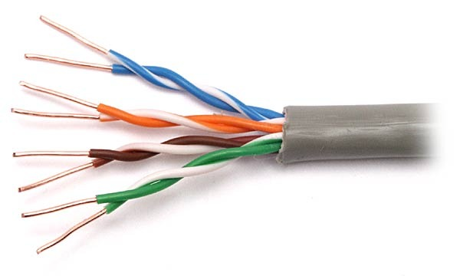

1. **Fiber Optic Cable:**

**Description: Uses light to transmit data through fibers made of glass or plastic. Offers high-speed data transfer over long distances with minimal signal loss.**

**Diagram :**

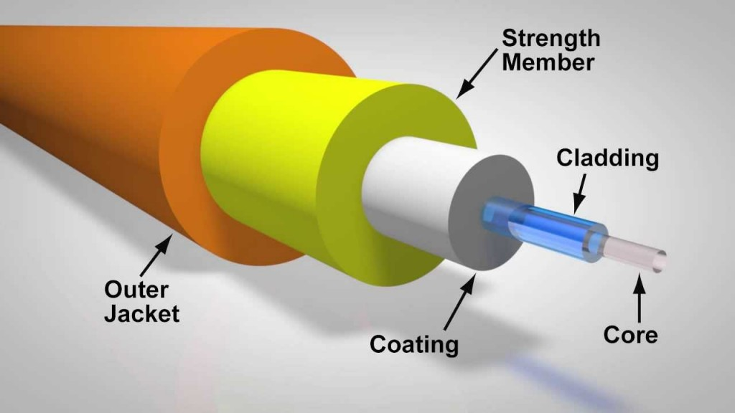

1. **Difference between guided and unguided media.**

|  |  |
| --- | --- |
| **Guided Media** | **Unguided Media** |
| The guided media is also called wired communication or bounded transmission media. | The unguided media is also called wireless communication or unbounded transmission media. |
| The signal energy propagates through wires in guided media. | The signal energy propagates through the air in unguided media. |
| Guided media is used for point-to-point communication. | Unguided media is generally suited for radio broadcasting in all directions. |
| It is cost-effective. | It is expensive. |
| Discrete network topologies are formed by the guided media. | Continuous network topologies are formed by the unguided media. |
| Signals are in the form of voltage, current, or photons in the guided media. | Signals are in the form of electromagnetic waves in unguided media. |
| Examples of guided media are twisted pair wires, coaxial cables, and optical fiber cables. | Examples of unguided media are microwave or radio links and infrared light. |
| By adding more wires, the transmission capacity can be increased in guided media. | It is not possible to obtain additional capacity in unguided media. |
| It sends out a signal that indicates which way to go. | It does not indicate which way to travel. |
| For a shorter distance, this is the best option. | For longer distances, this method is used. |
| It is unable to pass through walls. | It can pass through walls. |

## Give cross-wired cable and straight through cable diagram (Color Code wise).

1. Cross-wired Cable Diagram (Color Code)

* Color Code
  + - End1:
      * Pin 1: White/Orange
      * Pin 2: Orange
      * Pin 3: White/Green
      * Pin 4: Blue
      * Pin 5: White/Blue
      * Pin 6: Green
      * Pin 7: White/Brown
      * Pin 8: Brown
    - End2:
      * Pin 1: White/Green
      * Pin 2: Green
      * Pin 3: White/Orange
      * Pin 4: Blue
      * Pin 5: White/Blue
      * Pin 6: Orange
      * Pin 7: White/Brown
      * Pin 8: Brown
* Diagram :

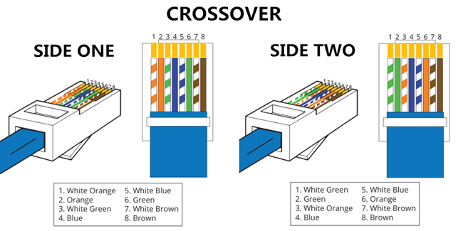

1. Straight Through Cable Diagram (Color Code)
   * **Diagram :**

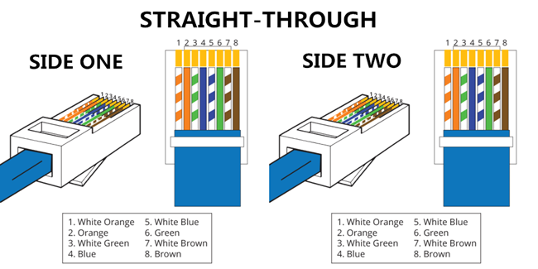

* + Color Code
* Both ends have the same color code:
  + Pin 1: White/Orange
  + Pin 2: Orange
  + Pin 3: White/Green
  + Pin 4: Blue
  + Pin 5: White/Blue
  + Pin 6: Green
  + Pin 7: White/Brown
  + Pin 8: Brown