* **What is SDLC.**
* Software Development Life Cycle.
* Series of Steps that provide model foe development.
* **What is software testing?**
* Software testing is a process that used to identify the correctness, completeness and quality of developed computer software.
* **What is agile methodology?**
* Agile means delivering software into small parts and give continues feedback and improvements.
* **What is SRS.**
* Software Requirement Specification.
* Complete description of system to be developed.
* **What is oops.**
* Object Oriented Programming
* The way to write code and it provide less code redundancy with more security.
* **Write Basic Concepts of oops.**
* Class
* Object
* Inheritance
* Polymorphism
* Abstraction
* Encapsulation
* **What is object.**
* **Give permission to access functionality of class.**

* **What is class.**
* Collection of data member and member function.
* **What is encapsulation.**
* Wrapping the data.
* **What is inheritance.**
* Derived attribute of some other class.
* **What is polymorphism.**
* One name multiple form.
* **Write SDLC phases with basic introduction.**
* SDLC means software development life cycle which provide series of steps that provide models of development.
* Requirement Gatherings
* Analysis
* Designing
* Implementation
* Testing
* Deployment
* Maintenance
* **Explain Phases of the waterfall model.**
* Requirement Gatherings
* Analysis
* Designing
* Implementation
* Testing
* Deployment
* Maintenance
* **Write phases of spiral model.**
* Planning
* Risk Analysis
* Engineering
* Customer Evaluation
* **Write agile manifesto principles.**
* Customer Satisfaction
* Frequent delivery of the working software
* Changing requirement through developing process
* Support, trust, motivate the people involve
* Face-to-face interaction
* **Explain working methodology of agile model and also write pros and cons.**
* It is like incremental model which used to dived working software into small parts and give the continuous feedback and improvement.
* Pros:
* Teamwork and cross training.
* Resource Requirement are less.
* Changing requirement during developing
* Cons:
* Not suitable for complex software
* Strict delivery management
* Depends heavily on customer, if customer is not clear then developer team goes on wrong way.
* Draw Usecase on online bill payment system (paytm).

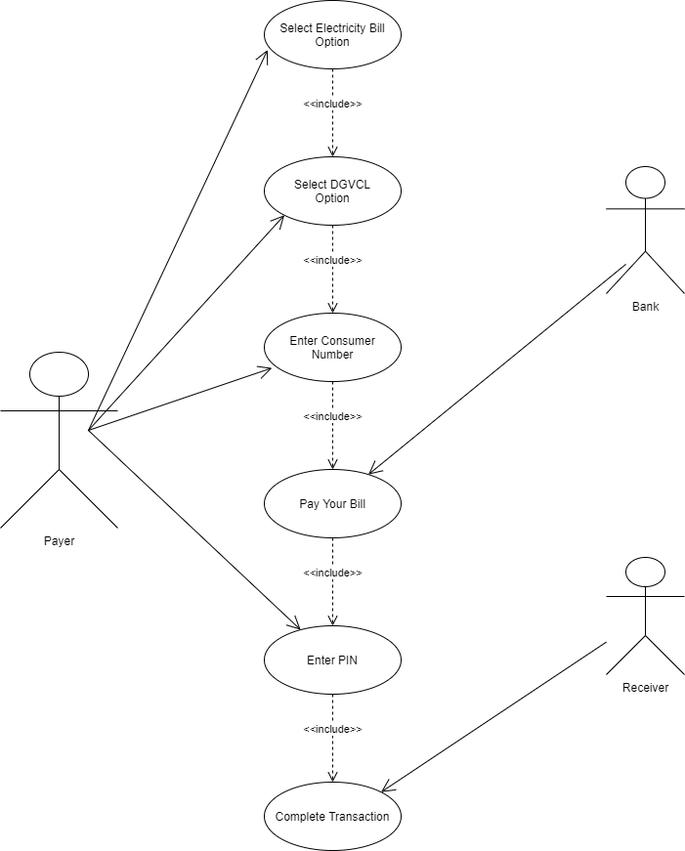

* Draw Use case on banking system for customers.

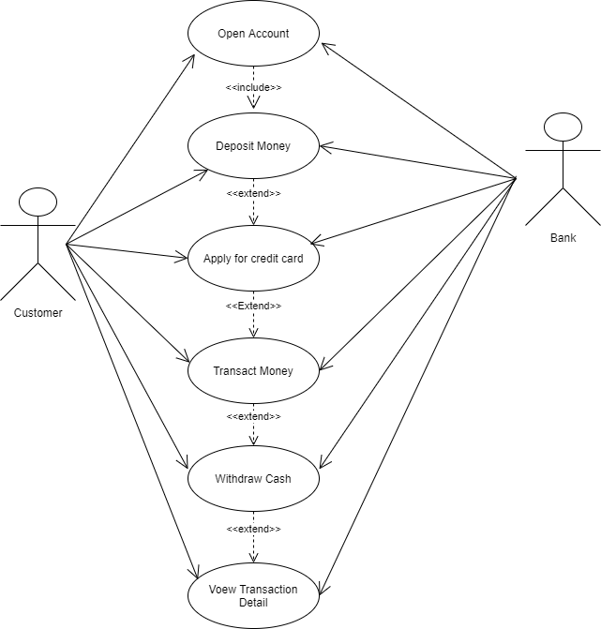

* Draw Use case on OTT Platform.

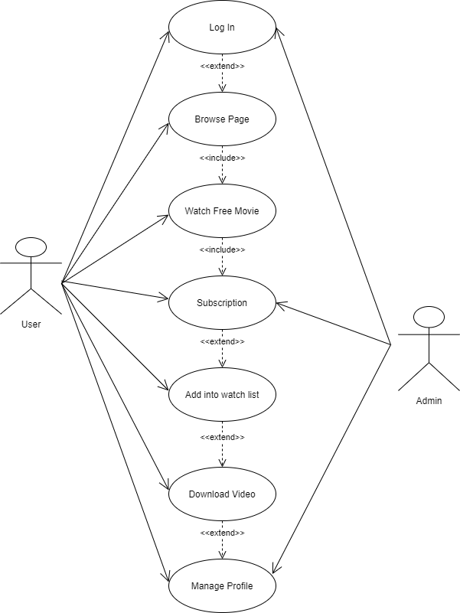

* Draw Use case on Broadcasting System.

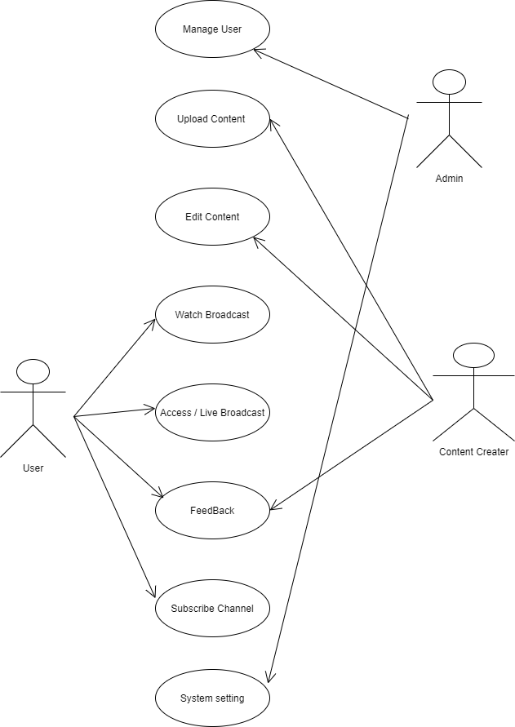

* Draw Use case on E-commerce application.

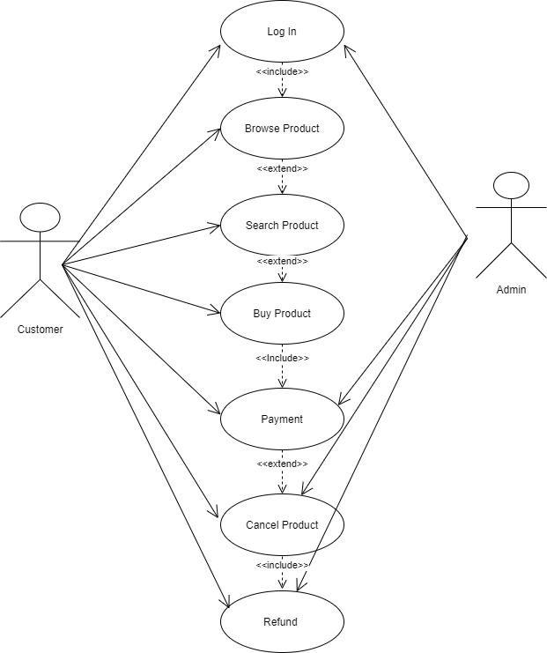

* Draw Use case on Online shopping product using payment gateway.

