Git Commands Assignment - Practical Submission
Name: Dhruv Gohil
Int Id: int_1053
Subject: Git Practical
Date: 18-02-2026

TASK 1: Repository Setup
1. mkdir git-assignment-dhruvgohel
2. cd git-assignment-dhruvgohel
3. git init
4. echo Hello Git > index.txt
5. git status
6. git add index.txt
7. git commit -m "Initial project setup"

TASK 2: Branch Creation & Work
1. git branch feature-header
2. git switch feature-header
3. echo This is header section > header.txt
4. git add header.txt
5. git commit -m "Added header section"

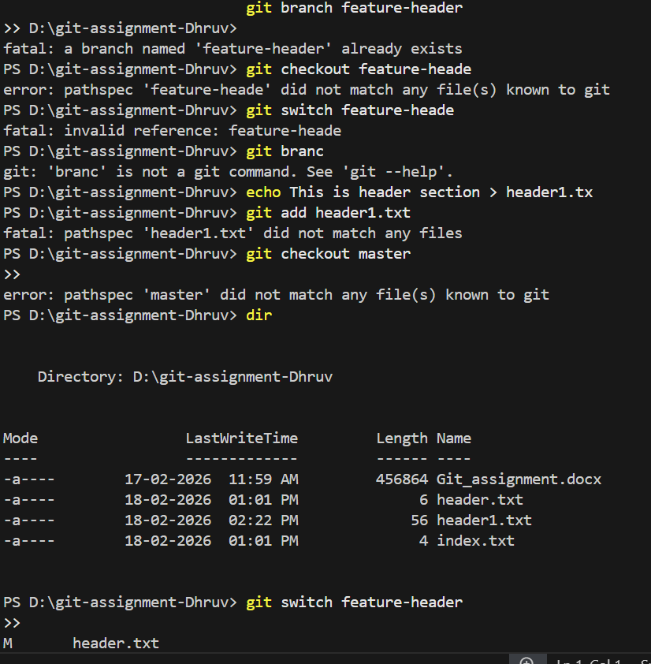
TASK 3: Branch Switching Observation
1. git switch master
2. dir (ls for Mac/Linux)
3. git switch feature-header
4. dir (ls for Mac/Linux)

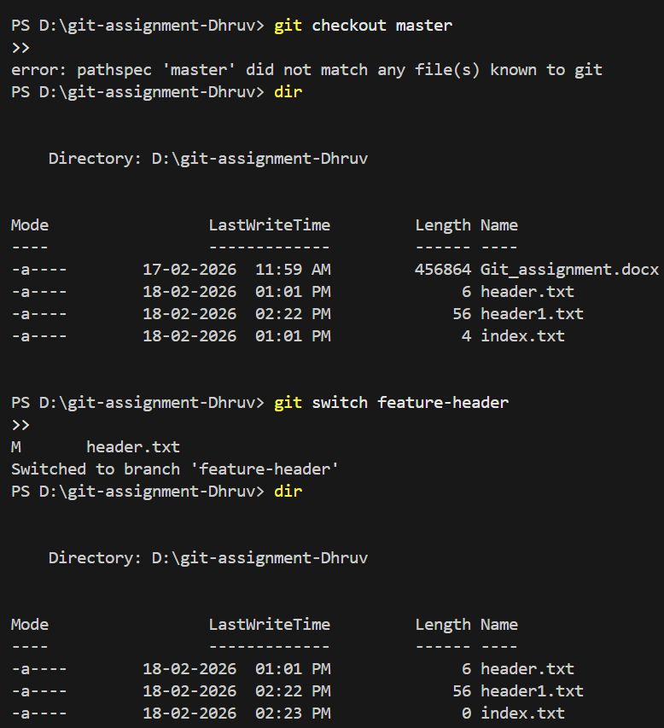
TASK 4: Undo a Mistake
1. echo Mistake line >> index.txt
2. git status
3. git restore index.txt
4. git status

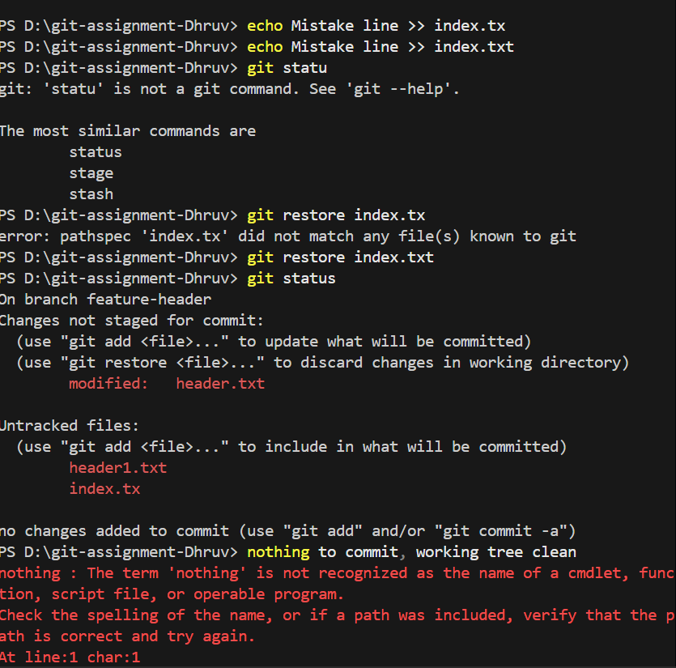
TASK 5: Merge Feature Branch
1. git switch master
2. git merge feature-header
3. dir (ls for Mac/Linux)
4. git log --oneline --graph --all

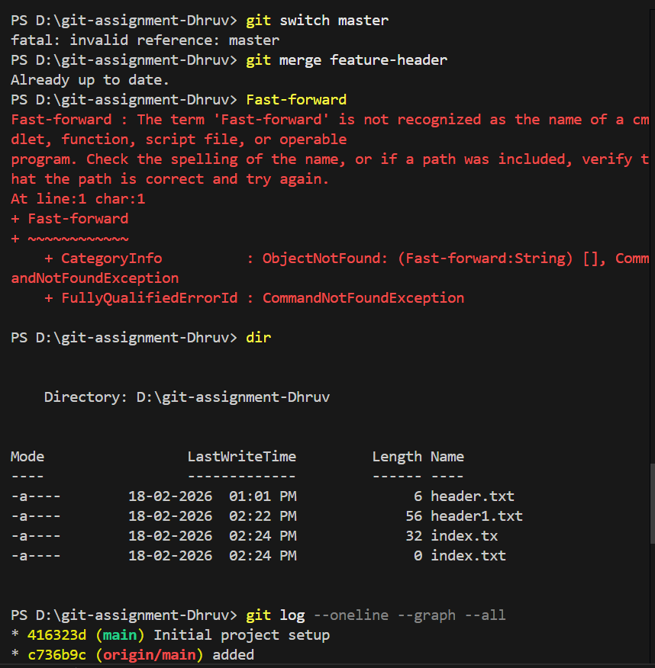
TASK 6: Checkout a Commit (Detached HEAD)
1. git log --oneline
2. git checkout <commit-id>
3. git branch
4. git switch master

