**JavaScript Introduction**

Q1: What is JavaScript? Explain the role of JavaScript in web development.

Ans: - JavaScript is a scripting or programming language. This is a lightweight, interpreted programming language primarily used to add dynamic and implement complex features on web pages.

Q2: How is JavaScript different from other programming languages like Python or Java?

Ans: - JavaScript is primarily used for client-side web development, while Python versatility, especially in data science, data mining and backend development, Java is a compiled language, run it through a compiler, and create bytecode.

Q3: Discuss the use of <script> tag in HTML. How can you link an external JavaScript file to an HTML document?

Ans: - I use the src attributewithin the <script> tag in the HTML file to specify the source file. The external JavaScript file is then linked to the HTML document, and the execution of its code.

**Lab Tasks**

* Create a simple HTML page and add a <script> tag within the page.
* Write JavaScript code to display an alert box with the message "Welcome toJavaScript!" when the page loads.

Code: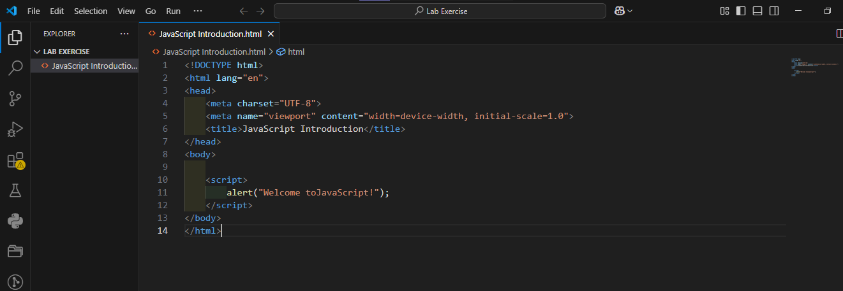

Output: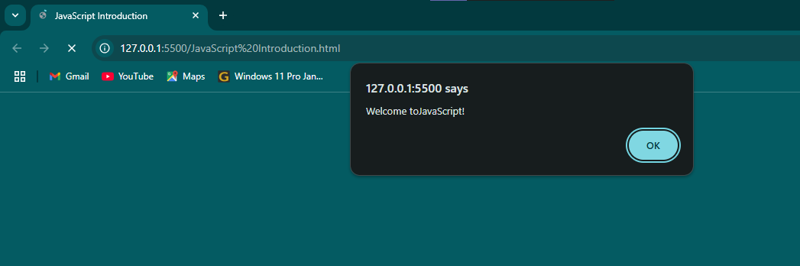

Variables and Data Types

Q1: What are variables in JavaScript? How do you declare a variable using var, let, and const?

Ans: - variables are named containers that store values that can be accessed and manipulated throughout your code. You can declare variables using var, let, or const. let and const are keywords introduced in ES6 for declaring variables.

Q2: Explain the different data types in JavaScript. Provide examples for each.

Ans: - JavaScript has two categories of data types:

* Primitive: String, Number, Boolean, Null, Undefined, Symbol, BigInt
* let name = "John" (String)
* let age = 30 (Number)
* let isOnline = true (Boolean)
* let value = null (Null)
* let x (Undefined)
* let symbol1 = Symbol("id") (Symbol)
* let largeNumber = BigInt(12345678900987654321) (BigInt)
* Non-Primitive: Object, Array, Function
* (Object)

person = {  
 name: "Kuldeep",  
 surname: "Gohil"  
 }

* (array)

const fruits = ["apple", "banana", "orange"];

* (function)

function add(a, b) {  
 return a + b;  
 }

Q3: What is the difference between undefined and null in JavaScript?

Ans: - undefined indicates a variable has been declared but hasn't been assigned a value. Null in JavaScript means an empty value and return object.

**Lab Tasks**

* Write a JavaScript program to declare variables for different data types (string,number, boolean, null, and undefined).
* Log the values of the variables and their types to the console using console.log()

Code: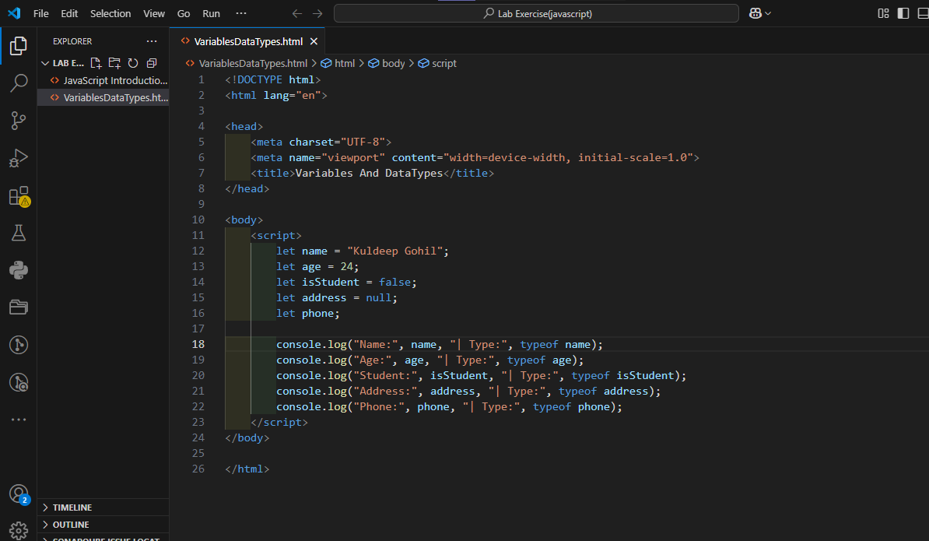

Output:

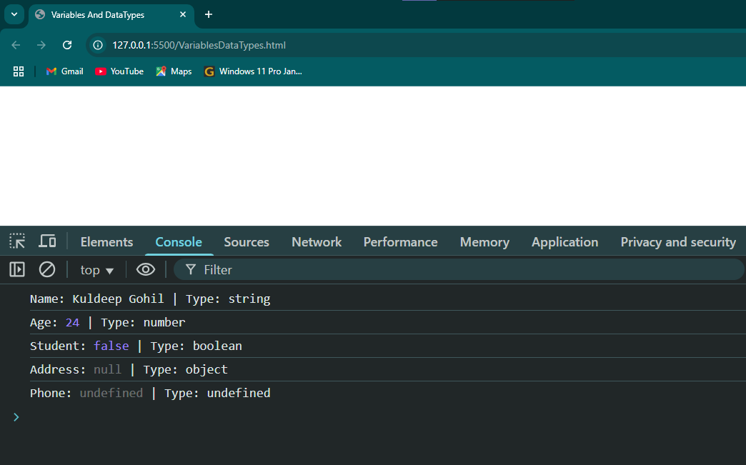

JavaScript Operators

Q1: What are the different types of operators in JavaScript? Explain with examples. Arithmetic operators, Assignment operators, Comparison operators, Logical operators.

Ans: - JavaScript provides various types of operators to perform different operations on variables.

1. **Arithmetic operators:-** These operators perform mathematical calculations.

**(+.**-,*,/,%,++,--)

Example:

let x = 10;

let y = 5;

x + y = 15 (Addition),

x – y = 5 (Subtraction),

x * y = 50 (Multiplication),

x / y = 2 (Division),

x % y = 0 (Modulus),

x++ = 11 (Increment),

y-- = 4 (Decrement)

1. **Assignment** **operators:-** These operators assign values to variables.

(=,+=,-=,*=,/=,%=)

Example:

let x = 10;

x += 5 (x = x + 5 → 15),

x -= 3 (x = x - 3 → 7),

x *= 2 (x = x * 2 → 20),

x /= 2 (x = x / 2 → 5),

x %= 5 (x = x % 5 → 0)

1. **Comparison operators:-** These operators compare values and return true or false.

(==,===,!=,!==,>,<,>=,<=)

Example:

2 == "2" → true (value check) (Equal to),

8 === "8" → false (both check value and type) (Strict Equal to),

4 != 6 → true (Not equal to),

4 !== 4→ false (Strict not equal to),

14 > 2 → true (Greater than),

1 < 6 → true (Less than),

8 >= 8 → true (Greater than or equal to),

8 <= 4 → false (Less than or equal to),

1. **Logical operators:-** These operators compare values and return true or false.

(&&, ||, ! )

Example:

let x = true, y = false;

x && y → false (Logical AND) (both true),

x || y → true (Logical OR) (one true),

(!(10 > 5)) → false (Logical NOT) (inverts truth value),

Q2: What is the difference between == and === in JavaScript?

Ans: -

Loose Equality (==): These are only check value.

For example: 1 == "1". The string "1" is implicitly converted to the number 1, so the comparison evaluates to true.

Strict Equality (===): checks both value and DataType.

For example: 2 === "2". The Number 2 is DataType(Number) vs String “2” is DataType (String), so the comparison evaluates to false.

**Lab Tasks**

Create a JavaScript program to perform the following:

* Add, subtract, multiply, and divide two numbers using arithmetic operators.
* Use comparison operators to check if two numbers are equal and if one number is greater than the other.
* Use logical operators to check if both conditions (e.g., a > 10 and b < 5)are true.

Code:

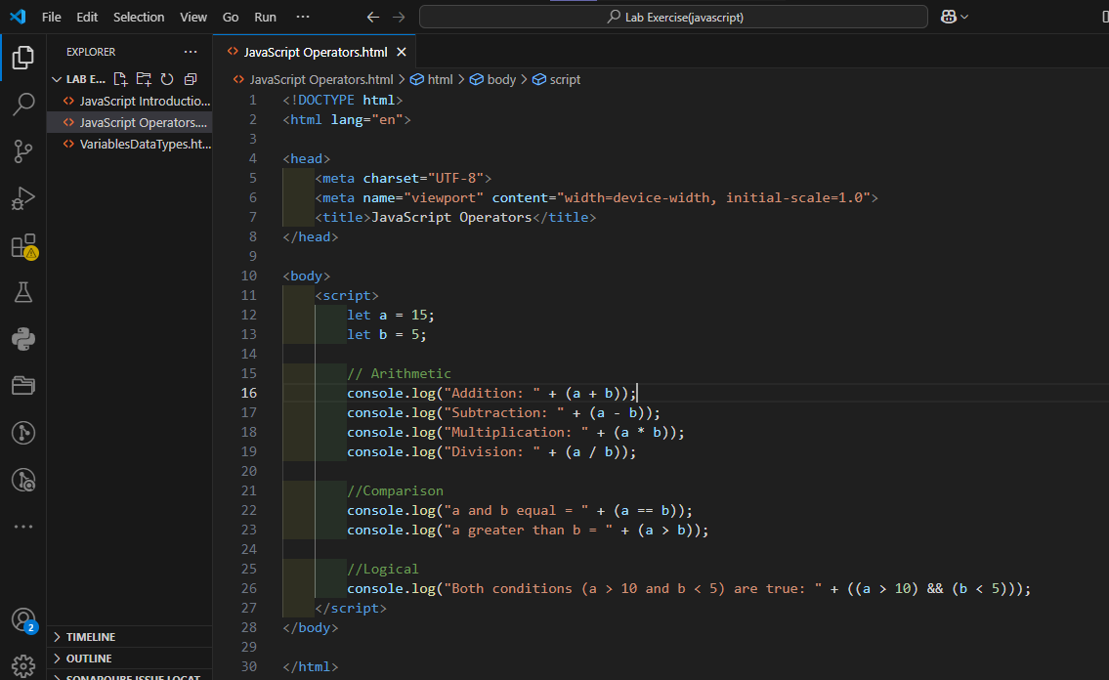

Output:

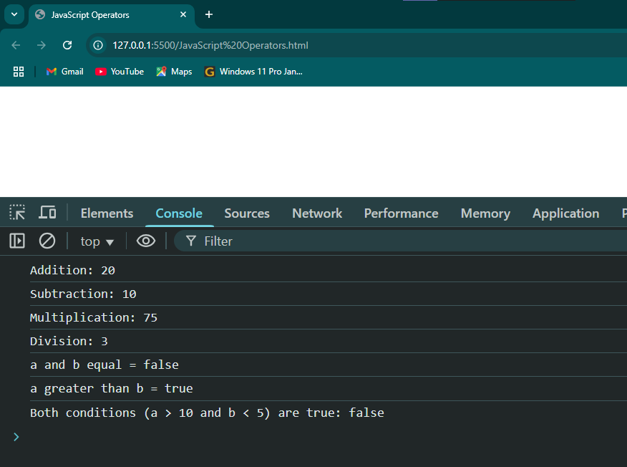

Control Flow (If-Else, Switch)

Q1: What is control flow in JavaScript? Explain how if-else statements work with an example.

Ans: - Control flow statement is an if-else statement. The if/else statement executes a block of code if a specified condition is true. If the condition is false, another block of code can be executed.

Example:

let marks = 75;

if (marks >= 90) {

console.log("Grade: A");

} else if (marks >= 70) {

console.log("Grade: B");

} else {

console.log("Grade: C");

}

Output:

Grade: B

Q2: Describe how switch statements work in JavaScript. When should you use a switch statement instead of if-else?

Ans: - A switch statement evaluates an expression is compared against multiple possible values, or the default case if no match is found. Switch case is considered faster and more readable than nested if-else statements. If-else statement is used to decide between two options.

**Lab Tasks**

**Task 1 : Write a JavaScript program to check if a number is positive, negative, or zero using an if-else statement.**

Code:

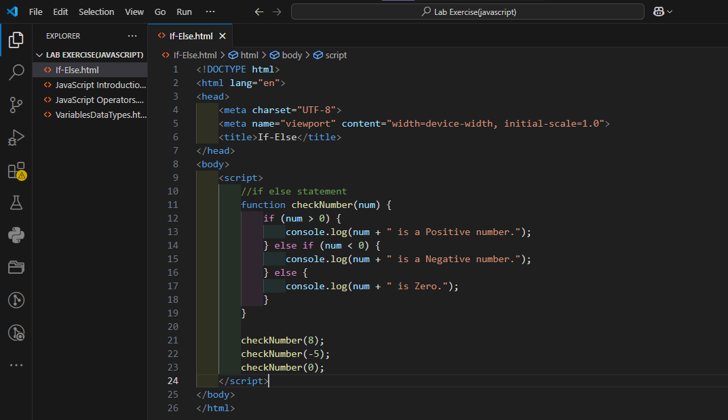

**Output:**

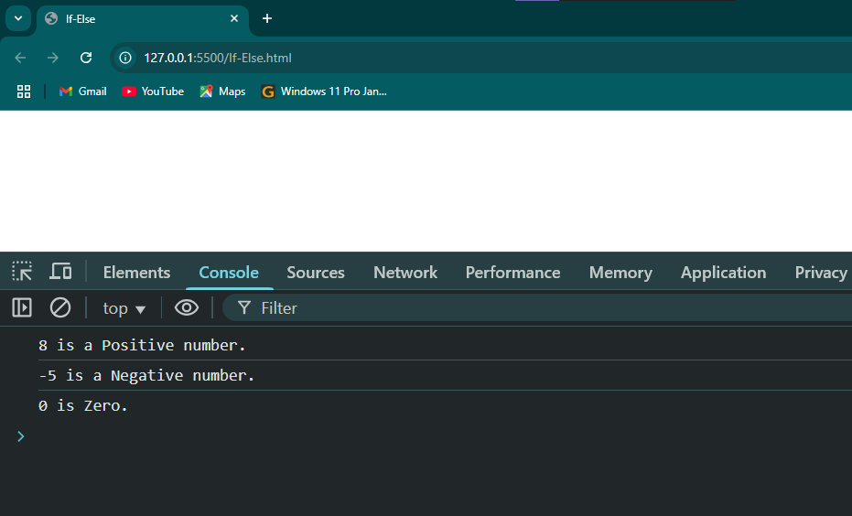

**Task 2 : Create a JavaScript program using a switch statement to display the day of the week based on the user input (e.g., 1 for Monday, 2 for Tuesday, etc.).**

**Code:**

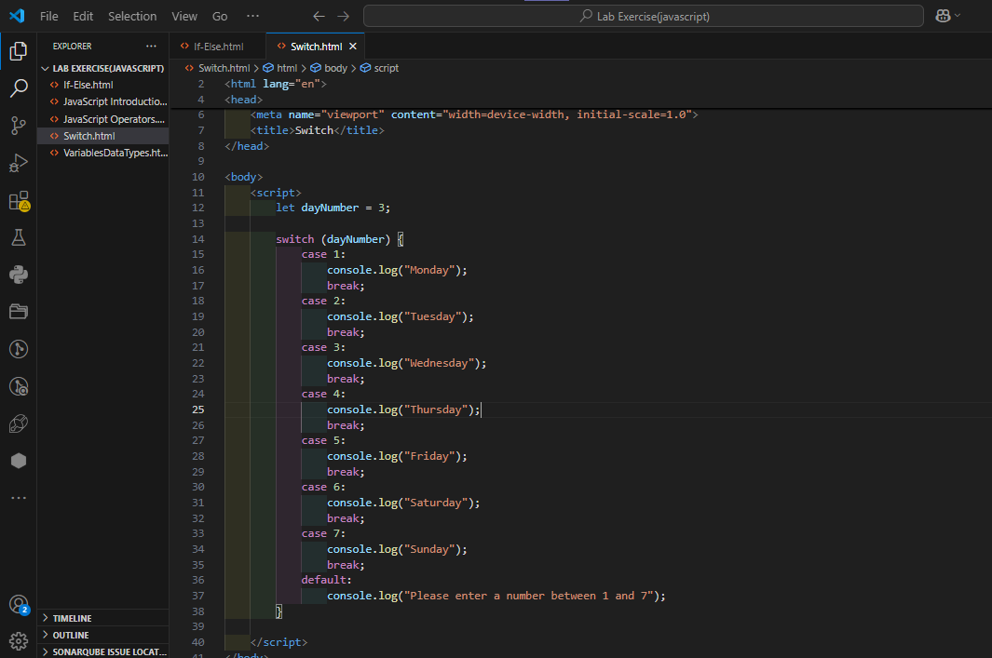

**Output:**

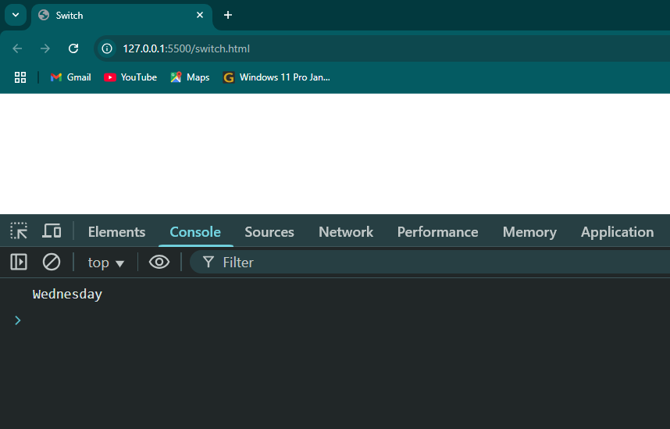

Loops (For, While, Do-While)

Q1: Explain the different types of loops in JavaScript (for, while, do-while). Provide a basic example of each.

Ans: -

* **For Loop** : - The for loop through a block of code a number of times. In first intial value, second condition, and third increment or decrement after code executed.

Example:

for (let i = 0; i < 4; i++) {

console.log("Number: ", i);

}

* **While Loop** : - The while loop repeatedly executes a block of code as long as a specified condition is true.  loop first evaluates the condition inside “(condition)”. In first condition check after block of code executed.

Example:

let i = 0;

while (i < 6) {

console.log("number:", i);

i++;

}

* **Do-While Loop** : - The do…while loop executes the code inside “{ }”. If the condition evaluates to true, the code inside { } is executed again. In first block of code executed after condition check.

Example:

let i = 0;

do {

console.log("number:", i);

i++;

} while (i < 5);

Q2: What is the difference between a while loop and a do-while loop?

Ans: - while loops check the condition before executing the loop body. If the condition is initially false, the loop body will never be executed. do-while loops execute the body once before checking the condition. First the loop body will be executed at least once, even if the condition is initially false.

**Lab Tasks**

**Task 1 : Write a JavaScript program using a for loop to print numbers from 1 to 10.**

Code:

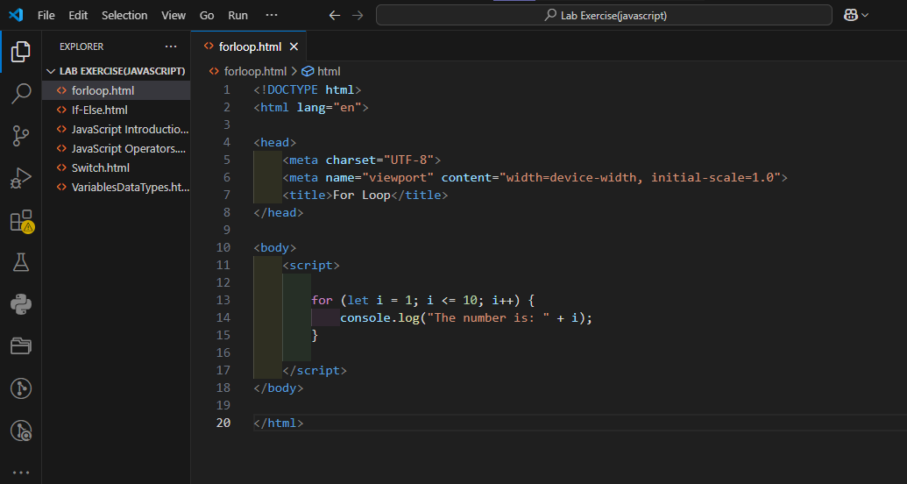

Output:

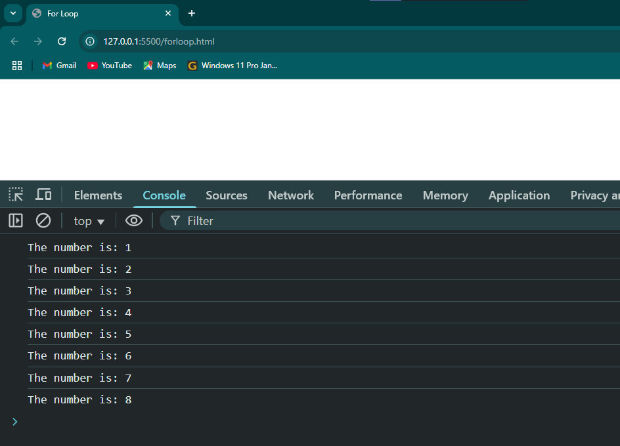

**Task 2 : Create a JavaScript program that uses a while loop to sum all even numbers between 1 and 20.**

Code:

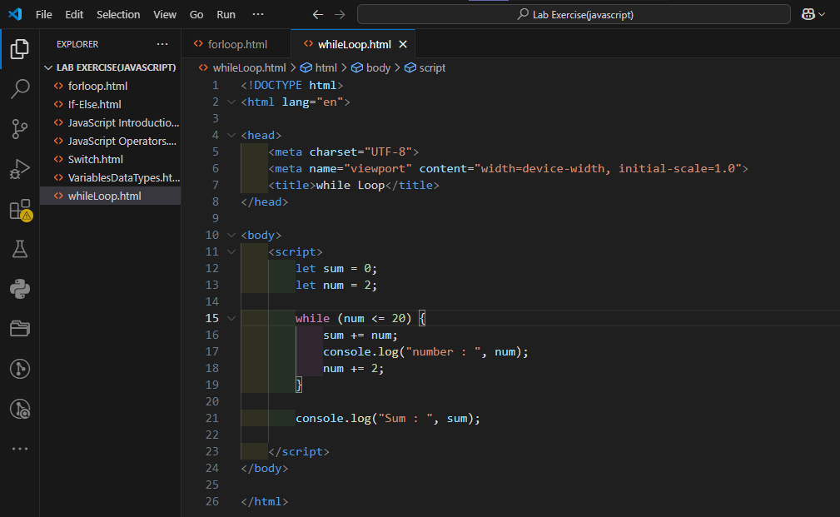

Output:

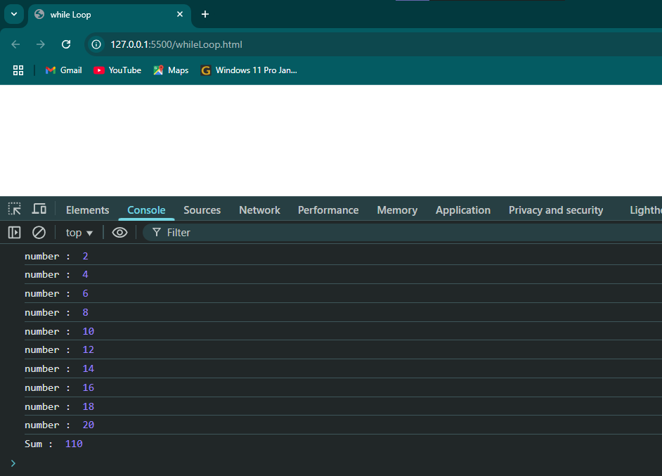

**Task 3 : Write a do-while loop that continues to ask the user for input until they enter a number greater than 10.**

Code:

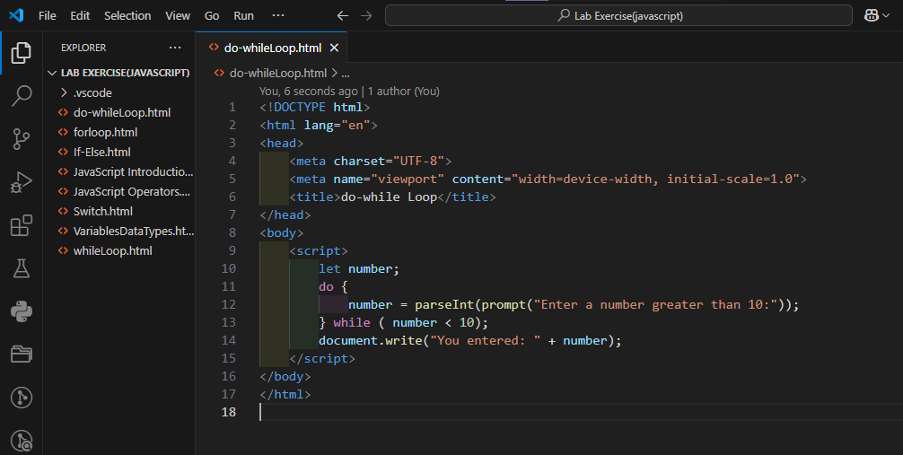

Output:

