**Routing in React (React Router)**

Q1: What is React Router? How does it handle routing in single-page applications?

Ans: - React Router is a standard library for routing in React. It enables the navigation among views from various components in a React application, allowing the URL to be updated without a full page reload. Single-page applications on the other hand, load a single HTML page and dynamically update its content as the user interacts with the application. This means the server isn't handling routing in the same way.

Q2: Explain the difference between BrowserRouter, Route, Link, and Switch components in React Router.

Ans: -

* **BrowserRouter**: is a router implementation that uses the HTML5 history API (pushState, replaceState, popState) to keep your UI in sync with the URL. It's the most commonly used router for web applications.
* **Route**: The Route component is responsible for rendering UI when its path prop matches the current URL.
* **Link**: The Link component is used to create declarative, accessible navigation links within your application.
* **Switch**: Switch was used to render only the *first* Route or Redirect that matches the current URL.

**Lab Tasks**

**Task 1 : Set up a basic React Router with two routes: one for a Home page and one for an About page. Display the appropriate content based on the URL.**

**Code:**

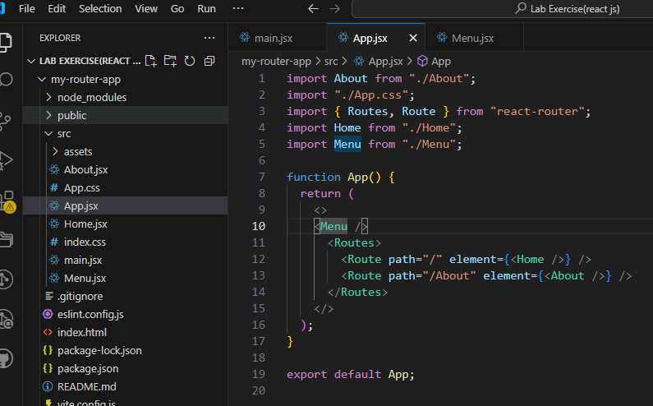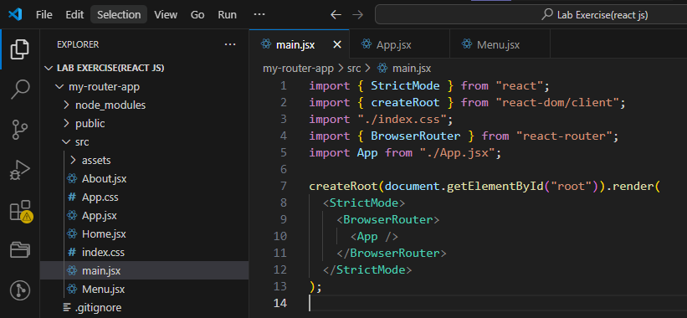

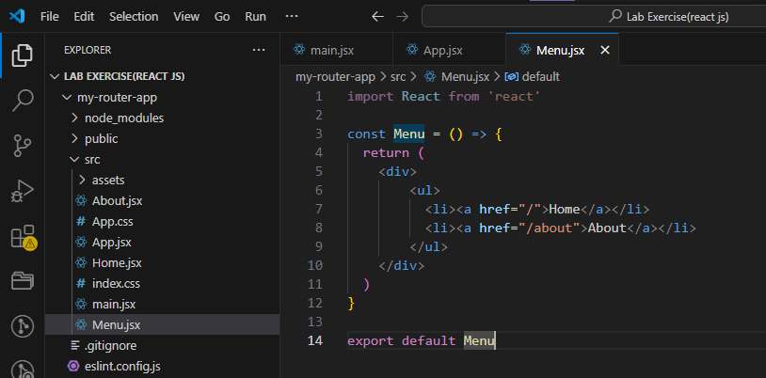

**Output:**

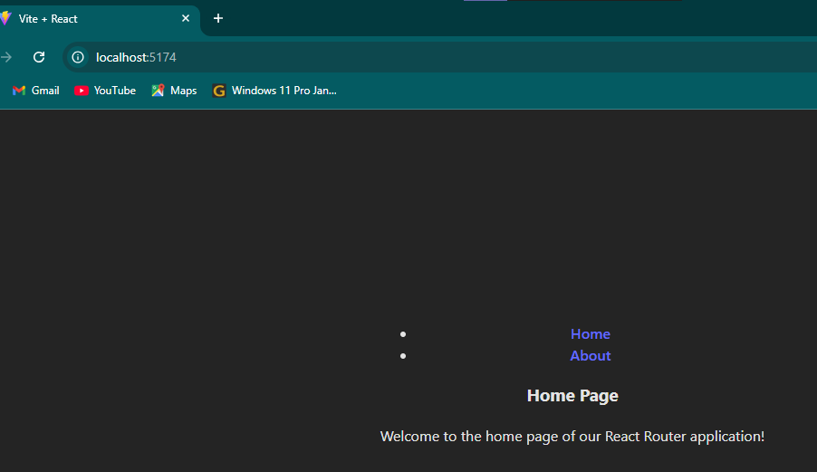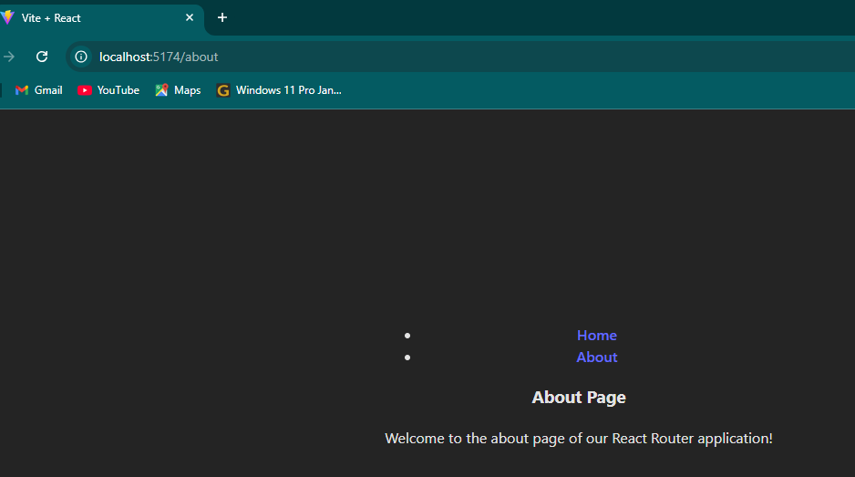

**Task 2 : Create a navigation bar using React Router’s Link component that allows users to switch between the Home, About, and Contact pages.**

**Code:**

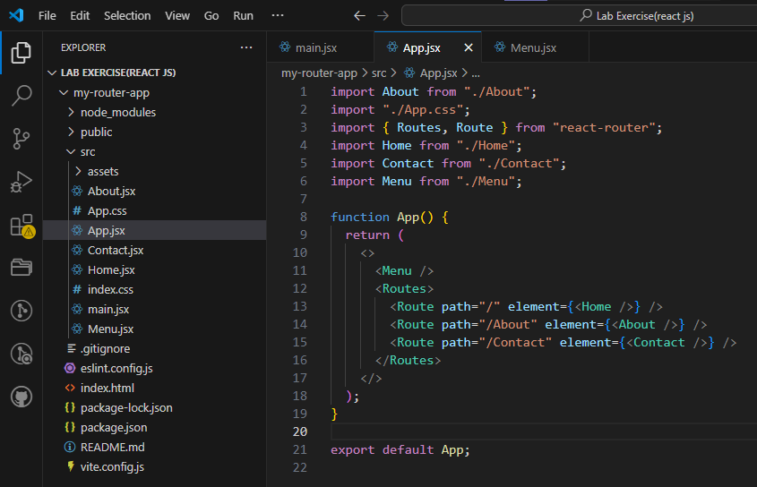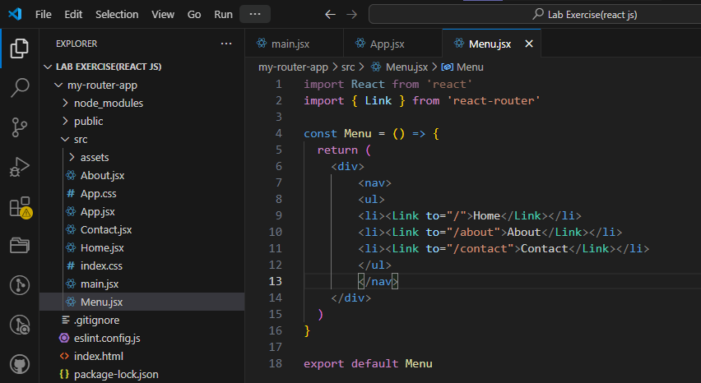

**Output:**

