**State Management (Redux, Redux-Toolkit or Recoil)**

Q1: What is Redux, and why is it used in React applications? Explain the core concepts of actions, reducers, and the store.

Ans: - Redux is a predictable state container for JavaScript applications, most commonly used with React for managing application-level state. It helps you write applications that behave consistently, are easy to test, and can run in different environments. React has a built-in component state (useState, useReducer), but it becomes hard to manage when:

* Multiple components need access to the same state.
* You need a global state (e.g., user authentication, theme, cart data).
* You want better control over state changes and debugging.

**Core Concepts of Redux :-**

1. **Store :-** The single source of truth. Holds the entire state of the app. Created using createStore(reducer) (or configureStore in Redux Toolkit).
2. **Actions :-** Plain JavaScript objects that describe what happened. Must have a type field. Can include a payload with additional data.
3. **Reducers :-** Pure functions that receive actions and update state accordingly. Return the new state based on the action type.

Q2: How does Recoil simplify state management in React compared to Redux?

Ans: - Recoil is a state management library for React developed by Facebook. It offers a simpler, more React-like way to handle shared and global state, especially compared to Redux.

**Lab Tasks**

**Task 1 : Create a simple counter application using Redux for state management. Implement actions to increment and decrement the counter.**

**Code:**

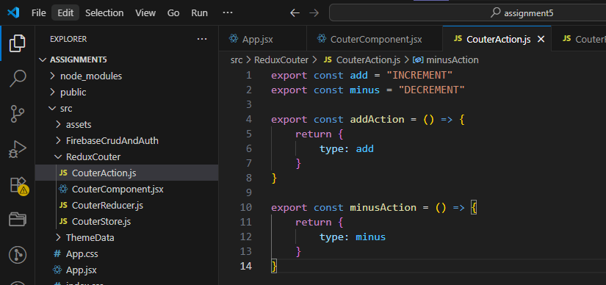

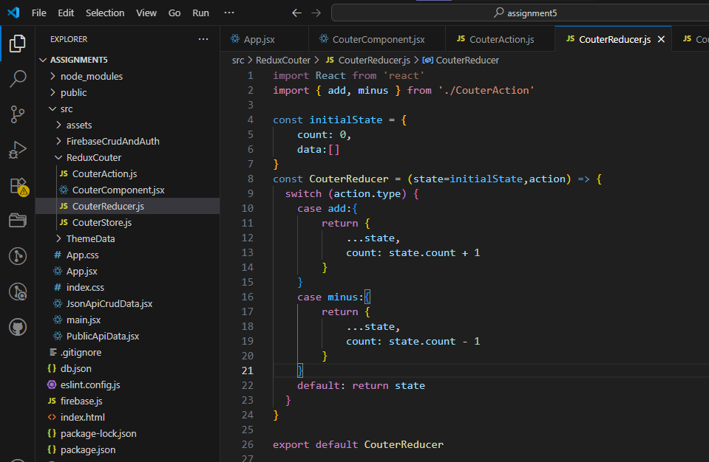

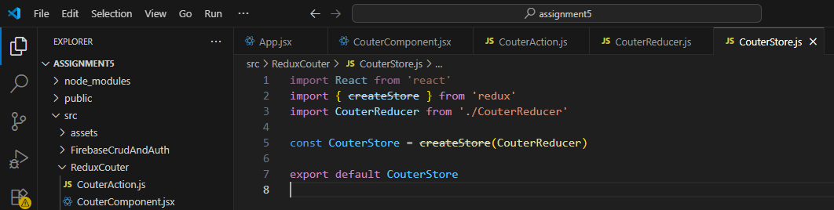

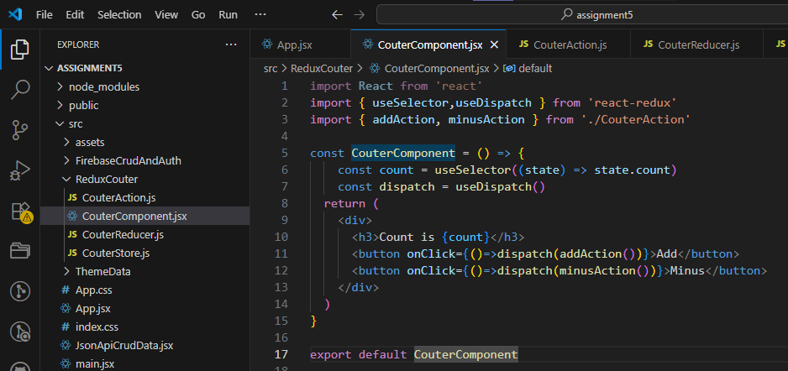

**Output:**

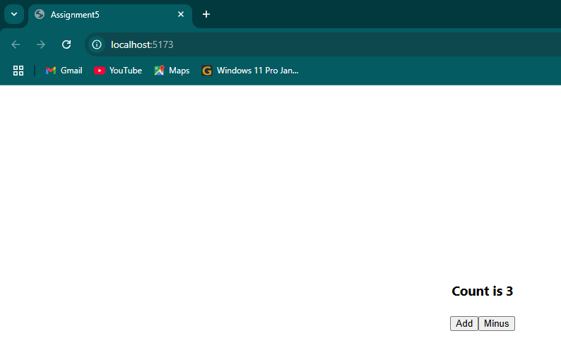

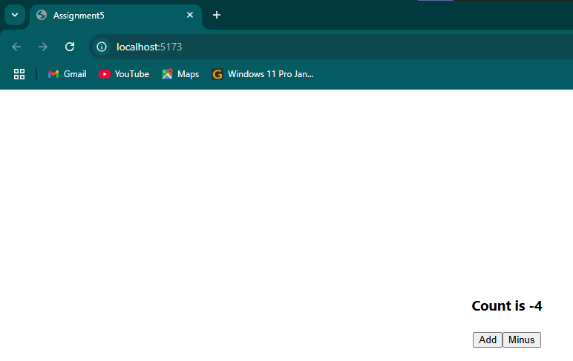

**Task 2 : Build a Todo list application using Recoil for state management. Allow users to add, remove, and mark tasks as complete.**

**Code:**

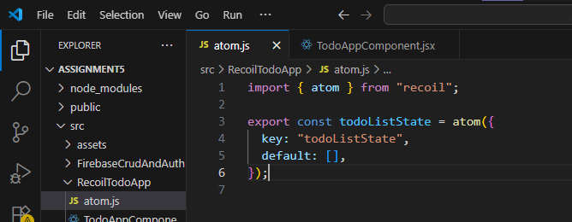

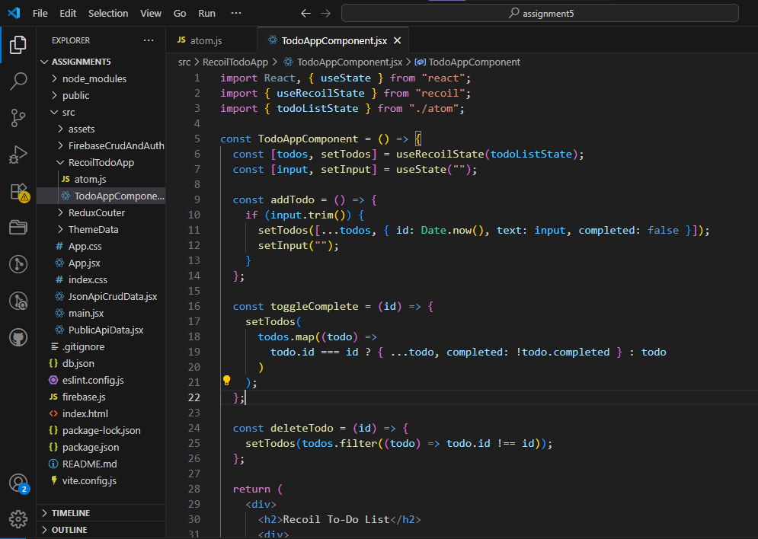

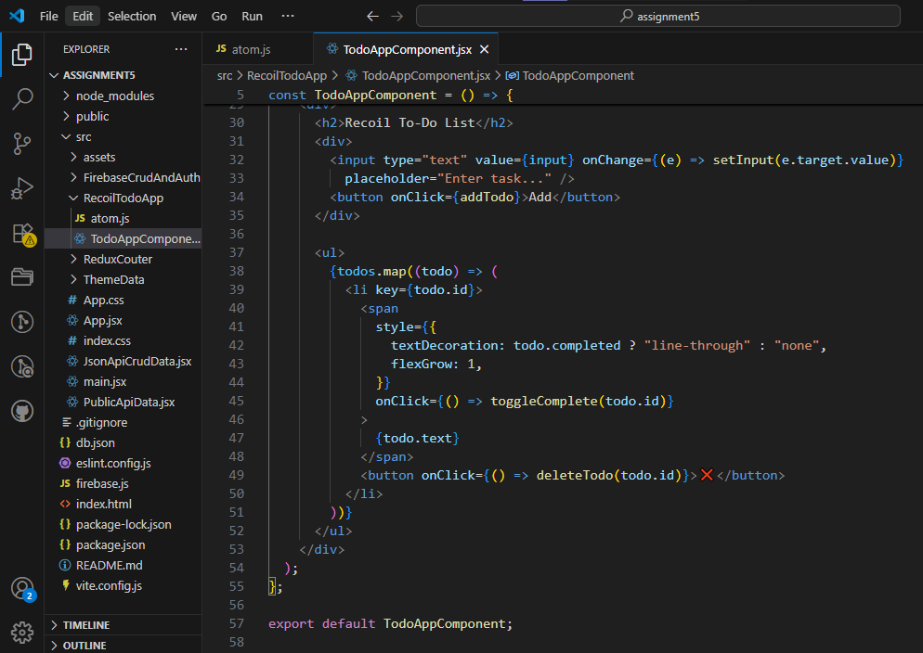

**Output:**

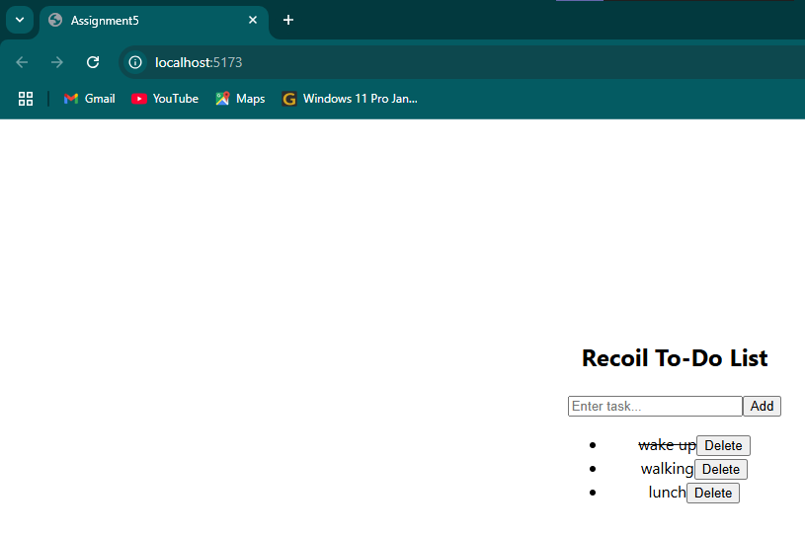

**Task 3 : Build a crud application using Redux-Toolkit for state management. Allow users to add, remove, delete and update.**

**Code:**

