**React.js Introduction**

Q1: What is React.js? How is it different from other JavaScript frameworks and libraries?

Ans: - React.js is a JavaScript library for building user interfaces, particularly single-page applications where performance and dynamic. React uses a UI development and virtual DOM to optimize rendering performance. because it's a lightweight UI library focused on building user interfaces using components and JSX syntax.

Q2: Explain the core principles of React such as the virtual DOM and component- based architecture.

Ans: - React works on two main ideas: Virtual DOM and Component-based architecture. The Virtual DOM is like a copy of the real webpage. Component-based architecture means the whole UI is made up of small, reusable pieces called components.

Q3: What are the advantages of using React.js in web development?

Ans: - React.js is popular in web development because it’s fast, easy to use, and lets developers build dynamic user interfaces using reusable components with efficient updates through the virtual DOM, making apps more responsive, maintainable, and scalable.

**Lab Tasks**

**Task 1 :**

* Set up a new React.js project using create-react-app.
* Create a basic component that displays "Hello, React!" on the web page.

Code:

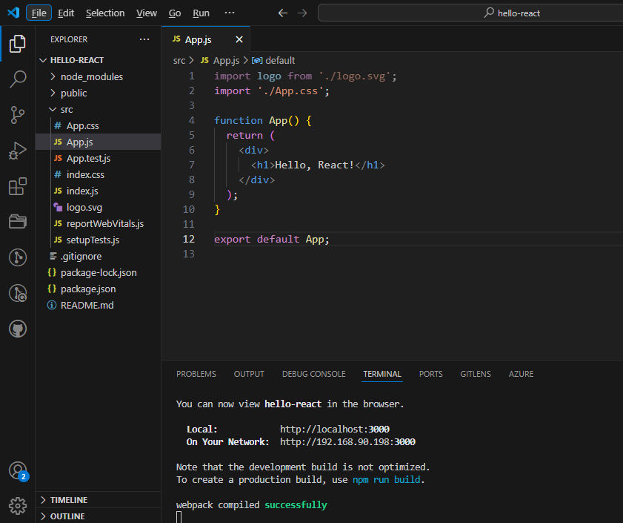

Output:

