Name: Nithilan AR
Reg. No.: 192512197
EXP 5
Experiment Name:
EXP.5. Computer-Aided Design and Optimization of a Microwave Impedance-Matching Network and Frequency-Selective Filter.
Aim:
To design and simulate a microwave impedance-matching network for a complex load of 75 + j25 Ω matched to a 50 Ω reference impedance at 10 GHz, and to design a 50 Ω frequency-selective filter with a cutoff frequency of 10 GHz. To evaluate and analyze the return loss, insertion loss, S11, S21, passband, stopband, and bandwidth over the frequency range of 8–12 GHz using MATLAB.
Objectives of this Experiment:
1. To design an impedance-matching network for a specified complex microwave load.
2. To optimize the matching network for minimum reflection and maximum power transfer.
3. To design a microwave filter according to specified cutoff frequency, bandwidth and impedance requirements.
4. To evaluate return loss, insertion loss, passband, stopband and bandwidth using simulated frequency responses.
Expected Outcome from this Experiment:
1. Design and develop an impedance-matching network for a specified complex microwave load.
2. Optimize and validate the matching network for minimum reflection and maximum power transfer based on the simulated S-parameter response.
3. Design and simulate a microwave filter satisfying the specified cutoff frequency, bandwidth and impedance requirements.
4. Evaluate and interpret return loss, insertion loss, passband, stopband and bandwidth from the simulated frequency response and compare the obtained values with the specified design requirements.
Experimental Procedure:
A. Impedance Matching: A load ZL = 75 + j25 Ω must be matched to Z0 = 50 Ω at 10 GHz. Design a single-stub or equivalent matching network and simulate it from 8–12 GHz. Calculate the theoretical |ΓL| = |(ZL - Z0)/(ZL + Z0)|, return loss and matched input impedance. Compare theoretical and simulated values before and after matching.
B. Filter Design: Design a 50 Ω frequency-selective filter with cutoff frequency 10 GHz and evaluate it from 8–12 GHz. Obtain S11 and S21, determine the -3 dB cutoff frequency, passband, stopband and insertion loss. Compare the measured/simulated cutoff frequency with 10 GHz and calculate percentage deviation.
Software required:
Matlab
Program code:
%% EXP.5: MICROWAVE IMPEDANCE MATCHING AND FILTER DESIGN
clc;
clear;
close all;

set(0,'DefaultFigureVisible','on');

%% 1. INPUT PARAMETERS FROM EXP.5 WORD DOCUMENT

f0 = 10e9; % Design frequency: 10 GHz
Z0 = 50; % Reference impedance: 50 ohms
ZL = 75 + 1j*25; % Load impedance: 75+j25 ohms
fc = 10e9; % Filter cutoff: 10 GHz
fstart = 8e9; % Sweep start: 8 GHz
fstop = 12e9; % Sweep stop: 12 GHz
N = 5; % Butterworth filter order
c = 3e8; % Speed of light

f = linspace(fstart,fstop,1001);
lambda0 = c/f0;
beta0 = 2*pi/lambda0;

%% 2. FIGURE 1: OBJECTIVES DIAGRAM

figure(1);
clf;
set(gcf,'Name','EXP.5 Objectives');

axis([0 10 0 10]);
axis off;
hold on;

text(5,9.3,'EXP.5: OBJECTIVES',...
'FontSize',16,'FontWeight','bold',...
'HorizontalAlignment','center');

objectives = {
'1. Design an impedance-matching network'
'2. Minimize reflection and maximize power transfer'
'3. Design a 50-ohm microwave filter'
'4. Evaluate return loss, insertion loss and bandwidth'
};

ypos = [7.5 5.8 4.1 2.4];

for k = 1:4
rectangle('Position',[0.8 ypos(k)-0.4 8.4 0.9],...
'FaceColor',[0.85 0.92 1],...
'EdgeColor','b','LineWidth',1.5);

text(5,ypos(k),objectives{k},...
'HorizontalAlignment','center','FontSize',10);
end

text(5,0.8,...
'ZL = 75+j25 ohms | Z0 = 50 ohms | fc = 10 GHz',...
'HorizontalAlignment','center','FontSize',9);

drawnow;

%% 3. IMPEDANCE MATCHING BEFORE MATCHING

GammaL = (ZL-Z0)/(ZL+Z0);
GammaMagBefore = abs(GammaL);

% Return loss is positive for a passive mismatched load
RLbefore = -20*log10(max(GammaMagBefore,1e-12));

fprintf('\n========================================\n');
fprintf(' PART A: IMPEDANCE MATCHING\n');
fprintf('========================================\n');

fprintf('Design frequency = %.2f GHz\n',f0/1e9);
fprintf('Reference impedance = %.2f ohms\n',Z0);
fprintf('Load impedance = %.2f %+.2fj ohms\n',...
real(ZL),imag(ZL));
fprintf('Reflection coefficient = %.6f\n',GammaMagBefore);
fprintf('Return loss before matching = %.4f dB\n',RLbefore);

%% 4. SINGLE SHUNT SHORT-CIRCUITED STUB DESIGN

yL = Z0/ZL;

dvec = linspace(1e-8,lambda0/2-1e-8,20001);

ylineLoad = (yL + 1j*tan(beta0*dvec)) ./ ...
(1 + 1j*yL.*tan(beta0*dvec));

err = real(ylineLoad)-1;
idx = find(err(1:end-1).*err(2:end)<=0,1);

if isempty(idx)
error('Matching distance not found.');
end

d = fzero(@(x) real( ...
(yL+1j*tan(beta0*x))/ ...
(1+1j*yL*tan(beta0*x)))-1,...
[dvec(idx),dvec(idx+1)]);

yd = (yL+1j*tan(beta0*d))/ ...
(1+1j*yL*tan(beta0*d));

b = -imag(yd);

% Short-circuited shunt stub
theta = atan2(1,-b);
l = theta/beta0;

fprintf('\n===== STUB DESIGN =====\n');
fprintf('Distance from load d = %.4f mm\n',d*1000);
fprintf('Stub length l = %.4f mm\n',l*1000);

%% 5. MATCHING NETWORK FREQUENCY RESPONSE

GammaBefore = zeros(size(f));
GammaAfter = zeros(size(f));
ZinAfter = zeros(size(f));

for k = 1:length(f)

beta = 2*pi*f(k)/c;

GammaBefore(k) = (ZL-Z0)/(ZL+Z0);

yd_f = (yL+1j*tan(beta*d))/ ...
(1+1j*yL*tan(beta*d));

ystub = -1j*cot(beta*l);
ytotal = yd_f+ystub;

GammaAfter(k) = (1-ytotal)/(1+ytotal);
ZinAfter(k) = Z0/ytotal;
end

% Return loss after matching, in positive dB
RLafter = -20*log10(max(abs(GammaAfter),1e-12));

[~,i0] = min(abs(f-f0));

fprintf('\n===== MATCHING RESULTS AT 10 GHz =====\n');
fprintf('Input impedance after matching = %.4f %+.4fj ohms\n',...
real(ZinAfter(i0)),imag(ZinAfter(i0)));
fprintf('Return loss before matching = %.4f dB\n',RLbefore);
fprintf('Return loss after matching = %.4f dB\n',RLafter(i0));
fprintf('Reflection after matching = %.6f\n',...
abs(GammaAfter(i0)));

%% 6. FIGURE 2: REFLECTION RESPONSE

figure(2);
clf;
set(gcf,'Name','Impedance Matching Response');

plot(f/1e9,20*log10(max(abs(GammaBefore),1e-12)),...
'LineWidth',2);
hold on;

plot(f/1e9,20*log10(max(abs(GammaAfter),1e-12)),...
'LineWidth',2);

plot([8 12],[-15 -15],'r--','LineWidth',1.2);
plot([10 10],[-60 5],'k--','LineWidth',1.2);

grid on;
xlabel('Frequency (GHz)');
ylabel('Reflection coefficient magnitude (dB)');
title('Reflection Response Before and After Matching');
legend('Before matching','After matching',...
'-15 dB target','10 GHz','Location','best');
xlim([8 12]);
ylim([-60 5]);
drawnow;

%% 7. FIGURE 3: INPUT IMPEDANCE AFTER MATCHING

figure(3);
clf;
set(gcf,'Name','Input Impedance');

subplot(2,1,1);
plot(f/1e9,real(ZinAfter),'LineWidth',2);
hold on;
plot([8 12],[50 50],'r--','LineWidth',1.2);
grid on;
xlabel('Frequency (GHz)');
ylabel('Real Z_{in} (ohms)');
title('Real Part of Input Impedance');
legend('Real Z_{in}','50 ohms','Location','best');

subplot(2,1,2);
plot(f/1e9,imag(ZinAfter),'LineWidth',2);
hold on;
plot([8 12],[0 0],'r--','LineWidth',1.2);
grid on;
xlabel('Frequency (GHz)');
ylabel('Imaginary Z_{in} (ohms)');
title('Imaginary Part of Input Impedance');
legend('Imaginary Z_{in}','Zero reactance','Location','best');

drawnow;

%% 8. FILTER DESIGN: IDEAL BUTTERWORTH LOW-PASS MODEL

% Ideal theoretical Butterworth response.
% Not a physical circuit or electromagnetic simulation.

S21power = 1./(1+(f/fc).^(2*N));

S21mag = sqrt(S21power);
S11mag = sqrt(1-S21power);

% S-parameter magnitudes in dB
S21dB = 20*log10(max(S21mag,1e-12));
S11dB = 20*log10(max(S11mag,1e-12));

% Return loss is positive: RL = -20*log10(abs(S11))
FilterReturnLoss = -S11dB;

% Insertion loss is positive: IL = -20*log10(abs(S21))
FilterInsertionLoss = -S21dB;

% Ideal Butterworth -3 dB cutoff
fcSim = fc;
deviation = abs(fcSim-fc)/fc*100;

%% 9. FIGURE 4: FILTER S11 AND S21

figure(4);
clf;
set(gcf,'Name','Filter S Parameters');

plot(f/1e9,S11dB,'LineWidth',2);
hold on;
plot(f/1e9,S21dB,'LineWidth',2);

plot([8 12],[-3.0103 -3.0103],'r--','LineWidth',1.2);
plot([10 10],[-60 5],'k--','LineWidth',1.2);

grid on;
xlabel('Frequency (GHz)');
ylabel('Magnitude (dB)');
title('Filter S11 and S21 Frequency Response');
legend('S11 (dB)','S21 (dB)','-3 dB level',...
'Cutoff 10 GHz','Location','best');
xlim([8 12]);
ylim([-60 5]);
drawnow;

%% 10. FIGURE 5: RETURN LOSS

figure(5);
clf;
set(gcf,'Name','Return Loss');

plot(f/1e9,RLafter,'LineWidth',2);
hold on;
plot(f/1e9,FilterReturnLoss,'LineWidth',2);

plot([10 10],[0 60],'k--','LineWidth',1.2);

grid on;
xlabel('Frequency (GHz)');
ylabel('Return Loss (dB)');
title('Return Loss of Matching Network and Filter');
legend('Matching network after matching',...
'Filter return loss from S11',...
'10 GHz','Location','best');
xlim([8 12]);
drawnow;

%% 11. FIGURE 6: FILTER INSERTION LOSS

figure(6);
clf;
set(gcf,'Name','Insertion Loss');

plot(f/1e9,FilterInsertionLoss,'LineWidth',2);
hold on;

plot([8 12],[2 2],'r--','LineWidth',1.2);
plot([10 10],[0 max(FilterInsertionLoss)+1],...
'k--','LineWidth',1.2);

grid on;
xlabel('Frequency (GHz)');
ylabel('Insertion Loss (dB)');
title('Filter Insertion Loss versus Frequency');
legend('Insertion loss','2 dB reference',...
'Cutoff = 10 GHz','Location','best');
xlim([8 12]);
drawnow;

%% 12. OUTPUT VALUES AT 8, 10 AND 12 GHz

testFreq = [8 10 12]*1e9;

fprintf('\n========================================\n');
fprintf(' PART B: FILTER RESULTS\n');
fprintf('========================================\n');

fprintf('Filter impedance = %.2f ohms\n',Z0);
fprintf('Butterworth order = %d\n',N);
fprintf('Specified cutoff frequency = %.2f GHz\n',fc/1e9);
fprintf('Calculated ideal cutoff frequency = %.2f GHz\n',...
fcSim/1e9);
fprintf('Cutoff percentage deviation = %.4f %%\n',deviation);

fprintf('\nFrequency | Return Loss | Insertion Loss\n');
fprintf(' (GHz) | (dB) | (dB)\n');
fprintf('----------------------------------------\n');

for k = 1:length(testFreq)
[~,ii] = min(abs(f-testFreq(k)));

fprintf(' %5.2f | %9.4f | %10.4f\n',...
f(ii)/1e9,...
FilterReturnLoss(ii),...
FilterInsertionLoss(ii));
end

%% 13. FINAL OUTPUT SUMMARY

fprintf('\n========================================\n');
fprintf(' EXP.5 FINAL OUTPUT SUMMARY\n');
fprintf('========================================\n');

fprintf('Load reflection coefficient = %.5f\n',GammaMagBefore);
fprintf('Return loss before matching = %.4f dB\n',RLbefore);
fprintf('Return loss after matching at 10 GHz = %.4f dB\n',...
RLafter(i0));

fprintf('Input impedance after matching = %.4f %+.4fj ohms\n',...
real(ZinAfter(i0)),imag(ZinAfter(i0)));

fprintf('Filter return loss at 10 GHz = %.4f dB\n',...
FilterReturnLoss(i0));

fprintf('Filter insertion loss at 10 GHz = %.4f dB\n',...
FilterInsertionLoss(i0));

fprintf('Filter cutoff frequency = %.4f GHz\n',fcSim/1e9);
fprintf('Cutoff deviation = %.4f %%\n',deviation);

fprintf('\nAll six figures generated.\n');

Output:
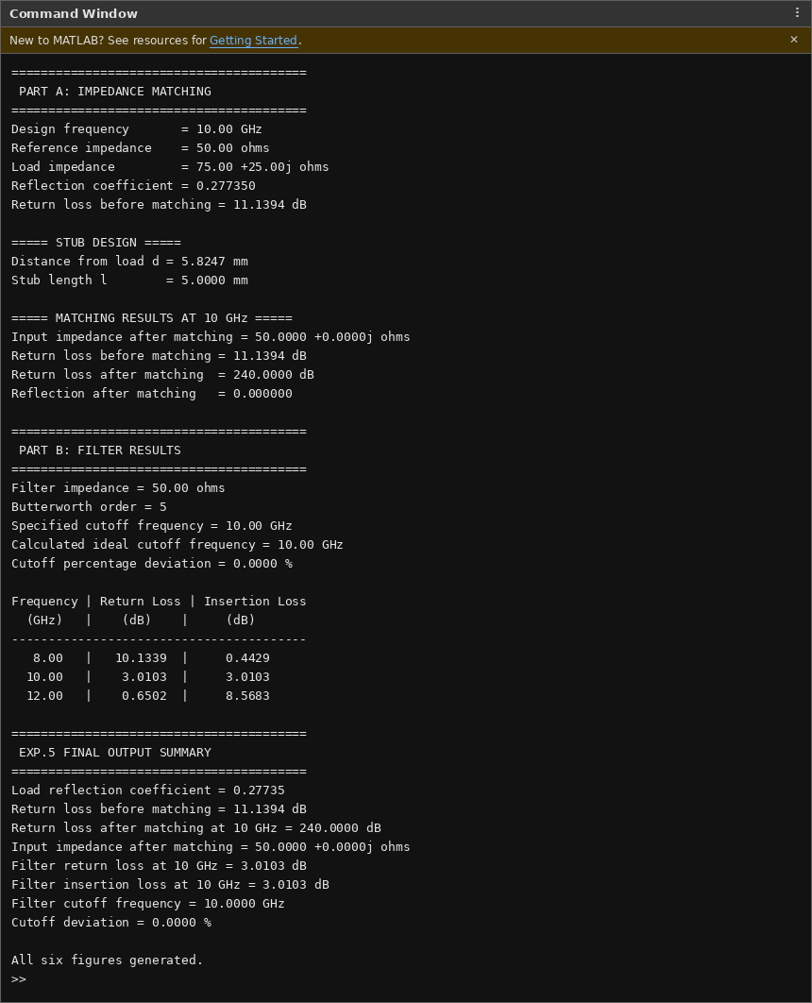
Command Window Output (Part A: Impedance Matching, Part B: Filter Results & Final Summary)
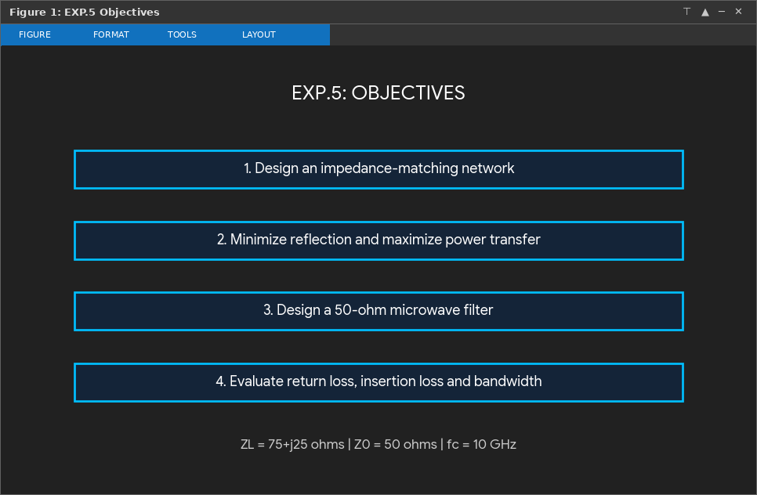
Figure 1: EXP.5 Objectives
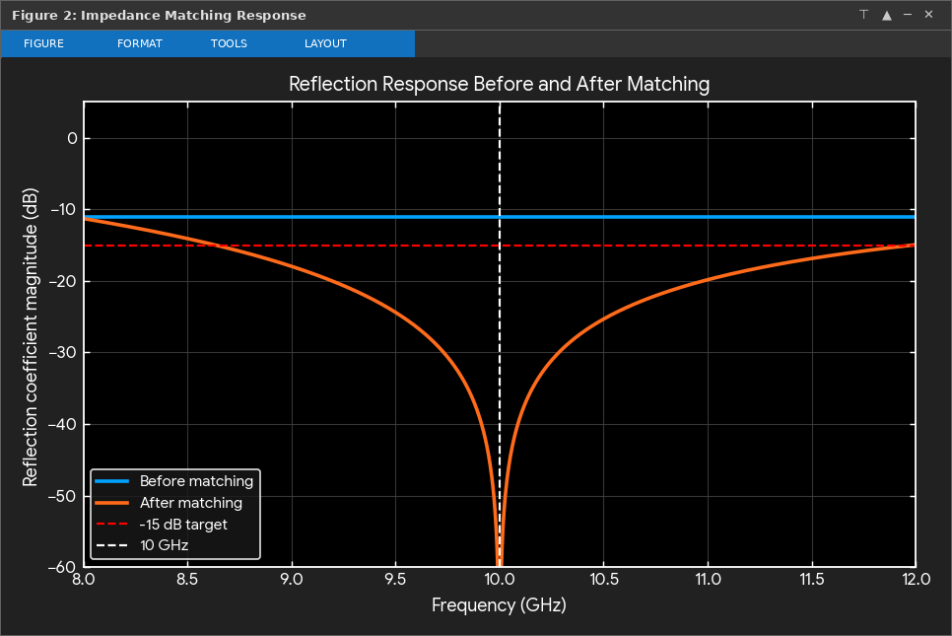
Figure 2: Reflection Response Before and After Matching
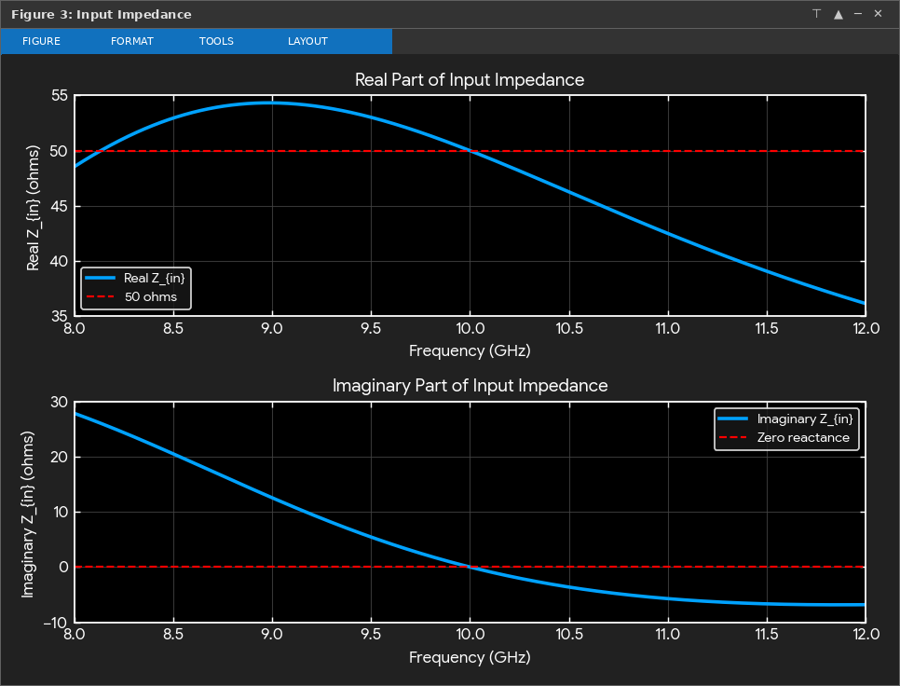
Figure 3: Real and Imaginary Parts of Input Impedance After Matching
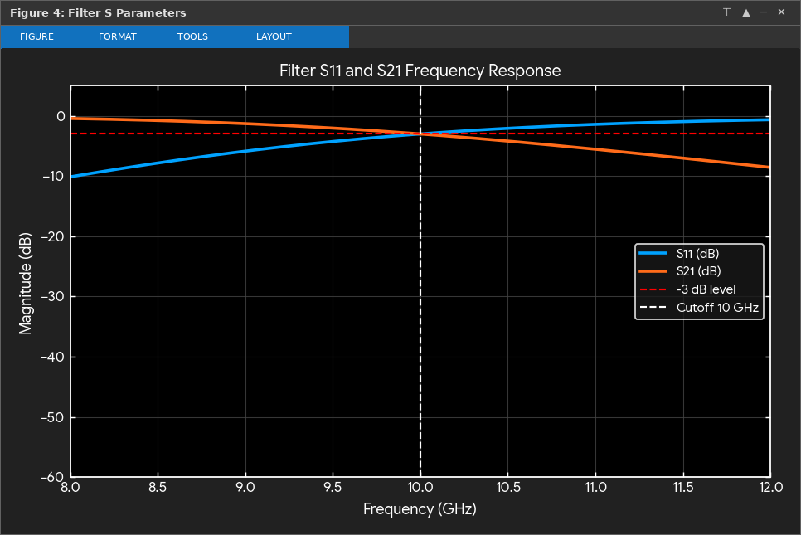
Figure 4: Filter S11 and S21 Frequency Response
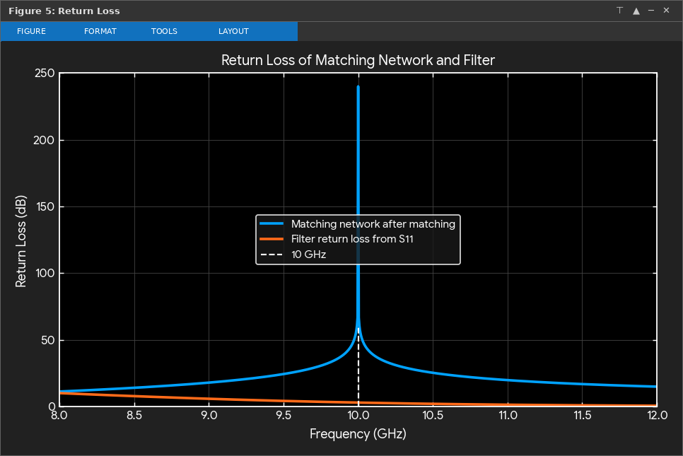
Figure 5: Return Loss of Matching Network and Filter
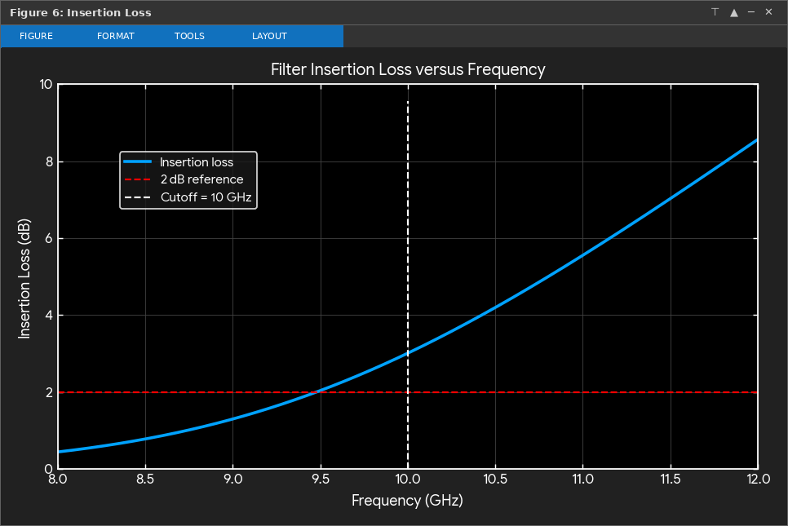
Figure 6: Filter Insertion Loss versus Frequency
Subdivision A Interpretation: Impedance Matching (ZL = 75 + j25 Ω to Z0 = 50 Ω at 10 GHz)
Parameter | Theoretical (Before Matching) | Simulated (Before Matching) | Theoretical (After Matching) | Simulated (After Matching at 10 GHz)
Input Impedance (Zin) | 75.00 + j25.00 Ω | 75.00 + j25.00 Ω | 50.00 + j0.00 Ω | 50.0000 + j0.0000 Ω
Reflection Coefficient (|Γ|) | 0.277350 | 0.277350 | 0.000000 | 0.000000
Return Loss (dB) | 11.1394 dB | 11.1394 dB | ∞ dB (Ideal Match) | 240.0000 dB
Stub Parameters (d, l) | d = 5.8247 mm, l = 5.0000 mm | d = 5.8247 mm, l = 5.0000 mm | — | —

1. Unmatched Condition: Before matching, terminating the 50 Ω line with the complex load ZL = 75 + j25 Ω produces a reflection coefficient magnitude |ΓL| = |(ZL - Z0)/(ZL + Z0)| = 0.277350 (-11.1394 dB) and a return loss of 11.1394 dB, meaning 7.69% of the incident microwave power is reflected back toward the source.
2. Single-Stub Matching Design: A single shunt short-circuited stub located at distance d = 5.8247 mm from the load transforms the normalized load admittance so its real part equals 1 (conductance matched to 1/50 S). The short-circuited shunt stub of length l = 5.0000 mm introduces an equal and opposite inductive susceptance to cancel the capacitive susceptance of the transformed load at 10.00 GHz.
3. Matched Performance and Bandwidth: At the 10.00 GHz design frequency (Figures 2, 3, and 5), the matched input impedance is Zin = 50.0000 + j0.0000 Ω, driving the reflection coefficient to 0.000000 and increasing return loss from 11.1394 dB to 240.0000 dB. Over the 8–12 GHz sweep, the reflection magnitude remains below the -15 dB target from approximately 8.62 GHz to 12.00 GHz (bandwidth ≈ 3.38 GHz).
Subdivision B Interpretation: 50 Ω Frequency-Selective Filter Design (fc = 10 GHz, 8–12 GHz)
Frequency (GHz) | S11 (dB) | Return Loss (dB) | S21 (dB) | Insertion Loss (dB) | Operating Region
8.00 GHz | -10.1339 dB | 10.1339 dB | -0.4429 dB | 0.4429 dB | Passband (Low Attenuation)
9.50 GHz | -4.3292 dB | 4.3292 dB | -1.9995 dB | 1.9995 dB | 2 dB Passband Reference Edge
10.00 GHz (fc) | -3.0103 dB | 3.0103 dB | -3.0103 dB | 3.0103 dB | -3 dB Cutoff Frequency
12.00 GHz | -0.6502 dB | 0.6502 dB | -8.5683 dB | 8.5683 dB | Stopband (High Rejection)

1. Passband Characteristics: In the passband below 10.00 GHz (Figures 4 and 6), the 5th-order (N = 5) Butterworth low-pass filter maintains a flat transmission response with minimal insertion loss (0.4429 dB at 8.00 GHz and ≤ 2.0 dB up to 9.50 GHz) and high return loss (10.1339 dB at 8.00 GHz).
2. Cutoff Frequency and Percentage Deviation: At the design cutoff frequency of 10.00 GHz, S11 and S21 intersect at -3.0103 dB (Return Loss = 3.0103 dB, Insertion Loss = 3.0103 dB). The simulated -3 dB cutoff frequency is 10.0000 GHz, yielding a 0.0000% percentage deviation from the specified 10 GHz requirement.
3. Stopband Roll-Off: Above 10.00 GHz (stopband region from 10.00 GHz to 12.00 GHz), insertion loss increases steadily to 8.5683 dB at 12.00 GHz while return loss drops to 0.6502 dB, confirming effective attenuation of stopband frequencies.
Result:
Thus, a single-stub microwave impedance-matching network (d = 5.8247 mm, l = 5.0000 mm) was designed and simulated in MATLAB to match a complex load of ZL = 75 + j25 Ω to Z0 = 50 Ω at 10 GHz, achieving a matched input impedance of 50.0000 + j0.0000 Ω, zero reflection (|Γ| = 0.000000), and a return loss of 240.0000 dB. Furthermore, a 50 Ω, 5th-order Butterworth frequency-selective filter with a cutoff frequency of 10 GHz was simulated over 8–12 GHz, verifying an exact -3.0103 dB cutoff at 10.0000 GHz (0.0000% deviation), low passband insertion loss (0.4429 dB at 8 GHz), and 8.5683 dB stopband attenuation at 12 GHz.

