SBONEST for decoupling sideband fitting in ¹⁵N and ¹³C CEST
  - A 30 ppm ¹⁵N benchmark at 1.2 GHz and a ¹³C–¹H implementation check

Abstract
SBONEST fits decoupling sidebands in heteronuclear chemical exchange saturation transfer (CEST), including ¹⁵N and ¹³C profiles described by an isolated XH spin pair. We use a 30 ppm ¹⁵N window at a proton frequency of 1.2 GHz as the quantitative benchmark. Although high-power composite pulse decoupling can suppress these artifacts, its use over a long saturation period is constrained by probe power handling and sample heating. When sidebands persist under the available RF conditions, quantitative fitting must account for the coupled XH dynamics. SBONEST propagates the applied proton pulse train explicitly. On the same noisy synthetic profiles, conventional nitrogen-only fitting gives χ²/dof=67.95 and kex=321.4 s⁻¹, whereas SBONEST gives 0.968 and 300.2 s⁻¹ for a generating rate of 300 s⁻¹. The conventional fit also lowers minor-state R2N from the generating 15.0 to 7.80 s⁻¹, compared with 15.22 s⁻¹ for SBONEST. The rate displacement persists without noise. Repeated 90x–240y–90x decoupling with a 70 μs 90° pulse has a nominal first-sideband separation of 1530.6 Hz, corresponding to 25.18, 18.88 and 12.59 ppm on ¹⁵N at 600 MHz, 800 MHz and 1.2 GHz, respectively. We combine this geometry with a coupled NH exchange model implemented in SBONEST. In independent simulations sampled uniformly across 105–135 ppm at approximately 25 Hz spacing, retaining sideband regions at 1.2 GHz reduced local standard errors of the nitrogen RF scale and minor-state population by 19.1% and 17.1%, whereas the exchange-rate improvement was 1.8%. Stock-pulse calculations imported from cestdec and independently checked here explain the RF dependence and offset shifts of the sidebands. These results support a conditional improvement in the use of already acquired data, rather than a general advantage in information per unit time. We specify experiments to test the effect of field, pulse timing, RF calibration and sampling phase. A separate noiseless ¹³C–¹H configuration test recovers all eight generating parameters. Experimental validation remains prospective.
Keywords: heteronuclear CEST; ¹⁵N CEST; ¹³C CEST; decoupling sidebands; 90x–240y–90x; radiofrequency calibration; SBONEST

Introduction
Heteronuclear CEST detects sparsely populated conformations through changes in the intensity of an observed ground-state resonance when a weak RF field on ¹⁵N or ¹³C is stepped across the corresponding spectrum [1,2,12]. Quantitative analysis usually aims to determine exchange rates, populations and excited-state chemical shifts. The need to model residual decoupling dynamics applies to both nuclei; the present field-dependent study uses ¹⁵N as a defined benchmark.
The motivation for 1.2 GHz CEST begins with the exchange process of interest. For a fixed chemical-shift difference, the separation in hertz increases in proportion to the static field. The 3 ppm nitrogen separation used here corresponds to 182.4 Hz at 600 MHz and 364.8 Hz at 1.2 GHz. At unchanged exchange rates and saturation RF, this increases the separation relative to the exchange and irradiation frequency scales and can help distinguish a minor-state dip from direct saturation of the major state [1,2]. Higher field also increases frequency dispersion in the detected correlation spectrum. Experiments at 1.2 GHz have demonstrated improved resolution and, for some proteins, sensitivity, although the gains depend on the sample, pulse sequence and hardware [7]. These considerations motivate high-field CEST for small shift differences or crowded spectra; they do not make 1.2 GHz a prerequisite for CEST.
Realizing this benefit requires adequate proton decoupling throughout the saturation period. The one-bond NH coupling cannot simply be ignored at the weak nitrogen RF amplitudes used for CEST: residual coupling can split or distort the major- and minor-state responses [1,8]. The original nitrogen CEST implementation used repeated composite inversion pulses to move prominent decoupling sidebands away from the main resonances [1]. At higher field, however, proton offsets in hertz also grow for a fixed amide chemical-shift range, so the decoupling bandwidth must be assessed together with the desired nitrogen coverage.
A fixed chemical-shift window changes this argument as the static field increases. A 30 ppm nitrogen sweep spans 1824 Hz at 600 MHz but 3648 Hz at 1.2 GHz. Sidebands generated by a pulse train with fixed timing remain on a frequency scale set predominantly by that timing; their separation in ppm therefore decreases. A sideband outside a conventional lower-field window can enter the same ppm window at 1.2 GHz. Thus, an experimental strategy chosen to increase exchange-site separation can also expose decoupling features within the required sweep. Their presence creates a modeling requirement before any possible gain in parameter precision is considered.
These features need not indicate poor calibration. Finite-period decoupling suppresses the average scalar splitting but leaves a time-dependent NH interaction during the pulse cycle. Suppressing the cycle average does not force the nonzero-frequency components of that interaction to vanish. Those components can drive additional transitions during nitrogen saturation and produce intensity dips (Equations 3–14). Our non-exchanging stock-pulse controls produce sidebands even with the proton on resonance and the proton RF exactly calibrated (Figure 3). Sidebands are therefore intrinsic to the retained RR train under the stated conditions; their amplitude and detectability still depend on offsets, RF strength, relaxation and sampling.
Our earlier work established high-power proton CPD as an effective way to suppress EST artifacts [8]. On an 800 MHz Bruker CP-TCI probe, 10 kHz decoupling applied for 400 ms strongly reduced sidebands and corrected the profile broadening produced by intermittent proton inversion pulses. That study also identified probe hardware, duty cycle and EST duration as limits on the usable RF amplitude. Its success establishes the value of stronger decoupling when the apparatus and sample permit it; it does not establish that the same sustained irradiation is available at 1.2 GHz.
At 1.2 GHz, the required bandwidth increases while cryoprobe power handling limits the available RF. Joseph and Griesinger [9] describe the need for twice the RF amplitude and four times the power on scaling from 600 MHz to 1.2 GHz. This scaling preserves relative bandwidth within a pulse family and assumes unchanged RF efficiency. Larger coils further reduce the amplitude attainable at a given power: their group subsequently demonstrated a 5 mm cryoprobe at 1.2 GHz whose sensitivity advantage was realized using low-power optimal-control sequences [11]. Long decoupling trains also deposit energy in the probe and sample, with conductive buffers complicating broadband excitation and temperature control [10]. The 8 kHz proton optimal-control pulses in Ref. 9 last 650–700 μs; their successful use does not establish an allowable sustained CPD amplitude for a 400 ms CEST period.
This distinction is especially relevant to CEST. In the present 400 ms design, constant 3.571 kHz proton decoupling has an integrated squared RF amplitude of 5.10 kHz² s per saturation period; 10 kHz for the same duration gives 40.0 kHz² s, a 7.84-fold increase. This is an RF exposure comparison, not a measured temperature rise. Raising the recycle delay reduces average RF loading but sacrifices throughput, and does not remove the exposure during each saturation block. Temperature changes can also alter the exchange process being measured. Thus, when the required sustained RF exceeds the probe or sample tolerance, the earlier high-power solution is unavailable even though short high-amplitude pulses remain possible. The present work addresses that power-constrained regime by retaining moderate-power stock decoupling and analyzing its residual sidebands.
This motivates a fitting capability that includes the decoupling mechanism. A conventional single-spin Bloch–McConnell model for the irradiated heteronucleus X treats the proton coupling as removed and cannot predict sideband positions or intensities that depend on the proton waveform. Masking affected offsets is useful when exchange and artifact regions are separable, but discards observations and can become ambiguous when they overlap. Assigning every additional dip to an exchanging state is likewise unsafe without a decoupling model. SBONEST extends the coupled-spin analysis used to evaluate high-power CPD [8] into the ONEST fitting workflow [5]: it propagates the actual pulse train while jointly fitting exchange, heteronuclear relaxation, chemical shifts and, when selected, heteronuclear RF calibration. The methodological requirement is this explicit forward model; SBONEST supplies its implementation for complete profiles. Its two spin-½ degrees of freedom describe either an NH or a CH pair when the nucleus-specific frequency, coupling and relaxation parameters are supplied.
With this model in place, the additional hypothesis is that a 30 ppm window at 1.2 GHz provides greater access to useful sideband constraints, especially on the nitrogen RF amplitude and parameters correlated with it. We distinguish geometric accessibility, statistical identifiability within an acquired dataset, and precision per unit acquisition time. The first can be derived, the second is tested by the simulations below, and the third requires acquisition-aware comparisons and experimental measurements [6].

Theory

A fixed chemical shift window
All magnetic-field labels refer to the proton Larmor frequency. We use X for the irradiated spin-½ heteronucleus, ¹⁵N or ¹³C. The equations and numerical geometry below retain N labels for the ¹⁵N benchmark; corresponding CH calculations use the carbon frequency and replace the N parameters by their C counterparts. Nitrogen frequencies are calculated using ν₀N = 0.101329118 ν₀H, with both quantities in MHz. A full ¹⁵N profile is defined here as irradiation throughout 105–135 ppm. This chosen 30 ppm window is specific to the benchmark. For a repeated inversion element R = 90x–240y–90x, the element duration and the nominal first-sideband separation are [1]
$p_{INV} = \frac{14}{3}p_{90}; T = 2p_{INV}; f_{1} = 1/T; d = \frac{f_{1}}{ν_{0N}}$ (1)
Here p90, pINV and T are in seconds, f₁ is in Hz, ν₀N is in MHz, and d is in ppm. The 70 μs value is the defined simulation setting; it should not be substituted for the calibrated pulse length of an actual dataset. RR denotes two identical R elements, with no 180° phase alternation. R and RR describe the same repeated train, but the two-element period restores the nominal toggling frame on resonance.
For a parent resonance δA, both nominal first sidebands fall within [L,U] if L+d ≤ δA ≤ U−d. With L=105, U=135 and d=12.588 ppm, this interval is 117.588–122.412 ppm at 1.2 GHz. It is empty at 600 and 800 MHz for the same pulse timing. If parent shifts are assumed uniformly distributed over a window of width W, the geometric fractions are
$F_{any} = min[1, max(0, 2(1−d/W))]; F_{both} = max(0, 1−2d/W)$ (2)
These fractions describe positions only. They do not predict sideband amplitudes or the fraction of experimentally usable residues. Proton offsets, RF inhomogeneity, finite nitrogen RF and higher harmonics change the observed pattern.
¹H / GHz | 30 ppm / Hz | Nominal d / ppm | At least one / % | Both / %
0.6 | 1823.9 | 25.176 | 32.2 | 0.0
0.8 | 2431.9 | 18.882 | 74.1 | 0.0
1.0 | 3039.9 | 15.105 | 99.3 | 0.0
1.2 | 3647.8 | 12.588 | 100.0 | 16.1

Table 1. Nominal first-sideband geometry for p90=70 μs. Fractions assume uniformly distributed parent shifts and are not measured detection probabilities.
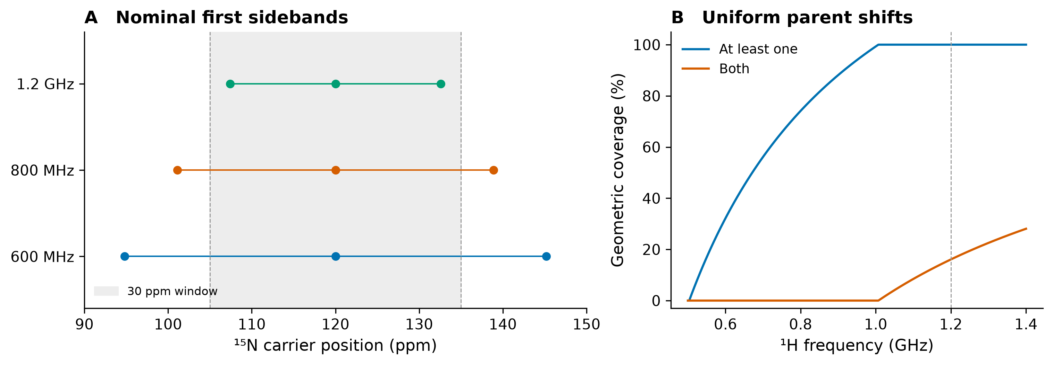
Figure 1. Accessibility of nominal decoupling sidebands in a fixed 30 ppm window. A, the parent peak is at 120 ppm and the shaded window spans 105–135 ppm. The first-sideband estimate is 1/(2pwINV) with p90=70 μs. B, purely geometric fractions for parent shifts uniformly distributed within the window. These curves describe nominal positions, not experimental detection rates; they omit offset-dependent sideband shifts and amplitudes.

Stock pulse sideband equations from cestdec
The following first-order formulation is taken from the 90x–240y–90x analysis in cestdec, including its relaxation correction. It is an explanatory approximation; SBONEST fitting uses the full coupled propagator. Let P(t) be the proton rotation generated by its RF and offset alone, z the unit vector along the static field, and H the vector of proton spin operators. Bold-vector notation is represented here by the vector symbols a and Φ. Define
$a(t) = {P(t)}^{T}z; Φ(t) = \int_{0}^{t}{a(t′)dt′}; \tilde{Φ}(t) = Φ(t)−(t/T)Φ(T)$ (3)
${\tilde{H}}_{J}(t) = 2πJ N_{z} [a(t)·H]$ (4)
J is in Hz, Φ has units of seconds, and H̃J is in angular-frequency units. For a cyclic proton trajectory and k ≠ 0, the Fourier coefficients are
${\hat{a}}_{k} = \frac{1}{T}\int_{0}^{T}{a(t)e^{−2πikt/T}dt}; {\hat{Φ}}_{k} = \frac{{\hat{a}}_{k}}{2πif_{k}}; f_{k} = k/T$ (5)
Equivalently, Φ̂k is the Fourier coefficient of Φ̃(t). If a cycle ends with a residual rotation β about an axis m, components parallel and perpendicular to m have frequencies k/T and k/T ± νeff, respectively, where νeff=β/(2πT). A dressed-spin resonance gives the approximate sideband positions
f ∈ {k/T, k/T ± β2πT}; Δsb ≈ ±f2−ν1N2, f > ν1N (6)
Δsb is the nitrogen RF offset in Hz relative to its parent resonance. The proton offset and RF scale affect β, so a universal ±1530.6 Hz mask is inadequate. When f ≤ ν₁N there is no separate resonance described by Equation 6; the corresponding modulation must be evaluated together with the main dip. Residual coupling and strong modulation can further alter the simple resonance condition.
For a noncyclic trajectory, let ec be a unit eigenvector of P(T)ᵀ: the residual-rotation axis m or either circular transverse eigenvector e±. At its corresponding frequency f from Equation 6, the component coefficients are
$\hat{a}(f) = \frac{e_{c}}{T}\int_{0}^{T}{({e_{c}}^{†}a(t))e^{−2πift}dt}; \hat{Φ}(f) = \frac{\hat{a}(f)}{2πif}$ (6a)
$|c_{k}| = π|J| ‖{\hat{Φ}}_{k}‖; ω_{e} = 2πν_{1N} |c_{k}|$ (7)
For a noncyclic trajectory, the Fourier coefficients must be resolved along the residual-rotation axis and its two circular transverse components at the frequencies in Equation 6; a simple k/T Fourier transform is insufficient. Equations 7–9 then use the coefficient Φ̂(f) of the corresponding component. The first-order sideband amplitude |ck| is dimensionless, and ωe is in rad s⁻¹. In saturation transfer, the transition probabilities associated with the proton spin states contribute to intensity loss; cancellation of a coherent signal in a decoupled FID does not guarantee cancellation of the CEST dip. Sideband coherences involve both N and H operators, so proton relaxation must be included in their damping.
${\bar{R}}_{H} = R_{2H}1 − (R_{2H}−R_{1H})〈aa^{T}〉$ (8)
$R_{H,eff} = \frac{Re({{\hat{Φ}}_{k}}^{†}{\bar{R}}_{H}{\hat{Φ}}_{k})}{{{\hat{Φ}}_{k}}^{†}{\hat{Φ}}_{k}}; R_{2s} = R_{2N} + R_{H,eff}$ (9)
Angle brackets denote an average over the cycle; 1 is the identity matrix. The isolated-sideband model evolves transverse and longitudinal components according to
$\frac{dM_{⊥}}{dt} = −R_{2s}M_{⊥} + ω_{e}M_{∥}; \frac{dM_{∥}}{dt} = −ω_{e}M_{⊥} − R_{1}M_{∥}$ (10)
With M⊥(0)=0 and M∥(0)=1, define
λ± = −R1+R2s2 ± (R2s−R12)2−ωe2 (11)
$M_{∥}(t) = \frac{(λ_{+}+R_{2s})e^{λ_{+}t}−(λ_{−}+R_{2s})e^{λ_{−}t}}{λ_{+}−λ_{−}}$ (12)
The repeated-root case is evaluated by its continuous limit, or by the 2×2 matrix exponential. Let y=I/I₀ and yideal=Iideal/I₀, with I₀ the reference signal without the saturation interval. Relative dip depth D and the absolute signal deficit then satisfy
$D = 1−M_{∥}(T_{EX})e^{R_{1}T_{EX}}; y_{ideal}−y = D y_{ideal}$ (13)
This distinction matters because the distant baseline is approximately exp(−R₁TEX)=0.549 for the present relaxation and delay, rather than one. In the weak-sideband limit, with κ=R₂s−R₁>0,
$D ≈ {ω_{e}}^{2}[\frac{T_{EX}}{κ}−\frac{1−e^{−κT_{EX}}}{κ^{2}}]$ (14)
For κTEX much larger than one, D is approximately proportional to ν₁N²J²‖Φ̂k‖²TEX/κ. This dependence explains why sidebands can constrain ν₁N, but also why uncertainty in proton relaxation or RF conditions can mimic a nitrogen RF error. The approximation yideal ≈ cos²θ exp[−(R₁cos²θ+R₂Nsin²θ)TEX], with sinθ=ν₁N/f, is useful for an isolated distant line; close to the main dip, the full propagator is required. The simplified expression that sets R₂s=R₂N and retains only the slow eigenvalue is not used for parameter fitting.

Computational methods

Coupled heteronuclear exchange model
SBONEST retains ONEST input and residual conventions but propagates an XH spin pair (X=¹⁵N or ¹³C) in each of two exchanging conformations. OC provides spin operators and the waveform interface. For each constant pulse segment, the Hamiltonian includes heteronuclear offset and RF, proton offset and RF, and the weak scalar coupling JXH XzHz. Exchange and phenomenological relaxation are included in the same generator. The 16 real product-operator components per conformation form a 32-dimensional system. Matrix exponentials are multiplied through the actual pulse train, including the fractional final segment of TEX.
The initial state is pA Xz in A and pB Xz in B, with unpolarized protons; the observable is Xz(A)/pA. We propagate the longitudinal deviation and omit an equilibrium source term, consistent with a preparation phase cycle that cancels recovery. Product-operator relaxation rates are sums of the relevant X and H rates. This model does not include CSA–dipolar cross-correlation, additional coupled spins or water exchange. Those omissions must be assessed before interpreting real sample data.

Application to ¹³C CEST
For ¹³C CEST, the irradiated-spin frequency in the data header is the ¹³C Larmor frequency, while the proton frequency is specified independently for the decoupler. Carbon chemical shifts, the actual JCH coupling, carbon relaxation rates and carbon saturation RF replace the nitrogen inputs. The implementation performs propagation in hertz and contains no fixed nitrogen gyromagnetic ratio in this path. Its legacy v1n option therefore controls the applied heteronuclear RF amplitude for either nucleus. The nitrogen example’s 92 Hz coupling must be replaced by the relevant carbon–proton coupling. Both propagation and detection assume a longitudinal-deviation preparation and the major-state Xz observable.
We checked this configuration without changing the production engine. An independent complex density-matrix calculation generated noiseless CH profiles at ν₀C=301.8 MHz and nominal ν₀H=1.2 GHz, with δCA=55 ppm, ΔδC=1.2 ppm, JCH=140 Hz, R1C=1.2 s⁻¹, R2CA=15 s⁻¹ and R2CB=20 s⁻¹. Proton shifts were 3.8 and 4.1 ppm with a 4.7 ppm carrier; R1H=2 s⁻¹ and R2H=25 s⁻¹ were fixed. The check retained kAB=15 s⁻¹, kBA=285 s⁻¹, an RF scale of 1.08, TEX=0.4 s and the 70 μs stock RR train. Three nominal carbon RF amplitudes (25, 50 and 100 Hz) used 121 uniformly spaced offsets from 45 to 65 ppm each. All eight parameters were refitted from a perturbed initial vector. This isolated-pair implementation check does not assess experimental accuracy or carbon sampling efficiency.

Fixed window and independent simulations
We used δNA=120 ppm, ΔδN=3 ppm, δHA=6.2 ppm, δHB=6.5 ppm and a proton decoupler carrier of 8.5 ppm. The exchange rates were kAB=15 s⁻¹ and kBA=285 s⁻¹, giving kex=300 s⁻¹ and pB=0.05. Relaxation rates were R1N=1.5 s⁻¹, R2NA=12 s⁻¹, R2NB=15 s⁻¹, R1H=2 s⁻¹ and R2H=25 s⁻¹. We set JNH=92 Hz, TEX=0.4 s, p90=70 μs and repeated RR decoupling at nominal proton RF 3571.43 Hz. The actual nitrogen RF values were 27, 54 and 108 Hz, corresponding to a common scale of 1.08 on nominal 25, 50 and 100 Hz.
Each field used an exactly 30 ppm, equally spaced grid. The number of intervals was 2 ceil(15ν₀N/25), giving 75, 99 and 147 points per RF at 600 MHz, 800 MHz and 1.2 GHz. The resulting spacings were 24.648, 24.815 and 24.985 Hz, respectively. This preserves both endpoints and the central point without claiming that all fields have exactly 25 Hz spacing. Such spacing is representative of conventional CEST sampling, although its efficiency depends on RF strength and lineshape [1,6].
Data were generated using a separate complex density-matrix implementation with reversed tensor ordering. Gaussian intensity noise with standard deviation 0.001 was added using seed 20261002 plus the proton frequency in MHz. Production and independent profiles agreed within 2×10⁻¹⁰. A noise-free 1.2 GHz fit was also performed. We held relaxation, proton pulse timing and noise per point constant across fields to define a controlled computational comparison; this is not a model of the sensitivity or relaxation differences between actual spectrometers.

Fitting and information comparisons
Eight parameters were varied jointly: kAB, kBA, the common ν₁N scale, δNA, ΔδN, R1N, R2NA and R2NB. Proton shifts, proton relaxation, JNH and decoupler amplitude were fixed at their generating values. Bounded least squares minimized the error-weighted intensity residuals. Rank and parameter correlations were assessed from the scaled Jacobian; covariance used the supplied absolute intensity errors without multiplication by reduced χ².
The prespecified comparison mask removed 1250 ≤ |offset from A| ≤ 1850 Hz. It excludes the major sideband regions in this example but also removes their surrounding baseline, so its incremental information should be attributed to the retained regions rather than solely to dip centers. The same coupled model was used for full and masked fits. At 600 and 800 MHz the mask lies outside this central residue’s window and removes no points. At 1.2 GHz it leaves 101 of 147 points per RF. A separate fit fixed ν₁N at the incorrect nominal values to distinguish RF-calibration bias from the effect of retaining sidebands.
Local expected standard errors were calculated at the true parameter vector from the inverse weighted information matrix, with kex and pB errors propagated using their gradients. They are local identifiability estimates, not confidence intervals validated by noise replicates. For an idealized equal-time comparison, the noise on the 101 retained offsets was multiplied by √(101/147), representing redistribution of the omitted scans. This assumes negligible overhead and independent noise. It is an allocation calculation for one residue, not a replacement for a shared multi-residue acquisition design.
To isolate model mismatch, we also fitted the identical 1.2 GHz profiles with a conventional nitrogen-only two-state Bloch–McConnell model. The comparison retained the eight free parameters above, the original error weights, RF-scale treatment and bounded least-squares optimizer. The primary comparison used signed major-state longitudinal magnetization, normalized by pA, in both models; the nitrogen-only propagator agrees with SBONEST at JNH=0 to within 3×10⁻¹³ over two tested parameter vectors. The legacy ONEST implementation clips negative predictions to zero, so we separately repeated its fits as a sensitivity check without clipping any observations. Nitrogen-only fits used three initial parameter vectors, including the generating vector, and all converged to the same objective within numerical tolerance. Full and masked analyses used 441 and 303 observations, giving 433 and 295 degrees of freedom. Noiseless profiles were fitted separately to distinguish deterministic model mismatch from the particular noise realization.

Stock calculations imported from cestdec
We imported only the stock 90x–240y–90x RR results and associated sideband equations from cestdec/results/final/REPORT.md and its stock entries in sideband_exact_check_nu100.json. The imported examples use a single non-exchanging NH pair with the proton on resonance and RF scale one. Their first-sideband maxima at ν₁N=25, 50 and 100 Hz were independently re-evaluated with the SBONEST segment propagator. This provides a numerical bridge between the existing sideband analysis and the new fitting study while keeping their different physical conditions explicit.

Results

The 30 ppm window captures the first sidebands at 1.2 GHz
At 1.2 GHz, a 30 ppm nitrogen profile spans 3647.85 Hz. For the central residue, both nominal first sidebands are inside the window, whereas neither is inside at 600 or 800 MHz (Table 1 and Figure 1). The off-resonance coupled calculation places the dominant features near ±1.72 kHz at 1.2 GHz, corresponding to approximately ±14.1 ppm. They remain within 105–135 ppm for the chosen 120 ppm parent. The actual inclusion margin is therefore smaller than the nominal on-resonance estimate. These positions depend on proton shifts and should not be generalized to all residues.
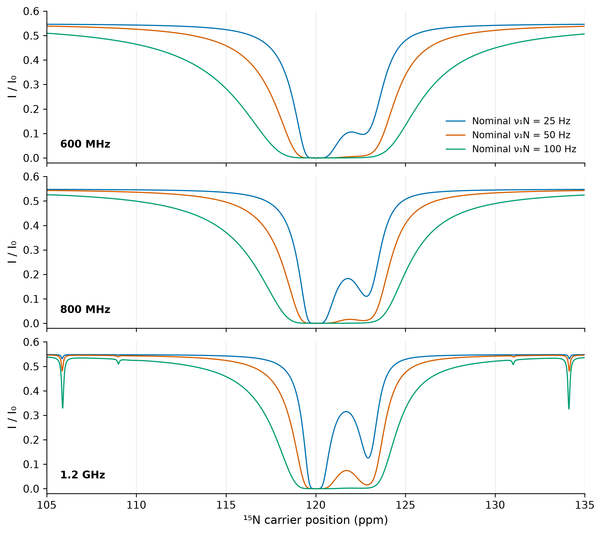
Figure 2. Simulated profiles across exactly 30 ppm at 600 MHz, 800 MHz, and 1.2 GHz. The same chemical shifts, relaxation rates, exchange parameters, pulse timing, and nitrogen RF amplitudes were used at each field. Actual ν₁N is 1.08 times the nominal amplitude. Smooth curves are model predictions, not interpolated experimental observations. The main sidebands of the central residue enter the window at 1.2 GHz. Holding relaxation and noise fixed isolates the modeled frequency-geometry effect and does not reproduce all physical changes between spectrometers.

Stock sideband depth increases with nitrogen RF
The imported and independently checked stock calculation reproduces first-sideband relative depths of 2.699%, 10.317% and 34.654% at ν₁N=25, 50 and 100 Hz. The corresponding absolute losses are 1.479%, 5.631% and 18.601% of I₀ (Table 2, Figure 3). Agreement with the stored cestdec relative depths was better than 0.001 percentage point. The dip moves from 1530.458 to 1527.392 Hz as the nitrogen RF increases, in agreement with the dressed-spin shift in Equation 6 to the precision of the sampled maximum.
ν₁N / Hz | Position / Hz | Relative dip / % | Loss / % of I₀ | FWHM / Hz
25 | 1530.458 | 2.699 | 1.479 | 10.50
50 | 1529.845 | 10.317 | 5.631 | 10.70
100 | 1527.392 | 34.654 | 18.601 | 11.60

Table 2. Independently checked first-sideband values for the non-exchanging, on-resonance stock RR case. FWHM was measured on a 0.05 Hz numerical grid; these widths are not experimental linewidths.
The calculated full width at half maximum is only 10.5–11.6 Hz, narrower than the approximately 25 Hz acquisition spacing. Consequently, geometric inclusion does not guarantee adequate sampling. At high RF the depth increases less than ν₁N² because the weak-sideband limit becomes inaccurate. The relaxation-corrected isolated-line equations explain this trend, but full NH propagation remains the fitting model. The stock second harmonic near 3061 Hz in cestdec would lie outside this central 30 ppm window at 1.2 GHz; it is not included in the claimed first-sideband benefit.
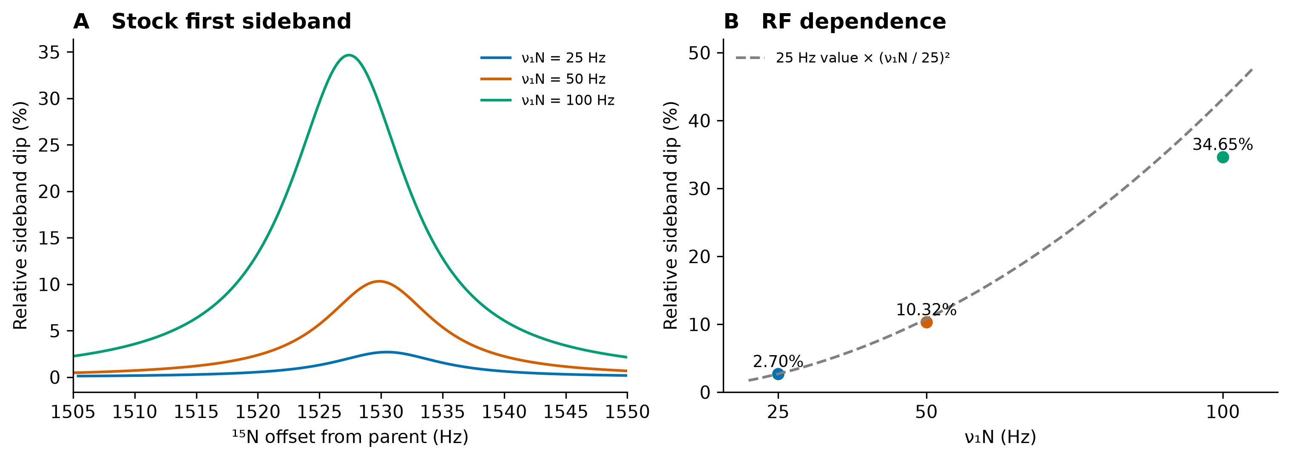
Figure 3. Stock 90x–240y–90x sideband evidence from cestdec, independently re-evaluated with the SBONEST segment propagator. A, the first sideband for a single NH pair with its proton on resonance, p90=70 μs, T=0.4 s, JNH=92 Hz, R1N=1.5, R2N=12, R1H=2 and R2H=25 s⁻¹. B, simulated depths compared with quadratic RF scaling anchored at 25 Hz. Relative depth is 100(1−I/Iideal), which differs from absolute loss as a percentage of I0. No chemical exchange or RF scaling error is present in this calculation. These conditions differ from the exchanging, off-resonance example in Figures 2 and 4.

Retaining sideband regions improves RF and population precision
The noise-free 1.2 GHz fit recovered all eight parameters, with reduced χ²=1.38×10⁻¹⁹. For noisy data, the full fit gave kex=300.224 s⁻¹, pB=4.9946% and ν₁N scale=1.08138, with reduced χ²=0.9679. The masked fit gave 300.316 s⁻¹, 4.9896% and 1.08205, respectively. Both fits had full Jacobian rank and no parameters at a bound. Thus, in this noise realization both recovered the exchange process; the main distinction is the uncertainty, not a dramatic shift in the point estimates.
1.2 GHz analysis | Points | kex / s⁻¹ | pB / % | ν₁N scale | χ²/dof
Full NH model | 441 | 300.224 | 4.9946 | 1.08138 | 0.9679
Same model with mask | 303 | 300.316 | 4.9896 | 1.08205 | 0.9985
Full with nominal RF fixed | 441 | 302.875 | 5.6654 | 1 fixed | 2.4233

Table 3. Fits to the same noisy 1.2 GHz dataset or its prespecified subset. The true values are kex=300 s⁻¹, pB=5% and RF scale=1.08. χ² values from different point sets are descriptive and are not a model-selection test.
Parameter | Full local SE | Masked local SE | SE reduction
kex / s⁻¹ | 1.0036 | 1.0216 | 1.8%
pB / percentage points | 0.02583 | 0.03115 | 17.1%
ν₁N scale | 0.003233 | 0.003999 | 19.1%

Table 4. Local information at the true parameters, with intensity error 0.001. Population errors are percentage points, not relative percent errors.
The ν₁N scale remains strongly correlated with R2NA (r=−0.948 in the noisy full fit). Allowing RF to vary is therefore feasible under the stated proton constraints, but does not eliminate degeneracy. Fixing the RF scale at 1.00 instead of its true value of 1.08 shifts the population to 5.6654%. That bias illustrates the need to model RF calibration; it should not be attributed entirely to sidebands.
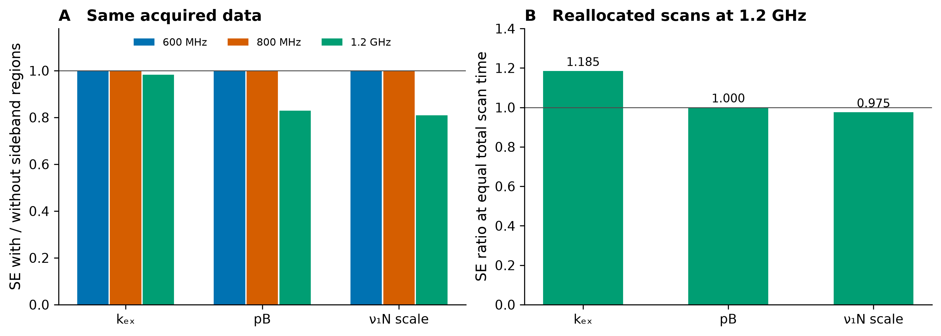
Figure 4. Local information from retaining sideband regions. All standard errors are calculated at the true parameters with independent intensity noise σ=0.001. A, the full-data to masked-data SE ratio; values below one favor retention. The fixed mask removes |offset|=1250–1850 Hz and does not intersect the lower-field windows for this central residue. B, an idealized equal-time comparison at 1.2 GHz that redistributes the omitted 46 of 147 offsets to the remaining 101 offsets. Noise is assumed to decrease as the square root of scan count, without overhead. This panel is an allocation calculation, not a second set of experimental measurements.

Acquisition time limits the strength of the claim
If all offsets have already been acquired, retaining sideband regions incurs no additional acquisition time. If the experiment can instead omit those offsets and reinvest their scans, the calculated RF-scale advantage falls to 2.5%; population precision is essentially equal, and kex precision favors the redistributed masked design by about 18.5% in the full-to-masked SE ratio (Figure 4B). Moreover, the full 1.2 GHz grid contains 147 points per RF compared with 75 at 600 MHz. Equal noise per point therefore does not represent equal total time across fields. These results establish increased usefulness of retained sidebands in this window, not a universal improvement in time efficiency at 1.2 GHz.

Conventional fitting leaves residual structure and shifts exchange parameters
Fitting the full sideband-containing profiles with the nitrogen-only model gives χ²/dof=67.95, compared with 0.968 for the coupled NH model on the identical observations (Table 5; Figure 5). The largest absolute standardized residual is approximately 109 for the nitrogen-only fit, versus 2.80 for SBONEST. The nitrogen-only model cannot reproduce the decoupling dips and compensates by shifting the parameters that govern the central and exchange responses: kex rises from the generating 300 s⁻¹ to 321.4 s⁻¹ (+7.13%), pB falls from 5.000% to 4.812%, and the RF scale rises from 1.080 to 1.0958. The fitted minor-state R2N also falls from 15.0 to 7.80 s⁻¹. SBONEST instead recovers kex=300.2 s⁻¹, pB=4.995%, RF scale=1.0814 and minor-state R2N=15.22 s⁻¹. These are deviations for one noise realization, not ensemble estimates of bias.
Excluding the prespecified sideband regions improves the nitrogen-only fit to χ²/dof=3.726, but kex remains 321.2 s⁻¹ and pB becomes 4.710%. The same masked observations fitted with the NH model give χ²/dof=0.999 and kex=300.3 s⁻¹. Thus, this particular mask removes the prominent sideband regions without making the retained profiles equivalent to perfect proton decoupling. It does not establish that every possible mask would fail. The noiseless nitrogen-only fits return kex=321.1 s⁻¹ for the full grid and 320.8 s⁻¹ for the masked grid, confirming a deterministic displacement of the optimum in this example. The legacy zero-clipping convention gives χ²/dof=67.950 and 3.732 for the noisy full and masked fits, respectively, and does not account for the model discrepancy. Formal covariance errors from the misspecified model should not be interpreted as validated confidence intervals.
1.2 GHz model | Points | kex / s⁻¹ | pB / % | ν₁N scale | χ²/dof
Generating values | — | 300.000 | 5.0000 | 1.08000 | —
SBONEST, full | 441 | 300.224 | 4.9946 | 1.08138 | 0.9679
N-only, full | 441 | 321.397 | 4.8121 | 1.09581 | 67.9519
SBONEST, masked | 303 | 300.316 | 4.9896 | 1.08205 | 0.9985
N-only, masked | 303 | 321.156 | 4.7095 | 1.11287 | 3.7260
Table 5. Matched fitting comparison for sideband-containing synthetic profiles at 1.2 GHz. All fitted rows use eight free parameters and the same σ=0.001 intensity errors. Full and masked comparisons use 441 and 303 observations, respectively; χ²/dof is evaluated only over the observations included in each fit. N-only denotes signed nitrogen-only Bloch–McConnell propagation. The mask and noise realization are identical within each comparison. Values are point estimates; the known generating values are shown for reference.
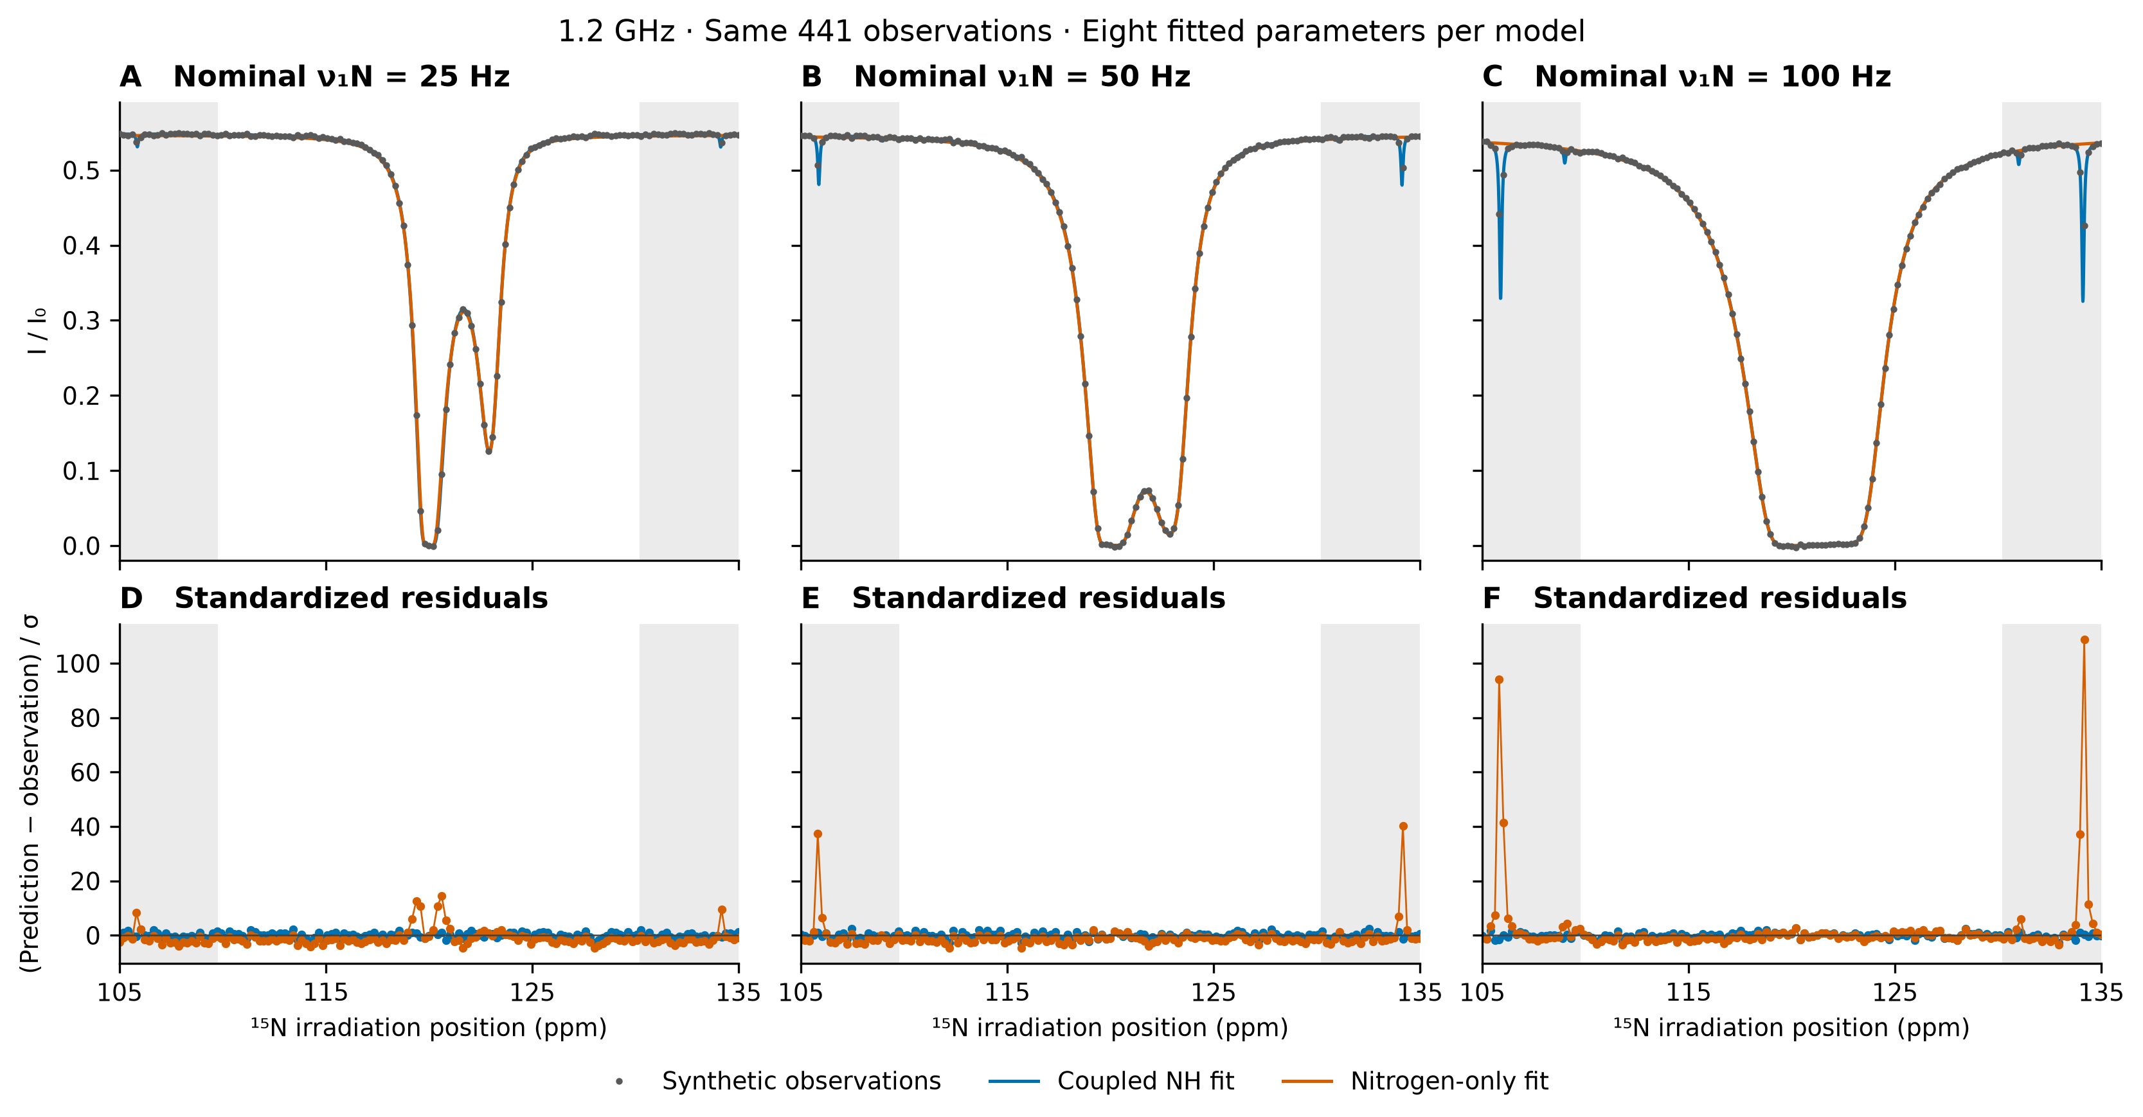
Figure 5. Conventional nitrogen-only fitting versus SBONEST on the same synthetic 1.2 GHz profiles. Top panels show the noisy observations (σ=0.001) and the full-data NH and nitrogen-only fits to the same 441 observations. Columns correspond to nominal nitrogen RF amplitudes of 25, 50 and 100 Hz. Bottom panels show standardized residuals, (prediction−observation)/σ, at the measured offsets. Shaded regions mark the mask used for the separate comparisons in Table 5; no shaded observations were excluded from the plotted fits. Sideband residuals persist in the nitrogen-only model, whereas the coupled model describes the data within the imposed noise.

Effects on all fitted parameters
Table 6 reports every independently fitted parameter for both models and both point sets. The changes are distributed unevenly: in the full nitrogen-only fit, kAB and kBA increase by 3.11% and 7.34%, while R1N changes by only +0.64%. R2NA decreases by 4.12% and R2NB by 48.03%; the RF scale increases by 1.46% relative to its generating value. The major-state shift moves by −0.01176 ppm (−1.43 Hz), and ΔδN by +0.01667 ppm (+2.03 Hz). Shift errors are reported as absolute displacements because relative errors in the referenced ppm value are not physically informative. Thus, a modest shift error and a nearly unchanged R1N can coexist with a substantially incorrect minor-state transverse relaxation rate.
Masking the prominent sideband regions does not restore all parameters in this example: the nitrogen-only R2NA and R2NB remain 6.63% and 43.57% below their generating values, and the RF scale is 3.04% high. The SBONEST full fit gives R2NA=11.971 s⁻¹ and R2NB=15.218 s⁻¹, corresponding to −0.24% and +1.46% deviations. Without noise, the full nitrogen-only fit still returns R2NB=7.554 s⁻¹, so this large displacement is not caused by the chosen noise realization. These are parameter errors in specified synthetic datasets, not ensemble bias estimates or confidence intervals. Proton relaxation rates and JNH were fixed in this matched comparison and therefore have no fitted displacement to report.
Parameter | Generating | SBONEST full | N-only full | SBONEST masked | N-only masked
kAB / s⁻¹ | 15.000 | 14.995 | 15.466 | 14.984 | 15.125
kBA / s⁻¹ | 285.000 | 285.229 | 305.931 | 285.331 | 306.031
ν₁N scale | 1.08000 | 1.08138 | 1.09581 | 1.08205 | 1.11287
δNA / ppm | 120.00000 | 120.00047 | 119.98824 | 119.99979 | 119.98740
ΔδN / ppm | 3.00000 | 2.99864 | 3.01667 | 2.99918 | 3.01873
R1N / s⁻¹ | 1.5000 | 1.4999 | 1.5096 | 1.5004 | 1.5009
R2NA / s⁻¹ | 12.000 | 11.971 | 11.506 | 11.932 | 11.204
R2NB / s⁻¹ | 15.000 | 15.218 | 7.796 | 15.218 | 8.465
δNB / ppm (derived) | 123.00000 | 122.99911 | 123.00491 | 122.99896 | 123.00613
Table 6. All eight independent fitting parameters in the ¹⁵N benchmark at 1.2 GHz, with the derived minor-state shift δNB=δNA+ΔδN shown separately. The exchange rate kex=kAB+kBA and population pB=kAB/kex are reported in Table 5 and are not additional free parameters. Full and masked fits use the same point sets as Table 5. These are point estimates from one noise realization. Fixed inputs in both fits include R1H=2 s⁻¹, R2H=25 s⁻¹ and JNH=92 Hz; the proton pulse settings and chemical shifts are also fixed.

Discussion
A fixed 30 ppm window changes the role of stock decoupling sidebands. In the center of the window, the nominal first pair becomes accessible at 1.2 GHz without extending the chemical-shift sweep. With a calibrated pulse model, these observations carry information about ν₁N and its correlations with exchange populations and transverse relaxation. The present calculations support the proposed benefit for RF and population precision, while the exchange-rate gain is small. This parameter-specific result is more useful for experimental design than a single claim that all fitting improves at higher field.
The distinction between a central residue and an entire nitrogen band also matters when considering stronger decoupling. In the nominal on-resonance geometry of Equation 1, moving the first sideband pair beyond the edges of a 30 ppm window centered on one residue at 1.2 GHz requires a 90° pulse shorter than 58.7 μs. Keeping that nominal pair outside the window for every parent position within the full 30 ppm band requires a pulse shorter than 29.4 μs. Relative to 70 μs, the latter condition requires more than 2.38 times the RF amplitude, or 5.68 times the nominal RF power at unchanged duty cycle. These are illustrative geometric bounds, not measured hardware limits or a guarantee against offset-dependent sidebands and higher harmonics. They show why increasing decoupling power is an experimental tradeoff requiring validation, rather than a general reason to assume the acquired profile is artifact free.
The need to represent the residual spin dynamics is separate from the statistical advantage of retaining sideband regions. A correct full-profile model is needed whenever those features are resolved in the data, even if their incremental information is small. Stronger CPD, as in our earlier work [8], remains a valid alternative when the sustained RF and temperature constraints are satisfied. Shaped decoupling can also suppress artifacts, as demonstrated in deuterium-decoupled carbon CEST [3], although that result does not establish performance for the present NH experiment. SBONEST addresses data acquired when adequate suppression is unavailable or incomplete. Its synthetic-data performance demonstrates a working analysis route; whether it reduces bias relative to a nitrogen-only fit in experimental 1.2 GHz profiles remains to be tested.
The analytical equations imported from cestdec explain why the effect is plausible and also why it is conditional. RF sensitivity follows from ωe=2πν₁N|ck|, but |ck|, the residual rotation and the proton contribution to R2s depend on the decoupling conditions. Treating proton RF or the excited-state proton shift as exactly known can overstate identifiability. In practice, ground-state proton shifts can be measured in an HSQC spectrum, whereas the minor-state shift may require complementary measurements or profiling over plausible values. Proton RF inhomogeneity must be propagated as an ensemble or its effect bounded; the present single-RF calculations do not supply that validation.
The narrow stock sidebands create a sampling problem. A 25 Hz grid can pass between their minima. Neither a smooth plotted curve nor a nominal frequency relation establishes that a measured dataset samples the feature. Grid phase, carrier errors and pulse timing should therefore be varied in validation. A denser diagnostic scan can verify the mechanism while the primary production comparison retains the same approximately 25 Hz uniform grid. Frequency-sampling efficiency has been studied for conventional CEST [6]; sideband-sensitive designs require their own assessment.
The direct comparison identifies why an explicit decoupling model is useful before considering any precision gain. Under the tested moderate-power RR train, nitrogen-only fitting leaves sideband residuals and changes exchange, relaxation and RF-calibration estimates even though the number of fitted parameters is unchanged. The corresponding noiseless fits show that the displaced optimum is not solely a random-noise effect. Masking the prominent sideband bands reduces the residual sum of squares but does not remove all coupled-spin contributions in this example. These results support fitting the actual acquired spin dynamics; the size and direction of parameter errors in other residues, pulse schemes or experimental samples require separate evaluation.
The quantitative ¹⁵N model-comparison evidence is restricted to one exchange parameter set, one central nitrogen site, one proton-shift pair, and one noise realization per field. Relaxation and pointwise noise were held fixed rather than predicted from field. The geometric fraction in Equation 2 assumes uniform parent shifts and ignores intensity thresholds. Additional sideband harmonics may enter the window for edge residues. These limits rule out interpreting the current calculations as an experimental demonstration or as proof that 1.2 GHz is always superior to a lower field.

Scope for ¹³C CEST
The unchanged SBONEST engine reproduced the independent ¹³C–¹H profiles with a maximum absolute intensity difference of 8.9e-13 and recovered all eight generating parameters to better than 10⁻⁵ in their respective numerical units. The fitted Jacobian had rank eight; χ²/dof=6.6e-20 with the assigned σ=0.001 weights. These noiseless results establish a working carbon configuration under the same pair-model assumptions. They do not establish the ¹⁵N benchmark’s parameter-error percentages or precision gains for ¹³C. Experimental ¹³C CEST and coupled CH analyses have been demonstrated previously [12].
Sideband accessibility must be calculated using the irradiated nucleus. For the same nominal 1530.6 Hz sideband separation, ν₀C≈301.8 MHz at a 1.2 GHz proton frequency gives about 5.07 ppm, compared with 12.59 ppm for ¹⁵N. At 600 MHz proton frequency, the corresponding carbon separation is already about 10.14 ppm, so both nominal sidebands of a central carbon site can lie within a 30 ppm window at that field. The high-field inclusion threshold of the nitrogen example therefore cannot be transferred to carbon. Carbon applications require their own chemical-shift window, RF amplitudes, relaxation rates, coupling constants and sampling assessment.
The implemented XH pair model covers isolated ¹⁵N–¹H and ¹³C–¹H dynamics. Carbon sites with relevant ¹³C–¹³C couplings, multiple attached protons or residual ²H couplings require those additional spins to be included or their contributions to be independently shown negligible. In particular, the ²H-decoupling sidebands in ¹³CHD₂ CEST [3] involve spin-1 deuterons and are not simulated by simply substituting C for N in a two-spin-½ model. The general waveform-aware fitting principle applies, with a generator appropriate to the actual spin system.

Prospective experimental validation

Samples and acquisition
We propose measurements on an assigned ¹⁵N-labeled protein with independently established two-state exchange, together with a protein or sample condition lacking detectable exchange as a sideband control. Sample identity, concentration, buffer and temperature should be recorded before acquisition; no sample is presumed measured here. The same sample condition should be compared at 1.2 GHz and an available 600 or 800 MHz instrument. Instrument-specific relaxation and signal-to-noise measurements will be retained rather than forced to match the simulations. A parallel ¹³C validation arm will use assigned carbon sites for which the relevant CH spin system is known, with carbon-specific offsets, coupling and relaxation inputs and an explicit assessment of additional couplings. The 105–135 ppm nitrogen sweep will not be imposed on this arm.
The primary comparison will use a 30 ppm nitrogen irradiation window centered at 120 ppm, or a prespecified alternative center appropriate to the sample, with uniform spacing near 25 Hz. At 1.2 GHz, 147 points give exact 105–135 ppm coverage with 24.985 Hz spacing. Initial RF conditions will be 25 and 50 Hz; 100 Hz will be a separate challenge because it increases sideband saturation and main-dip overlap. TEX=400 ms and stock 90x–240y–90x repetition will be retained. Calibrated p90, actual phase list, decoupler carrier and the final pulse truncation will be stored with every dataset.
Reference planes and repeated offset planes will be interleaved to quantify intensity error and drift. At least three independent acquisition blocks will be collected in the pilot, with their order balanced across RF and pulse settings. The definitive number of blocks will be determined from pilot variance rather than inferred from local covariance alone. Heating and water behavior will be monitored under the actual RF duty cycle, because changing p90 changes both the sideband pattern and deposited power. The probe model, calibrated proton RF amplitude, allowed RF duration, scan duty cycle, instrument power-check outcome and temperature change under the complete sequence will be recorded. These measurements will establish whether high-power CPD is excluded by the specific 1.2 GHz setup and whether the chosen lower-power condition preserves the intended sample temperature.

Mechanism controls for the stock pulse
A pulse-length control will compare calibrated 70 and 80 μs 90° settings while keeping the 90–240–90 flip angles. The nominal first-sideband positions are then 1530.6 and 1339.3 Hz. True chemical shifts should remain fixed in ppm while a decoupling artifact follows the pulse timing and proton offset. This comparison should be analyzed with the respective waveform, rather than assuming only a rigid shift of the artifact. The primary train must remain RR; a change to a phase-alternated train defines a different experiment.
For selected residues, a separate 1–2 Hz diagnostic scan around the predicted sideband region will establish the dip position and width. It will not be substituted silently into the uniform-grid primary analysis. A second uniform grid shifted by half an increment will test sampling-phase dependence. Major-state proton offsets will be drawn from the assigned spectrum, and the decoupling RF profile will be measured across the amide band. Minor-state proton shifts and proton relaxation will either be constrained by independent information or examined as nuisance parameters with reported sensitivity.

Primary comparisons and decision criteria
The primary analysis will compare the full XH model appropriate to the nucleus using all measured points with the same model using a mask fixed from pulse calculations before inspecting the noisy dips. This isolates the contribution of retained regions. Secondary analyses will compare with the corresponding X-only model, with calibrated ν₁X fixed or fitted, on a common point set where appropriate. RF calibration and the inclusion of sidebands will be separate factors. Lower reduced χ² from different point sets will not be treated as proof of improvement.
For each field, the main endpoint will be the full-to-masked ratio of RF-scale uncertainty, followed by population and kex uncertainty. Uncertainty will be evaluated by acquisition-block resampling and profile likelihood, with simulated coverage checks. Bias will be assessed against independent RF calibration and an exchange reference, not against the full fit itself. The high-field hypothesis will be supported if the 1.2 GHz uncertainty ratio improves reproducibly relative to lower field without introducing parameter bias or unstable nuisance-parameter dependence. A prospective target of at least 10% RF-scale SE reduction provides a practical threshold; the present 19% estimate is a planning value, not a promised outcome.
Equal-noise-per-point and equal-total-time comparisons will be reported separately. Selected residues must span the parent nitrogen window and proton decoupling bandwidth; the central-residue example cannot stand for the entire protein. If the gain disappears after accounting for calibration uncertainty, grid phase or allocation of scans, the conclusion will be restricted to more complete modeling of already acquired data. Held-out RF or pulse-length data will provide an additional prediction test.

Conclusion
SBONEST applies to ¹⁵N and ¹³C CEST under the stated XH spin-system assumptions. The larger frequency separation available at 1.2 GHz motivates CEST measurements of exchanging states with small chemical-shift differences. Transferring the earlier high-power CPD solution requires sustained RF and heating tolerances that cannot be inferred from a short-pulse calibration. Under the retained moderate-power stock 90x–240y–90x conditions, the field increase brings the first sidebands into the central 30 ppm ¹⁵N profile. SBONEST provides the coupled XH fitting model needed when these features remain detectable. In the ¹⁵N benchmark simulations, retaining those regions improves local RF-scale and population precision, with little effect on kex precision. The stock sideband equations and numerical checks explain the source of RF sensitivity and its dependence on proton relaxation and offsets. A matched nitrogen-only fit leaves structured residuals and overestimates kex by approximately 7% in this synthetic example; the displacement persists in noiseless profiles and after the specified sideband mask. The conventional fit also underestimates minor-state R2N by approximately 48% and shifts RF calibration and chemical shifts. A separate noiseless CH configuration check confirms that the unchanged engine recovers carbon parameters. The ¹⁵N comparison establishes a model-mismatch consequence in the simulated regime, in addition to the local precision gain from retaining sideband regions. The proposed experiments will test whether these conditional computational advantages persist in calibrated, uniformly sampled protein CEST data.

Data and code provenance
The new fixed-window calculations are generated by study_30ppm.py in sbonest/manuscript/sideband_30ppm. The output summary.json, field-specific input and fit files, and profiles.npz preserve the generating conditions. make_figures.py creates Figures 1, 2 and 4. cestdec_stock_check.py imports only the stock240 entries of cestdec/results/final/figs/sideband_exact_check_nu100.json, preserves the source hash, and creates the independently checked stock evidence and Figure 3. Equations 3–14 follow the stock-pulse theory in cestdec/results/final/REPORT.md, Section 2.5. The new 30 ppm results replace the earlier, wider ±2400 Hz demonstration for the quantitative ¹⁵N benchmark claims in this manuscript. These are local computational artifacts; a public data and code deposition will be required before submission. The unit-consistent redraws of Figures 1, 2 and 4 are generated by make_figures_ghz.py. compare_conventional.py generates the matched nitrogen-only fits, JNH=0 controls, clipping sensitivity check and Figure 5; results/conventional_comparison_20261003/summary.json records all starting points, fitted parameters, residual metrics and source hashes. Table 6 is generated directly from the same comparison summary. check_carbon_configuration.py preserves the independent CH data, fitting inputs, recovered parameters and code hashes in results/carbon_configuration_20261003. revise_parameters_carbon.py applies the scope and parameter-table revisions.

References
1. Vallurupalli P, Bouvignies G, Kay LE. Studying “invisible” excited protein states in slow exchange with a major state conformation. Journal of the American Chemical Society. 2012;134:8148–8161. https://doi.org/10.1021/ja3001419
2. Vallurupalli P, Sekhar A, Yuwen T, Kay LE. Probing conformational dynamics in biomolecules via chemical exchange saturation transfer: a primer. Journal of Biomolecular NMR. 2017;67:243–271. https://doi.org/10.1007/s10858-017-0099-4
3. Xia Y, Yuwen T, Liu A, Kalodimos CG. Removal of ²H-decoupling sidebands in ¹³CHD₂ ¹³C-CEST profiles. Journal of Biomolecular NMR. 2021;75:133–142. https://doi.org/10.1007/s10858-021-00362-0
4. Grün JT, Kim J, Jayanthi S, Lupulescu A, Kupče Ē, Schwalbe H, Frydman L. Identifying and overcoming artifacts in ¹H-based saturation transfer NOE NMR experiments. Journal of the American Chemical Society. 2023;145:6289–6298. https://doi.org/10.1021/jacs.2c13087
5. Choi J, Lee SY, Han K, Carneiro MG, Ryu KS, Lee D. ONEST: a web-based platform for the rapid and robust analysis of protein excited states through CEST spectroscopy. Bioinformatics. 2026;42(4):btag158. https://doi.org/10.1093/bioinformatics/btag158
6. Bolik-Coulon N, Hansen DF, Kay LE. Optimizing frequency sampling in CEST experiments. Journal of Biomolecular NMR. 2022;76:167–183. https://doi.org/10.1007/s10858-022-00403-2
7. Luchinat E, Barbieri L, Cremonini M, Banci L. Protein in-cell NMR spectroscopy at 1.2 GHz. Journal of Biomolecular NMR. 2021;75:97–107. https://doi.org/10.1007/s10858-021-00358-w
8. Chakrabarti KS, Ban D, Pratihar S, Reddy JG, Becker S, Griesinger C, Lee D. High-power ¹H composite pulse decoupling provides artifact free exchange-mediated saturation transfer (EST) experiments. Journal of Magnetic Resonance. 2016;269:65–69. https://doi.org/10.1016/j.jmr.2016.05.013
9. Joseph D, Griesinger C. Optimal control pulses for the 1.2-GHz (28.2-T) NMR spectrometers. Science Advances. 2023;9:eadj1133. https://doi.org/10.1126/sciadv.adj1133
10. Schiavina M, Bracaglia L, Rodella MA, Kümmerle R, Konrat R, Felli IC, Pierattelli R. Optimal ¹³C NMR investigation of intrinsically disordered proteins at 1.2 GHz. Nature Protocols. 2024;19:406–440. https://doi.org/10.1038/s41596-023-00921-9
11. Joseph D, Kümmerle R, Freytag N, Griesinger C. Low-power optimal control pulse sequences enhance the sensitivity of 5 mm triple resonance cryogenic probe optimized for proton-detection at 1.2 GHz NMR instruments. Journal of Magnetic Resonance. 2026;389:108081. https://doi.org/10.1016/j.jmr.2026.108081
12. Hansen AL, Kay LE. Measurement of histidine pKa values and tautomer populations in invisible protein states. Proceedings of the National Academy of Sciences USA. 2014;111:E1705–E1712. https://doi.org/10.1073/pnas.1400577111

한국어 실험 준비 요약
SBONEST는 ¹⁵N CEST와 ¹³C CEST에 사용할 수 있으며, 현재 구현은 두 spin-½로 이루어진 XH pair(X=¹⁵N 또는 ¹³C)를 전파한다. 이번 30 ppm·1.2 GHz 정량 비교는 ¹⁵N 예제이다. ¹³C에서는 carbon Larmor frequency, chemical shift, JCH, carbon relaxation 및 saturation RF를 입력해야 한다. 별도 noiseless ¹³C–¹H 합성 데이터에서도 기존 코드를 그대로 사용해 8개 parameter를 모두 회복했다. 추가 C–C, 여러 proton 또는 deuterium coupling이 유의하면 해당 spin들을 포함해야 한다. ¹⁵N 예제의 오차·정밀도 개선율을 ¹³C에 그대로 적용하지 않는다.
우리의 기존 high-power CPD 연구 [8]는 800 MHz CP-TCI에서 10 kHz를 400 ms 동안 사용해 artifact를 크게 줄였고, 동시에 허용 RF가 probe·duty cycle·EST 시간에 달린다고 명시했다. Joseph–Griesinger 연구 [9]는 1.2 GHz에서 필요한 대역폭 확대와 cryoprobe의 RF power 한계를 직접 설명한다. 같은 pulse family의 상대적인 대역폭과 RF 효율을 유지하는 800 MHz→1.2 GHz scaling은 RF 진폭 1.5배, nominal power 2.25배에 해당한다. 후속 5 mm cryoprobe 실증에서도 low-power optimal-control sequence가 감도 이점을 실현하는 데 필요했다 [11]. 여기에 장시간 조사에 따른 발열 제약이 더해진다 [10]. Ref. 9의 8 kHz proton pulse는 650–700 μs이며, 400 ms CPD의 허용치를 입증하지 않는다. 이번 3.571 kHz 조건을 10 kHz로 올리면 같은 400 ms에서 적분 RF 진폭 제곱은 5.10에서 40.0 kHz² s로, 7.84배 증가한다. 이는 온도 상승을 측정한 값이 아니라 RF 노출량의 비교이다.
따라서 필요한 장시간 RF가 장비 또는 시료의 허용치를 넘는 조건에서는 기존 high-power 해법을 사용할 수 없고, 낮춘 RF에서 남는 sideband를 모델에 포함해야 한다. 불가피성은 이처럼 stock pulse·허용 RF·측정 범위를 유지하는 조건으로 한정한다. 실제 1.2 GHz 장비의 제한을 논문에 확정하려면 probe 모델, 400 ms 허용 ¹H RF, duty cycle, power-check 결과와 온도 측정치를 제시해야 한다. SBONEST의 필요성은 이 조건에서 남아 있는 sideband와 교환 신호를 동일한 물리 모델로 정량 분석할 수 있다는 데 있다.

현재 확인한 내용
창을 105–135 ppm으로 고정하면 1.2 GHz에서 폭은 3647.85 Hz이다. p90=70 μs인 stock RR의 nominal 첫 sideband는 ±1530.6 Hz, 즉 ±12.59 ppm이다. 중심 120 ppm peak의 양쪽 sideband가 창에 들어온다. 600·800 MHz에서는 각각 ±25.18·18.88 ppm이므로 같은 중심 peak의 첫 sideband가 창 밖에 있다. 잔기가 창의 가장자리에 있거나 proton offset이 달라지면 포함 여부도 달라진다.
이번 두 상태 합성 데이터에서는 sideband 영역을 포함할 때 local 표준오차가 ν₁N scale 19.1%, pB 17.1%, kex 1.8% 감소했다. 모든 점을 이미 얻었다면 활용할 가치가 있지만, 제외한 점의 scan을 다른 점에 재배분하는 동일 시간 계산에서는 RF 이득이 2.5%로 줄었다. ν₁N–R2A 상관계수는 −0.948이므로 RF calibration을 생략할 근거는 없다.
동일한 sideband 포함 합성 데이터에 일반적인 nitrogen-only fitting을 적용하면 χ²/dof=67.95, kex=321.4 s⁻¹, pB=4.812%이며, SBONEST는 0.968, 300.2 s⁻¹, 4.995%를 준다(참값 300 s⁻¹, 5%). 지정한 sideband 구간을 제외해도 nitrogen-only 결과는 χ²/dof=3.726, kex=321.2 s⁻¹이다. 잡음 없는 데이터에서도 kex가 321.1 s⁻¹(전체) 및 320.8 s⁻¹(masked)로 이동하므로, 이번 조건의 차이는 잡음만으로 설명되지 않는 모델 불일치이다. Table 5와 Figure 5에 직접 비교를 추가했다. 이는 한 합성 조건의 결과이며 실제 시료에서의 편향 크기는 별도 검증이 필요하다.
다른 parameter도 Table 6에 모두 비교했다. 전체 profile의 일반 fitting에서 kAB=15.466, kBA=305.931 s⁻¹, RF scale=1.09581, δNA=119.98824 ppm, ΔδN=3.01667 ppm, R1N=1.5096, R2NA=11.506, R2NB=7.796 s⁻¹이다. 특히 R2NB는 참값 15 s⁻¹보다 48.0% 낮다. SBONEST는 R2NB=15.218 s⁻¹을 회복한다. Sideband 구간을 제외해도 일반 fitting의 R2NB는 8.465 s⁻¹이며 RF scale 오차는 +3.04%이다. R1H·R2H·J는 이 비교에서 고정했으므로 fitted parameter로 해석하지 않는다.
cestdec에서는 90x–240y–90x RR의 계산식과 stock 결과만 가져왔다. 본문 식 3–14는 sideband 위치·진폭, proton relaxation을 포함한 dip 깊이와 약한 RF 근사를 설명한다. 단일 NH의 ν₁N=25/50/100 Hz에서 상대 dip은 2.699/10.317/34.654%이다. FWHM은 10.5–11.6 Hz로 약 25 Hz 간격보다 좁으므로 sampling phase 검증이 필요하다.

우선 수행할 실험
항목 | 실행 조건
주 비교 | 동일 sample condition의 1.2 GHz 및 가능한 600 또는 800 MHz
전체 profile | 105–135 ppm, 균일 약 25 Hz; 1.2 GHz는 147점과 24.985 Hz
포화 RF와 시간 | 25 및 50 Hz를 먼저 측정; 100 Hz는 별도 challenge; TEX=400 ms
Decoupling | 90x–240y–90x 반복 RR; p90 실제 보정값, carrier 및 마지막 pulse 절단을 저장
기전 대조 | p90=70와 80 μs를 각기 보정하여 비교; nominal sideband 1530.6와 1339.3 Hz
Sampling 검증 | 선택 잔기의 1–2 Hz 진단 scan과 반 간격 이동한 별도 균일 grid
반복 및 오차 | reference plane과 반복점을 교차 배치; pilot 독립 acquisition block 최소 3회
필수 보조 정보 | major 및 가능한 minor proton shift, 실제 H/N RF, RF 분포, 이완과 온도

주 분석은 동일한 NH 모델에서 전체 점과 사전에 정한 sideband mask를 적용한 점을 비교한다. ν₁N 고정/가변 비교는 별도의 요인으로 둔다. pB와 kex를 전체 fit 자체에 맞는지로 판정하지 않고, 독립 calibration 또는 기존 교환 측정과 비교한다. 여러 잔기를 사용할 때에는 공통 교환 과정이라는 근거가 있는 집합만 global fitting한다.

논문의 주장으로 확정할 조건
실제 데이터에서 ν₁N 표준오차의 반복 가능한 감소, population의 bias 부재, proton 조건 불확실성을 포함한 안정성, 독립 RF 또는 pulse-length 조건에 대한 예측력이 함께 확인되어야 한다. 10% 이상의 RF 표준오차 감소를 pilot의 실용적 판단 기준으로 제안하며, 19%를 실험 결과로 가정하지 않는다. 동일 점당 SNR 비교와 동일 총 측정 시간 비교를 따로 제시한다.
실제 90° pulse 길이·phase list·온도·water signal을 기록한다. minor-state proton shift를 모르면 가능한 범위를 profile하거나 보조 실험으로 제약한다. 단일 RF 계산에서 얻은 이득이 실제 B1 분포를 반영한 뒤에도 유지되는지 확인한다.

