**C8-PRO-11 FINAL PROJECT**

**NAME: GOITSEONE BABITSENG**

**STUDENT ID: 1615048**

Table of Contents

LIST OF ACRONYMS/ ABBREVIATIONS 1

CHAPTER 1: PROJECT PROPOSAL 3

1.0 Choosing a Project Topic 3

1.1 Project Title 3

1.2 Introduction 3

1.3 Problem Statement 4

1.4 Proposed Solution 4

1.5 Aims and objectives 5

1.5.1 Aim 5

1.5.2 Objectives/Business requirements 5

1.6 Project scope 5

1.7 Ethical consideration 5

**CHAPTER 2: First Review** 6

2.1 Literature review 6

2.2 Research methodology 8

**2**.6 Project Plan 0

2.3 Required resources. 0

2.4 Functional and Non-Functional requirements 0

2.5 Network Diagram 2

Bibliography 4

CHAPTER 3: Second Project Review 5

3.1 Subnetting 5

3.2 VLAN Design 7

3.3 Addressing Table. 7

3.4 Safeguarding the network. 13

3.5 Logical network design 0

4.0 Final Project 0

4.1 Implementation of the design (simulation) 0

4.2 Testing techniques 0

# LIST OF ACRONYMS/ ABBREVIATIONS

TCE: Tonota College of Education

IT: Information Technology

WI-FI: Wireless Fidelity

LAN: Local Area Network

HTTP: Hypertext Transfer Protocol

DNS: Domain Name System

WWW: World Wide Web

CPU: Central Processing Unit

VoIP: Voice over Internet Protocol

ISP: Internet Service Provider

UML: Unified Modeling Language

POP3: Post Office Protocol

IP: Internet Protocol

FTP: File Transfer Protocol

SMTP: Simple Mail Transfer Protocol

WAN: Wide Area Network

# CHAPTER 1: PROJECT PROPOSAL

## 1.0 Choosing a Project Topic

* Wireless Local Area Network (LAN) Design

## 1.1 Project Title

Setting up a wireless LAN (WI-FI) connection to Tonota College of Education campus network.

## 1.2 Introduction

According to (Maran S, 1997) the term “digital” is very important in our present day, with escalation in the expansion of technology as the whole world is stirring in the direction of the digital age. The campus should familiarize to digital resources of networking and turn into a digital campus. Using wireless shows a vital role in this digitalization. Having a wireless network connection creates the connection to be easy and faster by reducing the use of cables or wires (Chellis & S, 2000). Most campus network connections are made using cables or wires including Tonota College of Education campus which is in Tonota Village. Network connections which are wired makes it hard to be able to have track of all devices and to manage cable connections, which are very perplexing to handle.

Campus networking through wireless connection has become a very vital portion of campus lifecycle and provides students and staff members to be able to access educational resources, which helps in altercation of information. As the technology industry expands, intelligent workstations are extensively used which enables users to access any information anywhere and at any time through wireless connections whereas cabling cannot see that these requests are met (B, 2001).

Some companies in Botswana have studied the skills and knowledge of installing wireless networks when it is not available for people including Smartminds Botswana Internet which is a private owned company that provides and installs wireless networks to business companies or institutes that do not have wireless network installed. It was established in 2018 by Habana Goitsemang and Future Babitseng who are the co-founders of the company. It currently consists of stakeholders such as managers, company liaisons, project managers, partners and IT technicians who are responsible for installing wireless networks in the field. The company is a well-known reliable company across the country which has also helped big institutes like University of Botswana, Limkokwing University, Botho University and others by replacing wired networks with wireless networks for easy mobility, secured browsing etc.

Tonota College of Education is a tertiary institute which is located in Tonota village. It was developed in 1998. It offers programs such as Mathematics, Biology, Home Economics, Sciences, Early childhood. The campus currently has approximately 400 students, 300 staff members. The campus is using Ethernet cables which are coax cables to link their devices to the campus network through a router. The campus network is alienated into two parts which one is the hostel area the other one is the campus area. It uses the star topology which is created on a central hub that connects all nodes, over this hub messages or data are directed to the router. The day-to-day duties of Tonota College of Education campus wired network is to allow users to exchange data through the network which usually students use to work as a team on the same given work by their lecturers. The campus uses a central database which allows users to restore their data if it is lost. Shared printers are used at the library. The use of wired cables can be a problem on the safety in the network as virus can spread hastily through the network, as it ranges the central backing storages.

## 1.3 Problem Statement

The campus employees and students are limited in their workplaces when they are using wired office resources which always limits the flexibility and amount of work duties done daily. Tonota College of Education campus also faces the problem of wired cables being damaged due to employees cleaning and wires that are mislaid causes tripping dangers. Wired products in the campus must always have power to function, but during tempestuous weathers or any electrical glitches it causes the production of daily basis of the campus to stop as the only option are wired technology devices. The other problem the campus is facing is shortage of space due to wired technology devices such as laptops, desktop computers which takes up extra space and this leads to school having a smaller number of student’s intakes due to shortage of classes occupied by wired technology devices.

## 1.4 Proposed Solution

We are going to use Email, HTTP servers and DNS for maximum operation of resources in order to offer the same functionality to all users in the campus. We will also install SSH Protocol which helps in encrypting and securing a user’s data from being eavesdropping. Henceforth the campus offers dissimilar services such as sharing data among users, gain access to different web services and connecting users to the internet, so it requires wireless networking for smooth handling.

## 1.5 Aims and objectives

### 1.5.1 Aim

The main aim of our project is to display the wireless connectivity that can be used in Tonota College of Education campus to create the network to be mobile and effective at the same time. Mobility is going to be our main aim in our project.

### 1.5.2 Objectives/Business requirements

The main objectives of our network design is to:

* Increasing network accessibility across the campus and speed to areas where there has been facing to reach network when using wired cables.
* To allow secure remote access.
* To offer verification on network.
* To allow less hassles of using many wires or cables which is hard to maintain.
* To allow free mobility where users move around the campus while connected to the campus network without worrying about cables connections.

## 1.6 Project scope

Tonota College of Education campus will have enhanced network for smooth data sharing, easy communications, easy wireless connections, and secured network. Students and staff members will not hassle to access the network across the campus. Our project is going to be carried out in a four-month cycle and user’s reviews are going to be gathered to check if our new design and implementation will be supported by the campus students and staff members.

Tasks to be carried out in our project are:

* Upgrading campus servers
* Increasing WAN speed
* Adding new Access Points
* Adding new routers
* Securing the network

## 1.7 Ethical consideration

I aptitude there will trustworthiness in the framework of the study. Information gathered from the participants will be firmly confidential in carrying out the study and will also pledge that there will be an improvement in the network performance and speed while refining security of on the network at the same time.

# **CHAPTER 2: First Review**

## 2.1 Literature review

**Wireless LAN**

(P & Gehl, 2005) Defines Wireless LAN as a computer network which make use of radio waves to connect devices or computers such as mobile phones, laptops, applications, and printers to the internet through the help of access points. This helps in enabling mobility amongst tablets, laptops, and PC’s from one location to another meanwhile maintaining a strong connection uninterruptedly. It also offers extra security necessities.

**Router**

(K & Lynch, 2001) State that these is a network layer device that links devices and workstations to the internet. It transports data packages constructed on their IP addresses. It also protects user’s information from security threats that might rise on the network (Chadwick, 2008). They are used to develop local networks of computers and other devices which help in sharing of data amongst users or devices.

**Server**

This is a computer that offers services, resources, programs, or data to computers in a network (Chadwick, 2008). When a computer shares data and resources with other user’s computers they are reflected as servers. There are many different types of servers that exist which include mail servers, virtual servers and web servers.

The servers that we will be using in our project are:

* WEB SERVER

A web server is a hardware or software that uses Hypertext Transfer Protocol (HTTP) and other practices to reply to users requests that are made over WWW (World Wide Web). The main function of the web server is to show website contents over delivering, storing and processing webpages to clients or users (Cowan, 1995).

* DNS SERVER

(Larry M, 2004) Explains that this is a server that translates web addresses into IP Addresses. Domain Name System server (DNS server) offers a naming method to the client’s computers so that IP addresses can be readable to users. When a client requests the address of a computer it sends a DNS demand with the name of the wanted resource to the DNS server and the DNS server replies with the specific IP Address from the table of names.

* EMAIL SERVER

This is a computer or device that receives and sends emails over a network. POP3 protocol is responsible for receiving messages and it is used to route incoming mails. SMTP protocol is used for sending messages and handling outgoing mail needs (Larry M, 2004).

**SSH Protocol**

(Chellis & S, 2000)States that this is a system for a secure and safe login between computers, it is referred to as Secure Shell. It can also be used to send data as it offers secure ways to all the protocols that are not protected such as rlogin, telnet, and other file transfers such as FTP.

**Computing Devices**

These are all electronic devices that are managed by the CPU such as printers, laptops, PCs, smartphones, and others (K & Lynch, 2001).

**Network Packet**

This is the element of information that is transported from foundation to a destination address (information from a sender to a receiver) on any packet-switched network or internet (K & Lynch, 2001).

**Switch**

(Cowan, 1995) Defines these as a network hardware that is used to connect devices that are on a computer network using packet switching to get and forward information to the targeted device.

**Ethernet**

This is a technology that is used to connect computers together in WANs (Wide Area Networks) and LANs (Local area Networks) which allows devices to interconnect. We have used the Gigabit Ethernet as it is capable to transfer data or information at a level of 1000 Mbs and used the Fast Ethernet cable which also transfers data or information at a level of 100Mbs (Maran S, 1997).

**Internet Protocol (IP)**

This is a set of rules or network level protocol that is in authority for addressing and routing packets of information or data so that it can travel through networks and reach its correct location or destination. In short it can be defined as a network level protocol that enables the internet to function (Maran S, 1997).

## 2.2 Research methodology

For our project to be successfully implemented immense planning must be measured when installing a wireless network and also, we will set a schedule that will identifies the entire implementation of the project by identifying what is required first. We are going to conduct a site survey around Tonota College of Education campus so that we can gather all data regarding the current network system they are using and pinpoint where our project starts. To get the exact and accurate data or information, different employees and students in the campus are interviewed to foresee what the current network offers and what the upcoming might become. Our collected data from the survey conducted are:

* **QUANTITIES OF USERS AND BRANDS OF EQUIPMENT USED**

Gathering numbers of computers, users, and other devices that our network will main. By gathering all this data, we are defining the numbers of users that the network will be able upkeep, be unquestionable to reflect how many users are going to be new over one year and how many network servers and network printers does the network has to maintain.

* **PROGRESS CALCULATION**

Is the campus going to enrol new students and employ new staff members? Is the campus going to build more new offices and classes that are going to require the network connections?

* **EXISTING INTERNET CONNECTIVITY**

In what methods does the campus link to the internet? What ISP equipment’s was presented? If there’s an improvement to the connectivity, all the tools that provides connection might also need to be improved or changed.

* **APPLICATION REQUIREMENTS**

Which applications are going to need network provision? Does the campus need facilities for applications like video conferencing or IP telephony in upcoming years?

* **CURRENT PHYSICAL PLAN AND NETWORK STRUCTURE**

In what ways are the networking devices linked in the current network? What are their functions? Recognizing devices that already exists aids in design of the network improvement. Filing the existing structures of the network is essential as it might be needed in the upcoming years.

* **NECESSARY SERVICES**

In the upcoming years, is there any necessary services going to be needed? Is the campus considering the use of video conferencing or VoIP technology? Some of the services need to use specific tools or structures to improve their performances.

* **TRUSTWORTHINESS AND UPTIME**

What ways does the campus ache when the network is unavailable? The network must always be up and working every time and be available.

When we are done with the documentation and surveys, we can now begin with installing Wireless LAN to the campus network. We do this in the following 5 stages:

**1. First stage: Requirements collection**

After collecting all the necessary data from the clients and the visiting of the site, the team which deals with development at the ISP studies the data to choose suitable network requirements and file an analysis report. If the data that is collected is not sufficient and incomplete to develop the project to be success, more data can be demanded by the planning team.

**2. Second stage: Design and selection**

After filing the report with all data that is needed, there will be some certain devices which will be selected for cabling. Designs that are shared will be prepared by the planning team as to let all members to be part of the documentation of the project and make implementations estimates and costs.

**3. Third stage: Implementing**

Accurate implementation of first stage and second stage makes the project to be fulfilled. If there is anything unfulfilled from the stages, modifications can be made to the project.

**4. Fourth stage: Operating**

This is the stage which checks out the project purpose. The network should be up and working to its full potential as to accomplish the responsibilities it was implemented for.

**5. Firth stage: Evaluating and examination.**

This is the stage, which is a grouping of all the total costs, how the network functions and to check if it is environment pleasant. The recommendations are as follows:

* Merging the clients understanding with objectives which are necessary of the project and continuous observing of the full development.
* Link expected designs and expenses with the real situation. These will assist in projects which will be designed in the future because of the skills and understanding gained in the process of developing the project.
* File all modifications and keep track of all processes. This helps in guaranteeing that the network is constantly accountable and fully functioning.

## **2**.6 Project Plan

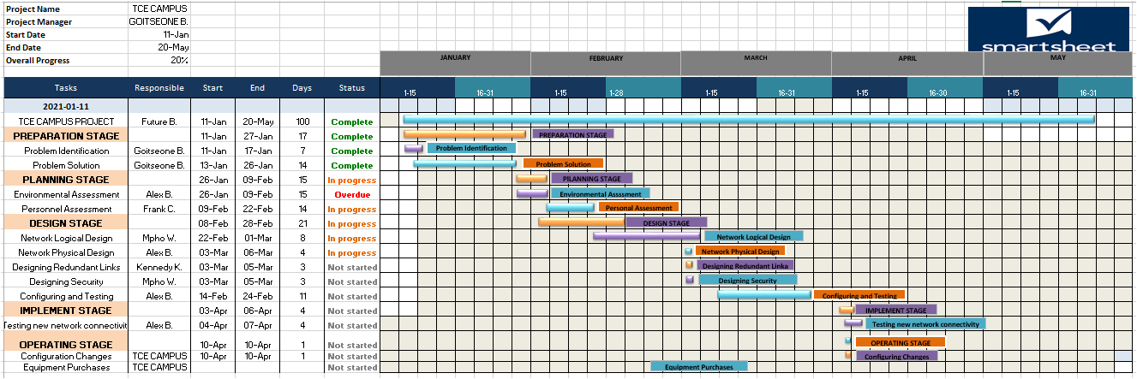

## 2.3 Required resources.

**Software requirements**

For our network design to turn out to be a success there are resources which assist in meeting what the project is developed for. Cisco Packet Tracer version 7.3.0 is the software which will let us simulate the network before it starts to be fulfilled. We are going to use Microsoft Visio software to draw the network diagram and lastly, we will use Smartsheet software to keep track of the project plan and timeline and for documentation.

**Cisco Packet Tracer version 7.3.0**

(Packet Tracer, 2021) Explains that it is a software-based technology display place developed by Cisco systems to allow clients to develop network topologies and imitator of the existing computer networking technologies. It permits network administrators to develop or create Cisco structures and to use the commands line interfaces. It offers assessment’s, visualizations, courses and free learning of complex IT models.

**Microsoft Visio**

(Microsoft, 2021) States that this is a platform that enables clients to create or develop commercial graphics, graphs, flowcharts, data presentation and visualizations. It is also used to create certified diagrams like UML network topologies. It offers drawing tools which can be used to build simulators of networking, building, and office topologies.

**SmartSheet**

This is a program which is used to combine and manage work that is being created or developed. It monitors the project processes, allocates tasks and manages time and calendars (Smartsheet, 2021).

**Networking requirements**

To design our network we are going to use the following networking hardware’s

* A Dell I7 laptop will suffice.
* 18GB hard disk space.
* 8 GB Ram
* 10 000+ CPU Dell processors
* USB 4.0+ ports

## 2.4 Functional and Non-Functional requirements

**Functional requirements**

* **Mobility**

Clients connected to the network will have the freedom to move around the campus as the network will allow them to move from one place to another with their devices without being worried about wired cables or connections being lost on their devices.

* **Accessibility**

The network will be available across the whole campus, including places that has been a challenge in reaching the wired network.

* **Guest client’s access**

It will bargain a secured network access to guests’ clients, business partners and customers in the meanwhile keeping the campus network resources safeguarded.

* **Scalability**

The network will manage and allows the increase of clients in the network. It will help in managing information traffics and have reliable interaction amongst devices.

* **Self-Optimizing**

The network will be able to a self-optimize, carry out automatic configurations and self-diagnosis. This helps in ensuring that there’s always connectivity in the devices.

* **Enhanced technology abilities**

The network is a remodelled technological network that helps in accessing latest services such as video conferencing and voice calls without hassles. It will be gained access to by devices which use the latest enhanced technologies, and all this will assist in ensuring that there is no data traffic within devices connected to the network.

* **Expandability**

Our network will enable in the extension of the network to a wide scale by adding new locations and clients without the need of using wires and cables.

**Non-Functional requirements**

* Our network is going to be able to manage up to 2 000 clients meanwhile delivering their needs.
* Trustworthiness and network enhancements will be defined by the ISP.
* Network latency should not be there of it happens it should be as little as possible.
* Only permitted devices shall be used and these devices should be accessible to appropriate clients.
* There will be an increase in Bandwidth.
* Network security must be enhanced.
* The network is going to be user friendly.

## 2.5 Network Diagram

The below illustration depicts how our network design will be:

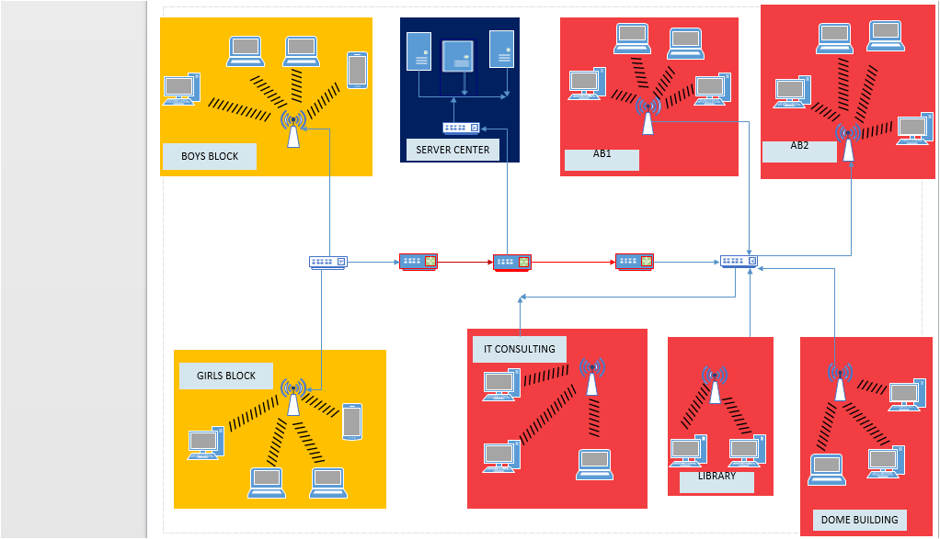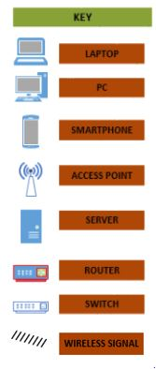

To develop the TCE Campus wireless network design we placed the core devices inside the frame. Then ***Main Router*** was placed at the midpoint of the campus which is linked to the ***Server Switch*** using ***Gigabit Ethernet Port*** through copper straight-through wires. The ***Hostel Router*** and ***Campus Router*** was linked using ***Serial Port*** through ***Serial DCE*** wires on the Campus area and the Hostel area separately.

***Email, WEB Servers and DNS*** were linked with the ***Server Switch*** separately. The ***Campus Router*** was linked to the ***Campus Switch*** which we later linked it with the ***Wireless Access*** ***Points*** at the ***Dome Building, IT consulting, Academic Block 1 and Academic Block 2 and the Library***. We further linked ***Access Points*** to the computing devices ***(PCs, Smartphones and Laptops)***. Also, the ***Hostel Router*** was linked with the ***Hostel Switch*** which was later linked through ***Access Points*** at the Girls and Boys Blocks. We then linked ***Wireless Access Points*** to the computing devices (Laptops, Smartphones and PCs). All places have an enthusiastic ***Wireless Access Point*** which can be accessed by inserting the corresponding password. Every connection in the campus is through Fast Ethernet and Gigabit Ethernet through the use of copper straight-through wires.

# Bibliography

B, M. (2001). Network Segmentation. In L. M, & H. G, *Wi-FI Implementation* (pp. 40-47). Gabon: The Tech Team.

Chadwick, D. (2008). *How to configure routers.* Europe: Big Books Pressworks.

Chellis, M., & S, P. (2000, June 8). *Timeline of Computer History*. Retrieved from Networking & Web: https://www.computerhistory.org/timeline/networking-the-web/

Cowan, D. M. (1995). *Dealing with Servers.* India: Collections Works.

K, J., & Lynch, M. (2001, April 20). *Routers.* Retrieved from CCNA : https://www.netacad.com/

Larry M, H. G. (2004, October 18). *Tips for upgrading network*. Retrieved from Network Computing : https://www.computerhope.com/jargon/n/network.htm#:~:text=A%20network%20is%20a%20collection,people%20all%20over%20the%20world.

Maran S, D. T. (1997, May 7). *Evolution of Computer Networks*. Retrieved from Www3.nd.edu: https://www3.nd.edu/-dwang5/courses/fall18/pdf/evolution

Microsoft. (2021, March 17). *Visio*. Retrieved from Microsoft: https://www.microsoft.com/en-ww/microsoft-365/visio/flowchart-software

P, F., & Gehl, B. F. (2005). Computing For Beginners. *Learn Computing*, 14-18.

*Packet Tracer*. (2021, March 15). Retrieved from Networking Academy: https://www.netacad.com/courses/packet-tracer

Smartsheet. (2021, March 17). *Download Smartsheet*. Retrieved from Smartsheet: https://www.smartsheet.com/

# CHAPTER 3: Second Project Review

## 3.1 Subnetting

|  |  |
| --- | --- |
| **AB1,AB2,IT CONSULTING,LIBRARY,DOME BUILDING** |  |
| **Specification** | **Values** |
| Hosts needed | 254 |
| Hosts Available | 254 |
| Unused Hosts | 0 |
| Network Address | 192.168.1.0 |
| IP Mask (Decimal) | 255.255.255.0 |
| IP Mask (Slash Notation) | 24 |
| Usable range of IP Address | 192.168.1.1 – 192.168.1.254 |
| Broadcast Address | 192.168.1.255 |
| Wildcard Mask | 0.0.0.255 |
|  |  |

|  |  |
| --- | --- |
| **SERVER CENTER** |  |
| **Specification** | **Values** |
| Hosts needed | 254 |
| Hosts Available | 254 |
| Unused Hosts | 0 |
| Network Address | 192.168.2.0 |
| IP Mask (Decimal) | 255.255.255.0 |
| IP Mask (Slash Notation) | 24 |
| Usable range of IP Address | 192.168.2.1 – 192.168.2.254 |
| Broadcast Address | 192.168.2.255 |
| Wildcard Mask | 0.0.0.255 |
|  |  |

|  |  |
| --- | --- |
| **BOYS BLOCK and GIRLS BLOCK** |  |
| **Specification** | **Values** |
| Hosts needed | 254 |
| Hosts Available | 254 |
| Unused Hosts | 0 |
| Network Address | 192.168.3.0 |
| IP Mask (Decimal) | 255.255.255.0 |
| IP Mask (Slash Notation) | 24 |
| Usable range of IP Address | 192.168.3.1 – 192.168.3.254 |
| Broadcast Address | 192.168.3.255 |
| Wildcard Mask | 0.0.0.255 |
|  |  |

3.2 VLAN Design**.**

This is a skill to allow all subnet masks to partake variable amounts. The network administrator is the one who divides the IP Address spaces into subnets of dissimilar amounts and assign them according to their specific need of place.

|  |  |
| --- | --- |
| **VLAN NAME** | **NAME NUMBER** |
| AB1 | 10 |
| AB2 | 20 |
| DOME_BUILDING | 30 |
| LIBRARY | 40 |
| IT_CONSULTING | 50 |
| GIRLS_BLOCK | 60 |
| BOYS_BLOCK | 70 |
| SERVER_CENTER | 99 |

## 3.3 Addressing Table.

The reason behind carrying out this method is to attempt to breakdown large block of IP Addresses into small blocks and develop interconnected networks that are separated from big networks. Breaking down of this Ip addresses into manageable networks and smaller sizes it helps in relieving overcrowding that is caused by unnecessary quantity of traffic flow in the network.

**Campus Area Switch**

These are addressing configuration’s that are configured in the Campus Area Switch.

|  |  |  |  |  |  |  |  |
| --- | --- | --- | --- | --- | --- | --- | --- |
| **Department** | **ASSIGNMENT** | **Interface/Port** | **Device name** | **IP Address** | **Subnet Mask** | **Default-gateway** | **DNS SERVER** |
|  | VLAN 10 | Fa0/6 | LAPTOP | 192.168.1.14 | 255.255.255.0 | 192.168.1.1 | 192.168.2.3 |
| **AB1** | VLAN 10 | Fa0/6 | PC | 192.168.1.15 | 255.255.255.0 | 192.168.1.1 | 192.168.2.3 |
|  | VLAN 10 | Fa0/6 | LAPTOP | 192.168.1.16 | 255.255.255.0 | 192.168.1.1 | 192.168.2.3 |
|  | VLAN 10 | Fa0/6 | PC | 192.168.1.17 | 255.255.255.0 | 192.168.1.1 | 192.168.2.3 |

|  |  |  |  |  |  |  |  |
| --- | --- | --- | --- | --- | --- | --- | --- |
| **Department** | **ASSIGNMENT** | **Interface/Port** | **Device name** | **IP Address** | **Subnet Mask** | **Default-gateway** | **DNS SERVER** |
|  | VLAN 20 | Fa0/5 | LAPTOP | 192.168.1.10 | 255.255.255.0 | 192.168.1.1 | 192.168.2.3 |
| **AB2** | VLAN 20 | Fa0/5 | PC | 192.168.1.11 | 255.255.255.0 | 192.168.1.1 | 192.168.2.3 |
|  | VLAN 20 | Fa0/5 | LAPTOP | 192.168.1.12 | 255.255.255.0 | 192.168.1.1 | 192.168.2.3 |
|  | VLAN 20 | Fa0/5 | PC | 192.168.1.13 | 255.255.255.0 | 192.168.1.1 | 192.168.2.3 |

|  |  |  |  |  |  |  |  |
| --- | --- | --- | --- | --- | --- | --- | --- |
| **Department** | **ASSIGNMENT** | **Interface/Port** | **Device name** | **IP Address** | **Subnet Mask** | **Default-gateway** | **DNS SERVER** |
|  | VLAN 30 | Fa0/4 | PC | 192.168.1.2 | 255.255.255.0 | 192.168.1.1 | 192.168.2.3 |
| **DOME_BUILDING** | VLAN 30 | Fa0/4 | PC | 192.168.1.3 | 255.255.255.0 | 192.168.1.1 | 192.168.2.3 |
|  | VLAN 30 | Fa0/4 | LAPTOP | 192.168.1.4 | 255.255.255.0 | 192.168.1.1 | 192.168.2.3 |
|  |

|  |  |  |  |  |  |  |  |
| --- | --- | --- | --- | --- | --- | --- | --- |
| **Department** | **ASSIGNMENT** | **Interface/Port** | **Device name** | **IP Address** | **Subnet Mask** | **Default-gateway** | **DNS SERVER** |
|  | VLAN 40 | Fa0/3 | PC | 192.168.1.5 | 255.255.255.0 | 192.168.1.1 | 192.168.2.3 |
| **LIBRARY** | VLAN 40 | Fa0/3 | PC | 192.168.1.6 | 255.255.255.0 | 192.168.1.1 | 192.168.2.3 |
|  |
|  |

|  |  |  |  |  |  |  |  |
| --- | --- | --- | --- | --- | --- | --- | --- |
| **Department** | **ASSIGNMENT** | **Interface/Port** | **Device name** | **IP Address** | **Subnet Mask** | **Default-gateway** | **DNS SERVER** |
|  | VLAN 50 | Fa0/1 | LAPTOP | 192.168.1.7 | 255.255.255.0 | 192.168.1.1 | 192.168.2.3 |
| **IT_CONSULTING** | VLAN 50 | Fa0/1 | PC | 192.168.1.8 | 255.255.255.0 | 192.168.1.1 | 192.168.2.3 |
|  | VLAN 50 | Fa0/1 | PC | 192.168.1.9 | 255.255.255.0 | 192.168.1.1 | 192.168.2.3 |
|  |

**Server Centre Switch**

These are addressing configuration’s that are configured in the Server Centre Switch.

|  |  |  |  |  |  |  |  |
| --- | --- | --- | --- | --- | --- | --- | --- |
| **Department** | **ASSIGNMENT** | **Interface/Port** | **Device name** | **IP Address** | **Subnet Mask** | **Default-gateway** | **DNS SERVER** |
|  | 802.1q trunks (native VLAN 99) | Fa0/1 | SERVER_EMAIL | 192.168.2.2 | 255.255.255.0 | 192.168.2.1 | 192.168.2.3 |
| **SERVER_CENTER** | 802.1q trunks (native VLAN 99) | Fa0/2 | DNS_SERVER | 192.168.2.3 | 255.255.255.0 | 192.168.2.1 | 192.168.2.3 |
|  | 802.1q trunks (native VLAN 99) | Fa0/3 | WEB_SERVER | 192.168.2.4 | 255.255.255.0 | 192.168.2.1 | 192.168.2.3 |
|  |

**Hostel Area Switch**

These are addressing configuration’s that are configured in the Hostel Area Switch.

|  |  |  |  |  |  |  |  |
| --- | --- | --- | --- | --- | --- | --- | --- |
| **Department** | **ASSIGNMENT** | **Interface/Port** | **Device name** | **IP Address** | **Subnet Mask** | **Default-gateway** | **DNS SERVER** |
|  | VLAN 60 | Fa0/3 | PC | 192.168.3.2 | 255.255.255.0 | 192.168.3.1 | 192.168.2.3 |
| **GIRLS_BLOCK** | VLAN 60 | Fa0/3 | LAPTOP | 192.168.3.3 | 255.255.255.0 | 192.168.3.1 | 192.168.2.3 |
|  | VLAN 60 | Fa0/3 | PC | 192.168.3.4 | 255.255.255.0 | 192.168.3.1 | 192.168.2.3 |
|  | VLAN 60 | Fa0/3 | SMARTPHONE | 192.168.3.5 | 255.255.255.0 | 192.168.3.1 | 192.168.2.3 |

|  |  |  |  |  |  |  |  |
| --- | --- | --- | --- | --- | --- | --- | --- |
| **Department** | **ASSIGNMENT** | **Interface/Port** | **Device name** | **IP Address** | **Subnet Mask** | **Default-gateway** | **DNS SERVER** |
|  | VLAN 70 | Fa0/2 | PC | 192.168.3.6 | 255.255.255.0 | 192.168.3.1 | 192.168.2.3 |
| **BOYS_BLOCK** | VLAN 70 | Fa0/2 | LAPTOP | 192.168.3.7 | 255.255.255.0 | 192.168.3.1 | 192.168.2.3 |
|  | VLAN 70 | Fa0/2 | PC | 192.168.3.8 | 255.255.255.0 | 192.168.3.1 | 192.168.2.3 |
|  | VLAN 70 | Fa0/2 | SMARTPHONE | 192.168.3.9 | 255.255.255.0 | 192.168.3.1 | 192.168.2.3 |

**Campus Routers**

These are addressing configuration’s that are configured in the Campus Routers.

|  |  |  |  |
| --- | --- | --- | --- |
| **Device name** | **Interface/Port** | **IP Address** | **Subnet Mask** |
| Main router | Gig0/1  Se0/1/0  Se0/1/1 | 192.168.2.1  10.0.0.1  11.0.0.1 | 255.255.255.0  255.0.0.0  255.0.0.0 |
| College Router | Gig0/0  Se0/1/0 | 192.168.1.1  11.0.0.2 | 255.255.255.0  255.0.0.0 |
| Hostel Router | Gig0/0  Se0/1/0 | 192.168.3.1  10.0.0.2 | 255.255.255.0  255.0.0.0 |

## 3.4 Safeguarding the network.

To access all the routers and wireless networks in the campus area, passwords are required. Passwords help in protecting unauthorized access to client’s personal information and computers. We gave our Wireless Access Points specific SSID’s so that clients can know which wireless network they should connect to.

Also our routers are configured with Secure Shell (ssh) and assigned them with specific passwords. This is done so that hackers can be prevented from gaining access to client’s data and networking devices.

|  |  |
| --- | --- |
| Main Router |  |
| Role | Server |
| Console Password | cisco |
| Secure shell ( Ssh) Password | admin |

|  |  |
| --- | --- |
| College Router (Router1) |  |
| Role | client |
| Console Password | tce@123 |
| Secure shell (Ssh) Password | admin |

|  |  |
| --- | --- |
| Hostel Router (Router2) |  |
| Role | client |
| Console Password | tce@123 |
| Secure shell (Ssh) Password | admin |

|  |  |
| --- | --- |
| Wireless Access Points |  |
| SSID | PASSWORD |
| tce_dome | 1234567890 |
| tce_library | 1234567890 |
| tce_ITC | 1234567890 |
| tce_AB1 | 1234567890 |
| tce_AB2 | 1234567890 |
| tce_boys | 1234567890 |
| tce_girls | 1234567890 |

## 3.5 Logical network design

The following snippet displays the full logical network design that we created for Tonota College of Education campus.

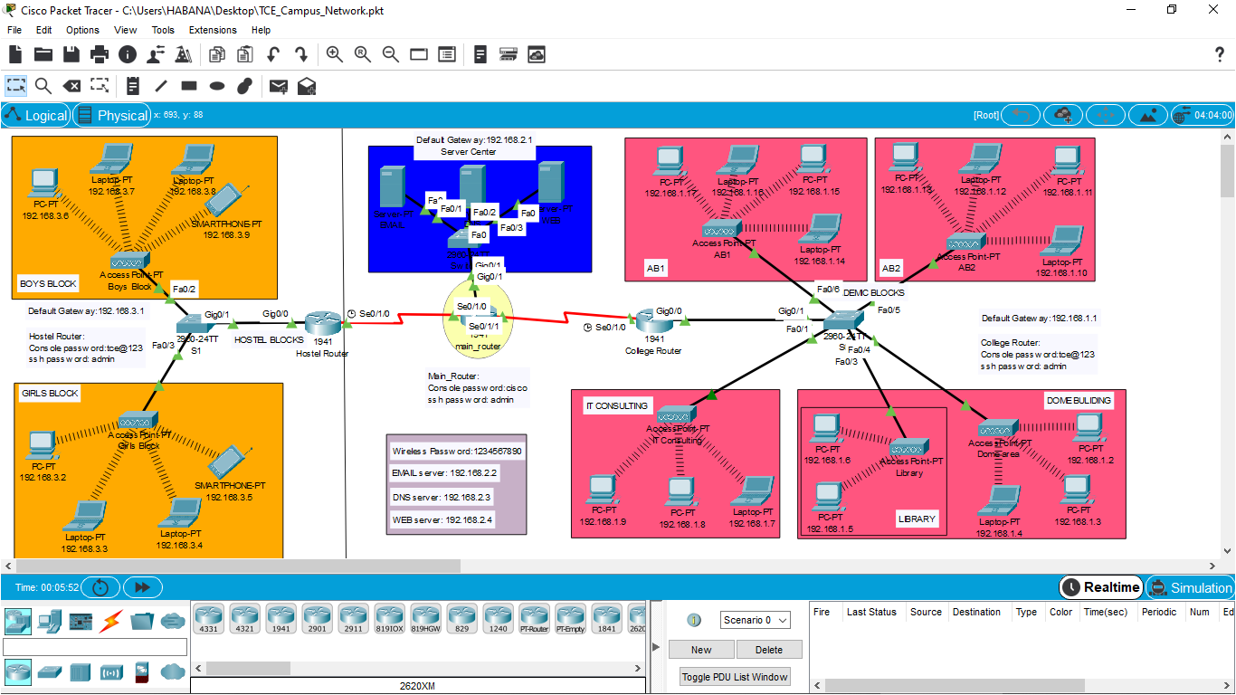

# 4.0 Final Project

## 4.1 Implementation of the design (simulation)

TCE Campus project exited through numerous phases of design which made the execution of the project to be perfect as all the data collection was well calculated. We used Packet Tracer 7.3.1.0362 which is a networking simulation software to design and check network communication between devices and different planned Vlans.

## 4.2 Testing techniques

This is where we test if our network design is responding to what it was designed to do and also this is where snippets displays all configurations and commands that were executed on devices, switches and routers respectively.

**CONFIGURATIONS ON SWITCH’S**

The following snippets displays a command that was executed that shows all configured Vlans and their interfaces on the switches on our design.

Academic Block Vlans

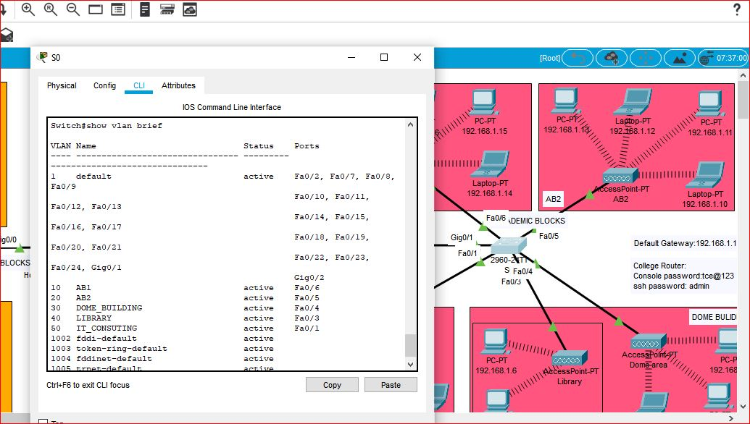

Server Centre Vlans

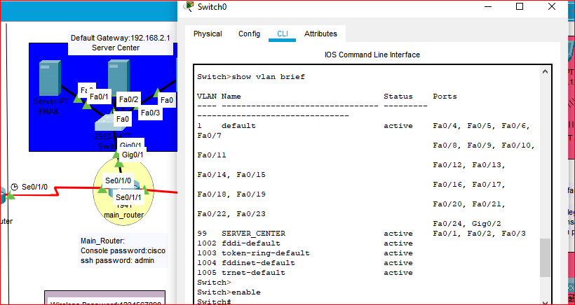

Hostel Switch Vlans

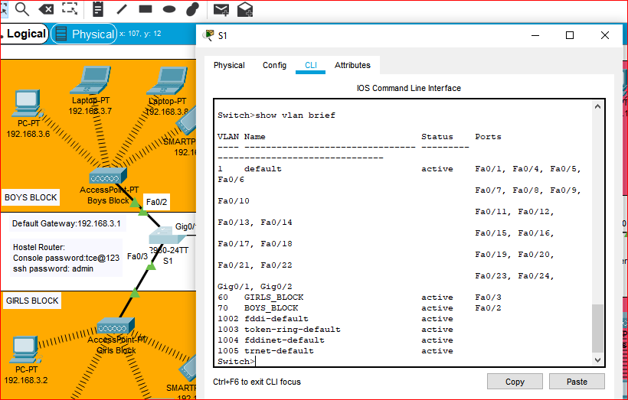

**CONFIGURATIONS ON ROUTERS**

The following snippet shows configurations configured in the routers when the show run command is executed.

College Router

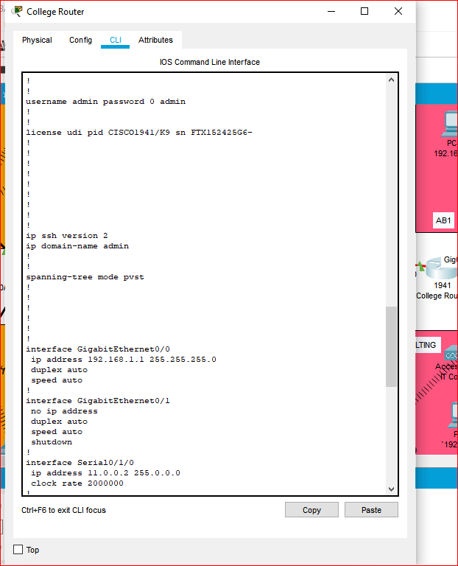

Main Router

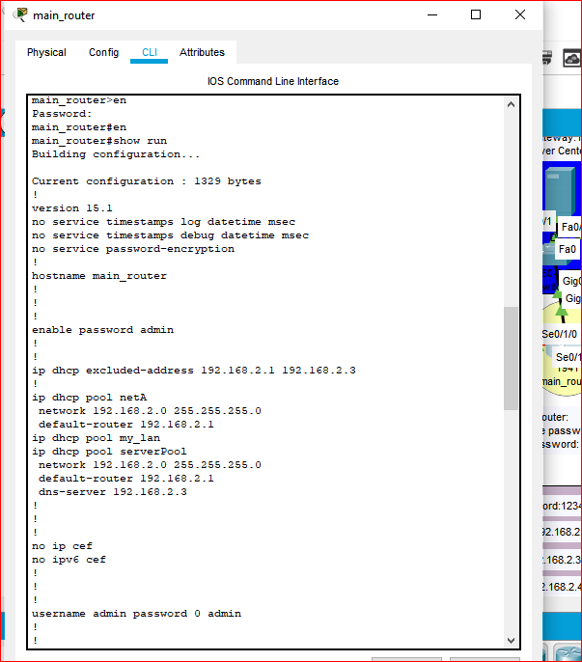

**CHECKING CONNECTIVITY**

To check for connection between devices in our network we are going to use the command prompt and the ping command.

***Testing Secure Shell on Routers***

The following snippet displays secure shell of all the routers responding when being tested using the laptop at the IT Consulting department.

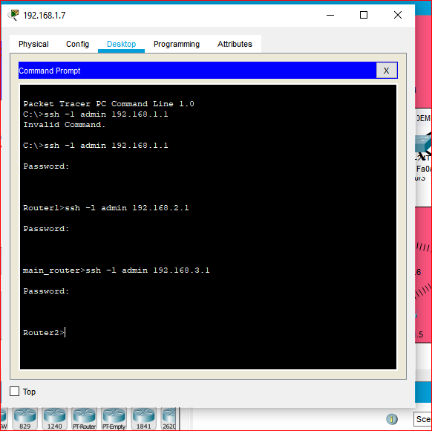

***Ping between Devices***

The following snippet shows that devices from different departments are communicating when the ping command is executed.

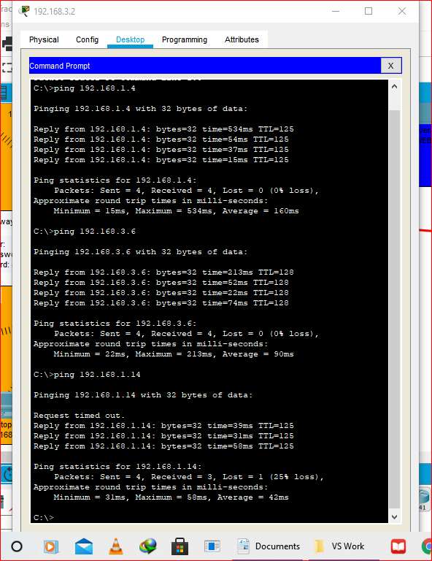

***Wireless Connection***

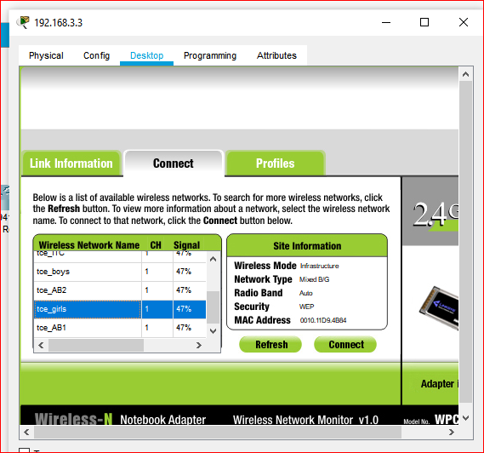

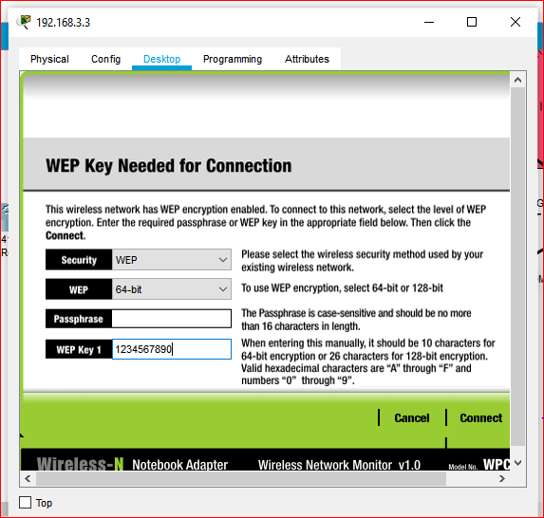

***Website Access***

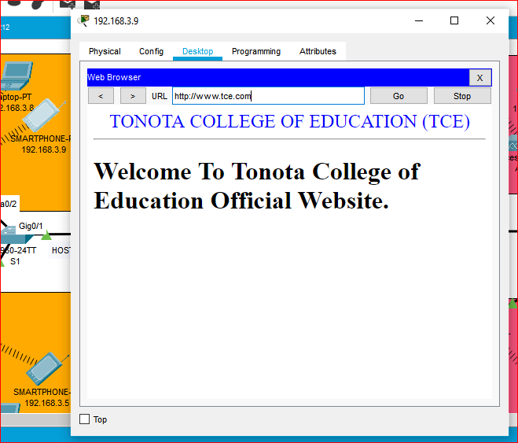

***Emails Connection***

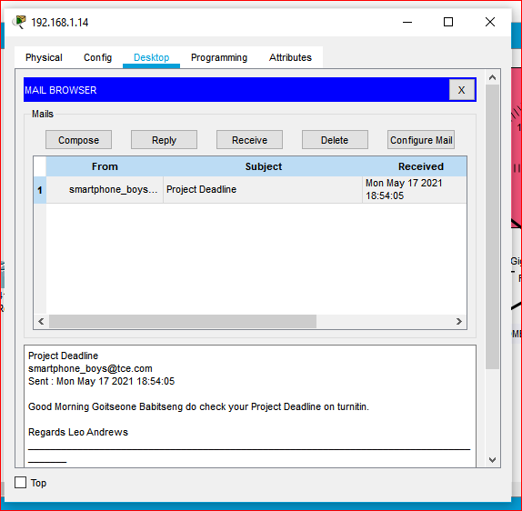

***Connection Simulation***

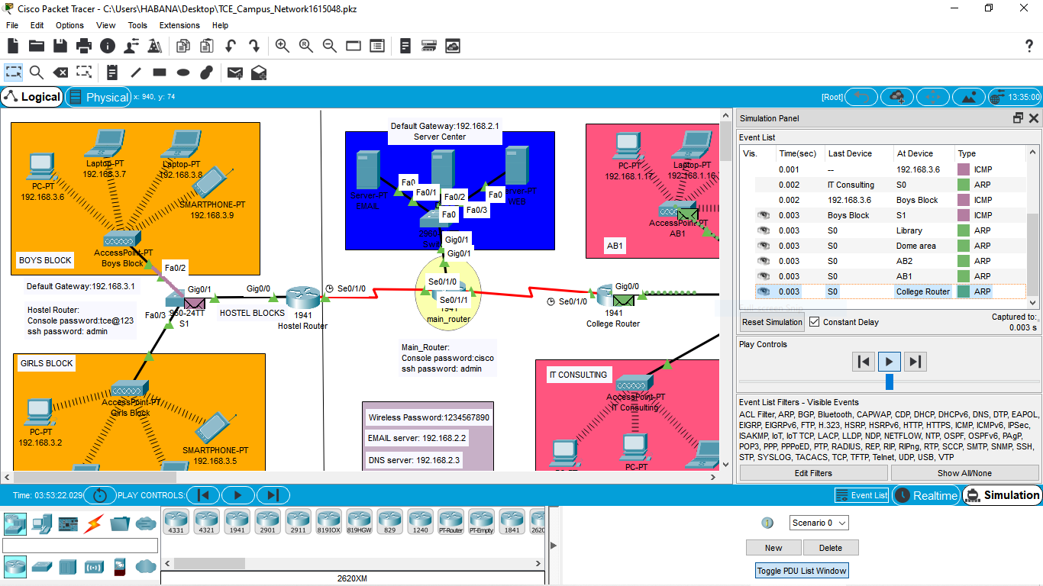

## 4.3 Project Evaluation

The project aims were all successfully met. The problem that was encountered mostly was that some of the commands were not executing or running in the Packet Tracer software. The project was well implemented.