DEPARTMENT OF INFORMATION TECHNOLOGY
MADRAS INSTITUTE OF TECHNOLOGY, ANNA UNIVERSITY – CHENNAI
REVIEW 2
Project Progress Report
Autonomous AIAugmented CI/CD Pipeline with
Adaptive TrustTiering and Chaos Engineering
Team 18
Praveen Kumar C (2023510023) • Jaiprakash S (2023510027) • Dharshini T (2023510062)
Guided by
Dr. P. Anandha Kumar, Professor, Department of Information Technology

Table of Contents
Table of Contents 2
1. Introduction 3
2. What This Review Adds 3
3. How the Pieces Fit Together 3
4. The AI TestTriage Model 4
4.1 Why “Attention Pooling” instead of just the last output 4
4.2 Code: how the model scores and pools the sequence 5
4.3 Results on the heldout test set 5
5. The TrustTier Engine 6
5.1 Promotion: proven, not assumed 7
5.2 Demotion: instant, and asymmetric 7
5.3 Proof it works: a real replay 7
5.4 From classification to action: the policy engine 7
6. RootCause Analysis (RCA) 8
6.1 How suspicion is measured 8
6.2 Does it actually work? Tested against two baselines 8
6.3 Example output 9
7. Limitations, Stated Plainly 9
8. What's Next 9
9. Conclusion 10

1. Introduction
Modern software teams run automated pipelines (CI/CD) that build, test and deploy code many times a day. When a test fails, someone has to figure out quickly whether it failed because of a real bug, a flaky network, a corrupted disk, or a bad server, and then decide whether it is safe to retry, safe to merge, or something a human must look at. Today this decision is almost always made by a person, by hand, which is slow and inconsistent.
This project builds an AI agent that makes this decision automatically, and just as importantly that is not blindly trusted from day one. The agent starts by only observing and slowly earns the right to act on its own, based on a measurable track record. This report (Review 2) covers everything built and verified since the Zeroth Review: a working classification model, a real trusttier engine, and a rootcause analysis tool.
In one sentence:
Take a failed test's trace → classify why it failed → decide what to do about it → only let the AI act autonomously once it has proven, with real statistics, that it can be trusted.

2. What This Review Adds
At the Zeroth Review, the project had a working data pipeline and a trained classification model. Since then, four more pieces were completed and verified endtoend:
- A working traceclassification model (BiLSTM with attention) that sorts a failed test into one of 5 categories, with real, honestlyreported accuracy numbers.
- A statistically grounded TrustTier Engine that promotes the AI agent from “observe only” to “act on its own” only when its accuracy is proven, and instantly demotes it if it misses a real bug.
- A RootCause Analysis (RCA) tool that points at the exact operation inside a failed trace most likely responsible for the failure not just “pass/fail”, but “here is where to look.”
- A policy engine that turns a classification into a concrete pipeline action (retry, block, quarantine, escalate), expressed both in Python and in Rego (the industrystandard policy language, Open Policy Agent).
Every number in this report comes from actually running the code against the heldout test set (10,513 real traces the model never saw during training) nothing here is a projection or an estimate.

3. How the Pieces Fit Together
The system is a pipeline of four stages. Each stage is a separate, independentlytested Python module:
- Stage 1 — Data: raw distributedsystem logs are turned into ordered, timestampaligned sequences of events (Review 0 work).
- Stage 2 — Triage Model: a neural network reads that sequence and classifies the failure into one of 5 categories.
- Stage 3 — Trust & Policy Engine: the classification is turned into a pipeline action, gated by how much the AI agent has earned the right to act on its own.
- Stage 4 — RootCause Analysis: for any failing trace, ranks the exact spans (operations) most likely responsible, and writes a short postmortem.
All four stages are exposed through one web API (FastAPI) so they can be called from a real CI pipeline: POST /api/v1/triage, POST /api/v1/triage/groundtruth, POST /api/v1/postmortem.

4. The AI TestTriage Model
The model reads a failed trace as a sequence of events for example: “call NameNode → OK”, “add data block → ERROR”, “check checksum → OK” in the order they happened, and predicts one of 5 classes:
Class | Meaning | Pipeline action
PASS | No failure signature | Allow merge
INFRA_FLAKE | Temporary network / process glitch | Retry automatically
DATA_FAULT | Data corruption or loss (permanent) | Escalate — never retry
ENV_FAULT | The server/host itself is unwell | Quarantine that node
REAL_BUG | An actual code defect | Block the merge, alert a developer

4.1 Why “Attention Pooling” instead of just the last output
The model reads the sequence with a BiLSTM (a neural network built for ordered data). A naive approach would just look at the network's very last output as the summary of the whole trace but for a short trace inside a large padded batch, that last output is mostly the network's memory of blank padding, not of the actual failure. Instead, this model gives every real step in the sequence a learned “importance score”, turns those scores into weights that add up to 1 (via softmax), and builds the trace's summary as a weighted average so the step that actually failed dominates the summary, wherever it happens to sit in the sequence.
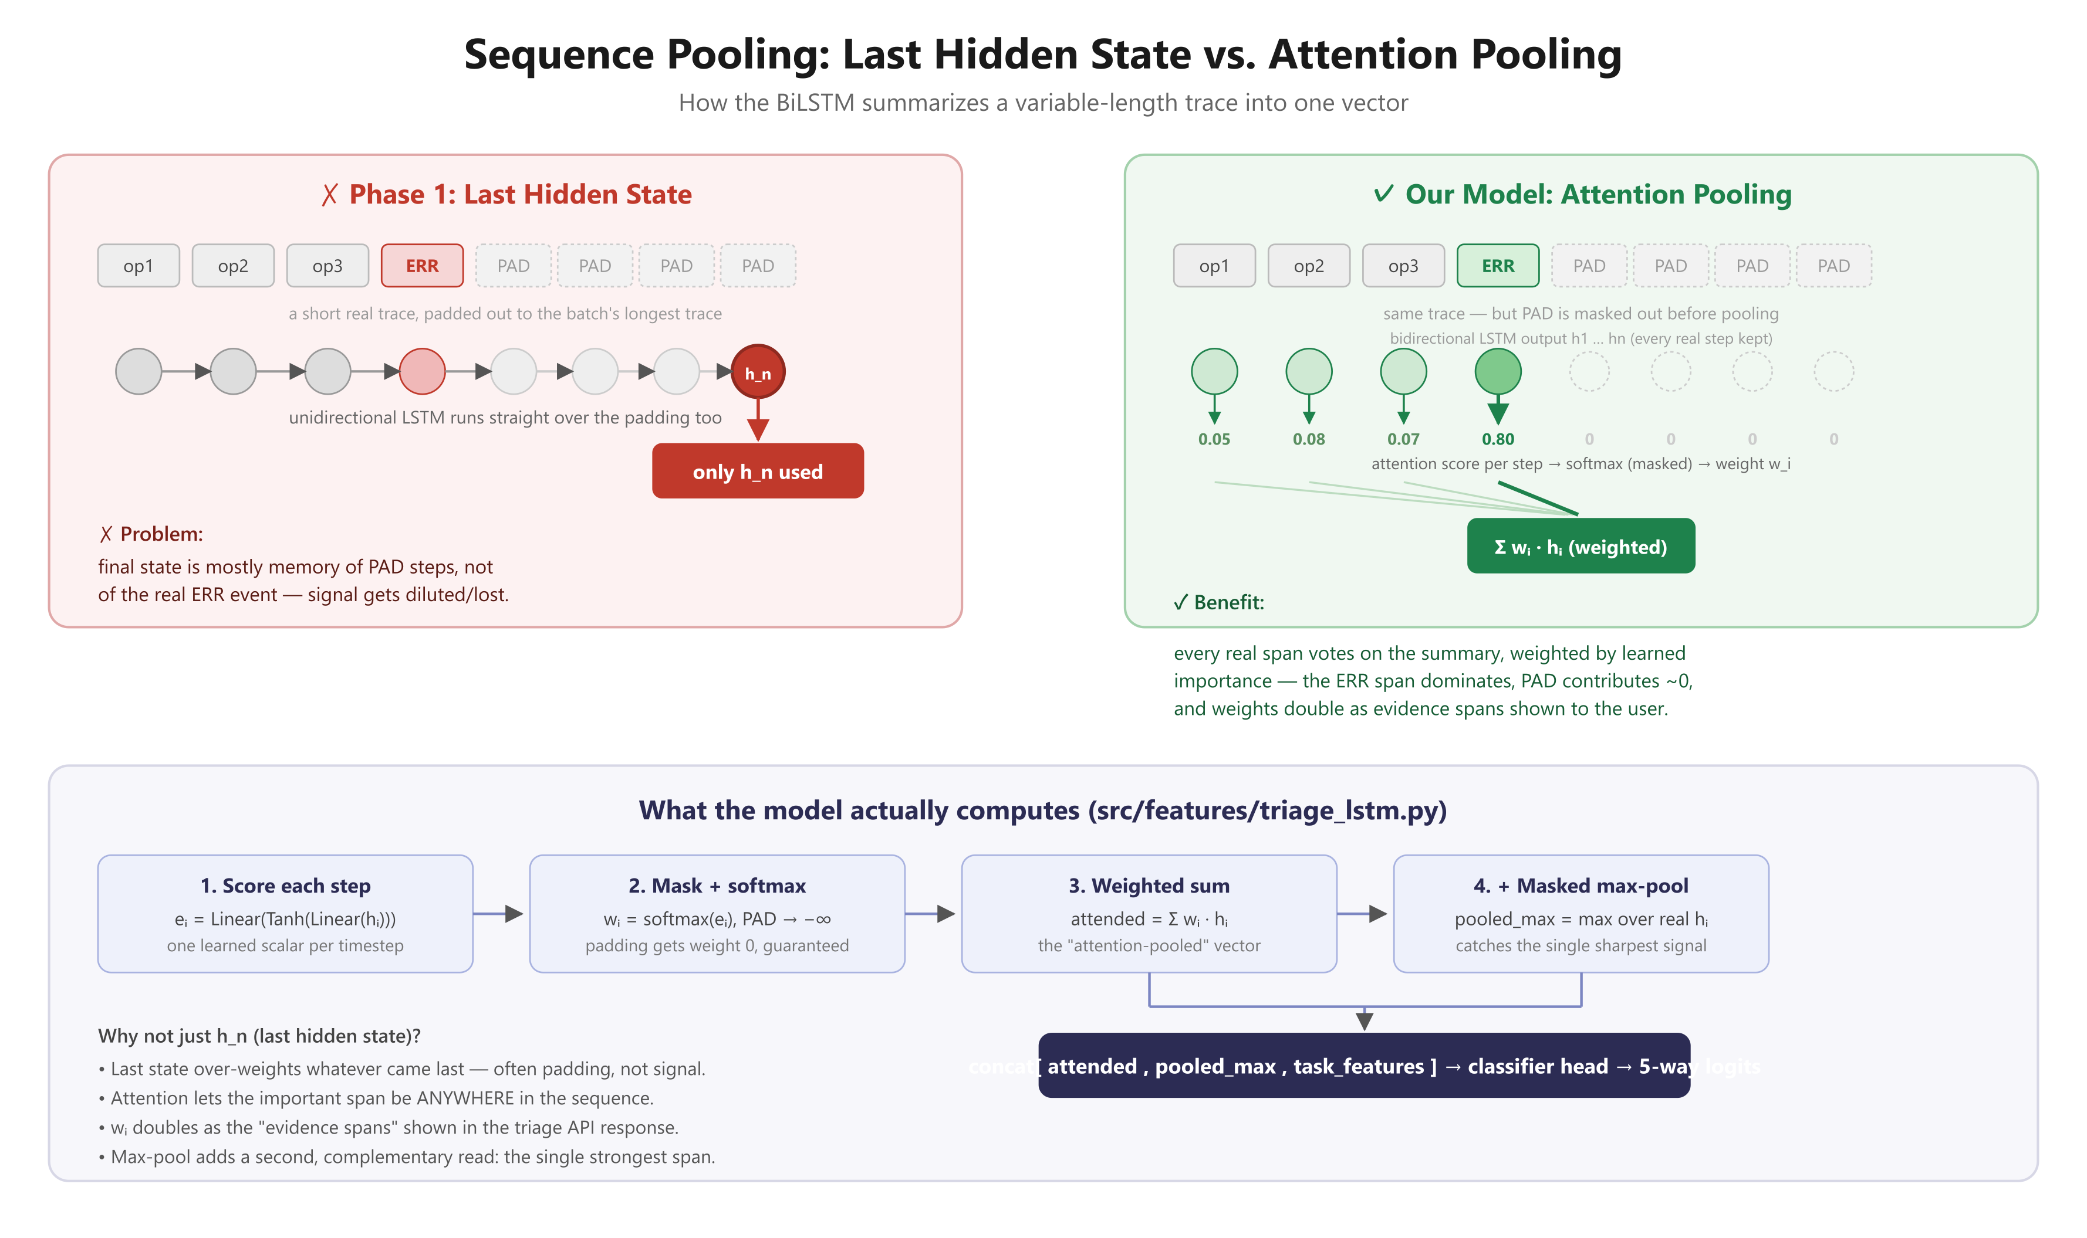
Figure 1 — Attention pooling vs. simply using the network's last output.

4.2 Code: how the model scores and pools the sequence
This is the core of src/features/triage_lstm.py. In plain terms: line 1 gives every timestep a raw importance score; line 2 forces padding positions to a score so low it becomes exactly zero after softmax; line 3 turns the scores into weights that sum to 1; line 4 builds the final summary vector as a weighted sum of every real timestep.
src/features/triage_lstm.py — attention pooling, simplified for readability

scores = self.att(out).squeeze(1) # 1. raw score per timestep
scores = scores.masked_fill(~mask, inf) # 2. padding > infinity
w = torch.softmax(scores, dim=1) # 3. scores > weights (sum to 1)
attended = torch.bmm(w.unsqueeze(1), out).squeeze(1) # 4. weightedaverage summary

A useful side effect: those same weights (w) tell us exactly which span the model paid the most attention to. The API returns the top weighted spans as “evidence” alongside every classification — so the answer is never a black box.

4.3 Results on the heldout test set
Tested on 10,513 real traces the model never saw during training, drawn from 57 scenario folders also never seen during training (a “grouped split” this prevents the model from just memorizing a scenario, see design notes in the code).
Class | Precision | Recall | F1 score
PASS | 0.79 | 0.60 | 0.69
INFRA_FLAKE | 0.72 | 0.79 | 0.76
DATA_FAULT | 0.73 | 0.91 | 0.81
ENV_FAULT | 0.61 | 0.40 | 0.48
REAL_BUG | 1.00 | 1.00 | 1.00

Overall: macroF1 = 0.746, accuracy = 76.9%. Operationally, only 1.3% of all decisions (139 / 10,513) would have retried something that should never be retried, and zero real bugs were missed.
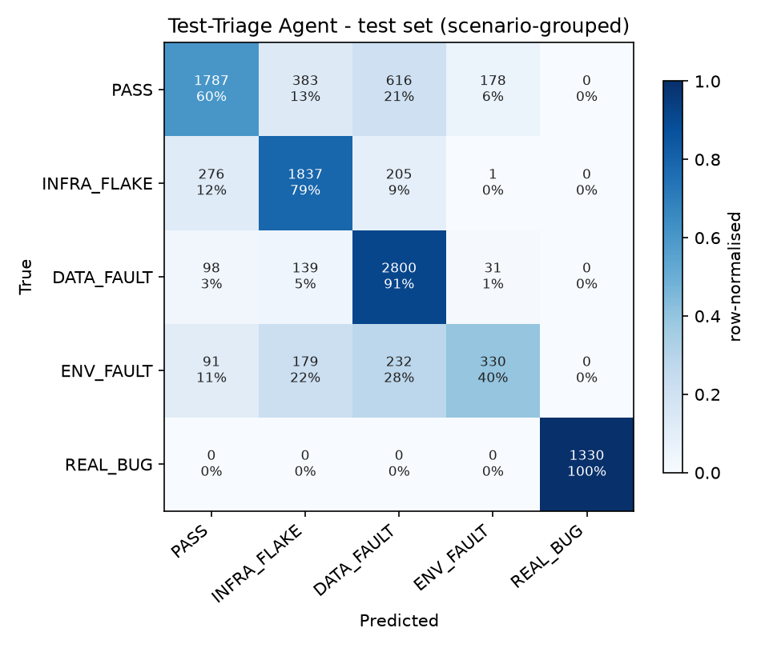
Figure 2 — Confusion matrix (rows = true class, columns = predicted class, on the test set).
Reported honestly, not hidden:
REAL_BUG's perfect score is partly because those particular scenarios happen to be much shorter traces, which makes them easy to spot by length alone not necessarily by understanding the bug. ENV_FAULT remains the hardest class: a recent fix traded some “catch rate” (recall) for far fewer false alarms (precision improved from 0.28 to 0.61), which is documented as a deliberate, debatable tradeoff rather than a solved problem.

5. The TrustTier Engine
Giving an AI agent the power to act on its own retrying a pipeline, blocking a merge, quarantining a server is risky unless that power is earned and can be taken away. This project uses four trust tiers:
Tier | Meaning
T0 | Observe only — the agent may only watch and log, never act
T1 | Recommend — the agent suggests an action, a human approves it
T2 | Act with rollback — the agent acts, but the action can be undone
T3 | Act autonomously — the agent's higheststakes actions run with no human step

5.1 Promotion: proven, not assumed
A tempting but wrong approach is: an agent that got 85% of its last 20 decisions right should be trusted more. The problem is that 17 out of 20 correct really could mean anywhere from about 65% to 95% true accuracy 20 samples is not enough evidence to be sure. This project instead computes the Wilson Score Lower Bound: the worst accuracy that is still statistically consistent with the evidence collected so far, at 95% confidence. The agent is only promoted once that worstcase number itself clears the tier's threshold so a lucky short streak can never fasttrack a promotion.
src/policy_engine/database.py — the statistic that gates every promotion

def wilson_lower_bound(k, n, z=1.96):
p = k / n # raw accuracy (e.g. 17/20 = 0.85)
denom = 1 + z*z / n
centre = p + z*z / (2*n)
spread = z * sqrt(p*(1p)/n + z*z/(4*n*n))
return max(0.0, (centre spread) / denom) # the honest, worstcase floor

With this formula, 17 correct out of 20 (85% raw) only clears a worstcase floor of about 64% not enough to promote. The same 85% accuracy over 1,000 decisions clears a floor of about 83% enough. More evidence, not just a higher percentage, is what earns trust.

5.2 Demotion: instant, and asymmetric
Promotion requires sustained proof; losing trust does not. If the agent misclassifies a genuine bug (REAL_BUG) as something harmless and acts on that classification on its own, it is demoted one tier immediately no averaging, no waiting for enough samples. Missing a real bug is the one mistake this project treats as unacceptable at any tier.

5.3 Proof it works: a real replay
The entire heldout test set (10,513 decisions) was streamed through this exact engine, with a handful of simulated missedbug faults injected at the end (representing what a chaosengineering experiment would provoke). The result:
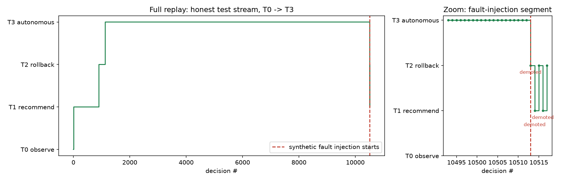
Figure 3 — Left: the agent climbing T0 to T1 to T2 to T3 purely from real, correct decisions. Right: zoomedin view of the injectedfault segment, showing the immediate demotions.

5.4 From classification to action: the policy engine
Once a class is known and the agent's tier is known, a simple, pure decision function (no side effects, fully unittested) decides the actual pipeline action:
src/policy_engine/policy.py — decide(), simplified

if classification == "REAL_BUG":
return BLOCK_MERGE_ALERT_DEV # never merge a real defect
if classification == "PASS":
return ALLOW_MERGE
if classification == "INFRA_FLAKE":
return RETRY if attempts left else ESCALATE_TO_INFRA
# DATA_FAULT > ESCALATE_TO_INFRA (retrying a corruption just fails again)
# ENV_FAULT > QUARANTINE_NODE (take the bad server out of rotation)

This same logic is also written as a Rego policy file (the language used by Open Policy Agent, an industrystandard policy tool), so the decision rules can run outside Python too for example as a gate inside a CI pipeline step.

6. RootCause Analysis (RCA)
A classification alone, such as this is a DATA_FAULT, is useful, but a developer still has to hunt through dozens or hundreds of operations to find the actual culprit. This module ranks every operation in a failing trace by how suspicious it looks, so the top of the list is the best place to start looking.

6.1 How suspicion is measured
First, a baseline is learned from thousands of healthy (PASS) traces: for every kind of operation, what is its normal duration (average and typical spread)? Then, for a failing trace, every operation is scored by three things: how many standard deviations slower it ran than normal (a zscore), whether it recorded an error status itself, and roughly how central it is in the call tree.
src/rca/localize.py — score_spans(), simplified

z = (duration baseline_mean) / baseline_std # how abnormal is the timing?
z = max(z, 0) # only slowerthannormal counts
err = status not in ("OK", "USER")
score = z + (2.0 if err else 0.0) + 0.25 * depth_bonus

Every span in the trace gets a score this way, and the ranked list, highest score first, is returned as the suspect list, alongside a readytopaste Markdown postmortem summary.

6.2 Does it actually work? Tested against two baselines
Because the dataset does not label the one true root cause for each trace, this was evaluated against a fair, stated proxy: does the ranked list surface the span that itself recorded a failure? Compared against picking spans at random, and against just picking the slowest span while ignoring what is normal for that operation type:
Fault class | Our method (top1) | Random pick (top1) | Slowest span (top1)
ENV_FAULT | 0.82 | 0.03 | 0.00
COMPOUND | 0.74 | 0.04 | 0.00
INFRA_FLAKE | 0.59 | 0.14 | 0.00
DATA_FAULT | 0.26 | 0.16 | 0.00

Reported honestly:
DATA_FAULT localization is the weak spot here (0.26 top1) — still far better than guessing, but not yet reliable enough to point a developer straight at the cause without doublechecking. This is stated plainly rather than glossed over.

6.3 Example output
For a real DATA_FAULT trace from the test set, the tool's top suspect was the operation chooseDataNode, which ran about 5 standard deviations slower than its normal baseline a strong, explainable signal, not a blackbox guess.

7. Limitations, Stated Plainly
Following the same discipline used throughout this project, where Phase 1's biggest failure was an accuracy number that hid a broken model, every known weakness is listed here rather than hidden:
- ENV_FAULT remains the hardest class to classify (F1 = 0.48). A recent fix reduced false alarms a lot, at the cost of catching fewer real cases a genuine tradeoff, not yet fully resolved.
- COMPOUND traces, meaning multiple faults at once, are still mostly misclassified as PASS, about 78% of the time. This class is deliberately never trained on, only tested against, as a generalisation check.
- DATA_FAULT rootcause localization (0.26 top1) is noticeably weaker than the other classes.
- The model's internal attention weights have partly collapsed onto a single token for many traces, so the evidence spans shown by the triage endpoint are not yet fully reliable. The postmortem endpoint uses a separate, unaffected method, so this does not block rootcause analysis.
- Sequence order was found to carry very little extra signal beyond which operations occurred an orderfree baseline performs almost as well as the full sequence model. This is reported as a genuine finding, not hidden to make the model look more necessary than it is.

8. What's Next
Four workstreams remain, each deliberately scoped down from heavy infrastructure, such as Kubernetes, a live OPA server, or Chaos Mesh, to a lightweight version that proves the same idea without the deployment risk:
Planned piece | Lightweight version chosen
Observability (live tracing) | A small adapter converting Jaeger/OpenTelemetry traces into the same format this model already reads
Security / CVE scanning | pipaudit for known vulnerabilities plus a simple reachability check to see if the vulnerable code is actually called
Chaos Engineering | A plain faultinjection script feeding synthetic failures into the trust engine, using the demotion path already proven in Section 5.3
CI Actuator | One GitHub Actions workflow that calls the live API and posts the decision as a pullrequest comment

9. Conclusion
Since the Zeroth Review, the project moved from a data pipeline and a trained model to a complete, tested decisionmaking system: a classifier with honestlyreported accuracy, a trust engine backed by real statistics rather than guesswork, and a rootcause tool that measurably beats naive baselines. Every result in this report was produced by actually running the code against real heldout data, including the parts that did not work perfectly, which are reported just as clearly as the parts that did.

