

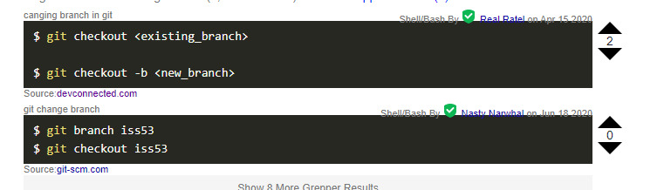

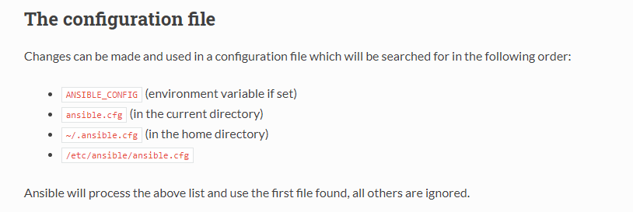

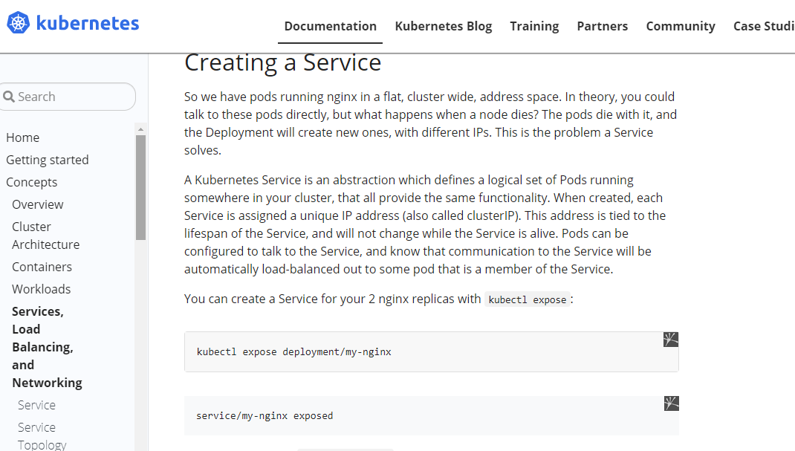

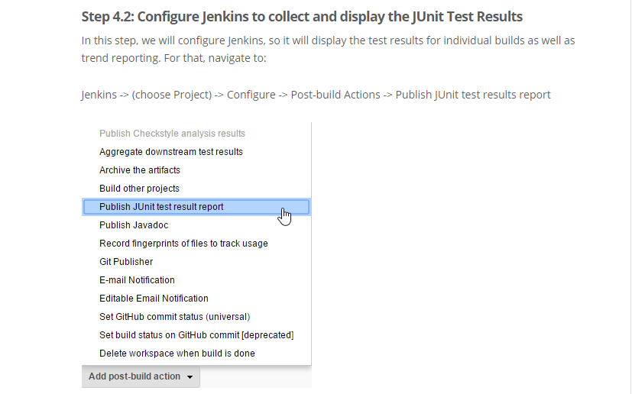

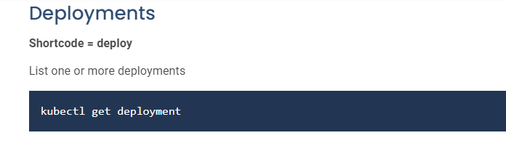

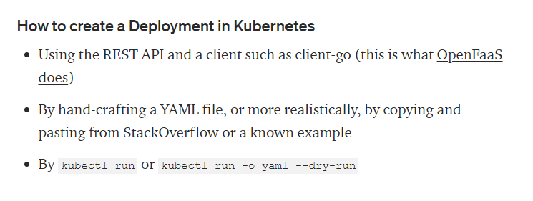

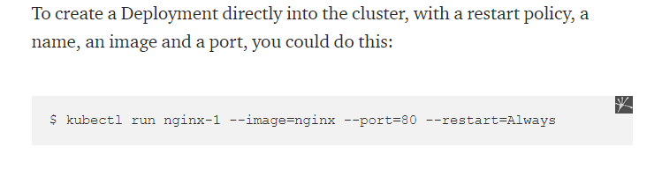

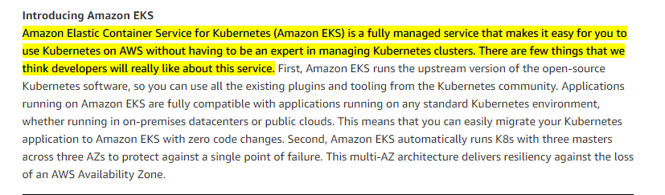

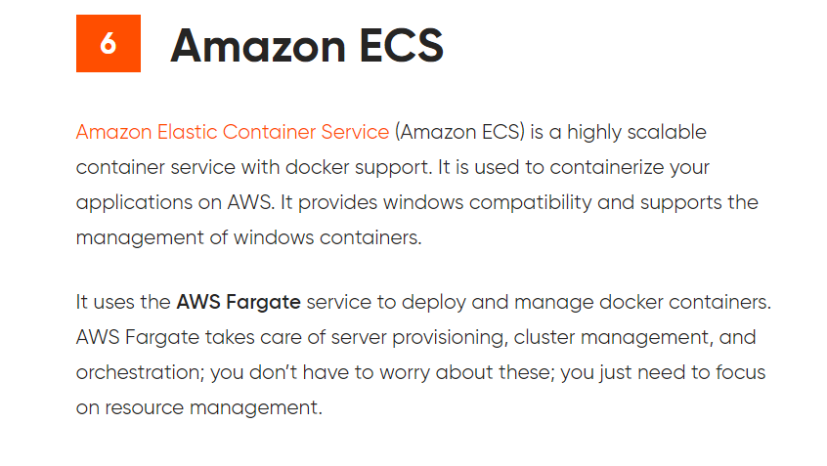

What are Kubernetes Pods?  
A pod is the smallest execution unit in Kubernetes. A pod encapsulates one or more applications. Pods are ephemeral by nature, if a pod (or the node it executes on) fails, Kubernetes can automatically create a new replica of that pod to continue operations. Pods include one or more containers (such as Docker containers).

Pods  
Pods are the smallest deployable units of computing that you can create and manage in Kubernetes.A Pod (as in a pod of whales or pea pod) is a group of one or more containers, with shared storage/network resources, and a specification for how to run the containers. A Pod's contents are always co-located and co-scheduled, and run in a shared context. A Pod models an application-specific "logical host": it contains one or more application containers which are relatively tightly coupled.

\*\*\* That being said, there is no rule that all your nodes must have the same size.