Student name: Gökay Gülsoy
Student number: 270201072

-CENG312-ASSIGNMENT 1 HTTP and DNS-

PART-1)

1.) Fundamental difference between GET and POST method according

to figure 1 and figure 2 is that POST method authenticates the user

credidentials using Base-64 encoding which we can see in the authorization

section, whereas GET method does not provide such an authentication

mechanism.

2.) In the authorization section of POST request we can see a encoded credidentials

that we have passed from terminal for userid and password.

3.) Actually it is not safe because POST request encodes the userid and password

for server authentication, but it is not using encryption because we are still making

this request over HTTP not over HTTPS. But compared to GET it is safer at least.

1
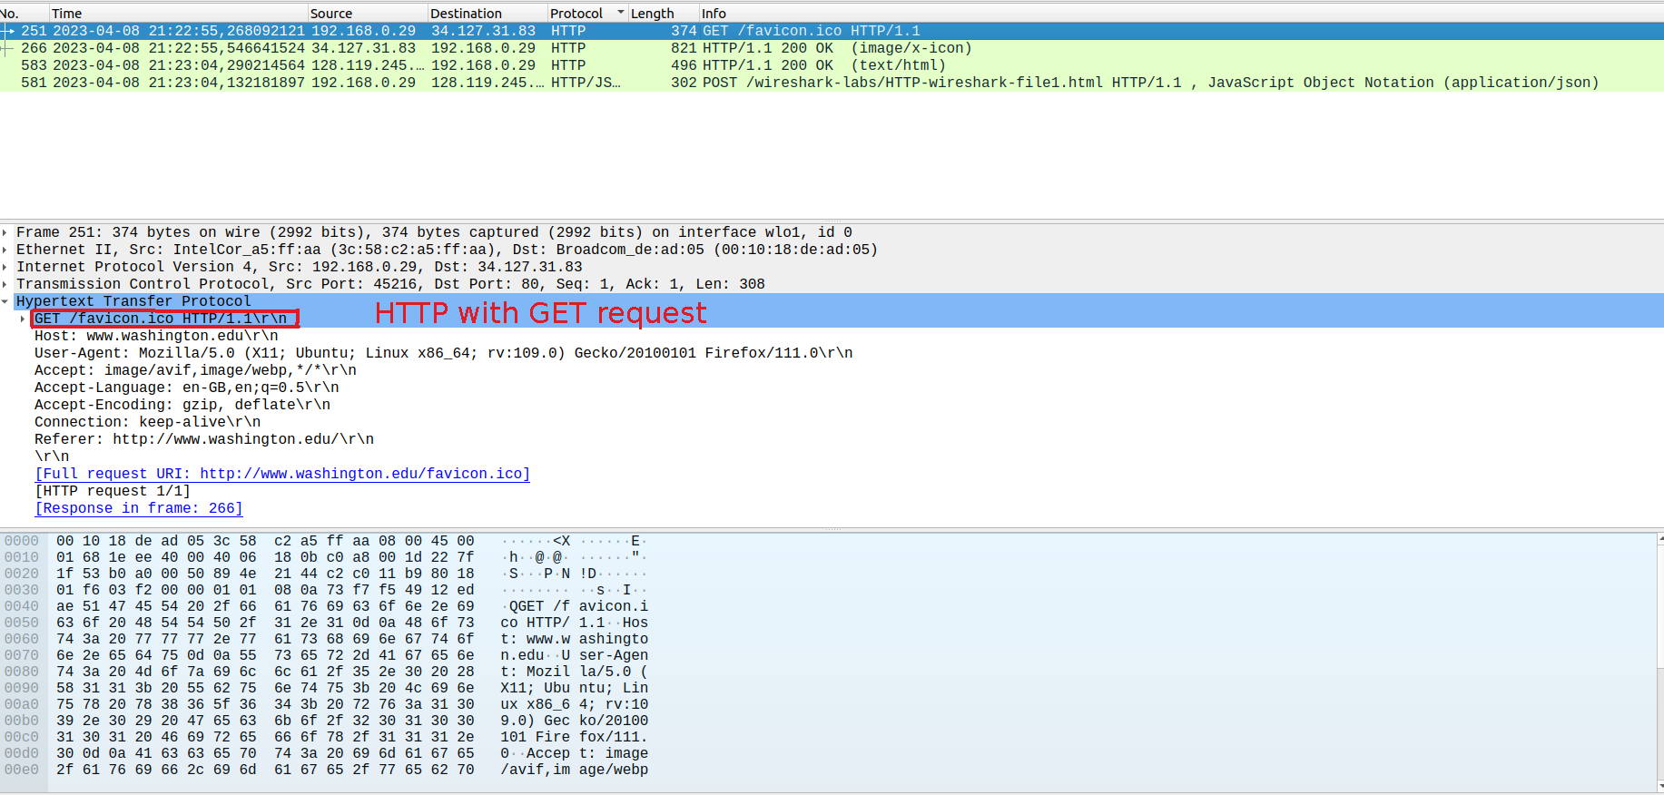Figure 1: GET request
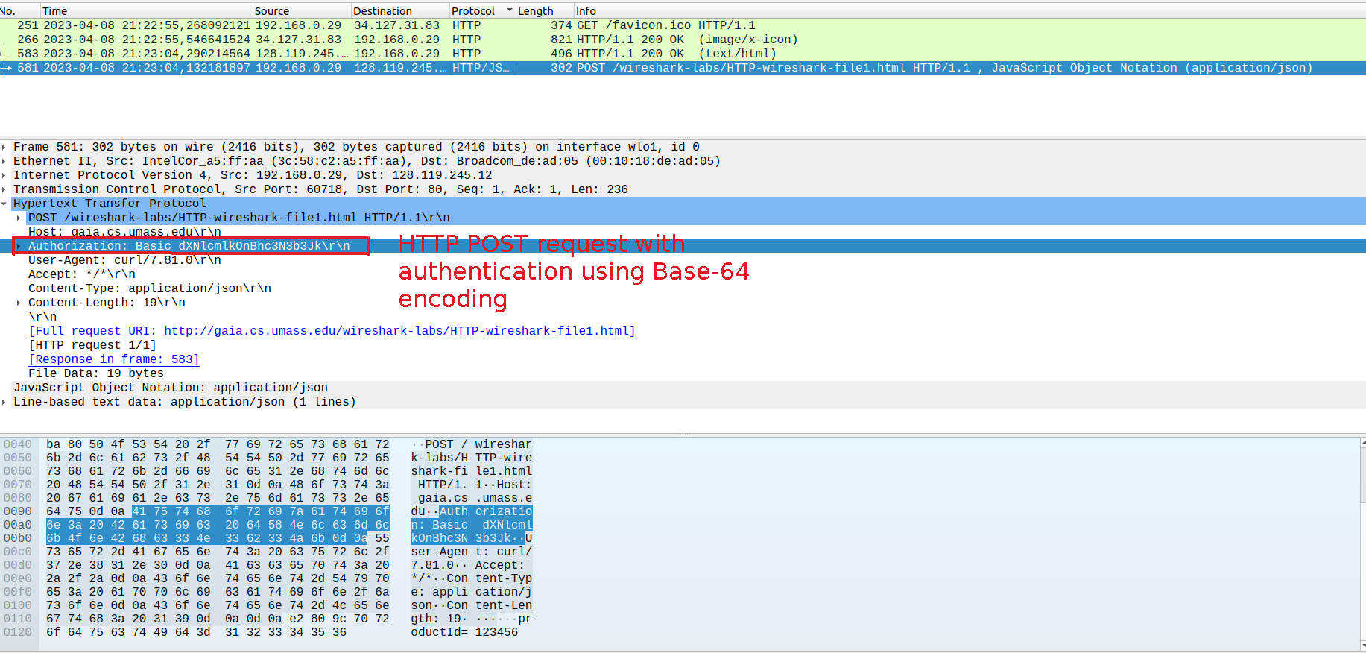Figure 2: POST request

PART-2)

1.) FTP (File transfer) protocol.

2.) FTP is used for transferring file from server to client over a computer

network.

3.) Name of the transferred file is cover.jpg and it’s file type is .jpg file.

4.) In the given scenario client is establishing connection with FTP server

initially, then user provides username and server asks for password of user.

After FTP server authenticated the username and password, user has successfully

logged in. Then user requests cover.jpg file from server, server opens data connection

and tranfers data then data connection was closed. Finally client makes a QUIT request

command and server closses control connection.

2
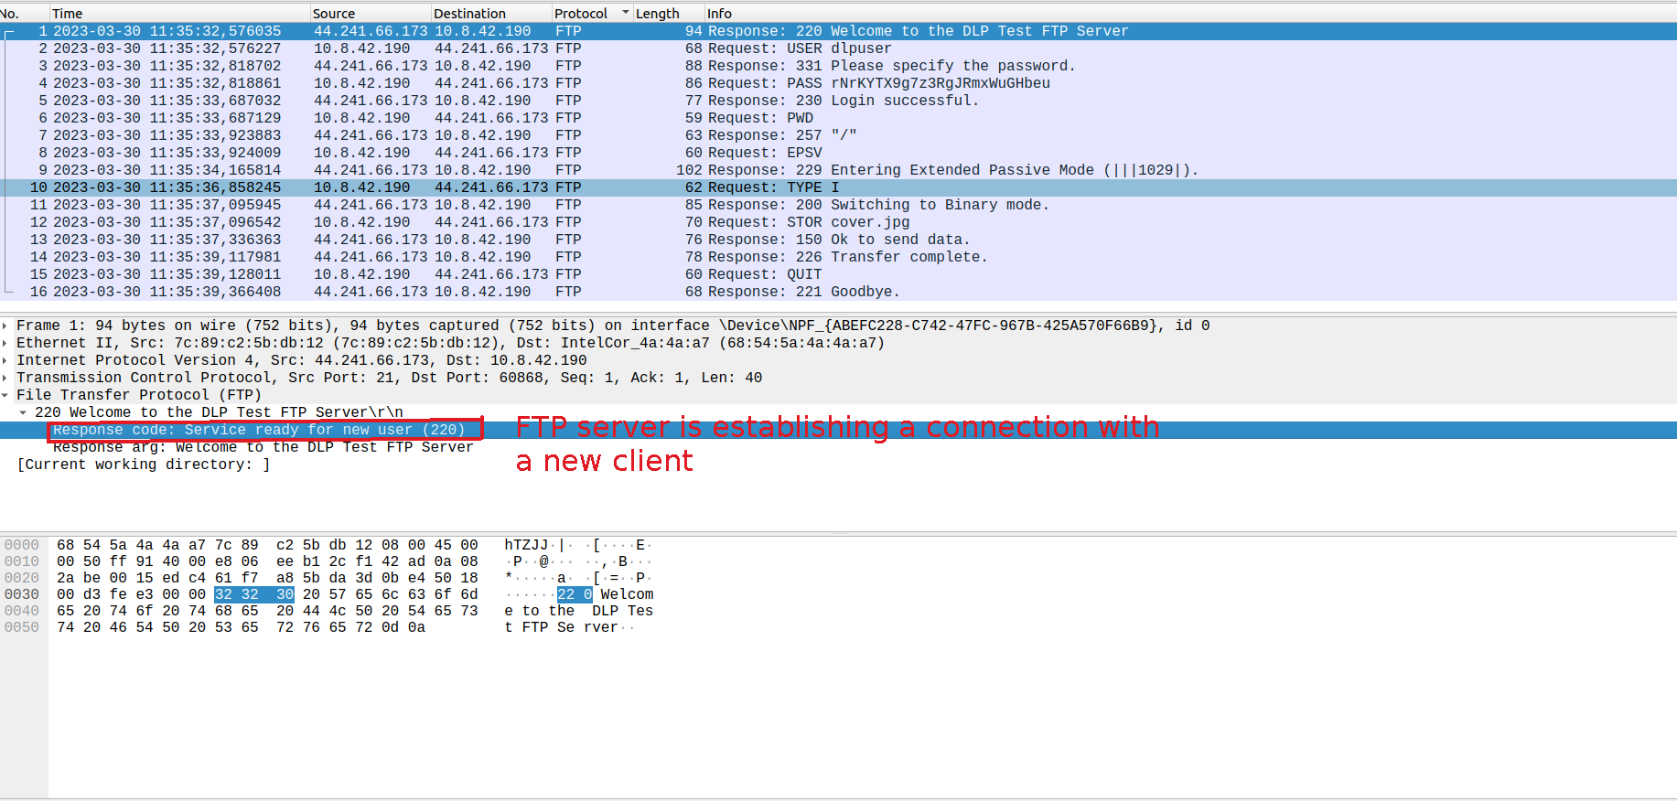Figure 3: Request-Response Flow-1

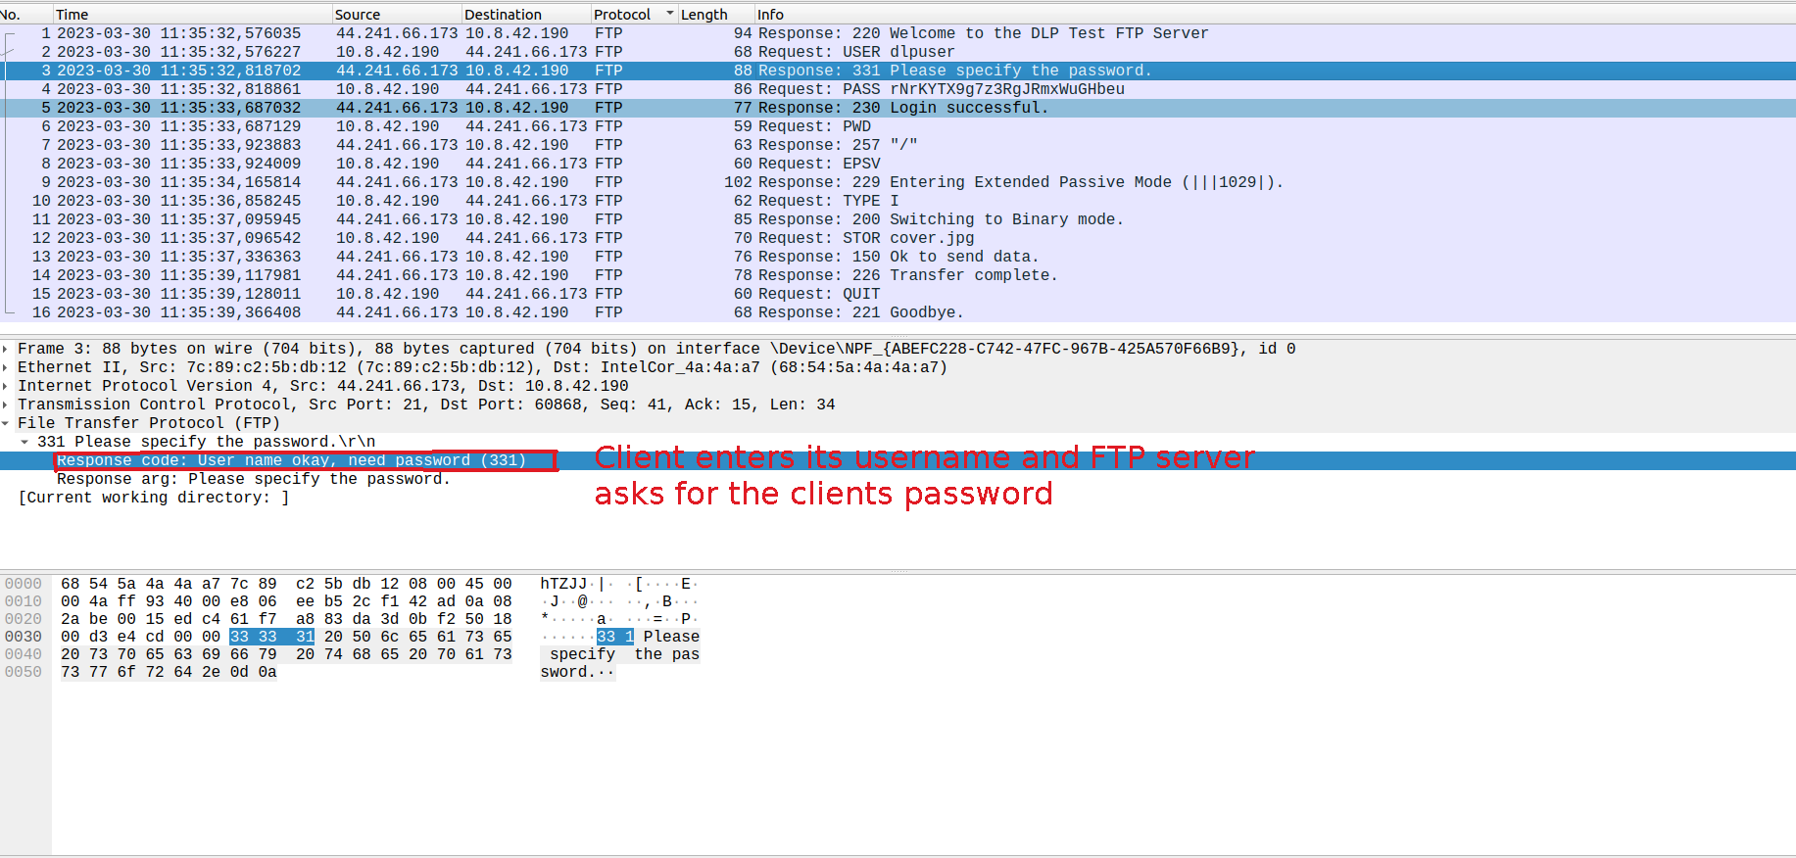Figure 4: Request-Response Flow-2

3
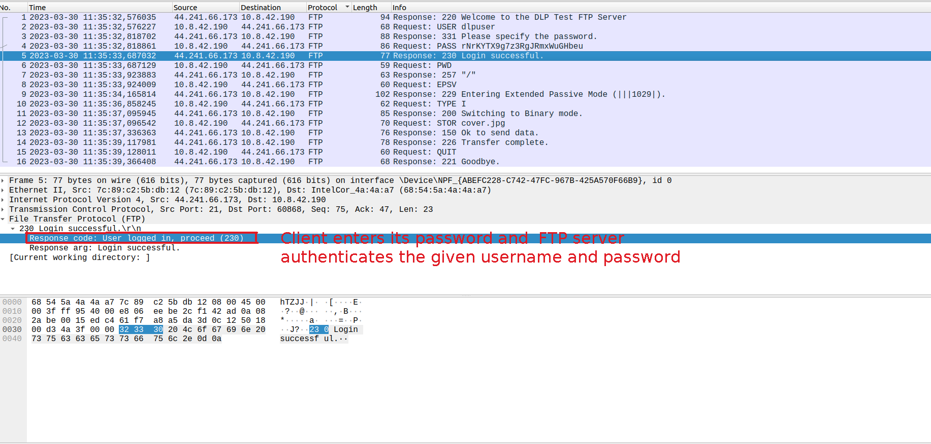Figure 5: Request-Response Flow-3

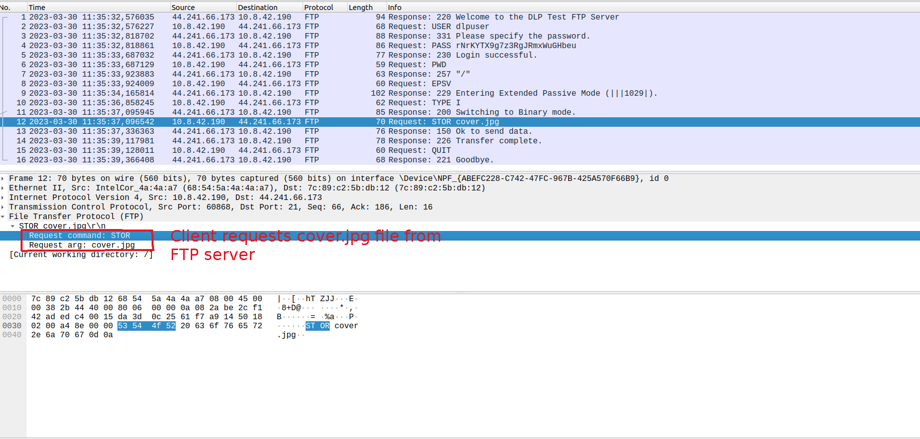Figure 6: Request-Response Flow-4

4
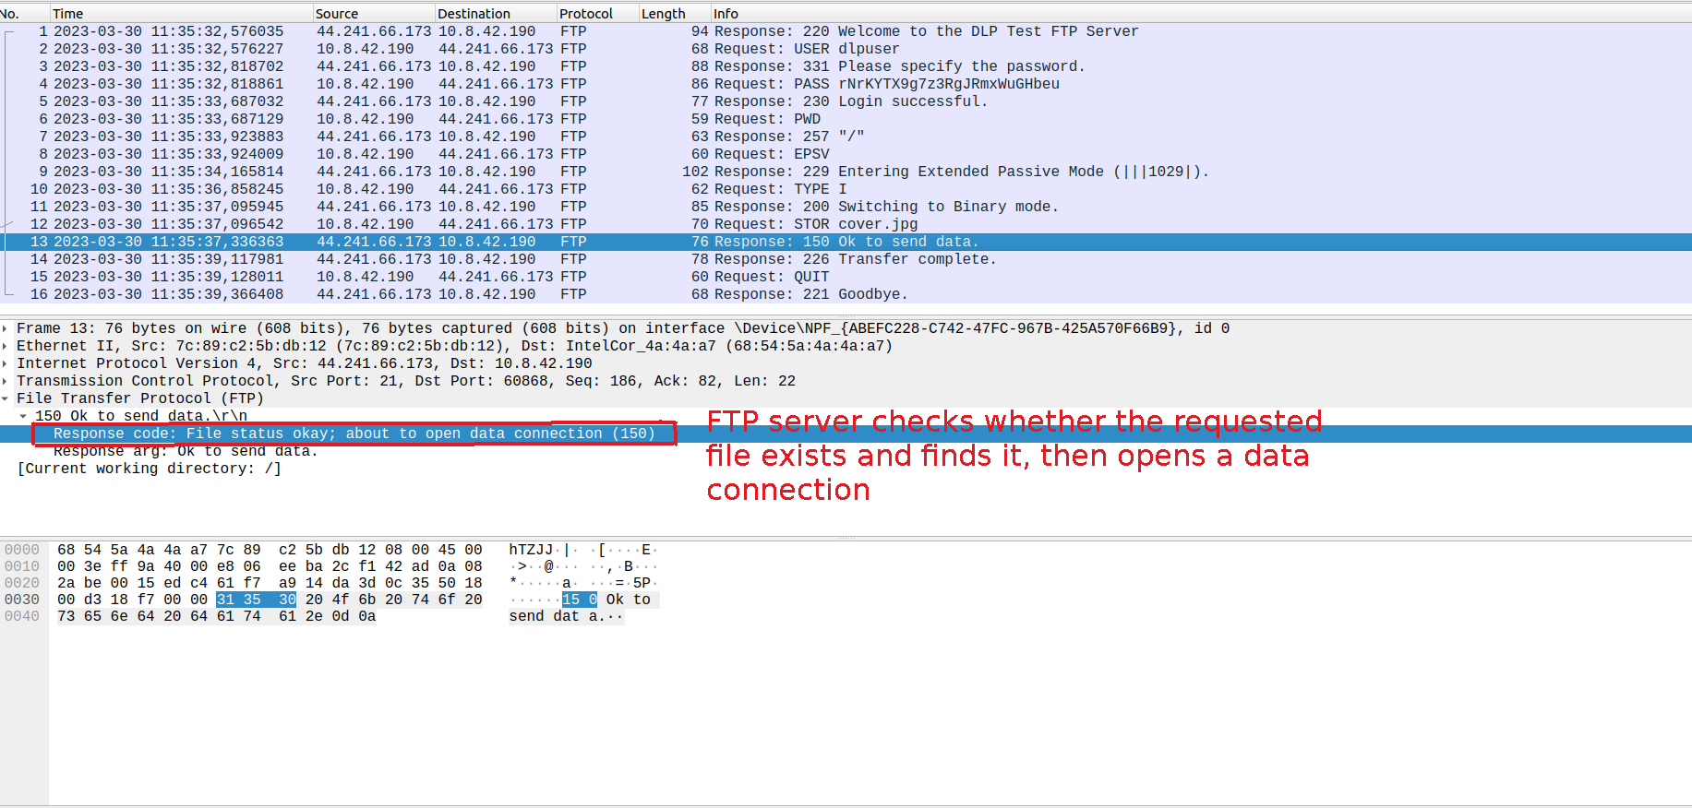Figure 7: Request-Response Flow-5

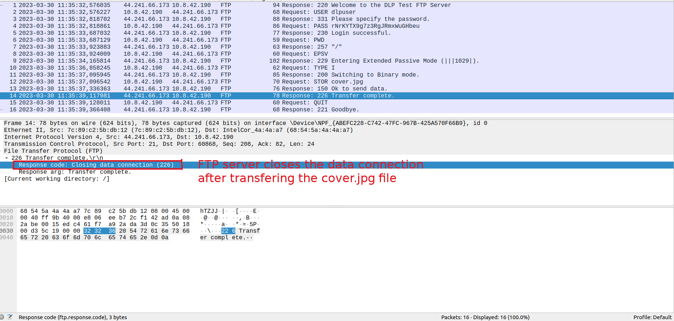Figure 8: Request-Response Flow-6
5
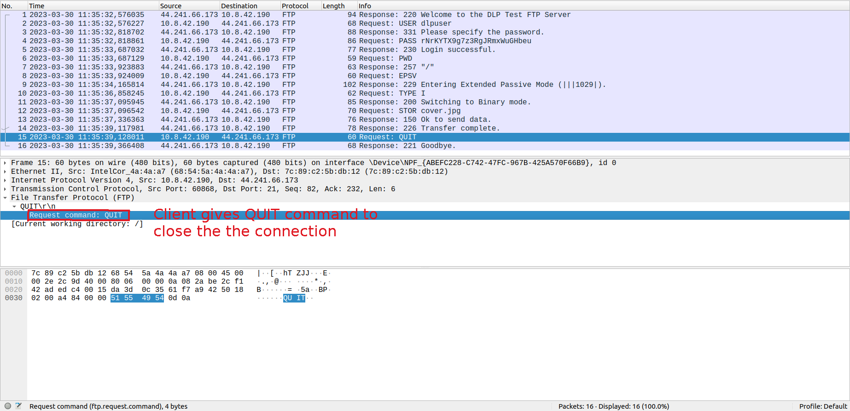Figure 9: Request-Response Flow-7

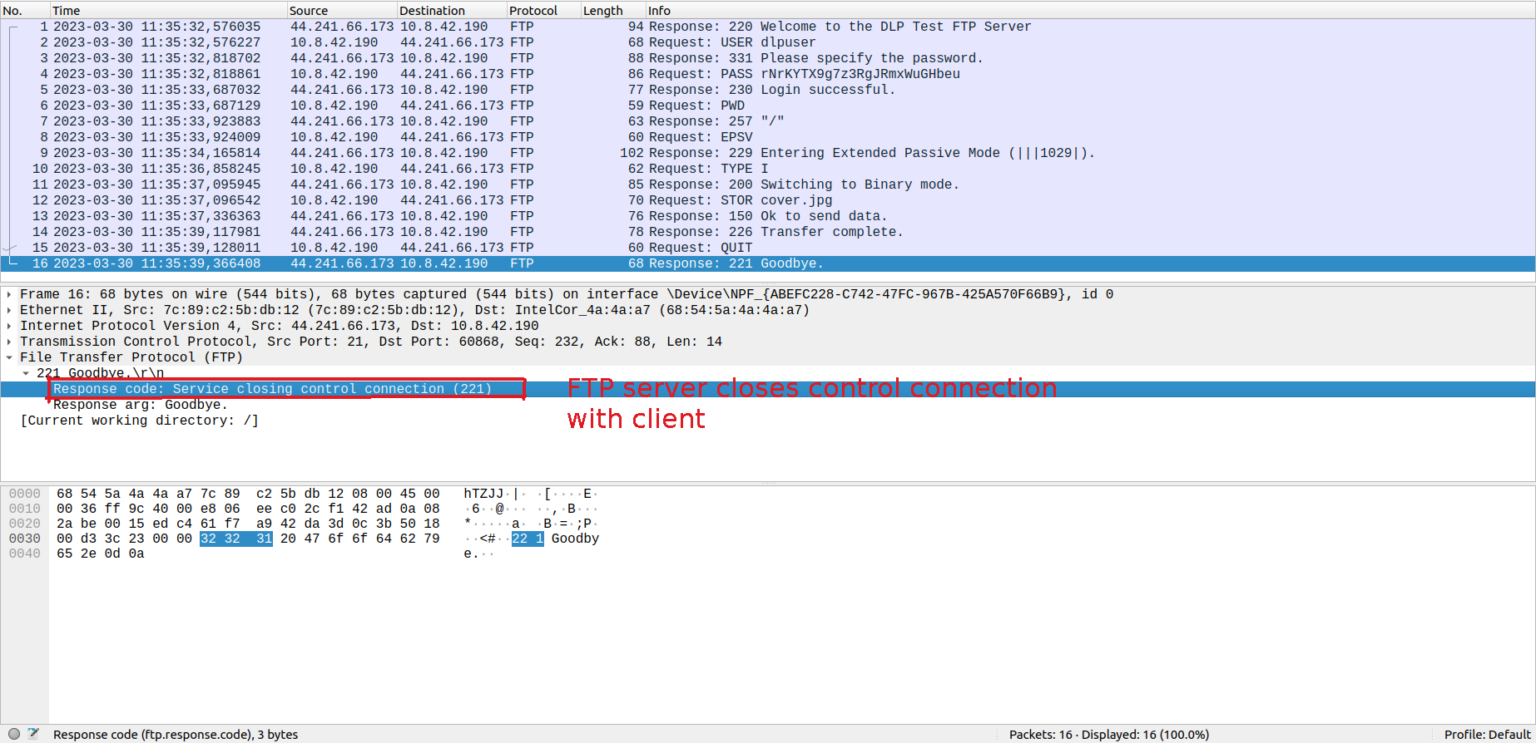Figure 10: Request-Response Flow-8

6

PART-3)

Section-1)

1.) Writing IP addresses instead of DNS name is known as name-to-address

translation.

2.) Because IP addresses are not usually human-readable or easy to recognize

even if they are better for routers. For the sake of easy understanding of domains,

DNS names are used.

3.) Query made was a recursive DNS query as we can see from figure 11 below.

4.) DNS name of the IP address 193.140.248.136 is webpro.iyte.edu.tr as we can

see from figure 12. below.

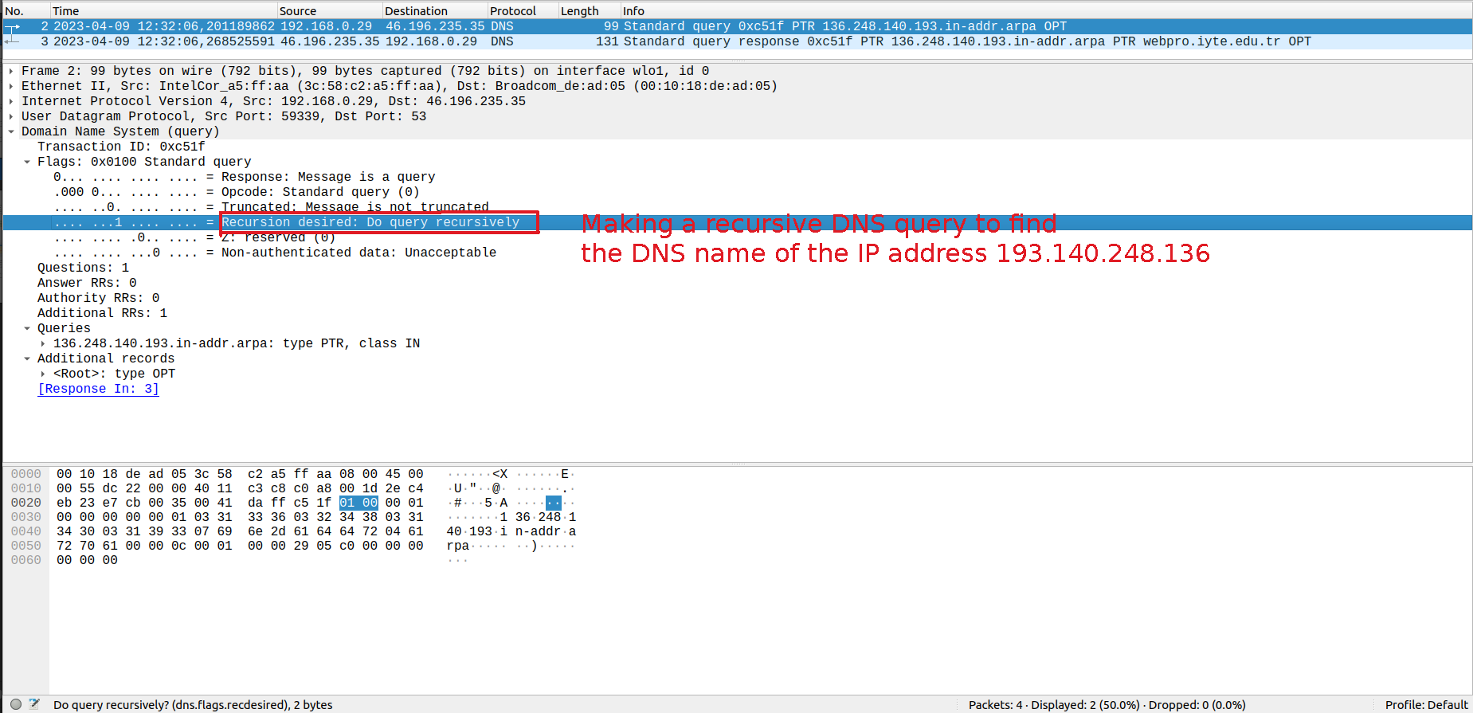Figure 11: DNS-query
7

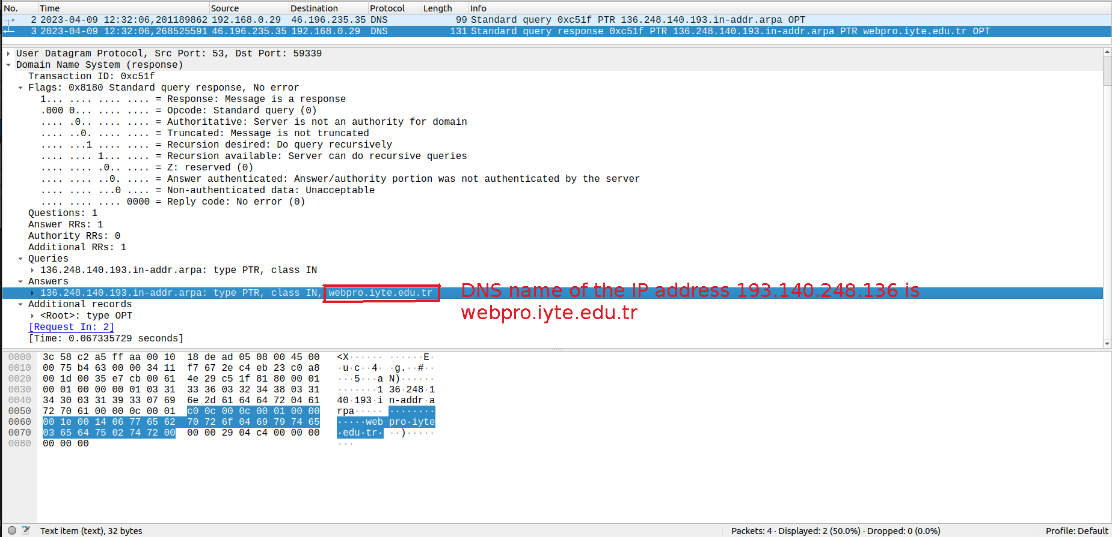Figure 12: DNS-response

PART-3)

Section-2)

1-) In the DNS query given in the figure 13 below we can see that DNS type

is A which is known as address mapping record or DNS host record that stores

a host name and its IPv4 address. In the DNS query given in the figure 14 below

we can see that DNS type is AAAA which stores hostname and it’s IPv6 address.

In the DNS query given in the figure 15 we can see that DNS type CNAME was

also used to alias a hostname to some other host name, if client requests a record

of type CNAME which is pointing to another hostname, DNS resolution process

will also repeat for this new hostname.

2.) We make a DNS request to www.microsoft.com using Google’s DNS server

running at IP address 8.8.8.8 instead of our local DNS server as we can see in figure 17.

8
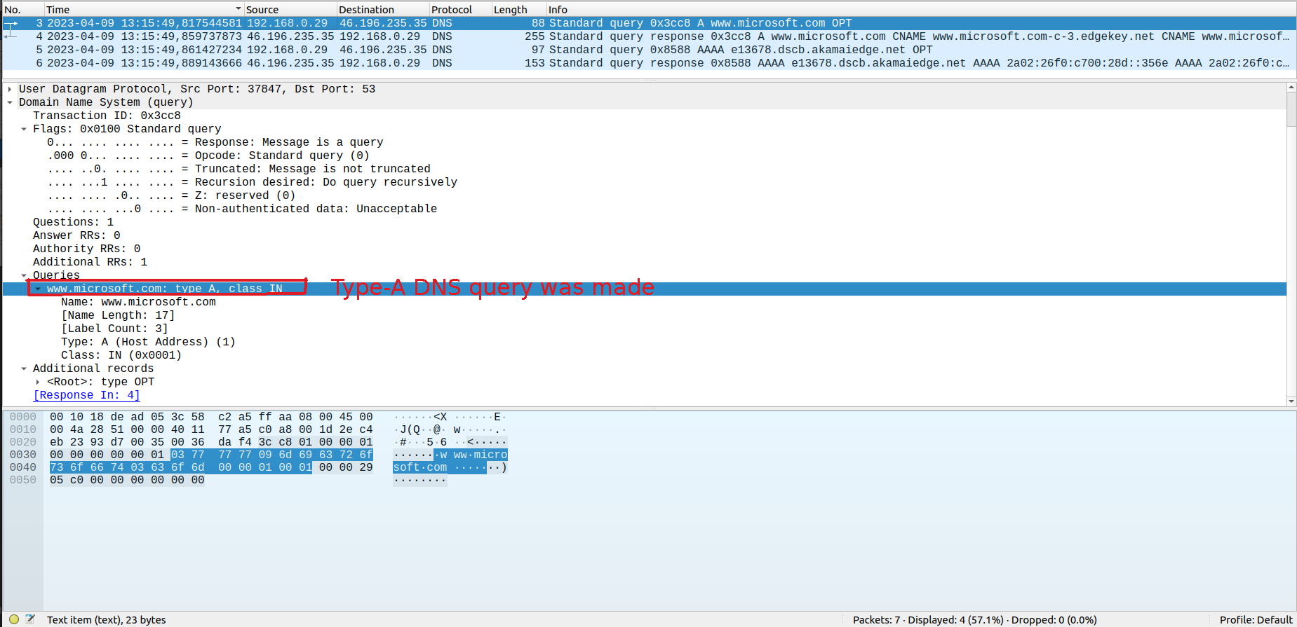Figure 13: Type-A DNS query

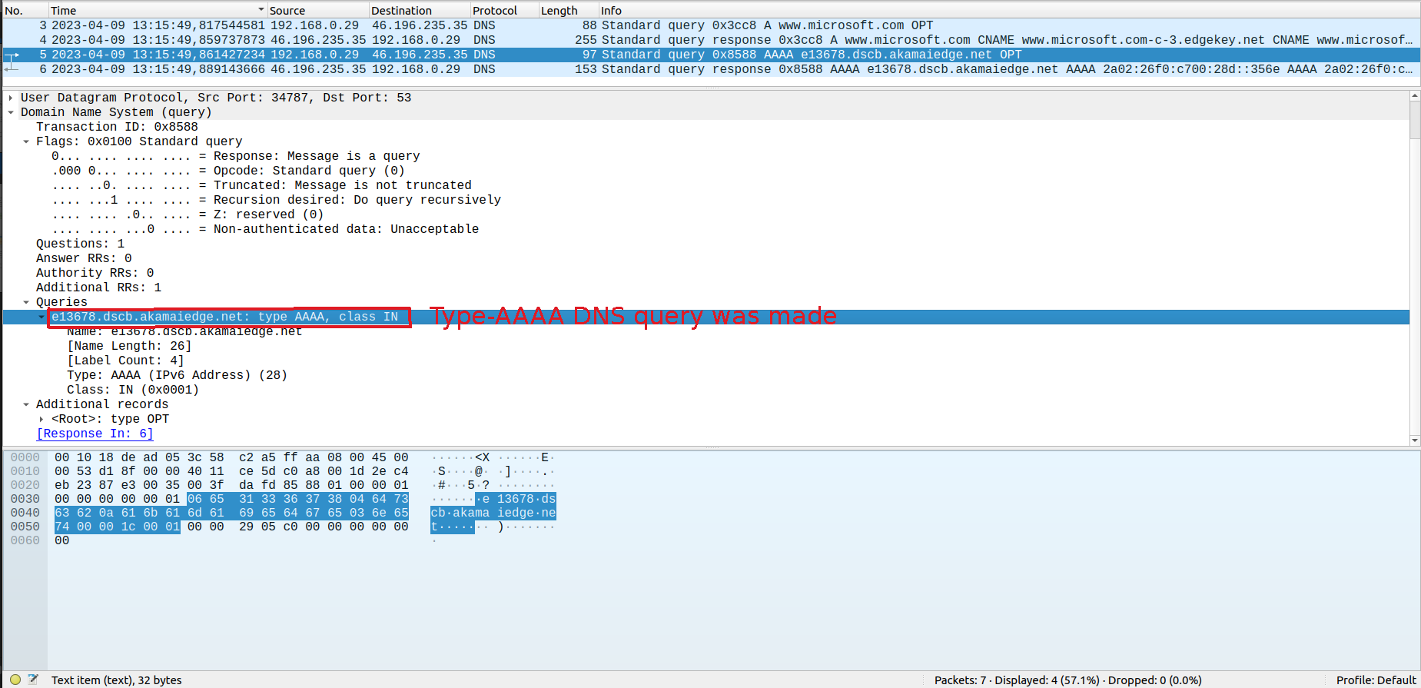Figure 14: Type-AAAA DNS query

9
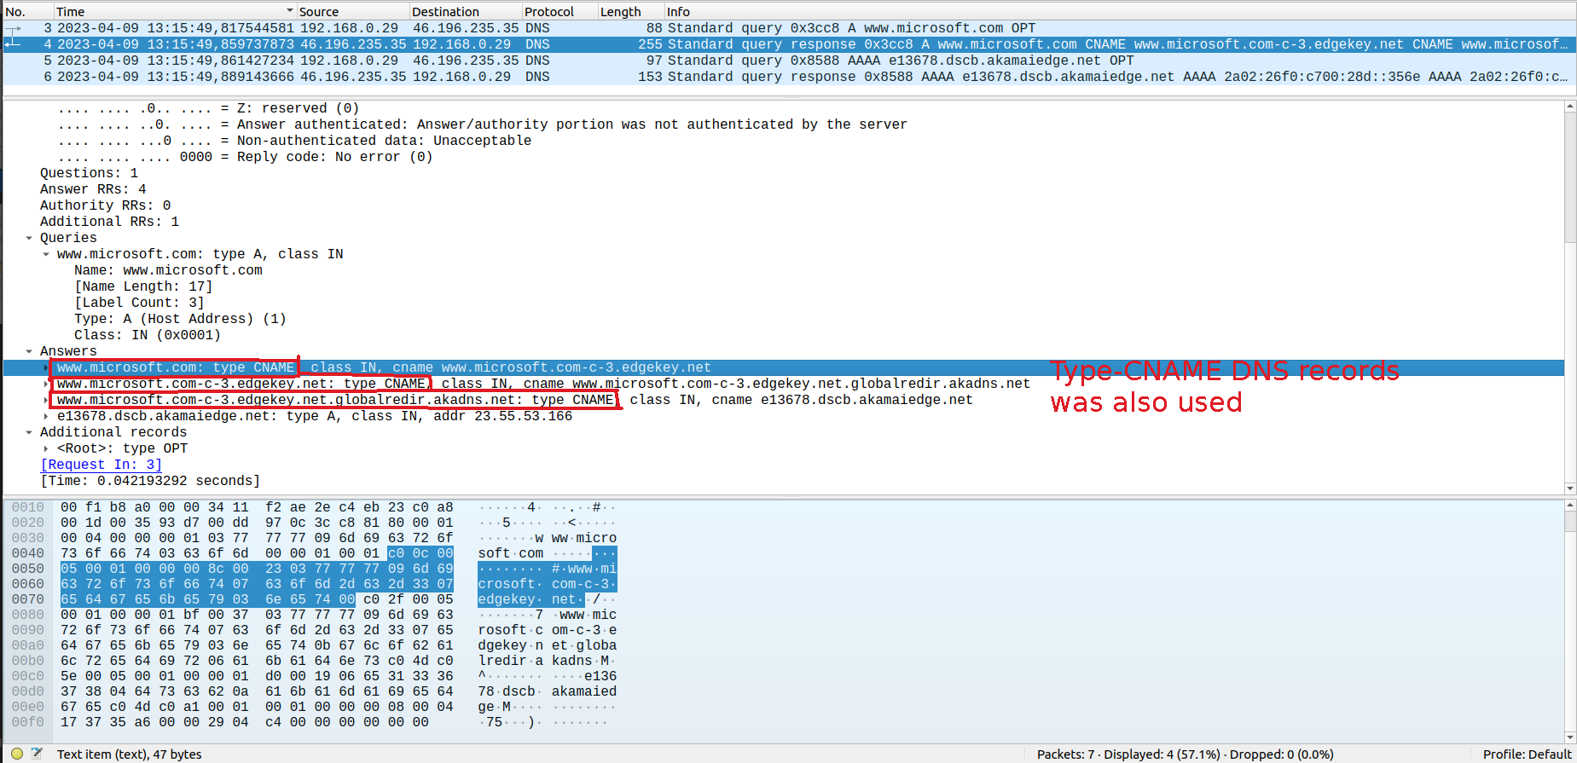Figure 15: Type-CNAME DNS query
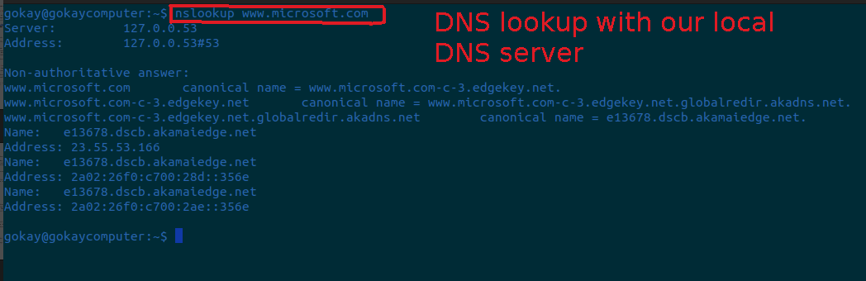Figure 16: DNS lookup with our local DNS server

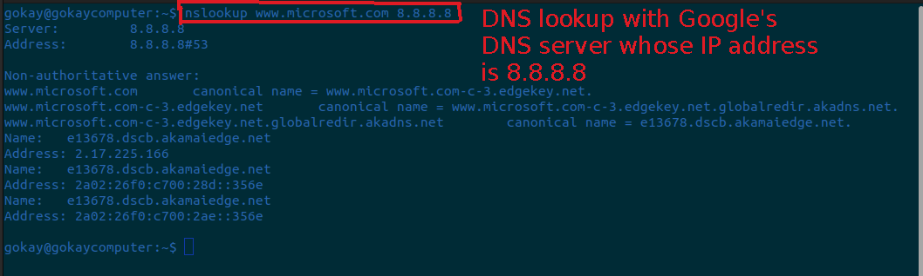Figure 17: DNS lookup with Google's DNS server

10

