Student name: Gökay Gülsoy
Student number: 270201072

-CENG312-ASSIGNMENT 2 TCP and UDP-

Q1-) Sender has sent packet with SYN to server and server has returned SYNACK to

sender, but when we look at the rest of this traffic we can see that third packet of the

handshake never arrived. Each duplicate ACK is querying for ACK 1 with sequence

number 1 in the handshake, but as the client has two different packets with sequence

number 1, this issue never solved.
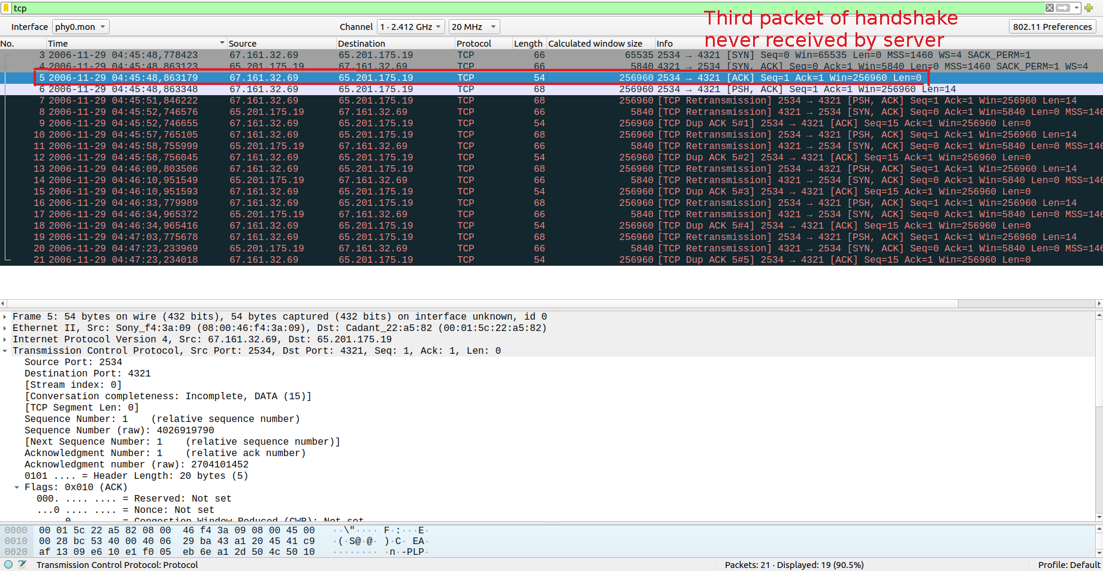Figure 1: assignment2-tcp-1 third packet in handshake never arrived

Q2-) Firstly server sends an ACK 1 for a packet with sequence number 1, then client with IP

address 192.168.0.104 sends a packet with sequence number 6349, but then server has sent

three duplicate ACKs for a packet with sequence number 1. Then client used fast-retransmission

to send the packet with sequence number 1, this indicates that it was a lost packet with high

probability. Then client retransmits packets with sequence numbers 1461, 2921, 4381, 1

respectively. Server ACKed the packet with sequence number 1, and client retransmitted

packets with sequence numbers 4381 and 5841. Server has returned cumulative ACK 4381, then

client has sent packet with sequence numbers 7301 and 8761. Then server returned cumulative

ACK 6861 and client has sent packets with sequence numbers 10221, 11681, and 12621. Server

Server then sent three duplicate ACK for cumulative ACK 6861 and as no ACK

has returned from client, client fast-retransmitted packet with sequence number 6861

in order to avoid congestion which may be caused by a lot of retransmissions. Finally

server retransmitted cumulative ACK 6861. In summary we can see that there were a lot

of packet loss and in order to avoid congestion, fast-retransmissions used so that no more

than three duplicate ACK’s will accumulate and this avoids congestion.

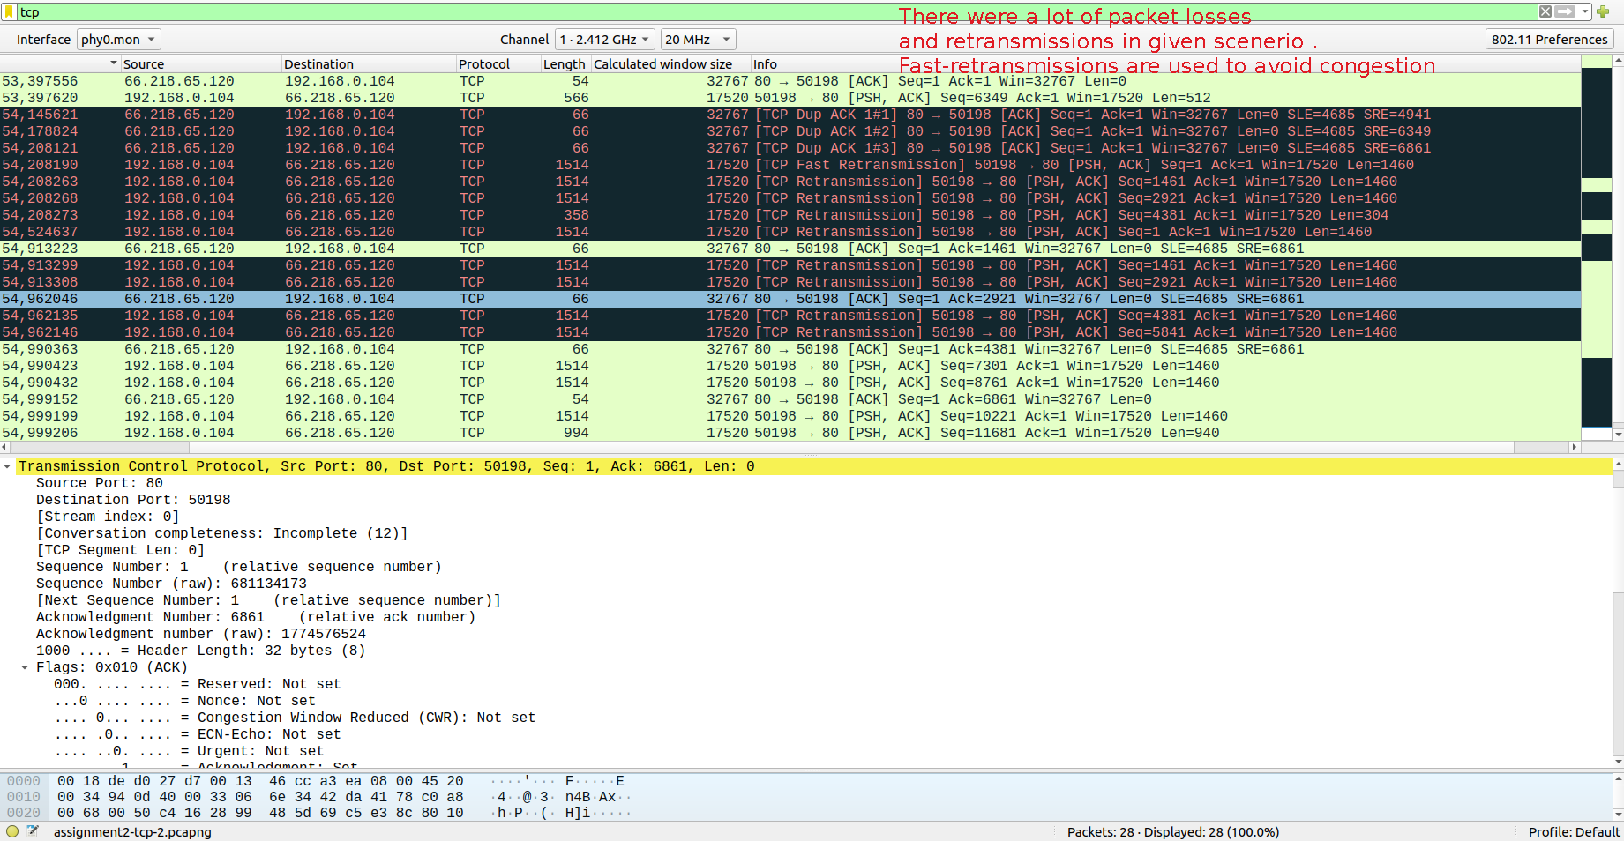Figure 2: assignment2-tcp-2 a lot of packet loss and retransmission scenerio

Q3-) When we monitor the traffic we can see 41 instances of “TCP ZeroWindow” segment

This means that due to lack of available buffer space, server is not able to receive any more

data. We can see that server sends a TCP segment with “TCP Window Full” 9 times. During

that time interval to keep TCP connection open even if no packet can be received, server also

sends TCP segment with “TCP-keep-alive” info.

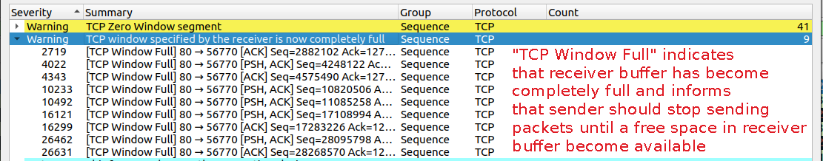Figure 3: assignment2-tcp-3 “TCP Window Full”
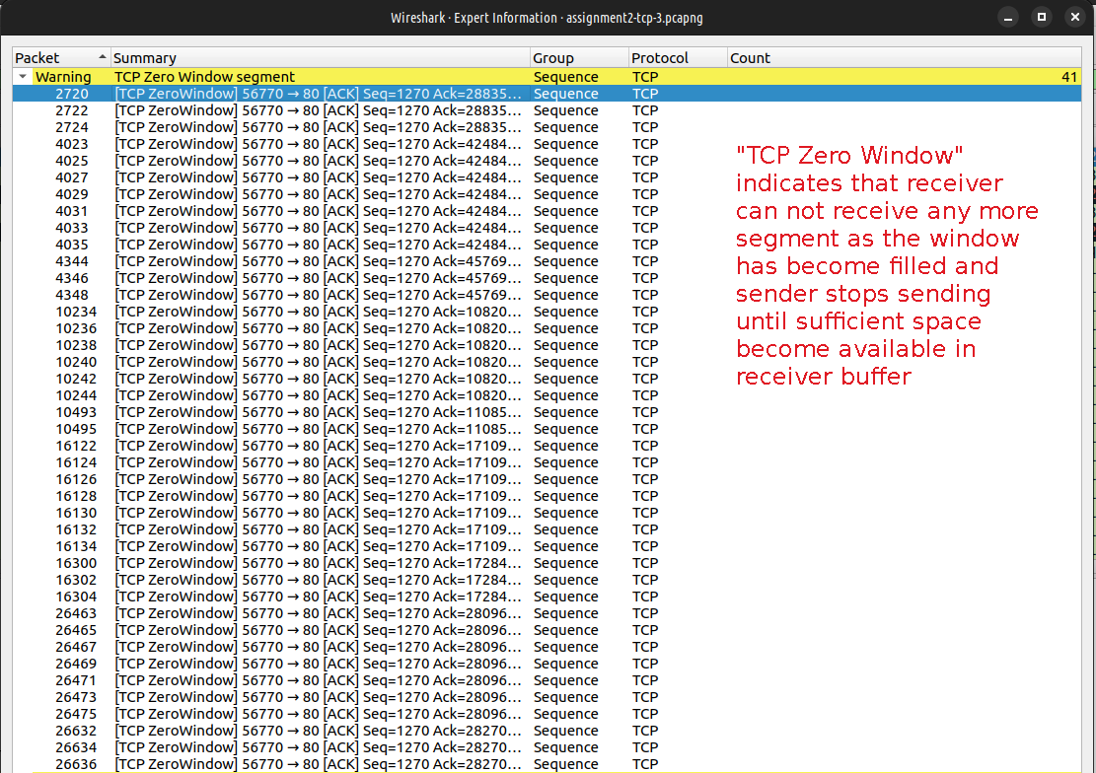Figure 4: assignmet2-tcp-3 “TCP Zero Window segment”

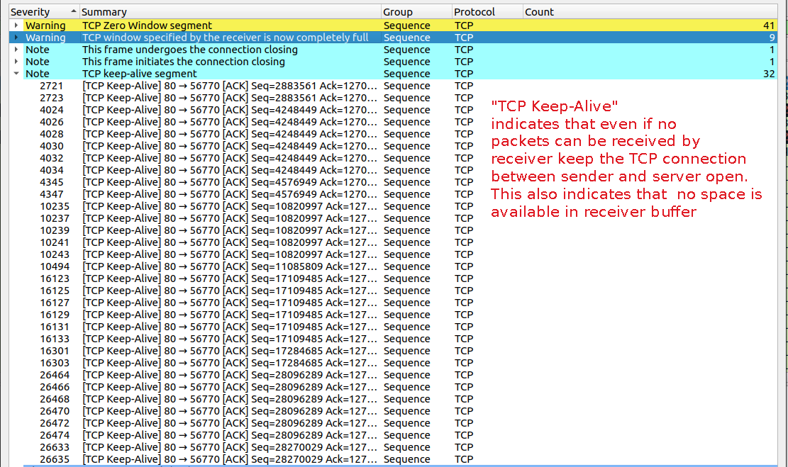Figure 5: assignment2-tcp-3 "TCP Keep Alive"

Q4-a-1) We can see from Time Sequence Stevens Graph that sequence numbers of

packets sent start with low sending rate, but after that it has increased exponentially until

approximately 4.127 second. After 4.193 second we can see that there is a congestion up

until to 4.418 second, then again sequence number of packets sent started to inrease at low

rate, after that it continued with exponential increase until approximately 5.983 second after

which increase switched to linear.

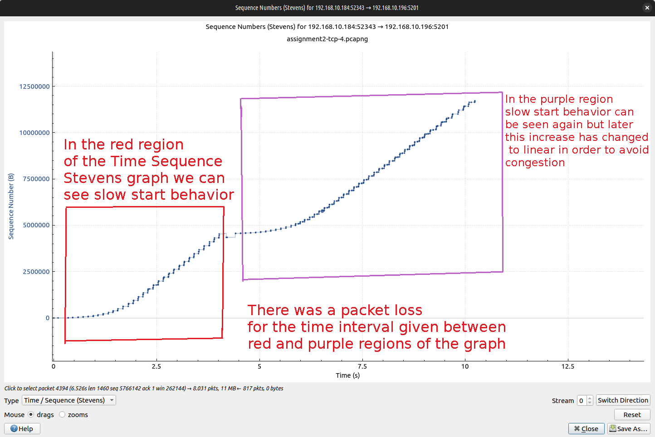Figure 6: assignmet2-tcp-4-a-1 Time Sequence Stevens Graph

Q4-a-2) In the Wİndow Scaling Graph we can see that receiving window is a flat

green line and it denotes the window’s size at a given time, so relation between

receiving window and bytes out (which denotes bytes in flight) is that number

of bytes out can never exceed current receiving window size. If receiving window

scales, then maximum number of bytes out can scale accordingly.

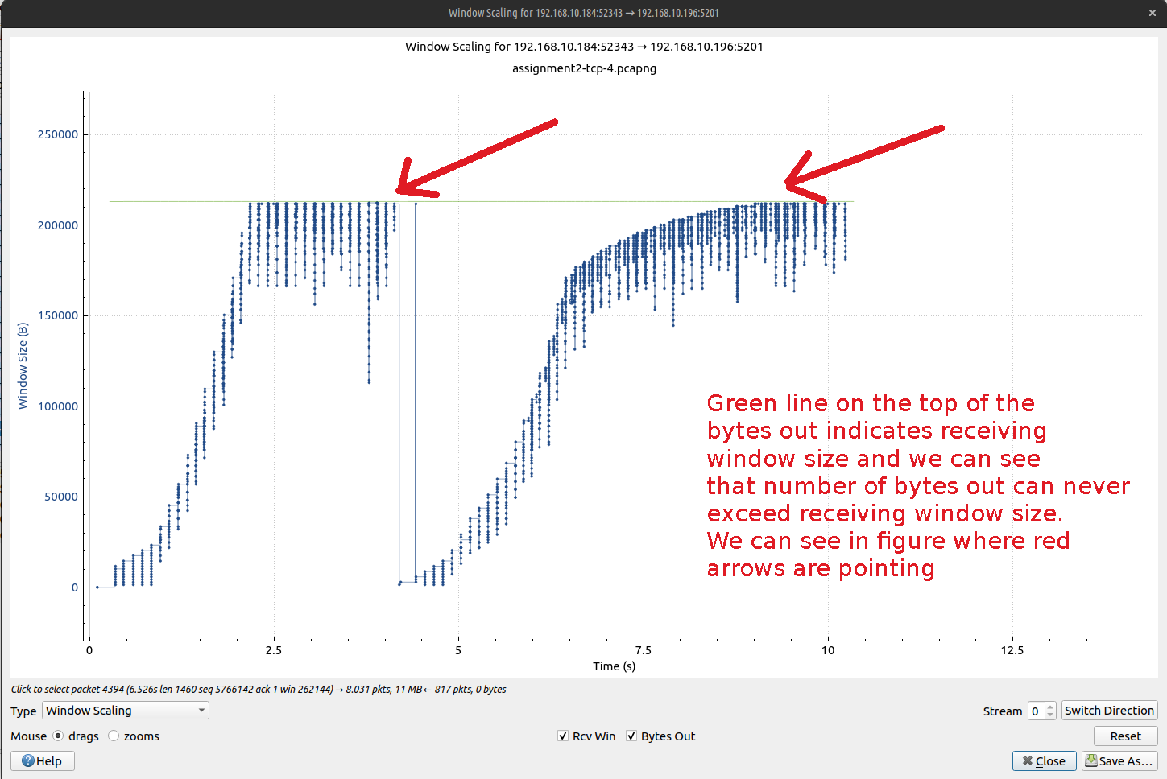Figure 7: assignment2-tcp-4-a-2 Window Scaling Graph

Q4-b-4) We can see the slow start behavior in Time Sequence Stevens graph and Window

Scaling Graph. At 0.00011 second sent packet number is 3, if we look at the 5.123 second sent

packet number reaches to 926, so number of packets sent per second is approximately 176.481

in time interval 0.00011 to 5.123 second. If we look at the 67.68 second, number of last

packet sent was 18805. if increase rate had remained same, then number of last packet

sent would have been 11944 but actual packet number sent at 67.68 second 18805. This

inidcates that packet sent rate has increased over time.

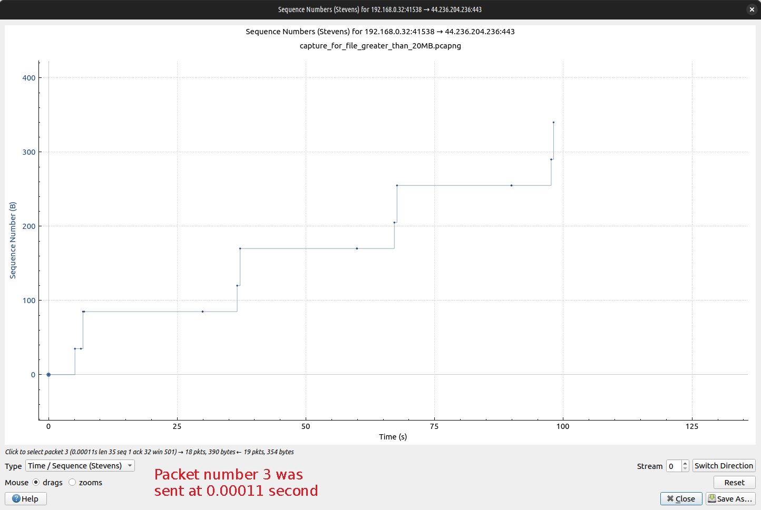Figure 8: assignment2-tcp-4-b-4 Time Sequence Stevens Graph

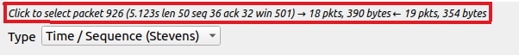Figure 9: Packet number 926 was sent at 5.123 second

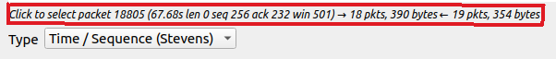Figure 10: Packet number 18805 was sent at 67.68 second

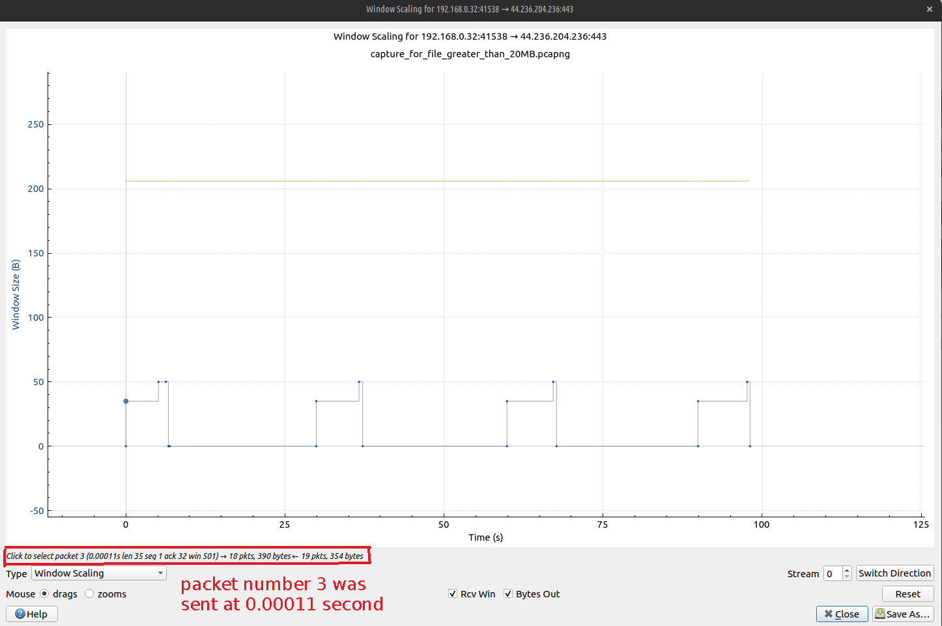Figure 11: assignment2-tcp-4-b-4 Window Scaling Graph

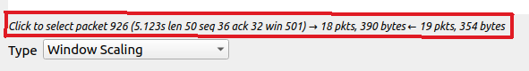Figure 12: Packet number 926 was sent at 5.123 second

Figure 13: Packet number 18805 was sent at 67.68 second

Q4-b-5) I have made an ftp request to gaia.cs.umass.edu.wireshark-labs/alice.txt

to download the file alice.txt. According to Time Sequence Stevens Graph at 1.334

second, packet number 13 was sent and at 1.564 second packet number 25 was sent.

Number of packet sent per second as a rate in time interval 1.334 to 1.564 is approximately 19.

If we look, at 1.789 second sent packet number was 51 and 2.088 second sent packet

number was 75 . Number of packets sent per seocnd as a rate in time interval

1.789 to 2.088 is approximately 67 so we can see that packet sending rate started

at slower rate and it has increased gradually. This indicates slow start behaviour.

Same behavior can be seen in Window Scaling Graph. Also when we look at the

window size it has increased gradually in certain time intervals in response to

increased number of sent packets.

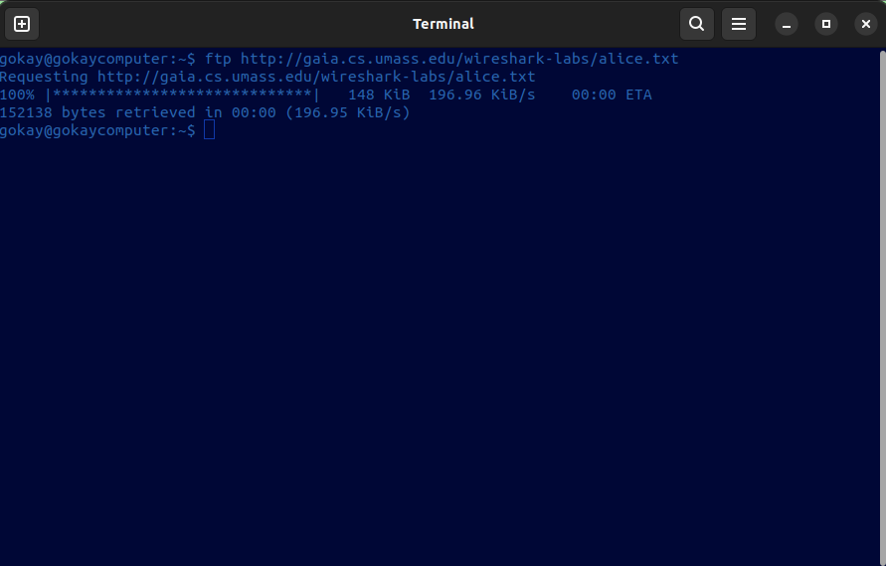Figure 14: ftp request made to gaia.cs.umass.edu to fetch alice.txt file

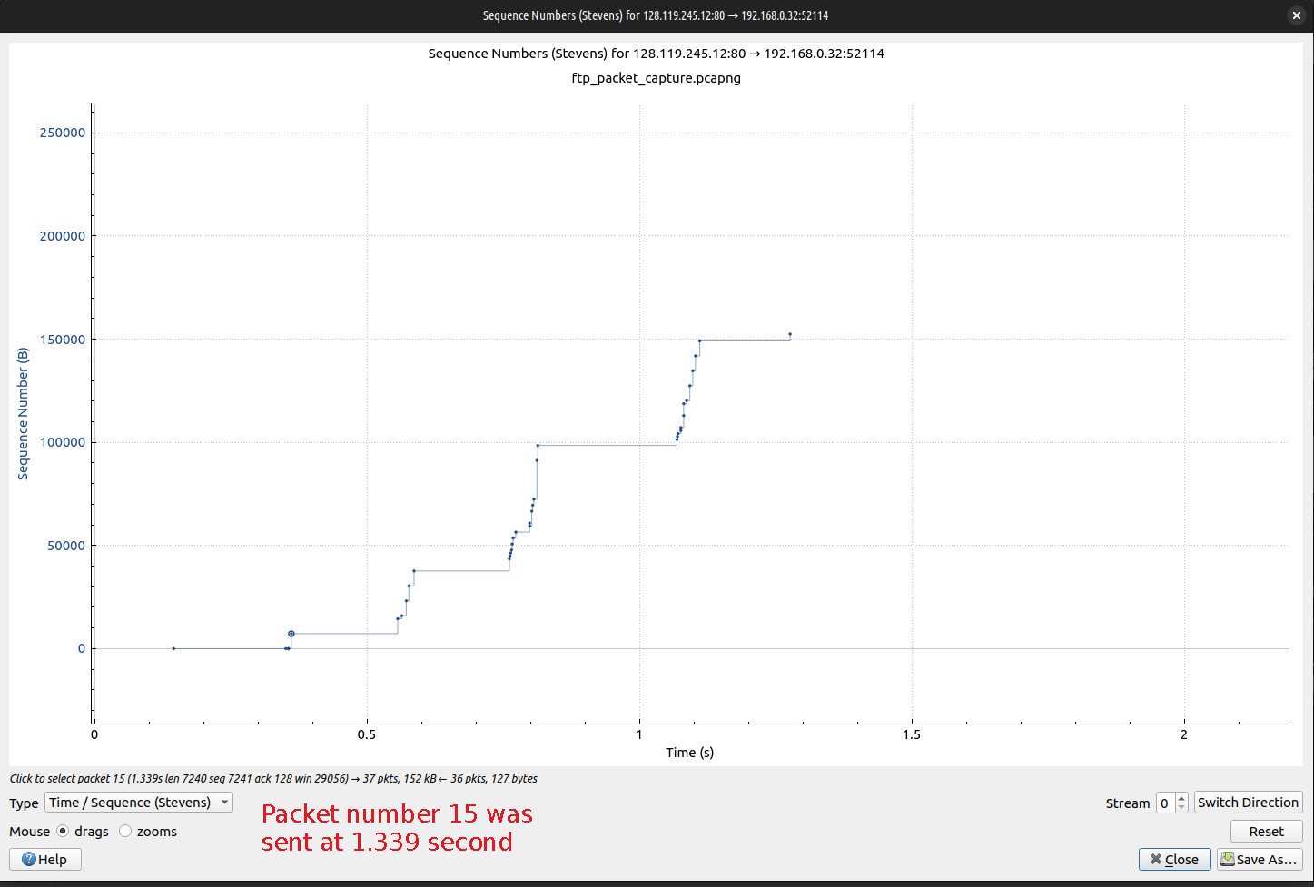Figure 15: assignment2-tcp-4-b-5 Time Sequence Stevens Graph

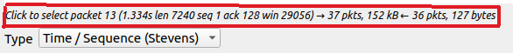Figure 16: Packet number 13 was sent at 1.334 second

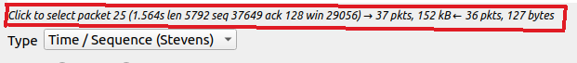Figure 17: Packet number 25 was sent at 1.564 second

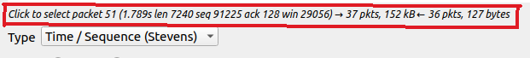Figure 18: Packet number 51 was sent at 1.789 second

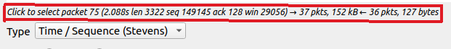Figure 19: Packet number 75 was sent 2.088 second
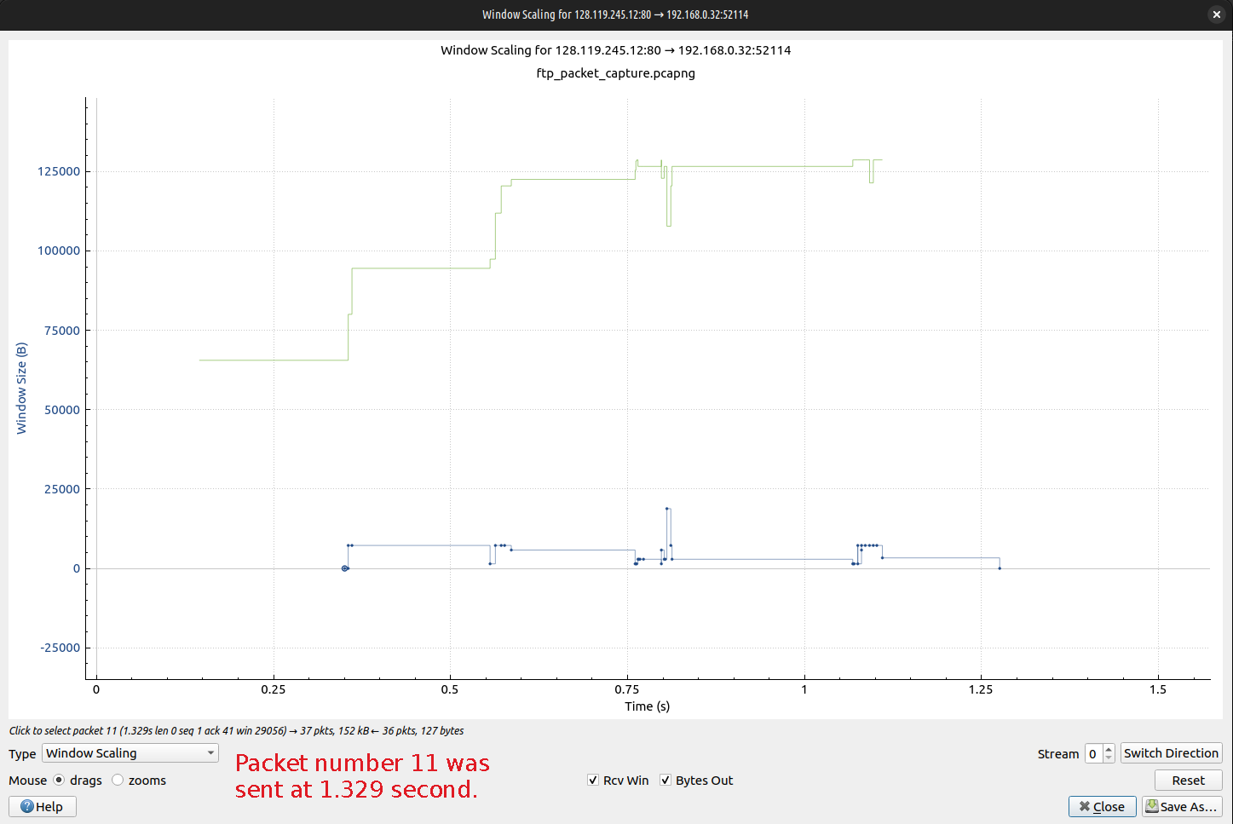Figure 20: assignment2-tcp-4-b-5 Window Scaling Graph

Figure 21: Packet number 13 was sent at 1.334 second

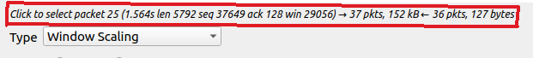Figure 22: Packet number 25 was sent at 1.564 second

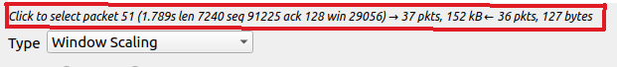Figure 23: Packet number 51 was sent at 1.789 second

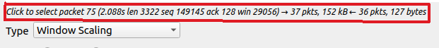Figure 24: Packet number 75 was sent 2.088 second

-UDP SECTION-

I have created a scenerio in which I made a DNS query for iyte.edu.tr domain

name with dig tool which can be used for making DNS queries from terminal

in Linux. As DNS uses UDP as an underlying transport layer protocol we can

analyze UDP packets send and recevied as well in this scenario.

Q1-) Destination IP address of the sent packet is 192.168.166.10. It is not

possible to be sure that packet reaches to destination address because UDP

does not use any acknowledgement mechanism. Packet may be lost and we

can never know this because of unavaliable acknowledgement mechanism.

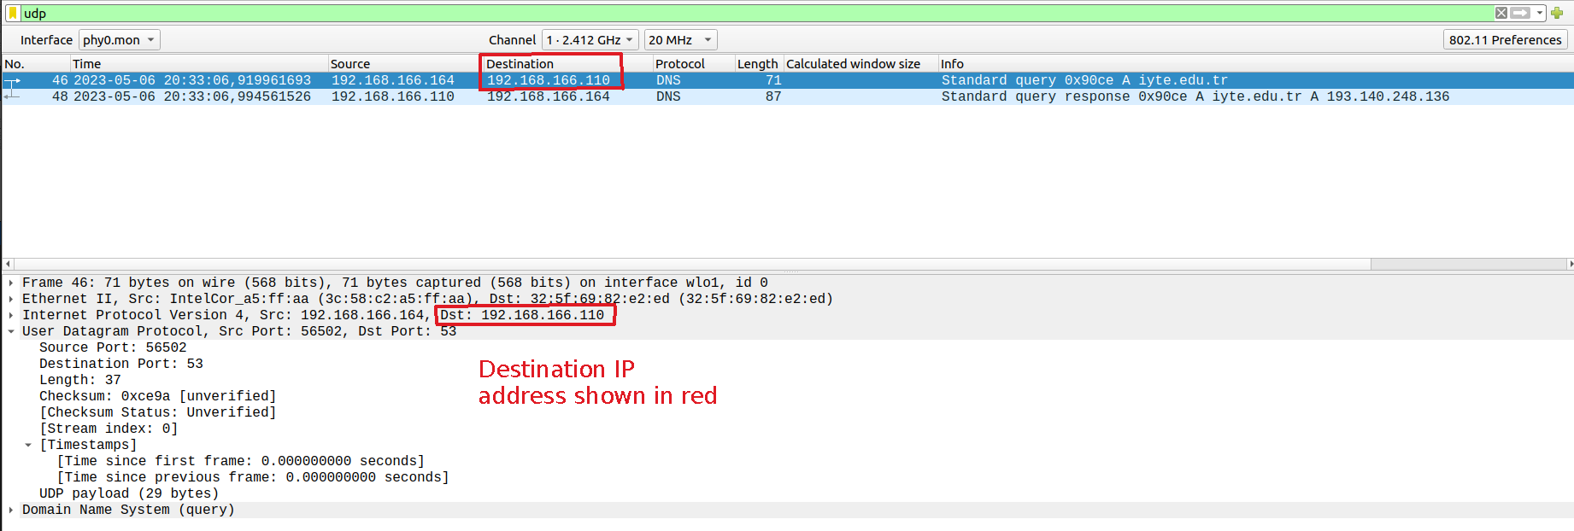Figure 25: Destination IP address of sent UDP packet
Q2-) Source port number for sent packet from my host is 56502, and

destination port number is 53. For received packet as a reply to this packet,

source port number is 53, and destination port number is 56502. Source and

destination port numbers are reverses of each other for the sent and received

packet.
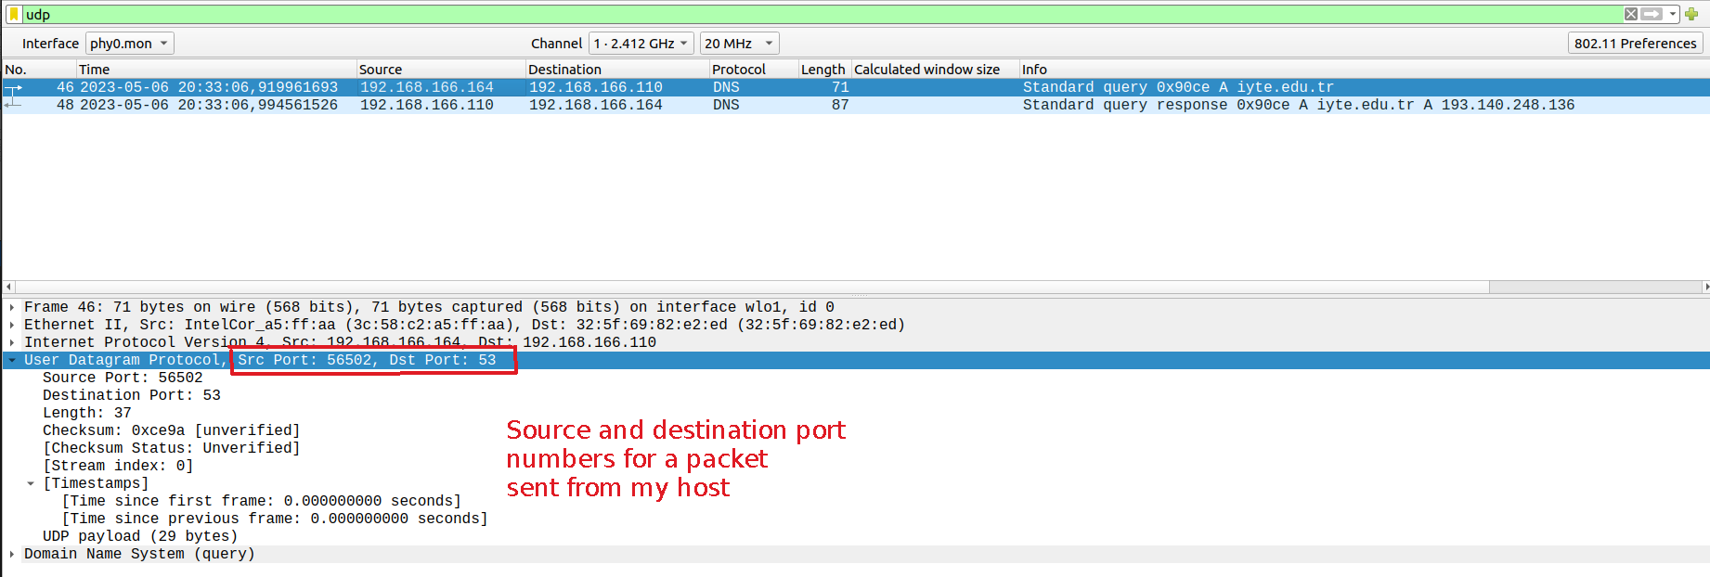Figure 26: Source and destination port numbers for sent packet

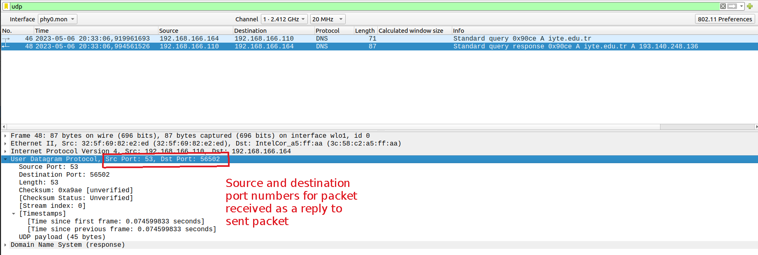Figure 27: Source and destination port numbers for received packet as a reply

Q3-) UDP header size is 8 bytes and UDP payload size is 29 bytes for packet

sent from my host. For the received packet header size is same which is 8 bytes

and payload size is 45 bytes. UDP header consists of 4 fields, 16 bits for source port

number, 16 bits for destination port number, 16 bits representing total length (header

plus data) and 16 bits for checksum.

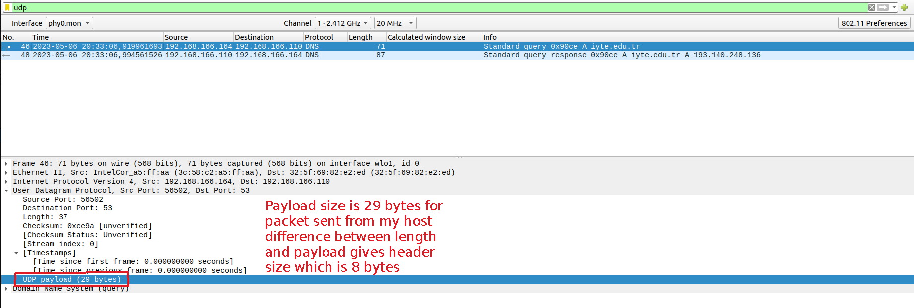Figure 28: Header and Payload size for sent packet
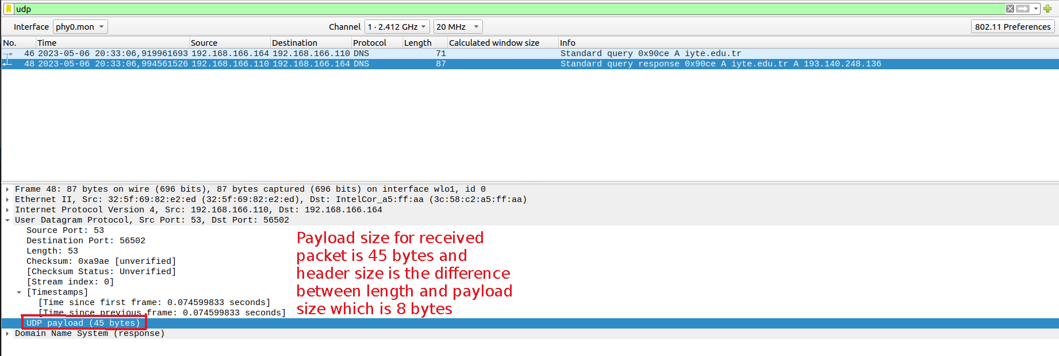Figure 29: Header and Payload size for received packet

-UDP Header Structure-

16 bits 16 bits
Source Port
Destination Port

UDP Header
Length
Checksum

Q4-) Checksum value of the packet sent from my host in hexadecimal

notation is ce9a (1100111010011010 in binary). Checksum value of the

of the packet received as a reply in hexadecimal notation is a9ae

(1010100110101110 in binary). Packets sent via UDP may become

corrupted while transmission. To check whether information is accurate

or not checksum values are used.

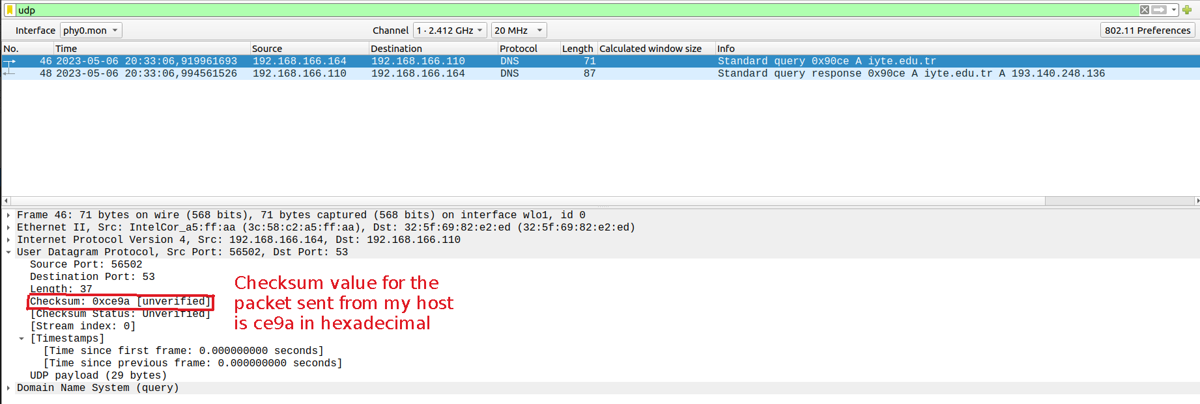Figure 30: Checksum value for the packet sent from my host
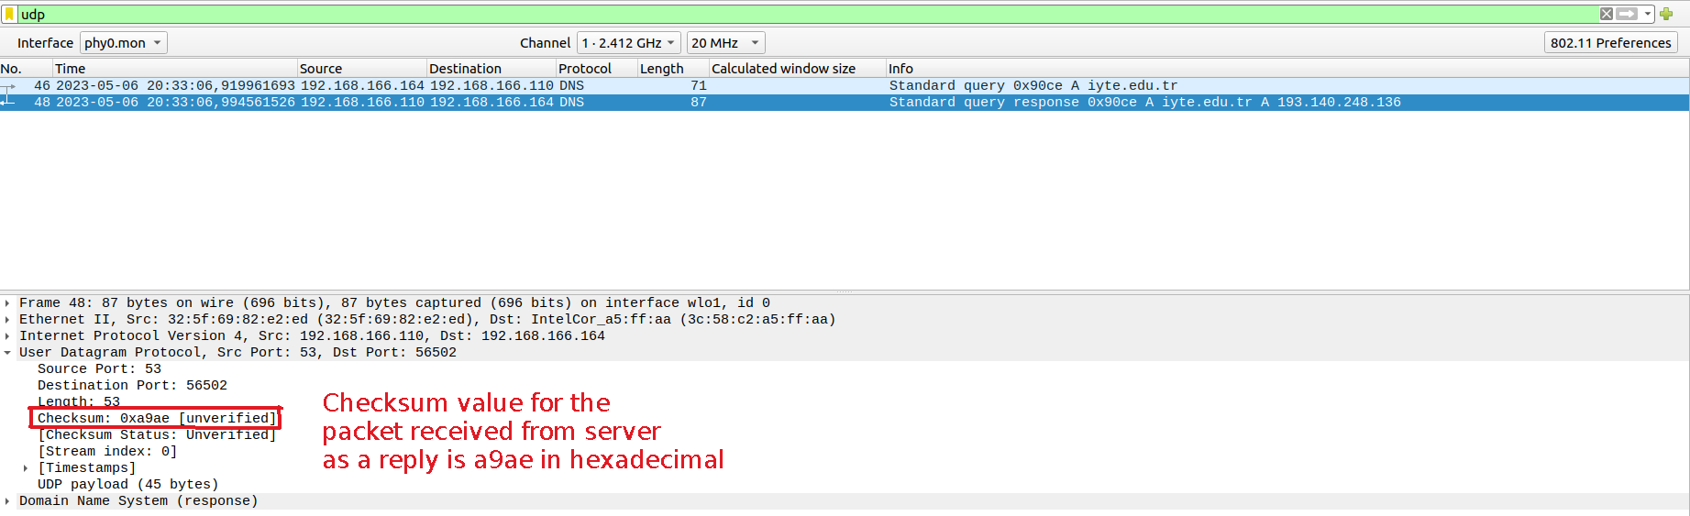Figure 31: Checksum value for the packet received from iyte.edu.tr

