**Vlan oluşturma**

Switch(config)#vlan 10

Switch(config-vlan)#name levo

Switch(config-vlan)#ex

Switch(config)#int fa 0/10

Switch(config-if)#switchport access vlan 10

**Vlan a bağlama**

GOKBERK(config)#int fa 0/21

GOKBERK(config-if)#switchport mode access

GOKBERK(config-if)#switchport access vlan 10

**VTP DOMAİN OLUŞTURMA**

client_01(config)#vtp domain cisco

client_01(config)#vtp mode client

client_01(config)#vtp password network8

client_01#sh vtp status

**SERVER A TRUNK YAPMA**

-client01#sh vtp status

-client01#sh vlan brief

-VTP_SERVER#sh int fa 0/1 switchport

-VTP_SERVER(config)#int fa0/1

VTP_SERVER(config-if)#switchport mode trunk

-VTP_SERVER(config-if)#switchport trunk all

VTP_SERVER(config-if)#switchport trunk allowed vlan 1-99

**RANGE KOMUTU İLE TRUNK YAPMA**

backup(config)# int range fa0/1-2

backup(config-if-range)#switchport mode trunk

backup(config-if-range)#switchport trunk allowed vlan 1-99

**DYNAMIC DESIRABLE YAPMA**

switch1(config)#int fa 0/1

switch1(config-if)#switchport mode dynamic desirable

**ROUTER 1 İÇİN KONFİGÜRASYON VE NEWORK TANITMA**

Router(config)#int fa 0/0

Router(config-if)#ip address 192.168.1.33 255.255.255.224

Router(config-if)#no shutdown

Router(config-if)#int se2/0

Router(config-if)#ip address 192.168.1.65 255.255.255.224

Router(config-if)#no shutdown

Router(config-if)#clock rate 56000

Router(config)#ip route 192.168.1.96 255.255.255.224 192.168.1.66

**ROUTER 2 İÇİN KONFİGÜRASYON VE NEWORK TANITMA**

Router(config)#int fa 0/0

Router(config-if)#ip address 192.168.1.97 255.255.255.224

Router(config-if)#no shutdown

Router(config-if)#int se2/0

Router(config-if)#ip address 192.168.1.66 255.255.255.224

Router(config-if)#no shutdown

Router(config)#ip route 192.168.1.32 255.255.255.224 192.168.1.65

3lü ROUTE YAPMA

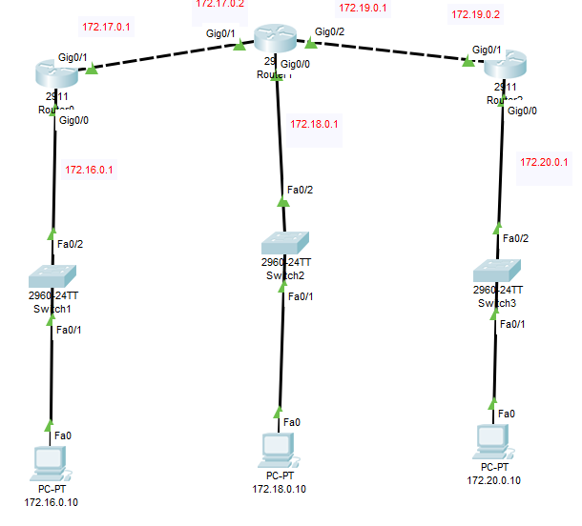

1.ROUTE

ip route 172.18.0.0 255.255.0.0 172.17.0.2

ip route 172.19.0.0 255.255.0.0 172.17.0.2

ip route 172.20.0.0 255.255.0.0 172.17.0.2

2. ROUTE

ip route 172.20.0.0 255.255.0.0 172.19.0.2

ip route 172.16.0.0 255.255.0.0 172.17.0.1

3. ROUTE

ip route 172.18.0.0 255.255.0.0 172.19.0.1

ip route 172.17.0.0 255.255.0.0 172.19.0.1

ip route 172.16.0.0 255.255.0.0 172.19.0.1

İNTER VLAN YAPMA

Switch:

1- VLAN ayarları :

Switch(config)#vlan 10

Switch(config-vlan)#name student

Switch(config-vlan)#vlan 20

Switch(config-vlan)#name faculty

Switch(config-vlan)#vlan 30

Switch(config-vlan)#name admin

2- Trunk ayarları :

Switch(config)#int fa0/1

Switch(config-if)#switchport mode trunk

Switch(config-if)#switchport trunk allowed vlan 1-99

3- Access ayarları :

Switch(config-if)#int fa0/2

Switch(config-if)#switchport mode access

Switch(config-if)#switchport access vlan 10

Switch(config-if)#int fa0/3

Switch(config-if)#switchport mode access

Switch(config-if)#switchport access vlan 20

Switch(config-if)#int fa0/4

Switch(config-if)#switchport mode access

Switch(config-if)#switchport access vlan 30

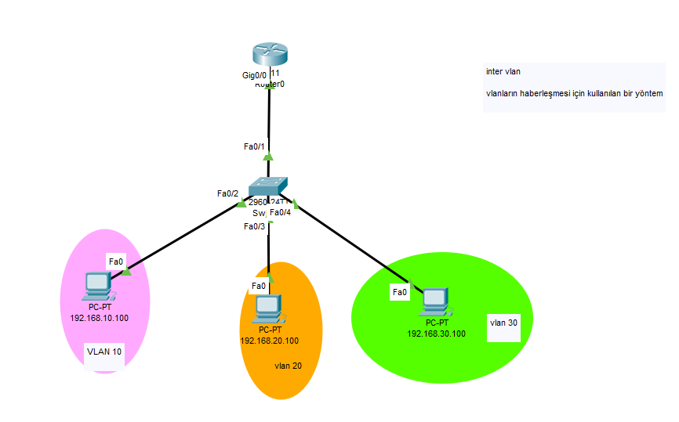

**ROUTER RİP YAPMA**

**VERSİON 1**

Router(config)#router rip

Router(config-router)#network 192.168.1.68

Router(config-router)#no auto-summary

**VERSİON 2**

Router(config)#router rip

Router(config)# version 2

Router(config-router)#network 192.168.1.68

Router(config-router)#no auto-summary

**Bağlantı olup olmadığını control etmek için kullanılır.CMD ortamında yazılır.**

**tracert …. (control edilmek istenilen ip)**

**EIGRP YAPMA**

Router(config)#router eigrp 23800

Router(config-router)#network 172.16.0.0

**REDİSTRİBUTE YAPMA**

**-EIGRP İÇİNDE RİP YAPARKEN**

R2(config)#router eigrp 900

R2(config-router)#redistribute rip metric 10000 10 255 125 1000

**-RİP İÇİNDE EIGRP YAPARKEN**

R2(config)#router rip

R2(config-router)#redistribute eigrp 900 metric 5

**EIGRP STATİK YAPMA**

-Routerda static tanımladıktan sonar bunu yapıyoruz. (Statik : routerın tanımadığı networkleri ve sonraki çıkışı tanımlıyoruz)

-Router(config)#router eigrp 900

-Router(config-router)#redistribute static metric 10000 5 255 100 1000

**OSPF YAPMA**

-**Kaç tane network varsa hepsini tanımlıyosun**

Router(config)#ROUter ospf 5

Router(config-router)#network 172.16.0.0 0.0.255.255 area 1

Router(config-router)#network 172.17.0.0 0.0.255.255 area 1

**REDISTRIBUTE KOMUTLARI**

Router(config)#router ospf 50

Router(config-router)#redistribute eigrp 60 metric 100000 subnets

Router(config-router)#redistribute rip metric 100000 subnets

Router(config)#router eigrp 60

Router(config-router)#redistribute ospf 50 metric 54000 10 255 125 1000

Router(config-router)#redistribute rip metric 54000 10 255 125 1000

Router(config)#router rip

Router(config-router)#redistribute ospf 50 metric 10

Router(config-router)#redistribute eigrp 60 metric 10

**ACL STANDART**

(SOL ROUTER İÇİN)

Router(config)#access-list 1 deny 192.168.2.101 0.0.0.0

Router(config)#access-list 1 permit any

Router(config)#int gig0/0

Router(config-if)#ip access-group 1 out

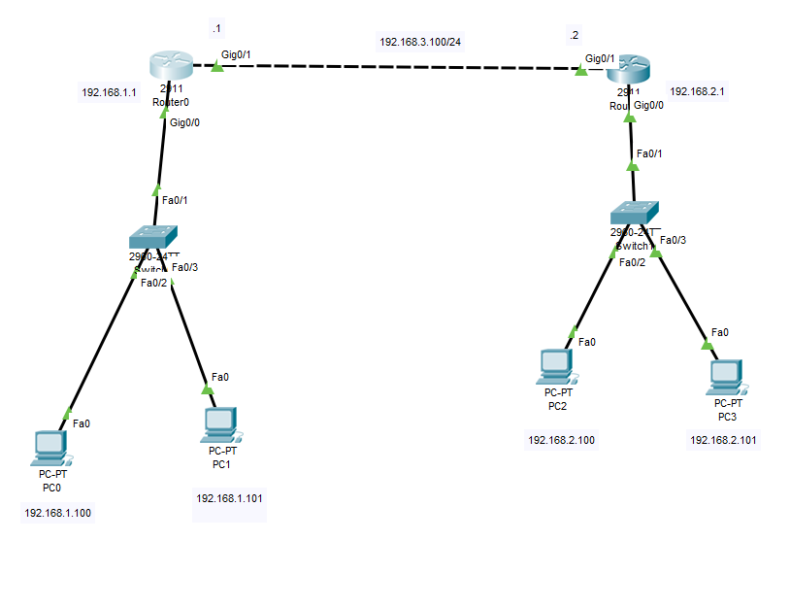

**ACL EXTENDED**

Router(config)#access-list 100 deny ip host 192.168.2.101 192.168.1.0 0.0.0.255

Router(config)#access-list 100 deny ip host 192.168.2.102 192.168.4.0 0.0.0.255

Router(config)#access-list 100 permit ip any any

**PORTLU EXTENDED**

Router(config)#access-list 150 permit tcp 192.168.2.0 0.0.0.255 host 192.168.1.254 eq 80

Router(config)#access-list 150 permit ip 192.168.2.0 0.0.0.255 192.168.4.0 0.0.0.255

Host yazarsan peşine bir cihazın ip gelir.Network tanımlamak istersen host yazamazsın.

Wildmask demek subnetmasktaki 0 VE 1 lerin yer değiştirmesi demek.0 1 olacak 1 0 olacak

**ACL EXTENDED İSİM VERME**

ip access-list extended WEB

permit tcp 192.168.2.0 0.0.0.255 host 192.168.1.254 eq www

permit ip 192.168.2.0 0.0.0.255 192.168.4.0 0.0.0.255

interface GigabitEthernet0/0

ip address 192.168.2.1 255.255.255.0

ip access-group WEB in

**DIŞARIDAN İÇERİYE TERSTEN TANIM**

access-list 100 permit tcp any eq www 192.168.1.0 0.0.0.255

access-list 100 permit tcp any eq 443 192.168.1.0 0.0.0.255

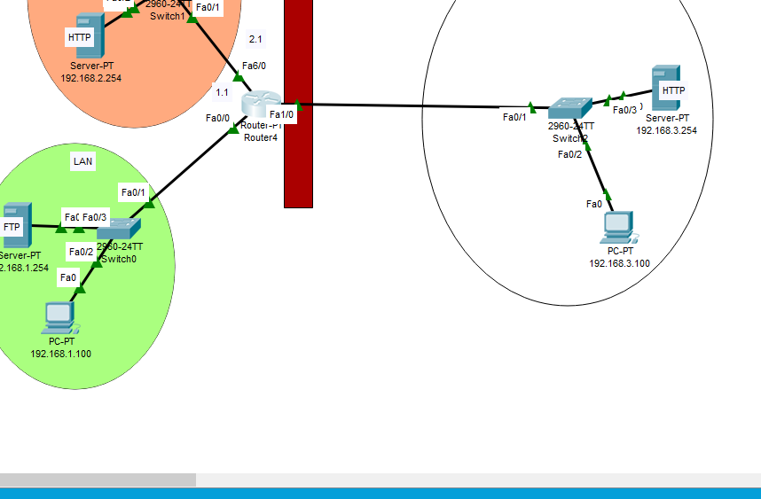

Burada , normalde source kısmı 192.168.3.0 networkü iken yukardaki kodda source 192.168.1.0 networkü oldu.

İki durumda da ‘in’ yaptığımız bacak fa1/0 bacağı olduğundan yuardaki kodda ‘eq ‘ yerleri ters vaziyettedir.

**NAT**

Router(config)#int fa0/0

Router(config-if)#ip nat outside

Router(config-if)#int fa1/0

Router(config-if)#ip nat inside

ip nat inside SOurce static 10.0.0.250 209.165.100.30 (önce server ıp sonra global ıp yazdık)

**PORTLU HALİ**

ip nat inside source static tcp 10.0.0.250 80 209.165.100.30 80

**NAT-OVERLOAD**

Router(config)#access-list 10 permit 10.0.0.0 0.0.0.255

Router(config)#ip nat inside source list 10 interface fa0/0 overload

**DYNAMİC NAT**

Router(config)#int fa1/0

Router(config-if)#ip nat outside

Router(config-if)#int fa0/0

Router(config-if)#ip nat inside

Router(config)#access-list 15 permit 192.168.1.0 0.0.0.255

Router(config)#ip nat pool MYPOOL 209.165.100.17 209.165.100.28 NETmask 255.255.255.0

Router(config)#ip nat inside source list 15 pool MYPOOL overload

**DHCP**

Router(config)#ip dhcp excluded-address 192.168.1.1 192.168.1.50

1ile 50 arasını router kolları için ayırdık

Router(config)#ip dhcp pool HAVUZ

Router(dhcp-config)#network 192.168.1.0 255.255.255.0

Router(dhcp-config)#default-router 192.168.1.1

Router ın ayağı belirlenir.

Router(dhcp-config)#dns-server 8.8.4.4

Router(config)#ip dhcp excluded-address 192.168.110.1

Router(config-if)#ip helper-address 192.168.1.200

**ÖRNEK**

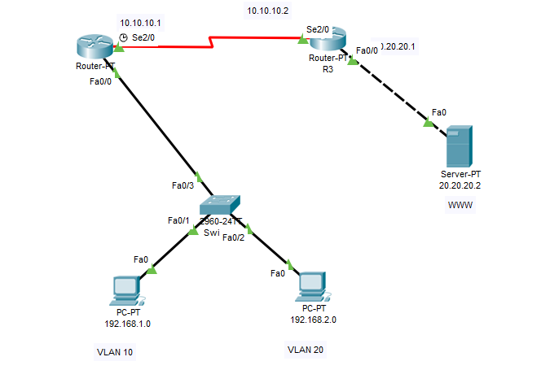

**SORULAR**

1) VLAN lara DHCP ile IP ayrı ayrı IP dağıtımı yapılsın.

2) VLAN ların dışarıya erişimleri sadece 80 ve 443 ile olsun.

3) İnternete çıkış NAT ile olsun.

4) Dışarıdan içeriye girişler de NAT ile olsun.

5) Routing için OSPF kullanılsın.

6) Cisco cihazlar SSH erişimine açılsın.

**1) R2 İÇİN**

hostname R2

ip dhcp excluded-address 192.168.1.1 192.168.1.50

ip dhcp excluded-address 192.168.2.1 192.168.2.50

ip dhcp pool WISSEN

network 192.168.1.0 255.255.255.0

default-router 192.168.1.1

ip dhcp pool WISSEN2

network 192.168.2.0 255.255.255.0

default-router 192.168.2.1

interface FastEthernet0/0.10

encapsulation dot1Q 10

ip address 192.168.1.1 255.255.255.0

ip nat inside

interface FastEthernet0/0.20

encapsulation dot1Q 20

ip address 192.168.2.1 255.255.255.0

ip nat inside

interface Serial2/0

ip address 10.10.10.1 255.0.0.0

ip access-group 150 out

ip nat outside

clock rate 2000000

router ospf 3

log-adjacency-changes

network 192.168.1.0 0.0.0.255 area 4

network 10.0.0.0 0.255.255.255 area 4

network 192.168.2.0 0.0.0.255 area 4

ip nat inside source list 100 interface Serial2/0 overload

access-list 150 permit tcp any 10.0.0.0 0.255.255.255 eq www

access-list 100 permit ip any 10.0.0.0 0.255.255.255

**2) R3 İÇİN**

R3#sh run

interface FastEthernet0/0

ip address 20.20.20.1 255.0.0.0

ip nat inside

duplex auto

speed auto

interface Serial2/0

ip address 10.10.10.2 255.0.0.0

ip nat outside

router ospf 3

log-adjacency-changes

network 10.0.0.0 0.255.255.255 area 4

network 20.0.0.0 0.255.255.255 area 4

ip nat inside source static 20.20.20.2 10.10.10.2

**3) SWİTCH İÇİN**

Switch#sh run

interface FastEthernet0/1

switchport access vlan 10

interface FastEthernet0/2

switchport access vlan 20

interface FastEthernet0/3

switchport mode trunk

Switch(config-if)#switchport trunk allowed vlan 1-99