Incident Response and Business Continuity Policy
Paylode Services Limited · CBN-licensed Payment Solution Service Provider
Prepared for: Alpha Morgan Bank — Information Security Division
Assessment reference: AMB-ISO-VRQ-019 · Classification: CONFIDENTIAL
Document ID | PSL-EV-02
Version | 1.0
Policy owner | [ ]
Approved by | [ ], Director
Date of approval | [ ]
Review cycle | Annually, or on material change
Addresses questionnaire items | 11.1–11.6, 12.1–12.7, 10.5, 10.6

PART A — INCIDENT RESPONSE

1. Scope
Any event that compromises, or credibly threatens, the confidentiality, integrity
or availability of Paylode systems or data — including data processed on behalf of
Alpha Morgan Bank, its customers, or Paylode's merchants.

2. Guiding principle
No response action may create a risk of double-payment or lost funds. A delayed
payment is recoverable; a duplicated one may not be. Where a containment action and
a settlement action conflict, containment proceeds and settlement is suspended
until reconciliation is complete.

3. Severity, escalation and notification
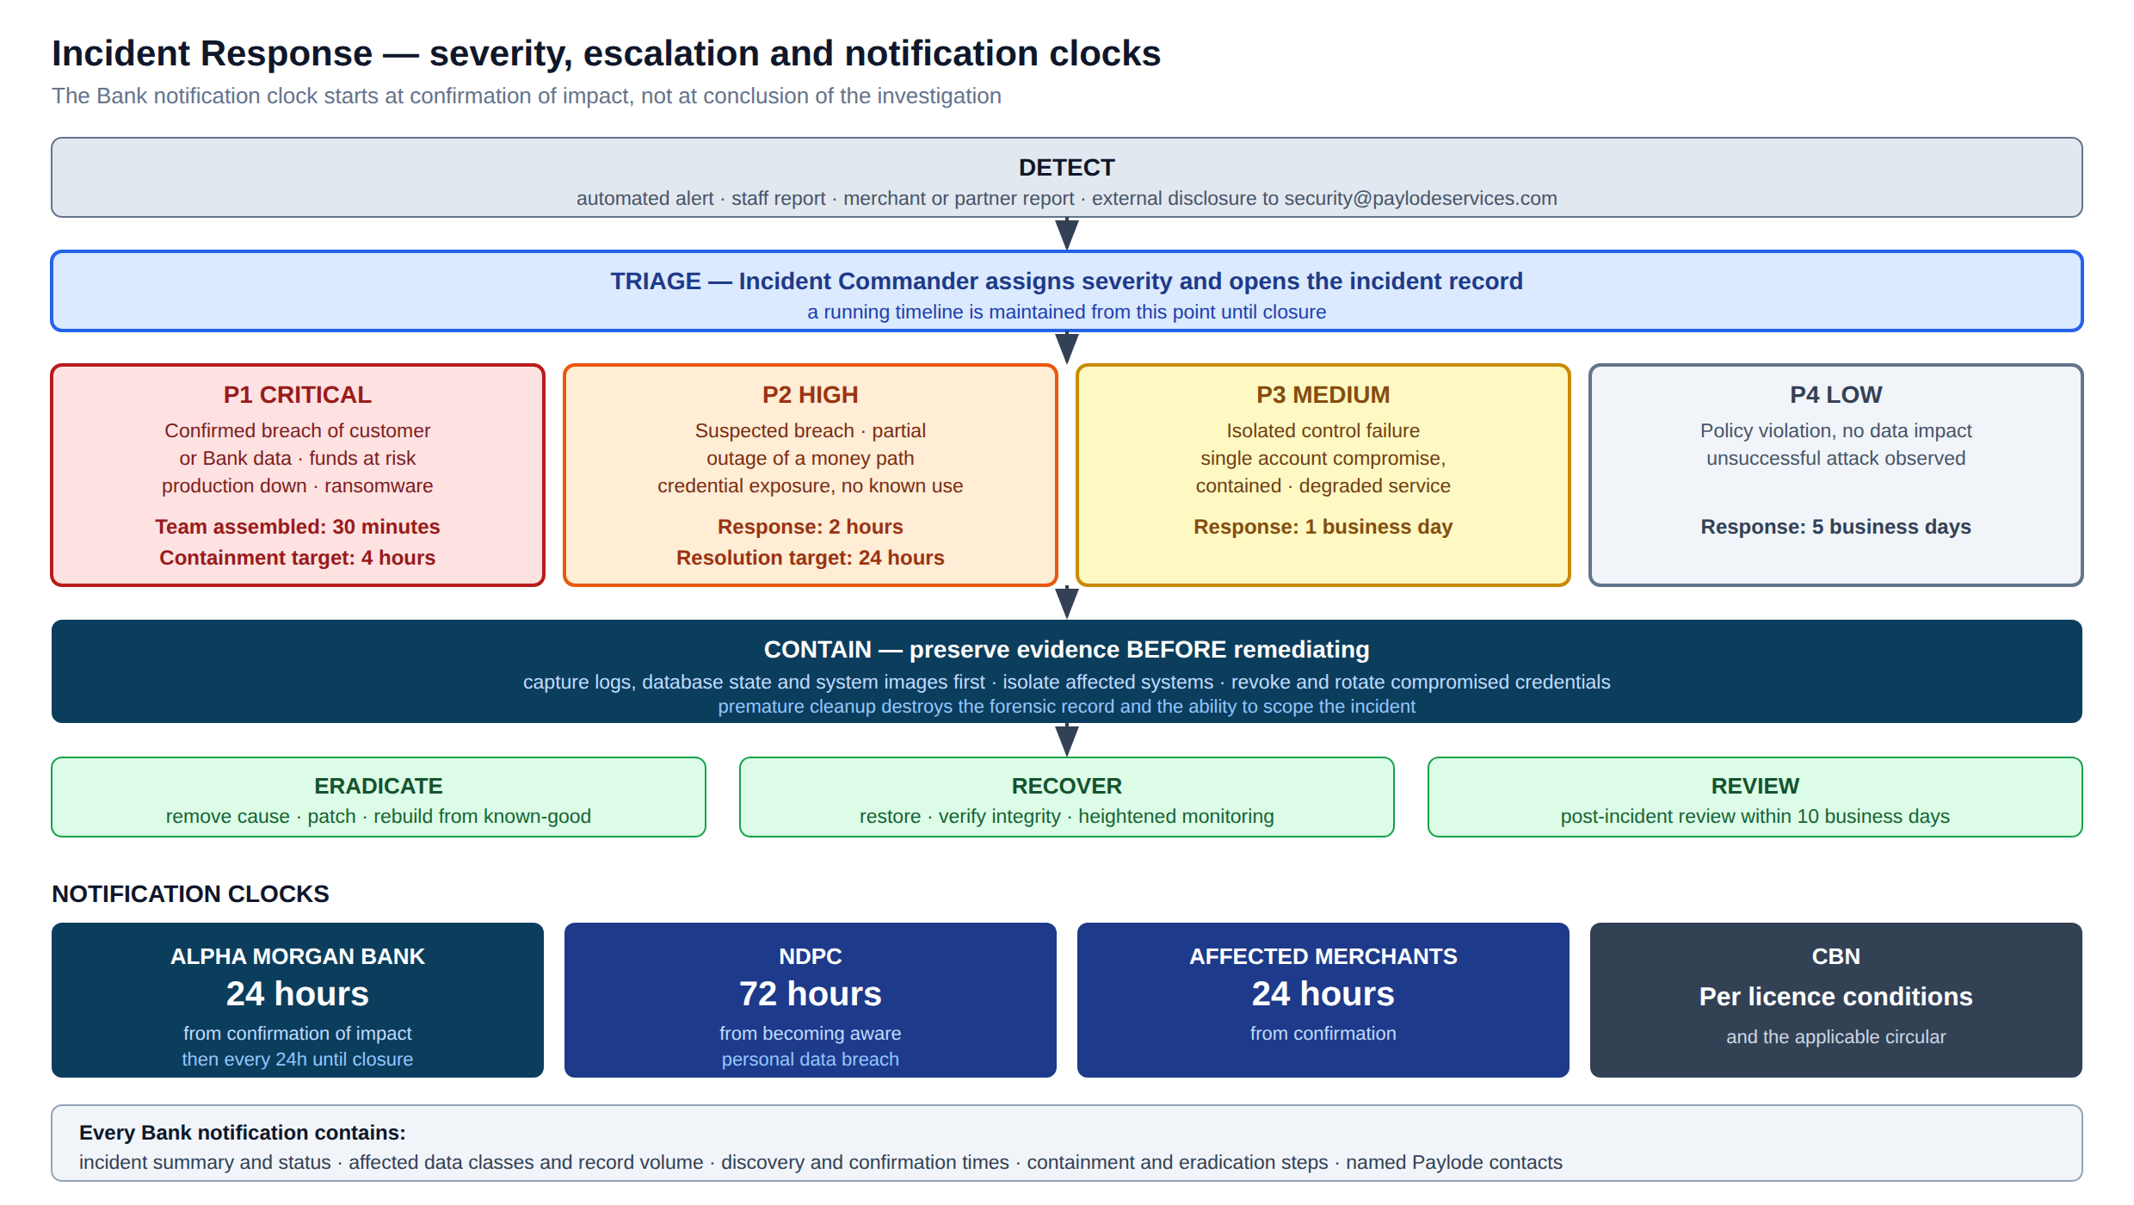
Figure 1 — Incident severity bands, the response lifecycle, and the notification clocks that run from confirmation of impact.

4. Response team
Role | Responsibility | Holder
Incident Commander | Owns the incident; declares severity; authorises containment; single decision-maker | [ ]
Technical lead | Investigation, containment, eradication, recovery | [ ]
Compliance / Data Protection Officer | Regulatory notification to CBN and NDPC; record-keeping | [ ]
Communications | Bank, merchant and customer notification | [ ]
Executive sponsor | Director-level decisions: service suspension, external counsel, law enforcement | [ ]

4.1 Incident contact card — to be shared with the Bank
Role | Name | Title | Mobile (24/7) | Email
Primary security incident contact | [ ] | [ ] | [ ] | security@paylodeservices.com
Secondary / escalation | [ ] | [ ] | [ ] | [ ]
Executive escalation | [ ] | Director | [ ] | [ ]
Data protection contact | [ ] | DPO | [ ] | dpo@paylodeservices.com

*The security@ and dpo@ mailboxes must be live and monitored before this card is
issued to the Bank.*

5. Response lifecycle
- Detect — automated alert, staff report, merchant or partner report, or
external disclosure.
- Triage — the Incident Commander assigns severity within the band's response
window and opens the incident record. A running timeline is maintained from this
point until closure.
- Contain — isolate affected systems; revoke or rotate compromised credentials;
suspend affected merchant accounts, rails or API keys. **Preserve evidence
before remediating** — capture logs, database state and system images first.
Premature cleanup destroys the forensic record and the ability to scope the
incident.
- Eradicate — remove the cause; patch; rebuild from a known-good state.
- Recover — restore service; verify integrity; monitor at heightened
sensitivity for a defined period.
- Notify — per section 6.
- Review — post-incident review within 10 business days (Appendix A).

6. Notification obligations
Recipient | Trigger | Deadline
Alpha Morgan Bank | Confirmed impact to Bank data or the Bank-connected service | 24 hours from confirmation, then every 24 hours until closure
Nigeria Data Protection Commission | Personal data breach | 72 hours from becoming aware
Central Bank of Nigeria | Per licence conditions and the applicable cybersecurity circular | As prescribed
Affected data subjects | High risk to their rights and freedoms | Without undue delay
Affected merchants | Their data or funds affected | 24 hours from confirmation

Every notification to the Bank contains, at minimum:
- incident summary and current status;
- affected data classes and estimated record volume;
- time of discovery and time of confirmation;
- containment and eradication steps taken and planned;
- named Paylode points of contact for the Bank's incident team.
Paylode notifies the Bank **regardless of whether the regulator's 72-hour threshold
is met**. The Bank's contractual clock is shorter than the regulator's, and it runs
from confirmation of impact rather than from conclusion of the investigation.

7. Playbooks

7.1 Credential exposure
- Identify every credential exposed and its blast radius.
- Rotate all of them immediately — do not assess likelihood of use first.
- Review access logs across the exposure window for use by an unrecognised source.
- Purge from the exposure vector (repository history, log, message, document).
- If evidence of use exists, escalate to P1 and treat as a breach.
- Add the detective control that would have caught it.

7.2 Data breach
- Contain — revoke access, isolate the system, preserve evidence.
- Scope — what data, whose, how many records, over what window.
- Notify per section 6. The Bank clock starts at confirmation.
- Support affected parties; remediate the root cause.

7.3 Ransomware
- Isolate affected hosts from the network immediately.
- Do not pay. Engage the executive sponsor and external counsel.
- Restore from verified clean off-site backup (Part B, section 9).
- Rebuild rather than clean; rotate every credential the host could reach.
- Report to the CBN and to law enforcement.

7.4 Insider threat
- Preserve the audit trail before acting — the audit log holds actor, before and
after state, and source IP for every privileged action.
- Suspend access without notice to the subject.
- Engage HR, the executive sponsor and legal counsel before any confrontation.
- Assess exfiltration; notify per section 6 if confirmed.

7.5 Payment rail or Bank integration compromise
- Disable the affected rail. Routing excludes it automatically and disbursement
continues on other rails.
- Reconcile every in-flight instruction before resuming. Never re-send an
instruction whose outcome is unknown — re-query it.
- Notify the Bank or rail partner and agree a joint reconciliation.
- Resume only once end-to-end reconciliation balances.

7.6 Production outage
- Confirm through the health endpoints.
- Identify the failing component; a failed module degrades rather than kills the
platform.
- Roll back from the timestamped deploy backup if a deployment is implicated.
- Invoke Part B if recovery will exceed the recovery time objective.

8. Detection and response targets
Metric | Target
Mean time to detect — payment or settlement anomaly | 5 minutes (met today by the payout watchdogs)
Mean time to detect — critical security event | 1 hour
Mean time to respond — P1 containment | 4 hours
Mean time to respond — P2 | 24 hours
Bank notification after confirmation | 24 hours
Scoped log extract to the Bank on request | 4 business hours; 1 business hour during a live incident

9. Exercising
A tabletop exercise or live simulation is conducted at least annually against at
least one playbook, producing a written after-action report that identifies what
worked, what did not, and dated remedial actions with named owners.
Exercise | Date | Playbook | After-action report
[ ] | [ ] | [ ] | [ ]

PART B — BUSINESS CONTINUITY AND DISASTER RECOVERY

10. Objective
To maintain, or restore within agreed time limits, the services Paylode provides to
its merchants and to its bank partners, with priority on **money-movement
integrity** over speed of restoration.

11. Business impact analysis
Service | Criticality | Maximum tolerable outage | Impact of outage
Payout dispatch | Critical | 4 hours | Merchants cannot disburse; beneficiaries unpaid
Collection webhook ingestion | Critical | 1 hour | Credits unrecorded; reconciliation exposure grows with the outage
Settlement processing | Critical | 24 hours | Merchants unfunded; cycle slips
Hosted checkout | High | 4 hours | Merchants cannot collect card payments
Merchant dashboard | Medium | 24 hours | No self-service; operations can act on merchants' behalf
Invoicing / wallet / assistant | Medium | 24 hours | Product features degraded; payments unaffected
Marketing site | Low | 72 hours | Reputational only

Collection webhook ingestion carries the shortest tolerance because a missed
notification is not merely a delay — it is an unrecorded credit that must later
be reconciled against the Bank's records.

12. Continuity capability
Capability | Mechanism
Process redundancy | The money core runs as a clustered pair with automatic restart
Service isolation | A product-service failure cannot stop payments
Graceful degradation | A failed module is reported at the health endpoint; the platform continues
Multi-rail failover | Payout routing automatically excludes any rail not marked live — a single rail outage, including the Bank's, does not stop disbursement
Deploy rollback | Every deployment retains the previous version of each overwritten file, timestamped, on the target host
Self-healing money paths | Dispatch recovery every 30 seconds; stuck-batch monitor and status re-query every 5 minutes
Static-content failover | The application host is configured as a Cloudflare failover origin and is refreshed on every release

13. Recovery objectives
Scenario | Objective
Single process crash | Seconds — automatic restart, cluster peer serves
Product-service failure | No payment impact
One payment rail unavailable | Immediate automatic re-route
Web tier host loss | Minutes — failover origin serves static content; the API is unaffected
Application host loss | RTO ≤ 4 hours · RPO ≤ 15 minutes
Data corruption or ransomware | RPO ≤ 24 hours from encrypted off-site backup
Region or provider loss | RTO ≤ 24 hours

*The objectives for application-host loss and data corruption depend on the standby
and backup capability described in sections 14 and 15. Current attainment against
each objective is to be recorded by Paylode below.*
Objective | Current attainment | Evidence
Application host loss — RTO 4h / RPO 15min | [ ] | [ ]
Data corruption — RPO 24h | [ ] | [ ]

14. Target site topology
The standby host sits in a separate region from the primary, carrying a
PostgreSQL streaming replica and a warm application stack. Replication traverses an
encrypted tunnel. Encrypted off-site backups are held on infrastructure independent
of both production hosts.

15. Backup standard
Property | Requirement
Scope | Full PostgreSQL dump; application, nginx and process-manager configuration; key custody records
Frequency | Nightly full, plus continuous write-ahead-log archiving once replication is in place
Encryption | Encrypted at rest, with the key held separately from the backup store
Location | Off-site, independent of both production hosts
Retention | 30 daily, 12 weekly, 12 monthly
Access | Restricted to two named individuals; access logged
Immutability | Write-once or object-lock storage, so ransomware cannot reach the backups
Restore testing | Quarterly, to an isolated environment, with row counts and ledger integrity verified and the result recorded

An untested backup is not a backup. The quarterly restore test, not the
existence of a dump file, is the control.
Restore test | Date | Performed by | Result
[ ] | [ ] | [ ] | [ ]

16. Disaster recovery procedure
- Declare — the Incident Commander or a director declares a disaster and
notifies the response team and affected bank partners.
- Assess — determine scope and whether data integrity is affected.
- Recover — promote the standby, or rebuild and restore the most recent
verified backup.
- Reconcile before resuming money movement. This step is mandatory and is
never skipped for speed. Reconcile every in-flight payout and collection against
the rail's and the Bank's records. Re-query, never re-send.
- Resume — restore service under heightened monitoring.
- Notify — inform merchants and bank partners of restoration and of any
transaction requiring their action.
- Review — post-incident review within 10 business days.

17. Testing schedule
Test | Cadence | Last performed
Backup restore verification | Quarterly | [ ]
Failover to standby | Annually | [ ]
Full DR simulation with the response team | Annually | [ ]
Rail failover verification | Semi-annually | [ ]

18. Capacity and demand management
Paylode forecasts payout float requirements daily from actual destination-bank
demand over a rolling history window, and pre-funds each rail accordingly. Per-rail
transactions-per-second limits and daily value caps prevent partner overload. Rail
float is polled continuously with low-balance alerting.
Documented headroom thresholds for compute, memory, disk and database connections,
and load testing against the projected peak, are maintained by the technical lead.

19. Service level commitment
Term | Commitment
Monthly uptime, Bank-facing collection and payout APIs | [ ] %
Measurement | Health probes at 1-minute intervals from an independent monitor, excluding scheduled maintenance
Scheduled maintenance | Notified 5 business days in advance; performed 00:00–04:00 WAT; capped at 4 hours per month
Service credits | [ ]
Reporting | Monthly availability report to the Bank

20. Crisis communication
Audience | Channel | Owner | Timing
Bank partners | Direct to the named contact | Incident Commander | Within 1 hour of declaration
Merchants | Email and dashboard banner | Operations | Within 2 hours
Staff | Internal channel | Incident Commander | Immediately
CBN | Per licence conditions | Compliance | As prescribed
Public | Status page | Communications | As material

Appendix A — Post-incident review template
Incident identifier · severity · detection time · containment time · resolution
time · timeline of events · root cause analysis · data and funds impacted · parties
notified and when · what worked · what did not · remedial actions with owners and
dates · lessons recorded in the risk register.

Document control
Field | Value
Prepared by | [ ]
Reviewed by | [ ]
Approved by | [ ]
Signature | [ ]
Date of issue | [ ]
Next review | [ ]

