**MACHINE LEARNING WITH PYTHON**

A Project Report Submitted to the Bharathidasan University in partial

fulfillment of requirement for the award of the degree of

**BACHELOR OF COMPUTER SCIENCE**

Under the guidance of

**Dr. K. ELANGOVAN, M.Sc., M.Phil., Ph.D**

Guest Lecturer



**DEPARTMENT OF COMPUTER SCIENCE**

**GOVERNMENT ARTS AND SCIENCE COLLEGE (Co-Ed),**

(Affiliated to Barathidasan University)

**THARAGAMPATTI-621 311.**

**APRIL -2023**

PROJECT REPORT

**Thyroid disease classification using ML**

**Team Leader** - Manjula K

**Team Member**  - Devika M

## Team Member - Gokiladevi P

## Team Member - Nanmaran S

**PROJECT REPORT**



|  |  |
| --- | --- |
| Team ID | NM2023TMID21821 |
| Project Name | Thyroid disease classification using ML |
| Maximum Marks | 5 Marks |

The Thyroid gland is a vascular gland and one of the most important organs of the human body. This gland secretes two hormones which help in controlling the metabolism of the body.

The two types of Thyroid disorders are Hyperthyroidism and Hypothyroidism. When this disorder occurs in the body, they release certain types of hormones into the body which imbalances the body’s metabolism. A thyroid-related Blood test is used to detect this disease but it is often blurred and noise will be present. Data cleansing methods were used to make the data primitive enough for the analytics to show the risk of patients getting this disease. Machine Learning plays a very deciding role in disease prediction. Machine Learning algorithms, SVM - support vector machine, Random Forest Classifier, XGB Classifier and ANN - Artificial Neural Networks are used to predict the patient’s risk of getting thyroid disease. The web app is created to get data from users to predict the type of disease.

# INDEX



|  |  |  |
| --- | --- | --- |
| **CHAPTER**  **NO** | **TITLE** | **PAGE.NO** |
| 1 | **INTRODUCTION**   * 1. Overview A brief description about your project   2. Purpose The use of this project. What can be achieved using this. | 1 |
| 2 | **PROBLEM DEFINITION & DESIGN THINKING**   * 1. Empathy Map Paste the empathy map screenshot   2. Ideation & Brainstorming Map Paste the Ideation & brainstorming map screenshot | 2 |
| 3 | **RESULT**  Final findings (output) of the project along with screenshots. | 3 |
| 4 | **ADVANTAGES & DISADVANTAGES**  List of advantages and disadvantages of the proposed solution |  |
| 5 | **APPLICATIONS**  The areas where this solution can be applied |  |

|  |  |  |
| --- | --- | --- |
| 6 | **CONCLUSION**  Conclusion summarizing the entire work and findings. |  |
| 7 | **FUTURE SCOPE**  Enhancements that can be made in the future. |  |
| 8 | **APPENDIX**   1. Source Code 2. Attach the code for the solution built |  |



**INTRODUCTION**



## OVERVIEW A BRIEF DESCRIPTION ABOUT YOUR PROJECT:

The Thyroid gland is a vascular gland and one of the most important organs of the human body. This gland secretes two hormones which help in controlling the metabolism of the body.

The two types of Thyroid disorders are Hyperthyroidism and Hypothyroidism. When this disorder occurs in the body, they release certain types of hormones into the body which imbalances the body’s metabolism. A thyroid-related Blood test is used to detect this disease but it is often blurred and noise will be present. Data cleansing methods were used to make the data primitive enough for the analytics to show the risk of patients getting this disease. Machine Learning plays a very deciding role in disease prediction. Machine Learning algorithms, SVM - support vector machine, Random Forest Classifier, XGB Classifier and ANN - Artificial Neural Networks are used to predict the patient’s risk of getting thyroid disease. The web app is created to get data from users to predict the type of disease.

## PURPOSE THE USE OF THIS PROJECT. WHAT CAN BE ACHIEVED USING THIS:

The business requirements for a machine learning model to predict thyroid disease include the ability to accurately predict thyroid disease based on the scan results, Minimise the number of false positives (wrong thyroid disease confirmations) and false negatives (thyroid is there but got as not thyroid disease). Provide an explanation for the model's decision, to comply with regulations and improve transparency. Thyroid conditions are difficult to detect in test results, and only trained professionals can do so. However, reading such extensive reports and predicting future results is difficult. Assume a machine learning model can detect the thyroid disease in a patient. The thyroid disease can then be easily identified based on the symptoms in the patient’s history. Currently, models are evaluated using accuracy metrics on a validation dataset that is accessible.

# PROBLEM DEFINITION & DESIGN THINKING



## EMPATHY MAP PASTE THE EMPATHY MAP SCREENSHOT:

Use this framework to develop a deep, shared understanding and empathy for

other people. An empathy map helps describe the aspects of a user's experience, needs and pain points, to quickly understand your users’ experience and mindset.

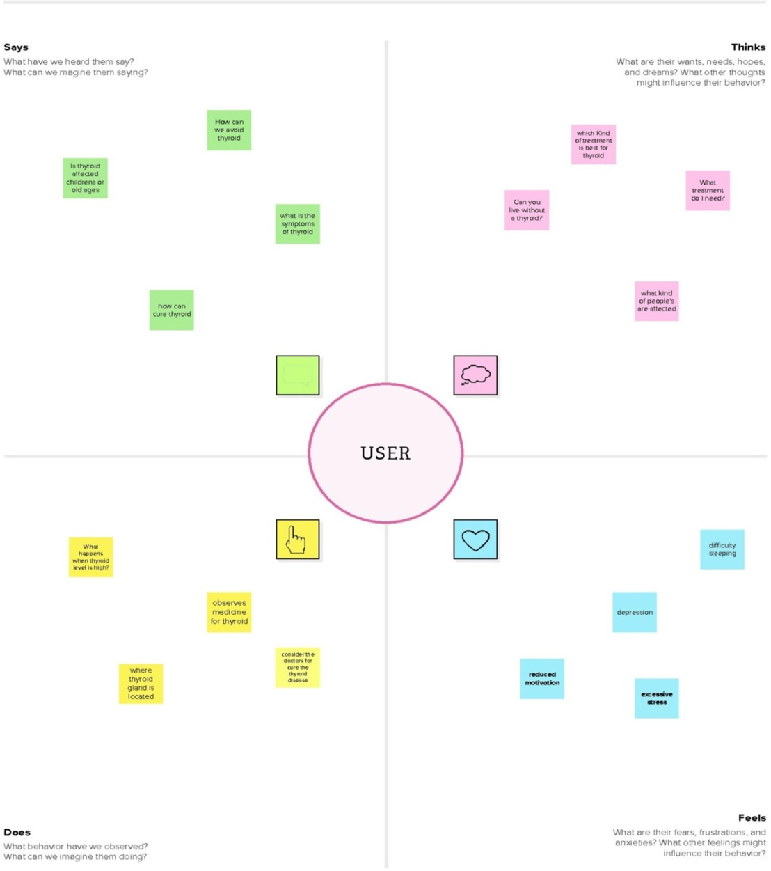

## IDEATION & BRAINSTORMING MAP PASTE THE IDEATION & BRAINSTORMING MAP SCREENSHOT:



Use this template in your own brainstorming sessions so your team can unleash their imagination and start shaping concepts even if you're not sitting in the same room.

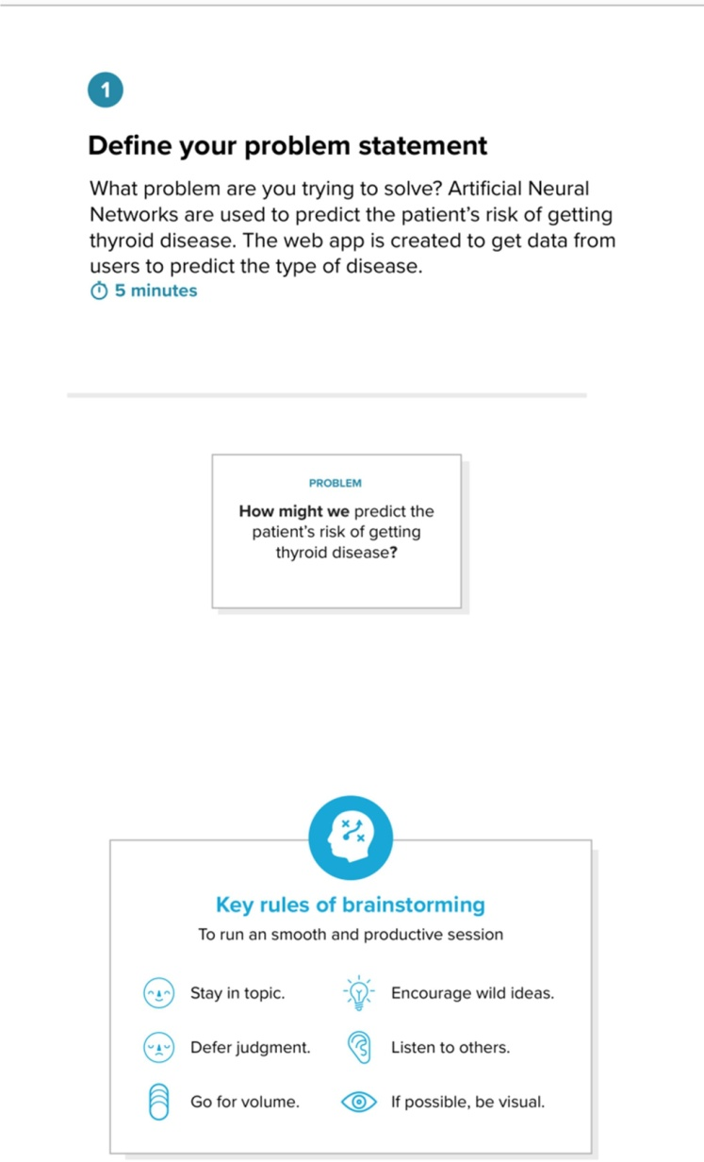



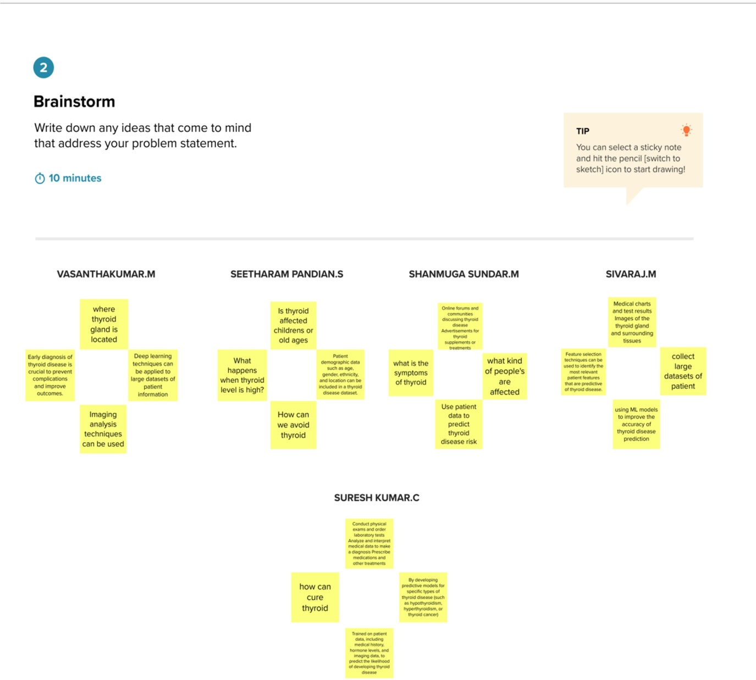

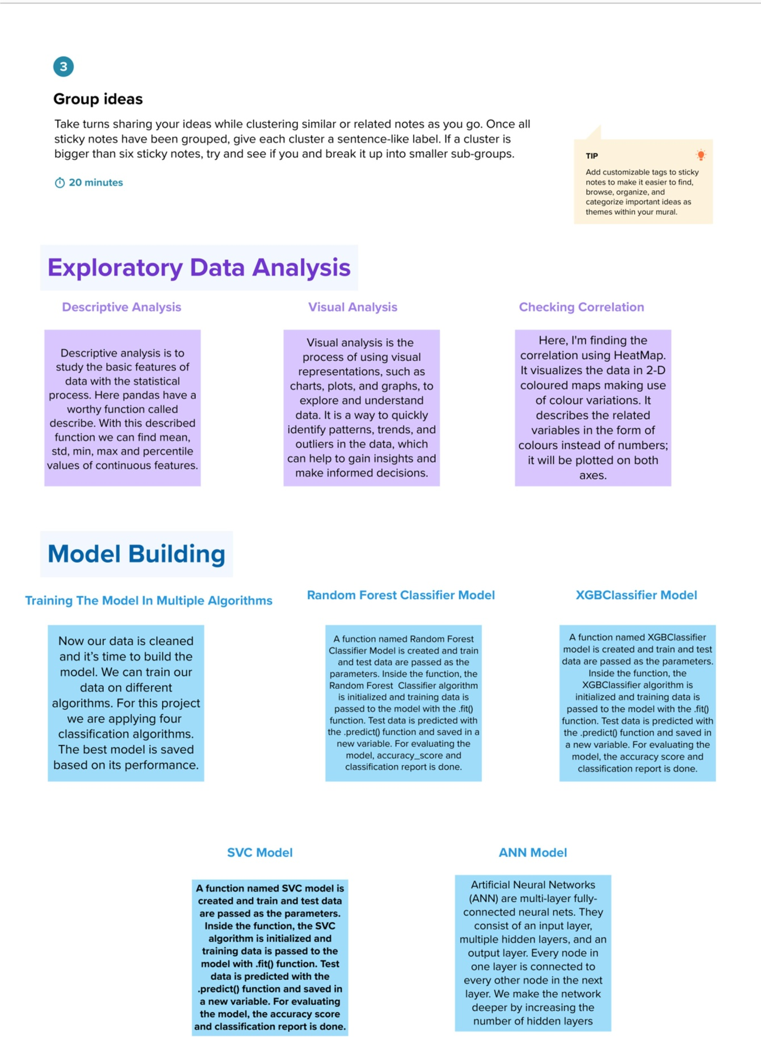



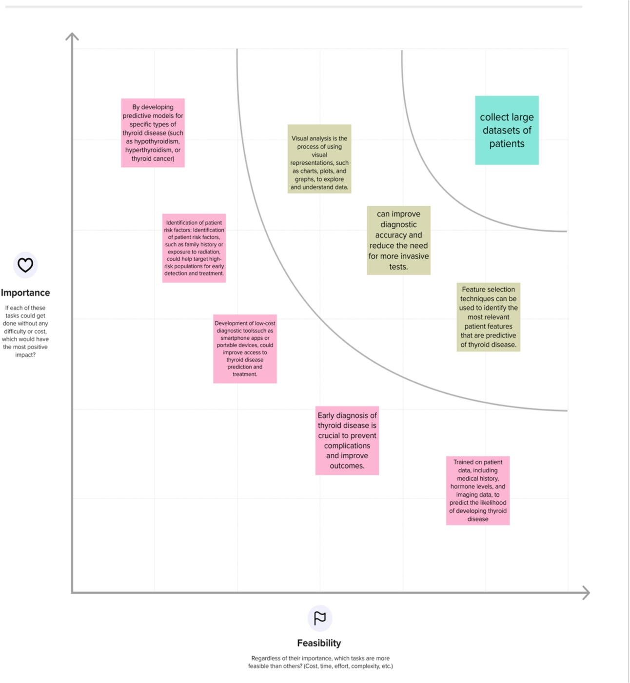

# RESULT



## FINAL FINDINGS (OUTPUT) OF THE PROJECT ALONG WITH SCREENSHOTS:

**HOME PAGE:**

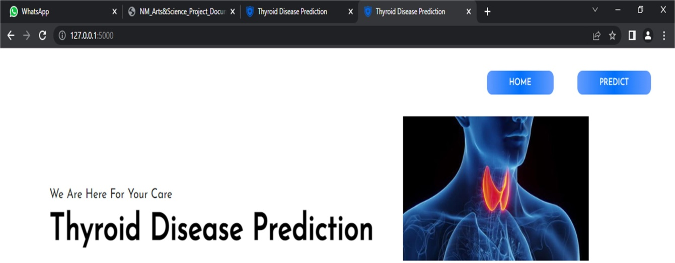

## PREDICTION FORM:



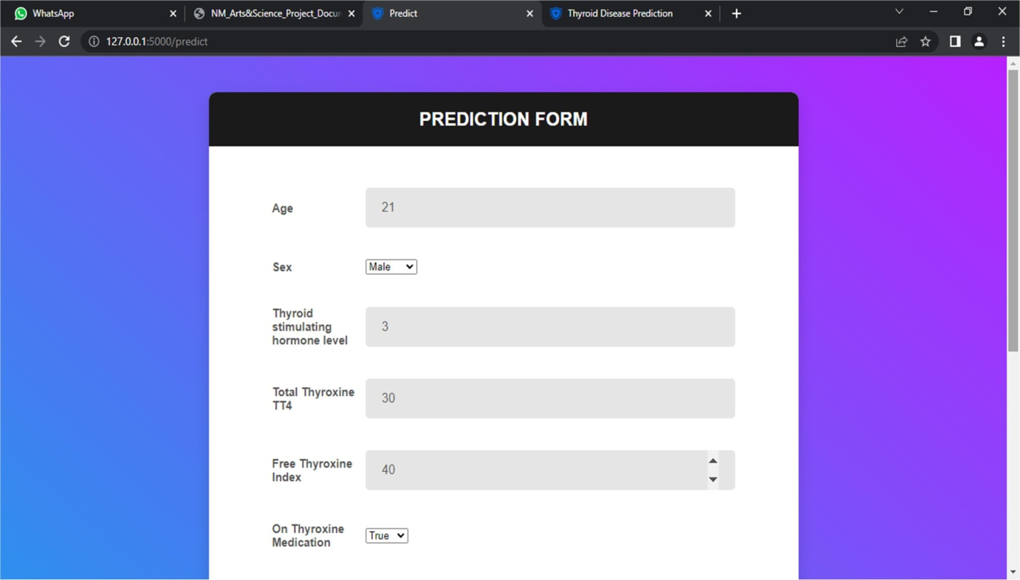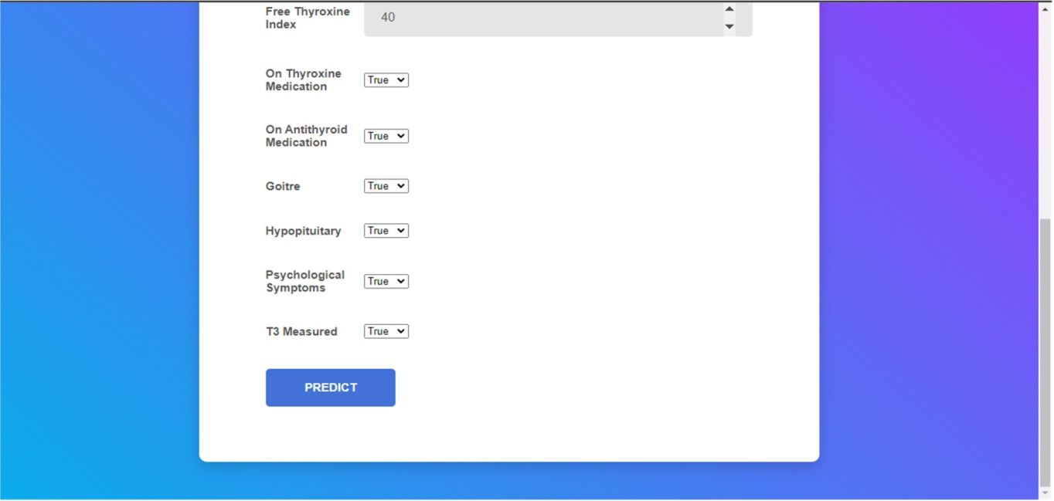

**PREDICTION RESULT:**



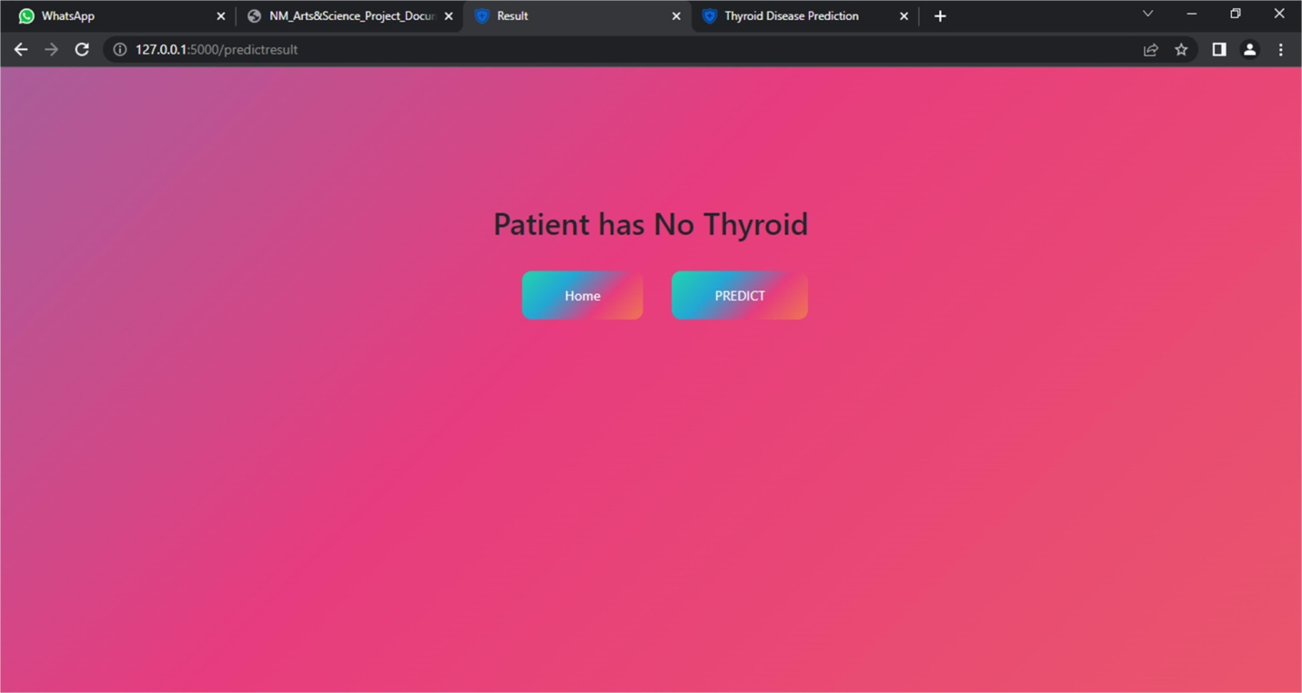

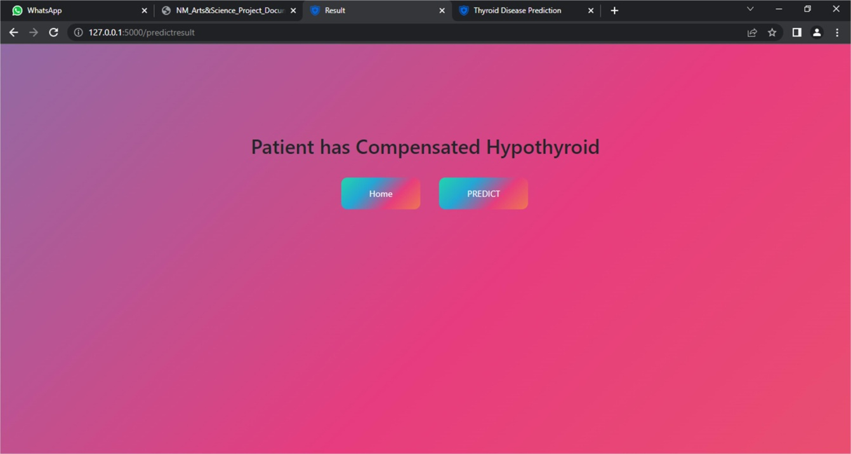

# ADVANTAGES & DISADVANTAGES



## LIST OF ADVANTAGES AND DISADVANTAGES OF THE PROPOSED SOLUTION

Thyroid prediction, also known as thyroid disease risk prediction, is a process that uses various factors to estimate an individual's likelihood of developing thyroid disease in the future. Here are some advantages and disadvantages of thyroid prediction:

## ADVANTAGES:

* Early detection: Thyroid prediction can help in the early detection of thyroid disease, enabling early treatment and management, which can improve the prognosis of the disease.
* Personalized approach: Thyroid prediction takes into account an individual's unique factors, such as family history, age, and sex, providing a personalized approach to disease prediction and management.
* Cost-effective: Predicting an individual's risk of thyroid disease can help to optimize healthcare resources and reduce healthcare costs, as individuals at high risk can be identified and targeted for screening and preventive measures.
* Improved diagnosis: Thyroid classification can help healthcare providers make a more accurate diagnosis of thyroid disorders. By identifying the specific type of thyroid disorder, providers can tailor the treatment plan to address the underlying cause and improve patient outcomes.
* Enhanced treatment strategies: The classification of thyroid disorders can help identify the most appropriate treatment strategy for each patient. For example, some types of thyroid disorders may respond better to medications, while others may require surgery or radiation therapy.
* Better monitoring of disease progression: By classifying thyroid disorders, healthcare providers can track the progression of the disease and monitor the effectiveness of treatment over time. This can help identify any necessary adjustments to the treatment plan.
* Improved patient education: Classification can also help patients understand their condition better. By providing patients with information about the type of thyroid disorder they have, providers can educate them on the disease's nature, treatment options, and potential complications.



* Research and development: The classification of thyroid disorders facilitates research and development efforts by creating a standardized system for identifying and studying different types of thyroid diseases. This, in turn, can lead to a better understanding of the underlying causes of thyroid disorders and more effective treatments.
* Overall, thyroid classification can help healthcare providers make more accurate diagnoses, tailor treatment plans, monitor disease progression, and educate patients better. It can also facilitate research and development efforts, ultimately leading to better outcomes for patients with thyroid disorders.

## DISADVANTAGES:

* Inaccuracy: The accuracy of thyroid prediction models depends on the quality and completeness of the data used. There may be errors in data collection or incomplete data, leading to inaccurate predictions.
* False positives and false negatives: Thyroid prediction models can sometimes produce false positive or false negative results, leading to unnecessary testing or missed diagnoses.
* Limited utility: Thyroid prediction models may not be suitable for all individuals or populations, as the factors that contribute to thyroid disease risk can vary depending on genetics, lifestyle, and other environmental factors.
* In summary, thyroid prediction can be a useful tool in predicting an individual's risk of thyroid disease, but it has its limitations and should be used in conjunction with other diagnostic tests and clinical assessments to improve accuracy and effectiveness.
* Overgeneralization: Sometimes, the classification of thyroid disorders may lead to overgeneralization. For example, a patient may have symptoms that do not fit neatly into a particular category, or their disorder may have features of more than one classification. In such cases, the classification system may not adequately capture the complexity of the patient's condition.



* Subjectivity: The classification of thyroid disorders can be subjective, as different healthcare providers may interpret the criteria differently or disagree on the classification. This can lead to confusion and inconsistency in diagnosis and treatment.
* Limited diagnostic tools: Some thyroid disorders can be difficult to diagnose accurately due to the limited diagnostic tools available. For example, some patients with thyroid disorders may have normal thyroid hormone levels, making it challenging to classify their disorder accurately.
* Misdiagnosis: There is always a risk of misdiagnosis when using a classification system. A patient may be classified incorrectly, leading to inappropriate treatment and potentially harmful outcomes.
* Lack of updates: As with any classification system, the classifications for thyroid disorders may become outdated as new research emerges. If the classification system is not updated to reflect the latest knowledge, it may become less useful for healthcare providers.

# APPLICATIONS



## THE AREAS WHERE THIS SOLUTION CAN BE APPLIED DIAGNOSIS OF THYROID DISORDERS:

Classification of thyroid disorders can help physicians to make an accurate diagnosis of the condition. This is important because different thyroid disorders require different treatment approaches.

## TREATMENT PLANNING:

The classification of thyroid disorders can also guide physicians in determining the appropriate treatment plan. For example, the treatment for hyperthyroidism may be different from that of hypothyroidism.

## MONITORING DISEASE PROGRESSION:

Thyroid classification can also be used to monitor the progress of the disease and assess the effectiveness of treatment. For example, a patient with hyperthyroidism may be classified as having mild, moderate, or severe disease, and the severity classification can be used to monitor the patient's response to treatment.

## RESEARCH:

Thyroid classification is also important in research studies focused on thyroid disorders. Standardized classification systems help ensure consistency in the diagnosis and treatment of thyroid conditions, making it easier to compare results across different studies.

## PUBLIC HEALTH:

Finally, thyroid classification can also be used in public health efforts to monitor the incidence and prevalence of thyroid disorders in a population. This information can be used to develop strategies to prevent and treat thyroid disorders in the population.

# CONCLUSION



## CONCLUSION SUMARIZING THE ENTIRE WORK AND FINDINGS:

Thyroid disease classification is an important area of study as thyroid disoprders are prevalent worldwide, and accurate classification is crucial for effective treatment and management. There are several types of thyroid diseases, including hypothyroidism, hyperthyroidism, thyroid nodules, thyroid cancer, and autoimmune thyroid disease.

The classification of thyroid diseases involves various factors such as symptoms, hormone levels, imaging studies, and biopsy results. Laboratory tests, including thyroid function tests, thyroid autoantibody tests, and imaging tests such as ultrasound, CT, and MRI, are commonly used to aid in the diagnosis and classification of thyroid diseases.

Treatment options for thyroid diseases vary depending on the type and severity of the condition, and can range from medication to surgery. Accurate classification of thyroid diseases is crucial in determining the most effective treatment approach for patients.

Overall, thyroid disease classification is an important area of study that requires a multidisciplinary approach involving endocrinologists, radiologists, pathologists, and other healthcare professionals. Ongoing research in this field is necessary to improve diagnostic accuracy and treatment outcomes for patients with thyroid disorders.

# FUTURE SCOPE



## ENHANCEMENTS THAT CAN BE MADE IN THE FUTURE:

Thyroid disease classification is an area that has been constantly evolving over the years. As we continue to gather more knowledge about the thyroid gland and its associated diseases, there is a great potential for future advancements in thyroid disease classification.

1. Precision medicine: With advances in genetic testing and molecular profiling, there is a growing interest in developing personalized approaches to the diagnosis and treatment of thyroid diseases. This may involve sub-classifying thyroid cancers based on their genetic profiles or developing targeted therapies based on specific mutations or gene expression patterns.
2. Integration of imaging technologies: Imaging technologies such as ultrasound, computed tomography (CT), and magnetic resonance imaging (MRI) are increasingly being used to diagnose and monitor thyroid diseases. As these technologies continue to evolve, they may play an even larger role in thyroid disease classification, particularly in distinguishing between benign and malignant nodules.
3. Use of machine learning algorithms: Machine learning algorithms can be trained on large datasets of thyroid disease cases to identify patterns and develop predictive models. This may help in classifying different types of thyroid diseases and predicting their progression and response to treatment.
4. Incorporation of patient-reported outcomes: Patient-reported outcomes such as quality of life measures and symptom severity scales can provide valuable insights into the impact of thyroid diseases on patients. Incorporating these outcomes into thyroid disease classification may help in developing more patient-centered approaches to treatment.

.

# APPENDIX



A.Source Code:

1. APP.PY FILE

from os import O_TRUNC

from flask import Flask,render_template,request import requests

import pickle import numpy as np

app = Flask( name )

with open("src/Thyroid_model.pkl","rb") as model_file: model=pickle.load(model_file)

@app.route('/') def index():

return render_template('home.html')

@app.route("/predict", methods = ["GET", "POST"]) def predict():

return render_template('predict.html')

@app.route("/predictresult", methods = ["GET", "POST"]) def predictresult():

if request.method == "POST": Age=float(request.form.get('age')) Sex= request.form.get('sex')

Level_thyroid_stimulating_hormone= float(request.form.get('TSH')) Total_thyroxine_TT4= float(request.form.get('TT4')) Free_thyroxine_index=float(request.form.get('FTI'))

On_thyroxine= request.form.get('on_thyroxine') On_antithyroid_medication= request.form.get('on_antithyroid_medication') Goitre= request.form.get('goitre')

Hypopituitary = request.form.get('hypopituitary') Psychological_symptoms = request.form.get('psych') T3_measured= request.form.get('T3_measured')

#Sex

if Sex=="Male":

Sex=1 else:

Sex=0 #On_thyroxine



if On_thyroxine=="True":

On_thyroxine=1 else:

On_thyroxine=0

#On_antithyroid_medication

if On_antithyroid_medication=="True":

On_antithyroid_medication=1 else:

On_antithyroid_medication=0

#Goitre

if Goitre=="True":

Goitre=1 else:

Goitre=0

#Hypopituitary

if Hypopituitary=="True":

Hypopituitary=1 else:

Hypopituitary=0

#Psychological_symptoms

if Psychological_symptoms=="True":

Psychological_symptoms=1 else:

Psychological_symptoms=0

#T3_measured

if T3_measured=="True":

T3_measured=1 else:

T3_measured=0

arr=np.array([[Age,Sex,Level_thyroid_stimulating_hormone,Total_thyroxine_TT4,Free_thyroxi ne_index,

On_thyroxine,On_antithyroid_medication,Goitre,Hypopituitary,Psychological_symptoms,T3_m easured]])

pred=model.predict(arr)



if pred==0:

res_Val="Compensated Hypothyroid" elif pred==1:

res_Val="No Thyroid" elif pred==2:

res_Val='Primary Hypothyroid' elif pred==3:

res_Val='Secondary Hypothyroid'

Output=f"Patient has {res_Val}"

return render_template('predictresult.html',output=Output)

return render_template("home.html") if name == " main ":

app.run(debug=False)

## HOME.HTML

<!DOCTYPE html>

<html lang="en">

<head>

<meta http-equiv="X-UA-Compatible" content="IE=edge">

<meta name="viewport" content="width=device-width, initial-scale=1.0">

<title>Thyroid Disease Prediction</title>

<link rel="stylesheet" type="text/css" href="static/css/style.css">

<link href="https://fonts.googleapis.com/css?family=Josefin+Sans&display=swap" rel="stylesheet">

<link rel="shortcut icon" type="image/jpg" href="static/images/banner_1.png"/>



<link href="//maxcdn.bootstrapcdn.com/font-awesome/4.1.0/css/font-awesome.min.css" rel="stylesheet">

<title>Thyroid Disease Prediction</title>

</head>

<body>

<bgcolor=”#DBF9FC">

<header>

<div class="mainheader">

<nav class="nav">

<div class="container">

<div id="mainListDiv" class="main_list">

<ul class="navlinks">

<li> <a href="/"><span></span><button class="btn btn--radius-3 btn--violet" type="submit">HOME</button>

<li> <a href="/predict"><span></span><button class="btn btn--radius-3 btn--violet" type="submit">PREDICT</button>

</a></li>

</ul>



</div>

<span class="navTrigger">

<i></i>

<i></i>

<i></i>

</span>

</div>

</nav>

</div>

<main>

<section class="left-sec">

<h2> We Are Here For Your Care</h2>

<h1>Thyroid Disease Prediction</h1>

</section>

<section class="right-sec">

<figure>

<img src="static/images/thyroid.jpg">

</figure>

</section>

</main>

</header>



</body>

</html> 2.PREDIT.HTML

<!DOCTYPE html>

<html lang="en">

<head>

<!-- Required meta tags-->

<meta charset="UTF-8">

<meta name="viewport" content="width=device-width, initial-scale=1, shrink-to-fit=no">

<meta name="keywords" content="Thyroid Disease Prediction">

<!-- Title Page-->

<title>Predict</title>

<!-- Icons font CSS-->

<link rel="shortcut icon" type="image/jpg" href="static/images/banner_1.png" />

<link href="static/vendor/mdi-font/css/material-design-iconic-font.min.css" rel="stylesheet" media="all">

<link href="static/vendor/font-awesome-4.7/css/font-awesome.min.css" rel="stylesheet" media="all">

<!-- Font special for pages-->

<link href="https://fonts.googleapis.com/css?family=Open+Sans:300,300i,400,400i,600,600i,700,700i



,800,800i" rel="stylesheet">

<!-- Vendor CSS-->

<link href="static/vendor/select2/select2.min.css" rel="stylesheet" media="all">

<link href="static/vendor/datepicker/daterangepicker.css" rel="stylesheet" media="all">

<!-- Main CSS-->

<link href="static/css/main.css" rel="stylesheet" media="all">

<link href="static/css/predict.css" rel="stylesheet">

</head>

<body>

<div class="page-wrapper bg-gra-03 p-t-45 p-b-50">

<div class="wrapper wrapper--w790">

<div class="card card-5">

<div class="card-heading">

<h2 class="title">Prediction Form</h2>

</div>

<div class="card-body">

<form action="/predictresult" method="POST">

<div class="form-row">

<div class="name">Age</div>

<div class="value">

<div class="input-group">



<input class="input--style-5" type="number" name="age" min="1" max="100" placeholder="Age" required="required">

</div>

</div>

</div>

<div class="form-row">

<div class="name">Sex</div>

<div class="value">

<div class="input-group">

<div class="rs-select2 js-select-simple select--no-search">

<select name="sex" required="required">

<option>Male</option>

<option>Female</option>

</select>

<div class="select-dropdown"></div>

</div>

</div>

</div>

</div>

<div class="form-row">

<div class="name">Thyroid stimulating hormone level</div>



<div class="value">

<div class="input-group">

<input class="input--style-5" type="number" name="TSH" min="0.4" max="24.0" placeholder="0.4 to 24.0 mlU/L" required="required" step="any">

</div>

</div>

</div>

<div class="form-row">

<div class="name">Total Thyroxine TT4</div>

<div class="value">

<div class="input-group">

<input class="input--style-5" type="number" name="TT4" min="20" max="150" placeholder="20-150" required="required" step="any">

</div>

</div>

</div>

<div class="form-row">

<div class="name">Free Thyroxine Index</div>

<div class="value">

<div class="input-group">

<input class="input--style-5" type="number" name="FTI" min="20" max="160" placeholder="20-160" required="required" step="any">



</div>

</div>

</div>

<div class="form-row">

<div class="name">On Thyroxine Medication</div>

<div class="value">

<div class="input-group">

<div class="rs-select2 js-select-simple select--no-search">

<select name="on_thyroxine" required="required">

<option>True</option>

<option>False</option>

</select>

<div class="select-dropdown"></div>

</div>

</div>

</div>

</div>

<div class="form-row">

<div class="name">On Antithyroid Medication</div>

<div class="value">



<div class="input-group">

<div class="rs-select2 js-select-simple select--no-search">

<select name="on_antithyroid_medication" required="required">

<option>True</option>

<option>False</option>

</select>

<div class="select-dropdown"></div>

</div>

</div>

</div>

</div>

<div class="form-row">

<div class="name">Goitre</div>

<div class="value">

<div class="input-group">

<div class="rs-select2 js-select-simple select--no-search">

<select name="goitre" required="required">

<option>True</option>

<option>False</option>

</select>

<div class="select-dropdown"></div>



</div>

</div>

</div>

</div>

<div class="form-row">

<div class="name">Hypopituitary</div>

<div class="value">

<div class="input-group">

<div class="rs-select2 js-select-simple select--no-search">

<select name="hypopituitary" required="required">

<option>True</option>

<option>False</option>

</select>

<div class="select-dropdown"></div>

</div>

</div>

</div>

</div>

<div class="form-row">

<div class="name">Psychological Symptoms</div>

<div class="value">



<div class="input-group">

<div class="rs-select2 js-select-simple select--no-search">

<select name="psych" required="required">

<option>True</option>

<option>False</option>

</select>

<div class="select-dropdown"></div>

</div>

</div>

</div>

</div>

<div class="form-row">

<div class="name">T3 Measured</div>

<div class="value">

<div class="input-group">

<div class="rs-select2 js-select-simple select--no-search">

<select name="T3_measured" required="required">

<option>True</option>

<option>False</option>

</select>

<div class="select-dropdown"></div>



</div>

</div>

</div>

</div>

<div>

<button class="btn btn--radius-2 btn--blue" type="submit">Predict</button>

</div>

</form>

</div>

</div>

</div>

</div>

</body>

</html>

<!-- end document-->

## PREDIT RESULT.HTML



<!DOCTYPE html>

<html lang="en">

<head>

<meta charset="UTF-8">

<meta http-equiv="X-UA-Compatible" content="IE=edge">

<meta name="viewport" content="width=device-width, initial-scale=1.0">

<title>Result</title>

<link rel="shortcut icon" type="image/jpg" href="static/images/banner_1.png" />

<link rel="stylesheet" type="text/css" href="static/css/predictresult.css">

<link href="//maxcdn.bootstrapcdn.com/font-awesome/4.1.0/css/font-awesome.min.css" rel="stylesheet">

<link rel="stylesheet" href="https://stackpath.bootstrapcdn.com/bootstrap/4.3.1/css/bootstrap.min.css" integrity="sha384- ggOyR0iXCbMQv3Xipma34MD+dH/1fQ784/j6cY/iJTQUOhcWr7x9JvoRxT2MZw1T" crossorigin="anonymous">

</head>

<body>

<br><br><br><br><br><br>

<section class="result"></section>

{% if output is defined and output|length %}

<div class="col-md-12 text-center">

<h2>{{ output }}</h2>



</div>

<br>

{% else %}

<br>

{% endif %}

</section>

<div class="Btn">

<a href="/"><span></span>Home</a>

<a href="/predict"><span></span>PREDICT</a>

</html>