# PROJECT REPORT

# INTRODUCTION

# 1.1 Overwise

My project title was the RETAIL MANAGEMENT APPILICATION USING SALES FORCE.

This is a high level summary theme about that the RETAIL MANAGEMENT . Hereby , I have submitted do list of retail manager , the duty of employees, the expectation of customer, the challenges in retail management and the goals of retail management in Empathization , Brainstorming and Ideation mind map.

Time Management easy hiring employees and soft work can be achieved by this. First we had finished empathy map and ideation brainstorming and it submit on Github. We had create a Developer Account in sales force.

Retailing is the distribution process of a retailer obtaining goods or services and selling them to customers for use. This process is explained through the supply chain.

Retail is the sale of goods and services to consumers, in contrast to wholesaling, which is sale to business or institutional customers. A retailer purchases goods in large quantities from manufacturers, directly or through a wholesaler, and then sells in smaller quantities to consumers for a profit.

1.2 Purpose.

* A retailer provides different services to the customers, like home delivery and credit facility. the GDP, and acts as a preferred shopping channel during the holiday season
* A manufacturer going in for sales promotion has to provide it to the final point from where the customer buy. Sale, Point of Purchase display, discounts, etc. have to be offered at this point only.
* Retail stores are the final channels where the actual decisions are made. Hence, they act as important [marketing channels](https://www.feedough.com/marketing-channel-definition-functions-types/) for the brands. The manufacturers execute smart placements, banners, advertisements, offers, and other strategies to increase their sales in retail stores.
* **Internet retailing:** Internet retailing or online retailing works on a similar concept

of selling small quantities of goods to the final consumer, but they serve a larger

market and don’t have a physical retail outlet where the customer.

* Besides this, retailing is a [great asset to the economy](https://study.com/academy/lesson/social-economic-impact-of-retailing.html). It provides jobs, adds to the GDP, and acts as a preferred shopping channel during the holiday season.
* Adaptability. Greater competition requires you to work harder at differentiating your retail business from your rivals.

**2. Problem Definition & Design Thinking**

**2.1 Empathy Map**

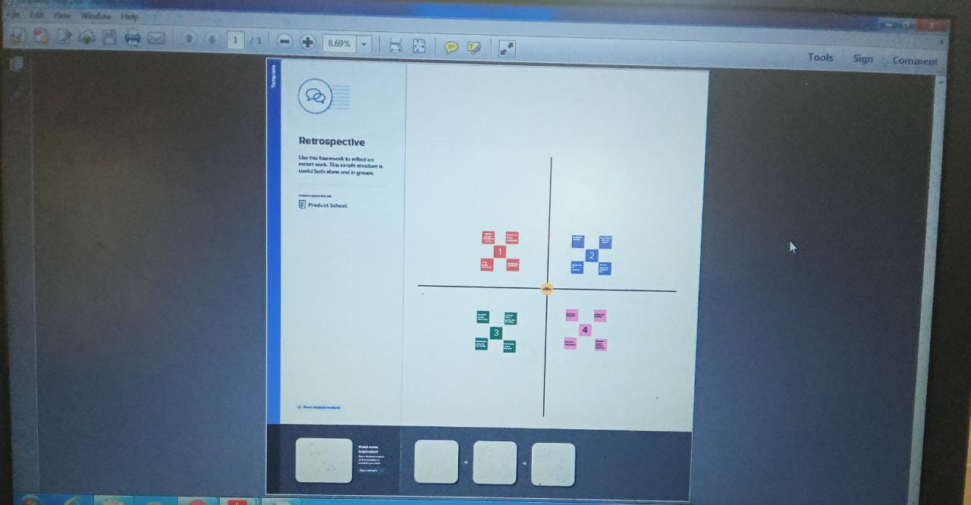

**2.2 Ideation & Brainstorming Map**

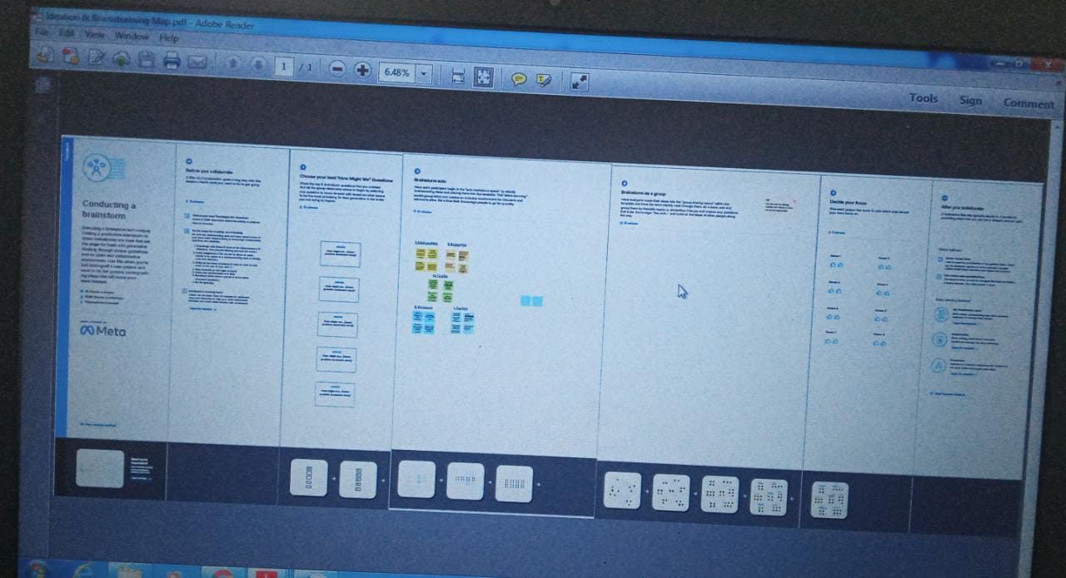

3. **RESULT**

3.1 Data Model

|  |  |  |
| --- | --- | --- |
| Object Name | Field Label | Data Model |
| Job Positing Sites | Job Positing Sites | Text |
| Job Positing URL | Job Positing URL | Text |
| Review | Review | Auto-Number |
| Account | Account | Auto-Number |

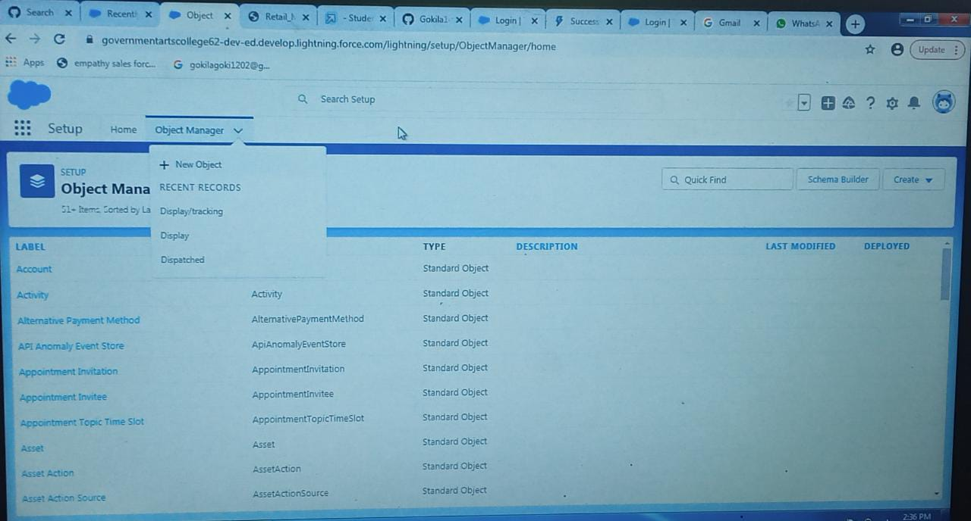

**3.3 TRAILHEAD PROFILE PUBLIC URL**

**Team Lead –** https://trailblazer.me/id/gokila14

**Team member 1-**https://trailblazer.me/id/sachinl07

**Team member 2-** https://trailblazer.me/id/nishanisha

**Team member 3-** https://trailblazer.me/id/rajinisha20

**Team member 4-** https://trailblazer.me/id/kmani66

**4. ADVANTAGES & DISADVANTAGES**

**Advantages**

 Human resource planning

 Hiring workforce

 Enhance organization effectiveness

 Handles disputes and queries

 Motivating employees

 Improve employee relation .

**Disadvantages**

 Human resource planning

 Hiring workforce

 Enhance organization effectiveness

 Handles disputes and queries

 Motivating employees

 Improve employee relation .

**Application**

 HRIS is a type of business application that enables companies to store employee information ,manage common HR functions ,and execute critical HR activities such as processing payroll and administering benefits.

 Features oh HRIS application include an employee self-service portal , payroll , workforce management ,recruitment and hiring

,benefits administration ,and talent management .

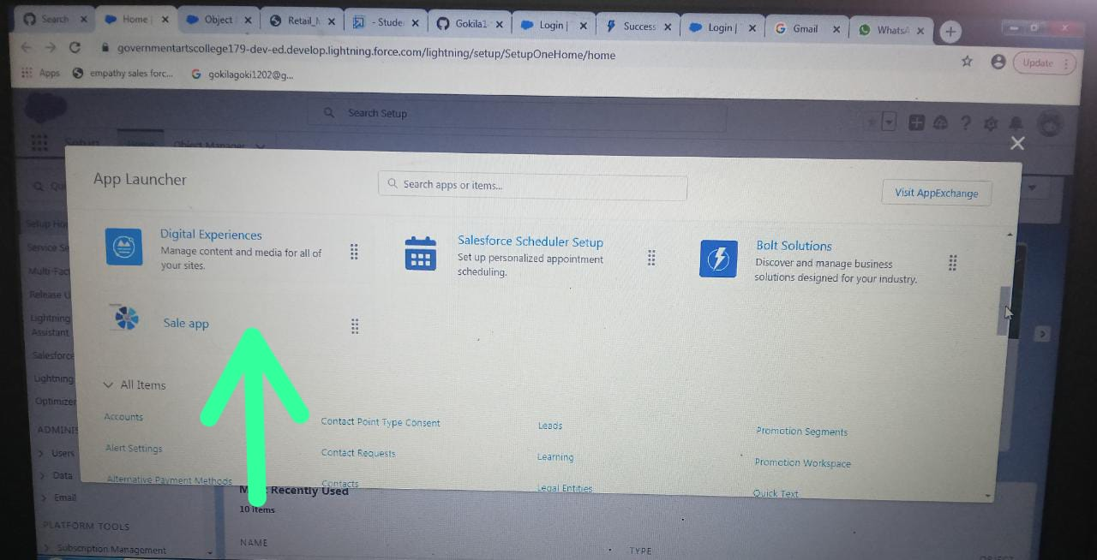

**Concluion**

In conclusion ,due many challenges that are facing human resource departments , there is need for organizations to adopt correct and workable policies that will not only ensure they alleviate these challenges but also develop mechanisms of Dellinger with such challenge in case they occur in the future .

**Future Scope**

The project has a very vast scope in future . The project can be implemented on internet in future.

.

.