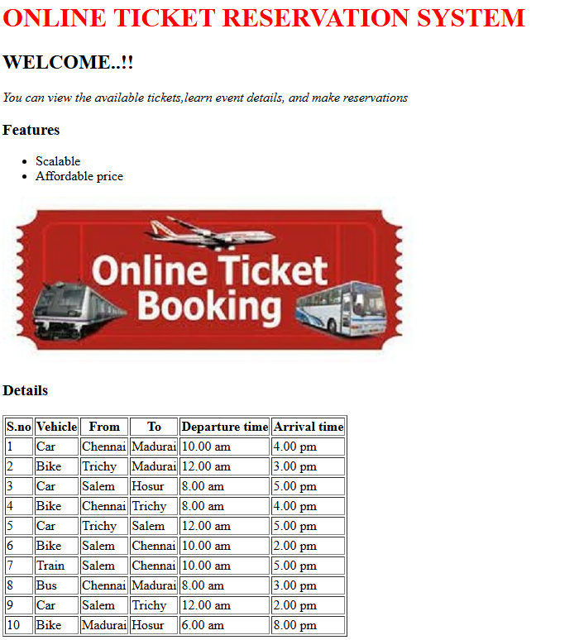
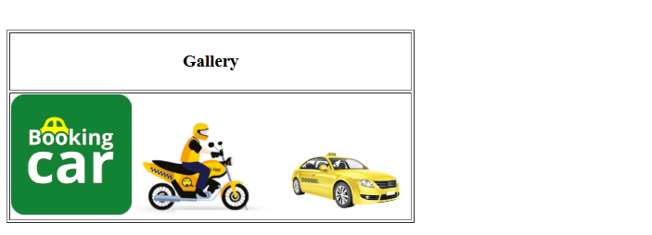

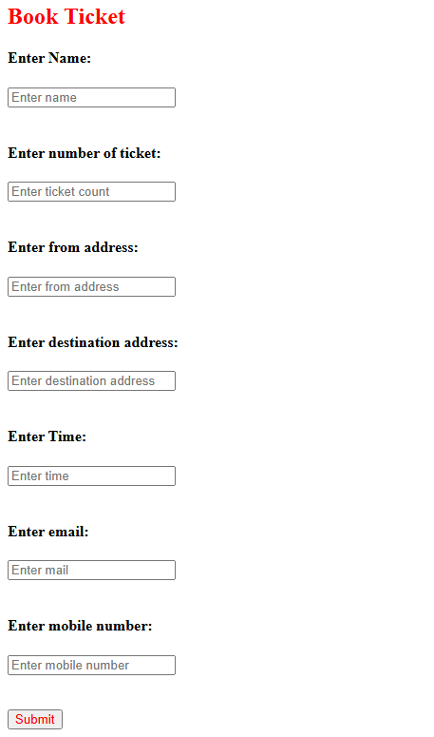

<!DOCTYPE html>
<!--
To change this license header, choose License Headers in Project Properties.
To change this template file, choose Tools | Templates
and open the template in the editor.
-->
<html>
<head>
<title>Ticket Reservation System</title>
<meta charset="UTF-8">
<meta name="viewport" content="width=device-width, initial-scale=1.0">
</head>
<body>
<div>

<h1 style="color:red">ONLINE TICKET RESERVATION SYSTEM</h1>
<h2 >WELCOME..!!</h2>
<p><i>You can view the available tickets,learn event details, and make reservations</i></p>
<h3>Features</h3>
<ul>
<li>Scalable</li>
<li>Affordable price</li>
</ul>
<img src="img1.jpg">
<h3>Details</h3>

<table border='1'>
<tr>
<th>S.no</th>
<th>Vehicle</th>
<th>From</th>
<th>To</th>
<th>Departure time</th>
<th>Arrival time</th>
</tr>
<tr>
<td>1</td>
<td>Car</td>
<td>Chennai</td>
<td>Madurai</td>
<td>10.00 am</td>
<td>4.00 pm</td>
</tr>
<tr>
<td>2</td>
<td>Bike</td>
<td>Trichy</td>
<td>Madurai</td>
<td>12.00 am</td>
<td>3.00 pm</td>
</tr>
<tr>
<td>3</td>
<td>Car</td>
<td>Salem</td>
<td>Hosur</td>
<td>8.00 am</td>
<td>5.00 pm</td>
</tr>
<tr>
<td>4</td>
<td>Bike</td>
<td>Chennai</td>
<td>Trichy</td>
<td>8.00 am</td>
<td>4.00 pm</td>
</tr>
<tr>
<td>5</td>
<td>Car</td>
<td>Trichy</td>
<td>Salem</td>
<td>12.00 am</td>
<td>5.00 pm</td>
</tr>
<tr>
<td>6</td>
<td>Bike</td>
<td>Salem</td>
<td>Chennai</td>
<td>10.00 am</td>
<td>2.00 pm</td>
</tr>
<tr>
<td>7</td>
<td>Train</td>
<td>Salem</td>
<td>Chennai</td>
<td>10.00 am</td>
<td>5.00 pm</td>
</tr>
<tr>
<td>8</td>
<td>Bus</td>
<td>Chennai</td>
<td>Madurai</td>
<td>8.00 am</td>
<td>3.00 pm</td>
</tr>
<tr>
<td>9</td>
<td>Car</td>
<td>Salem</td>
<td>Trichy</td>
<td>12.00 am</td>
<td>2.00 pm</td>
</tr>
<tr>
<td>10</td>
<td>Bike</td>
<td>Madurai</td>
<td>Hosur</td>
<td>6.00 am</td>
<td>8.00 pm</td>
</tr>
</table>
<br>
<br>
<br>

<table border="1">
<tr><th><h3>Gallery</h3></th></tr>
<tr><td><img src='img2.png' width="130"><img src='img6.jfif' width="150"><img src='img4.jfif' width="150"></td></tr>
</table>
<br>

<h2 style="color:red">Book Ticket</h2>
<form>
<h4>Enter Name:</h4>
<input type="text" name="name" placeholder="Enter name">
<br>
<br>
<h4>Enter number of ticket:</h4>
<input type="text" name="name" placeholder="Enter ticket count">
<br>
<br>
<h4>Enter from address:</h4>
<input type="text" name="name" placeholder="Enter from address">
<br>
<br><h4>Enter destination address:</h4>
<input type="text" name="name"placeholder="Enter destination address">
<br>
<br>
<h4>Enter Time:</h4>
<input type="text" name="name" placeholder="Enter time">
<br>
<br>
<h4>Enter email:</h4>
<input type="email" name="name" placeholder="Enter mail">
<br>
<br>
<h4>Enter mobile number:</h4>
<input type="tel" name="tel" placeholder="Enter mobile number">
<br>
<br>
<br>
<input type="submit" name="submit" style="color:red">
</form>
</div>
</body>
</html>

