Operating Systems and Concurrency

Part 1.1
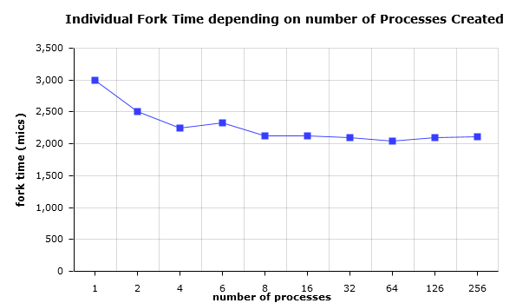
Observations:

Individual time for forks was high for 1 fork (3000) and started getting smaller until reaching around 2000-2100 for 8+ forks and remaining at around that number until 256 forks.
Total wait time doesn't vary too much. It is around 0-1000 for 1-32 forks, 1000-2000 for 64-126 forks and 4000 for 256 forks.
The individual sum varies about the same way as the individual fork time does, times being a little higher depending on the wait time.

Note:

The program was run using cygwin and would give “fork: Resource temporarily unavailable” for more than 256 processes created, this is why the graph and observations are done for 1-256 processes.

Part 1. 2

Overall time for thread creation and termination, based on
number of threads.

Time for an individual thread, based on number of threads called for
creation by the program

Individual threads tend to decrease their creation-execution-termination (i.e. lifecycle) times, the bigger the number of those is called at once with the program. The graph in yellow illustrates that.
Thread individual time tends to get halved with every 2^2 more threads passed to the problem.
The overall time, however is growing and tends to be doubling, again, with every 2^2 number of threads passed to the function. This is illustrated in the blue graph.
As the pthread_join() function handles the waiting for a thread to complete, there are no wait times, with this implementation of the program.

Part 2

Processes were chosen as the means of implementation for better control of the shared information between each other and their parent, which could not be achieved with threads since they share resource space with the main process.

