1.CLASSIFICATION
Data=cars_dataset

library(e1071)
d<-read.csv(file.choose(),header=T)
model<- naiveBayes(d[1:1725,1:6],d[1:1725,7])
predict(model,d[1726:1728,1:6])

OUTPUT

[1] unacc good vgood
Levels: acc good unacc vgood

2. DECISION TREE
Data=decitree

da<-read.csv(file.choose(),header=T)
tr<-rpart(car~buying+maint+doors+persons+lug_boot+safety,data=da)
library("rpart.plot")
rpart.plot(tr,extra=4)

OUTPUT

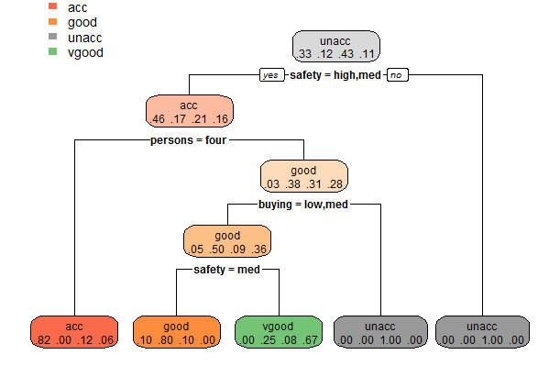

3. SINGLE LAYER PERCEPTRON
Data=perceptron
data<-read.csv(file.choose(),header=T)
data$buying<-(data$buying-min(data$buying))/(max(data$buying)-min(data$buying))
data$maint<-(data$maint-min(data$maint))/(max(data$maint)-min(data$maint))
data$doors<-(data$doors-min(data$doors))/(max(data$doors)-min(data$doors))
data$persons<-(data$persons-min(data$persons))/(max(data$persons)-min(data$persons))
data$lug_boot<-(data$lug_boot-min(data$lug_boot))/(max(data$lug_boot)-min(data$lug_boot))
data$safety<-(data$safety-min(data$safety))/(max(data$safety)-min(data$safety))
set.seed(22)
ind <- sample(2,nrow(data),replace = TRUE,prob = c(0.7,0.3))
trs=data[ind==1,]
ts=data[ind==2,]
library(neuralnet)
set.seed(33)
n<- neuralnet(car~buying+maint+doors+persons+lug_boot+safety,data=trs,hidden=1,err.fct = "ce",linear.output = FALSE)
plot(n)
o<-compute(n,trs[,-7])
head(o$net.result)
head(trs[1,])
#prediction
op<-compute(n,trs[-7])
p<-op$net.result
pred<-ifelse(p>0.5,1,0)
tab<-table(pred,trs$car)
tab
acc<-sum(diag(tab))/sum(tab)
acc
op1<-compute(n,ts[-7])
p1<-op1$net.result
pred1<-ifelse(p1>0.5,1,0)
tab1<-table(pred1,ts$car)
tab1
acc1<-sum(diag(tab1))/sum(tab1)
acc1
> tab

pred 0 1
0 830 130
1 71 185
> acc<-sum(diag(tab))/sum(tab)
> acc
[1] 0.8347039
> op1<-compute(n,ts[-7])
> p1<-op1$net.result
> pred1<-ifelse(p1>0.5,1,0)
> tab1<-table(pred1,ts$car)
> tab1

pred1 0 1
0 323 51
1 37 82
> acc1<-sum(diag(tab1))/sum(tab1)
> acc1
[1] 0.821501

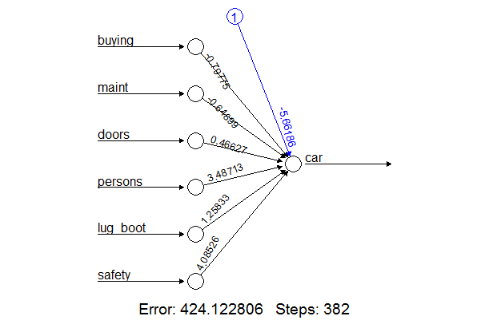

4. MULTILAYER PERCEPTRON
Data=perceptron

n< -neuralnet(car~buying+maint+doors+persons+lug_boot+safety,data=trs,hidden=c(2,1),err.fct = "ce",linear.output = FALSE)
> tab

pred 0 1
0 784 14
1 117 301
> acc<-sum(diag(tab))/sum(tab)
> acc
[1] 0.8922697
> op1<-compute(n,ts[-7])
> p1<-op1$net.result
> pred1<-ifelse(p1>0.5,1,0)
> tab1<-table(pred1,ts$car)
> tab1

pred1 0 1
0 307 6
1 53 127
> acc1<-sum(diag(tab1))/sum(tab1)
> acc1
[1] 0.8803245
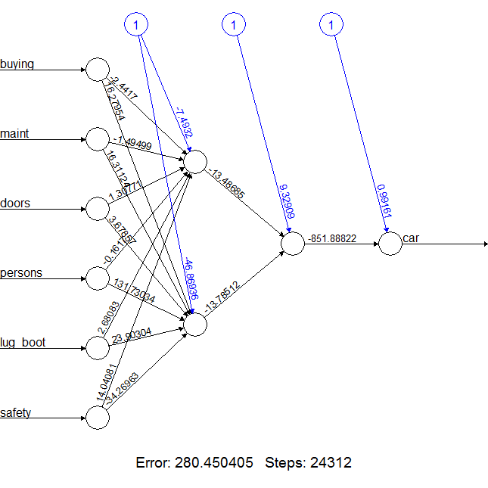

5.SVM
(2-D)
Data=Svm-2D

d<-read.csv(file.choose(),header=T)
library(caTools)
set.seed(123)
sp=sample.split(d$car,SplitRatio = 0.75)
trs=subset(d, sp == TRUE)

ts=subset(d,sp==FALSE)
trs[-3]=scale(trs[-3])
ts[-3]=scale(ts[-3])
library(e1071)
c=svm(formula=car~.,data=trs,type='C-classification',kernel='linear')
p=predict(c,newdata = ts[-3])
p
cm=table(ts[,3],p)
cm
library(ElemStatLearn)
set=ts
x1=seq(min(set[,1])-1,max(set[,1])+1,by =0.01)
x2=seq(min(set[,2])-1,max(set[,2])+1,by =0.01)
grid_set=expand.grid(x1,x2)
colnames(grid_set)=c('maint','safety')
y_grid=predict(c,newdata = grid_set)
plot(set[,-3],main='SVM(Test Set)',xlab='Maint',ylab='Safety',xlim=range(x1),ylim=range(x2))
points(grid_set,pch=21,col=ifelse(y_grid==1,'springgreen3','tomato'))
points(set,pch=21,bg=ifelse(set[,3]==1,'green4','red3'))

cm
p
0 1
0 7 2
1 4 6

