**Aim:** Create a Virtual Hard Disk and allocate the storage using VM ware Workstation.

**Step 1:** Create a virtual machine.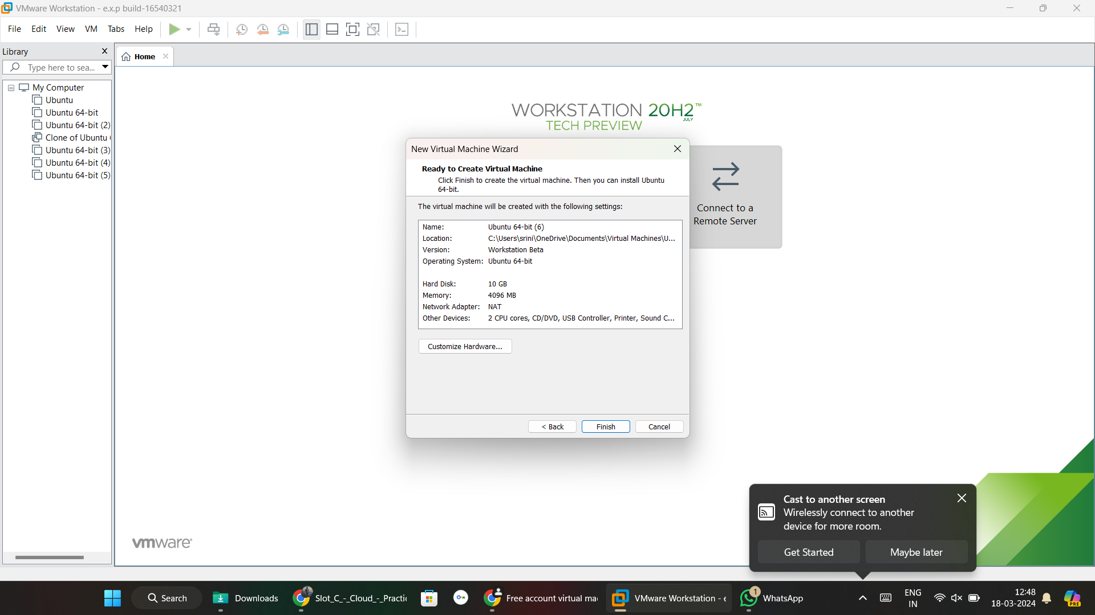

**Step 2:** Click on edit virtual machine and click add.

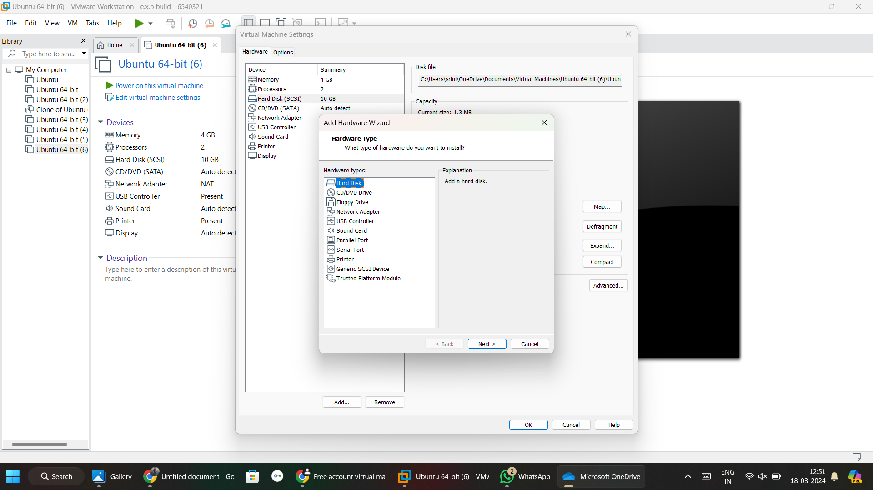

**Step 3:** Select hard disk and click on next, you can see to add another hard disk storage

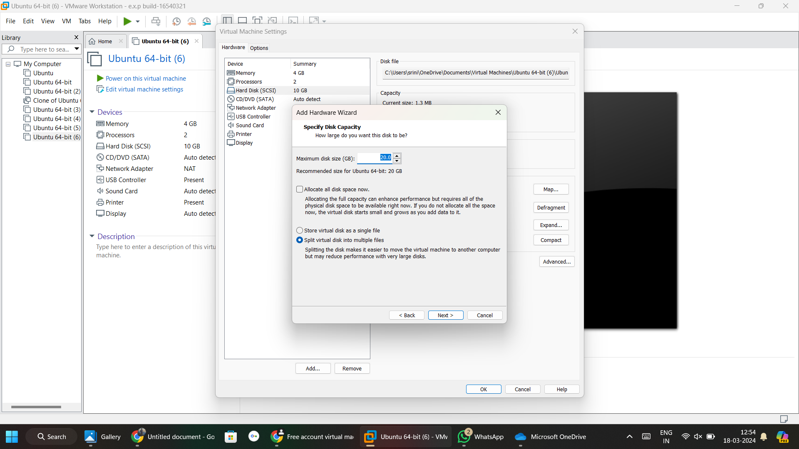

**Step 4:** Additional hard disk added.

