Create a simple cloud software application for Students Attendance System using any Cloud Service Provider to demonstrate SaaS include the necessary fields such as name of the students, course, present , Absent, course attendanc request, grade, attendance percentage, etc.

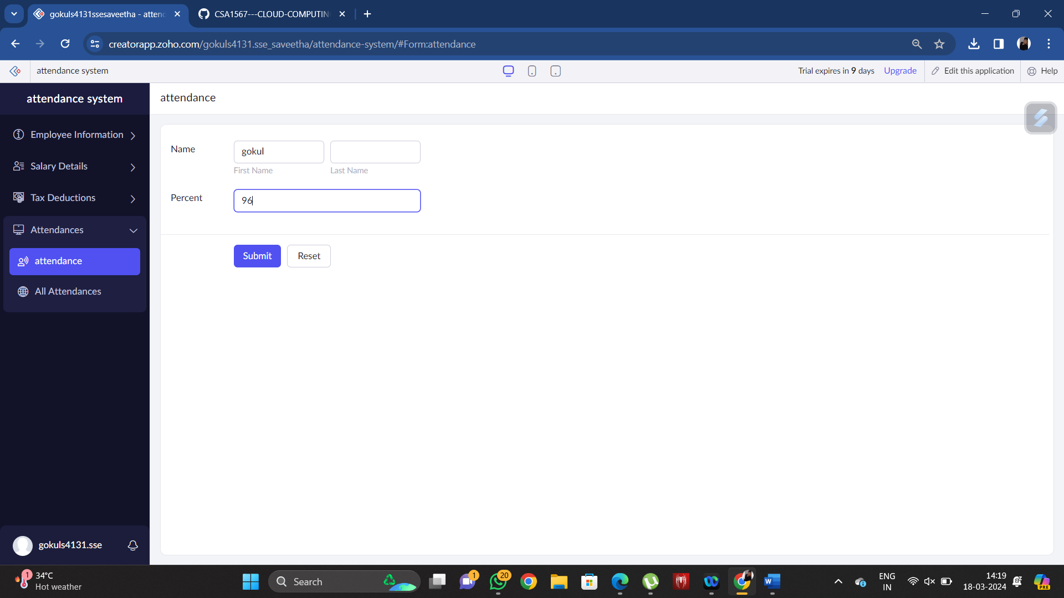

To add exam details

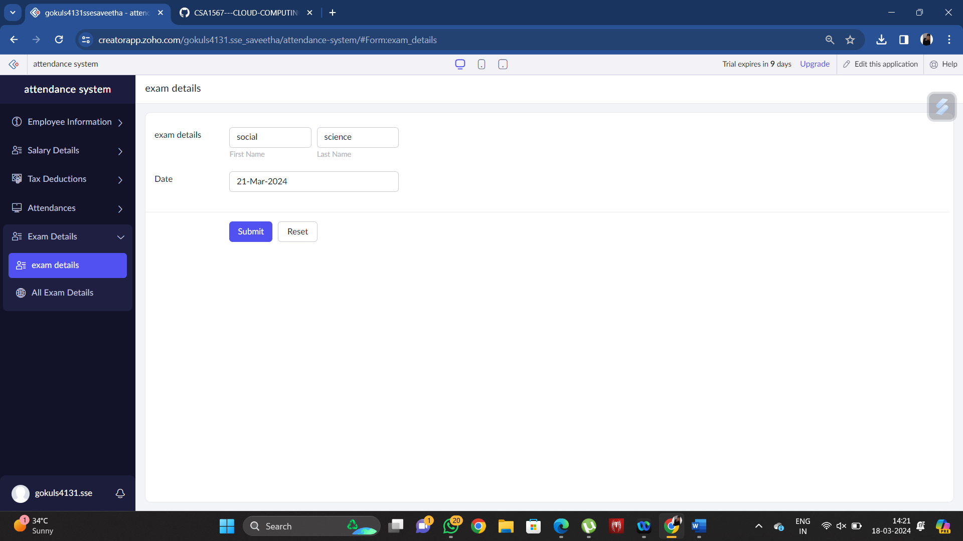

To Attendance attendance percentage

