# Lab: Creating an ECommerce Application

## Tasks

### Task 1: Create Base Classes

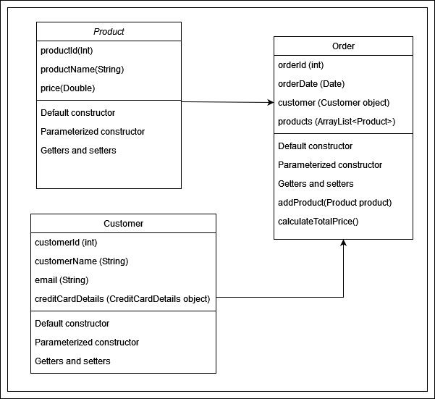

### Task 2: Create Subclasses

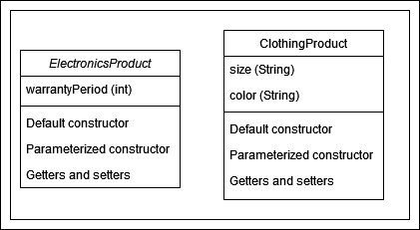

### Task 3: Implement Polymorphism

* Modify the calculateTotalPrice() method in the Order class to use polymorphism to calculate the total price based on the product type.
* Create a method in the Product class called calculatePrice() that will be overridden in the subclasses to calculate the price based on specific product types (e.g., applying discounts or additional charges).

### Task 4: Encapsulation

* Create a separate class CreditCardDetails to store sensitive information like credit card number, expiration date, and CVV.
* Make the creditCardDetails attribute in the Customer class private and provide public getter and setter methods to access and modify it in a controlled way.

### Task 5: Testing

* Write unit tests to test the functionality of each class and method.
* Create test cases for different scenarios, such as adding products to an order, calculating the total price, and applying discounts.