AI Service Desk
Technical Documentation by Gokul M
(Trainee - MTS Full Stack)
Date: July 24, 2026 Version: 1.0

Version | Date | Author | Description
1.0.0 | July 24, 2026 | Gokul M | Python Backend Training task

Table of Contents
Technical Documentation
1. Introduction 1
1.1 Purpose 1
1.2 Scope 1
1.3 Intended Audience 1
1.4 References 1
1.5 Acronyms and Definitions 1
2. System Overview 2
2.1 High-Level Architecture 2
2.2 System flow - Key Components 2
2.3 User Roles and Access Levels 2
3. Functional Requirements 2
3.1 Module/Feature Name 2
3.2 Inputs/Outputs 3
3.3 Business Rules 3
3.4 Error Handling 3
4. Non-Functional Requirements 3
4.1 Performance 3
4.2 Security 3
4.3 Availability 4
4.4 Maintainability 4
5. Data Model / Database Design 4
5.1 Entity-Relationship Diagram 5
5.2 Tables and Fields 5
5.3 Indexes and Keys 5
5.4 Sample Data 5
6. Integration Points 5
6.1 External Systems 5
6.2 APIs Used 5
6.3 Data Flow Diagram 5
6.4 Authentication/Authorization 6

7. Test Strategy 6
7.1 Test Scenarios 6
7.2 Expected Results 6
7.3 Traceability to Requirements 6
8. Deployment & Configuration 6
8.1 Environments 6
8.2 Setup Steps 7
8.3 Configuration Files and Parameters 7
9. Appendix 8
Glossary 8
Code Snippets 9
Screenshots 10
References 13
1. Introduction

1.1 Purpose
This document describes the technical implementation of the AI Service Desk API, a FastAPI-based backend service for managing support tickets with AI-powered summarization and response suggestions.

1.2 Scope
The system provides RESTful APIs for ticket management (create, read, update, delete) and AI-powered ticket analysis using Amazon Bedrock. It includes database persistence, health checks, error handling, and comprehensive test coverage.

1.3 Intended Audience
- Developers maintaining or extending the system
- DevOps engineers deploying and monitoring the service
- QA engineers verifying functionality
- Product owners understanding technical capabilities

1.4 References
- FastAPI Documentation: https://www.tutorialspoint.com/fastapi
- SQLAlchemy Documentation: https://docs.sqlalchemy.org/
- AWS Bedrock Documentation: https://docs.aws.amazon.com/bedrock/
- Pydantic Documentation: https://docs.pydantic.dev/

1.5 Acronyms and Definitions
Acronym | Definition
API | Application Programming Interface
ORM | Object-Relational Mapping
DTO | Data Transfer Object
REST | Representational State Transfer
HTTP | Hypertext Transfer Protocol
JSON | JavaScript Object Notation
AWS | Amazon Web Services
Bedrock | AWS service for generative AI

2. System Overview

2.1 High-Level Architecture
The system follows a layered architecture:
- API Layer: FastAPI routers handling HTTP requests/responses
- Service Layer: Business logic for ticket operations and AI services
- Repository Layer: Data access abstraction over SQLAlchemy ORM (PostgreSQL/SQLAlchemy interactions)
- External Services integration (Bedrock for AI)
- Cross-cutting: Exception handling, middleware, configuration

2.2 System Flow - Key Components
- API Entry Point: FastAPI application with versioned API routes (v1,…)(/tickets)
- Request Validation: Pydantic models validate incoming request data
- Service Layer: Business logic orchestrates ticket creation/retrieval/update/deletion, status transition validation, and AI service integration for summarization
- Data Access: Repository pattern with SQLAlchemy ORM
- External Integration: AWS Bedrock service for AI capabilities
- Response Formation: Pydantic models format outgoing responses
- Cross-cutting Concerns: Exception handling converts domain exceptions to HTTP responses; middleware adds response timing and profiling; created health/readiness endpoints for monitoring

2.3 User Roles and Access Levels
The system currently implements role-less access control where all authenticated users have full access to all endpoints. Authentication is not implemented in the current version, focusing on core functionality.

3. Functional Requirements

3.1 Module: Ticket Management
Purpose: Provides CRUD operations for support tickets with status tracking and assignment capabilities.
Functionality:
- Create new tickets with title, priority, and contact email
- Retrieve tickets with optional filtering by status and priority
- Update ticket fields including status transitions with validation
- Delete tickets
- Automatic timestamp tracking for creation

3.2 Inputs/Outputs

Create Ticket
- Input: title (string, 3-100 chars), priority (low/medium/high), email (valid format)
- Output: Ticket object with ID, timestamps, and default status "open"

Get Tickets
- Input: Optional status and priority query parameters
- Output: List of ticket objects matching filters

Update Ticket
- Input: Ticket ID and optional fields to update (title, priority, status, assignee, email)
- Output: Updated ticket object
- Business Rule: Cannot transition from "resolved" to another status

Delete Ticket
- Input: Ticket ID
- Output: Success confirmation message

3.3 Business Rules
- Ticket titles must be 3-100 characters after trimming whitespace
- Priority must be one of: low, medium, high
- Status must be one of: open, in_progress, resolved
- Email must be valid format when provided
- Cannot transition a resolved ticket to open or in_progress status
- New tickets always start with "open" status
- Timestamps are automatically set on creation

3.4 Error Handling
- Custom exception hierarchy extends ServiceDeskException
- TicketNotFoundException: Returns 404 when ticket ID doesn't exist
- InvalidTicketStatusTransitionException: Returns 400 for invalid status transitions
- Validation errors from Pydantic models return 422 with details
- Global exception handler formats errors as JSON with status code and message
- AI service failures return 502 Bad Gateway with generic message

4. Non-Functional Requirements

4.1 Performance
- Health check endpoint responds in <100ms under normal conditions
- Database operations use async SQLAlchemy for non-blocking I/O
- API endpoints designed for concurrent request handling via FastAPI/Starlette
- Response time middleware tracks and reports request processing time

4.2 Security
- CORS middleware configured for controlled cross-origin access
- Input validation prevents injection and malformed data
- Error messages avoid exposing internal implementation details
- Secrets managed via environment variables (AWS credentials, database URLs)
- Passwords/secrets not logged or exposed in responses
- HTTPS recommended for production deployment (handled at reverse proxy level)

4.3 Availability
- Health check endpoint (/health) verifies database connectivity
- Readiness endpoint (/ready) indicates service readiness
- Automatic fallback to in-memory SQLite database when PostgreSQL unavailable
- Graceful degradation: AI service failures don't break ticket operations
- Stateless horizontal scaling possible (except for database affinity)

4.4 Maintainability
- Separation of concerns via layered architecture
- Clear separation: API contracts, business logic, data access
- Configuration centralized in Pydantic settings model
- Database migrations managed via Alembic
- Comprehensive test coverage with unit and integration tests
- Dependency injection for testability (Bedrock service client injection)
- Type hints throughout for IDE support and error prevention

5. Data Model / Database Design

5.1 Entity-Relationship Diagram
Entity: Ticket
Field | Type
id | Integer (PK)
title | String(100)
priority | Enum [low, medium, high]
status | Enum [open, in_progress, resolved] (default: open)
assignee | String(255, nullable)
created_at | DateTime (default: utcnow)
email | String(255, nullable)

5.2 Tables and Fields
Table: tickets
- id: Primary key, auto-incrementing integer
- title: Non-nullable string (max 100 chars)
- priority: Non-nullable enum (low/medium/high)
- status: Non-nullable enum (open/in_progress/resolved, default: open)
- assignee: Nullable string (max 255 chars)
- created_at: Non-nullable datetime (default: utcnow)
- email: Nullable string (max 255 chars)

5.3 Indexes and Keys
- Primary key index on id column
- Index on id (automatic from primary key)
- No additional indexes currently defined (may be added based on query patterns)

5.4 Sample Data
id | title | priority | status | assignee | created_at | email
1 | Database connection failing | high | open | null | 2026-07-24T10:30:00Z | admin@example.com
2 | Password reset request | medium | in_progress | support_team | 2026-07-24T09:15:00Z | user@example.com

6. Integration Points

6.1 External Systems
- Amazon Bedrock: AI service for ticket summarization and response generation
- PostgreSQL: Primary relational database (with SQLite fallback for development/testing)

6.2 APIs Used
- Internal: Self-contained REST API with versioned endpoints (/v1/tickets, /v1/ai)
- External: AWS Bedrock Converse API for AI text generation; no external APIs consumed beyond AWS and database drivers
Method | Endpoint | Description
POST | /tickets/ | Create a new ticket (title, priority, email)
GET | /tickets/ | List tickets, optional ?status= and ?priority= filters
GET | /tickets/{id} | Retrieve a single ticket by ID
PUT / PATCH | /tickets/{id} | Update ticket fields (title, priority, status, assignee, email)
DELETE | /tickets/{id} | Delete a ticket by ID
POST | /ai/summarize | AI-powered ticket summarization via BedrockService → Bedrock Converse API
GET | /health | Health check — verifies database connectivity
GET | /ready | Readiness check — indicates service is ready to accept traffic
GET | /docs | Auto-generated Swagger/OpenAPI documentation UI

6.3 Data Flow Diagram
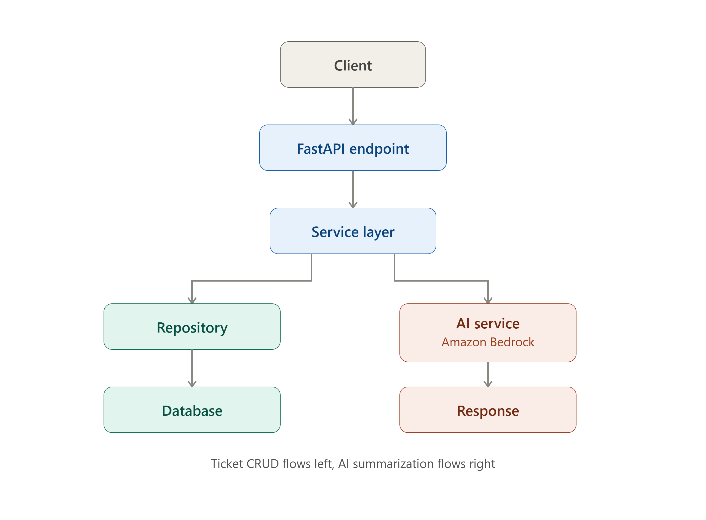

6.4 Authentication/Authorization
Currently not implemented in our system .

7. Test Strategy

7.1 Test Scenarios

Unit Tests
- Pydantic model validation (email, title length, enum values)
- Exception formatting and message correctness
- Property-based testing for computed fields

Integration Tests
- Ticket creation with valid/invalid data
- Title whitespace trimming validation
- Status filtering and retrieval
- Update operations including status transitions
- Delete operations
- Error conditions (not found, invalid transitions)

7.2 Expected Results
- All validation rules enforced correctly
- Proper HTTP status codes returned (200, 201, 400, 404, 422, 502)
- Response bodies match defined Pydantic models
- Database state changes correctly reflect operations
- Error messages are clear and actionable
- AI service failures handled gracefully without crashing ticket operations

7.3 Traceability to Requirements
- Test cases map directly to functional requirements in Section 3
- Validation tests cover business rules (Section 3.3)
- Error handling tests validate exception responses (Section 3.4)
- Integration tests verify end-to-end API functionality
- Performance characteristics validated through test execution timing

8. Deployment & Configuration

8.1 Environments
- Development: postgreSQL db through Docker Image
- Testing: In-memory SQLite for isolated tests
- Staging/Production: PostgreSQL with connection pooling
- All environments configurable via environment variables

8.2 Setup Steps
- Clone repository
git clone https://github.com/Gokul-272/python-backend-Ai-Ticket-Service
Create a .env file with required variables
Install dependencies:
pip install -r requirements.txt
Run database migrations:
alembic upgrade head
Start the application:
uvicorn app.main:app --reload
Access the API at http://localhost:8000
View documentation at http://localhost:8000/docs

8.3 Configuration Files and Parameters
Required Environment Variables:
Variable | Description
APP_NAME | Application name (default: "AI Service Desk")
API_VERSION | API version (default: "1.0.0")
DEBUG | Boolean flag for debug mode
DATABASE_URL | PostgreSQL connection string
AWS_ACCESS_KEY_ID | AWS credentials for Bedrock
AWS_SECRET_ACCESS_KEY | AWS credentials for Bedrock
AWS_REGION_NAME | AWS region (e.g., "us-east-1")
BEDROCK_MODEL_ID | Bedrock model identifier

Configuration File: pyproject.toml contains project dependencies and metadata.
Configuration Class: app.core.config.Settings uses Pydantic for type-safe environment variable parsing with .env file support.

9. Appendix

Glossary
Term | Definition
DTO (Data Transfer Object) | Object used to encapsulate data for transfer between system layers
ORM (Object-Relational Mapping) | Technique for converting data between relational databases and object-oriented models
REST (Representational State Transfer) | Architectural style for networked applications
JWT (JSON Web Token) | Open standard for securely transmitting information as a JSON object

Code Snippets

Ticket Creation Endpoint
@app.post("/tickets/", response_model=TicketResponse, status_code=201)
async def raise_ticket(ticket: CreateTicketRequest, db: AsyncSession = Depends(get_db)):
return await create_ticket(db, ticket)

Ticket Model Validation
class Ticket(Base):
__tablename__ = "tickets"

id = Column(Integer, primary_key=True, index=True)
title = Column(String(100), nullable=False)
priority = Column(SQLEnum(PriorityEnum), nullable=False)
status = Column(SQLEnum(StatusEnum),nullable=False,default=StatusEnum.OPEN,)
assignee = Column(String(255), nullable=True)
created_at = Column(DateTime,default=datetime.utenow,nullable=False,)
email = Column(String(255), nullable=True)

@validates("title")
def validate_title(self, key, value):
if not isinstance(value, str):
raise TypeError("Title must be a string")
return value

Exception Handler
@app.exception_handler(ServiceDeskException)
async def service_desk_exception_handler(request, exc: ServiceDeskException):
return JSONResponse(status_code=exc.status_code,content={"detail": exc.message})

Database Connection with Fallback
@asynccontextmanager
async def lifespan(app):
try:
async with engine.begin() as conn:
await conn.run_sync(Base.metadata.create_all)
except Exception:
use_in_memory_fallback()
async with engine.begin() as conn:
await conn.run_sync(Base.metadata.create_all)
Yield

Screenshots
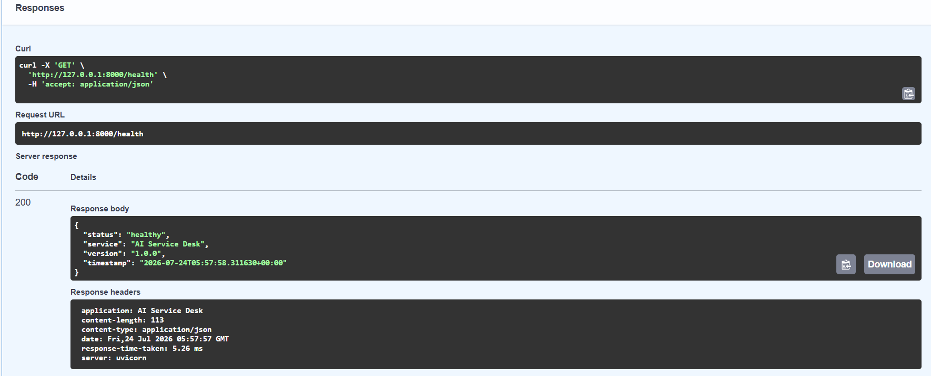
- Health check

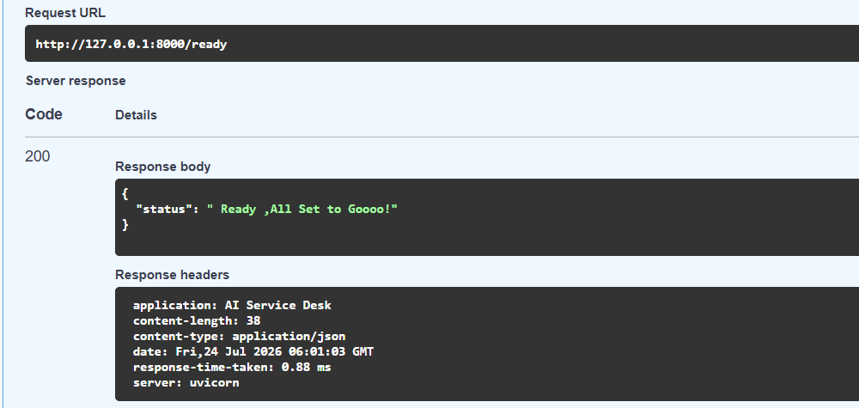
2.Readiness Check

3. Create Ticket
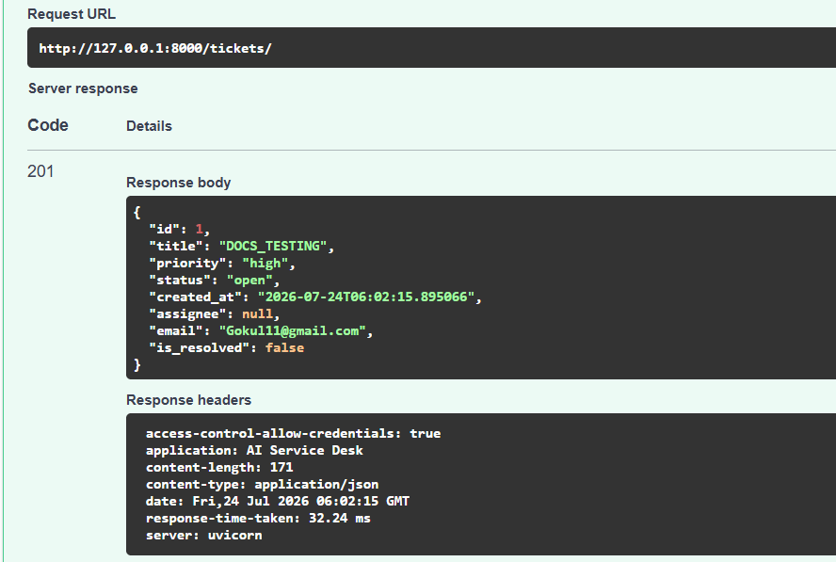
4.Get Ticket
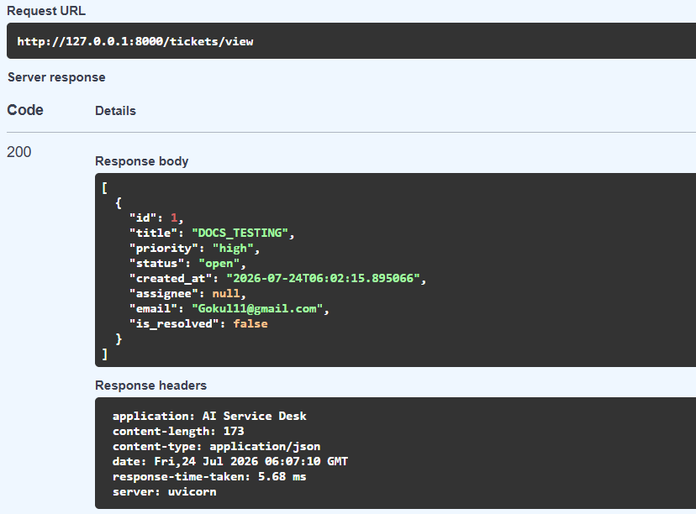

5.Update Ticket
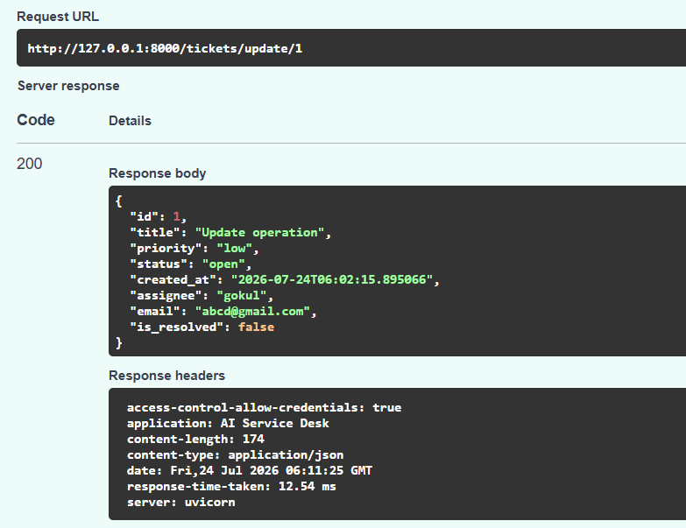
- Delete Ticket

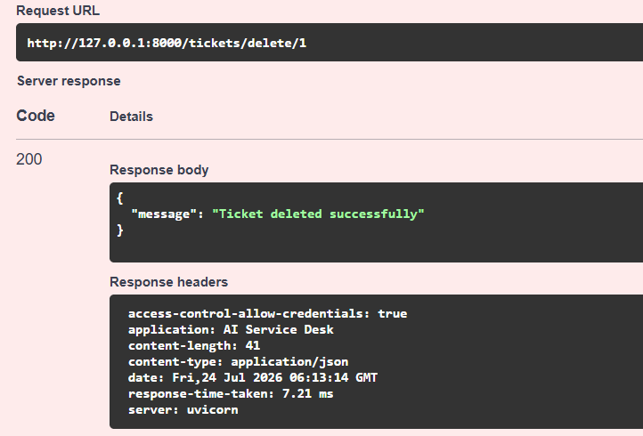

References
Frameworks & Libraries
- FastAPI — https://fastapi.tiangolo.com/
- Pydantic — https://docs.pydantic.dev/
- SQLAlchemy — https://docs.sqlalchemy.org/
- Alembic (database migrations) — https://alembic.sqlalchemy.org/
- Uvicorn (ASGI server) — https://www.uvicorn.org/
- Starlette (underlying FastAPI) — https://www.starlette.io/
Database
- PostgreSQL — https://www.postgresql.org/docs/
- SQLite (dev/test fallback) — https://www.sqlite.org/docs.html
AI / Cloud Services
- Amazon Bedrock — https://docs.aws.amazon.com/bedrock/
- Bedrock Converse API — https://docs.aws.amazon.com/bedrock/latest/userguide/conversation-inference.html
- AWS SDK for Python (Boto3) — https://boto3.amazonaws.com/v1/documentation/api/latest/index.html
Testing & Quality
- pytest — https://docs.pytest.org/
- pytest-asyncio (for async test support) — https://pytest-asyncio.readthedocs.io/
- Locust (load testing) — https://docs.locust.io/en/stable/
Standards Referenced
- REST architectural style (Fielding's dissertation) — https://ics.uci.edu/~fielding/pubs/dissertation/rest_arch_style.htm
s

