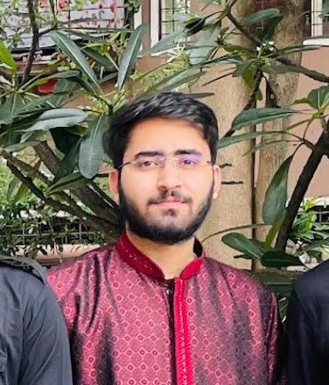
Aakarsh Divyam

Address: Reside Inn, AECS Layout – D Block
Bengaluru - 560037
Email ID: aakarshdivyam17@gmail.com
Mobile No: 9334511122
LinkedIn: https://www.linkedin.com/in/aakarsh-divyam-291512309/
GitHub: https://github.com/ChillyColor

CAREER OBJECTIVE
Motivated college student with a strong foundation in computer science and a passion for problem-solving. Eager to leverage academic knowledge and hands-on coding experience to develop innovative software solutions. Seeking opportunities to grow technical skills and contribute to impactful projects in a dynamic software development environment.

EDUCATION QUALIFICATION
- Bachelor of Engineering – Computer Science Engineering
CMRIT, AECS Layout, Bangalore
7.6, 2026 (Pursuing)
- 12th – Science
St Karen’s Secondary School, Patna
76%, 2022
- 10th
- St Karen’s High School, Patna
85%, 2019

TECHNICAL SKILLS
Languages: C, Java(Advanced), Python, JavaScript
Frameworks: ReactJs, NodeJS, ExpressJs
Software: MS Excel, Power Bi, Tableau, Postman
Database: MySQL, MongoDB, PostgreSQL

PROJECTS
- Title: Tenant Management System
Description: Developing a system for PG owners to track tenants, manage payments, and monitor occupancy using
Node.js and MySQL for backend and database management. The user interface, built with React and Tailwind CSS, is designed to provide a seamless experience for both tenants and PG owners.
Tech Stack: PERN (PostgreSQL, ExpressJS, NodeJS, ReactJs)

- Title: Simon’s Game
Description: Developed an interactive Memory Game . The game challenges players to memorize and replicate sequences of colours and sounds, progressively increasing difficulty with each round. Designed a dynamic UI with engaging sound effects and responsive gameplay mechanics for an immersive user experience.
Tech Stack: HTML , CSS , JavaScript

CO-CURRICULAR & EXTRA CURRICULAR ACTIVITIES
- Hackathons:
- Participated in SIH (Smart India Hackathon) 2024 and cleared the preliminary round
- Participated in competitive programming hackathon conduced in CMR Institute of Technology
- Algorithms Data Structures in Java
- Clubs:
  - Active member of the Code Chef Technical Club
- Online Courses & Certifications:
- The complete Web Development bootcamp – Udemy

ACHIEVEMENTS
- FKCCI Manthan 2024 Finalist
- Finished in the top 29 out of 300+ participants in the Manthan FKCCI Business Plan competition of 2024.
- Gained valuable insights into business strategy and startup growth through an innovative business idea presentation.

PERSONAL DETAILS
Date of Birth : 18/04/2004
Gender : Male
Nationality : Indian
Permanent Address : VijayNagar, Rukanpura , Patna , Bihar
Linguistic Competency : Hindi, English
Hobbies : Playing Badminton, Cricket and listening to music

