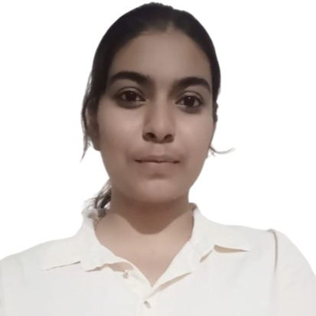

SREEJA SALAPU
Address: Flat no:2A- 311 Krishna Ikon Apartment, Annasandrapalya , Vimanapura, Bengaluru,560017
Email ID: srsa22cse@cmrit.ac.in
gayatrisreeja19@gmail.com Mobile No: +91 7013227963
LinkedIn: www.linkedin.com/in/sreeja-salapu-838013273
Github : https://github.com/sree-1908

CAREER OBJECTIVE
Motivated software developer with strong analytical and problem-solving skills, experienced in full-stack web development, data analytics, and AI. Proven ability to lead, create engaging content, and collaborate in fast-paced environments. Eager to contribute to impactful tech solutions and drive innovation in software development

EDUCATION QUALIFICATION

Bachelor of Engineering – Computer science Engineering
CMR Institute of Technology, Bangalore, AECS Layout, Bangalore 9.24, 2026

12th – Science
HAL Public School, Bengaluru 82.6%,2022

10th
HAL Secondary School, Hyderabad 88.2%,2020

TECHNICAL SKILLS
- Programming Languages: Python, C, Java
- Web Technologies: HTML, CSS, JS,PHP
- Database: MYSQL
- Software: Windows, Visual Studio Code, Excel

PROJECTS

SafeVoice: Speak Without Fear
Description: A women’s safety web app with a Panic Button that sends live location alerts and an Anonymous Reporting feature for discreet incident reporting.
Includes an Anonymous Reporting feature to encourage discreet sharing of incidents without fear of judgment.
Additional Info: Integrated user authentication and alert logs for admin monitoring. Designed with user-centered UI for ease of access during emergencies.
Tech Stack: HTML, CSS, JavaScript, PHP
Achievements : Won 3rd place in the hackathon conducted by IIIT Nagpur

- CredCrop:
Description:. A platform that promotes organic farming by rewarding farmers with carbon credits. Encourages sustainable practices through tech-driven incentives.
Empowers eco-friendly farming using a tech-driven incentive model tied to environmental benefits.
Additional Info: Developed farmer dashboards, visual analytics for carbon savings, and a submission-verification pipeline for credit approval.
Tech Stack: HTML, CSS, JavaScript, PHP
Achievements : Won 2nd place in National Level Social Hackathon, CMRIT

SkillSync
Description: An AI-powered job-matching platform that analyzes resumes and job roles to offer accurate matches. Includes a bio-map for visualizing regional skill demand and decency filter for jobs and specific companies.
Includes a bio-map that visualizes region-wise skill demand and a decency filter to flag toxic employers and unsafe job listings.
Additional Info: Built to reduce unemployment by connecting people to jobs they actually qualify for, based on soft and hard skills.
Tech Stack: HTML,CSS,JS, Artificial Intelligence

ONLINE INTERNSHIPS

Accenture North America Job Simulation Duration: October 2024
Designation: Data Analyst

Responsibilities:
  - Completed a simulation focused on advising a hypothetical social media client as a Data Analyst at Accenture
  - Cleaned, modelled and analyzed 7 datasets to uncover insights into content trends to inform strategic decisions
  - Prepared a PowerPoint deck and video presentation to communicate key insights for the client and internal

Internpe
Duration: February-March
Designation: AI developer
Responsibilities:
- Worked on real-world ML projects.
- Built and optimized models using Python, pandas, scikit-learn, and applied data preprocessing and EDA techniques.
- Focused on improving model accuracy through feature engineering and performance evaluation.

CO-CURRICULAR & EXTRA CURRICULAR ACTIVITIES

Hackathons:
- Awarded third prize in the WomenTech Hackathon organized by IIIT Nagpur.
- Awarded second prize in National Level Social Hackathon conducted by CMRIT
- Participated in the Rapid Innovation Challenge Hackathon conducted by IEEE in collaboration with CMRIT.
- Participated in the preliminary rounds of the Smart India Hackathon in 2023 and 2024.

Online Courses & Certifications:
  - Certified on Python Programming course from Udemy
  - Certified on Complete Data Analytics course from Udemy
  - Certified on Data Structures and Algorithms course from Infosys Springboard

Non Technical Clubs:
- President of Higher Studies Club -organized interactive events regarding higher studies
- Member of Minerva club – member of content ideation team
- Membership Drive Chair IEEE Club

PERSONAL DETAILS:
Date of Birth : 19th August,2005
Gender : Female
Nationality : Indian
Permanent Address : Flat no: 408 Manjeera Smart Homes Apartment, Quthbullapur,Hyderabad,Telengana,500055
Linguistic Competency : English, Telugu, Hindi
Hobbies : Writing poetry, painting, cooking, playing badminton

