ADITYA.V
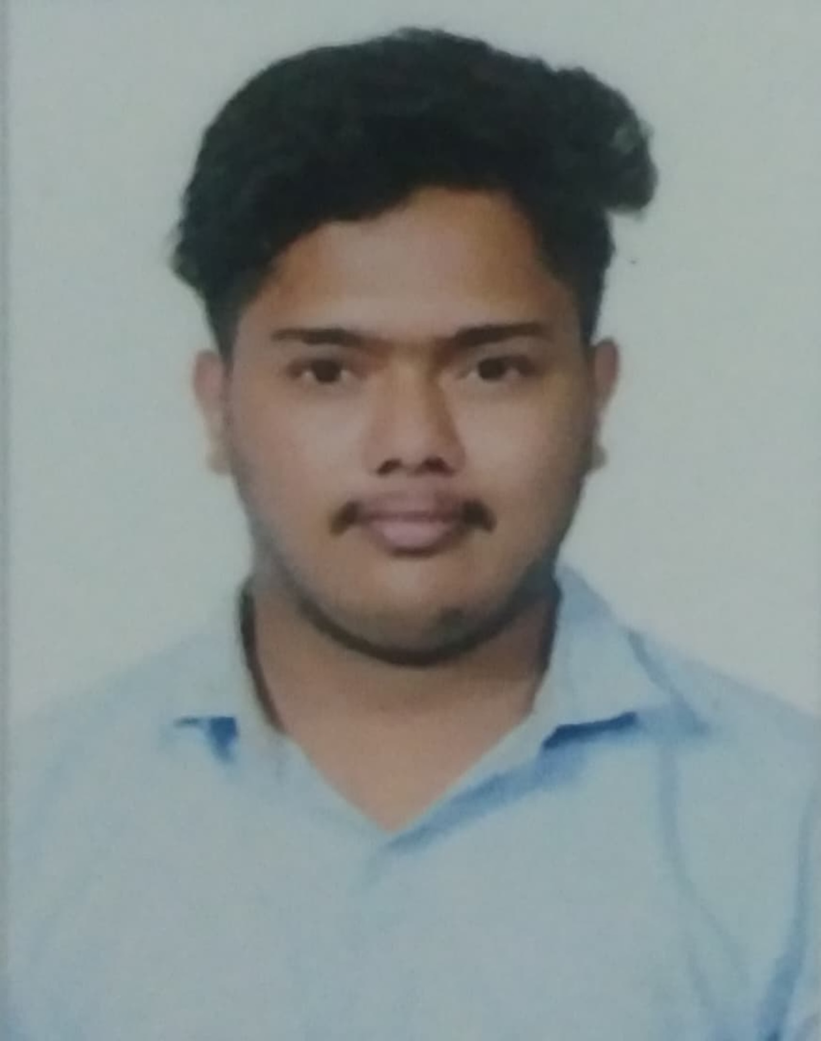
Address : Sri Tulasi
Riches Garden Layout, 4th West Cross
Ramamurthy Nagar
Bengaluru - 560016
Email ID: adiv22ece@cmrit.ac.in / adityavenkatesh08@gmail.com
Mobile No: +917975778101
LinkedIn: https://www.linkedin.com/in/aditya-v-93a7982ba/
Github: https://github.com/Adityavktesh

CAREER OBJECTIVE
I aim to become a software developer where I can apply my technical skills effectively and contribute towards innovative projects for the betterment of the self and the society.
EDUCATIONAL QUALIFICATION
- Bachelors of Engineering – Electronics and Communication Engineering
CMR Institute of Technology Affiliated to VTU( Visvesvaraya Technological University)
Karnataka, Bengaluru - 560037
CGPA : 7.09, Pursuing -2026
- Pre – University-Science–(PCMC)
CMR PUC – HBR Layout Affiliated to KPUC( Karnataka Pre-University)
Karnataka, Bengaluru – 560084
78%
2020-2022
- SSLC Affiliated to CBSE( Central Board of Secondary Education)
Maithry Vidyanikethan School
Karnataka
Bengaluru -560016
75%
TECHNICAL SKILLS
Languages: Matlab , C++, Java
Software: Solid edge, Xilinx’s, Turbo C++, Tinker CAD, Matlab, Python ,KeiluVision5.
Database: SQL, MongoDB
PROJECTS
- PROJECT 1(Entrepreneurship project)
Title : E-commerce website
Description: Designed and developed a responsive, full-stack e-commerce website for Shilpa’s Sunshine Bakes, a small-scale cake and sweets business in London. The website has a Seamless user experience with features like product browsing, “add to cart,” and a secure payment gateway for orders.
Tools used: HTML,CSS,NODE.JS,REACT(Full stack development)
Learning outcomes: Through the development of the Shilpa’s Sunshine Bakes website, I enhanced my skills in full-stack web development, particularly in integrating frontend and backend systems. I gained hands-on experience with responsive UI design, implementing secure payment gateways (Stripe),and optimizing the user experience for e-commerce functionality and Node.js/Express, and ensure cross-device compatibility.
- Project 2(Mini Project)
Title: Task Manager
Description: The Task manager is a dynamic and efficient web application designed to streamline your daily task and enhance productivity.
Tools used: AngularJS,HTML,CSS
Learning Outcomes: Through developing the Task Manager, I gained proficiency in AngularJS,enchancing my skills in creating dynamic and responsive web applications. I improved my frontend development capabilities in HTML,CSS. Learnt to handle real-time data updates and designed an intuitive user interface focused on efficient task management
INTERSHIPS
- COMPANY NAME: CodSoft Pvt. Ltd.
PLACE: Whitefield, Bengaluru
Duration: 3 Months, September 2023 to December 2023
Designation: Intern.
Roles and Responsibility
- Created game projects for the users.
- Games involved - Snake Game, Tic Tac Toe, Connect Four
- Successfully contributed to creating a engaging and functional web solutions, demonstrating my practical skills in coding and project execution.

CO-CURRICULAR & EXTRA CURRICULAR ACTIVITIES
Co-curricular Activities
- Online courses & certifications: Completed courses on Python, Java, HTML AND CSS from udemy
- Seminar: Attended seminar on AI for chips conducted and Smart everything by BTS( Bengaluru Tech Summit-24)
- Hackathon : Participated in Aptitude 1.1 hackathon organized by CMRIT
- Technical Clubs Events
- Participated in Coding Padawan conducted by MINDSPARK CLUB at CMRIT
- Core member of MINDSPARK CLUB
Extra-curricular Activities
- SPORTS
- Active Football player
- Active Go-karting Racer
- Cultural Fests/Events
- CULTURA (CMRIT College Fest):Co-ordinated Western Solo Event as the Event Coordinator
- Played Men’s Football for ECE Dept Team in IGNITE ‘23

PERSONAL DETAILS
Date of Birth : 11/11/2003
Gender : Male
Nationality : Indian
Linguistic Competency : English, Kannada, Hindi, Marathi, Tamil
Interest : Cycling, Football, Racing

