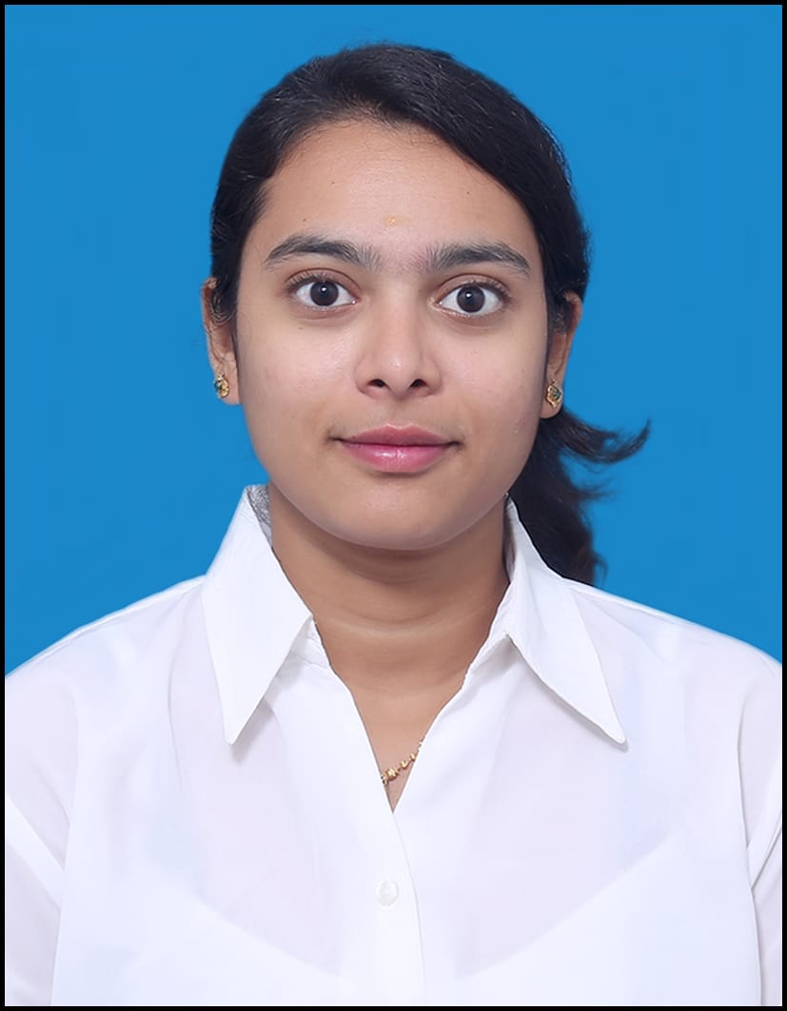
HARINI.R
Address: CMRIT AECS Layout , kundalahalli Bangalore-560037
Email ID:har22ise@cmrit.ac.in
harinir804@gmail.com
Mobile No: 9972407406
LinkedIn:https://www.linkedin.com/in/harini-r-5b694525a
Github: https://github.com/HariniR2003

CAREER OBJECTIVE
A motivated fresher looking to apply my skills in web development and data analysis to contribute to a growing team and learn from new challenges

EDUCATION QUALIFICATION
- Bachelor of Engineering – Information Science and Engineering
CMRIT, AECS Layout, Bangalore
8.23, 2025
- 12th – Science
KVR Maruthi independent pu college, Tumkuru
84.33%, 2021
- 10th
Assumption English High School, Hiriyuru-577598
71.84%, 2019
TECHNICAL SKILLS
Languages: HTML, CSS, JavaScript, SQL, Python
Frameworks: React, Node.js
Software: Power BI, Tableau, Microsoft Excel
Database: MySQL
PROJECTS
- Title:Online Shopping Platform
Description:Developed a full-stack responsive e-commerce web application with features including user authentication, product catalog, cart management, and payment integration. Built a secure and dynamic shopping experience with a clean UI and real-time cart updates. Designed an admin dashboard for managing products and viewing orders.
Tech Stack:HTML, CSS, JavaScript, React, Node.js, MySQL
- Title:Sales Dashboard with Power BI
Description:Built an interactive dashboard to visualize company-wide sales performance and KPIs. Integrated data from Excel and SQL, created DAX measures for metrics like total sales and YoY growth, and designed dynamic visuals with filters to support strategic decision-making.
Tech Stack:Power BI, SQL, Excel
- Title:Student Management System
Description:Developed a full-stack web app to manage student records with features for adding, editing, deleting, and viewing data. Built responsive React-based UI with HTML/CSS and designed RESTful APIs in Node.js connected to a MySQL database. Implemented search, filtering, and Excel export to enhance data management. Followed modular coding and clear state management for maintainability and scalability.
Tech Stack:HTML, CSS, JavaScript, React, Node.js, MySQL

INTERNSHIPS
- Company Name:Adapt Hive
Duration:3 Months
Responsibilities:Graphic Designer and Video Editor intern

CO-CURRICULAR & EXTRA CURRICULAR ACTIVITIES
- Sports
Participated in Throwball,javlin throw,discuss throw. I represented my school at district level in throw ball.

- Online Courses & Certifications:
Maturing Devpos Practice in EnterPrise
Artificial intelligence with python
Computer Netwotks

PERSONAL DETAILS
Date of Birth :11 Dec 2003
Gender :Female
Nationality :Indian
Permanent Address :Poudiyamma temple street hiriyur-577598
Linguistic Competency :Kannada,Tamil,English
Hobbies :Travelling,Playing games,listening music

