**Data analyst Capstone**

**Examining Factors Responsible for Heart Attacks**

Dashboard 1

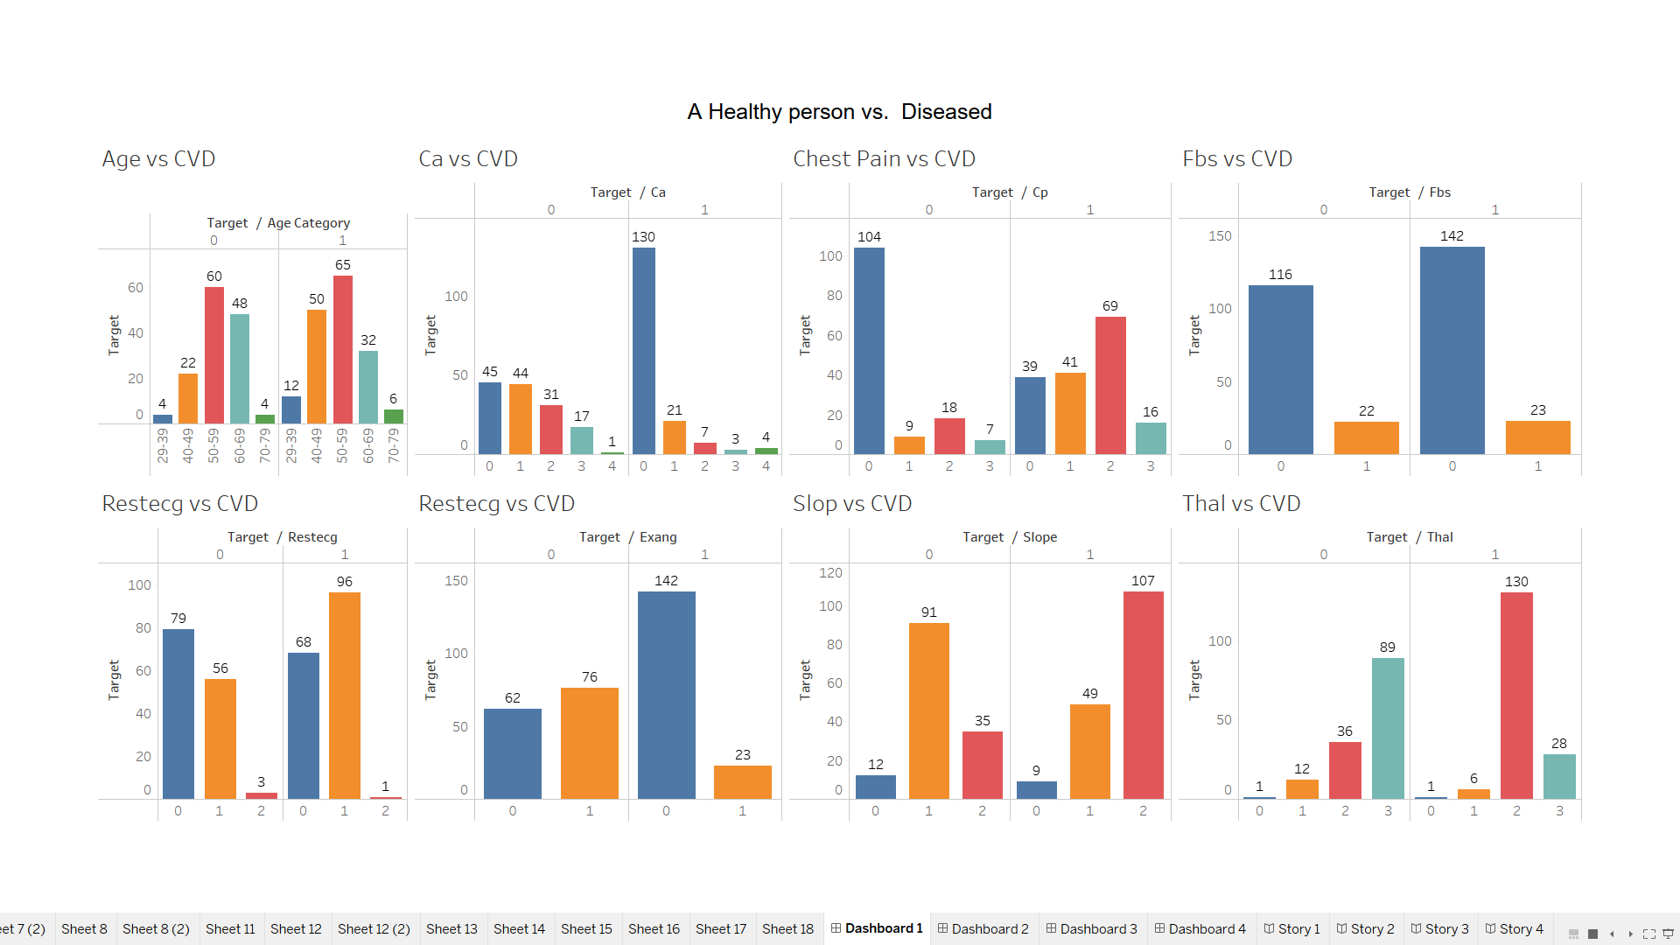

Dashboard 2

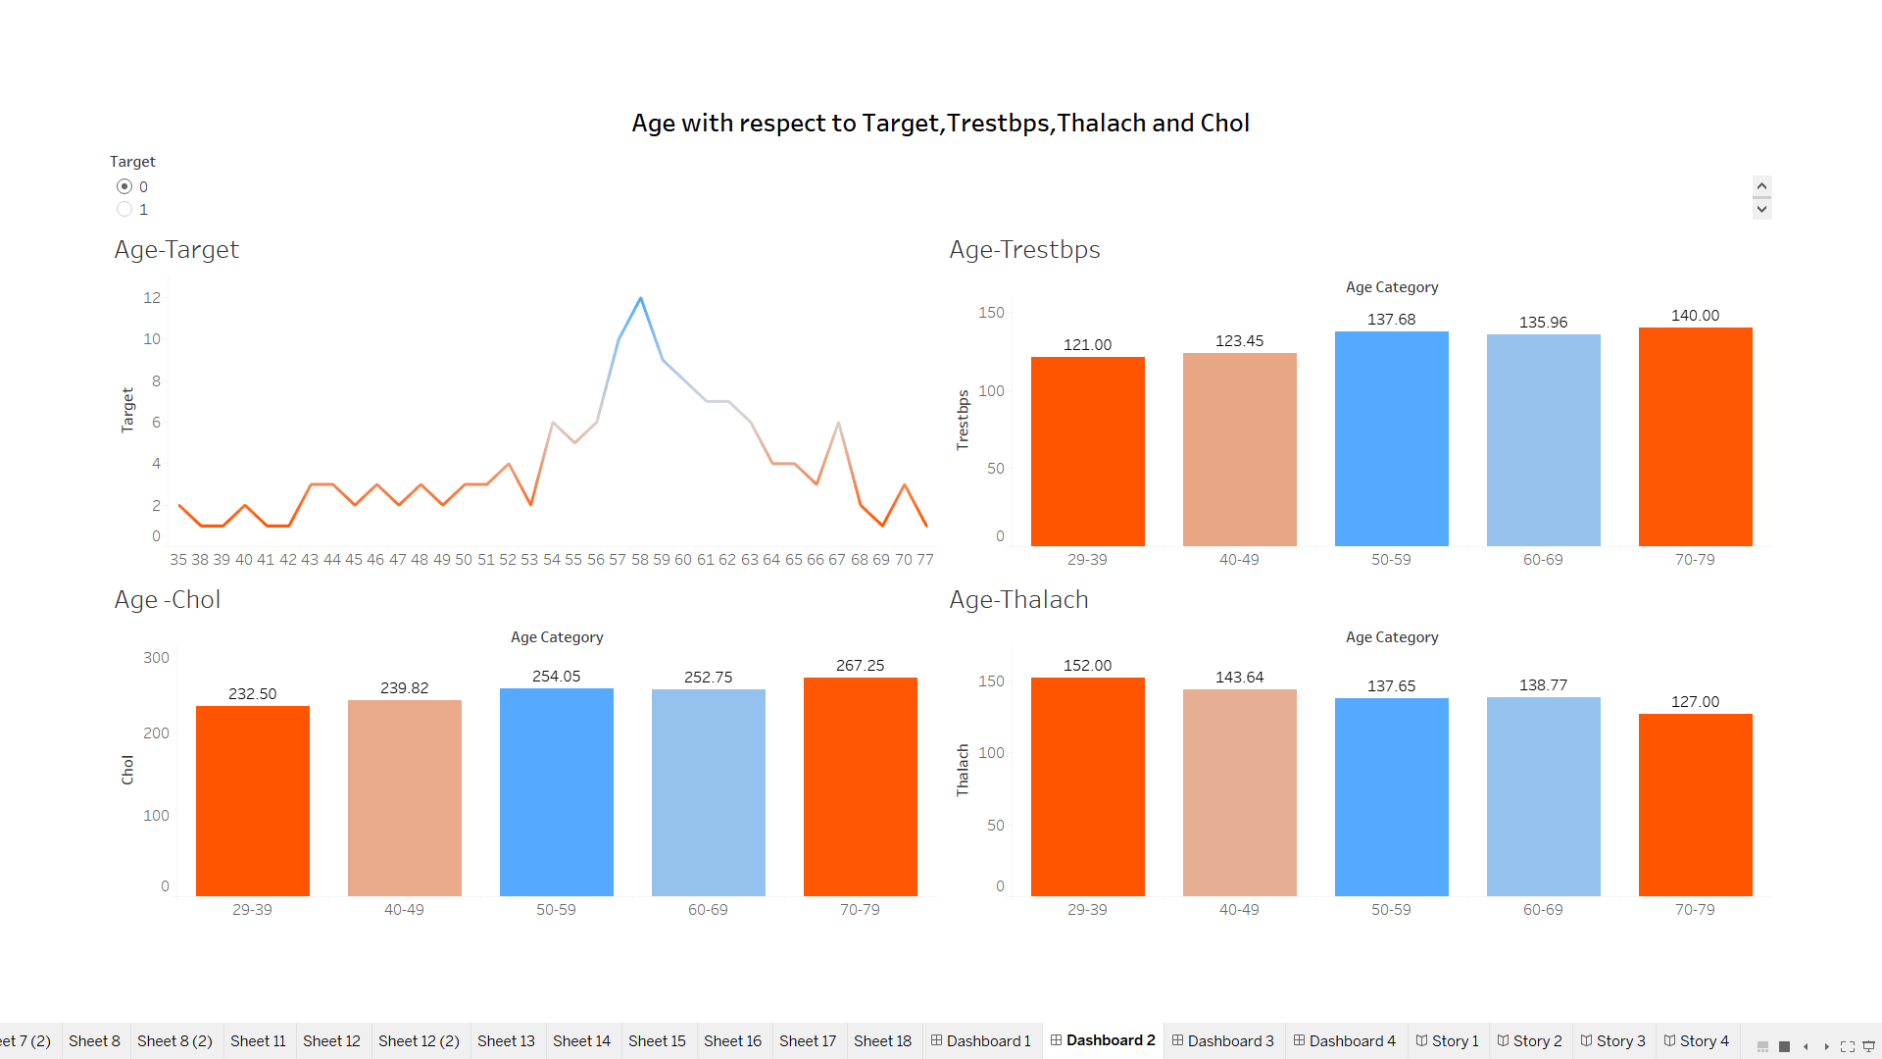

Dashboard 3

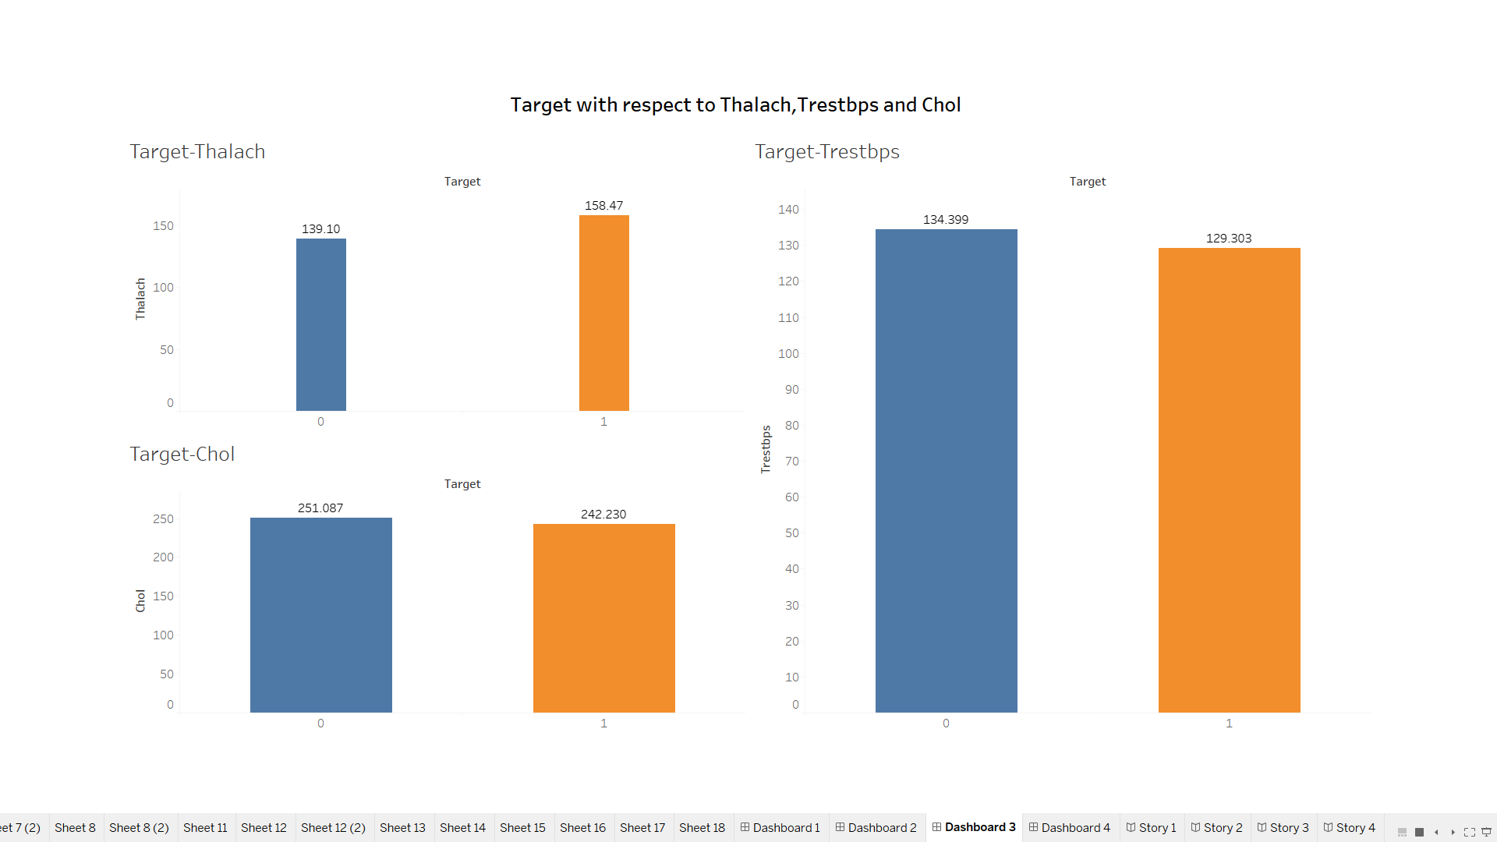

Dashboard 4

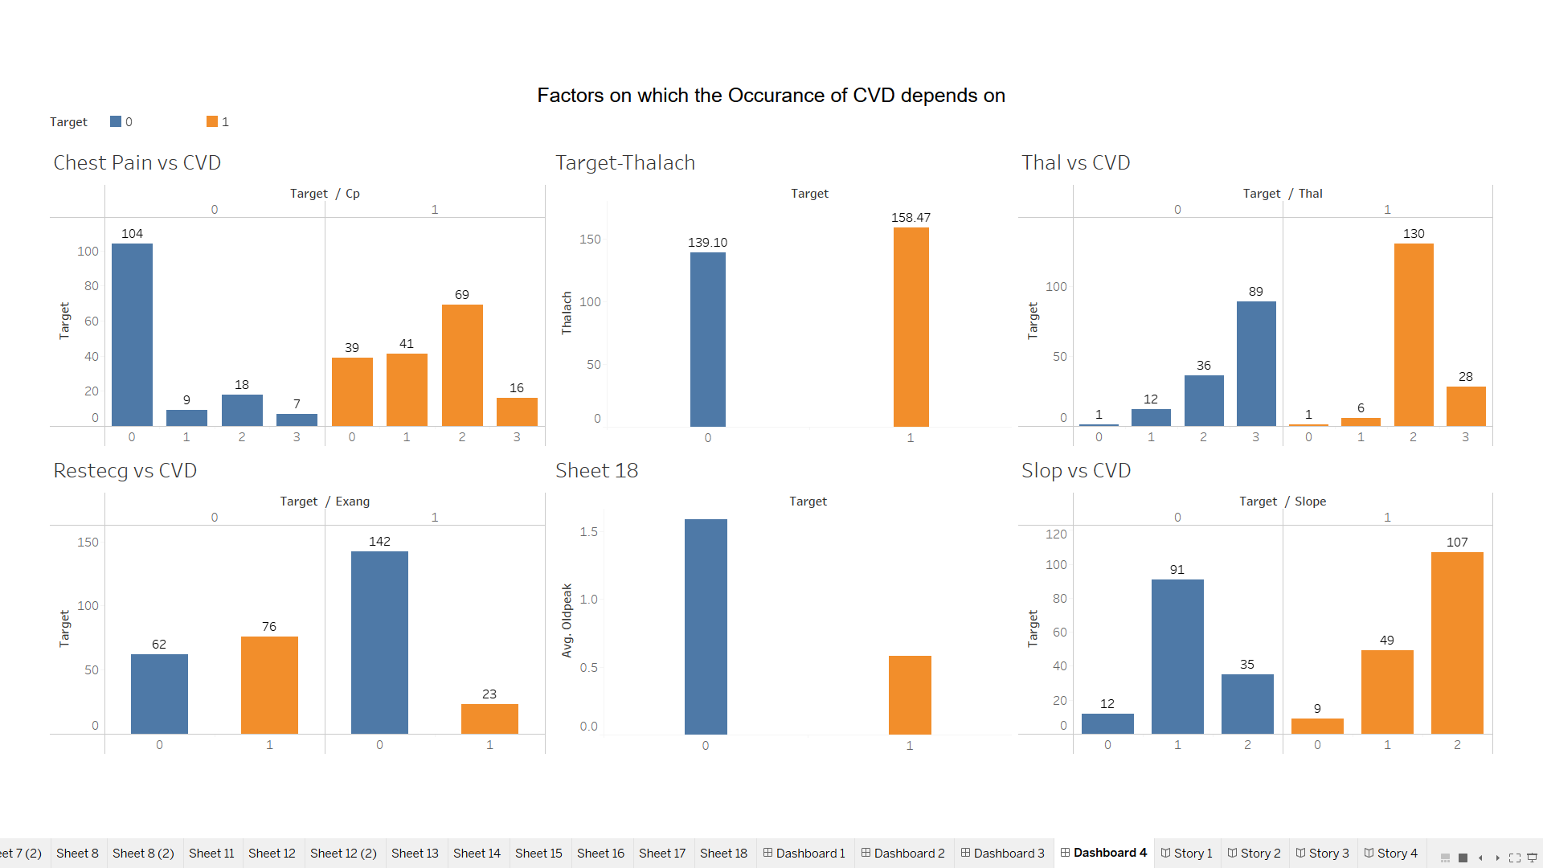

Story 1

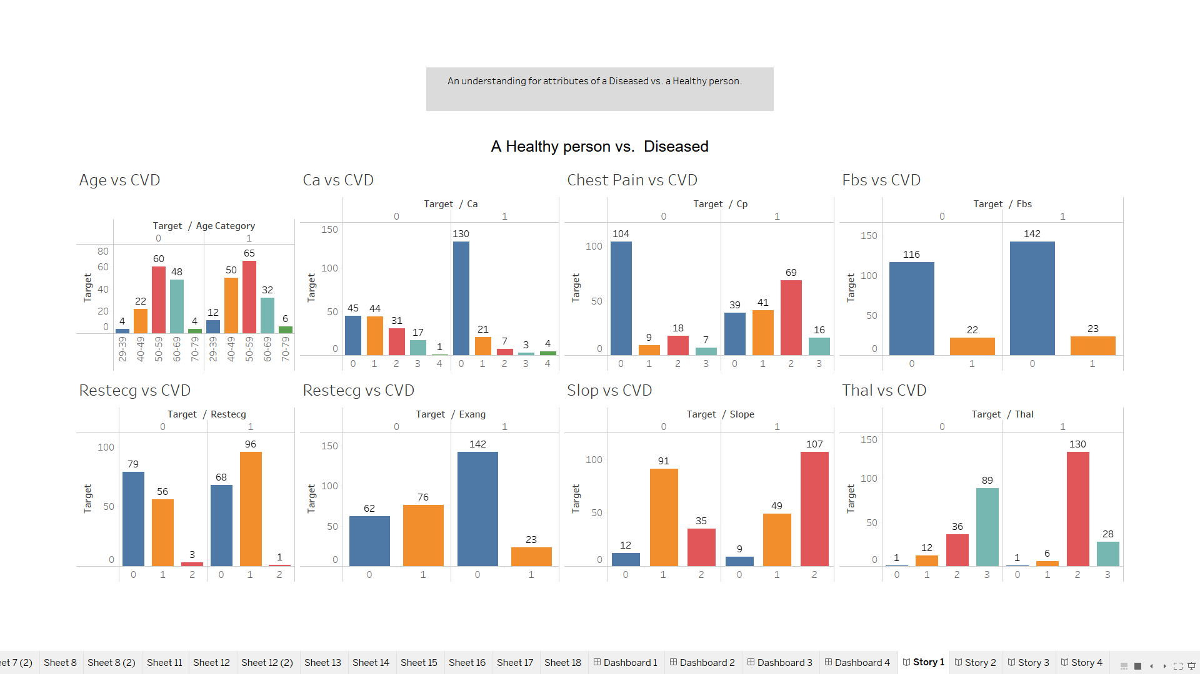

Story 2

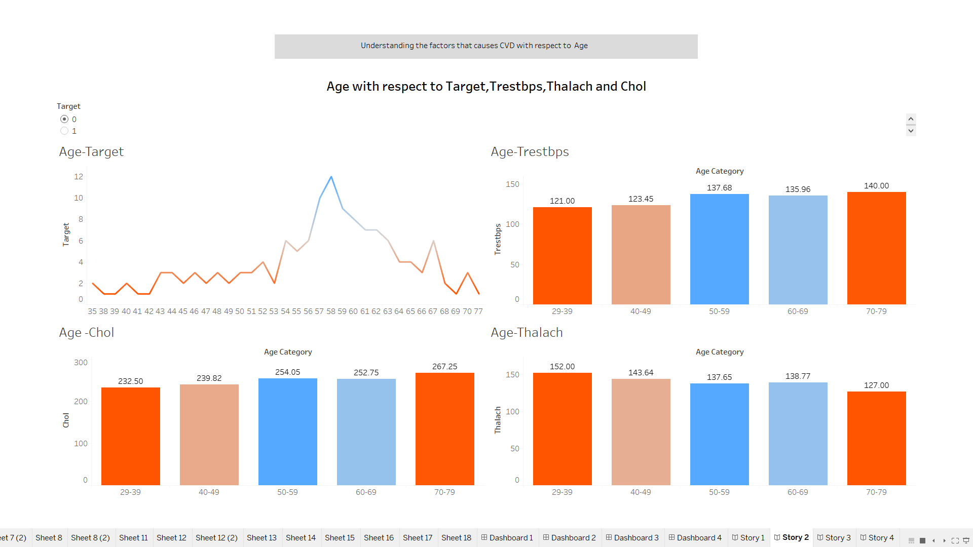

Story 3

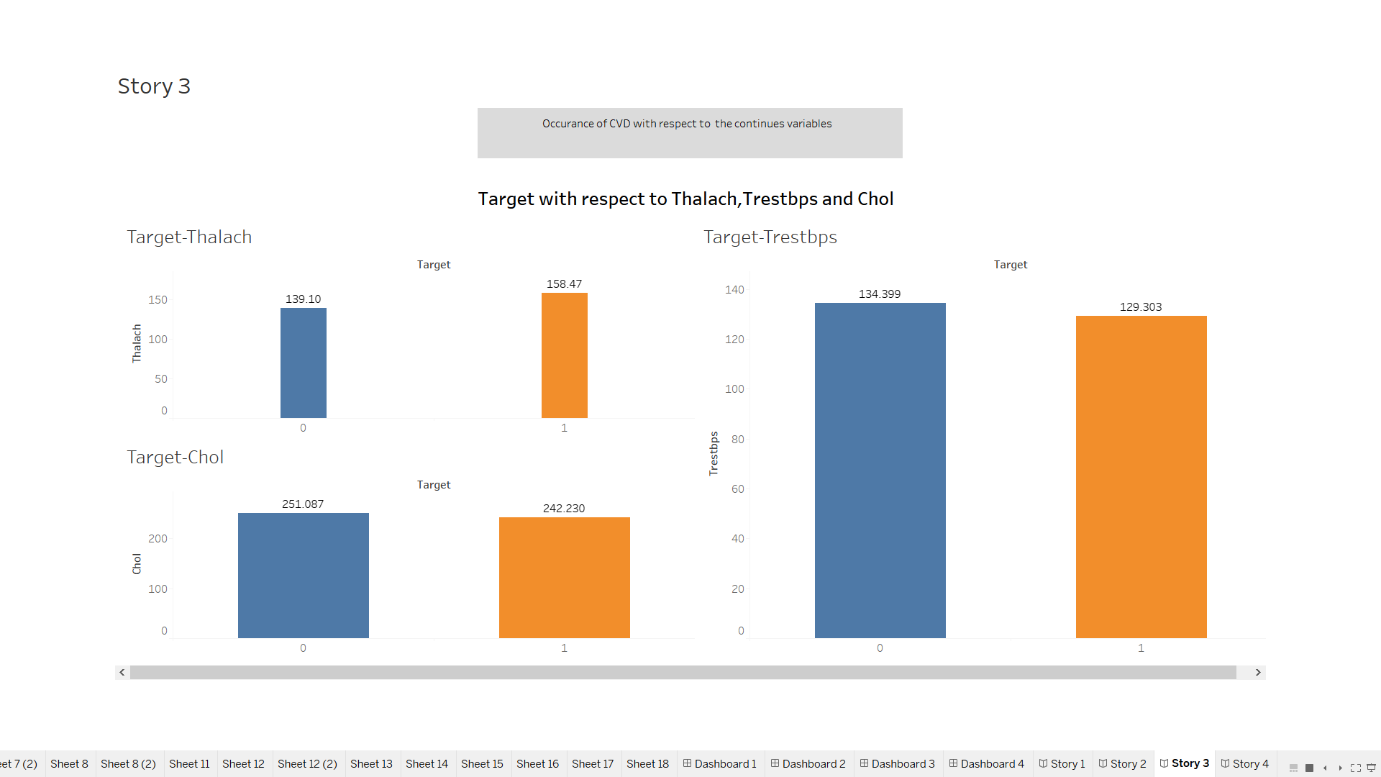

Story 4:

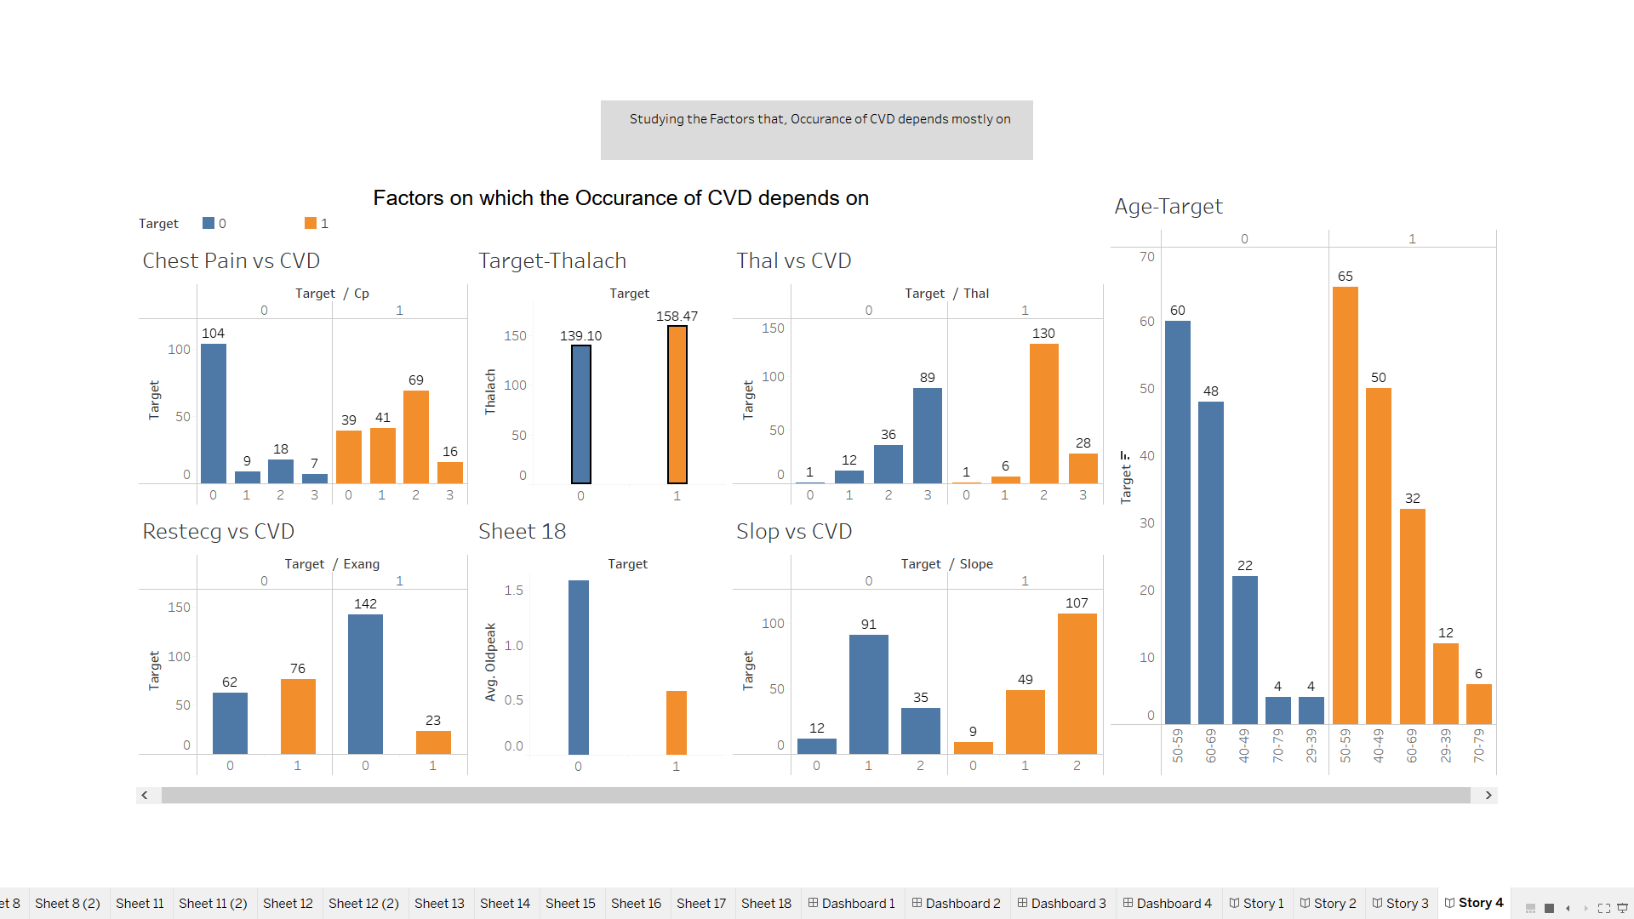

Link: https://public.tableau.com/views/Capstoneproject_16197715308030/Story4?:language=en&:display_count=y&publish=yes&:origin=viz_share_link