Optracare Facebook & Instagram Lead Generation Ad

Description
Physiotherapy Lead Ad | 15 Days
Ad Budget | Lifetime Budget - ₹10000 (incl tax)
Ad Placements | Facebook & Instagram feeds, stories and marketplace | Ad creative below
Result Estimation | Reach - 3 to 10K people (per day) | 3 to 6 leads (per day) | Estimated 13 to 26 leads in 15 days.
Ad Location | Koramangala | Radius 10 Km
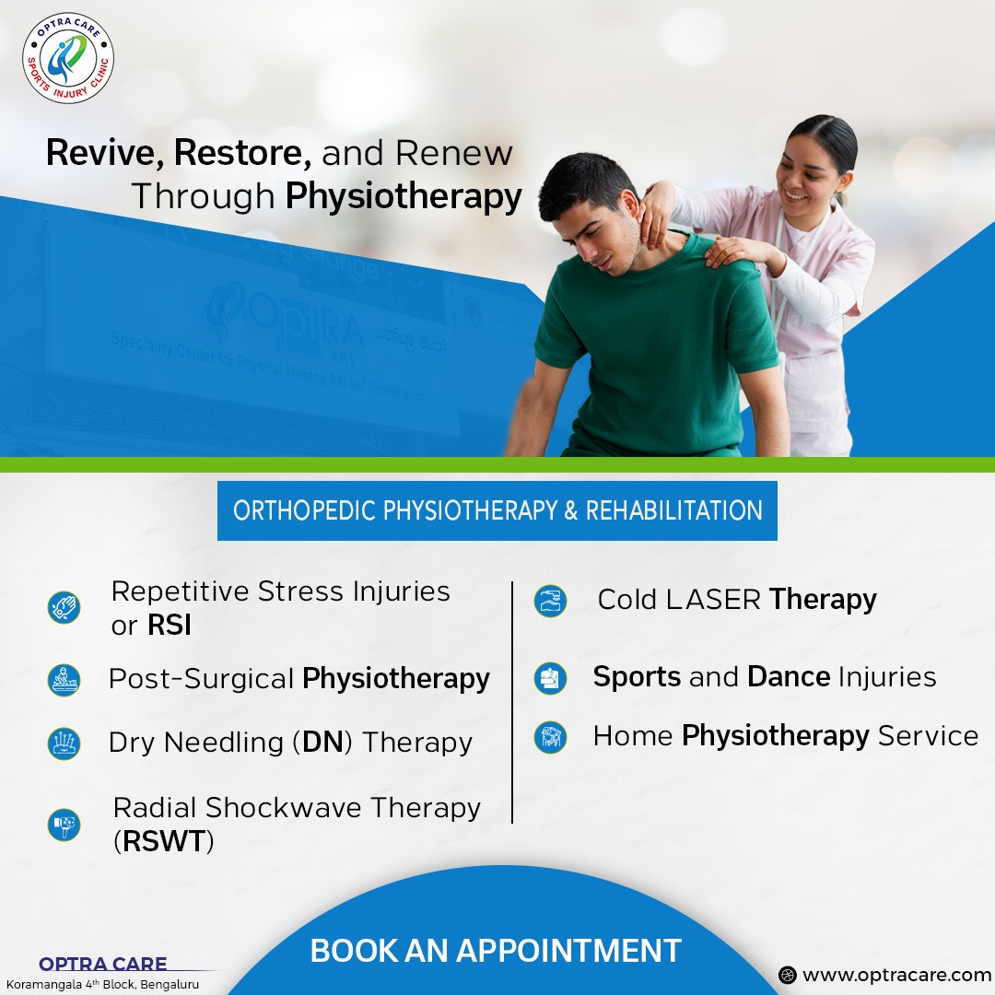

Form looks like this…we can add questions and form details.

