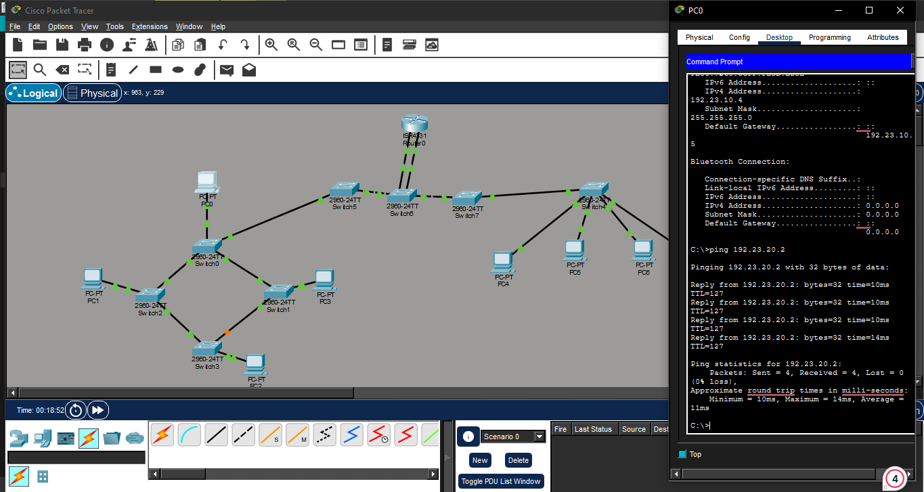
2.) Implement an intervlan with two vlans vlan10 and vlan20 vlan10 design using ringtopology and vlan 20 using bus topology

