EXPERIMENT–1
IoE Sensor Data Acquisition and Preprocessing using Python in Google Colab

Aim;
To acquire IoE sensor data, perform preprocessing techniques such as handling missing values, removing duplicates, detecting outliers, normalizing data, and preparing the dataset for AI/ML applications using Python in Google Colab.
Objectives;
- Understand IoE sensor datasets.
- Import IoE sensor data into Python.
- Perform data cleaning.
- Handle missing values.
- Remove duplicate records.
- Normalize sensor values.
- Visualize the processed data.
- Prepare the dataset for machine learning.
- Software Requirements
- Google Colab
- Python 3
- Pandas
- NumPy
- Matplotlib
- Seaborn
- Scikit-learn
- Theory
- Internet of Everything (IoE)
The Internet of Everything (IoE) extends the Internet of Things (IoT) by integrating four major components:
- People
- Processes
- Data
- Things
Sensor devices continuously generate environmental data such as:

- Temperature
- Humidity
- Pressure
- Gas concentration
- Heart Rate
- Oxygen Saturation
- Before AI models can use this information, the raw sensor data must undergo preprocessing.
Data Acquisition
Data acquisition is the process of collecting information from sensors.
Example sensors include:

- Temperature Sensor
- Humidity Sensor
- Motion Sensor
- Gas Sensor
- Heart Rate Sensor
- GPS Sensor
- Data Preprocessing

Data preprocessing includes:
Missing Value Handling
Replace missing values using

- Mean
- Median
- Mode
- Duplicate Removal
- Remove repeated records.
- Outlier Detection
- Detect abnormal values using
- IQR
- Z-score
- Normalization
- Convert values into the same range (0–1).
- Visualization
- Visualize data using
- Histograms
- Boxplots
- Scatter plots
- Correlation matrix

Algorithm;
Step 1
Start Google Colab.
Step 2
Import required libraries.
Step 3
Load IoE sensor dataset.
Step 4
Display dataset.
Step 5
Check missing values.
Step 6
Fill missing values.
Step 7
Remove duplicate records.
Step 8
Normalize sensor values.
Step 9
Visualize sensor readings.
Step 10
Save cleaned dataset.
Step 11
Stop.

Flowchart;
Start
│
Import Libraries
│
Load Dataset
│
Check Missing Values
│
Fill Missing Values
│
Remove Duplicates
│
Normalize Data
│
Visualize Data
│
Save Dataset
│
End

Python Program (Google Colab);
# Sensor Data Acquisition and Preprocessing using Python

import pandas as pd
import matplotlib.pyplot as plt

# ----------------------------
# Step 1: Create Sensor Dataset
# ----------------------------
sensor_data = {
"Temperature":[28,29,30,31,29],
"Humidity":[65,66,68,69,67],
"Pressure":[1012,1011,1010,1013,1011],
"HeartRate":[78,80,81,79,80],
"SpO2":[98,99,97,98,99]
}

df = pd.DataFrame(sensor_data)

# Save dataset
df.to_csv("sensor_data.csv", index=False)

# ----------------------------
# Step 2: Read Dataset
# ----------------------------
df = pd.read_csv("sensor_data.csv")

print("Original Dataset")
print(df)

# ----------------------------
# Step 3: Data Preprocessing
# ----------------------------

# Check missing values
print("\nMissing Values:")
print(df.isnull().sum())

# Remove duplicate rows
df = df.drop_duplicates()

# Display cleaned dataset
print("\nCleaned Dataset")
print(df)

# Statistical Summary
print("\nStatistical Summary")
print(df.describe())

# ----------------------------
# Step 4: Data Visualization
# ----------------------------

# Temperature
plt.figure(figsize=(6,4))
plt.plot(df["Temperature"], marker='o')
plt.title("Temperature")
plt.xlabel("Sample")
plt.ylabel("Temperature (°C)")
plt.grid()
plt.show()

# Humidity
plt.figure(figsize=(6,4))
plt.plot(df["Humidity"], marker='o')
plt.title("Humidity")
plt.xlabel("Sample")
plt.ylabel("Humidity (%)")
plt.grid()
plt.show()

# Heart Rate
plt.figure(figsize=(6,4))
plt.bar(df.index, df["HeartRate"])
plt.title("Heart Rate")
plt.xlabel("Sample")
plt.ylabel("Heart Rate (BPM)")
plt.show()

# SpO2
plt.figure(figsize=(6,4))
plt.bar(df.index, df["SpO2"])
plt.title("SpO2")
plt.xlabel("Sample")
plt.ylabel("SpO2 (%)")
plt.show()

# Pressure
plt.figure(figsize=(6,4))
plt.plot(df["Pressure"], marker='o')
plt.title("Pressure")
plt.xlabel("Sample")
plt.ylabel("Pressure (hPa)")
plt.grid()
plt.show()

print("\nExperiment Completed Successfully!")
Sample Dataset (sensor_data.csv)
Temperature Humidity Pressure HeartRate SpO2
28 65 1012 78 98
29 66 1011 80 99
30 68 1010 81 97
31 69 1013 79 98
29 67 1011 80 99a

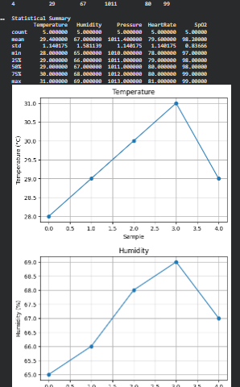

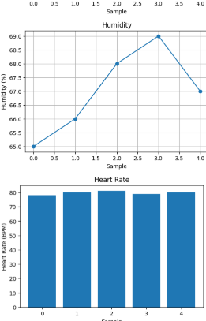
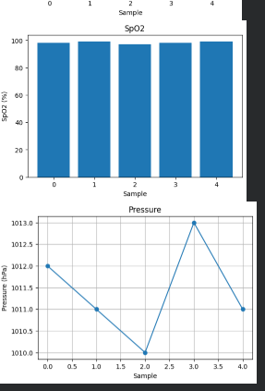

Result;
The IoE sensor dataset was successfully acquired, preprocessed, normalized, and visualized using Python in Google Colab. The cleaned dataset is now suitable for AI and machine learning applications.

