Experiment No. 2: Real-Time Heart Rate Stream Analytics and High–Low Anomaly Detection using Python (Google Colab)

AIM
To design and implement a real-time heart rate stream analytics system and perform high and low heart rate anomaly detection using Python in Google Colab.

OBJECTIVE
- Generate real-time heart rate sensor data.
- Simulate real-time data streaming using Python.
- Analyze incoming heart rate data.
- Detect high and low heart rate anomalies.
- Display real-time graphs.
- Store heart rate data for future analysis.

SOFTWARE REQUIRED
- Google Colab
- Python 3
- pandas
- matplotlib
- numpy

THEORY
Heart rate monitoring is an important application in IoE healthcare systems. Sensor data is continuously collected and analyzed to detect abnormal heart rate conditions.
In this experiment, heart rate data is generated and analyzed in real time using Python. The system classifies heart rate readings as Normal, Low Anomaly, or High Anomaly based on predefined threshold values.

Heart Rate Categories:
- Heart Rate < 60 BPM → Low Anomaly (Bradycardia)
- Heart Rate = 60–100 BPM → Normal
- Heart Rate > 100 BPM → High Anomaly (Tachycardia)
The collected data is stored, analyzed, and visualized using line graphs with threshold lines.

SAMPLE DATA
Time | Heart Rate (BPM)
1 | 72
2 | 78
3 | 55
4 | 80
5 | 98
6 | 110
7 | 76
8 | 58
9 | 125
10 | 85

ALGORITHM
- Start the program.
- Generate heart rate readings.
- Store the heart rate data.
- Display the dataset.
- Compare each reading with threshold values.
- If heart rate < 60 BPM, mark it as Low Anomaly.
- If heart rate > 100 BPM, mark it as High Anomaly.
- Otherwise, mark it as Normal.
- Plot the heart rate graph with threshold lines.
- Highlight anomalies on the graph.
- Display the number of normal, low, and high anomaly readings.
- Stop the program.

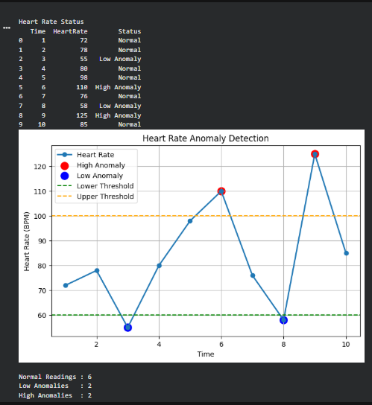

RESULT
The real-time heart rate stream analytics system successfully generated heart rate data, analyzed the readings, detected both low and high heart rate anomalies using predefined threshold values, and visualized the results using Python in Google Colab. The experiment demonstrates how real-time health monitoring can identify abnormal heart rate conditions and support IoE-based healthcare applications.

