TDIS / TEXAS DISASTER SUPPORT

Damage Assessment Tab
Frontend Implementation Specification
A single top-level Damage Assessment tab with three compact circular map-view controls. H3 aggregation is the default view.
Scope: frontend navigation, Mapbox layers, interaction state, and data integration. The existing HASTE / DamageTriageFormer inference pipeline remains unchanged.
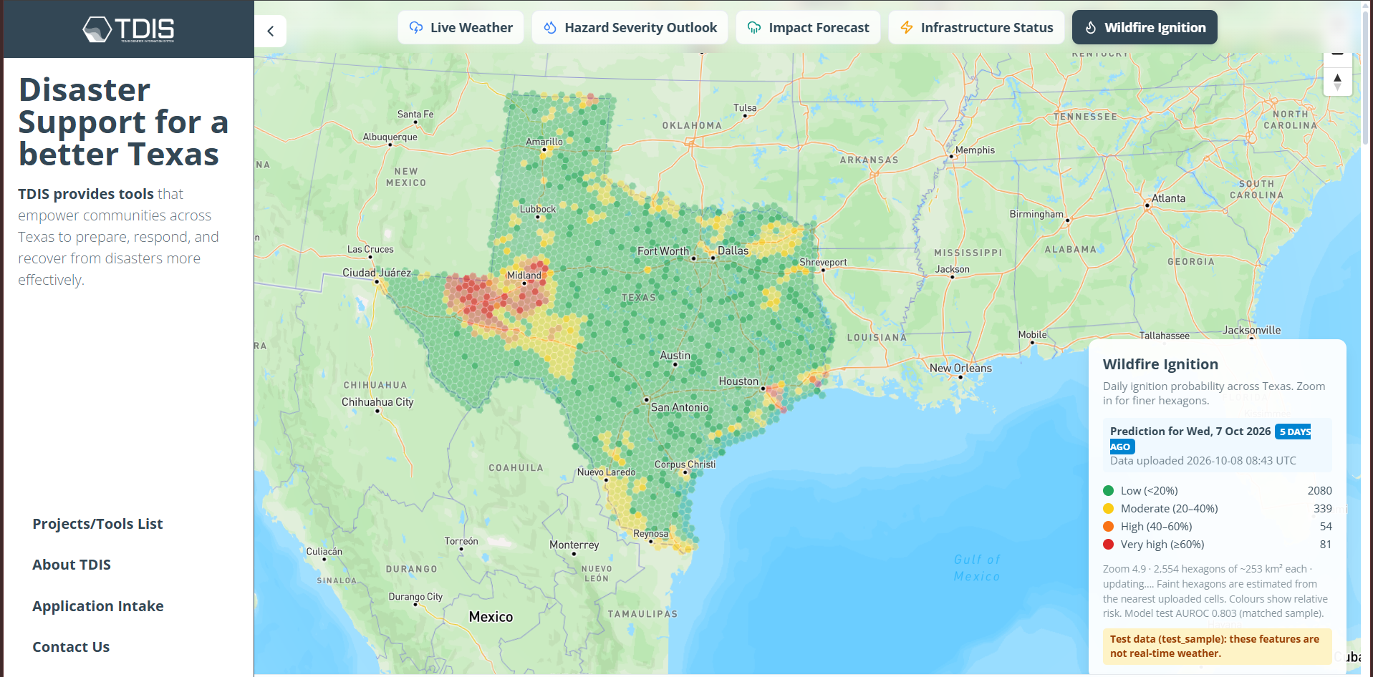
Reference 1 — Current TDIS map UI. Add Damage Assessment beside the existing map modes.
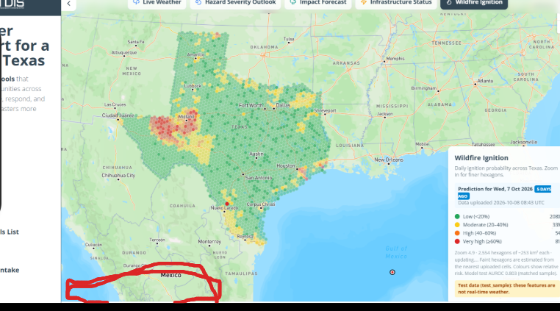
Reference 2 — User markup showing the intended bottom-left control area. The red annotation is not part of the final UI.
Version 1.0 | 12 October 2026

1. Objective
Add a Damage Assessment tab to the existing top horizontal map-navigation bar, alongside Live Weather, Hazard Severity Outlook, Impact Forecast, Infrastructure Status, and Wildfire Ignition.
- Selecting Damage Assessment activates the tab and opens the Damage Assessment map context.
- H3 hierarchical damage map is selected by default.
- Three small circular icon buttons appear at the bottom-left inside the map viewport.
- The icons switch between H3 Aggregation, Building Damage, and Building Density without leaving the tab.
- The active icon, visible map layer, legend, and summary remain synchronized.

2. Top Navigation Tab
Add a tab named Damage Assessment near the existing disaster map modes, preferably beside Wildfire Ignition. Match the current tab height, radius, font, icon size, padding, spacing, and dark active state. Use a building or shield-alert icon consistent with the app's current icon library.
- If the navigation row becomes crowded, use existing responsive overflow or horizontal scrolling.
- Switching to another top tab should preserve the Damage Assessment view selection when the user returns, unless the product deliberately resets modes.

3. Three Round View Controls
Show these controls only while Damage Assessment is active. Position them at the bottom-left of the map viewport, inside the map and clear of the white application sidebar, attribution, map controls, and fixed overlays. They are compact round icon buttons, not large cards or separate top-level tabs.
Icon concept | View name | Purpose
Hexagon / grid | H3 Aggregation | Default; aggregated damage by H3 cell
Building / footprint | Building Damage | Individual building polygons and class labels
Heat / radar | Building Density | Urban building concentration

Control styling and accessibility
- Use a consistent circular diameter, padding, and gap.
- Inactive controls use a neutral translucent surface; active control uses the app's high-contrast active treatment.
- Provide hover, keyboard-focus, active, and loading/disabled states.
- Add tooltips and accessible names; icons alone are insufficient.
- Keep the group inside the viewport on narrow screens and above any fixed bottom overlays.
- Do not reproduce the red annotation in the product UI.

4. Default Behavior
- activeTopTab = damage-assessment
- activeDamageView = h3
- Show H3 polygons, H3 legend, and cell summary.
- Hide building damage and density layers.
- Activate the H3 circular icon.
- Do not start inference when the tab opens or when the user switches views.

5. The Three Visualization Modes

A. H3 Hierarchical Damage Map — Default
- Render real H3 cell polygons using backend-provided cell summaries.
- Color by a clearly named metric, such as dominant damage class or severe-damage percentage.
- Show a legend and identify the selected metric.
- Selecting a cell displays its H3 index/resolution and aggregated counts/percentages.
- Transition to finer available H3 resolutions according to a tested zoom configuration.
- H3 cells are aggregation units, not building boundaries.

B. Building-Level Damage Map
Render actual source building footprints. Each building polygon uses its own stored DamageTriageFormer class.
Exact class label | Color | Hex
Undamaged | Green | #22A65A
Partial Roof Damage | Yellow | #F5D547
Total Roof Damage | Orange | #F28C28
Partial Structural Collapse | Red | #E44747
Total Structural Collapse | Dark red | #991F36
- On click, show building_id, exact class, damage percentage if defined, confidence if available, assessment timestamp/version, and imagery reference.
- Use one shared color mapping across the map, legend, popup, and detail panel.
- At low zoom, avoid rendering every footprint; use H3/density until zoomed in.

C. Building-Density Heatmap
- Show where buildings are concentrated, independently of damage severity.
- Use one representative point per footprint or precomputed density tiles.
- Use a subtle pale-mint-to-teal palette with lower opacity at broad scales; sparse areas remain mostly transparent.
- Label the legend Building Density, not Damage Severity.
- A standard Mapbox heatmap is smoothed relative concentration, not exact buildings per km². Compute exact density in the backend if required.
- Do not use damage-class colors for the building-density layer.

6. Interaction Flow
User selects Damage Assessment → H3 opens by default → user selects one of the three round icons → corresponding layer and legend become visible → selected AOI and map position remain stable.
The Markdown companion includes the Mermaid flowchart and component/state examples for direct use by an IDE agent.

7. Suggested Component Structure
MapWorkspace
├── TopMapNavigation
│ └── DamageAssessmentTab
├── MapViewport
│ ├── MapboxMap
│ ├── DamageAssessmentLayers
│ │ ├── H3AggregationLayer
│ │ ├── BuildingDamageLayer
│ │ └── BuildingDensityHeatmapLayer
│ ├── DamageViewSwitcher # three round icons, bottom-left
│ ├── DamageLegend
│ └── SelectedFeaturePanel
└── ExistingSidebar / ExistingMapCards

8. State and Layer Visibility
Recommended view state: "h3" | "building-damage" | "building-density". Reuse the existing Mapbox map instance if consistent with the application architecture.
- H3: show H3 fill/outline and H3 legend; hide other damage layers.
- Building Damage: show footprint polygons and five-class legend; hide H3 fill and density.
- Building Density: show density heatmap; hide building class fills and H3 damage fills.
- Keep map center, zoom, and selected AOI stable while switching modes.
- Clear incompatible selected features or preserve them only when meaningful in the new mode.

9. Data Integration
The frontend reads existing assessment data; it must not implement or invoke model inference.
- GET /api/assessments/h3?resolution={r}&bbox={bbox}&aoi_id={id}
- GET /api/assessments/buildings?bbox={bbox}&damage_class={class}
- GET /api/assessments/buildings/{building_id}
- GET /api/assessments/building-density?bbox={bbox}&zoom={z}
These are proposed endpoint shapes; adapt them to the existing backend. Use vector tiles or viewport-based requests for large datasets. Debounce viewport requests, cancel obsolete requests, cache where appropriate, and handle loading, empty, error, and stale-data states.

10. Responsive Layout
- Top tab stays in the existing top map-navigation row.
- Round controls sit inside the map viewport at bottom-left, never inside the left white sidebar.
- Keep clear of attribution, scale/zoom controls, and fixed banners.
- On desktop, display all three controls horizontally; on narrow screens, reduce gaps or reposition within the map.
- Use existing TDIS fonts, color tokens, shadows, focus rings, and z-index conventions.

11. Acceptance Criteria
- Damage Assessment appears beside the existing map modes.
- Selecting it opens H3 by default.
- Exactly three small round controls appear at the annotated bottom-left map position.
- The controls switch among H3, Building Damage, and Building Density.
- The active control and legend match the visible layer.
- Building Damage uses actual footprints and the five exact class labels.
- Building Density represents building concentration, not damage severity.
- View switching preserves map center/zoom and AOI where appropriate.
- No map interaction triggers model inference.
- Controls work at supported desktop/mobile sizes and existing tabs have no regressions.

12. Implementation Order
- Inspect existing navigation, map component, icon library, and CSS tokens.
- Add the Damage Assessment tab and active-tab state.
- Add the three circular controls at the annotated map position.
- Make H3 the default and wire active-state styling.
- Connect H3 data, layer, legend, and cell interaction.
- Connect building footprints, five-class styling, and detail panel.
- Connect building-density heatmap and legend.
- Add loading/error states, responsive behavior, and shared map state.
- Compare implementation with supplied references and test existing tabs.
- Verify that zoom, pan, clicks, and view changes never trigger inference.

Final Rule
One Damage Assessment top tab; three compact round visualization controls inside the map; H3 is the default. The three controls are view modes within Damage Assessment, not separate top-level tabs.

