DAMAGE ASSESSMENT
VISUALIZATION TECHNICAL DESIGN
Three-view architecture, algorithms, spatial methods, APIs, and validation

Scope: visualization and spatial serving over assessment data supplied to the project

Reference imagery
These supplied images are conceptual references for the H3-style grid and regional damage visualization. They are not treated as authoritative data or exact final styling.

Reference A — Hexagonal spatial grid concept
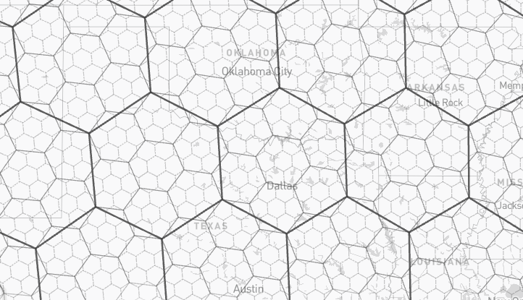
Illustrates a hexagonal spatial index overlay across a regional map.

Reference B — Regional H3 damage summary concept
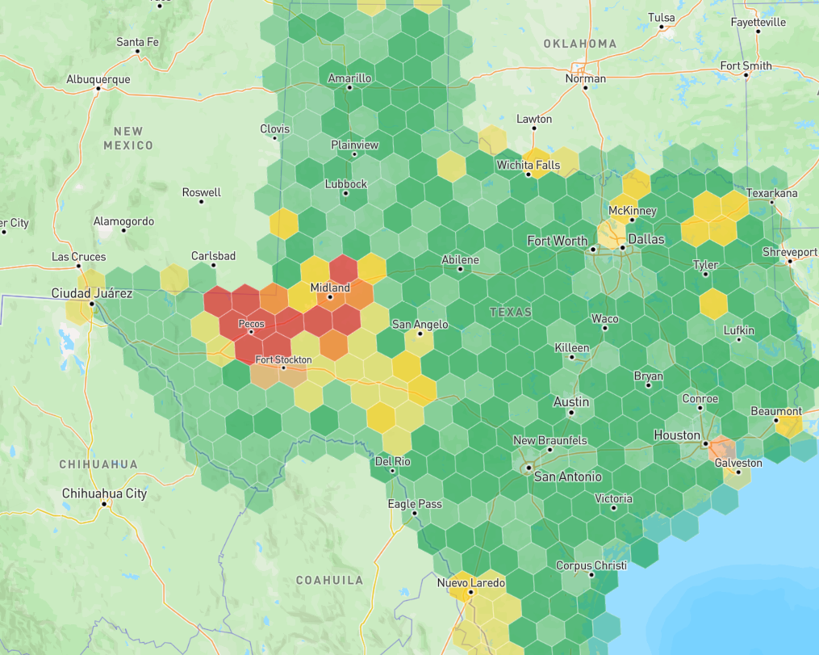
Illustrates hexagonal cells colored by an aggregated regional metric.

Document type: Technical design specification
Scope: Visualization, spatial aggregation, serving, and map interaction only
Primary frontend: Mapbox GL JS
Spatial index: H3
Spatial database: PostgreSQL with PostGIS (or the equivalent spatial database already used by the project)

1. Objective
Build three map views over the assessment records and building footprints supplied for the project:
- **H3 Hierarchical Damage Map** — regional-to-local summaries represented by H3 cells.
- **Building-Level Damage Map** — actual building footprint polygons, each styled using its own damage class.
- **Building-Density Heatmap** — a view of where buildings are concentrated, independent of their damage classes.
All three views must use a consistent assessment version and stable building identifiers. Switching views, zooming, panning, or selecting a feature must not start a new assessment computation. The map is a visualization and read-serving layer over the data supplied to it.

2. Scope and design principles

In scope
- H3 cell summaries and hierarchical rollups.
- Building-footprint vector tiles and per-building detail lookup.
- Building-density heatmap or precomputed density grid.
- Map viewport handling, feature selection, legends, and tooltips.
- Version-aware APIs, caching, and performance controls.
- Validation of spatial counts and consistency between the three views.

Explicit design constraints
- H3 cells are aggregation areas, **not building boundaries**.
- A building must be counted once per H3 resolution for building-count metrics.
- The density view represents building concentration by default, not damage severity.
- “Not assessed” must not be displayed as “Undamaged.”
- Use the five damage class names exactly as defined below.
- Do not send the entire Texas building inventory to the browser in one response.
- Do not calculate statewide aggregates repeatedly during map navigation.

3. Shared data contract
The visualization layer assumes that the project supplies the required records. It does not define a data-ingestion or model-processing workflow.
Field | Purpose | Requirement
`building_id` | Stable identity used for selection and detail lookup | Required and unique
`geometry` | Building footprint polygon/multipolygon | Required for building view
`damage_class` | One of the five exact labels below, or an explicit unassessed/null state | Required when assessed
`assessment_version` | Identifies a consistent assessment snapshot | Required
`updated_at` | Timestamp for the supplied assessment record | Recommended
`damage_percentage` | Optional supplied metric; display only if its definition is documented | Optional
`confidence` | Optional supplied confidence value; display only if available and defined | Optional
`imagery_reference` | Optional pointer to supporting imagery | Optional
`representative_point` | One stable point within each footprint for H3 assignment and density rendering | Derivable from geometry if not supplied

Exact damage classes and map colors
Exact class label | Color | Hex
`Undamaged` | Green | `#22A65A`
`Partial Roof Damage` | Yellow | `#F5D547`
`Total Roof Damage` | Orange | `#F28C28`
`Partial Structural Collapse` | Red | `#E44747`
`Total Structural Collapse` | Dark red | `#991F36`

Use the same labels and colors in the map, legend, detail panel, and any exported visualization. Missing or unassessed records must use a separate neutral/transparent treatment.

4. High-level architecture
flowchart TD
A[Assessment records and building footprints supplied to the project] --> B[(Spatial database / PostGIS)]
B --> C[H3 summary service]
B --> D[Building vector-tile service]
B --> E[Building-density service]
C --> F[Versioned read APIs and cache]
D --> F
E --> F
F --> G[Mapbox GL JS frontend]
G --> H[H3 hierarchical damage map]
G --> I[Building-level damage map]
G --> J[Building-density heatmap]
G --> K[Feature selection and detail panel]

Component responsibilities
- **Spatial database:** authoritative read source for stable building IDs, geometries, supplied damage classes, available metrics, and assessment version.
- **H3 summary service:** returns precomputed or efficiently queried cell summaries and parent-level aggregates.
- **Building vector-tile service:** returns only features intersecting the requested map tile, with zoom-appropriate geometry detail.
- **Building-density service:** returns representative building points or density tiles/grids.
- **Read API/cache:** enforces version consistency and avoids repeating expensive spatial work.
- **Mapbox GL JS:** renders the three views and manages map navigation, highlighting, selection, legends, and popups/details.

5. View A — H3 hierarchical damage map

5.1 What H3 contributes
H3 partitions geographic space into a hierarchy of hexagonal cells (with pentagons also present in the global grid). Its resolutions are numbered 0–15; higher resolutions represent smaller cells. A fine cell has a parent at each coarser resolution.
H3 is suitable for regional summaries because the frontend can switch between larger and smaller spatial units without drawing every building at every zoom level. It is not a replacement for building footprints.

5.2 Resolution strategy
Treat this as an initial tuning range, not a fixed zoom-to-resolution mapping.
H3 resolution | Approximate average edge length | Intended display scale
3–4 | ~23–60 km | Statewide and very broad regions
5–6 | ~3–9 km | Large regions and county-scale overview
7–8 | ~0.46–1.2 km | Cities and subregions
9–10 | ~66–174 m | Neighborhoods
11–12 | ~9–25 m | Fine local aggregation
13–15 | ~0.5–3.5 m | Usually unnecessary for damage-cell visualization unless testing proves otherwise

Lengths are approximate averages; actual cell dimensions vary. Start by testing resolutions 4–12 with real map data and choose the display resolution using both map zoom and the number of visible cells. Avoid a simplistic one-to-one mapping from Mapbox zoom to H3 resolution.

5.3 Assign each building to one cell
For building-count metrics, assign each building to exactly one H3 cell at a given resolution.
Recommended rule:
- Use a representative point guaranteed to be inside the building footprint, such as a point-on-surface.
- Compute the H3 index for that point at the selected resolution.
- Store the stable `building_id` with that cell assignment.
- Do not count a building in every H3 cell that its footprint intersects. That inflates building counts along cell boundaries.
If a future metric explicitly measures footprint area inside each cell, implement it as a separate area-weighted metric and label it accordingly.

5.4 Cell summary fields
Recommended summary fields:
- h3_index
- h3_resolution
- parent_h3_index
- building_count
- assessed_building_count
- undamaged_count
- partial_roof_damage_count
- total_roof_damage_count
- partial_structural_collapse_count
- total_structural_collapse_count
- damaged_building_count
- severe_damage_count
- numerator and denominator fields for any percentage metrics
- assessment_version
- updated_at
Define “damaged” and “severe damage” explicitly in the product logic. A reasonable proposed definition for severe damage is the two structural-collapse classes, but it must be approved as the metric definition rather than silently assumed.

5.5 Aggregation algorithm
For each supplied building record:
validate building_id and footprint
choose one representative point inside the footprint
for each supported H3 resolution:
h3_index = H3(point, resolution)
increment building_count for h3_index
if the record is assessed:
increment assessed_building_count
increment exactly one damage-class counter
update defined damage/severity numerators and denominators
For each parent H3 cell:
sum child counts and class counts
sum metric numerators and denominators
calculate percentages from summed numerators / summed denominators
persist the summary under the same assessment_version
Do not average child percentages without weighting. If child A has 10 buildings and a 50% damage rate, and child B has 1,000 buildings and a 10% damage rate, the parent rate must be calculated from total damaged buildings divided by total assessed buildings—not the average of 50% and 10%.

5.6 Example
Suppose one cell contains 100 assessed buildings:
- 40 Undamaged
- 20 Partial Roof Damage
- 15 Total Roof Damage
- 15 Partial Structural Collapse
- 10 Total Structural Collapse
Then:
- building_count = 100
- damaged_building_count = 60, if all classes other than Undamaged count as damaged
- severe_damage_count = 25, if severe damage is defined as the two structural-collapse classes
- damaged_building_percentage = 60%
- severe_damage_percentage = 25%

5.7 Cell coloring modes
Support one clearly labeled metric at a time:
Mode 1 — Dominant damage class
- Choose the class with the highest count in the cell.
- Show its share of assessed buildings in the tooltip.
- Use a deterministic tie-break rule.
- Do not imply that a low plurality is a majority.
Mode 2 — Severe-damage rate
- Use a continuous sequential palette based on the defined severe-damage percentage.
- Include a visible legend and exact metric definition.
Empty or unassessed cell
- Render as transparent or neutral.
- Never imply that missing assessment data means “Undamaged.”

5.8 H3 aggregation flow
flowchart TD
A[Supplied building footprint and assessment record] --> B[Validate stable building ID and geometry]
B --> C[Choose one representative point inside footprint]
C --> D[Compute H3 index at supported resolution]
D --> E[Group unique buildings by H3 index]
E --> F[Calculate class counts and metric numerators / denominators]
F --> G[Roll counts up to parent H3 cells]
G --> H[Validate parent totals against child totals]
H --> I[Persist summaries by assessment version]
I --> J[Serve summaries for current viewport]
J --> K[Render H3 layer in Mapbox]

6. View B — building-level damage map

6.1 Rendering method
Render the actual building footprint polygons and style each polygon using its own supplied damage_class. This is the authoritative view for individual-building inspection; H3 cells should not be used as proxies for building boundaries.
For a Texas-scale inventory, use Mapbox Vector Tiles (MVT) rather than downloading one giant GeoJSON collection to the browser.

6.2 Tile request and response
Proposed tile route:
GET /tiles/{assessment_version}/buildings/{z}/{x}/{y}.mvt
The service should:
- Convert `{z}/{x}/{y}` into a geographic tile envelope.
- Use a spatial index to find only footprints intersecting that envelope.
- Simplify geometries according to zoom, preserving valid polygon topology where possible.
- Include the fields needed for styling and feature identity.
- Encode the response as an MVT tile.
- Return cache headers appropriate to the immutable assessment version.
Recommended tile attributes:
- building_id
- damage_class
- optional damage_percentage
- optional confidence
- assessment_version
Avoid sending large detail records in every tile. The tile should contain only what is needed to draw and identify features.

6.3 Building click flow
sequenceDiagram
participant U as User
participant M as Mapbox GL JS
participant T as Building tile API
participant D as Building detail API
participant DB as Spatial database
M->>T: Request visible tile z/x/y and assessment version
T->>DB: Spatial-index query for tile envelope
DB-->>T: Intersecting footprints and styling attributes
T-->>M: Versioned MVT tile
U->>M: Click a building footprint
M->>D: GET /api/assessments/buildings/{building_id}
D->>DB: Lookup record by stable building_id
DB-->>D: Supplied assessment details
D-->>M: Building detail response
M-->>U: Show detail panel and highlight selected footprint

6.4 Detail panel
On click, display only fields that are actually supplied and defined:
- building_id
- exact damage class
- damage percentage, if available and documented
- confidence, if available and documented
- assessment version and timestamp
- available imagery reference
- optional footprint attributes
Keep a selected-building highlight visible until the user selects another building or clears the selection. Do not infer missing values in the frontend.

6.5 Low-zoom behavior
Drawing every building at low zoom creates clutter and wastes bandwidth. Use the H3 layer at broad scales, and transition to building footprints only when the viewport and zoom level make individual polygons useful. The threshold should be tuned against tile size, rendering time, and feature density.

7. View C — building-density heatmap

7.1 Purpose
This view answers “where are buildings concentrated?” It must remain independent of the damage class by default. A dense cluster of buildings should look dense whether the buildings are damaged or undamaged.

7.2 Option A — representative-point heatmap
Recommended first implementation:
- Derive one stable representative point per building footprint.
- Serve points or point vector tiles for the current viewport.
- Render a Mapbox GL JS heatmap layer.
- Tune radius, intensity, and opacity with zoom.
- Use a subtle sequential palette such as pale mint to teal.
- Keep empty areas transparent and provide a legend that explains the surface as relative concentration.
Conceptual kernel-density model:
\[
I(x) = \sum_{i=1}^{N} w_i K(d(x,p_i))
\]
where p_i is the representative point for building i, d is distance from map location x to that point, K is a distance-decay kernel, and w_i is normally 1 for a simple building-concentration view. This formula explains the concept; it is not a claim that Mapbox GL JS exposes this exact formula as its internal implementation.
A standard point heatmap is a smoothed visual concentration surface. Its intensity is not automatically an exact number of buildings per square kilometre.

7.3 Option B — precomputed density grid
Use a grid when the product requires reproducible, numeric density statistics:
\[
\text{building density} = \frac{\text{unique buildings in area}}{\text{area in km}^2}
\]
Requirements:
- Define the grid cell size and spatial reference.
- Use an appropriate projected coordinate system for area calculations.
- Count unique buildings consistently.
- Store the grid version and metric definition.
- Render the cells as a choropleth or tiled surface.

7.4 Recommendation
Start with the representative-point heatmap for a smooth exploratory view. Add a precomputed density grid only if users need exact, comparable density values or reporting. If a damage-focused density view is later added, name it separately (for example, “Damaged Building Density”) and calculate it from a clearly defined subset; do not silently change the default layer.

8. API design
Endpoint names below are proposals and can be aligned with existing backend conventions.
Endpoint | Purpose
`GET /api/assessments/h3?resolution={r}&bbox={bbox}&assessment_version={v}` | H3 summaries intersecting the requested view
`GET /tiles/{version}/buildings/{z}/{x}/{y}.mvt` | Building footprint vector tile
`GET /api/assessments/buildings/{building_id}?assessment_version={v}` | Selected building details
`GET /tiles/{version}/density/{z}/{x}/{y}` | Density tile, if using a precomputed density service
`GET /api/assessments/density?bbox={bbox}&zoom={z}&assessment_version={v}` | Viewport density points/grid, if not using density tiles

API behavior
- Every response should be tied to an explicit assessment version or a well-defined active version.
- Validate building_id and return a clear not-found response when it does not exist in that version.
- Keep map tile payloads small.
- Use bounding-box/viewport requests or tiles for large spatial results.
- Do not expose database internals or return every record to the browser.
- Use the same version across the map layer and selected-building detail panel to avoid mismatched states.

9. Caching and performance
Recommended cache keys:
h3:{assessment_version}:{resolution}:{tile_or_aoi}
building-tile:{assessment_version}:{z}:{x}:{y}
building-detail:{assessment_version}:{building_id}
density:{inventory_version}:{z}:{x}:{y}
Recommendations:
- Use spatial indexes for footprint queries.
- Precompute H3 summaries for commonly used resolutions.
- Cache immutable, versioned tiles aggressively.
- Use Redis only if it is useful in the existing architecture; first prioritize correct queries, indexes, tile delivery, and HTTP caching.
- Recalculate only summaries affected by changed records when incremental updates are required.
- Use geometry simplification at low zoom and full-enough geometry at high zoom.
- Avoid returning statewide GeoJSON.
- Avoid running H3 aggregation for every pan or zoom event.
- Debounce viewport requests where appropriate and cancel stale requests when the viewport changes.
- Keep selected feature state separate from transient tile features so selection remains stable across tile refreshes.

10. Frontend view-switching behavior
The three views should share the same map instance, assessment version, selected AOI where applicable, and relevant filters.
Control | Expected behavior
H3 view | Default mode; shows H3 summaries at the resolution appropriate to the viewport
Building view | Shows actual footprint polygons and exact class colors at useful zoom levels
Density view | Shows building concentration independently of damage class
Building click | Opens the detail panel for the clicked `building_id`
H3 cell click/hover | Shows cell counts and the currently selected summary metric
Switch view | Changes visible layers without changing the assessment version or triggering a new assessment run
Pan/zoom | Requests only the current viewport's required data
Empty/unassessed area | Uses transparent/neutral styling and never means “Undamaged”

Keep the view-switch controls compact and consistent with the rest of the map interface. Use a visible selected state and accessible labels/tooltips rather than relying on icons alone.

11. Correctness and validation tests

H3 tests
- Every building is assigned to exactly one H3 cell per selected resolution for building-count metrics.
- The sum of all five class counters equals the assessed-building count, if each assessed building has exactly one class.
- Parent building counts equal the sum of their child counts under the chosen hierarchical partition.
- Parent percentages are recomputed from summed numerators and denominators.
- Empty/unassessed cells are not styled as undamaged.

Building map tests
- Every feature has a stable building_id.
- Each polygon uses the correct class color.
- Clicking a polygon fetches details for the same assessment version as the tile.
- Tile queries return only features intersecting the requested tile.
- Low-zoom simplification does not produce invalid or visually misleading footprints.

Density tests
- Density counts buildings regardless of their damage class.
- One building contributes one point to the representative-point view.
- A density grid counts unique buildings and uses a defined area calculation.
- Empty areas remain visually distinct from low but non-zero density.

Cross-view tests
- H3 counts and building-level records reconcile for the same assessment version and area.
- Switching views does not alter stored assessment values.
- The density view does not accidentally inherit the damage-class filter unless the UI explicitly offers a separately named filtered mode.

12. Implementation sequence
- **Confirm the supplied data contract:** stable `building_id`, geometry, exact class labels, versioning, and definitions for any optional metrics.
- **Implement H3 assignment and aggregation:** one representative point per building, class counters, parent rollups, and reconciliation tests.
- **Implement H3 read API:** viewport/resolution filtering, versioned responses, and caching.
- **Implement building vector tiles:** spatial-index query, zoom-appropriate geometry, MVT output, and stable feature IDs.
- **Implement building detail lookup:** click interaction and version-consistent detail panel.
- **Implement density view:** representative-point heatmap first; grid only if exact density values are required.
- **Implement shared UI state:** view switcher, legends, selected building/cell, AOI, and loading/error states.
- **Run performance and correctness checks:** use representative city, rural, and high-density AOIs before broad rollout.

13. Final engineering recommendation
Treat the three views as three separate spatial presentation strategies over the same supplied assessment data:
- **H3 view:** hierarchical aggregation, unique building assignment, and weighted parent rollups.
- **Building view:** indexed viewport vector tiles plus a stable-ID detail lookup.
- **Density view:** independent representative-point heatmap, with a precomputed grid only when exact numeric density is required.
The strongest design is not to force one data representation to serve all three purposes. H3 is best for summaries, vector tiles are best for individual footprints at scale, and a density surface is best for spatial concentration. Shared versioning, stable IDs, spatial indexes, and explicit metric definitions keep all three views consistent.

Visual flow references

High-level architecture reference
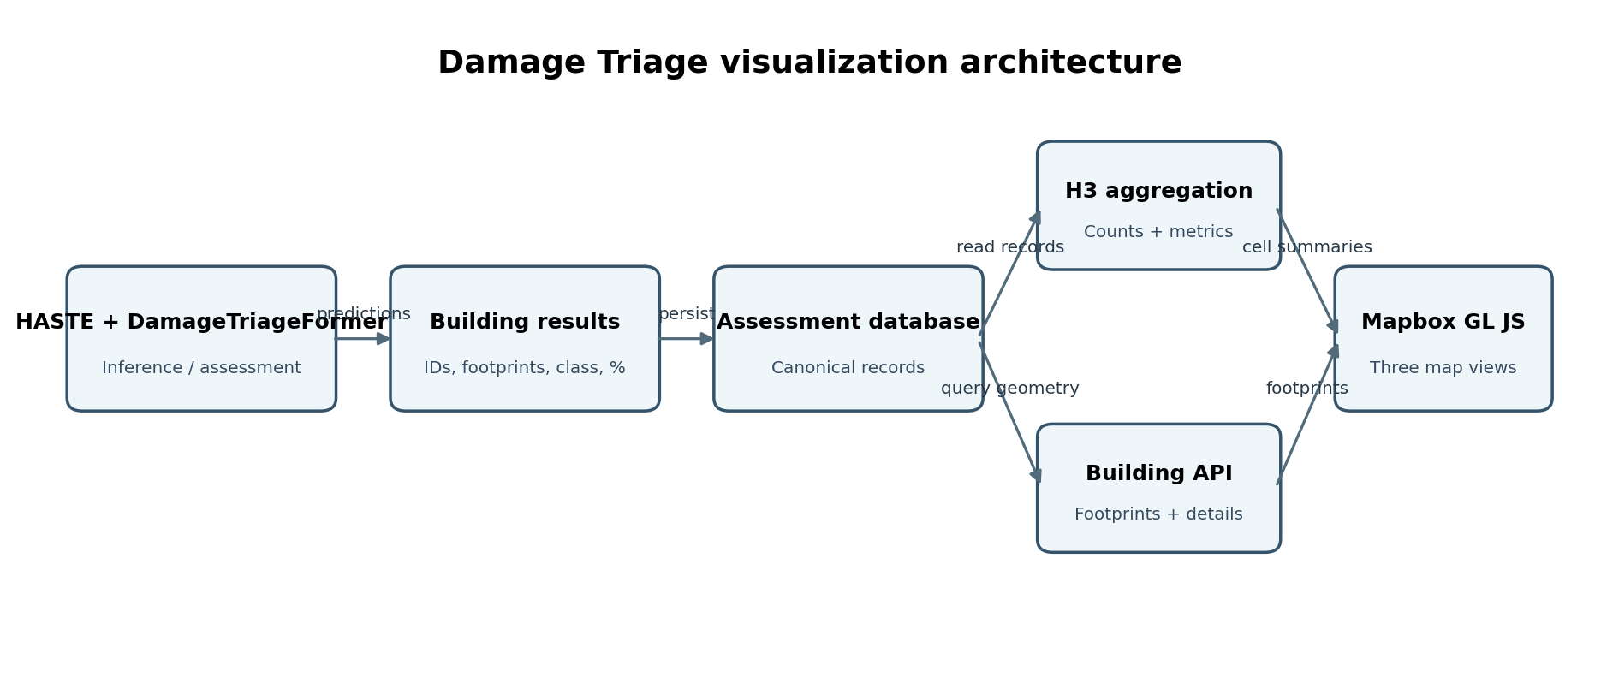
Reference diagram for the separation between spatial data services, APIs/cache, and the three frontend views.

H3 aggregation flow reference
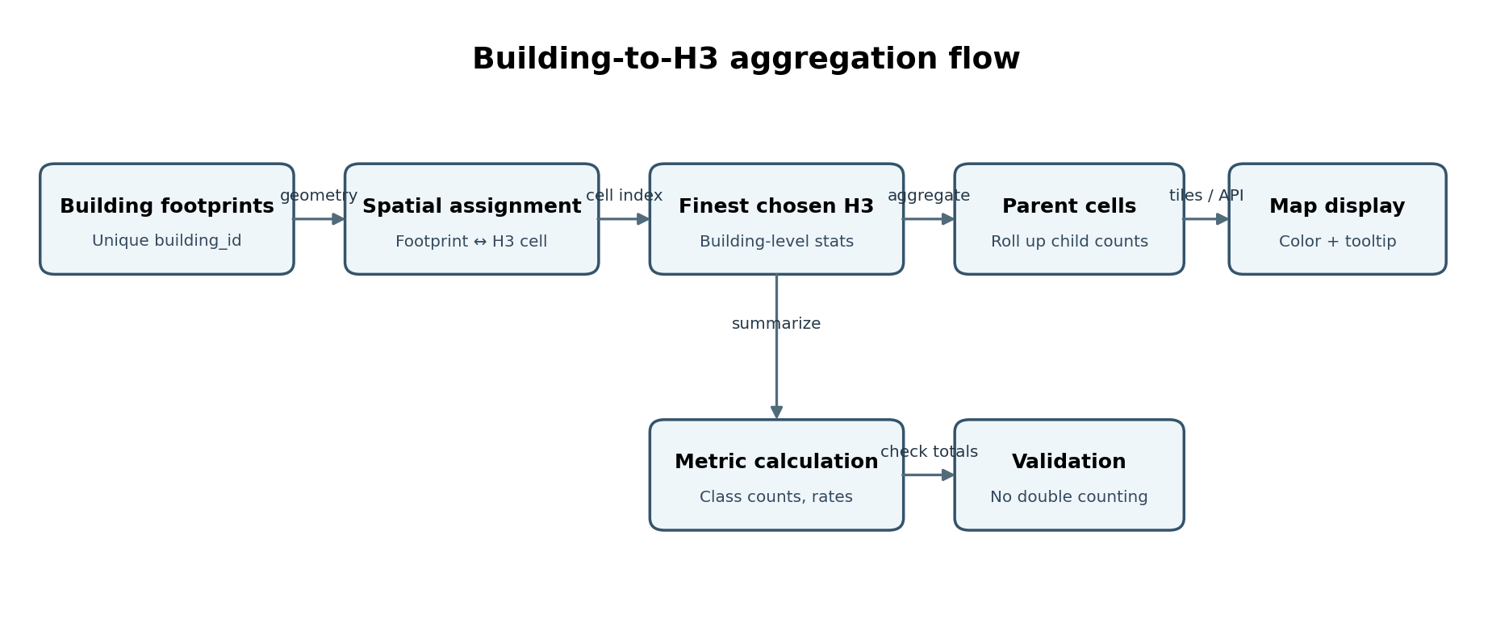
Reference diagram for unique building assignment, cell aggregation, parent rollups, validation, and serving.

