DAMAGE TRIAGE

Visualization Layer
Technical Specification
Texas Satellite-Based Damage Assessment
Three coordinated Mapbox views: H3 hierarchical aggregation, building-level damage polygons, and building-density heatmap.
Scope: frontend visualization and spatial aggregation. The existing HASTE and DamageTriageFormer inference workflow remains separate.
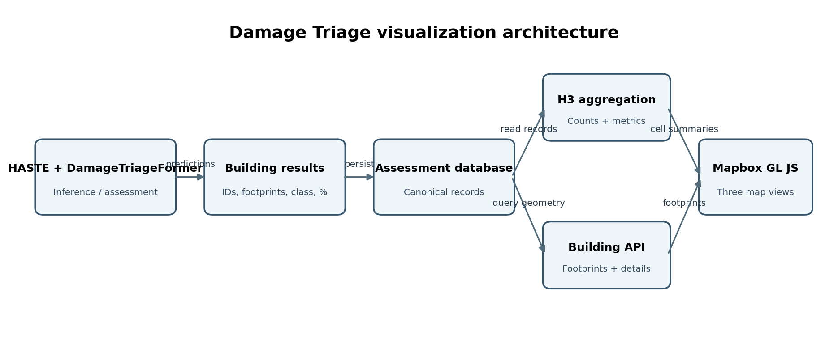
Version 1.0 | Proposed implementation specification | 12 October 2026

1. Executive Summary
The Damage Triage tab will provide three visualization modes backed by the same persisted assessment data. H3 supports scalable regional exploration, building polygons support precise inspection, and the density heatmap reveals built-up areas independently of damage severity.
- H3 hierarchical damage map — aggregated statistics across regional-to-local spatial cells.
- Building-level damage map — actual building footprints colored by their own model-predicted class.
- Building-density heatmap — a subtle concentration surface based on the building inventory, not damage labels.
A map interaction must never trigger inference. Mapbox renders and interacts with results; the assessment database remains the source of truth.

2. Scope and Non-Goals

In scope
- Texas map navigation and basemap styling in Mapbox GL JS.
- H3 cell aggregation and resolution-aware display.
- Five-class building footprint rendering and building detail panel.
- Building-density heatmap, shared filters, selected AOI, caching, and viewport-based loading.

Out of scope
- Replacing HASTE imagery preparation, model inference, GeoTIFF inputs, or source building footprints.
- Treating H3 cells as individual buildings.
- Running DamageTriageFormer on zoom, pan, or layer switch.
- Inventing damage percentages or confidence scores not produced by the assessment pipeline.

3. Mapbox GL JS: Role in the System
Mapbox GL JS is the browser-side interactive map renderer. It supplies the basemap, navigation, controls, polygon fills, heatmap rendering, and click/hover interactions. It is not the inference engine and does not create authoritative damage assessments.
- H3 polygons: cell fill, outline, metric tooltip, and drill-down.
- Building polygons: class-specific fill, selection highlight, and detail panel.
- Density heatmap: representative building points rendered as a smoothed concentration surface.

4. Reference Images Provided
The following images were supplied by the project owner and are included as conceptual references. They are not generated replacement images and are not exact production output.

Reference A — Hexagonal spatial grid concept
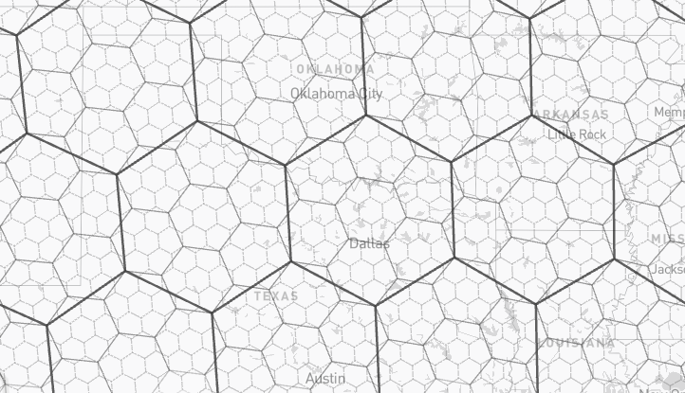
Use as a visual reference for the hexagonal tessellation concept. Production cells must use actual H3 indexes and geometries.

Reference B — Aggregated regional damage view
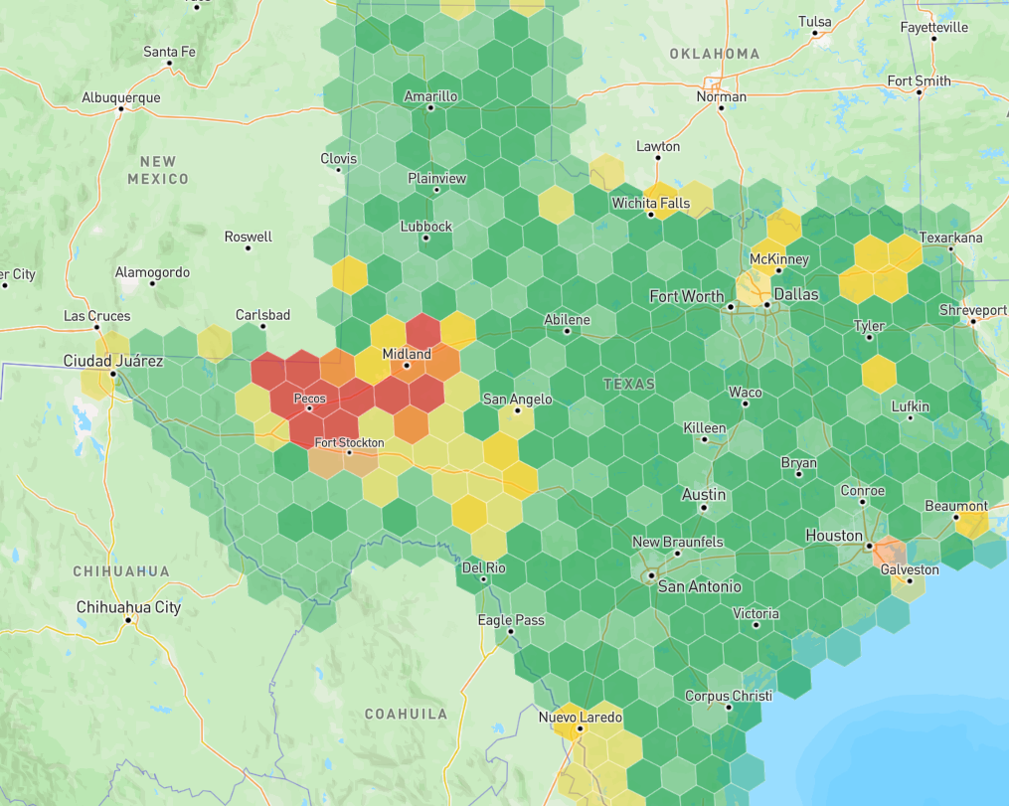
Use as a reference for color-coded cell aggregation over a regional basemap. Production colors and cell statistics must be driven by real assessment records.

5. Visualization A — H3 Hierarchical Damage Map

5.1 What is H3?
H3 is a hierarchical geospatial indexing system that partitions the world into hexagonal cells (with pentagons also present in the global grid). It has 16 resolutions numbered 0–15. Higher resolution numbers mean smaller cells. Each finer cell has a parent at a coarser resolution, allowing counts and other metrics to be aggregated upward.
H3 cells are spatial bins, not building boundaries. A building may intersect multiple cells. Building-level inspection must use the actual source footprint geometry.

5.2 Suggested resolution strategy
H3 resolution | Approx. average edge | Suggested purpose
3–4 | ~23–60 km | Statewide / broad regions
5–6 | ~3–9 km | Large regions / counties
7–8 | ~0.46–1.2 km | Cities / subregions
9–10 | ~66–174 m | Neighborhoods
11–12 | ~9–25 m | Fine local aggregation
13–15 | ~0.5–3.5 m | Usually unnecessary for displayed damage cells
Lengths are approximate average cell-edge lengths, not exact diameters; actual cell dimensions vary geographically. Start with resolutions 4–12 and select resolution based on viewport/zoom and performance testing. Do not map each Mapbox zoom level directly to a single H3 resolution without tuning.

5.3 Building assignment and cell aggregation
- Use a stable building_id and validated building footprint.
- For building counts, assign each building to exactly one cell using a representative point guaranteed to lie inside its footprint (for example, a point-on-surface).
- Avoid counting one footprint in every cell it intersects unless the metric explicitly measures footprint coverage.
- Calculate statistics at the finest resolution needed by the product.
- Roll parent counts up by summing child counts or recomputing from underlying unique building records.
- Compute percentages from summed numerators and denominators; never average child percentages without weighting.
- Serve precomputed summaries to Mapbox rather than calculating statewide statistics in the browser.

5.4 Suggested H3 attributes
h3_index, h3_resolution, parent_h3_index, building_count, assessed_building_count, undamaged_count, partial_roof_damage_count, total_roof_damage_count, partial_structural_collapse_count, total_structural_collapse_count, damaged_building_count, severe_damage_count, severe_damage_percentage, optional average_damage_percentage, optional mean_confidence, assessment_version, updated_at.

5.5 Cell coloring modes
- Dominant class: most frequent building class in the cell; display the class share so a plurality is not mistaken for a majority.
- Damage severity: a documented metric such as severe-damage share, with a continuous palette and visible legend.
- Empty or unassessed cells should be neutral/transparent and must not be presented as undamaged.

6. Visualization B — Building-Level Damage Map
Render the actual source building footprints as polygons. Each polygon uses that building’s own stored damage label.
Exact class label | Suggested color | Hex
Undamaged | Green | #22A65A
Partial Roof Damage | Yellow | #F5D547
Total Roof Damage | Orange | #F28C28
Partial Structural Collapse | Red | #E44747
Total Structural Collapse | Dark red | #991F36
On click, show building_id, exact damage class, damage percentage only if defined by the model/output pipeline, confidence if available, assessment timestamp/version, and available imagery reference. Keep colors consistent across map, legend, detail panel, and reports. Use H3 or density rendering at low zoom to avoid drawing every building at once.

7. Visualization C — Building-Density Heatmap
This view answers “where are buildings concentrated?” It does not answer “where is damage severe?”
- Create one representative point per building footprint.
- Render the points with a Mapbox GL JS heatmap layer; tune radius, intensity, and opacity by zoom.
- Use a subtle sequential palette such as pale mint to teal; keep sparse or empty areas mostly transparent.
- Explain whether the legend means relative intensity or a measured building count.
- If exact buildings per km² are required, calculate the statistic in a backend grid or administrative area. A conventional point heatmap is a smoothed concentration surface, not a direct density count.
- Keep building density independent of damage labels. If needed, offer a separate, explicitly named damaged-building-density metric.

8. Architecture
Responsibilities: inference pipeline persists predictions; database stores canonical records; H3 service calculates cell summaries; building API returns footprints/details; density source supplies building points or density tiles; Mapbox renders the three modes.

9. Building-to-H3 Aggregation Flow
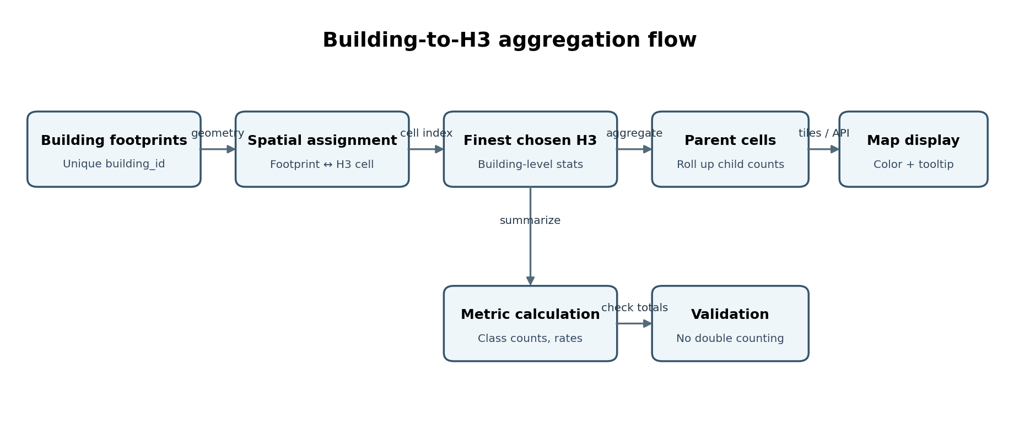
Aggregation steps: validate geometry and unique IDs → assign each building once → compute fine-resolution H3 index → group and calculate statistics → roll counts to parent cells → validate totals → persist/version summaries → serve to Mapbox.

10. Worked Example
Suppose one cell contains 100 assessed buildings:
- 40 Undamaged
- 20 Partial Roof Damage
- 15 Total Roof Damage
- 15 Partial Structural Collapse
- 10 Total Structural Collapse
Then building_count = 100, damaged_building_count = 60, damaged-building percentage = 60%, and severe_damage_count = 25 if severe damage is defined as the two structural-collapse classes. The severe-damage percentage is 25%. These numbers are illustrative only.
Parent cells sum child counts (or recompute from underlying unique building records). For any percentage, calculate summed numerator / summed denominator × 100. Never take an unweighted average of child percentages.

11. Suggested API Surface
- GET /api/assessments/h3?resolution={r}&bbox={bbox}&aoi_id={id}
- GET /api/assessments/buildings?bbox={bbox}&damage_class={class}
- GET /api/assessments/buildings/{building_id}
- GET /api/assessments/building-density?bbox={bbox}&zoom={z}
These are proposed endpoint shapes; adapt them to existing backend conventions. Use vector tiles or viewport/bounding-box responses, AOI filtering, pagination, caching, and assessment version/timestamp. Do not send the entire Texas building inventory to the browser.

12. Performance and Consistency Requirements
- Layer switching never triggers model inference.
- Preserve selected AOI and filters when switching modes.
- Show a loading state for new viewport/resolution requests.
- Cache common H3 resolutions and AOI summaries.
- Recompute only affected aggregates when assessment records change.
- Prevent double counting of buildings that intersect multiple cells.
- Distinguish not assessed from undamaged.
- Display assessment timestamp/version and metric definition.
- Ensure parent counts equal the sum of uniquely assigned child counts.

13. Acceptance Criteria
- All three modes render from the same persisted assessment dataset.
- Every building feature links to its persistent building_id.
- All five damage labels and colors match this specification.
- H3 cells show documented aggregates and valid parent rollups.
- Parent totals and class counts reconcile with unique building records.
- The density heatmap reflects building concentration by default, not damage severity.
- Selecting a building or H3 cell shows correct details.
- Zoom, pan, and layer switching never trigger inference.
- Texas-wide data loads progressively through tiles or viewport-based requests.
- Missing, unassessed, and undamaged states are visually distinct.

14. Recommended Implementation Order
- Confirm assessment schema, building_id, and footprint geometry.
- Confirm definitions for damage percentage, confidence, and severe damage.
- Implement unique building-to-H3 assignment and unit tests.
- Build H3 aggregation and parent-rollup validation.
- Implement building footprint styling and the detail panel.
- Implement building-density points/heatmap.
- Add shared AOI/filter state, legends, caching, and performance tests.
- Validate against known sample AOIs before statewide rollout.

Design Principle
Use H3 for scalable regional aggregation, actual building footprints for precise inspection, and a separate building-density heatmap for urban context. All views must read the same persisted assessment results.

