AI/ML TRAINEE ASSIGNMENT
AccuKnox
Gokul M
B.Tech Information Technology
Thalassery, Kerala | gokul.mulloli@gmail.com | +91 9745504804
GitHub: Assignment Repository

Problem Statement 1

1. API Data Retrieval and Storage
I used the Open Library Search API to retrieve book records, extracted the title, author and first publication year, stored the selected fields in SQLite, and displayed the stored records. The script also handles API request failures and missing author data.
Assumption: When multiple authors are returned, their names are stored as one comma-separated value.

2. Data Processing and Visualization
I retrieved student score data from a REST API and calculated the average score for each subject across the available student records. The results are visualized as a bar chart. Missing scores are excluded from the corresponding subject average.
Assumption: The visualization uses the seven subject score fields provided by the API and averages them across the returned records.

3. CSV Data Import to Database
I used Python's csv.DictReader to read name and email values from a CSV file and inserted the records into a local SQLite database. Existing rows are cleared before import so repeated execution refreshes the database instead of creating duplicates.

4. Most Complex Python Code
File: backend/run_pipeline.py
This is the batch prediction and explainability pipeline from my telecom retention project. It retrieves active customers from the database, performs feature engineering and preprocessing, runs XGBoost inference and SHAP analysis, assigns risk tiers, and writes prediction results back to the database. I selected it because it combines several non-trivial Python, ML and backend steps in one workflow.

5. Most Complex Database Code
File: backend/app/models.py
This file defines the SQLAlchemy models for users, customers and churn predictions, including the foreign-key and one-to-one relationship used between customer records and prediction results. These models support the database operations used by the backend and prediction pipeline.

Assignment 2

1. Self Assessment
LLM - A , Deep Learning - B , AI - A , ML - A
The ratings reflect my current ability to work independently. I rated Deep Learning as B because I have conceptual understanding and hands-on experience fine-tuning DistilBERT, but less extensive practical experience with deeper architecture experimentation and advanced training/tuning compared with my ML and LLM work.

2. LLM Chatbot Architecture
A high-level chatbot architecture can be organized as a frontend, backend API, conversation/session management, an LLM service, and optional retrieval and tool layers.
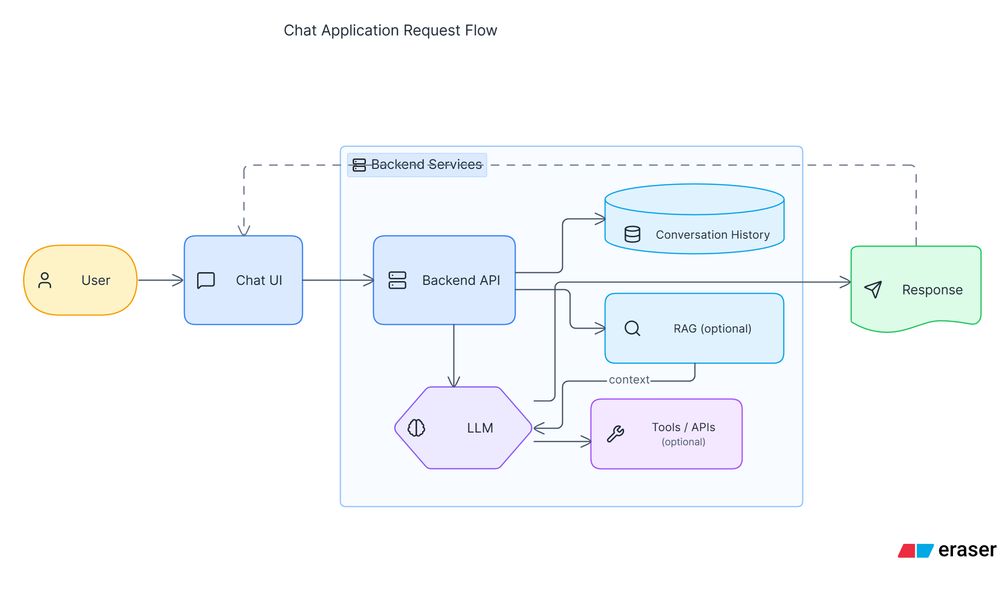
The backend receives and validates the user's message and maintains the relevant conversation context. For a domain-specific chatbot, the query can be embedded and used to retrieve relevant information from a vector database. The retrieved context, conversation history and system instructions are combined into a prompt for the LLM. If external actions or real-time information are required, defined tools or APIs can be invoked through the backend. In a production system, logging, monitoring, security, rate limiting, error handling and evaluation would also be included.

3. Vector Databases
A vector database is designed to store and retrieve vector representations such as embeddings. It supports similarity-based retrieval, allowing semantically related items to be found even when the query and stored text do not share the same keywords. Typical capabilities include vector indexing, similarity search, metadata filtering and persistent storage.
Hypothetical use case: An internal company knowledge chatbot that answers questions using thousands of internal documents.
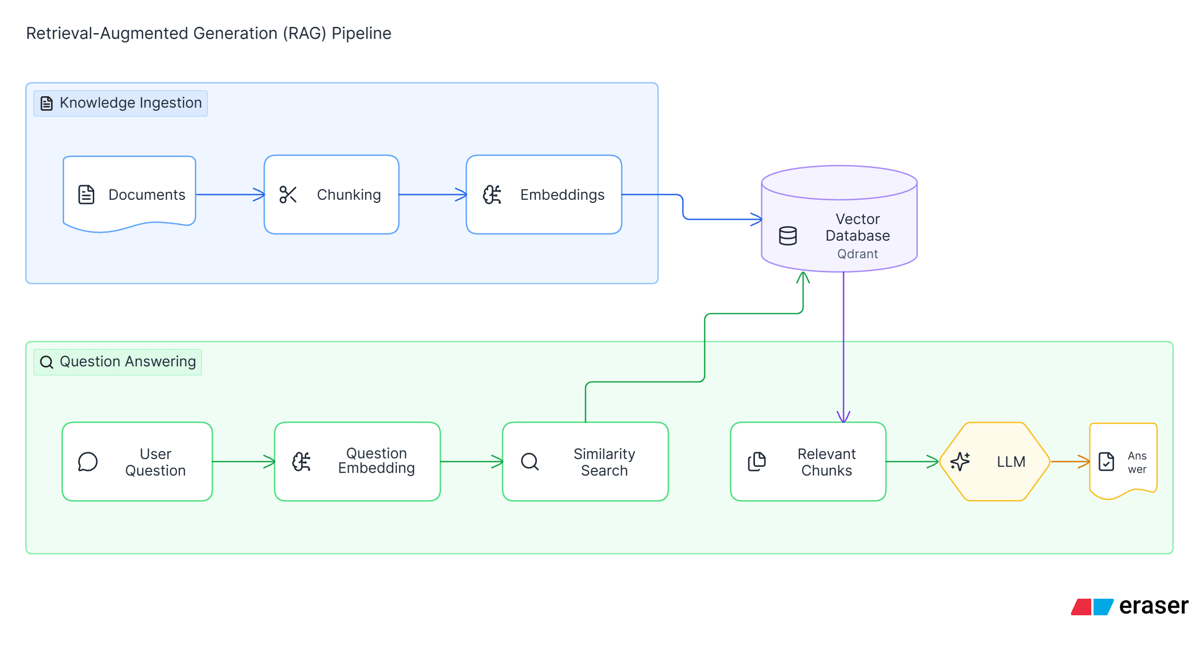 For this hypothetical system, I would choose Qdrant because the primary workload is semantic retrieval over a collection of document chunks. Qdrant is purpose-built for vector search and provides similarity search together with metadata filtering. If the existing application already used PostgreSQL extensively, I would instead consider pgvector to avoid introducing a separate database and to keep relational and vector data together

Assumptions
- The Open Library response is reduced to the fields required by the assignment.
- Multiple book authors are stored as a comma-separated value in one database field.
- Missing student score values are excluded from the relevant subject average.
- The student visualization shows subject-wise averages across the available API records.

Repository
https://github.com/Gokul-m-2000/accuknox-ai-ml-assignment

