TECHNICAL REPORT
Enhanced Keyword Spotting on STM32F411
Embedded CNN Inference and Early-Exit Optimization

Project | Arm-Optimized Keyword Spotting
Target Platform | STM32F411 / Arm Cortex-M4
Deployment Framework | STM32 X-CUBE-AI
Team / Author(s) | Roshan R, Shree Bala K, Gokul Prasad K, Jaya Adithya
Challenge / Event | Arm AI Optimization Challenge 2026

1. Abstract
Keyword Spotting (KWS) models have long represented the pinnacle of efficiency for always-on, low-power speech recognition, enabling seamless voice-triggered interactions in resource-constrained edge devices such as smartphones, wearables, and IoT sensors. These systems are designed to continuously monitor audio streams while operating under strict energy and latency budgets, making computational efficiency just as critical as recognition accuracy. However, conventional KWS architectures typically apply a fixed amount of computation to every input, regardless of its complexity, often leading to unnecessary energy expenditure on easily classifiable samples. To address this limitation, recent research has begun exploring adaptive inference strategies that dynamically adjust computational depth based on input difficulty. Such approaches allow confidently recognized keywords to exit processing early, while more ambiguous inputs are routed through additional layers for refined analysis—paving the way for a new generation of KWS models that balance efficiency and accuracy more intelligently.

2. Introduction
Keyword spotting on resource-constrained embedded systems presents a fundamentally different design challenge than server-side speech recognition. Devices built around Cortex-M-class microcontrollers typically operate with only a few hundred kilobytes of SRAM, limited flash storage, and clock speeds in the tens to hundreds of MHz, all while running on battery power for extended periods, often years, without recharging. In this context, low latency is essential because keyword detection must trigger downstream actions, such as waking a larger processor or initiating a voice assistant, in near real time, without perceptible delay to the user. Low memory usage is equally critical, since these microcontrollers lack the RAM and storage capacity to accommodate large neural network models or extensive intermediate activations. Similarly, low computational cost directly determines power consumption; every additional multiply-accumulate operation drains the battery faster and generates heat that can affect device reliability. Together, these constraints mean that KWS models deployed on Cortex-M hardware must be aggressively optimized, balancing accuracy against a tight envelope of memory, compute, and energy, making architectural efficiency a first-class design objective rather than an afterthought.

3. Problem Statement and Motivation
Deploying keyword spotting (KWS) models on microcontroller-class hardware requires balancing classification performance against strict memory, compute, and power constraints. Lightweight architectures such as depthwise-separable CNNs help reduce this burden, but they still execute a fixed computational path for every input, regardless of how easily it could be classified — an inefficiency, since many keyword utterances are distinct enough to be recognized using only partial network depth. This motivates adaptive inference strategies, such as early-exit mechanisms, that reduce average computation without materially affecting accuracy.
In the baseline implementation, the compact depthwise-separable CNN is first characterized at the model level using the Python-based analysis pipeline. The model accepts a 49 × 10 × 1 feature tensor and produces probabilities for 12 classes. The Python-side characterization reports 24,908 parameters for the original model and 2,656,768 MACs per inference. The baseline model achieves 92.1677% accuracy on the evaluated 4,890 samples. The model is then split into Network 1, Network 2, and an EE1 classifier. The split consists of 13,504 parameters in Network 1, 11,404 parameters in Network 2, and 780 parameters in EE1. Forced-split validation produced 92.1677% accuracy, with 100% prediction agreement and zero probability difference compared with the original model.
This motivates the need for an inference strategy that can adapt the amount of computation to the difficulty of each input. Rather than executing the complete network for every input, an intermediate classification stage can be introduced to identify inputs that can be classified with sufficient confidence before the remaining layers are executed. Such an approach has the potential to reduce the average computational workload and inference latency while retaining the classification capability of the original model.

4. Project Objectives
- Deploy a compact CNN-based keyword spotting model on the STM32F411 Arm Cortex-M4 using STM32 X-CUBE-AI / ST Edge AI Core.
- Establish and characterize the full CNN implementation as the baseline for evaluating computational and deployment requirements.
- Develop a novel early-exit inference architecture that divides the CNN into a feature-extraction stage, an intermediate classifier, and a remaining network stage.
- Implement confidence-based adaptive inference that allows sufficiently confident inputs to terminate at the intermediate classifier while forwarding uncertain inputs through the remaining network.
- Implement and validate the complete the proposed early-exit architecture on the STM32F411 alongside the baseline implementation.
- Compare the baseline and the proposed early-exit implementations under consistent hardware and inference conditions.
- Evaluate the practical trade-offs introduced by the proposed approach in terms of computational requirements, memory utilization, inference latency, and classification performance.

5. System Overview
The system implements an embedded keyword spotting inference pipeline targeting the STM32F411 Arm Cortex-M4 microcontroller. The deployed neural-network models are exported in TensorFlow Lite (.tflite) format and converted into optimized C implementations using STM32 X-CUBE-AI / ST Edge AI Core for execution on the target hardware.
The model receives a 1 × 49 × 10 × 1 floating-point feature tensor, corresponding to 490 input values, and produces a 1 × 12 output representing the classification probabilities for the 12 output classes. The audio acquisition and feature-extraction stage that produces this input tensor is outside the scope of the current repository; therefore, the exact feature-extraction process is not specified here.
Two inference configurations are implemented. The Full Model executes the complete CNN for every input. The Early-Exit configuration divides the network into three components: network_1, which extracts intermediate features; network_ee, which performs an intermediate 12-class classification; and network_2, which contains the remaining CNN layers. When the intermediate classifier produces sufficient confidence, inference terminates without executing network_2. Otherwise, the intermediate feature representation is passed to network_2 to obtain the final prediction.

6. Baseline KWS Model
The baseline KWS system uses the Speech Commands dataset with 12 classes: Down, Go, Left, No, Off, On, Right, Stop, Up, Yes, Silence, and Unknown. The baseline configuration uses a 16 kHz sampling rate and 1.0 s audio duration. Adaptive MFCC processing is disabled for the baseline characterization.

6.1 Feature Extraction
The baseline preprocessing converts each 1.0 s audio sample into a fixed MFCC representation. The audio is processed using 480-sample (30 ms) frames with a 320-sample (20 ms) frame hop, producing 49 spectrogram frames. The STFT uses TensorFlow's default FFT length with a Hann window and magnitude spectrum. A 40-bin Mel filterbank covering 20–4000 Hz is then used, followed by MFCC extraction with 10 coefficients, including coefficient 0. The resulting feature representation has the shape [49, 10, 1], which is used as the CNN input.

6.2 CNN Architecture
The baseline CNN is identified in the repository as a DS-CNN. The network begins with a standard convolutional layer followed by batch normalization. This is followed by four depthwise-separable convolutional blocks, with each block consisting of a depthwise convolution, batch normalization, pointwise convolution, and batch normalization. The network ends with a dense layer mapping the 64-feature representation to 12 output classes.
The repository's manual parameter calculation gives 24,908 total parameters, consisting of 23,756 trainable and 1,152 non-trainable parameters. The report explicitly notes that this manual count should be checked against model.count_params() in a TensorFlow environment.

6.3 Baseline Model Configuration
The baseline characterization uses Adam as the optimizer, with a configured learning-rate argument of 0.00001, a batch size of 100, and 36 epochs as the default training configuration. The repository also specifies a step-based learning-rate schedule in its configuration.
The repository identifies the baseline model as:
- Architecture: DS-CNN
- Input: [49, 10, 1]
- Output classes: 12
- Dataset: Speech Commands
- Sample rate: 16 kHz
- Audio duration: 1.0 s
- MFCC coefficients: 10
- Feature representation: [49, 10, 1]
- Manual parameter count: 24,908
- Optimizer: Adam
- Batch size: 100
- Default epochs: 36

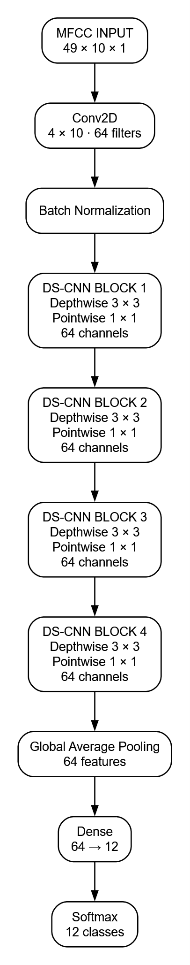
FIG. 1: Baseline KWS Architecture

6.4 Exported and Embedded Baseline Model
The baseline model, full_model_float32_test, is a floating-point TFLite model generated for the STM32F4 target using ST Edge AI Core. The model accepts an input tensor of 1 × 49 × 10 × 1 and produces an output tensor of 1 × 12. It contains 22,604 parameters, with 90,416 B (88.30 KiB) of weights and 50,432 B (49.25 KiB) of activation memory. The reported computational requirement is 2,737,536 MACC.
The generated C representation contains 21 C-nodes and 47 C-arrays. The first convolutional layer takes the 1 × 49 × 10 × 1 input and produces a 1 × 25 × 5 × 64 feature map, with 320,064 MACC. The subsequent convolutional layers operate on the 1 × 25 × 5 × 64 representation.
The final part of the network contains a pooling operation followed by a dense layer with 780 MACC and 3,120 B of weights, followed by a SoftMax layer producing the 1 × 12 output.

7. Early-Exit Architecture
The optimization approach uses an early-exit architecture that splits the baseline CNN into three stages: network_1, network_ee, and network_2. network_1 performs the initial feature extraction and generates an intermediate feature representation. This representation is passed to network_ee, which acts as an intermediate classifier and produces a 12-class prediction.
A confidence-based decision is then applied to the output of network_ee. If the prediction meets the implemented confidence threshold of 0.90, inference terminates at the intermediate classifier through an early exit. If the confidence is below the threshold, the intermediate feature representation is passed to network_2, which performs the remaining CNN computation and produces the final classification.
Thus, the early-exit architecture provides two inference paths: a short path through network_1 → network_ee for sufficiently confident inputs, and a full path through network_1 → network_ee → network_2 for inputs requiring further computation.
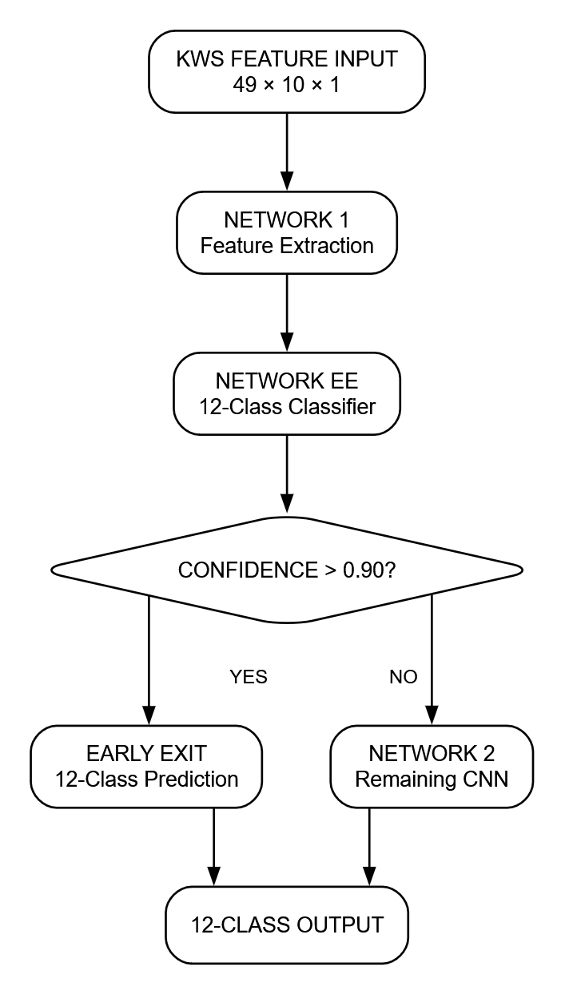
FIG. 2: Proposed Early Exit KWS Architecture

8. Software and Hardware Implementation

8.1 Software / Model Implementation
The Python implementation is used for the KWS model development, characterization, splitting, and validation. The baseline model operates on the 49 × 10 × 1 feature representation and produces 12-class predictions. The model is split into network_1, network_ee, and network_2 for the early-exit architecture. The Python implementation also performs forced-split validation and evaluates the expected computation at different confidence thresholds.
The Python-side implementation and model definitions are project-authored components. The reported baseline and split-model characterization is performed before the models are exported for embedded deployment.

8.2 Hardware / STM32 Implementation
For embedded deployment, the models are exported as TensorFlow Lite (.tflite) models and processed using STM32 X-CUBE-AI / ST Edge AI Core for the STM32F4 target. X-CUBE-AI generates the corresponding C neural-network implementation, including the generated network source/header files, model weights, and activation structures.
The STM32 firmware is project-authored around these generated network components. For the early-exit implementation, the firmware executes network_1, passes its intermediate output to network_ee, evaluates the confidence against the implemented 0.90 threshold, and either terminates through the early exit or continues execution using network_2.
The division between the two implementations is therefore:
- Python / project-authored: model development, splitting, characterization, validation, and threshold analysis.
- X-CUBE-AI generated: embedded neural-network C implementation and associated model data.
9. Benchmark Results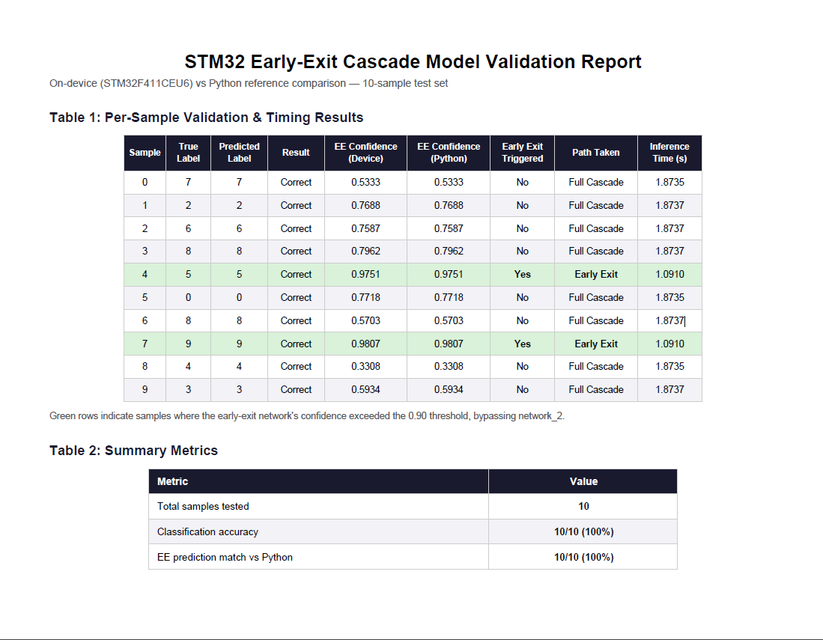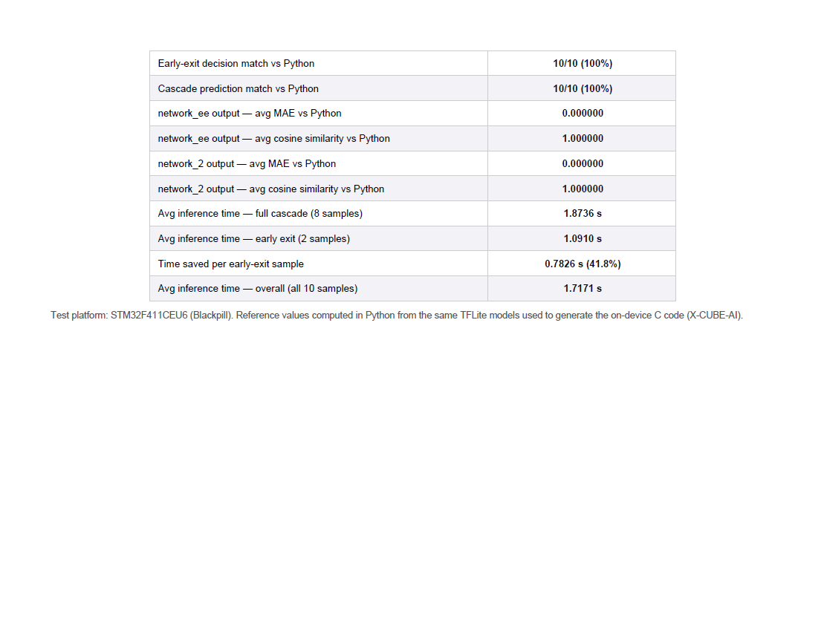

10. Conclusion
The early-exit keyword spotting architecture was implemented and validated across the Python reference and STM32F411CEU6 (BlackPill) deployment. On the 10-sample on-device validation set, the implementation achieved 10/10 correct classifications (100%). The embedded early-exit decisions and cascade predictions both matched the Python reference for 10/10 samples.
The numerical outputs of the embedded network_ee and network_2 also matched the Python reference, with an average MAE of 0.000000 and average cosine similarity of 1.000000 for both networks. Of the 10 tested samples, 2 triggered the early exit at the implemented 0.90 confidence threshold, while 8 followed the full cascade.
For the measured inference times, the full-cascade samples averaged 1.8736 s, while the early-exit samples averaged 1.0910 s. This corresponds to a measured saving of 0.7826 s (41.8%) per early-exit sample. Across all 10 tested samples, the overall average inference time was 1.7171 s.
Overall, the supplied validation results confirm that the implemented STM32 early-exit cascade reproduced the Python reference behaviour for the tested samples and demonstrated a measurable inference-time reduction for samples that triggered the early exit.

Appendix A. STM32 Project Structure
The STM32 implementation is organized into two separate projects: Full Model F4 and Early Exit F4. Both projects contain an X-CUBE-AI/App directory containing the application code and generated neural-network implementation.
A.1 Full Model F4
The Full Model F4 project contains the complete baseline neural network and its STM32 application. The generated X-CUBE-AI network is represented by the following files:
network.c — generated neural-network implementation.
network.h — generated neural-network interface.
network_config.h — generated network configuration.
network_data.c / network_data.h — generated model data structures.
network_data_params.c / network_data_params.h — generated model parameters and associated data.
These files are generated as part of the X-CUBE-AI deployment. The project also contains app_x-cube-ai.c, which provides the application-side integration and inference execution around the generated network.
A.2 Early Exit F4
The Early Exit F4 project contains three separately generated neural-network components:
network_1 — initial feature-extraction stage.
network_ee — intermediate early-exit classifier.
network_2 — remaining CNN computation.
Each generated network has its own corresponding C source, header, configuration, data, and parameter files.
The project-authored application code coordinates these generated networks. It executes the stages in sequence, evaluates the intermediate classifier output against the early-exit condition, and determines whether to terminate inference or continue with network_2.
A.3 Simplified Project Structure
Full Model F4
└── X-CUBE-AI
└── App
├── app_x-cube-ai.c [Project-authored]
├── network.c [Generated]
├── network.h [Generated]
├── network_config.h [Generated]
├── network_data.c [Generated]
├── network_data.h [Generated]
├── network_data_params.c [Generated]
└── network_data_params.h [Generated]
Early Exit F4
└── X-CUBE-AI
└── App
├── app_x-cube-ai.c [Project-authored]
├── network_1.* [Generated]
├── network_ee.* [Generated]
└── network_2.* [Generated]

