Autonomous Security Lab Assistant
Complete Product Guide

Product Purpose
A secure MCP-style backend for authorized cybersecurity lab reconnaissance, evidence collection, reporting, auditability, and AI-agent tool orchestration.

Document metadata
Field | Value
Project | Autonomous Security Lab Assistant
Version | 0.4.0
Workspace | D:\MCP_Demo
Audience | Students, backend engineers, AI engineers, security learners, reviewers
Generated artifact | PDF manual with diagrams and detailed explanations

Table of Contents
- Executive Summary
- Who Uses This Product
- Primary Use Case
- What The Product Does
- How To Run The Product
- How To Use The MCP-Style Server
- Security Model
- Artifact System
- File-By-File Walkthrough
- Line-By-Line Conceptual Workflow
- How Testing Works
- Example Output Explained
- What This Product Does Not Do
- How To Present This Project
- Future Improvements

1. Executive Summary
The Autonomous Security Lab Assistant is a safe-by-default cybersecurity lab assistant built around MCP-style tool orchestration. It lets a user or AI agent inspect authorized lab targets, collect structured evidence, generate findings, save reports, export SARIF, index runs, and maintain tamper-evident audit logs.
The project is intentionally not a chatbot, not a CRUD app, and not a simple API wrapper. It is a security orchestration backend that demonstrates AI agents, MCP architecture, defensive cybersecurity workflows, policy enforcement, persistence, reporting, and backend engineering discipline.
The central design rule is simple: policy first, tools second, evidence always.
Plain-English Definition
This project is a secure AI-agent tool server for authorized cybersecurity lab reconnaissance. It checks scope before action, refuses unsafe requests, runs bounded tools, and records evidence.

2. Who Uses This Product
Cybersecurity students use it to learn safe reconnaissance workflows without building unsafe habits.
Backend engineers use it to study protocol design, tool registries, persistence, reporting, and secure input validation.
AI engineers use it to understand how an agent can call tools through a controlled MCP-style interface.
Security researchers and CTF players use it inside owned labs, private ranges, and intentionally vulnerable training environments.
Teachers and mentors use it as a controlled demonstration of how security automation should be bounded.
User groups and value
User | Why they use it | What they learn or gain
Cybersecurity student | Practice safe lab recon | Scope validation, evidence, reports
Backend engineer | Study serious service design | JSON-RPC, validation, storage, tests
AI engineer | Build safe agent tools | MCP-style tool schemas and orchestration
Security team | Prototype defensive workflows | Auditability, SARIF, risk scoring
Portfolio builder | Show advanced capability | Security plus backend plus agent architecture

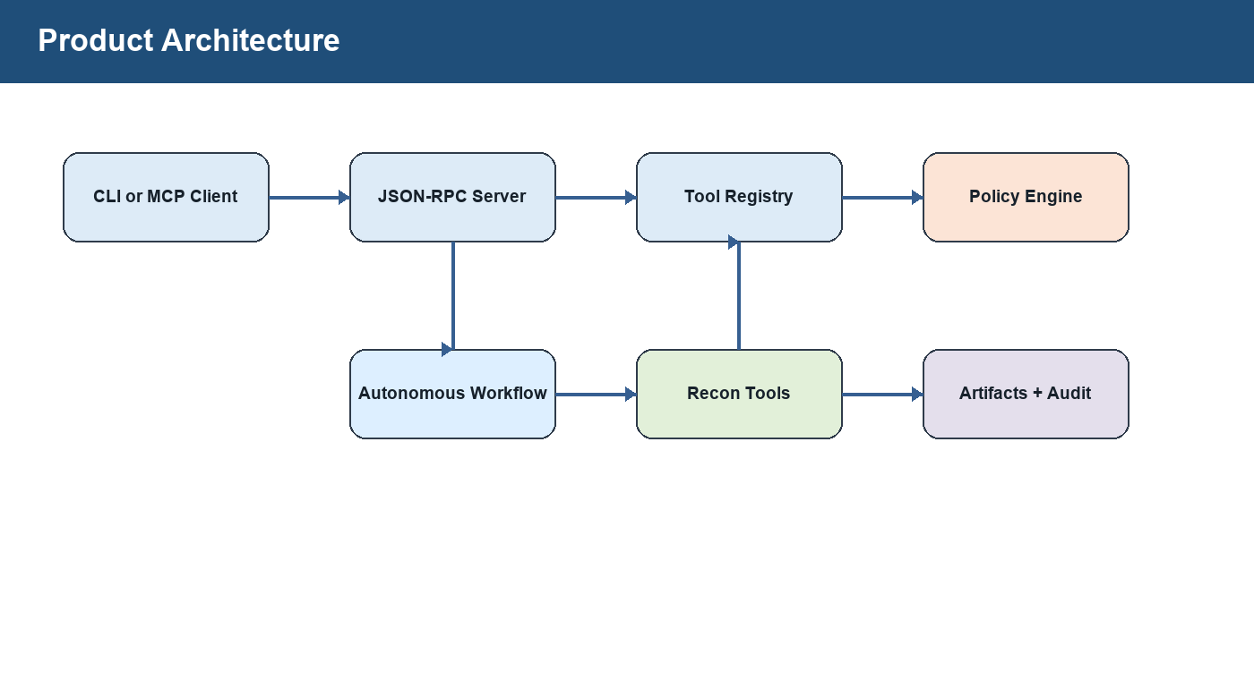
Figure 1. Product architecture: clients call a controlled tool server, tools pass through policy, and workflow artifacts are persisted.

3. Primary Use Case
The main use case is authorized lab reconnaissance. A user points the assistant at an allowed local or private target, chooses ports, and receives structured results.
For example, a developer may run a local test application on 127.0.0.1:8000 and ask the assistant to inspect common web ports. The assistant validates scope, scans only the requested ports, collects HTTP headers, checks TLS metadata when HTTPS exists, checks security.txt and robots.txt, extracts safe HTML page intelligence, generates findings, scores risk, and saves artifacts.
CLI recon example
python -m security_lab_assistant.cli recon 127.0.0.1 --ports 80,443,8000,8080

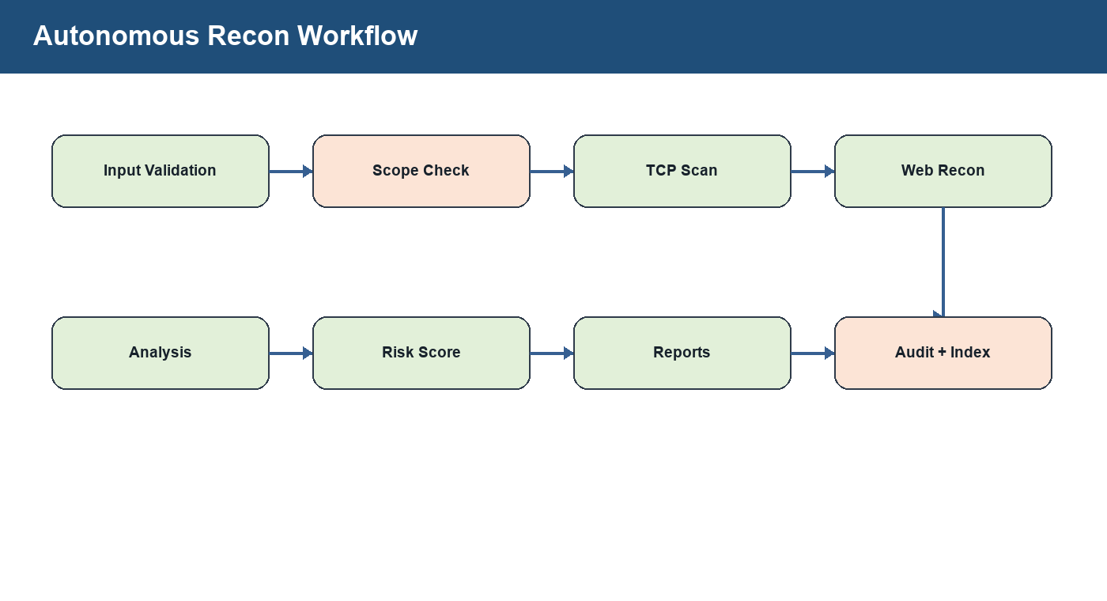
Figure 2. Autonomous recon workflow from input validation to persisted artifacts.

4. What The Product Does
The product exposes narrow security tools. Each tool has a name, description, input schema, and handler function. The MCP-style server lists these tools and allows clients to call them with JSON arguments.
Every active network tool checks the policy engine before it touches a target. Unsafe requests produce structured refusals instead of silent failures or uncontrolled exceptions.
Tool catalog
Tool | Purpose | Safety controls
scope.validate | Checks whether a target is allowed | Target normalization, CIDR and hostname policy
scan.tcp_connect | Bounded TCP connect scan | Port limit, blocked ports, timeout, worker cap
recon.http_headers | Collect selected HTTP headers | URL policy, no auto-follow redirects
recon.tls_certificate | Inspect TLS certificate metadata | Target and port policy
recon.well_known_security | Check robots.txt and security.txt | In-scope URL checks
recon.web_page_intel | Extract safe HTML indicators | No JavaScript execution
web.fetch_text | Fetch bounded text content | Max byte limit, URL policy
analyze.security_headers | Create header-hardening finding | Structured analysis only
run.list | List persisted runs | Bounded limit
run.get | Load a run by ID | UUID-only lookup
run.search | Search indexed runs | Bounded query, status validation
run.verify_audit | Verify audit hash chain | Tamper-evidence check
workflow.autonomous_recon | Run the full workflow | All controls combined

5. How To Run The Product
Open PowerShell in the project directory. In this workspace, the project lives at D:\MCP_Demo.
The project requires Python 3.11 or newer and currently has no third-party runtime dependencies beyond the bundled environment used to generate this guide.
Run all tests
python -m unittest discover -s tests

Run a recon workflow
python -m security_lab_assistant.cli recon 127.0.0.1 --ports 80,443,8000,8080

List saved runs
python -m security_lab_assistant.cli runs

Search saved runs
python -m security_lab_assistant.cli search --query 127.0.0.1 --status completed

Show one saved run
python -m security_lab_assistant.cli show <run_id>

6. How To Use The MCP-Style Server
The server reads newline-delimited JSON-RPC messages from stdin and writes JSON-RPC responses to stdout. This keeps the transport simple and inspectable.
Supported methods are initialize, tools/list, tools/call, and notifications/initialized.
Start the MCP-style server
python -m security_lab_assistant.server

Initialize request
{"jsonrpc":"2.0","id":1,"method":"initialize","params":{"clientInfo":{"name":"demo-client","version":"0.1.0"}}}

List tools request
{"jsonrpc":"2.0","id":2,"method":"tools/list","params":{}}

Run workflow request
{"jsonrpc":"2.0","id":4,"method":"tools/call","params":{"name":"workflow.autonomous_recon","arguments":{"target":"127.0.0.1","ports":[80,443,8000,8080],"objective":"baseline product smoke test"}}}

7. Security Model
The security model is strict because this project is used in a cybersecurity context. The product is built to refuse risky behavior by default.
No software can honestly promise zero vulnerabilities. The correct professional claim is that the project uses layered controls, regression tests, narrow tool boundaries, and explicit residual-risk documentation.
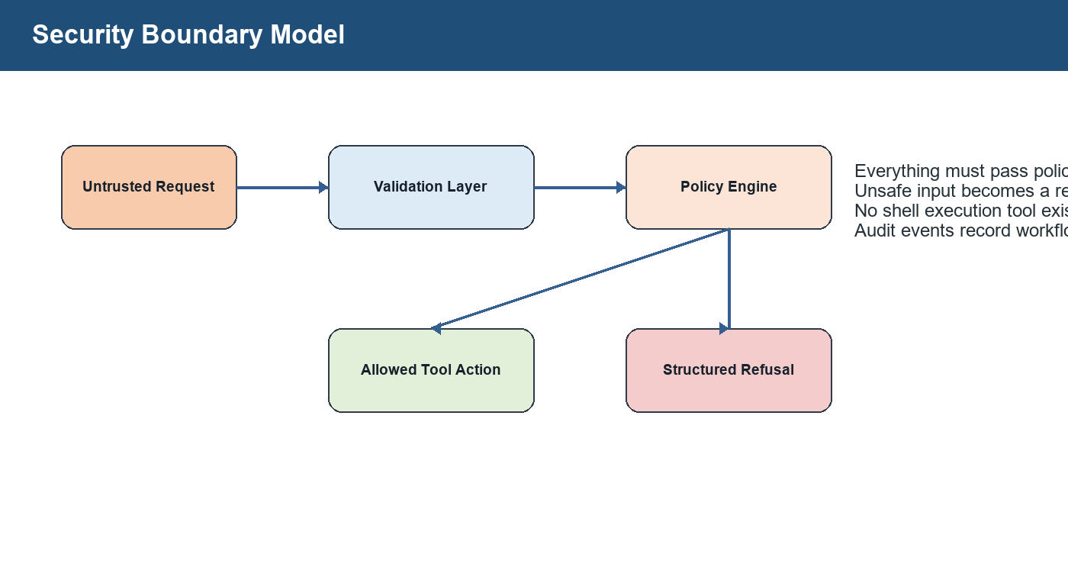
Figure 3. Security boundary model: every active operation must pass policy before reaching a target or artifact path.
Security controls
Control | What it prevents
Deny-by-default DNS targets | Accidental public-host scans
CIDR allowlist | Out-of-scope IP targets
Hostname allowlist | Unapproved DNS names
Blocked ports | Unsafe or unwanted service probing
Max ports per scan | Large unintended scans
URL credential rejection | Credential leakage and ambiguous authority
Fragment and parameter rejection | Ambiguous browser-only or legacy URL behavior
UUID-only run lookup | Path traversal through run IDs
Project-local artifact root | Writing outside the workspace
Atomic writes | Partial or corrupted artifact files
Hash-chained audit log | Undetected audit tampering
No shell tool | Arbitrary command execution
No JavaScript execution | Browser-side execution risk

8. Artifact System
A serious security product must preserve evidence. This project creates a local artifact directory when workflows run.
The artifact directory is project-local by policy. Absolute artifact directories and out-of-project paths are refused.
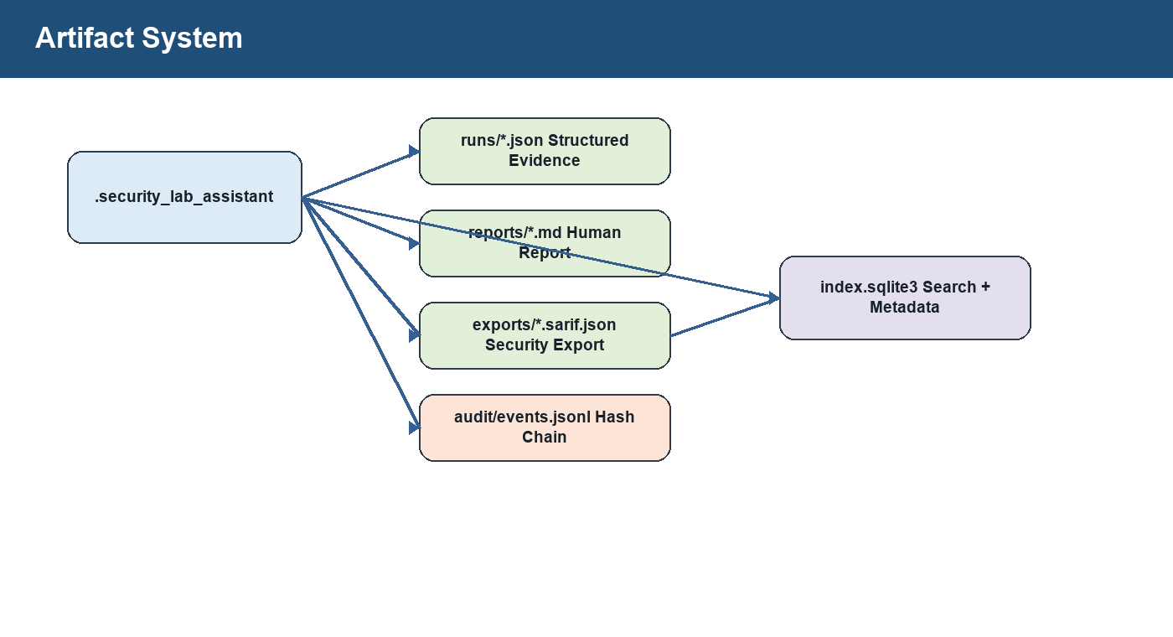
Figure 4. Artifact layout created by workflow runs.
Artifacts
Path | Purpose
.security_lab_assistant/runs/<run_id>.json | Complete structured evidence
.security_lab_assistant/reports/<run_id>.md | Human-readable Markdown report
.security_lab_assistant/exports/<run_id>.sarif.json | Security tooling export
.security_lab_assistant/audit/events.jsonl | Tamper-evident audit events
.security_lab_assistant/index.sqlite3 | Run and audit index

9. File-By-File Walkthrough
This section explains what each important file does and why it exists.
Important files
File | Purpose
pyproject.toml | Package metadata, version, Python requirement, CLI entry points.
configs/lab_policy.json | Default security policy: allowed CIDRs, hostnames, blocked ports, scan limits, artifact path.
models.py | Core dataclasses: ToolResult, Finding, RunContext.
policy.py | Security gatekeeper for targets, URLs, ports, and artifact paths.
validation.py | Shared safe parsing for strings, ports, limits, statuses, run IDs, and timeouts.
tools/base.py | ToolSpec abstraction and structured refusal helper.
tools/scope.py | Implements scope.validate.
tools/network.py | Implements TCP scan, HTTP headers, TLS certs, well-known files, fetch, and page intel.
tools/reporting.py | Analyzes security headers and creates findings.
tools/runs.py | Run list, get, search, and audit verification tools.
tools/registry.py | Central catalog of exposed MCP tools and schemas.
workflows/autonomous_recon.py | Main orchestration loop from validation to persistence.
storage.py | Atomic artifact writes, SQLite index, audit hash chain, run persistence.
reporting.py | Markdown report renderer.
risk.py | Risk scoring and band calculation.
sarif.py | SARIF export renderer.
mcp_protocol.py | MCP-style JSON-RPC method handler.
server.py | Stdio JSON-RPC server.
cli.py | Command-line interface for recon and run management.
tests/ | Security, protocol, persistence, and feature regression tests.

10. Line-By-Line Conceptual Walkthrough Of The Main Workflow
The main workflow lives in security_lab_assistant/workflows/autonomous_recon.py. The exact source code should be read in the repository, but the following walkthrough explains the logic line by line at a conceptual level.
Conceptual line-by-line workflow
Step | Code idea | Explanation
1 | Read target | require_string rejects empty, overlong, or control-character input.
2 | Read objective | Uses provided objective or defaults to baseline web reconnaissance.
3 | Parse ports | parse_ports rejects invalid values, booleans, duplicates, and unsafe types.
4 | Create RunContext | A run object stores target, status, phases, evidence, findings, warnings.
5 | Audit start | workflow.started is appended to the tamper-evident audit log.
6 | Scope phase | scope.validate confirms target is allowed before network activity.
7 | Refusal path | If scope fails, status becomes refused and artifacts are still saved.
8 | Port scan phase | scan.tcp_connect checks requested ports with bounded concurrency.
9 | Service recon phase | Open web ports are converted into HTTP or HTTPS URLs.
10 | Header recon | recon.http_headers captures selected headers without following redirects.
11 | TLS recon | HTTPS services trigger certificate metadata collection.
12 | Well-known checks | robots.txt and security.txt locations are inspected.
13 | Page intelligence | HTML structure is parsed safely without executing scripts.
14 | Analysis | analyze.security_headers turns observations into findings.
15 | Risk and reports | Risk score, Markdown report, SARIF, JSON evidence, SQLite index, and audit events are written.
16 | Return result | The workflow returns run ID, risk, warnings, findings, steps, and artifact paths.

11. How Testing Works
The tests are built with Python's standard unittest framework. The suite verifies policy behavior, refusal paths, protocol handling, persistence, SARIF export, risk scoring, audit verification, and security edge cases.
Test files
Test file | What it verifies
tests/test_policy.py | Default policy, local targets, public IP refusal, port limits
tests/test_tools.py | Tool refusal behavior and workflow stopping
tests/test_mcp_protocol.py | JSON-RPC initialize, tools/list, tools/call validation
tests/test_product_edges.py | Persistence, invalid URLs, DNS denial, path traversal, limits
tests/test_enterprise_features.py | SARIF, risk scoring, SQLite search, audit verification

Expected test command
python -m unittest discover -s tests

Expected result
Ran 28 tests
OK

12. Example Output Explained
A successful workflow response contains ok, run_id, target, status, open ports, severity counts, risk information, warnings, evidence steps, findings, and artifact paths.
Simplified output
{
"ok": true,
"data": {
"run_id": "44da8f18-1368-425a-85d8-ee1e519e6a2f",
"target": "127.0.0.1",
"status": "completed",
"open_ports": [],
"risk": {"score": 2, "band": "low"},
"warnings": ["No open ports were detected in the requested scan set."],
"run_path": ".security_lab_assistant/runs/<run_id>.json",
"report_path": ".security_lab_assistant/reports/<run_id>.md",
"sarif_path": ".security_lab_assistant/exports/<run_id>.sarif.json"
}
}

13. What This Product Does Not Do
It does not exploit vulnerabilities.
It does not brute force passwords.
It does not run malware.
It does not execute arbitrary shell commands.
It does not scan arbitrary public internet targets by default.
It does not bypass authentication.
It does not perform stealth scanning.
It does not replace professional security testing.

14. How To Present This Project
Long version: Autonomous Security Lab Assistant is a safe-by-default MCP-style security orchestration backend. It validates scope before action, exposes narrow security tools through structured schemas, performs bounded recon against authorized lab targets, persists evidence, generates reports, exports SARIF, maintains a SQLite run index, and records tamper-evident audit logs.
Short version: It is a secure AI-agent tool server for authorized cybersecurity lab reconnaissance.

15. Future Improvements
Add official MCP SDK integration.
Add authenticated HTTP transport if the server is exposed beyond stdio.
Add Docker Compose vulnerable lab targets for demos.
Add HTML report export.
Add CI with unit tests, type checks, and security scans.
Add signed releases and stricter filesystem permission checks.
Add role-based policies and human approval gates for higher-risk tools.
Final Summary
This project combines AI agents, MCP architecture, cybersecurity guardrails, backend engineering, security reporting, persistent evidence, auditability, and tests. The most important principle is: policy first, tools second, evidence always.

