### COVID VACCIENS ANALYSIS

**TEAM MEMBER**

**412621243020: Gokul.P**

# Phase-2 Document Submission

**Project: Covid Vaccines Analysis**

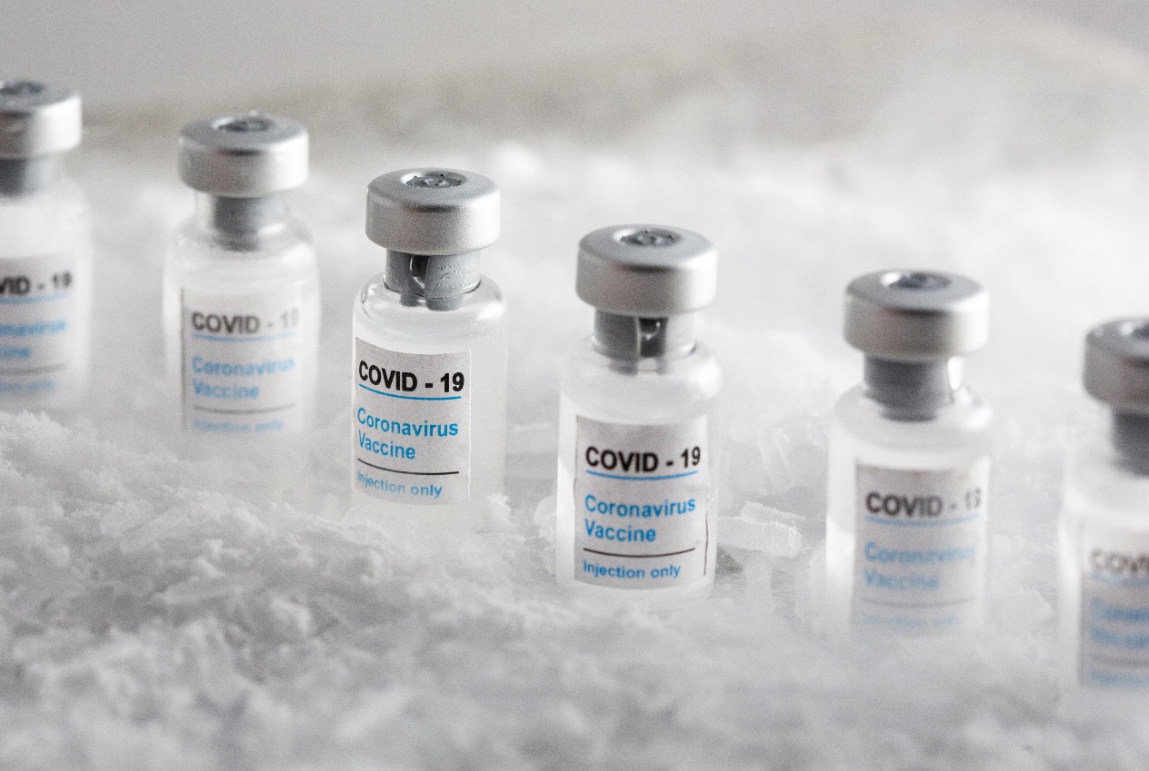

### OBJECTIVE:

The objective of COVID-19 vaccine analysis is to assess the safety, efficacy, and overall performance of COVID-19 vaccines in preventing COVID-19 infections, reducing the severity of the disease, and minimizing its impact on public health. This analysis involves rigorous testing, clinical trials, and ongoing monitoring to ensure that vaccines are effective and safe for widespread use. Additionally, vaccine analysis aims to identify any potential adverse effects and to provide data to guide vaccination strategies and public health policies.

**Phase 2: *Innovation:***

**Title:** Leveraging Advanced Machine Learning Techniques for COVID Vaccine Analysis

**Introduction:**

The analysis of COVID vaccine distribution and adverse effects data is critical

for public health decision-making. To uncover hidden patterns and insights in this data, we propose the use of advanced machine learning techniques, including clustering and time series forecasting. In this document, we will detail the steps involved in transforming our design concept into a working solution.

**Step 1: Problem Definition:**

* 1. **Identify the Problem:**
* Clearly define the problem we aim to solve, such as understanding the relationship between vaccine distribution patterns and adverse effects.

**1.2 Data Collection:**

* Collect relevant data sources, including vaccine distribution records, adverse event reports, demographic data, and vaccination coverage.

**Step 2: Data Preprocessing:**

**2.1 Data Cleaning:**

* Remove duplicates, handle missing values, and perform outlier detection and correction.

**2.2 Data Integration:**

* Combine data from various sources into a unified dataset.

**2.3 Feature Engineering:**

* Create new features or transform existing ones to provide more meaningful information for the analysis.

**2.4 Data Splitting:**

* Split the dataset into training, validation, and test sets for model development and evaluation.

**Step 3: Clustering Analysis:**

**3.1 Cluster Selection**

* Choose an appropriate clustering algorithm for the analysis, such as K-Means, DBSCAN, or hierarchical clustering.

**3.2 Cluster Analysis:**

* Apply the selected clustering algorithm to group regions or areas with similar vaccine distribution and adverse effects patterns.

**3.3 Interpretation:**

* Interpret the clusters to understand the characteristics of regions within each cluster. This may involve visualization and statistical analysis.

**Step 4: Time Series Forecasting**

**4.1 Time Series Data Preparation:**

* Prepare the data for time series forecasting, including selecting a suitable time interval (daily, weekly, monthly) and aggregating data accordingly.

**4.2 Model Selection:**

* Choose time series forecasting models, such as ARIMA, LSTM, or Prophet, depending on the data characteristics.

**4.3 Model Development:**

* Develop time series forecasting models for vaccine distribution and adverse effects.

**4.4 Model Evaluation:**

* Assess model performance using appropriate metrics like Mean Absolute Error (MAE) or Root Mean Squared Error (RMSE).

**Step 5: Integration and Visualization:**

**5.1 Integration of Clustering and Time Series Forecasting**

* Integrate the results from clustering analysis and time series forecasting to uncover insights about the relationship between vaccine distribution patterns and adverse effects over time.

**5.2 Visualization**

* Create visualizations (e.g., heatmaps, line charts) to present the findings in an interpretable and user-friendly manner.

**Conclusion:**

Leveraging advanced machine learning techniques such as clustering and time series forecasting can provide valuable insights into the relationship between COVID vaccine distribution and adverse effects. This document outlines the comprehensive steps from problem definition to data preprocessing, analysis, and visualization. By following these steps, we can develop a data-driven solution to

aid public health decision-makers.For a more detailed implementation plan and code, please refer to the accompanying technical documentation.

Please note that this document provides a high-level overview of the steps involved. Each step would require further planning, data preparation, modeling, and expertise. It's crucial to engage data scientists, epidemiologists, and domain experts to ensure the success of the project.